Supplementary information

Table S1. Environmental parameters identified in linear and logistic regression models predicting microcystin contamination using bidirectional stepwise elimination (M3-M6). An ‘x’ indicates the parameter was selected: parameters identified in two models are shaded light orange, and parameters identified in three models are shaded dark orange. Note that no environmental parameters were selected in M7 and M8.
Environmental parameter | M3 | M4 | M5 | M6 | M7 | M8
Chlorophyll | x | x
pH | x | x |  | x
Temperature |  | x
Particulate organic carbon |  |  | x | x
Particulate organic nitrogen |  |  | x | x
Sulfate |  |  |  | x
Ammonium |  |  | x | x

Table S2. Model equations for prediction of microcystin concentration using VOCs, environmental parameters, or both. Abbreviations for environmental parameters are given in Table 1.
Model | Equations: $\hat{Y}$ is microcystin concentration in ppb; logit(p) is the log odds of microcystin ≥0.3 ppb | Statistics | Alpha
M1ª | $\hat{Y}$ = – 11.02 + 4.88(80.045) + 11.22(148.073) -1.35(149.117) + 29.94(151.119) – 40.39(157.157) + 58.46(171.171) – 72.06(175.159) – 10.18(185.185) – 11.21(193.153) + 6.78(203.185) | MSPE=1.03  SD=0.90 | 0.015
M2ª | logit(p) = -10.17 +0.06(83.055) + 0.01(83.078) + 0.15(103.070) – 0.09(151.119) + 0.05(199.189) + 0.97(203.185) + 3.68(233.959) + 7.25(332.868) | AIC=66.66 AUC=0.78 | 0.8
M3^{b} | $\hat{Y}$ = 2.24(logCH) – 3.08(PH) + 52.92 | MSPE=19.10 SD=3.92 | -
M4^{b} | logit(p) = 0.52(Month)² – 8.57(SiteNAL) – 3.85(SiteWBR) + 1.76(logCH) + 1.94(TEMP) -2.54(PH)– 31.95 | AIC=27.14 AUC=0.50 | -
M5^{c} | $\hat{Y}$ = 7.47(Month) – 0.50(Month)² + 3.027(POC) – 15.37(PON) + 6.12(AMM) – 25.86 | MSPE = 0.15  SD = 0.05 | -
M6^{c} | logit(p) = [7.44(Month) – 0.40(Month)² + 1.71(PH) + 0.50(POC) – 2.59(PON) + 0.59(SUL) +3.01(AMM) – 5.08] · 10⁵ | AIC=22.99 AUC=0.22 | -
M7ª | $\hat{Y}$ = – 19.15(80.045) + 48.87(98.040) – 5.25(111.102) -18.39(137.129) + 198.95(138.131) – 20.49(148.073) + 17.80(149.117) + 30.65(151.119) – 8.43(153.095) – 37.61(157.157) – 21.23(169.113) – 28.741(171.171) –423.44(175.159) + 20.01(185.185) – 19.68(189.151) – 43.99(193.153) + 5.69(199.189) + 147.59(203.185) – 32.44 | MSPE = 1.09  SD = 1.02 | 0.008
M8ª | logit(p) = 0.29(35.042) + 0.09(111.102)-0.07(157.157) + 0.80(199.189) + 13.77(332.868) + 0.14(Month)–11.45 | AIC 50.37 AUC=0.88 | 0.45
ªm/z+1 values selected by the model are given in parentheses
^{b}”low-cost” parameters selected by the model are given in parentheses
^{c}”low-cost” and “high cost” parameters selected by the model are given in parentheses

Excel Table S3. showing the adjusted R² value, p-value, intercept, alpha value, and coefficients for m/z+1 values that were retained in the elastic net models predicting bacterial relative abundance. m/z+1 values retained by elastic net models predicting microcystin contamination are highlighted.

Table S4. Table of removed contaminants and isotopic pattern peaks (IPP). Inclusion of IPPs that are highly correlated can negatively impact an elastic net analysis that leans heavily towards the L1-norm (as used in a least absolute shrinkage and selection operator, or LASSO, analysis).
Mass removed | Type | Notes
31.988 | Contaminant | O2+ (ion source)
32.992 | Contaminant | O2H+ (ion source)
33.993 | Contaminant | H2O.H3O+ (hydrate cluster)
37.044 | Contaminant | H2O.H317O+ (hydrate cluster)
38.033 | Contaminant | 3H2O.H3O+ (hydrate cluster)
39.033 | IPP | Mass 38.033
44.05 | IPP | Mass 43.046
44.993 | Contaminant | CO2H+ (contaminant peak)
47.022 | Contaminant | NO2+ (ion source contaminant)
51.009 | IPP | Mass 50.014
55.052 | Contaminant | 15NO2+ (ion source contaminant)
57.036 | Contaminant | 2H2O.H3O+ (hydrate cluster)
57.064 | Contaminant | 2H2O.H318O+ (hydrate cluster)
58.072 | IPP | Mass 57.064
61.03 | IPP | Mass 60.049
64.029 | IPP | Mass 63.027
65.025 | IPP | Mass 63.027
73.057 | Contaminant | 3H2O.H3O+ (hydrate cluster)
74.036 | IPP | Mass 73.057
76.023 | IPP | Mass 75.023
82.067 | IPP | Mass 81.063
84.077 | IPP | Mass 83.078
86.07 | IPP | Mass 85.064
88.051 | IPP | Mass 87.05
89.052 | IPP | Mass 87.05
94.073 | IPP | Mass 93.047
98.04 | IPP | Mass 97.069
102.087 | IPP | Mass 101.053
122.102 | IPP | Mass 121.092
123.963 | Contaminant | Teflon rings (drift tube contaminant)
136.033 | IPP | Mass 135.049
144.123 | IPP | Mass 143.131
150.045 | IPP | Mass 149.042
156.094 | IPP | Mass 155.065
158.168 | IPP | Mass 157.157
186.201 | IPP | Mass 185.185
192.154 | IPP | Mass 191.154
203.955 | Contaminant | 1,3-diiodobenzene (internal calibrant)
204.959 | Contaminant | 1,3-diiodobenzene (internal calibrant)
205.956 | Contaminant | 1,3-diiodobenzene (internal calibrant)
210.159 | IPP | Mass 209.162
220.18 | IPP | Mass 219.182
222.16 | IPP | Mass 221.166
235.19 | IPP | Mass 234.192
282.051 | IPP | Mass 281.047
298.12 | IPP | Mass 297.111
299.115 | IPP | Mass 297.111
329.904 | Contaminant | 1,3-diiodobenzene (internal calibrant)
330.931 | Contaminant | 1,3-diiodobenzene (internal calibrant)
331.935 | Contaminant | 1,3-diiodobenzene (internal calibrant)

Figure S1. Correlation plot of the independent environmental variables calculated using Pearson correlation coefficient.
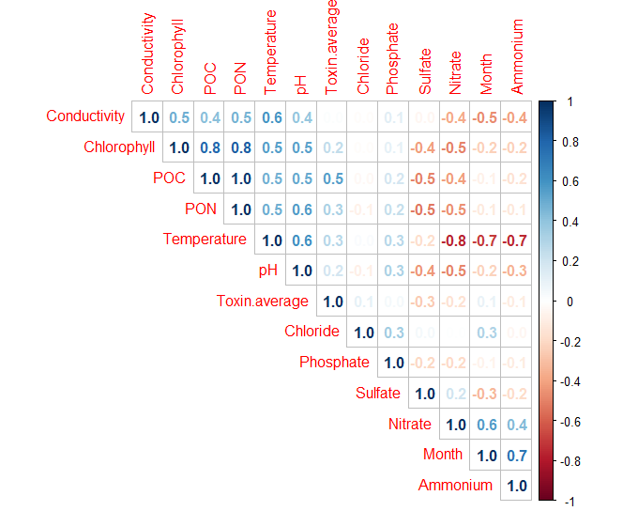

Figure S2. Heatmap of all centered and scaled m/z+1 values detected in UKL. Samples are listed on the right side of heatmap, and arranged by dendrogram based on Pearson correlation values. m/z+1 values are listed on the bottom side of heatmap and ordered by mass. The magnitude of correlation for each m/z+1 value to the sample date and site is represented by the color shift, with yellow being a positive correlation and blue a negative correlation.
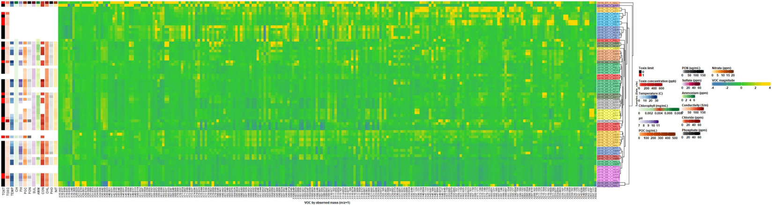

Figure S3. Morphological identification of cyanobacteria collected at UKL. Cyanobacteria identified include Anabaena/Dolichospermum (a,b), Aphanizomenon (c), Gloeotrichia (d), and Microcystis (e) are given in the figure. Of particular note are panels (f) and (g), which are examples of samples in which morphology typical of Aphanizomenon was observed in abundance, but 16S rRNA analysis of these samples were dominated by Anabaena/Dolichospermum. Scale bar is 100 µm.
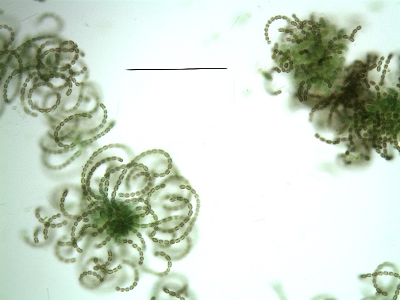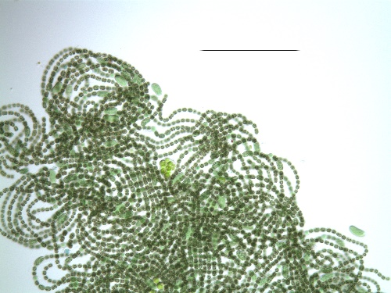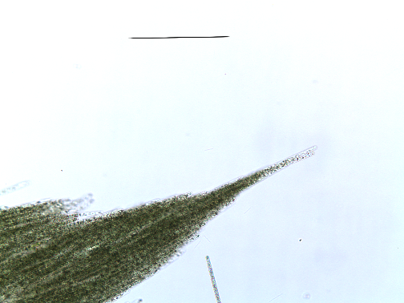
b.
a.
c.
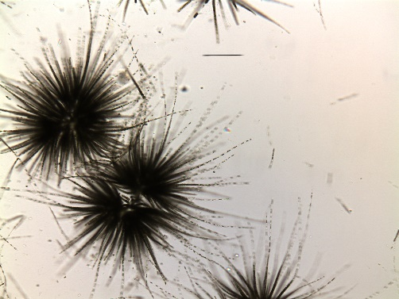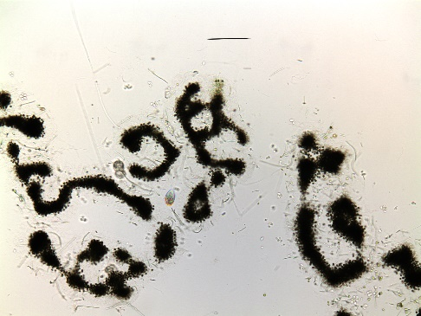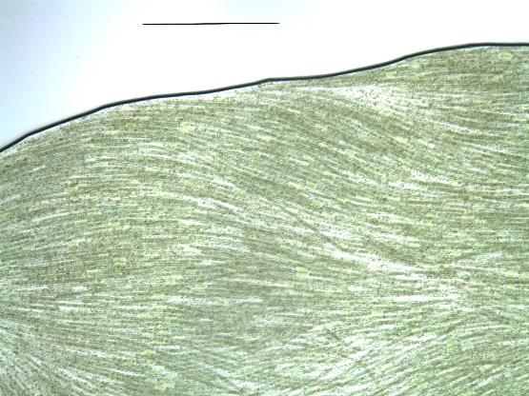
d.
e.
f.
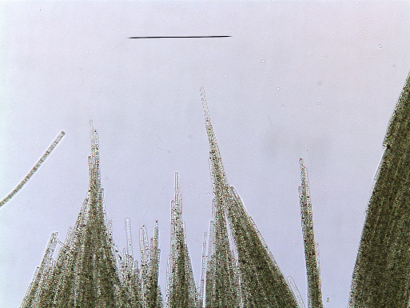
g.
Figure S4. Receiver operating characteristic curves (ROC curves) for the logistical output models: M2 (a), M8 (b), M4 (c), M6 (d). Plots evaluate the diagnostic ability of the logistical regression to predict microcystin concentration ≥0.3 ppb at a probability of 0.5. Area under the curve (AUC) was calculated by averaging the AUCs from the 10 elastic net model runs. Note than in (a), Runs 3 and 6 are on the 50:50 line.

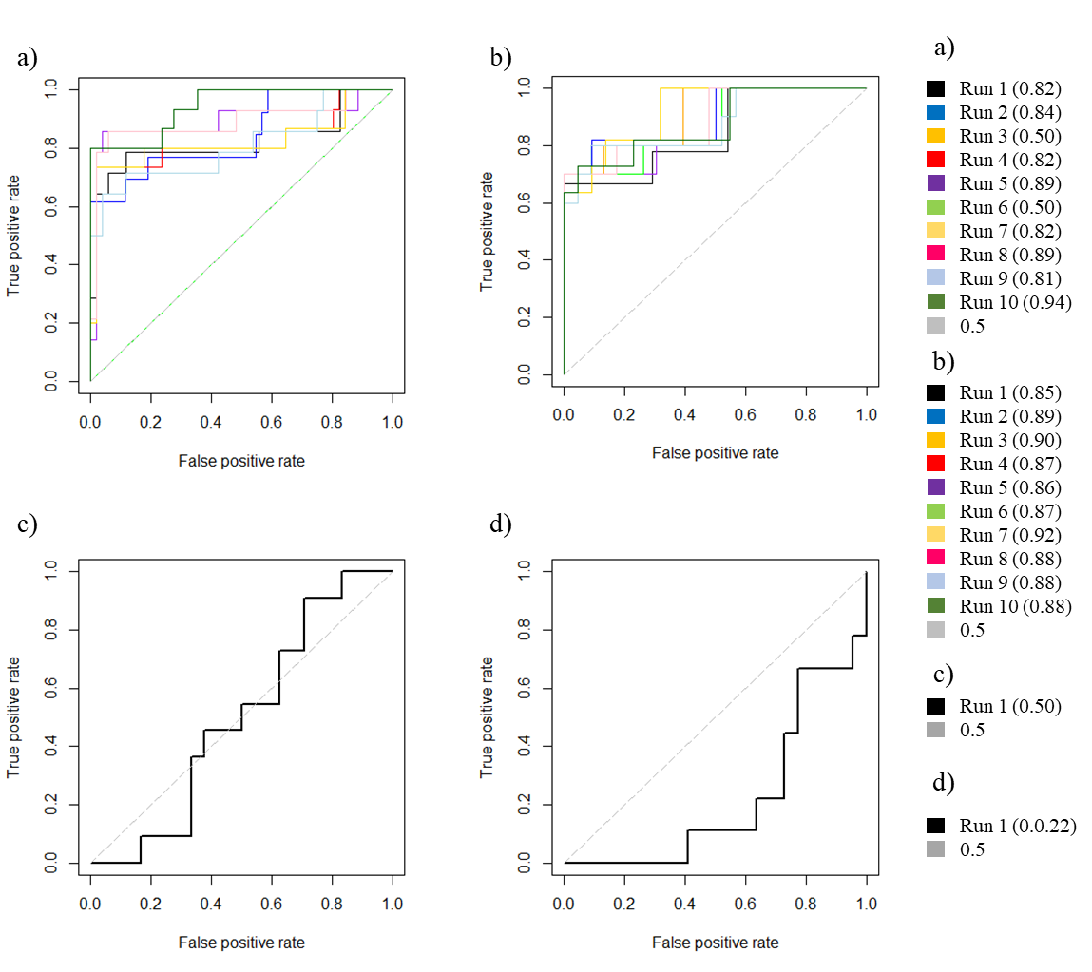

Figure S5. Statistical performances (Mean square prediction error) of elastic net models predicting relative abundances of the four most abundant microbial phyla, classes, and cyanobacterial genera. Error bars are SD.

Figure S6. Pruned tree from Itol used for manually classifying ASVs into their respective groups. Circle location denotes the placement location within the tree, while circle size denotes the number of ASVs placed within that location. Manual classification included extraction of ASVs in each color-coded area within the tree, and reassignment of taxonomy to the genus level. Yellow denotes the ASVs that were identified as Gloeotrichia, red are Anabaena, green are Aphanizomenon, and blue are Microcystis. Trees (a) and (b) represent the first and second sequencing runs, respectively.
a.
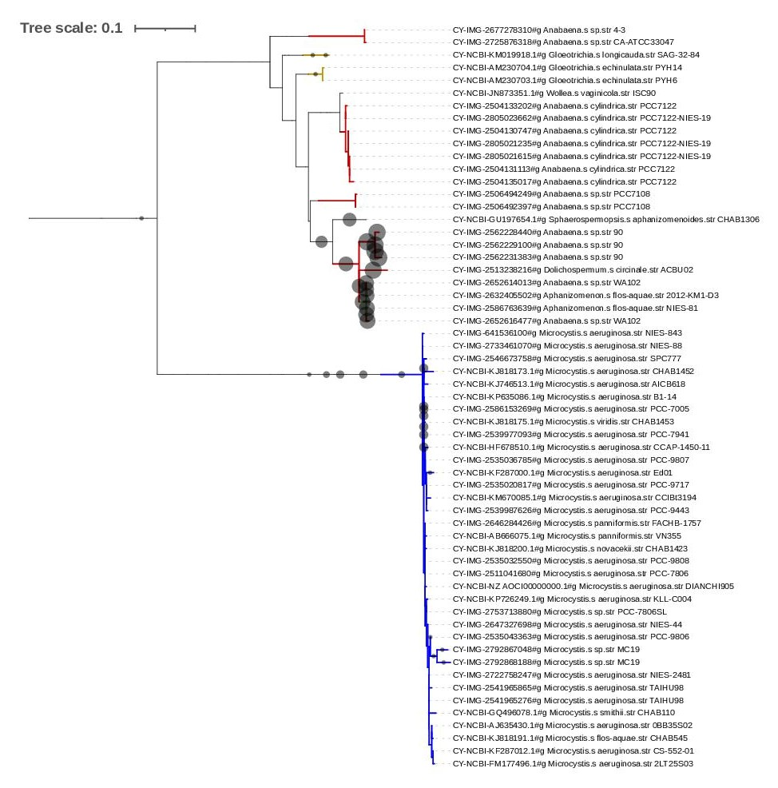
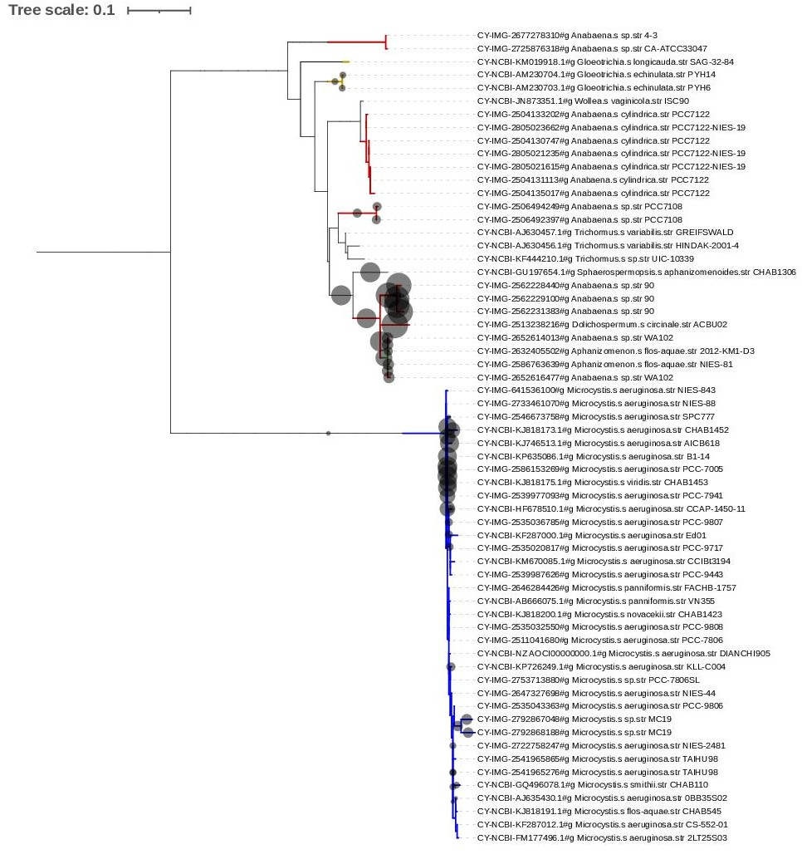
b.

