APPENDICES
Appendix 1. Full search terms of our review
We show the search strategy for a) Pubmed, b) Scopus, c) Embase, d) Web of Science, e) IEEE Xplore.
a) Pubmed
((((((myopia) OR (high myopia)) OR (pathologic myopia)) OR (refractive error)) OR (HM)) OR (PM)) AND (fft[Filter]) AND ((((((((artificial intelligence) OR (machine learning)) OR (deep learning)) OR (transfer learning)) OR (neural network)) OR (algorithms)) OR (Supervised Machine Learning)) OR (Unsupervised Machine Learning)) Filters: Full text

b) Scopus
( TITLE-ABS-KEY ( (“pathologic myopia” OR PM OR HM OR “high myopia” OR myopia OR “refractive error” ) ) ) AND ( TITLE-ABS-KEY ( ( diagnos* OR screen* ) ) ) AND ( ( TITLE ( “artificial intelligence” OR “random forest” OR AI) ) OR ( TITLE ( ( ( deep OR convolutional OR neural Or bayesian ) W/3 network* ) OR ( ( classification OR regression OR probability ) W/3 tree* ) ) ) OR ( TITLE ( ( vector W/3 machine ) OR ( ( machine OR deep OR ensemble ) W/3 learning ) ) ) )

c) Embase
#3: #1 AND #2 AND ('article'/it OR 'article in press'/it)
#2: 'artificial intelligence'/exp OR 'artificial intelligence' OR (artificial AND ('intelligence'/exp OR intelligence)) OR 'machine learning'/exp OR 'machine learning' OR (('machine'/exp OR machine) AND ('learning'/exp OR learning)) OR 'deep learning'/exp OR 'deep learning' OR (deep AND ('learning'/exp OR learning)) OR 'transfer learning'/exp OR 'transfer learning' OR (('transfer'/exp OR transfer) AND ('learning'/exp OR learning)) OR 'neural network'/exp OR 'neural network' OR (neural AND ('network'/exp OR network)) OR 'algorithms'/exp OR algorithms
#1: 'myopia'/exp OR myopia OR 'high myopia'/exp OR 'high myopia' OR (high AND ('myopia'/exp OR myopia)) OR 'pathologic myopia'/exp OR 'pathologic myopia' OR (pathologic AND ('myopia'/exp OR myopia)) OR 'refractive error'/exp OR 'refractive error' OR (refractive AND ('error'/exp OR error))

d) Web of Science
#3 AND #2 AND #1
Indexes=SCI-EXPANDED, SSCI, A&HCI, CPCI-S, CPCI-SSH, BKCI-S, BKCI-SSH, ESCI, CCR-EXPANDED, IC
Timespan=All years
1. TS = (“pathologic myopia” OR PM OR HM OR “high myopia” OR myopia OR “refractive error”)
Indexes=SCI-EXPANDED, SSCI, A&HCI, CPCI-S, CPCI-SSH, BKCI-S, BKCI-SSH, ESCI, CCR-EXPANDED, IC
Timespan=All years
2. TS = (diagnos* OR screen*)
Indexes=SCI-EXPANDED, SSCI, A&HCI, CPCI-S, CPCI-SSH, BKCI-S, BKCI-SSH, ESCI, CCR-EXPANDED, IC
Timespan=All years
3. TI = (((vector NEAR/3 machine) OR ((machine OR deep OR ensemble) NEAR/3 learning) OR ((deep OR convolutional OR neural OR bayesian) NEAR/3 network*) OR ((classification OR regression OR probability) NEAR/3 tree*) OR “artificial intelligence” OR “random forest”OR AI )))
Indexes=SCI-EXPANDED, SSCI, A&HCI, CPCI-S, CPCI-SSH, BKCI-S, BKCI-SSH, ESCI, CCR-EXPANDED, IC
Timespan=All years

e) IEEE Xplore
((“Abstract”: myopia OR PM OR HM OR “high myopia” OR “refractive error” OR “pathologic myopia” ) AND ( “Document Title” : “machine learning” OR “deep learning” OR “artificial intelligence” OR “neural network” OR “vector machine” OR AI OR “transfer learning” OR algorithms))

Appendix 2. Summary of classification standards for pathologic myopia
META-PM classification system |  |  | ATN grading system
Category | “Plus’’ Lesions | Classification | Atrophic (A) | Tractional (T) | Neovascular (N)
0: No macular lesions | None | Non-PM | A0: No myopic retinal lesions | T0: No macular schisis | N0: No myopic CNV
1: Tessellated fundus | None | Non-PM | A1: Tessellated fundus only | T1: Inner or outer foveoschisis | N1: Macular lacquer cracks
2: Diffuse chorioretinal atrophy | Lacquer cracks;  CNV;  Fuchs spot | PM | A2: Diffuse chorioretinal atrophy | T2: Inner and outer foveoschisis | N2a: Active CNV
3: Patchy chorioretinal atrophy | Lacquer cracks;  CNV;  Fuchs spot | PM | A3: Patchy chorioretinal atrophy | T3: Foveal detachment | N2s: Scar or Fuchs spot
 |  |  |  | T4: Full-thickness MH | N2s: Scar or Fuchs spot
4: Macular atrophy | Lacquer cracks;  CNV;  Fuchs spot | PM | A4: Complete macular atrophy | T5: MH and retinal detachment | N2s: Scar or Fuchs spot
META-PM, Meta-analysis for Pathologic Myopia; PM, pathologic myopia; ATN, atrophy, traction, and neovascularization; MH, macular hole; CNV, choroidal neovascularization.

Appendix 3. Methodological quality assessment of the included studies assessed by Quality Assessment of Diagnostic Accuracy Studies-2 (QUADAS-2) tool
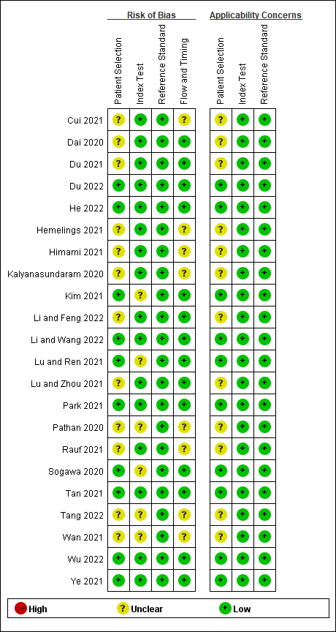
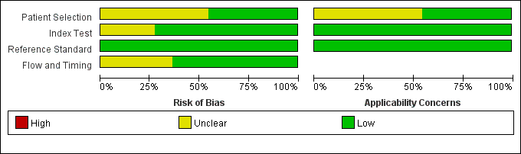

Appendix 4. Deek’s plot for publication bias assessment
