File:
IR Spectrum of compound (6a)
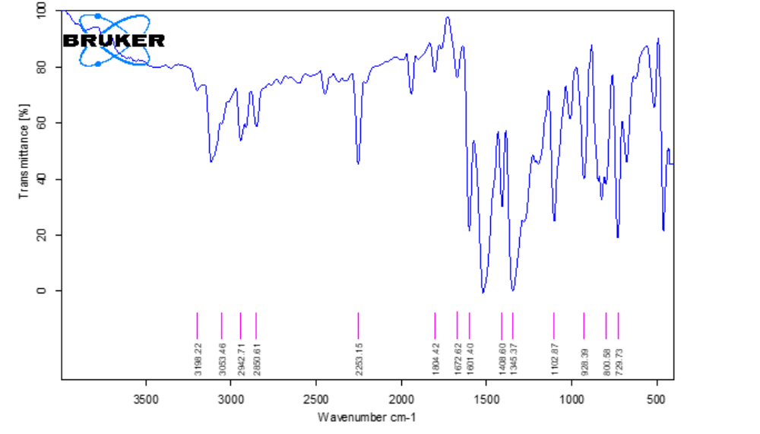

¹HNMR Spectrum of compound (6a)
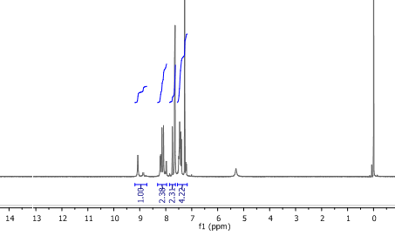

¹³CNMR Spectrum of compound (6a)
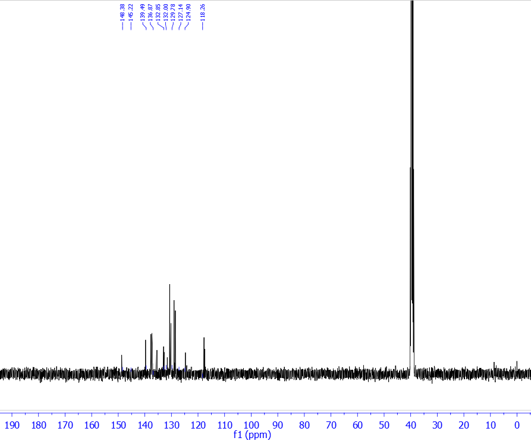

Mass spectrum of compound (6a)
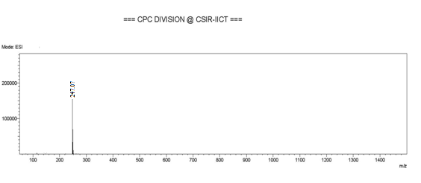

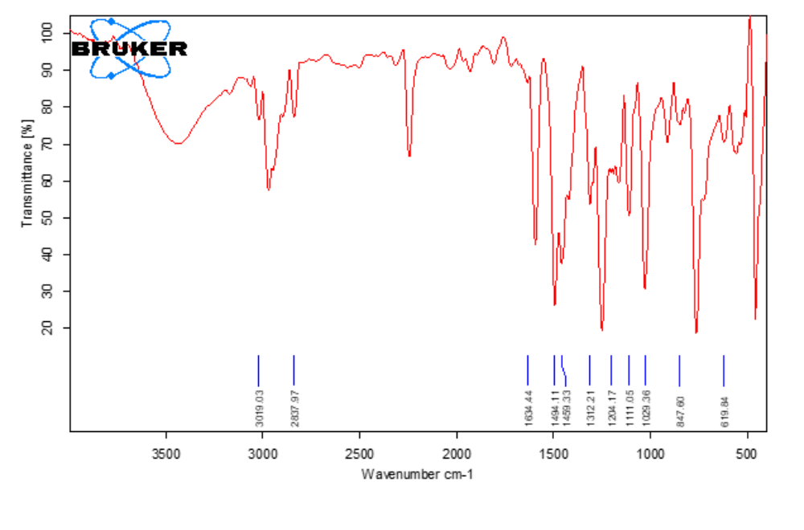
IR Spectrum of compound (6b)
¹HNMR Spectrum of compound (6b)
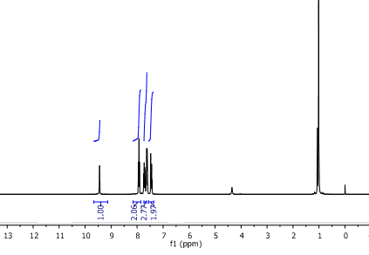

¹HNMR Spectrum of compound (6c)
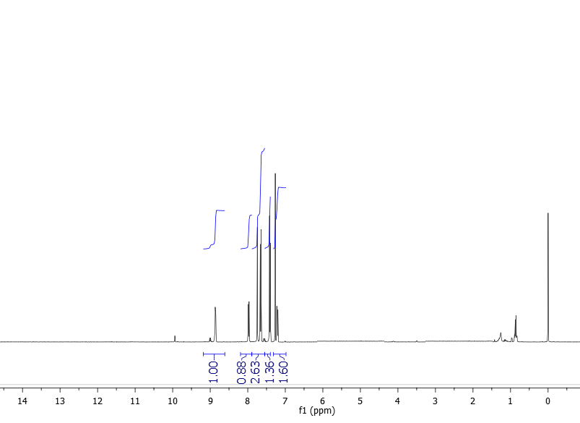

¹³CNMR Spectrum of compound (6c)
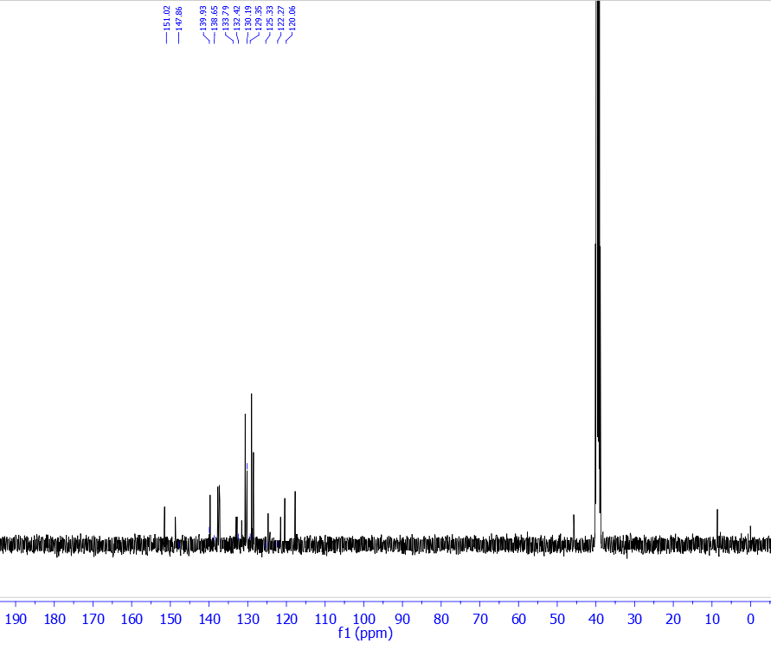

¹HNMR Spectrum of compound (6d)
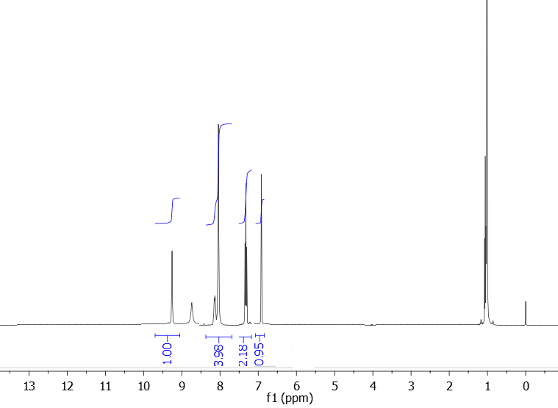

Mass spectrum of compound (6d)
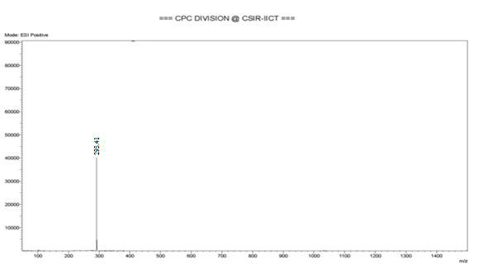

¹HNMR Spectrum of compound (6e)
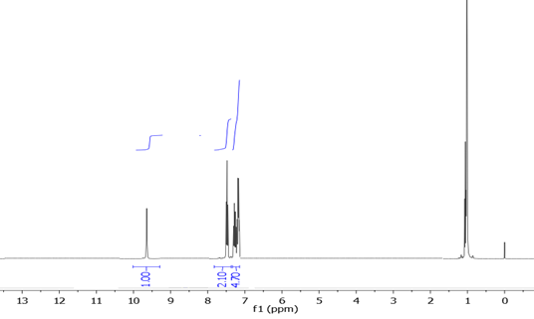

¹³CNMR Spectrum of compound (6e)
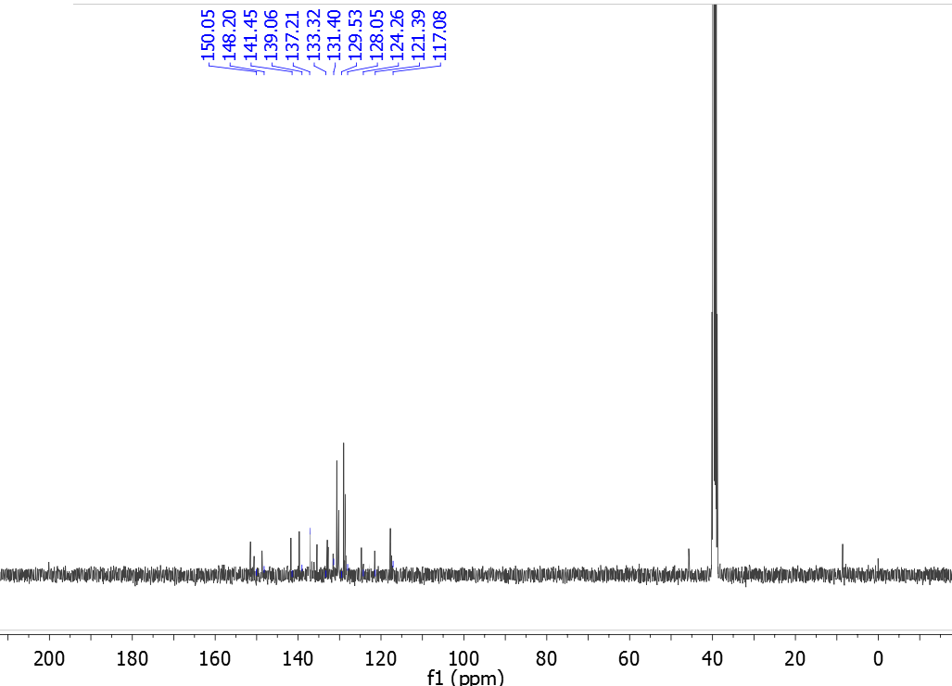

¹HNMR Spectrum of compound (6f)
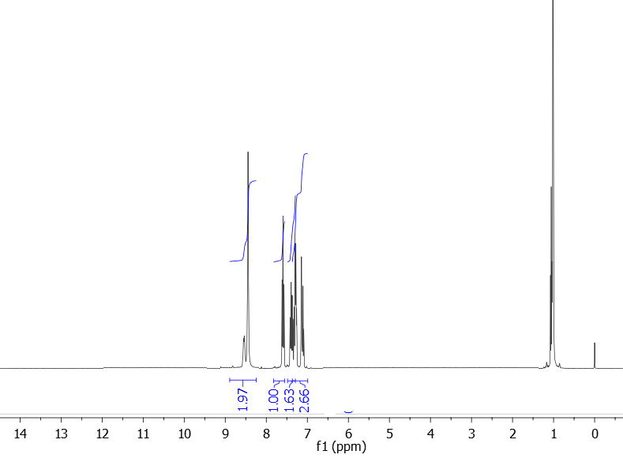

¹³CNMR Spectrum of compound (6f)
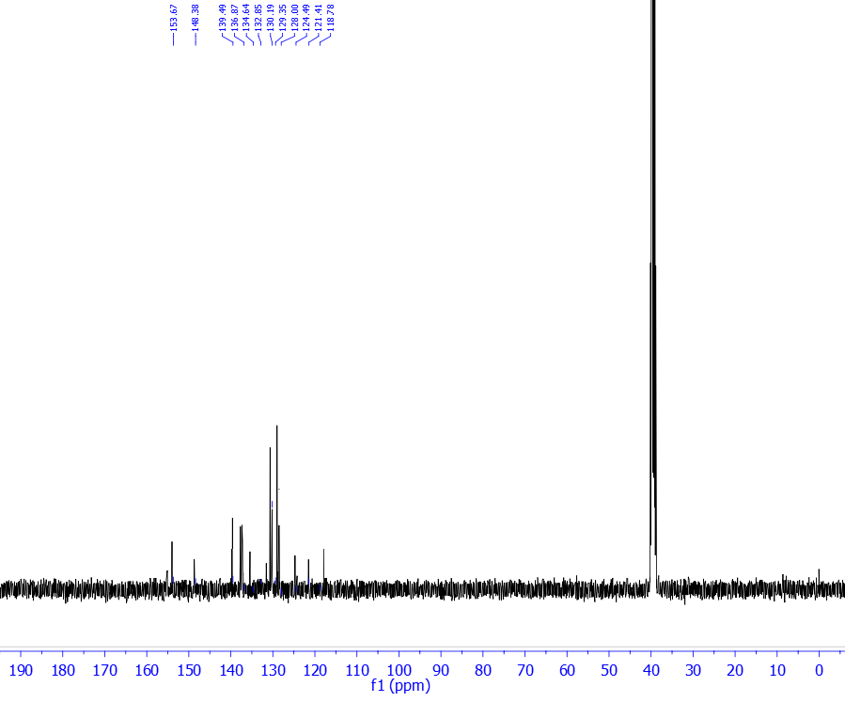

¹HNMR Spectrum of compound (6g)
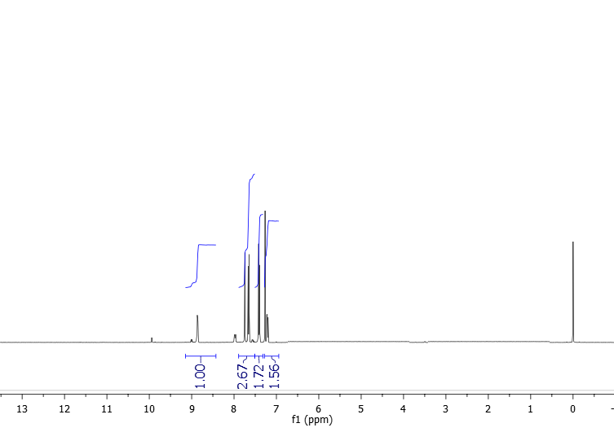

¹HNMR Spectrum of compound (6h)
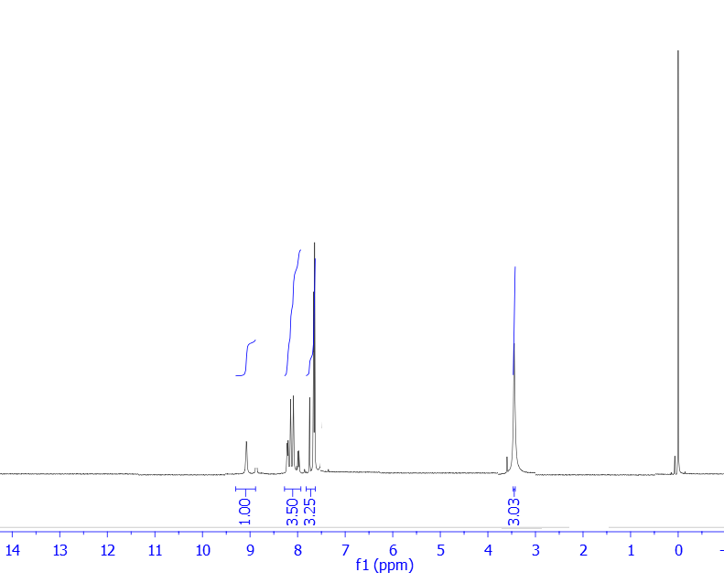

¹³CNMR Spectrum of compound (6h)
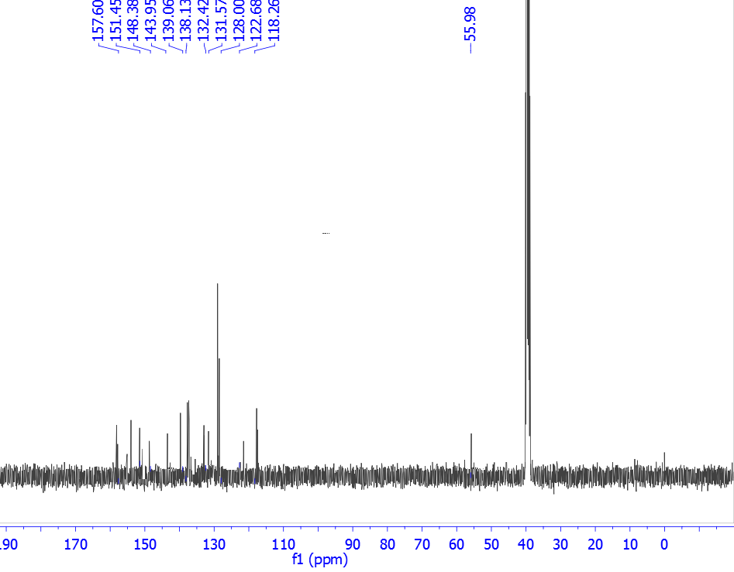

Mass spectrum of compound (6h)
