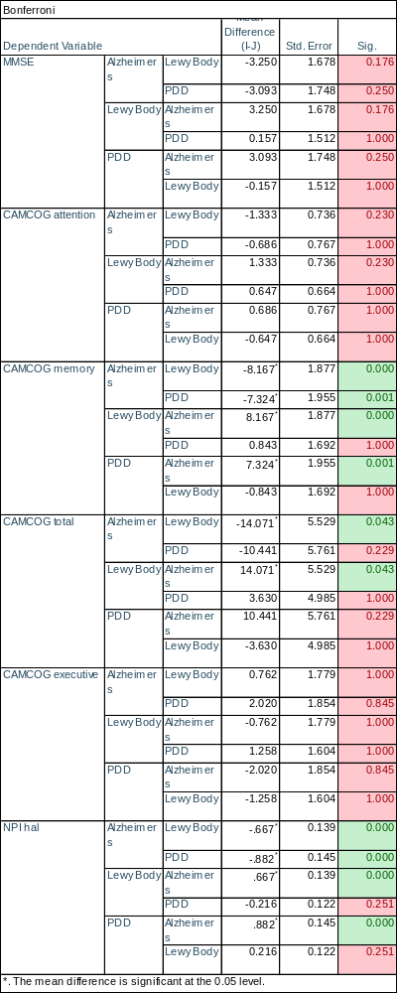
Supplementary Table 2
Outputs from one way four group ANOVA, with post-hoc unpaired Bonferroni correction. For testing the significance of the difference between dementia patient’s MMSE, CAMCOG and NPI hal values. With a significant difference seen in AD patients CAMCOG memory and NPI hal scores when compared to DLB and PDD patients. Additionally, a significant difference is seen between AD and DLB patients for CAMCOG total that is not seen when comparing AD and PDD patients.

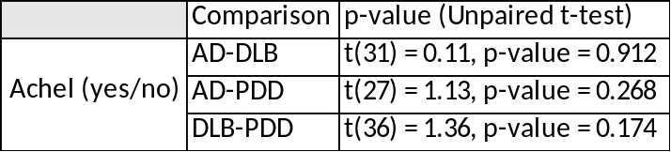
Supplementary Table 3
Outputs from unpaired t-test between each dementia subgroup for cholinesterase inhibitor usage. With no significant inter-group difference (p-value < 0.05) for any two subgroup comparisons.

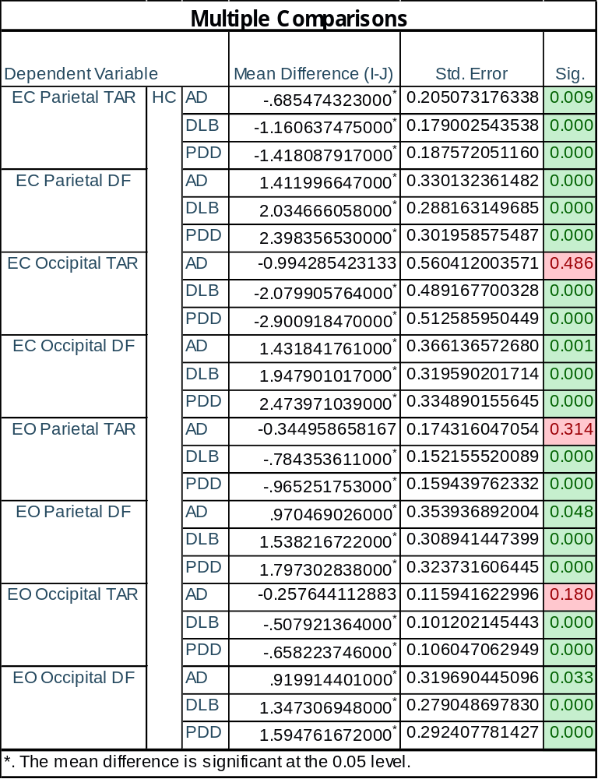
Supplementary Table 4
Outputs from one way four group ANOVA, with post-hoc unpaired Bonferroni correction. For testing the significance of the difference between HC and dementia patient’s theta-alpha ratio (TAR) and dominant frequency (DF) in the parietal and occipital regions. With a significant decrease in the DF of dementia patients not only in the EC but also the EO resting state. In addition, the TAR was found to also be significantly different for the DLB and PDD groups when compared to healthy controls in the same regions.

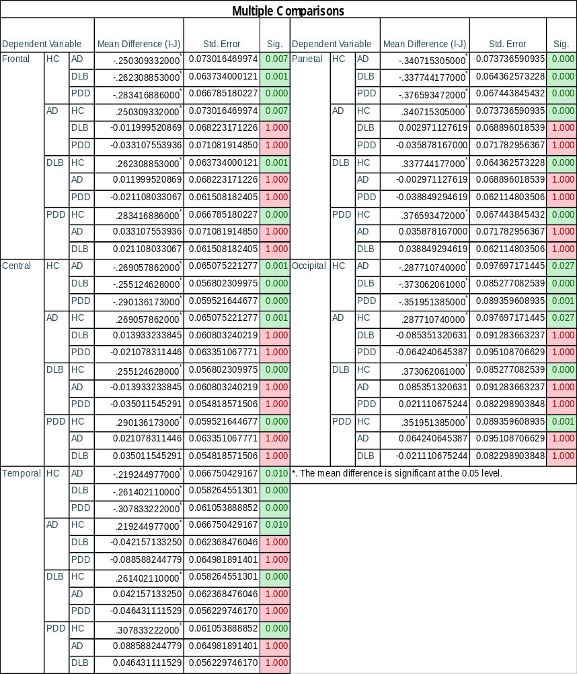
Supplementary Table 5
Outputs from one-way ANOVA, four group, with post-hoc unpaired Bonferroni correction. For testing the significance of change in DFV between the EO and EC resting state for HC, AD, DLB and PDD patients. Notably, HC was found to be the only group to experience a significant change between the two states when compared to other groups. In addition, no dementia group was found to have a significant difference between the two states when compared with other dementia groups.
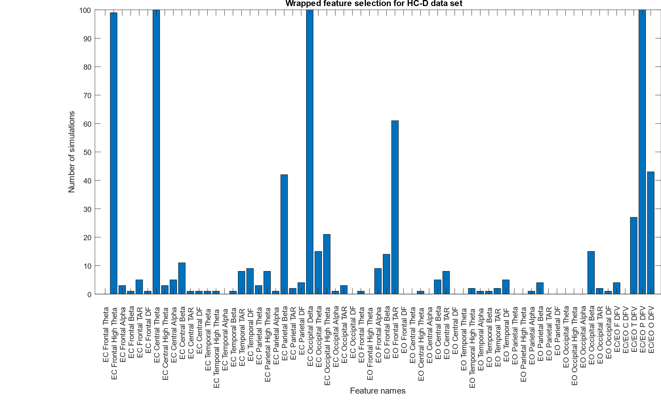
Supplementary Figure 1
Figures showing the total number of times that full feature set for HC-D (A) classification were selected. Utilising training and testing data sets across 100 simulated runs. With features consisting of the relative delta, theta, high theta, alpha and delta power in addition to the ration of the hightheta-alpha relative power (TAR) dominant frequency (DF), dominant frequency variance (DFV) and the ratio of the dominant frequency variance between the EC and EO state (EC/EO).

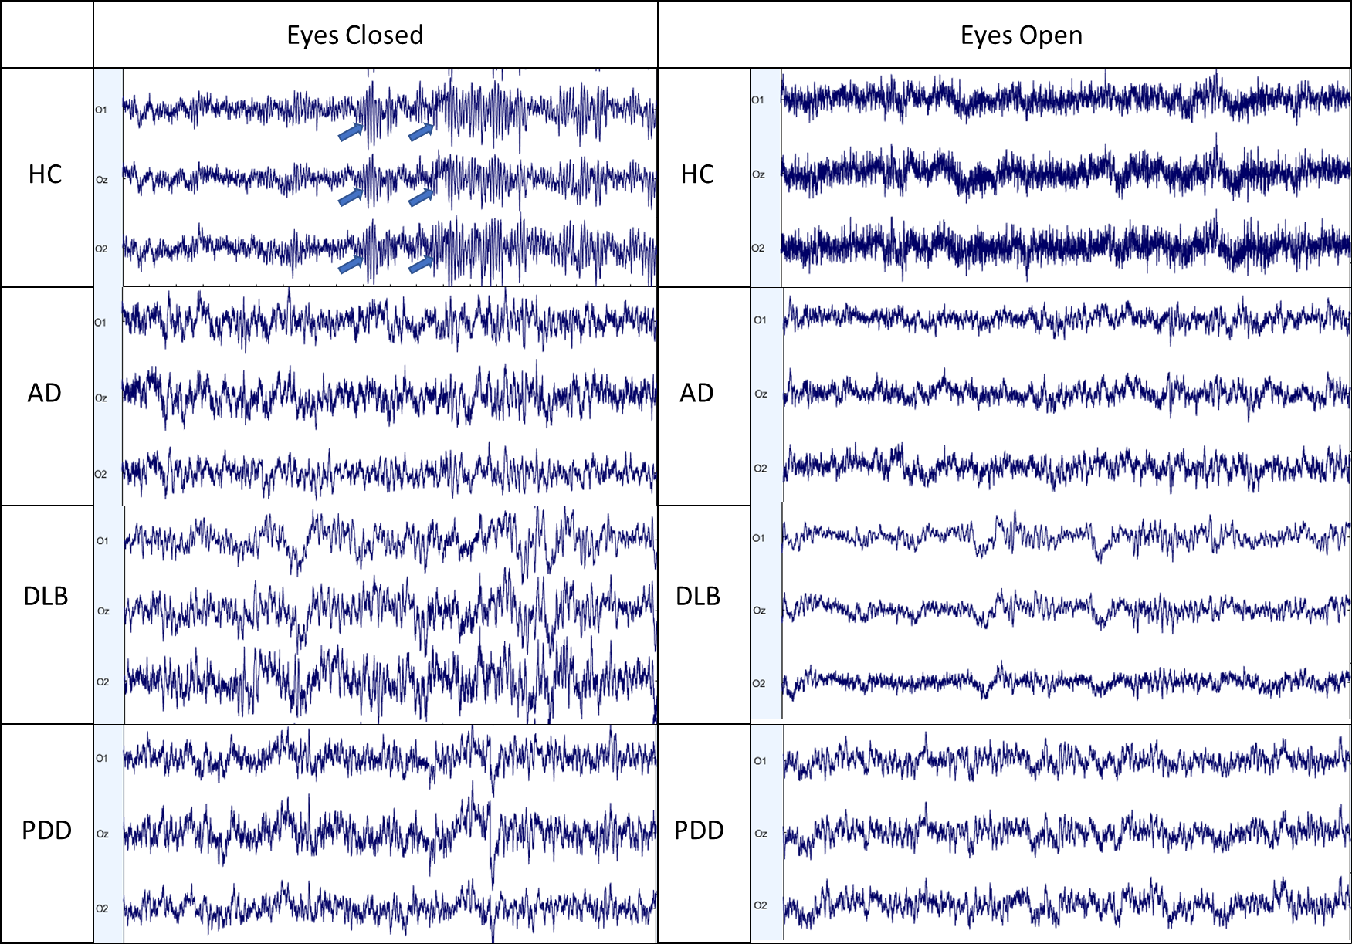
Supplementary Figure 2
EEG data scrolls in the EC and EO state exported from EEGLAB for examples of AD, DLB and PDD patients with an exemplary HC example for displaying DFV differences between both stats. Firstly, this Figure displays the expected alpha rhythms (arrow) in the EC state for the HC participant which are not present for the AD, DLB or PDD participants. Secondly, displaying the difference between the EC and EO state for all participants with a notable decrease in wavelengthfor the HC participant within the EO state when compared to the EC with the loss of the alpha rhythms. It is notable that no significant difference is seen between the EC and EO state for any dementia patient.

