Divergent epigenetic responses to birth asphyxia in severe mental disorders
Laura A. Wortinger, PhD ^{1, 2 *} #; Anne-Kristin Stavrum, PhD ^{3, 4 #}; Alexey A. Shadrin, PhD ^{2, 5, 6}; Attila Szabo, PhD ^{2, 5, 6}; Sondre Høeg Rukke, MS ⁷; Stener Nerland, MS ^{1, 2}; Runar Elle Smelror, PhD ^{1, 2}; Kjetil Nordbø Jørgensen, PhD ^{2, 8}; Claudia Barth, PhD ^{1, 2}; Dimitrios Andreou, MD PhD ^{1, 2, 9}; Melissa A. Weibell, PhD ^{10, 11}; Srdjan Djurovic, PhD ^{3, 6, 12}; Ole A. Andreassen, MD PhD ^{2, 5, 6}; Marianne Thoresen, MD PhD ^{13, 14}; Gianluca Ursini, MD PhD ^{15, 16}; Ingrid Agartz, MD PhD ^{1, 2, 6, 9 •} ; Stephanie Le Hellard, PhD ^{3, 4 •}

¹ Department of Psychiatric Research, Diakonhjemmet Hospital, Oslo, Norway
² NORMENT, Institute of Clinical Medicine, University of Oslo, Oslo, Norway
³ NORMENT, Department of Clinical Science, University of Bergen, Bergen, Norway
⁴ Dr. Einar Martens Research Group for Biological Psychiatry, Center for Medical Genetics and Molecular Medicine, Haukeland University Hospital, Bergen, Norway
⁵ NORMENT, Division of Mental Health and Addiction, Oslo University Hospital, Oslo, Norway
⁶ KG Jebsen Centre for Neurodevelopmental Disorders, University of Oslo, Oslo, Norway
⁷ Faculty of Medicine, University of Bergen, Bergen, Norway
⁸ Department of Psychiatry, Telemark Hospital, Skien, Norway
⁹ Centre for Psychiatry Research, Department of Clinical Neuroscience, Karolinska Institutet and Stockholm Health Care Services, Stockholm County Council, Stockholm, Sweden
¹⁰ TIPS—Network for Clinical Research in Psychosis, Department of Psychiatry, Stavanger University Hospital, Stavanger, Norway,
¹¹ Faculty of Health, Network for Medical Sciences, University of Stavanger, Stavanger, Norway
¹² Department of Medical Genetics, Oslo University Hospital, Oslo, Norway
¹³ Department of Physiology, Institute of Basic Medical Sciences, University of Oslo, Oslo, Norway
¹⁴ Neonatal Neuroscience, Translational Health Sciences, University of Bristol, Bristol, United Kingdom
¹⁵ Lieber Institute for Brain Development, Johns Hopkins Medical Campus, Baltimore, MD
¹⁶ Department of Psychiatry and Behavioral Sciences, Johns Hopkins University School of Medicine, Baltimore, MD

* To whom correspondence should be addressed: Dr. Laura Anne Wortinger, Department of Psychiatric Research, Diakonhjemmet Hospital, Postbox 23 Vinderen, 0319, Oslo, Norway; e-mail: l.a.w.bakke@medisin.uio.no

# Equal contributions for first authorship
• Equal contributions for last authorship
Supplementary Figure 1: Sample overview
Supplementary Figure 2: Manhattan plot for differentially methylated positions (DMPs) associated with birth asphyxia.
Supplementary Figure 3: Scatterplot demonstrating the correlation between DNA methylation profiles associated with birth asphyxia in females (top) and males (bottom) between groups.
Supplementary Figure 4-7: DNA methylation of probes associated with LINGO3, BLCAP;NNAT, NANOS2 and SLC2A14 in whole blood significantly correlates with that in the brain at some genomic loci.
Supplementary Table 1: Significant interaction between differentially methylated regions (DMRs) and birth asphyxia on Case/Control status in males
Supplementary Table 2: Significant interaction between differentially methylated regions (DMRs) and birth asphyxia on Case/Control status in females
Supplementary Table 3: Differentially methylated regions and birth asphyxia on disease severity
Supplementary Table 4: Differentially methylated regions and birth asphyxia on age of disease onset in males

Supplementary Figure 1: Overview of the participants included in the sample. The CLEAN file represents the name of the database at NORMENT. Birth asphyxia data from the Medical Birth Registry of Norway (MBRN) is available on births from 1967; therefore, most participants over 50 years do not have birth registry information.
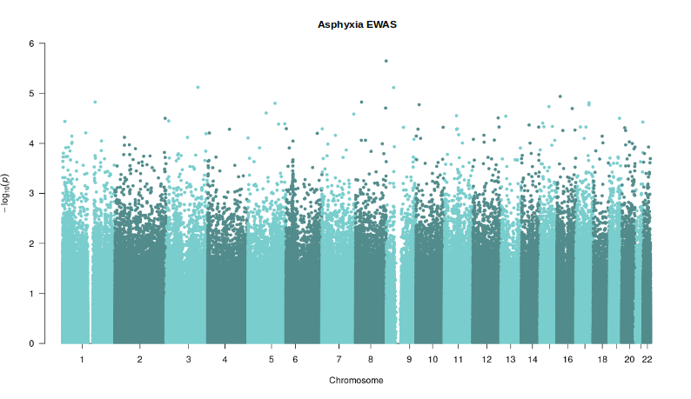
Supplementary Figure 2: Manhattan plot for differentially methylated positions (DMPs) associated with birth asphyxia.

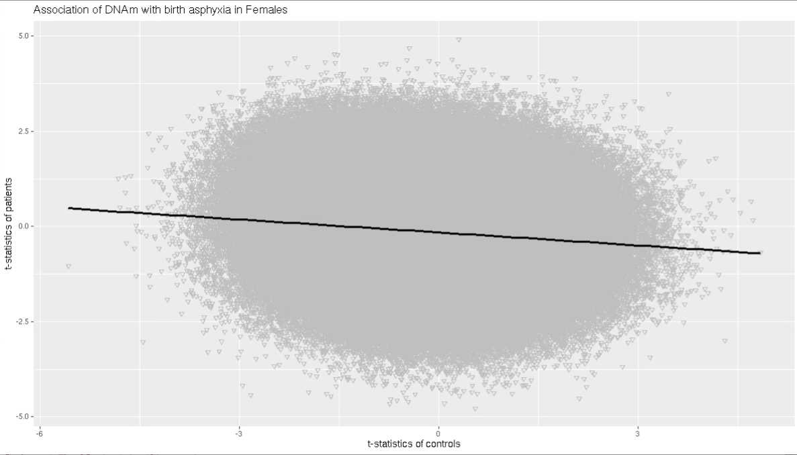

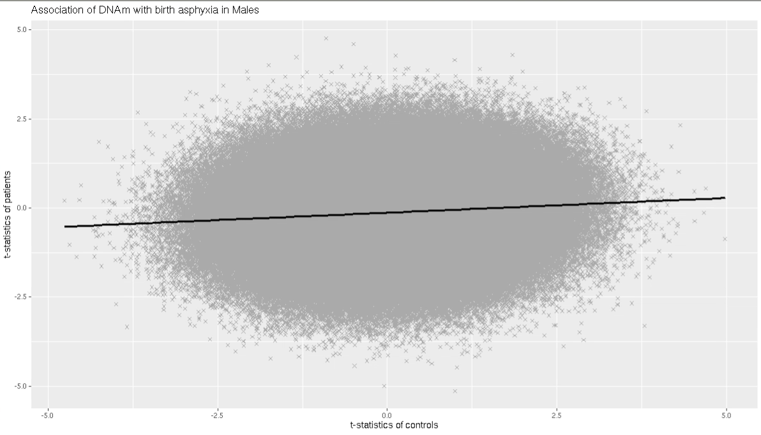
Supplementary Figure 3: Scatterplot demonstrating the correlation between DNA methylation profiles associated with birth asphyxia in females (top) and males (bottom) between groups.

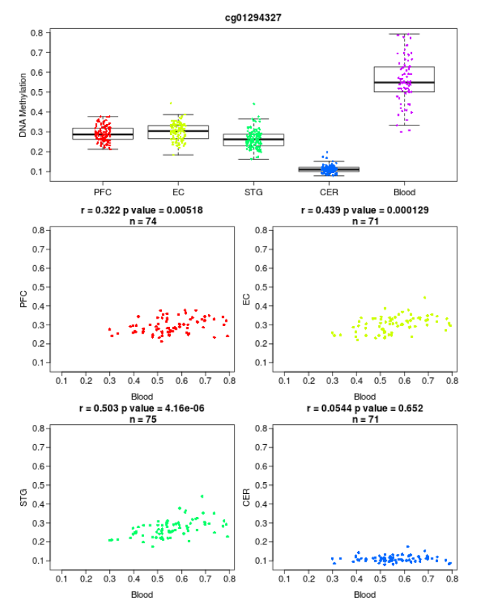
Supplementary Figure 4: DNA methylation correlation between blood and four different brain regions, retrieved from the searchable database by Hannon and colleagues (1). Shown is a boxplot of the distribution of DNA methylation values across all individuals split by tissue and four scatterplots demonstrating the relationship between DNA methylation of probe cg01294327 associated with LINGO3 in whole blood and four brain regions (PFC, prefrontal cortex; EC, entorhinal cortex ; STG, superior temporal gyrus; CER, cerebellum). At this probe there is a significant correlation between individual variation in whole blood and that observed in the PFC, EC and STG.

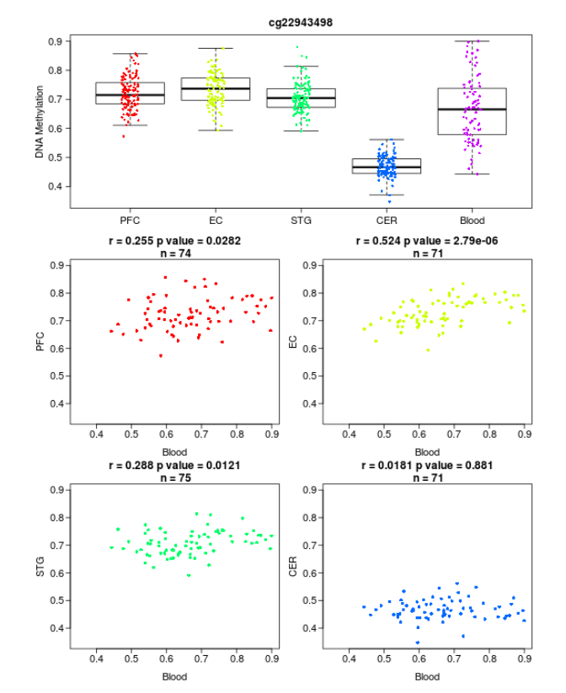
Supplementary Figure 5: DNA methylation correlation between blood and four different brain regions, retrieved from the searchable database by Hannon and colleagues (1). Shown is a boxplot of the distribution of DNA methylation values across all individuals split by tissue and four scatterplots demonstrating the relationship between DNA methylation of probe cg22943498 associated with BLCAP;NNAT in whole blood and four brain regions (PFC, prefrontal cortex; EC, entorhinal cortex ; STG, superior temporal gyrus; CER, cerebellum). At this probe there is a significant correlation between individual variation in whole blood and that observed in the PFC, EC and STG.

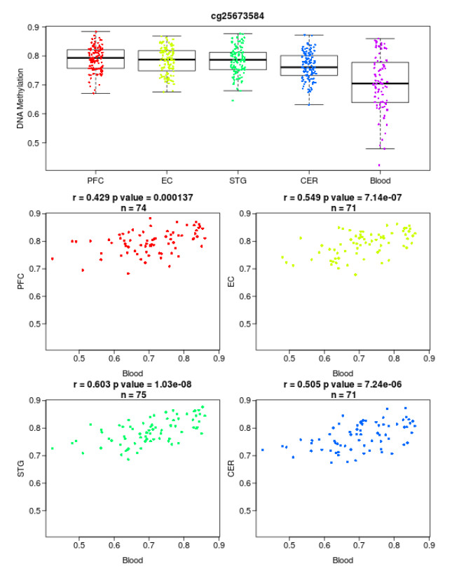
Supplementary Figure 6: DNA methylation correlation between blood and four different brain regions, retrieved from the searchable database by Hannon and colleagues (1). Shown is a boxplot of the distribution of DNA methylation values across all individuals split by tissue and four scatterplots demonstrating the relationship between DNA methylation of probe cg25673584 associated with NANOS2 in whole blood and four brain regions (PFC, prefrontal cortex; EC, entorhinal cortex ; STG, superior temporal gyrus; CER, cerebellum). At this probe there is a significant correlation between individual variation in whole blood and that observed in all four brain regions.

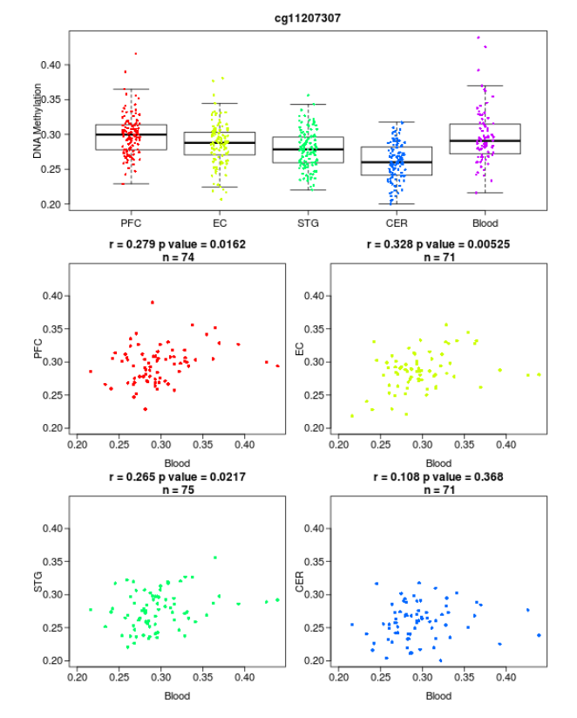
Supplementary Figure 7: DNA methylation correlation between blood and four different brain regions, retrieved from the searchable database by Hannon and colleagues (1). Shown is a boxplot of the distribution of DNA methylation values across all individuals split by tissue and four scatterplots demonstrating the relationship between DNA methylation of probe cg11207307 associated with SLC2A14 in whole blood and four brain regions (PFC, prefrontal cortex; EC, entorhinal cortex ; STG, superior temporal gyrus; CER, cerebellum). At this probe there is a significant correlation between individual variation in whole blood and that observed in the PFC, EC and STG.

Supplementary Table 1: Significant interaction between differentially methylated regions (DMRs) and birth asphyxia on Case/Control status in males
Šidák p <.05 |  |  |  | Birth Asphyxia * DNAm |  |  | Birth Asphyxia |  |  | DNAm
chromosome | start | end | gene | Min p | n probes | Šidák p | Min p | n probes | Šidák p | Min p | n probes | Šidák p
5 | 118603742 | 118603938 | TNFAIP8 | 3.49E-05 | 4 | 1.78E-07 | 1.52E-05 | 4 | 7.75E-08
10 | 1704858 | 1705085 | ADARB2 | 4.05E-03 | 3 | 2.01E-04 | 3.31E-02 | 3 | 2.33E-03
11 | 45825300 | 45825518 | SLC35C1 | 4.05E-03 | 8 | 2.01E-04
16 | 50913874 | 50914024 |  | 4.05E-03 | 5 | 3.72E-04
4 | 186732837 | 186733060 | SORBS2 | 1.46E-02 | 8 | 1.93E-03
12 | 2944286 | 2944493 | NRIP2 | 1.46E-02 | 6 | 1.02E-02
3 | 39543544 | 39543776 | MOBP | 2.19E-02 | 5 | 3.17E-02 | 2.93E-03 | 6 | 2.61E-04
2 | 242802009 | 242802192 | PDCD1 |  |  |  |  |  |  | 4.47E-07 | 5 | 1.22E-08
15 | 40268610 | 40268777 | EIF2AK4 |  |  |  |  |  |  | 1.76E-06 | 4 | 8.43E-08
17 | 1665119 | 1665303 | SERPINF1 |  |  |  |  |  |  | 7.25E-06 | 6 | 5.52E-07
17 | 75789279 | 75789529 |  |  |  |  |  |  |  | 2.89E-04 | 5 | 2.31E-05
6 | 166260319 | 166260572 |  |  |  |  |  |  |  | 8.83E-04 | 3 | 1.04E-04
12 | 131322960 | 131323042 | STX2 |  |  |  |  |  |  | 5.18E-04 | 3 | 1.45E-04
20 | 5485144 | 5485511 | LOC149837 |  |  |  |  |  |  | 2.72E-03 | 8 | 2.83E-04
17 | 75096202 | 75096382 |  |  |  |  |  |  |  | 2.71E-03 | 3 | 4.21E-04
2 | 239140032 | 239140369 | LOC151174;LOC643387 |  |  |  |  |  |  | 3.65E-03 | 7 | 5.44E-04
15 | 69385753 | 69385944 | EWSAT1;MIR548H4 |  |  |  |  |  |  | 2.92E-03 | 3 | 5.97E-04
16 | 50647607 | 50647798 | NKD1 |  |  |  |  |  |  | 8.98E-03 | 3 | 2.57E-03
10 | 123355239 | 123355454 | FGFR2 |  |  |  |  |  |  | 2.72E-03 | 3 | 2.83E-03
11 | 73116210 | 73116329 | FAM168A |  |  |  |  |  |  | 8.98E-03 | 3 | 4.29E-03
20 | 19915716 | 19915874 | RIN2 |  |  |  |  |  |  | 5.12E-03 | 5 | 4.30E-03
16 | 85096433 | 85096666 | KIAA0513 |  |  |  |  |  |  | 1.71E-02 | 4 | 9.55E-03
20 | 20248523 | 20248696 | CFAP61 |  |  |  |  |  |  | 2.65E-02 | 3 | 1.34E-02
6 | 168393963 | 168394198 |  |  |  |  |  |  |  | 2.66E-02 | 4 | 1.62E-02
16 | 28518114 | 28518347 | IL27 |  |  |  |  |  |  | 3.22E-02 | 6 | 1.62E-02
12 | 53443877 | 53443962 | TNS2;LOC283335;TENC1 |  |  |  |  |  |  | 2.07E-02 | 3 | 1.93E-02
19 | 24097543 | 24097753 | ZNF726 |  |  |  |  |  |  | 3.37E-02 | 4 | 1.97E-02
5 | 7519455 | 7519574 | ADCY2 |  |  |  |  |  |  | 2.66E-02 | 3 | 2.10E-02
10 | 29194973 | 29195190 |  |  |  |  |  |  |  | 3.62E-02 | 3 | 2.15E-02
13 | 24825649 | 24825781 | SPATA13 |  |  |  |  |  |  | 1.05E-02 | 3 | 3.01E-02
3 | 195943149 | 195943366 | OSTalpha;SLC51A |  |  |  |  |  |  | 2.65E-02 | 5 | 3.24E-02
17 | 1686627 | 1686737 | SMYD4 |  |  |  |  |  |  | 3.22E-02 | 3 | 3.26E-02
14 | 65204509 | 65204625 | PLEKHG3 |  |  |  |  |  |  | 3.23E-02 | 3 | 3.34E-02
1 | 40025232 | 40025415 | LOC728448 |  |  |  |  |  |  | 4.76E-02 | 3 | 3.82E-02
2 | 220264753 | 220264849 |  |  |  |  |  |  |  | 3.40E-02 | 3 | 4.39E-02
Positions of DMRs are given according to hg19 reference genome with chromosome: start-end. DMRs were identified using a seed with a p value of < 0.05. For each DMR, the table lists the minimum p value (Min p), the number of probes (n probes) and the Šidák corrected p value (Šidák p).

Supplementary Table 2: Significant interaction between differentially methylated regions (DMRs) and birth asphyxia on Case/Control status in females
Šidák p <.05 |  |  |  | Birth Asphyxia * DNAm |  |  | DNAm
chromosome | start | end | gene | Min p | n probes | Šidák p | Min p | n probes | Šidák p
2 | 183943319 | 183943698 | DUSP19 | 8.31E-03 | 7 | 9.31E-04
1 | 35586358 | 35586588 |  | 2.70E-02 | 4 | 1.87E-03
3 | 195538675 | 195538961 | MUC4 |  |  |  | 3.40E-05 | 6 | 9.97E-07
8 | 23563859 | 23564193 | NKX2-6 |  |  |  | 4.78E-05 | 8 | 6.03E-06
16 | 1480790 | 1480970 | C16orf91 |  |  |  | 2.24E-04 | 4 | 2.07E-05
1 | 42384284 | 42384647 | HIVEP3 |  |  |  | 3.63E-04 | 8 | 3.73E-05
14 | 58905592 | 58905740 | KIAA0586 |  |  |  | 4.05E-04 | 3 | 9.21E-05
17 | 39969239 | 39969397 | SC65;FKBP10;P3H4 |  |  |  | 8.14E-04 | 6 | 2.27E-04
2 | 220436856 | 220436948 | OBSL1;INHA |  |  |  | 3.40E-05 | 5 | 2.56E-04
1 | 223566643 | 223566794 | C1orf65;CCDC185 |  |  |  | 4.05E-04 | 6 | 2.71E-04
6 | 28226885 | 28227220 | NKAPL;ZKSCAN4 |  |  |  | 2.24E-04 | 11 | 2.84E-04
20 | 39766765 | 39766794 | PLCG1-AS1;PLCG1 |  |  |  | 3.63E-04 | 3 | 3.14E-04
2 | 204801413 | 204801510 | ICOS |  |  |  | 1.30E-03 | 4 | 6.83E-04
20 | 35233380 | 35233582 | C20orf24;TGIF2-C20orf24 |  |  |  | 2.36E-03 | 4 | 7.12E-04
20 | 35422495 | 35422703 | C20orf117 |  |  |  | 6.96E-03 | 3 | 2.44E-03
1 | 55271673 | 55271927 | C1orf177 |  |  |  | 7.78E-03 | 7 | 2.59E-03
19 | 37825211 | 37825572 | HKR1 |  |  |  | 4.38E-03 | 9 | 3.13E-03
8 | 143859669 | 143859906 | LYNX1 |  |  |  | 8.07E-03 | 7 | 3.49E-03
17 | 79817079 | 79817271 | P4HB |  |  |  | 8.64E-03 | 4 | 4.29E-03
2 | 210444075 | 210444364 | MAP2 |  |  |  | 9.49E-03 | 7 | 4.92E-03
3 | 3152201 | 3152530 | IL5RA |  |  |  | 2.91E-03 | 3 | 5.30E-03
9 | 117266783 | 117266918 | DFNB31 |  |  |  | 1.87E-02 | 3 | 2.19E-02
18 | 13611190 | 13611576 | LDLRAD4;C18orf1;MIR4526 |  |  |  | 2.16E-02 | 8 | 2.41E-02
10 | 119184448 | 119184664 |  |  |  |  | 3.07E-02 | 4 | 3.03E-02
1 | 2949633 | 2949673 |  |  |  |  | 1.20E-02 | 3 | 3.67E-02
7 | 27183591 | 27183950 | HOXA5 |  |  |  | 1.23E-02 | 7 | 4.19E-02
4 | 107236270 | 107236485 | AIMP1;TBCK |  |  |  | 4.03E-02 | 3 | 4.38E-02
Positions of DMRs are given according to hg19 reference genome with chromosome: start-end. DMRs were identified using a seed with a p value of < 0.05. For each DMR, the table lists the minimum p value (Min p), the number of probes (n probes) and the Šidák corrected p value (Šidák p).

Supplementary Table 3: Differentially methylated regions and birth asphyxia on disease severity
 | Šidák p <.05 |  |  |  | Asphyxia * DNAm |  |  | DNAm
 | chromosome | start | end | gene | Min p | n probes | Šidák p | Min p | n probes | Šidák p
males
 | 1 | 59042971 | 59043280 | TACSTD2 | 1.53E-04 | 7 | 3.45E-05
 | 6 | 164506789 | 164507305 |  |  |  |  | 6.59E-04 | 8 | 5.88E-08
 | 13 | 113242878 | 113243279 | TUBGCP3 |  |  |  | 1.62E-04 | 6 | 1.05E-06
 | 6 | 29648161 | 29648628 |  |  |  |  | 2.72E-04 | 17 | 5.60E-06
 | 19 | 40919245 | 40919485 | PRX |  |  |  | 1.57E-03 | 3 | 1.31E-04
 | 2 | 27301252 | 27301597 | EMILIN1 |  |  |  | 1.08E-03 | 5 | 1.53E-04
 | 1 | 200842126 | 200842282 | GPR25 |  |  |  | 1.68E-03 | 3 | 2.40E-04
 | 12 | 131519883 | 131520095 | ADGRD1;GPR133 |  |  |  | 2.18E-03 | 5 | 3.29E-04
 | 12 | 131401275 | 131401509 |  |  |  |  | 2.97E-03 | 3 | 7.95E-04
 | 6 | 31939025 | 31939322 | STK19;DOM3Z |  |  |  | 1.37E-03 | 10 | 1.02E-03
 | 17 | 1478463 | 1478604 | SLC43A2 |  |  |  | 4.05E-03 | 3 | 1.21E-03
 | 7 | 44795713 | 44795780 | ZMIZ2 |  |  |  | 2.50E-03 | 3 | 6.31E-03
 | 17 | 2294951 | 2295150 | MNT |  |  |  | 2.21E-02 | 3 | 9.82E-03
 | 16 | 29832601 | 29832769 | PAGR1;MVP |  |  |  | 2.57E-02 | 4 | 1.51E-02
 | 19 | 12958803 | 12958913 | MAST1 |  |  |  | 2.18E-02 | 4 | 1.69E-02
 | 6 | 32014381 | 32014605 | TNXB |  |  |  | 6.55E-03 | 4 | 1.81E-02
 | 21 | 40759534 | 40759694 | WRB |  |  |  | 2.81E-02 | 6 | 1.85E-02
 | 3 | 196705742 | 196705898 |  |  |  |  | 1.06E-02 | 5 | 1.95E-02
 | 11 | 47282968 | 47283025 | NR1H3 |  |  |  | 2.05E-02 | 3 | 2.80E-02
 | 8 | 17433694 | 17433926 | PDGFRL |  |  |  | 2.85E-02 | 6 | 3.22E-02
 | 11 | 1475775 | 1475899 | BRSK2 |  |  |  | 2.81E-02 | 3 | 4.66E-02
females
 | 1 | 236686618 | 236686849 | LGALS8;LGALS8-AS1 | 5.64E-03 | 8 | 2.27E-04
 | 7 | 27183133 | 27184316 | HOXA5;HOXA-AS3 |  |  |  | 1.45E-05 | 24 | 1.09E-10
 | 17 | 6796745 | 6797708 | ALOX12P2 |  |  |  | 7.67E-04 | 8 | 4.00E-09
 | 16 | 2907695 | 2908245 | PRSS22 |  |  |  | 3.02E-05 | 10 | 1.14E-08
 | 19 | 38794514 | 38794845 | YIF1B;C19orf33 |  |  |  | 1.45E-05 | 7 | 2.09E-07
 | 22 | 42095347 | 42095536 | MEI1 |  |  |  | 2.21E-05 | 6 | 1.59E-06
 | 4 | 184961220 | 184961374 |  |  |  |  | 2.51E-05 | 3 | 1.95E-06
 | 6 | 31690998 | 31691442 | C6orf25;LY6G6C |  |  |  | 2.57E-04 | 9 | 1.68E-05
 | 6 | 33091407 | 33091841 | HLA-DPB2 |  |  |  | 7.67E-04 | 7 | 6.49E-05
 | 1 | 159770136 | 159770368 | FCRL6 |  |  |  | 8.57E-04 | 5 | 1.37E-04
 | 11 | 75921940 | 75922323 |  |  |  |  | 1.17E-03 | 5 | 1.72E-04
 | 1 | 95698827 | 95699097 | RWDD3 |  |  |  | 3.07E-03 | 6 | 7.59E-04
 | 20 | 5485144 | 5485294 | LOC149837 |  |  |  | 2.19E-03 | 6 | 7.60E-04
 | 5 | 140787623 | 140787864 | PCDHGA4 |  |  |  | 3.99E-03 | 3 | 1.22E-03
 | 11 | 102638432 | 102638706 |  |  |  |  | 3.99E-03 | 5 | 1.34E-03
 | 19 | 695447 | 695642 | PRSS57;PRSSL1 |  |  |  | 3.99E-03 | 6 | 1.65E-03
 | 1 | 120438925 | 120439138 | ADAM30 |  |  |  | 2.33E-03 | 6 | 2.03E-03
 | 1 | 1148973 | 1149192 | TNFRSF4 |  |  |  | 7.97E-03 | 3 | 4.39E-03
 | 2 | 198651076 | 198651356 | BOLL |  |  |  | 1.85E-03 | 6 | 5.21E-03
 | 10 | 5638081 | 5638276 |  |  |  |  | 9.95E-03 | 3 | 6.56E-03
 | 1 | 202172778 | 202172912 | LGR6 |  |  |  | 7.97E-03 | 5 | 7.29E-03
 | 8 | 124191131 | 124191241 | FAM83A |  |  |  | 7.74E-03 | 3 | 7.65E-03
 | 7 | 44888622 | 44888679 | H2AFV |  |  |  | 4.78E-03 | 3 | 8.10E-03
 | 1 | 236686618 | 236686849 | LGALS8;LGALS8-AS1 |  |  |  | 9.78E-03 | 8 | 8.15E-03
 | 21 | 45705543 | 45705742 | AIRE |  |  |  | 3.99E-03 | 8 | 8.29E-03
 | 13 | 112627458 | 112627641 |  |  |  |  | 1.37E-02 | 3 | 1.15E-02
 | 11 | 131630464 | 131630648 | NTM |  |  |  | 1.77E-02 | 3 | 1.70E-02
 | 1 | 68512777 | 68512971 | DIRAS3 |  |  |  | 9.51E-04 | 5 | 1.74E-02
 | 16 | 3062296 | 3062597 | CLDN9 |  |  |  | 1.38E-02 | 6 | 2.12E-02
 | 4 | 186732837 | 186733060 | SORBS2 |  |  |  | 3.46E-02 | 8 | 3.62E-02
 | 19 | 35490470 | 35490624 | GRAMD1A |  |  |  | 2.87E-02 | 4 | 3.92E-02
 | 16 | 69966815 | 69967063 | MIR140;WWP2 |  |  |  | 1.88E-02 | 5 | 4.25E-02
 | 12 | 2944286 | 2944493 | NRIP2 |  |  |  | 2.53E-02 | 6 | 4.30E-02
Positions of DMRs are given according to hg19 reference genome with chromosome: start-end. DMRs were identified using a seed with a p value of < 0.05. For each DMR, the table lists the minimum p value (Min p), the number of probes (n probes) and the Šidák corrected p value (Šidák p).

Supplementary Table 4: Differentially methylated regions and birth asphyxia on age of disease onset in males
Šidák p <.05 |  |  |  | Birth Asphyxia * DNAm |  |  | Birth Asphyxia |  |  | DNAm
chromosome | start | end | gene | Min p | n probes | Šidák p | Min p | n probes | Šidák p | Min p | n probes | Šidák p
5 | 110062384 | 110062837 | TMEM232 | 2.08E-06 | 10 | 3.57E-08 | 2.33E-04 | 5 | 2.45E-03
17 | 3289363 | 3289798 |  |  |  |  |  |  |  | 1.25E-05 | 6 | 1.53E-07
2 | 206628415 | 206628773 | NRP2 |  |  |  |  |  |  | 9.48E-06 | 9 | 1.86E-07
1 | 59042971 | 59043370 | TACSTD2 |  |  |  |  |  |  | 1.25E-05 | 8 | 7.02E-07
22 | 50585161 | 50585538 | MOV10L1 |  |  |  |  |  |  | 7.96E-07 | 10 | 7.36E-07
19 | 11784514 | 11784955 | ZNF833 |  |  |  |  |  |  | 2.14E-05 | 8 | 1.00E-06
2 | 198651111 | 198651590 | BOLL |  |  |  |  |  |  | 4.14E-05 | 8 | 3.68E-06
1 | 153599479 | 153600064 | S100A13;S100A1 |  |  |  |  |  |  | 2.30E-04 | 13 | 6.68E-06
17 | 2169571 | 2169989 | SMG6 |  |  |  |  |  |  | 1.64E-03 | 5 | 1.19E-05
8 | 144120335 | 144120681 | C8orf31 |  |  |  |  |  |  | 2.08E-04 | 7 | 3.39E-05
5 | 131808798 | 131808970 | C5orf56 |  |  |  |  |  |  | 2.08E-04 | 3 | 4.92E-05
1 | 26233332 | 26233709 | STMN1 |  |  |  |  |  |  | 1.17E-03 | 10 | 2.10E-04
9 | 140197553 | 140197890 | NRARP |  |  |  |  |  |  | 1.48E-03 | 4 | 3.10E-04
1 | 38022316 | 38022607 | DNALI1 |  |  |  |  |  |  | 1.63E-03 | 9 | 4.50E-04
3 | 39543515 | 39543776 | MOBP |  |  |  |  |  |  | 2.30E-03 | 6 | 8.75E-04
16 | 86229698 | 86229910 |  |  |  |  |  |  |  | 3.58E-03 | 3 | 1.54E-03
6 | 41068553 | 41068741 | NFYA;LOC221442 |  |  |  |  |  |  | 5.34E-03 | 4 | 2.93E-03
19 | 8591721 | 8591776 | MYO1F |  |  |  |  |  |  | 2.26E-03 | 2 | 3.11E-03
12 | 1025529 | 1025772 | RAD52 |  |  |  |  |  |  | 6.73E-03 | 4 | 3.21E-03
22 | 32058500 | 32058810 |  |  |  |  |  |  |  | 7.27E-03 | 6 | 3.43E-03
20 | 11899739 | 11899859 | BTBD3 |  |  |  |  |  |  | 5.07E-03 | 3 | 4.82E-03
22 | 45809793 | 45810043 | RIBC2;SMC1B |  |  |  |  |  |  | 1.11E-03 | 3 | 5.17E-03
11 | 86142407 | 86142587 |  |  |  |  |  |  |  | 8.14E-03 | 4 | 5.82E-03
22 | 50528213 | 50528312 | MOV10L1 |  |  |  |  |  |  | 1.41E-03 | 4 | 1.02E-02
13 | 21900392 | 21900591 |  |  |  |  |  |  |  | 4.67E-03 | 4 | 1.41E-02
16 | 87781336 | 87781501 | KLHDC4 |  |  |  |  |  |  | 1.65E-02 | 4 | 1.50E-02
1 | 228291486 | 228291705 | C1orf35 |  |  |  |  |  |  | 2.13E-02 | 4 | 1.69E-02
20 | 25129457 | 25129562 | LOC284798 |  |  |  |  |  |  | 4.07E-03 | 6 | 3.27E-02
6 | 32116841 | 32117088 | PRRT1 |  |  |  |  |  |  | 3.34E-02 | 10 | 3.65E-02
16 | 8806531 | 8806756 | ABAT |  |  |  |  |  |  | 5.34E-03 | 8 | 3.87E-02
12 | 46660255 | 46660469 | SLC38A1 |  |  |  |  |  |  | 4.16E-02 | 4 | 4.39E-02
Positions of DMRs are given according to hg19 reference genome with chromosome: start-end. DMRs were identified using a seed with a p value of < 0.05. For each DMR, the table lists the minimum p value (Min p), the number of probes (n probes) and the Šidák corrected p value (Šidák p).

References

1. Hannon E, Lunnon K, Schalkwyk L, Mill J. Interindividual methylomic variation across blood, cortex, and cerebellum: implications for epigenetic studies of neurological and neuropsychiatric phenotypes. Epigenetics. 2015;10:1024-1032.

