Unravelling the Electronic Structure and Dynamics of the Atomically Dispersed Iron Sites in Electrochemical CO₂ Reduction

Yaqiong Zeng^{a,b}, Jian Zhaoª, Shifu Wang^{a,c}, Xinyi Ren^{a,b}, Yuanlong Tanª, Ying-Rui Lu^{d}, Shibo Xi^{e}, Junhu Wang^{f}, Frédéric Jaouen^{g,*}, Xuning Li^{a,*}, Yanqiang Huangª, Tao Zhangª, and Bin Liu^{h,*}

ªState Key Laboratory of Catalysis, Dalian Institute of Chemical Physics, Chinese Academy of
Sciences, Dalian 116023, P.R. China.

^{b}University of Chinese Academy of Sciences, Beijing 100049, P.R. China.

^{c}Department of Chemical Physics, University of Science and Technology of China, Hefei 230026, P.R. China.

^{d}National Synchrotron Radiation Research Center, Hsinchu 300, Taiwan.

^{e}Institute of Chemical and Engineering Sciences, A*STAR, Singapore 627833, Singapore.

^{f}Center for Advanced Mössbauer Spectroscopy, Mössbauer Effect Data Center, Dalian Institute of Chemical Physics, Chinese Academy of Sciences, Dalian 116023, P. R. China.

^{g}Institut Charles Gerhardt Montpellier, CNRS, Université de Montpellier, ENSCM, 34293 Montpellier, France.

^{h}School of Chemical and Biomedical Engineering, Nanyang Technological University, 62 Nanyang Drive, Singapore 637459, Singapore.

*Corresponding Authors:

frederic.jaouen@umontpellier.fr (F.J.)

lixn@dicp.ac.cn (X.L.)

liubin@ntu.edu.sg (B.L.)

Methods
Chemicals
Phthalic anhydride (99.7%), urea (99.999%), ammonium molybdate (99%), iron chloride hexahydrate (99%), ammonium chloride (99.5%), sodium carbonate (99.8%), ethanol (99.7%), acetone (99.5%), N,N-dimethylformamide (DMF, 99.5%) and carbon nanotubes (CNT, 99%) were purchased from Aladdin. Potassium bicarbonate (99.7%), potassium hydroxide (99.99%), Nafion 117 solution (∼5%), iron(III) phthalocyanine-tetrasulfonic acid (O₂-Fe(III)Pc, 80%), iron(II) phthalocyanine (Fe(II)Pc, 95%) were obtained from Sigma-Aldrich. Carbon paper was purchased from Fuel Cell Store (P75T hydrophobic carbon paper). All reagents were used without further purification. All solutions were prepared with ultrapure water (18.2 MΩ·cm⁻¹).
Catalyst Preparation
Preparation of FePc
Phthalic anhydride (1.18 g), urea (2.40 g), ammonium molybdate (23.68 mg), and iron chloride hexahydrate (648.05 mg) were mixed and ground evenly, and then placed into a round-bottom flask. The mixture was stirred at 140 ºC until molten followed by adding ammonium chloride (246.05 mg) and sodium carbonate (478.56 mg), heating and stirring for 30 min. Subsequently, the reaction mixture was placed in a crucible and heated in a muffle furnace at 240 °C at a ramp rate of 5 °C min⁻¹ for 3 hours and then cooled down to room temperature. The resulting sample was boiled in 1 M hydrochloric acid, deionized water, 1 M sodium hydroxide for 30 min consecutively and then filtered until the filtrate was colorless and neutral. Finally, the mixture was washed with DMF, ethanol and acetone successively until the filtrate was colorless, and then dried overnight in dark at 70 °C in a vacuum oven.

Preparation of FePc-CNT
FePc was linked onto CNT via π–π interaction. In a typical experiment, CNT (100 mg) was dispersed in DMF (100 mL) under sonication for 30 min, followed by adding FePc (25 mg) and sonicated for another 30 min. The resulting mixture was stirred for 2 days at room temperature. Subsequently, the precipitate was vacuum filtered and sequentially washed with DMF and ethanol until the filtrate was colorless. Finally, the product was collected by freeze-drying. ⁵⁷Fe-enriched ⁵⁷FePc-CNT was prepared through the same process with FePc-CNT, except that ⁵⁷FeCl₃ was obtained by using ⁵⁷Fe foil dissolved in HCl solution accompanied by oxidation of H₂O₂.
Electrochemical Measurements
LSV and CV curves
The linear sweep voltammogram (LSV) curves were recorded in Ar-saturated or CO₂-saturated 0.5 M KHCO₃ electrolyte at a scan rate of 10 mV s⁻¹. The cyclic voltammetry (CV) curves were recorded at a scan rate of 10 mV s⁻¹. A three-electrode system was applied for the measurements, including a glassy carbon electrode as the working electrode, a platinum plate as the counter electrode and a SCE as the reference electrode. The catalyst loading on the glassy carbon disk is 0.2 mg cm⁻². All the potentials were measured against a reference electrode and calibrated to a reversible hydrogen electrode (RHE) using the equation: E_{RHE} = E_{SCE} + 0.2415 + 0.0592 × pH.
Electrolysis in H-type cell
The H-type electrochemical cell was separated by a cation exchange membrane (Nafion 117), and it was equipped with three electrodes, namely the working electrode, a saturated calomel electrode (SCE) as a reference electrode, and Pt plate (1 cm × 2 cm) as a counter electrode. The potential was controlled by an electrochemical workstation (CHI660e). The electrolyte was a 0.5 M KHCO₃ aqueous solution. To form the working electrode, 2 mg of CO₂RR catalyst was dispersed in a water-isopropyl alcohol solution (1:1, v/v) that contained 1 vol.% of 5% Nafion 117 solution to form a homogeneous catalytic ink under ultrasonication for three hours. The resulting catalyst ink was then brushed onto one side of a carbon paper to obtain a mass loading of 1 mg cm⁻². Before the CO₂ reduction, the cathodic electrolyte was continuously purged with gaseous CO₂ at an average flow rate of 20 mL min⁻¹ for 30 min to ensure the electrolyte was saturated with CO₂. The gaseous products of CO₂RR were analyzed during the one-hour electrolysis time at each constant potential through an on-line gas chromatography (Agilent 7890B) equipped with a thermal conductivity detector (TCD) and a flame ionization detector (FID).
Electrolysis in flow cell
The gas diffusion electrodes (GDEs) were evaluated in a flow-cell reactor, which consists of a gas diffusion chamber, a cathodic chamber and an anodic chamber. A three-electrode system consisting of a working electrode, an Ag/AgCl reference electrode and a counter electrode (Ni foam) were used. To prepare the working electrode, the ink was sprayed onto the diffusion laver of GDE. The total mass catalyst loading was controlled at 1.5 mg cm⁻². A 1.0 M KOH aqueous solution (pH=14) was used as both cathode and anode electrolytes. The flow rate of the electrolyte was controlled at 10 mL min⁻¹ using a peristaltic pump. The CO₂ flow rate was 20 mL min⁻¹ controlled by a mass flow controller. In order to determine solution resistance, potentiostatic electrochemical impedance spectroscopy (EIS) was conducted at open circuit potential (OCP) after electrocatalytic performance test at each applied potential. The potential amplitude was 10 mV and the frequency range was from 0.1 Hz to 100 kHz. All the potentials vs. Ag/AgCl were converted with respect to reversible hydrogen electrode (RHE) and corrected for iR drop: E(RHE) = E(Ag/AgCl) + 0.197 V + 0.0592 × pH–iR.
Characterization
The Fourier-transform infrared spectroscopy (FT-IR) spectra were recorded on Nicolet iS50. Raman measurements were performed on a Renishaw Raman microscope spectrometer using a 532 nm excitation laser. X-ray diffraction (XRD) was carried out on a PAN Analytical X’pert Pro diffractometer equipped with Cu Kα radiation (λ=0.15432 nm, 40 kV, 40 mA). The ⁵⁷Fe Mössbauer spectra of the samples were measured on a Topologic 500 A spectrometer using a ⁵⁷Co:Rh source at 298 K and were calibrated with the α-iron foil at 298 K. The morphology of the FePc-CNT catalyst was examined by field emission scanning electron microscopy (FE-SEM, JEOL, JSM-7800F). High-angle annular dark-field scanning transmission electron microscopy (HAADF-STEM) as well as energy-dispersive X-ray spectroscopy (EDX) characterizations were conducted on JEOL JEM-ARM200F STEM/TEM.
Operando XAS measurements
Operando Fe K-edge XAS spectra were collected at different applied potentials on the BL 11B station in Shanghai Synchrotron Radiation Facility (SSRF). The area of catalyst layer is 2.5 × 2.5 cm² with a mass loading of 2 mg cm⁻². The working electrode was installed onto an XAS electrolytic cell with a three-electrode system, with graphite rod as a counter electrode and Ag/AgCl electrode as a reference electrode. All operando XAS spectra were obtained in fluorescence mode. The spectra were collected at OCP, -0.4 V vs. RHE, -0.8 V vs. RHE and AFT in the CO₂-saturated electrolyte, and OCP and -0.4 V vs. RHE in Ar-saturated electrolyte. Simulations of XANES were performed using the finite difference method as implemented within the FDMNES package¹.

Operando ⁵⁷Fe Mössbauer measurements
Operando ⁵⁷Fe Mössbauer measurements were carried out in CO₂-saturated or Ar-saturated 0.5 M KHCO₃ electrolyte. To avoid the minor presence of O₂ and associated interference from the oxygen reduction reaction (ORR), a H-type electrolytic cell was designed for the experiments, as reported in our previous work². The ⁵⁷Fe-enriched catalyst loading on carbon paper was 5 mg cm⁻² and the irradiation cross-section area of the γ-ray source was 1 cm⁻². The spectra were collected at OCP, -0.4 V vs. RHE, -0.8 V vs. RHE and AFT in the CO₂-saturated electrolyte, and -0.4 V vs. RHE in Ar-saturated electrolyte. The acquisition time of each spectrum was more than 24 h.
Operando Raman experiments
Operando Raman experiments were carried out in the CO₂-saturated and Ar-saturated 0.5 M KHCO₃ electrolyte. The catalyst loading of carbon-fiber electrode was 1 mg cm⁻². The spectra were recorded under the following conditions: OCP, -0.2 V, -0.3 V, -0.4 V, -0.5 V, -0.6 V, -0.7 V, -0.8 V vs. RHE, AFT in CO₂-saturated and in Ar-saturated electrolyte.
Density Functional Theory Calculations
DFT calculations were carried out at the level of PBE0 functional and def2-SVP basis set via Gaussian 16 software package³⁻⁶. Geometry optimization was performed whose minima was confirmed by the vibrational frequency, where there is zero imaginary frequency for optimized structures. Moreover, Grimme’s DFT-D3 scheme was considered for the long-range van der Waals interactions⁷. The molecular orbitals, electron spin density, charge density difference, density of state (DOS), and d-band center were gained from Multiwfn 3.8 whose input files were extracted from Gaussian formatted checkpoint files at PBE0-D3(BJ)/def2-TZVP level of theory, and plotted by VMD 1.9.3^{8,9}. The solvent effect of water for all above calculations was implicitly incorporated by the solvation model based on density (SMD) model¹⁰.
Supplementary Figures
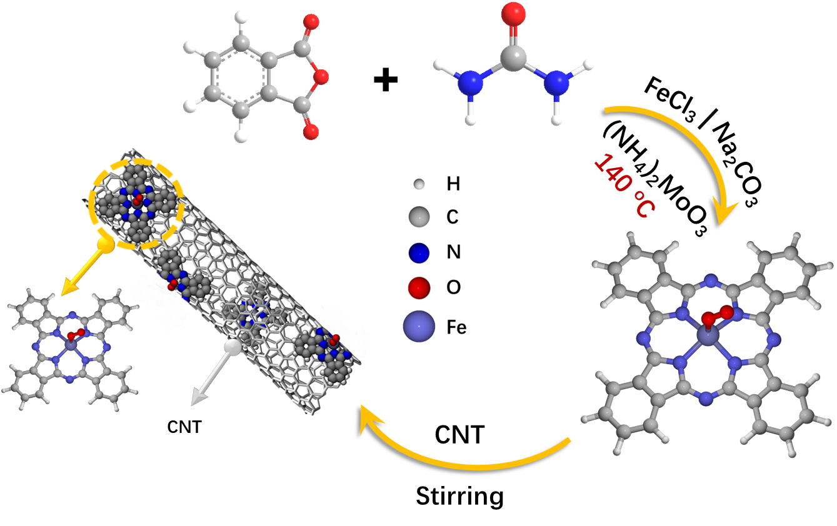
Supplementary Fig. 1. Synthesis strategy of the model single-Fe-atom catalyst.

Supplementary Fig. 2. Fourier transform infrared spectroscopy (FT-IR) spectrum of the as-synthesized FePc¹¹.

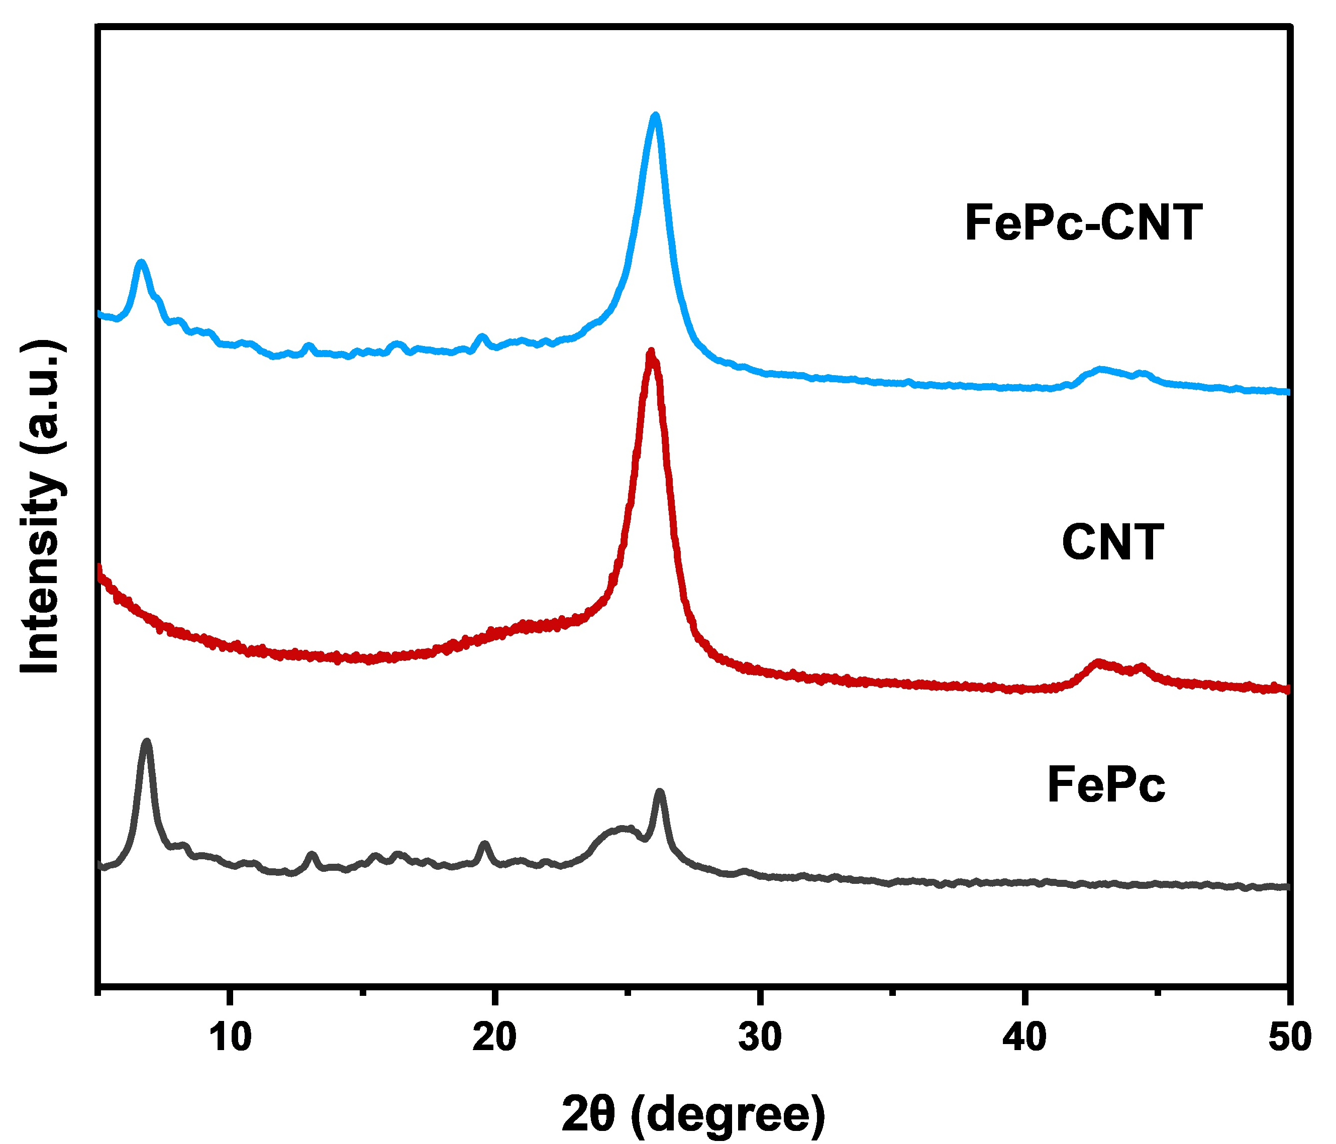
Supplementary Fig. 3. X-ray diffraction (XRD) pattern of FePc, FePc-CNT and CNT. The XRD pattern of the as-prepared FePc shows an intense peak (2θ = 6.9°), which could be assigned to the diffraction from (200) plane of α-FePc.

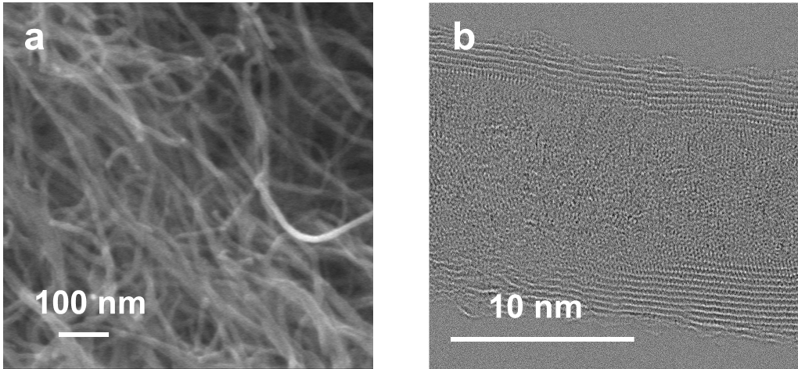
Supplementary Fig. 4. a, FE-SEM, b, HAADF-STEM image of the as-synthesized FePc-CNT. No
Fe cluster could be detected by FE-SEM and HAADF-STEM.

Supplementary Fig. 5. Normalized Fe K-edge XANES spectra of as-synthesized FePc, FePc-CNT together with those of commercial O₂-Fe(III)Pc (O₂-Fe(III)Pc-c), commercial Fe(II)Pc (Fe(II)Pc-c) and Fe foil standards for comparison. The Fe K-edge XANES spectrum of FePc shows that the edge energy of the as-synthesized FePc is close to that of O₂-Fe(III)Pc-c, suggesting that the central iron is in +3 oxidation state in the former.

Supplementary Fig. 6. The k²-weighted FT-EXAFS spectra of as-synthesized FePc (k range, 2-12 Å⁻¹). The main peak at 1.53 Å of FePc (distance not corrected for phase shift) can be attributed to the Fe-N in the first coordination shell. Meanwhile, no Fe-Fe bond is observed in FePc.
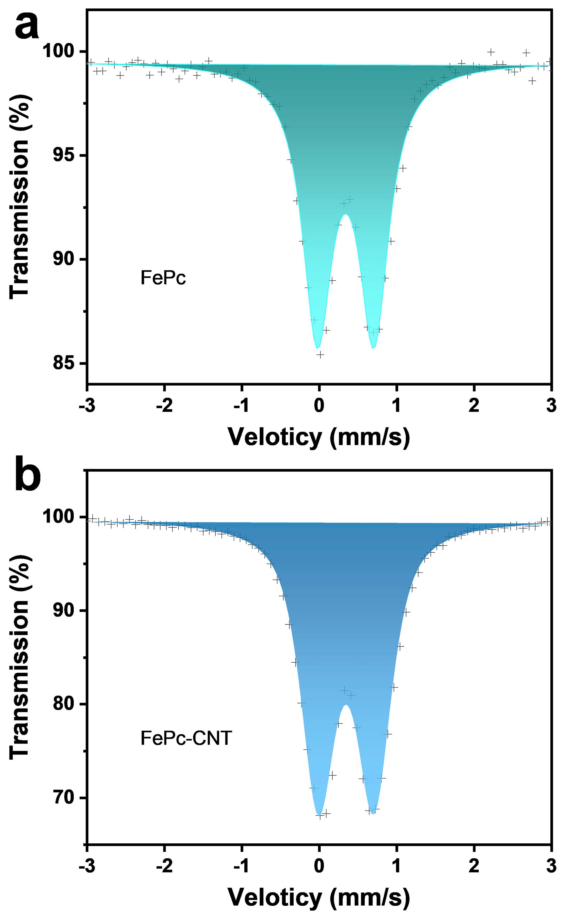
Supplementary Fig. 7. a, Room-temperature ⁵⁷Fe Mössbauer spectrum of as-synthesized FePc, and b, FePc-CNT. The Mössbauer spectrum of FePc can be well fitted using one quadrupole doublet (IS = 0.35 mm s⁻¹, QS = 0.73 mm s⁻¹), which could be assigned to a high spin (HS) Fe(III) species. The fitted parameters of the Mössbauer spectra of FePc and FePc-CNT are shown in Supplementary Table 2.

Supplementary Fig. 8. Normalized Fe K-edge XANES spectra of FePc-CNT. Black and red lines represent experimental and calculated spectra, respectively. Inset image shows the corresponding geometric configuration. Fe: purple; C: grey; N: blue; O: red; and H: white. The pre-edge peak B matches well with the structure model of O₂-Fe(III)Pc.

Supplementary Fig. 9. ¹H NMR spectra of liquid products for FePc-CNT after CO₂RR at -0.3 V to -0.7 V vs. RHE, and for H₂Pc-CNT at -0.4 V to -0.7 V vs. RHE in CO₂-saturated 0.5 M KHCO₃ solution.

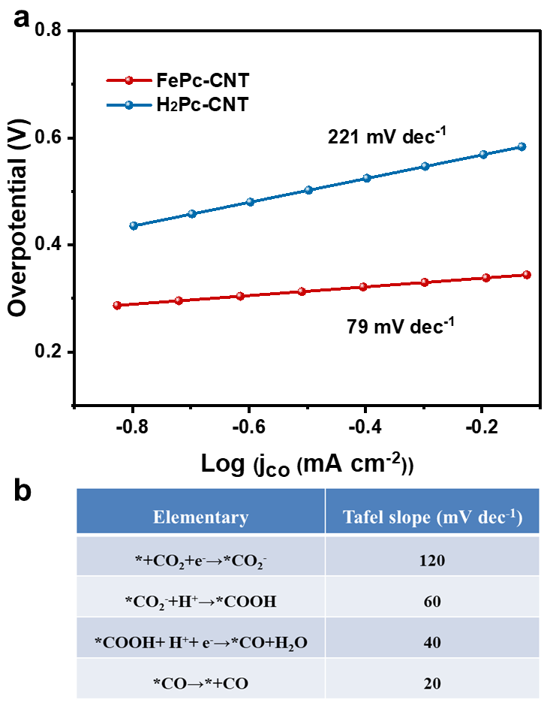
Supplementary Fig. 10. a, CO₂RR Tafel plots of FePc-CNT and Pc-CNT. b, The elementary step as the RDS with the corresponding theoretical Tafel slope¹².
Supplementary Fig. 11. Amperometry stability curves and the corresponding FE_{CO} of FePc-CNT vs. time, measured at -0.45 V vs. RHE in CO₂-saturated 0.5 M KHCO₃ electrolyte.

Supplementary Fig. 12. Normalized Fe K-edge XANES spectra of FePc-CNT recorded under OCP in CO₂-saturated 0.5 M KHCO₃ solution. Black and red curves represent experimental and calculated spectra, respectively. Inset image shows the corresponding geometric configuration. Fe: purple; C: grey; N: blue; O: red; and H: white. The energy position of pre-edge peak B matches well with the structural model of O₂-Fe(III)Pc.

Supplementary Fig. 13. Normalized Fe K-edge XANES spectra of FePc-CNT recorded at -0.4 V vs. RHE in CO₂-saturated 0.5 M KHCO₃ solution. Black and red curves represent experimental and calculated spectra, respectively. Insets image shows the corresponding geometric configuration. Fe: purple; C: grey; N: blue; O: red; and H: white. The energy position of pre-edge peak C matches well with the structural model of Fe(II)Pc.

Supplementary Fig. 14. Normalized Fe K-edge XANES spectra of FePc-CNT recorded at -0.8 V vs. RHE in CO₂-saturated 0.5 M KHCO₃ solution. Black and red curves represent experimental and calculated spectra, respectively. Inset image shows the corresponding geometric configuration. Fe: purple; C: grey; N: blue; O: red; and H: white. The energy position of pre-edge peak A matches well with the structural model of Fe(II)Pc-CO₂⁻.

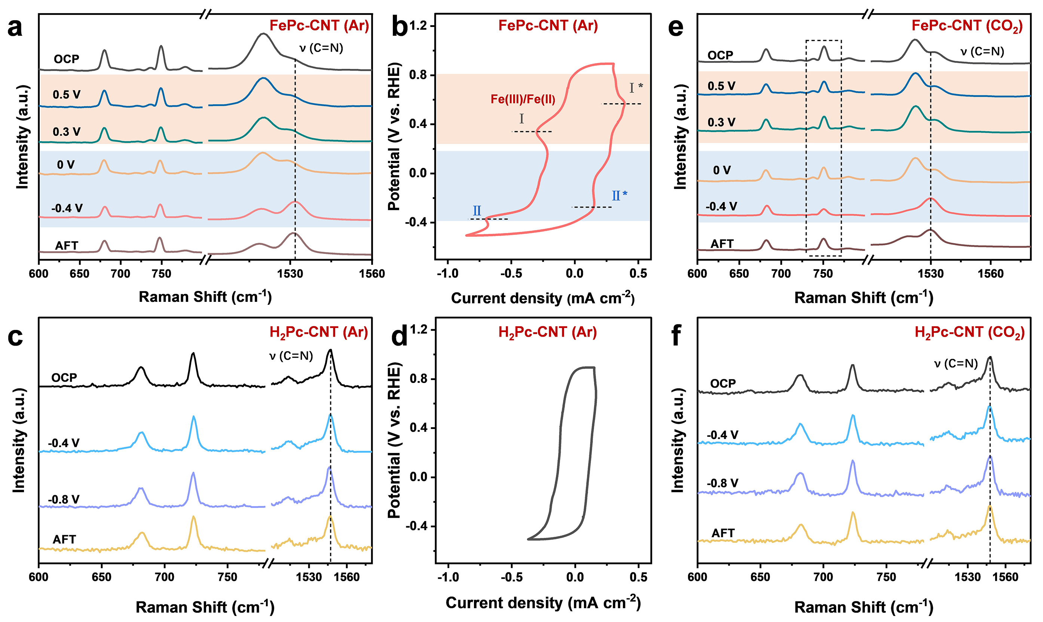
Supplementary Fig. 15. Operando Raman characterization. a, Operando Raman spectra of FePc-CNT recorded at OCP, 0.5 V, 0.3 V, 0 V, -0.4 V vs. RHE and AFT in Ar-saturated 0.5 M KHCO₃ solution. b, CV curves for FePc-CNT recorded in Ar-saturated 0.5 M KHCO₃ electrolyte at 50 mV s⁻¹. c, Operando Raman spectra of H₂Pc-CNT recorded at OCP, -0.4 V, -0.8 V vs. RHE and AFT in Ar-saturated 0.5 M KHCO₃ solution. d, CV curves for H₂Pc-CNT recorded in Ar-saturated 0.5 M KHCO₃ electrolyte at 50 mV s⁻¹. e, Operando Raman spectra of FePc-CNT and f, H₂Pc-CNT recorded in CO₂-saturated 0.5 M KHCO₃ solution.
In Supplementary Fig. 15c,d, no significant changes were observed in the Raman spectra of H₂Pc-CNT at -0.4 V vs. RHE in Ar-saturated conditions (as compared to the case at OCP), and no redox peaks were seen in the CV curves of H₂Pc-CNT from 0.9 to -0.4 V vs. RHE in Ar-saturated conditions. While this might seemingly be in contradiction with the assignment of the low potential redox to the reduction of the Pc ligand in FePc, Alsudairi et al. discussed the electron shuttling effect between the central iron cation and the Pc ligand, demonstrating that the observation of the low potential redox requires the simultaneous presence of the Pc ligand and of the central iron cation¹³. The redox transition from Fe(II) to Fe(I) may take place but be not captured by XAS if, on average over time, the dominant species is Fe(II), and the formed Fe(I) rapidly shuttles one electron to the Pc ligand.
In Supplementary Fig. 15e,f, under CO₂-saturated conditions, when the applied potentials were decreased to -0.4 V vs. RHE, the intensity of the C=N vibration of FePc-CNT increased markedly while that of H₂Pc-CNT was essentially unchanged. The same observation was made in Ar-saturated electrolyte Supplementary Fig. 15a,c. This is in line with the fact that the Pc ring in FePc-CNT was reduced at -0.4 V vs. RHE, while it remained the same in H₂Pc-CNT. Simultaneously, at -0.4 V vs. RHE in CO₂-saturated electrolyte, the 750 cm⁻¹ band of FePc-CNT dramatically decreased, which can be ascribed to the adsorption of CO₂ molecule on central iron. After removing the applied potential, the 750 cm⁻¹ band could be recovered due to the loss of the intermediate species.

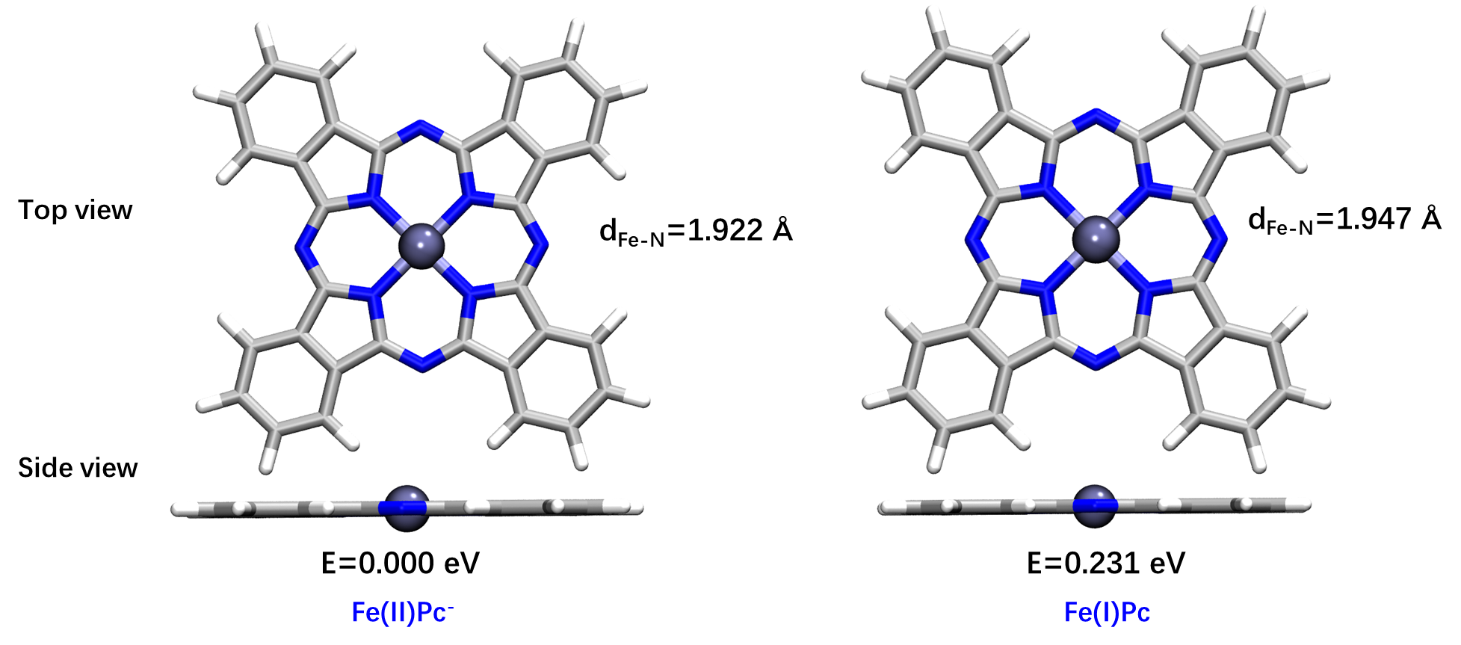
Supplementary Fig. 16. The optimized structures of Fe(I)Pc and Fe(II)Pc⁻ as well as their relative single point energy (eV) and Fe-N bond length (d_{Fe-N}, Å). Both the Fe of Fe(I)Pc and Fe(II)Pc⁻ are in plane, while the Fe(I)Pc has a higher single point energy (0.231 eV) and longer Fe-N bond length (1.947 Å) as compared to Fe(II)Pc⁻, making it less stable than Fe(II)Pc⁻.

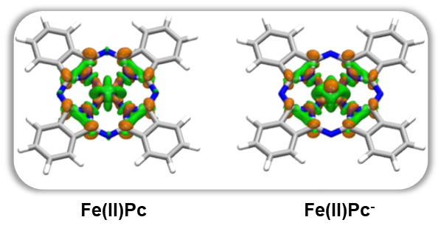
Supplementary Fig. 17. Charge density difference plots of Fe(II)Pc and Fe(II)Pc⁻, where the orange and green regions represent the increase and decrease of charge density whose isosurface is 0.02 a.u.³. The increasing electron density of Fe(II)Pc is between Fe and N, while the upper electron density of Fe decreases, indicating that Fe(II)Pc is not conducive to binding CO₂. After adding electron to the Pc ring, the upper electron density of Fe increases, which is beneficial to CO₂ bonding.

Supplementary Table 1. Structural parameters fitted from EXAFS for FePc-CNT.
Sample | k-range (Å⁻¹) | R-range (Å) | Shell | CN | R (Å) | σ² (10⁻³ Å²) | ΔE (eV) | R-factor
FePc-CNT | 2 - 12 | 1 - 2.2 | Fe-N | 3.8 | 2.02 | 1.32 | -0.827 | 0.02
FePc-CNT | 2 - 12 | 1 - 2.2 | Fe-O | 1.3 | 1.79 | 1.32 | -0.827 | 0.02
The accuracies of coordination number (CN), average absorber-backscatter distance (R), Debye-Waller factor (σ²), inner potential correction (ΔE) are estimated as ± 20%, ± 1%, ± 20%, ± 20%, respectively. R-factor is the goodness of fit.

Supplementary Table 2. The fitted parameters of ex situ ⁵⁷Fe Mössbauer spectra of as-synthesized FePc and FePc-CNT.
Sample | Component | IS (mm s⁻¹) | QS (mm s⁻¹) | Ӷ (mm s⁻¹) | Area (%)
FePc | HS Fe(III) | 0.35 | 0.73 | 0.46 | 100.0%
FePc-CNT | HS Fe(III) | 0.35 | 0.71 | 0.51 | 100.0%

Experimental errors for isomer shift (IS), and quadrupole splitting (QS) are ± 0.02 mm s⁻¹, ± 0.08 mm s⁻¹, respectively. The IS is given relative to α-iron foil.

Potential | Component | Assignment | IS  (mm s⁻¹) | QS  (mm s⁻¹) | Magnetic  field (kOe) | Ӷ  (mm s⁻¹) | Area  (%)
CO₂ (OCP) | D1 | HS Fe(III) | 0.33 | 0.69 | - | 0.43 | 100.0%
CO₂ (-0.4 V  vs. RHE) | D1  D2a  D2b | HS Fe(III)  HS Fe(II)  HS Fe(II)-CO₂⁻ | 0.34  1.19  1.18 | 0.67  1.80  2.50 | -  -  - | 0.42  0.34  0.31 | 32.7%  55.0%  12.3%
CO₂ (-0.8 V  vs. RHE) | D1  D2a  D2b | HS Fe(III)  HS Fe(II)  HS Fe(II)-CO₂⁻ | 0.34  1.20  1.20 | 0.67  1.74  2.25 | -  -  - | 0.54  0.27  0.32 | 20.2%  53.5%  26.2 %
CO₂ (AFT) | D1  D2a | HS Fe(III)  HS Fe(II) | 0.40  1.21 | 0.87  1.89 | -  - | 0.48  0.40 | 51.0%  49.0%
Ar (-0.4 V  vs. RHE) | D1  D2a  Sextet | HS Fe(III)  HS Fe(II)  Metallic Fe | 0.34  1.18  0 | 0.67  1.93  - | -  -  324 | 0.50  0.55  0.24 | 25.4%  57.9%  16.6%
Supplementary Table 3. The fitted parameters of operando ⁵⁷Fe Mössbauer spectra over FePc-CNT recorded at various applied cathodic potentials¹⁴⁻¹⁶.
Experimental errors for isomer shift (IS), quadrupole splitting (QS) and relative area are ± 0.02 mm s⁻¹, ± 0.08 mm s⁻¹ and less than 3%, respectively. IS is given relative to α-iron foil.
References
1. Joly, Y. X-ray absorption near-edge structure calculations beyond the muffin-tin approximation. Phys. Rev. B 63, 125120 (2001).
2. Li, X. et al. Unveiling the in situ generation of a monovalent Fe(I) site in the single-Fe-atom catalyst for electrochemical CO₂ reduction. ACS Catal. 11, 7292-7301 (2021).
3. Weigend, F. Accurate coulomb-fitting basis sets for H to Rn. Phys. Chem. Chem. Phys. 8, 1057-1065 (2006).
4. Caldeweyher, E. et al. A generally applicable atomic-charge dependent London dispersion correction. J. Chem. Phys. 150, 154122 (2019).
5. Weigend, F. & Ahlrichs, R. Balanced basis sets of split valence, triple zeta valence and quadruple zeta valence quality for H to Rn: Design and assessment of accuracy. Phys. Chem. Chem. Phys. 7, 3297-3305 (2005).
6. Lars Goerigk, S. G. Efficient and accurate double-hybrid-meta-GGA density functionals—evaluation with the extended GMTKN30 database for general main group thermochemistry, kinetics, and noncovalent interactions. J. Chem. Theory Comput. 7, 291–309 (2011).
7. Grimme, S., Ehrlich, S. & Goerigk, L. Effect of the damping function in dispersion corrected density functional theory. J. Comput. Chem. 32, 1456-1465 (2011).
8. William Humphrey, Andrew Dalke & Schulten, K. VMD: visual molecular dynamics. J. Mol. Graphics 14, 33-38 (1996).
9. Lu, T. & Chen, F. Multiwfn: a multifunctional wavefunction analyzer. J. Comput. Chem. 33, 580-592 (2012).
10. Aleksandr V. Marenich, Christopher J. Cramer & Truhlar, D. G. Universal solvation model based on solute electron density and on a continuum model of the solvent defined by the bulk dielectric constant and atomic surface tensions. J. Phys. Chem. B 113, 6378–6396 (2009).
11. Xu, S. et al. Immobilization of iron phthalocyanine on pyridine-functionalized carbon nanotubes for efficient nitrogen reduction reaction. ACS Catal. 12, 5502-5509 (2022).
12. Fang, Y.-H. & Liu, Z.-P. Tafel kinetics of electrocatalytic reactions: from experiment to first-principles. ACS Catal. 4, 4364-4376 (2014).
13. Alsudairi, A. et al. Resolving the iron phthalocyanine redox transitions for ORR catalysis in aqueous media. J. Phys. Chem. Lett. 8, 2881-2886 (2017).
14. Chen, J. Y. et al. Operando analysis of NiFe and Fe oxyhydroxide electrocatalysts for water oxidation: detection of Fe⁴⁺ by mossbauer spectroscopy. J. Am. Chem. Soc. 137, 15090-15093 (2015).
15. Li, X. et al. Identification of the electronic and structural dynamics of catalytic centers in single-Fe-atom material. Chem 6, 3440-3454 (2020).
16. Li, J. et al. Identification of durable and non-durable FeNx sites in Fe–N–C materials for proton exchange membrane fuel cells. Nat. Catal. 4, 10-19 (2021).

