Modeling chronic pain experiences from online reports using the Reddit Reports of Chronic Pain dataset
Appendix II

Diogo A.P. Nunes^{1,2}, Joana Ferreira-Gomes^{3,4}, Fani Neto^{3,4}, David Martins de Matos^{1,2}

¹INESC-ID, Lisbon, Portugal
² Instituto Superior Técnico, Universidade de Lisboa, Lisbon, Portugal
³ Department of Biomedicine, Experimental Biology Unit, Centre for Medical Research (CIM), Faculty of Medicine, University of Porto, Porto, Portugal
⁴ i3S - Instituto de Investigação e Inovação em Saúde, University of Porto, Porto, Portugal

Corresponding author

Diogo A.P. Nunes
INESC-ID, Lisbon, Portugal
Instituto Superior Técnico, Universidade de Lisboa, Lisbon, Portugal
diogo.p.nunes@inesc-id.pt

Appendix II

In this appendix we describe in greater detail the Reddit Reports of Chronic Pain (RRCP) dataset, which is the one used for analysis in the main body of our work. We analyze the following distributions: (1) subreddit activity, (2) author contribution, (3) submission sentiment, and (4) vocabulary.

In sum, the preprocessed RRCP dataset is composed of 86,537 Reddit submissions with a body of text, from 12 subreddits, from 2013 to 2020 inclusive. These subreddits were manually selected from a sample of related subreddits. Submissions prior to 2013 were discarded, because not all the considered subreddits were fully active before then.

1. Subreddit activity
With this analysis we were interested in learning the user activity distribution of each subreddit and each year, as given by submission count. This is an important analysis because our main body of work describes experiments that compare subreddits between themselves. These results provide context for those comparisons.

The following metrics were used as measures of user activity, either by subreddit, or by year: (1) the number of comments per submission, reflecting the interactivity or discussion stemmed from an average submission, and (2) the length, in tokens, of each submission, which reflects how lengthy the ideas being discussed are in an average submission. Finally, we analyzed the number of submissions per subreddit in a year, as an additional measure of user activity.

Starting the analysis by subreddit, we can observe in Fig. II1 the comment distribution and in Fig. II2 the body length distribution, per submission. We conclude that the distribution of comments is similar for all subreddits, rendering comparable the amount of discussion an average submission generates in each of the considered subreddits. Moreover, the distribution of the body length of a submission is very similar for all subreddits, rendering comparable the elaboration of ideas in each of the considered subreddits. According to these metrics, all subreddits have comparable distributions of activity.

Shifting to the analysis by year, we observe the same metrics, in Fig. II3 and in Fig. II4, respectively. For both metrics, very similar distributions for each year occur, both presenting a slight tendency to decrease along the years. Nonetheless, according to these metrics, all years have comparable distributions of activity.

Finally, the distribution of the number of submissions in a year per subreddit, as shown in Fig. II5, allows to identify the largest differences between subreddits. According to this metric, CrohnsDisease is an outlier, with the following 3 subreddits forming a group, and another group formed by the remaining. Excepting ChronicPain, which is an all-encompassing topic, it is not clear why the other top-3 subreddits display so much more activity than the other subreddits, especially because they are specifically centered on one pathology. Attending to the number of users of each subreddit, and the known population incidence of the considered pathologies, no direct justification was found for these discrepancies.
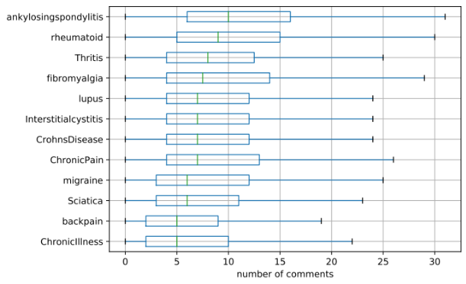 | 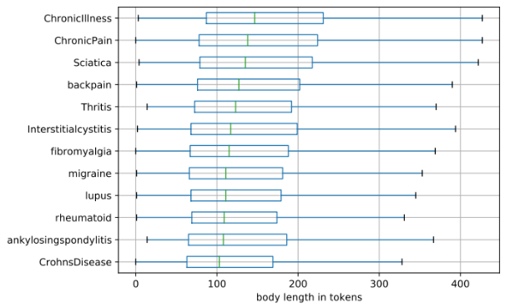
Fig. II1 Distribution of the number of comments per submission (outliers are omitted). | Fig. II2 Distribution of the body length in tokens per submission (outliers are omitted).

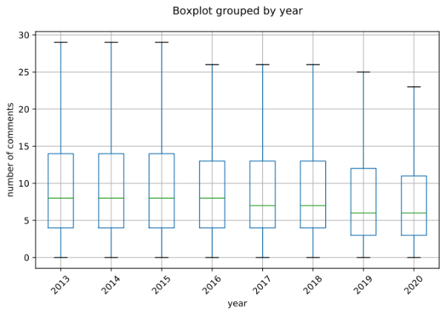 | 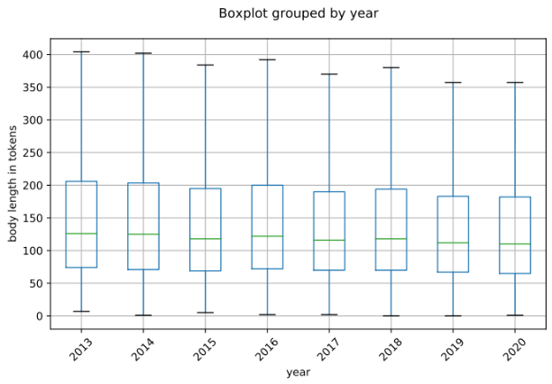
Fig. II3 Distribution of the number of comments per year (outliers are omitted). | Fig. II4 Distribution of the body length in tokens per year (outliers are omitted).

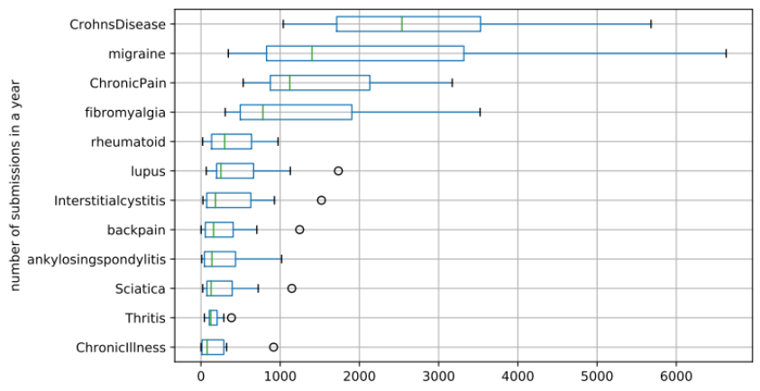
Fig. II5 Distribution of the number of submissions per year for each subreddit.

2. Author contribution
With this analysis we were interested in learning the distribution of author contribution, as given by the number of submissions per author. This is an important analysis because it can reveal textual biases due to over-contribution of specific authors.

The preprocessed RRCP dataset contains 44,815 unique authors. By design, authors only posted submissions to one of the 12 subreddits. Tab. I1 shows the number of authors and submissions per subreddit. This table shows that the number of authors per subreddit is proportional to the number of submissions per subreddit (Pearson’s r = 0.98).

Assessing the contribution of each author in each subreddit, Fig. II6 shows the percentage of submissions per author, for each subreddit. We can observe that all subreddits have a similar distribution of author contribution. Fig. II7 shows the variations between these distributions (percentage of author contribution). We observe that the mean, first, second, and third quartiles of each subreddit’s distribution have a variation of less than 0.2 percentage points. Moreover, there is no single author that contributes to a large percentage of one subreddit’s submissions (the maximum being 2.2%). These findings point to there not being relevant textual bias due to over-contribution of a single author or a restricted group of authors, for both the whole RRCP and for each subreddit.

Tab. II1 Number of authors and submissions per subreddit. Percentage in relation to the whole dataset is shown in parentheses.
Subreddit | Authors | Submissions
migraine | 10,741 (24.0) | 18,911 (21.6)
CrohnsDisease | 9,409 (21.0) | 22,836 (26.4)
ChronicPain | 6,423 (14.3) | 12,365 (14.3)
fibromyalgia | 5,148 (11.5) | 10,764 (12.4)
lupus | 2,367 (5.3) | 4,300 (5.0)
backpain | 2,217 (4.9) | 2,667 (3.1)
rheumatoid | 1,823 (4.1) | 3,258 (3.8)
Interstitialcystitis | 1,658 (3.7) | 3,500 (4.0)
Sciatica | 1,572 (3.5) | 2,555 (3.0)
ankylosingspondylitis | 1,340 (3.0) | 2,450 (2.8)
ChronicIllness | 1,105 (2.5) | 1,596 (1.8)
Thritis | 1,012 (2.3) | 1,335 (1.5)

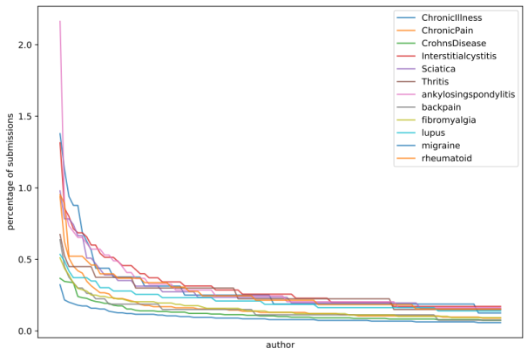 | 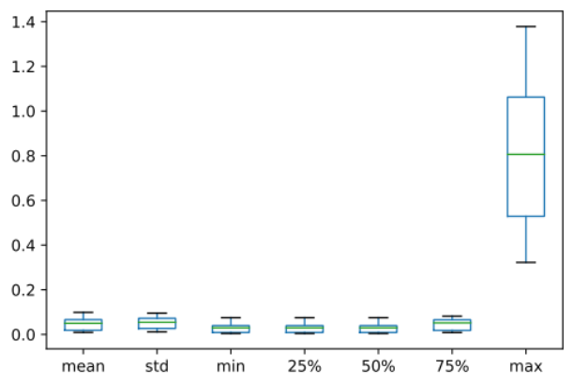
Fig. II6 Percentage of submissions per author, for each subreddit. | Fig. II7 Variations between the distribution of percentage of author contribution per subreddit (outliers are omitted).

3. Submission sentiment
With this analysis we were interested in learning the distribution of sentiment in the RRCP as a whole and per subreddit. Specifically, we were interested in understanding if submissions, in general and per subreddit, tend more towards a negative, neutral, or positive sentiment. For that, we used the Valence Aware Dictionary and sEntiment Reasoner (VADER) sentiment analysis engine [1], which is specifically designed for social media text. Even though this engine outputs a continuous sentiment score ranging between -1 (most negative) and 1 (most positive), we used the proposed standardized thresholds to classify a given document as being of positive sentiment (score >= 0.05), neutral sentiment (-0.05 < score > 0.05), and negative sentiment (score <= -0.05). This analysis was motivated by the possibility that the types of forums (i.e., subreddits) explored in our work tend to be more negative and incentivize catastrophizing, losing relevancy for the overall population.

The results of this analysis classify 38,964 (45.03%) documents as negative sentiment, 29,027 (33.54%) as positive sentiment, and 18,546 (21.43%) as neutral sentiment. Fig. II8 shows the ratios of negative, neutral, and positive sentiment documents per subreddit, in a stacked bar plot. This figure shows that some subreddits, especially backpain, ChronicPain, and Sciatica, tend more towards negative sentiment than the remaining subreddits. All subreddits show a similar ratio of neutral sentiment submissions. Indeed, these results seem to suggest a tendency towards negative sentiment submissions, however, the discrepancy is not large enough to sustain the hypothesis that catastrophizing is the norm. Indeed, it seems natural that reports of chronic pain experiences tend slightly towards negative sentiment.

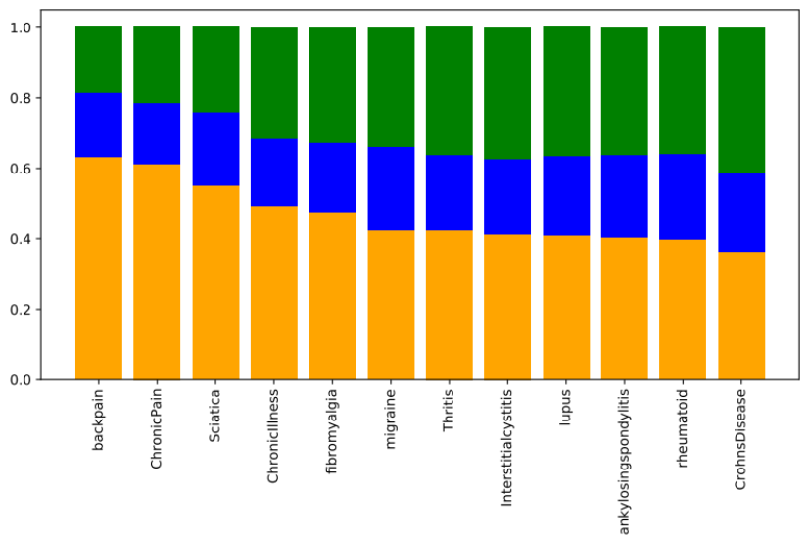
Fig. II8 Ratio of negative (orange), neutral (blue), and positive (green) sentiment documents per subreddit.

4. Vocabulary
The corpus vocabulary is composed of 84,108 unique tokens (unigrams and bigrams). Tab. II2 shows the top unigrams and bigrams in terms of corpus coverage (i.e., the percentage of documents in the corpus in which they appear). According to this table, all tokens have a corpus coverage below 25%, and all bigrams have a corpus coverage below 5%. The low corpus coverage indicates that there is indeed a very diversified vocabulary. An omitted, additional analysis showed that the least representative tokens mostly corresponded to miscellaneous morphosyntactic errors.

Tab. II3 shows the top unigrams and bigrams per subreddit, along with the percentage of terms which are exclusive to each subreddit. This table shows that, in total, 48.03% of the vocabulary is not shared between subreddits (i.e., only 55.91% of the corpus vocabulary is shared). This is an important indicator that a large part of the vocabulary used to express, describe, and discuss experiences of chronic pain is exclusive to the type of experience under consideration. It also suggests a significant separation of subreddits in the vocabulary space. We observe that the unigrams back and work are in the top list of almost all subreddits, possibly relating to the location on the body and problems with work life, respectively. It is not clear to us if these unigrams should be considered stop words: on the one hand, they are irrelevant for differentiation between subreddits; on the other hand, they are very relevant concepts surrounding the common experience of chronic pain. We decided to maintain these tokens due to their clinical relevance.

Tab. II2 Top 10 tokens with most corpus coverage, separated as unigrams and bigrams. Percentage is shown in parentheses.

Unigrams | Bigrams
back (21.1) | side effects (4.1)
day (18.1) | every day (2.9)
work (16.5) | lower back (2.8)
bad (14.3) | months ago (2.5)
started (14.1) | last week (2.4)
first (14.1) | last year (2.4)
want (14.0) | last night (2.1)
else (13.3) | two weeks (2.1)
see (12.8) | came back (1.9)
last (12.5) | weeks ago (1.8)

Tab. II3 Top 3 most frequent unigrams and bigrams per subreddit, along with the percentage of terms which are exclusive to each subreddit

Subreddit | Unique vocabulary (%) | Top-3 most frequent unigrams | Top-3 most frequent bigrams
CrohnsDisease | 11.9 | back, day, first | side effects, last week, last year
migraine | 9.6 | day, work, started | side effects, every day, last night
ChronicPain | 8.8 | back, day, work | lower back, physical therapy, every day
fibromyalgia | 5.6 | work, day, back | brain fog, side effects, every day
lupus | 2.4 | back, diagnosed, day | came back, blood work, side effects
Interstitialcystitis | 2.0 | bladder, flare, uti | pelvic floor, flare ups, came back
backpain | 1.6 | back, work, day | lower back, upper back, right side
rheumatoid | 1.5 | started, day, diagnosed | side effects, months ago, blood work
ankylosingspondylitis | 1.4 | back, diagnosed, humira | lower back, ankylosing spondylitis, side effects
Sciatica | 1.3 | back, surgery, leg | lower back, herniated disc, left leg
ChronicIllness | 1.1 | people, illness, work | chronically ill, brain fog, mental health
Thritis | 0.8 | back, bad, work | side effects, months ago, lower back

References
- Hutto, C.J., Gilbert, E.: VADER: A Parsimonious Rule-Based Model for Sentiment Analysis of Social Media Text. In: Proceedings of the International AAAI Conference on Web and Social Media. pp. 216–225. The AAAI Press (2014). https://doi.org/10.1609/ICWSM.V8I1.14550.

