Modeling chronic pain experiences from online reports using the Reddit Reports of Chronic Pain dataset
Appendix I

Diogo A.P. Nunes^{1,2}, Joana Ferreira-Gomes^{3,4}, Fani Neto^{3,4}, David Martins de Matos^{1,2}

¹INESC-ID, Lisbon, Portugal
² Instituto Superior Técnico, Universidade de Lisboa, Lisbon, Portugal
³ Department of Biomedicine, Experimental Biology Unit, Centre for Medical Research (CIM), Faculty of Medicine, University of Porto, Porto, Portugal
⁴ i3S - Instituto de Investigação e Inovação em Saúde, University of Porto, Porto, Portugal

Corresponding author

Diogo A.P. Nunes
INESC-ID, Lisbon, Portugal
Instituto Superior Técnico, Universidade de Lisboa, Lisbon, Portugal
diogo.p.nunes@inesc-id.pt

Appendix I

In this appendix we describe a baseline experiment of subreddit similarity, using the Reddit Reports of Chronic Pain (RRCP) dataset. We decided to include this experiment in appendix because it was the motivation for the more intricate experiment presented and discussed in the main body, although the results and conclusions of this experiment are reflected in those of that experiment. Moreover, we use this appendix to describe in greater detail the techniques and technologies used.

Baseline analysis of subreddit similarity
The objective of this experiment was to gain insights on how the various subreddits are related based on what their users described and discussed regarding their experiences of chronic pain. For that, the RRCP corpus was projected onto a latent space as given by the Latent Dirichlet Allocation (LDA) topic model [1], with k = 20 topics, which was empirically determined to identify regions of interest. This k-dimensional topic space defines the semantic space of the experiments described in this document.

Topic modelling extracts implicit (latent) information in each document belonging to a corpus, explicitly representing them with that information. Thus, each document is projected into the latent space of (abstract) semantic concepts of the corpus, where the value of each dimension represents the weight of that latent topic in the given document. A topic is itself a distribution of weights over the corpus vocabulary, where the weight indicates the level of relevance that word has in the topic, in such a way that the top relevant words of a topic are syntactically and/or semantically related, given that corpus. More specifically, taking a Bag-of-Words (BOW) representation of the corpus (i.e., each document is represented in the corpus vocabulary space, where each dimension is the frequency of a given word in that document), LDA represents each document as a mixture of multinomial distributions (defined in the latent k topics space), in which each multinomial is defined over the corpus vocabulary space. Each topic mixture θ is sampled from a k-dimensional Dirichlet distribution (k having to be defined a priori), parameterized by α which intuitively models the concentration of topics per document in a collection. Finally, each multinomial is parameterized by another Dirichlet prior β, which models the concentration of words per topic. This relaxed paradigm allows for many-to-many relationships both between topics and words, and documents and topics, which fits the intuition that a document may comprise several topics and that a word may belong to multiple topics. We chose LDA because it is widely used in the literature, including health related research [2–5]. We used Gensim’s implementation of LDA with default parameters, setting the number of topics k = 20.

In this experiment, each subreddit was characterized by a single point in the semantic space, called the subreddit centroid, allowing for a coarse-grained analysis. The centroid was given by the average of the document-topic vectors of that subreddit. Thus, in this setting, each subreddit was fully characterized by a single vector of length k. Subreddit similarity was given by the cosine-similarity between the subreddits' centroids, as defined in Eq. I1. This metric ranges from 0 to 1, where 1 is assigned to identical vectors, and 0 to orthogonal vectors. Cosine-similarity is commonly used to compare vectors, because it emphasizes vectors with similar normalized weights assigned to the same dimensions [6–8].

$$\text{sim}\left(c_{i},c_{j}\right)=\frac{c_{i}⋅c_{j}}{\left|\left|c_{i}\right|\right|×\left|\left|c_{j}\right|\right|}$$

Eq. I1 Cosine-similarity between two vectors of the same length.

We assessed the results using a similarity graph. In this graph, the nodes represent the centroid of each subreddit, and an edge between two nodes represents a cosine-similarity ≥ 0.96, which was empirically determined to show regions of interest. Taking advantage of graph plotting and graph theory, we then identified the (dis)connected components, or sub-graphs to draw conclusions.

Results
Appendix III shows the top-10 words of each of the k = 20 topics extracted for the whole corpus.

Fig. I1 shows the similarity graph between all subreddits. We observe 7 sub-graphs: 4 disconnected nodes, 2 sub-graphs of 2 nodes each, and a sub-graph of 4 nodes, where only one (rheumatoid) is connected to all other nodes. Fig. I2 presents the same results, but in more detail, showing the exact cosine-similarity between every pair of subreddits. We observe that, according to our metric, the most similar subreddits are backpain and Sciatica (0.99), followed by ankylosingspondylitis and Thritis (0.98). The least similar subreddits are backpain and CrohnsDisease (0.54), followed by backpain and Interstitialcystitis (0.56). On average, the subreddit which is most similar to all other subreddits is lupus (0.89), and the subreddit which is, on average, least similar to all other subreddits is backpain (0.70).
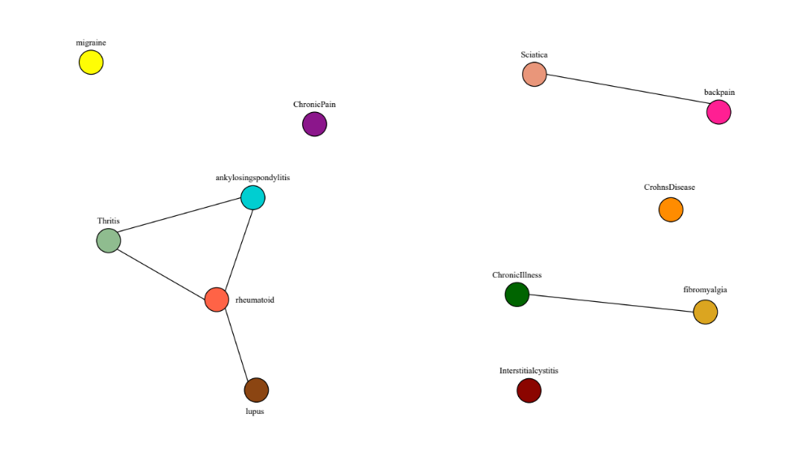
Fig. I1 Similarity graph between subreddit centroids (nodes). Edges between two nodes represent similarities ≥ 0.96. Nodes are colored by subreddit. The adjacent label indicates the corresponding subreddit.

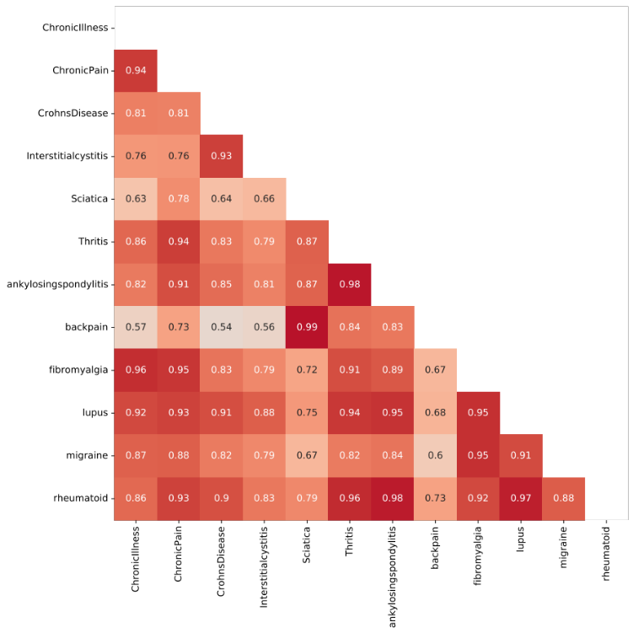
Fig. I2 Similarity heatmap between subreddit centroids. Annotations represent the similarity between each pair of subreddits.

Discussion
The results of this experiment reveal important latent structures in the RRCP: overall, the reported experiences of Sciatica and backpain, ChronicPain and fibromyalgia, and Thritis, ankylosingspondylitis, lupus, and rheumatoid are very similar. Additionally, the remaining reported experiences are considered dissimilar from all the rest. This suggests that, in the RRCP, there are, overall, 7 distinct types of reported chronic pain experiences, although there are 12 distinct subreddits, each focused on a specific pathology. This suggests that there are reports of chronic pain experiences in different subreddits (i.e., of different pathologies) that are, overall, very similar. However, attending to the RRCP characteristics in Tab. 1 of the main body, we consider it to be sub-optimal to summarize thousands of documents in a single point (i.e., the subreddit centroid) and use it to fully characterize the entire subreddit, since this leads to the dilution of meaningful information in the document-topic distribution. Moreover, in determining the similarity between subreddits, there may be specific areas in the semantic space which are very similar between two subreddits, and other areas which are very different. This experiment does not capture that information.

References
- Blei, D.M., Ng, A.Y., Edu, J.B.: Latent Dirichlet Allocation Michael I. Jordan. (2003).
- Goudman, L., de Smedt, A., Moens, M.: Social Media and Chronic Pain: What Do Patients Discuss? J Pers Med. 12, (2022). https://doi.org/10.3390/jpm12050797.
- Foufi, V., Timakum, T., Gaudet-Blavignac, C., Lovis, C., Song, M.: Mining of textual health information from Reddit: Analysis of chronic diseases with extracted entities and their relations. J Med Internet Res. 21, (2019). https://doi.org/10.2196/12876.
- Nzali, M.D.T., Bringay, S., Lavergne, C., Mollevi, C., Opitz, T.: What patients can tell us: Topic analysis for social media on breast cancer. JMIR Med Inform. 5, (2017). https://doi.org/10.2196/medinform.7779.
- Brody, S., Elhadad, N.: Detecting Salient Aspects in Online Reviews of Health Providers. In: AMIA Annual Symposium Proceedings. pp. 202–206. American Medical Informatics Association (2010).
- Gokul, P.P., Akhil, B.K., Shiva, K.K.M.: Sentence similarity detection in Malayalam language using cosine similarity. In: RTEICT 2017 - 2nd IEEE International Conference on Recent Trends in Electronics, Information and Communication Technology, Proceedings. pp. 221–225. Institute of Electrical and Electronics Engineers Inc. (2017). https://doi.org/10.1109/RTEICT.2017.8256590.
- Rakholia, R.M., Saini, J.R.: Information retrieval for Gujarati language using cosine similarity based vector space model. In: Advances in Intelligent Systems and Computing. pp. 1–9. Springer Verlag (2017). https://doi.org/10.1007/978-981-10-3156-4_1/COVER.
- Al-Anzi, F.S., AbuZeina, D.: Toward an enhanced Arabic text classification using cosine similarity and Latent Semantic Indexing. Journal of King Saud University - Computer and Information Sciences. 29, 189–195 (2017). https://doi.org/10.1016/j.jksuci.2016.04.001.

