Modeling chronic pain experiences from online reports using the Reddit Reports of Chronic Pain dataset
Appendix III

Diogo A.P. Nunes^{1,2}, Joana Ferreira-Gomes^{3,4}, Fani Neto^{3,4}, David Martins de Matos^{1,2}

¹INESC-ID, Lisbon, Portugal
² Instituto Superior Técnico, Universidade de Lisboa, Lisbon, Portugal
³ Department of Biomedicine, Experimental Biology Unit, Centre for Medical Research (CIM), Faculty of Medicine, University of Porto, Porto, Portugal
⁴ i3S - Instituto de Investigação e Inovação em Saúde, University of Porto, Porto, Portugal

Corresponding author

Diogo A.P. Nunes
INESC-ID, Lisbon, Portugal
Instituto Superior Técnico, Universidade de Lisboa, Lisbon, Portugal
diogo.p.nunes@inesc-id.pt

Appendix III

In this appendix we show the top-10 words of the 20 extracted topics of the whole RRCP corpus, and the clustering metrics for each subreddit, which allowed for the definition of the number of clusters to extract, per subreddit.

Extracted topics

Topic number | Top-10 most weighted words
0 | taking, side effects, tried, medication, meds, started, day, methotrexate, daily, try
1 | don’t, high, Topamax, experience, brain fog, wondering, low, see, use, blood pressure
2 | eat, food, eating, drink, water, trigger, day, drinking, triggers, stomach
3 | sensitivity, triggered, bent, tolerate, benlysta, next appointment, long periods, bar, drain, cream
4 | people, life, want, lot, diagnosed, don’t, advice, always, way, love
5 | neck, don’t, back, cold, won’t, idk, caffeine, head, coffee, right side
6 | diet, exercise, weight, diagnosed, lot, trying, months, tried, good, study
7 | head, sometimes, one, else, usually, feeling, always, feels, almost, weird
8 | hair, skin, red, hot, wear, heat, products, use, shower, sun
9 | work, need, appointment, patients, see, office, one, insurance, called, new
10 | diagnosed, test, normal, diagnosis, fatigue, pregnancy, pregnant, stomach, inflammation, crohn’s
11 | botox, Enbrel, rheum, glasses, pcp, wouldn’t, right eye, ear, ears, hair loss
12 | started, first, last, week, flare, months, weeks, went, back, prednisone
13 | looking, one, find, use, good, people, found, recommendations, helpful, wondering
14 | dizziness, biologics, biologic, wondering, experience, sex, liver, curious, tips, advice
15 | surgery, back, done, recovery, one, mri, long, good, procedure, surgeon
16 | new, month, insurance, treatment, work, one, months, medication, humira, meds
17 | work, day, one, today, bad, want, don’t, need, home, sleep
18 | https www, com, https, watch, video, link, articles, gets better, patients, everyone
19 | back, started, joints, hurt, went, joint, lower back, one, day, right

Clustering metrics

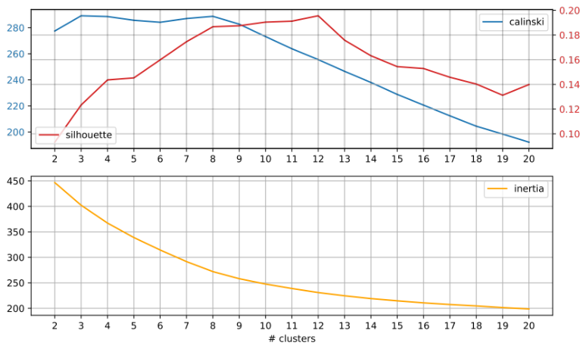
Fig. III1 ankylosingspondylitis

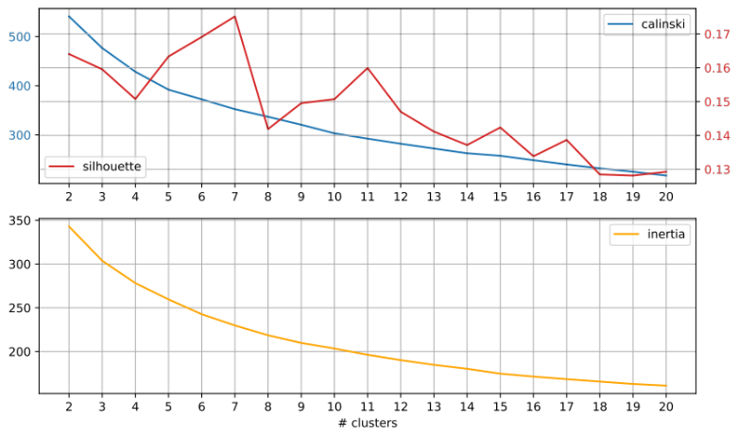
Fig. III2 backpain

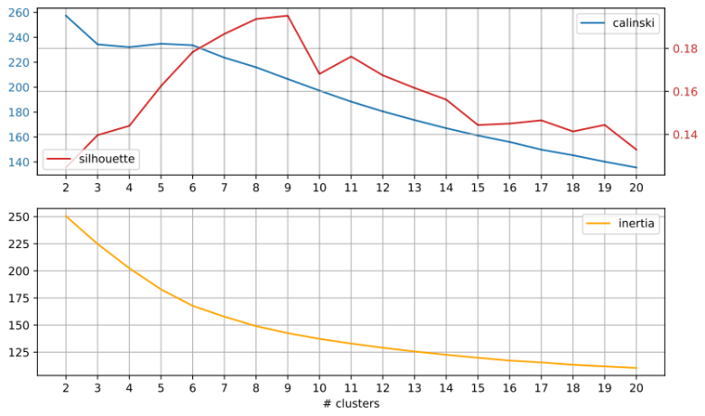
Fig. III3 ChronicIllness

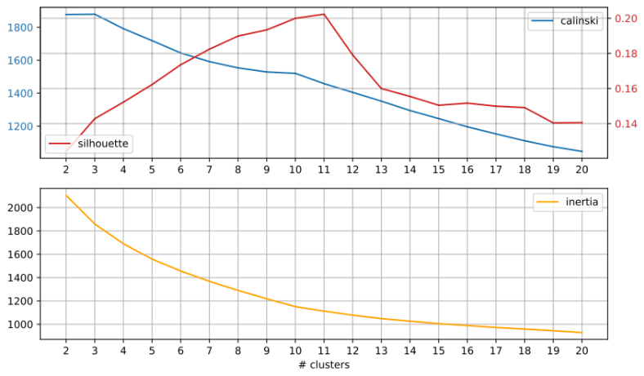
Fig. III4 ChronicPain

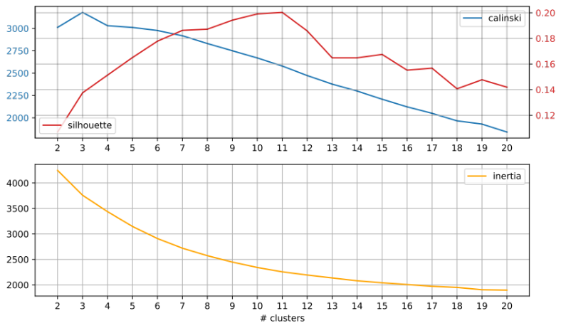
Fig. III5 CrohnsDisease

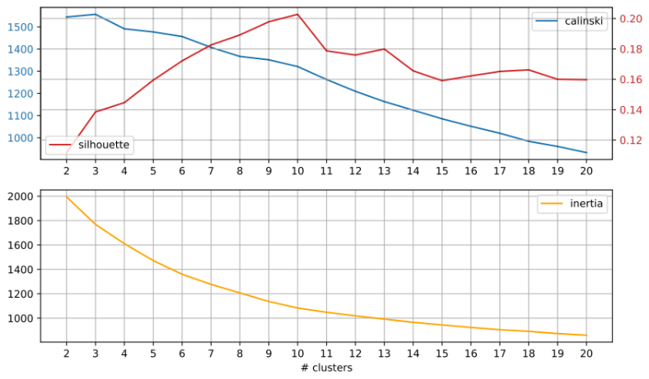
Fig. III6 fibromyalgia

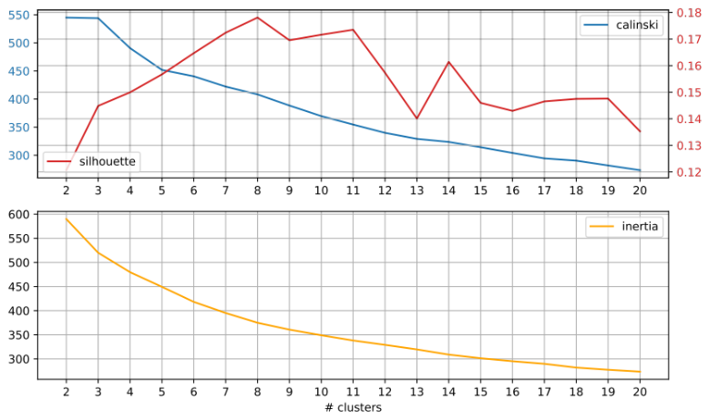
Fig. III7 Interstitialcystitis

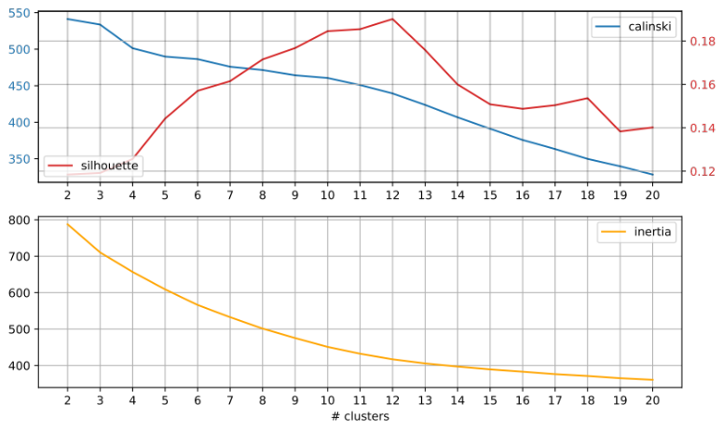
Fig. III8 lupus

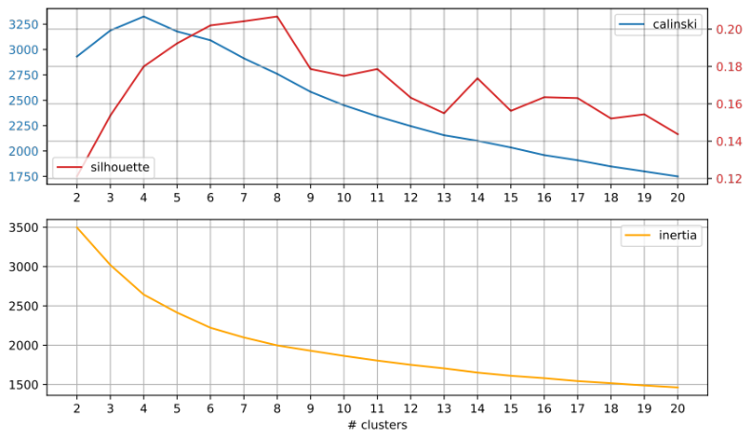
Fig. III9 migraine

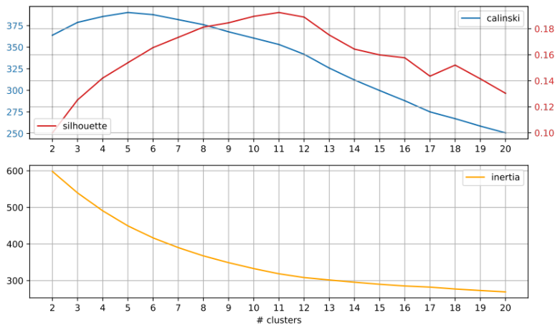
Fig. III10 rheumatoid

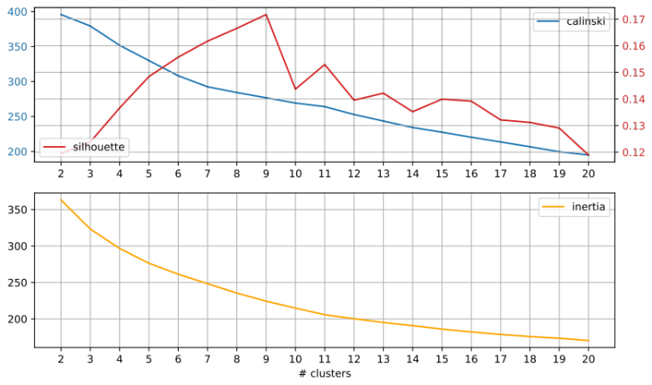
Fig. III11 Sciatica

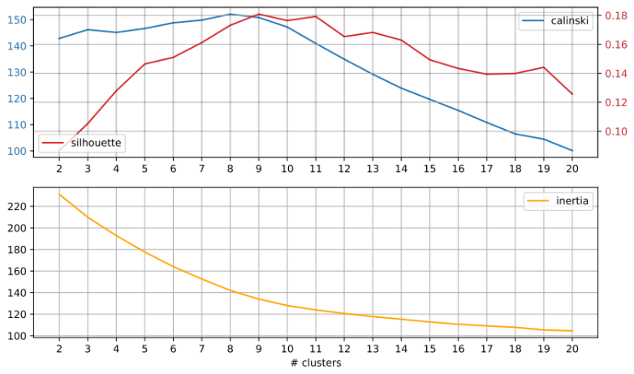
Fig. III12 Thritis

