Supplementary Materials for

Calpeptin is a potent cathepsin inhibitor and drug candidate for SARS-CoV-2 infections
Patrick YA Reinke¹†, Edmarcia Elisa de Souza²†, Sebastian Günther¹†, Sven Falke¹, Julia Lieske¹, Wiebke Ewert¹, Jure Loboda^{3,4}, Alexander Herrmann⁵, Aida Rahmani Mashhour¹, Katarina Karničar^{3,6}, Aleksandra Usenik^{3,6}, Nataša Lindič³, Andreja Sekirnik³, Viviane Fongaro Botosso⁷, Gláucia Maria Machado Santelli⁸, Josana Kapronezai⁷, Marcelo Valdemir de Araújo^{7,9}, Taiana Tainá Silva-Pereira^{9,10}, Antônio Francisco de Souza Filho⁹, Mariana Silva Tavares⁹, Lizdany Flórez-Álvarez², Danielle Bruna Leal de Oliveira⁹, Edison Luiz Durigon⁹, Paula Roberta Giaretta^{11,} Marcos Bryan Heinemann¹⁰, Maurice Hauser¹², Brandon Seychell¹³, Hendrik Böhler¹³, Wioletta Rut¹⁴, Marcin Drag¹⁴, Tobias Beck^{13,15}, Russell Cox¹², Henry N Chapman^{1,15,16}, Christian Betzel^{15,17}, Wolfgang Brehm¹, Winfried Hinrichs¹⁸, Gregor Ebert^{5,19}, Sharissa L Latham^{20, 21}, Ana Marcia de Sá Guimarães⁹, Dusan Turk^{3,6}*, Carsten Wrenger²*, Alke Meents¹*
*Corresponding author. Email: dusan.turk@ijs.si, cwrenger@icb.usp.br, alke.meents@desy.de

This PDF file includes:

Supplementary Text
Figs. S1 to S10Tables S1 to S3

Supplementary Materials

Detailed description of the X-ray crystal structures of protease-inhibitor complexes
M^{pro} inhibitor complexes. The structures of Calpeptin and GC-376 bound to M^{pro} were previously described^{3,19,29,60}. Calpeptin binds covalently to Cys¹⁴⁵ of M^{pro} (PDB: 7AKU)³ with its aldehyde group, forming a thiohemiacetal (Figure S2F). This structure was solved in a monoclinic space group, where Calpeptin occupies the S1 to S3 pockets. Overall, the peptidomimetic backbone of Calpeptin forms hydrogen bonds corresponding to the native peptide substrate⁶¹. The backbone carbonyl of His¹⁶⁴ forms a hydrogen bond to the peptidomimetic Calpeptin amidenitrogen of the norleucine residue-analog (Table S2). The terminal ester carbonyl forms a hydrogen bond with the backbone nitrogen of Glu¹⁶⁶. The norleucine side chain exhibits van der Waals contacts with the backbone of Phe¹⁴⁰, Leu¹⁴¹, and Asn¹⁴². The terminal Cbz-group is oriented to the S3 pocket between the side chains of Glu¹⁶⁶ and Gln¹⁸⁹ and exhibits hydrophobic interactions with norleucine (Figure S2F). The structure of GC-376 aldehyde bound to M^{pro} solved in a monoclinic space group (PDB: 7QKA) resembles this conformation. Substitution of norleucine by 2-oxopyrrolidine leads to additional hydrogen bonds to His¹⁶³ and Glu¹⁶⁶(Figure S2H). In addition to the monoclinic form with one monomer per asymmetric unit, M^{pro} also crystallizes in an orthorhombic space group containing two monomers per asymmetric unit⁴⁴ and the two monomers within the dimer exhibit structural variations. The structure of Calpeptin derived from S-Calpeptin bound to M^{pro} was solved in an orthorhombic space group (PDB 7Z3U) and shows more flexibility with respect to the conformation of the Cbz- group (Figure S2D). This group is oriented in the S4 pocket in one monomer, while it exhibits an alternative conformation oriented to the S3 or S4 pocket in the other monomer. This is linked to an alternative orientation of the loop containing Gln¹⁸⁹, which is shifted by about 2 Å, further opening this pocket. In addition to the previously described interactions of Calpeptin, the Cbz-group interactions via hydrophobic interactions with the backbone of Thr¹⁹⁰ and Gln¹⁹² are evident in the S4 pocket. In the- structure co-crystallized with S-Calpeptin, the monomers exhibit a NOS-bridge, which is an oxygen-mediated link between Cys²² and Lys⁶¹ (molecule B) and a SONOS-bridge, which is a three-way covalent bond between Cys²², Cys⁴⁴ and Lys⁶¹ (molecule A). These covalent links in M^{pro} were previously observed⁶².

CatK/V Calpeptin complex. The binding mode of Calpeptin to CatK (PDB: 8C3D) and CatV (PDB: 7QGW) is similar to that of CatL, which can be explained by the high conservation of the active site cleft (Table S2). Small differences occur in the S3-pocket in the vicinity of the terminal Cbz-group of Calpeptin. While in CatL Leu⁶⁹ and Tyr⁷² form a hydrophobic pocket in which the phenyl ring is located, this hydrophobic pocket is less voluminous in CatK because it is constrained by Tyr⁶⁷ (in CatL Leu⁶⁹), which is oriented toward the Cbz-group, resulting in a restriction of the pocket that forces the phenyl ring towards Asp⁶¹ (in CatL Glu⁶³). CatV Phe⁶⁹ and Arg⁷² (in CatL Leu⁶⁹ and Tyr⁷²) are directed towards this pocket, leading to a restriction of the pocket and forcing the phenyl ring into a slightly different orientation towards Gln⁶³ (in CatL Glu⁶³).

Calpeptin cell experiments. To test whether the viral particles are entrapped in endosomes after S-Calpeptin treatment, the distribution of S-protein containing vesicle size in infected LC-HK2 cells was analyzed by fluorescence microscopy. This analysis did not reveal any significant differences between S-Calpeptin treated cells and the control group (Figure S4).

Calpeptin toxicity experiments in hamsters. At the time of this study, we did not find any study that used Calpeptin in hamsters. Therefore, prior to the antiviral experiment, we performed a small study to investigate if different doses of Calpeptin could lead to acute toxicity in hamsters. Animals were subjected to daily subcutaneous doses of 1 mg/kg (n=3), 2 mg/kg (n=3), 3 mg/kg (n=3) of S-Calpeptin or 1:100 DMSO (vehicle control; n=3) for seven consecutive days, starting at day zero. The route of administration and doses were chosen based on literature reports of the use of Calpeptin in mouse studies^{63–69}. Clinical signs and weight were followed until day 6, when the animals were euthanized, necropsied, and organs were collected for histopathology analysis. Treated animals did not display acute toxicity-related clinical signs or weight loss during the experiment (Figure S7A and B) nor any noteworthy histopathological lesion in brain, liver, pancreas, gastro-intestinal tract, kidney, lungs, spleen, or trachea. However, a complete blood cell count performed on day 6 showed marked leukopenia caused by lymphopenia and neutropenia in animals treated with 2 mg/kg and 3 mg/kg of S-Calpeptin compared to those that received only 1 mg/kg of S-Calpeptin or 1:100 DMSO (Figure S7C-F). For this reason, we opted to test the dose of 1 mg/kg of S-Calpeptin in the anti-viral animal experiment (Figure S7A and B).

Histopathological lesions in hamsters infected with SARS-CoV-2. Corroborating previous studies^{31,56,57,70}, typical histopathological lesions were seen in hamsters inoculated with SARS-CoV-2 (G1 and G2). Findings in the lungs included bronchointerstitial pneumonia, suppurative bronchitis, endothelialitis, necrosis of epithelial cells, and hyperplasia of bronchial and alveolar type II epithelial cells (Figure S5). Occasional atypical syncytial cells were seen. Areas of interstitial pulmonary fibrosis and/or inflammation were occasionally detected on both infected groups. On day 7 p.i., there were higher tissue repair scores in infected animals (Figure S5F), coinciding with a lower viral load in respiratory tissues and beginning of the recovery phase (Figure 5). Lesions in the trachea of infected hamsters consisted of loss of cilia, degeneration and/or necrosis of epithelial cells and inflammatory infiltrate in the lumen and/or in the lamina propria. Histopathology analysis showed no statistically significant differences in lesion scores between SARS-CoV-2 infected animals that were treated with S-Calpeptin and to those that were not (Figure S6). Lung vascular lesions are a hallmark of COVID-19 in hamsters³¹. Although S-Calpeptin-treated animals showed lower scores for vascular damage compared to the untreated group on days 5 and 7 p.i., these results were also not statistically significant (Figure S6). As expected, the lungs and trachea of hamsters from control groups (G3 and G4) were unremarkable.

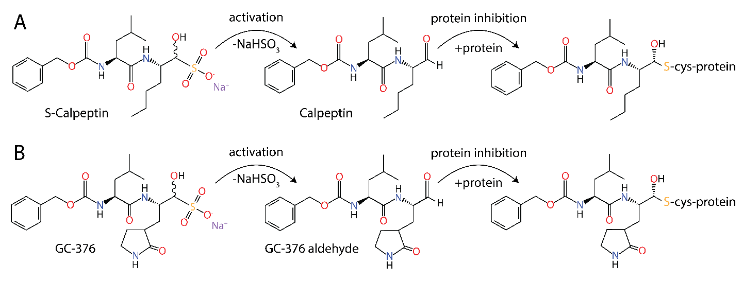

Fig. S1.
Activation of the prodrugs S-Calpeptin and GC-376. (A) S-Calpeptin and (B) GC-376 contain a sulfonated aldehyde, which under physiological conditions slowly converts into hydrogensulfite and the aldehyde, thereby unmasking the warhead. The aldehyde warhead binds covalently to catalytic cysteines of cathepsins and M^{pro}.
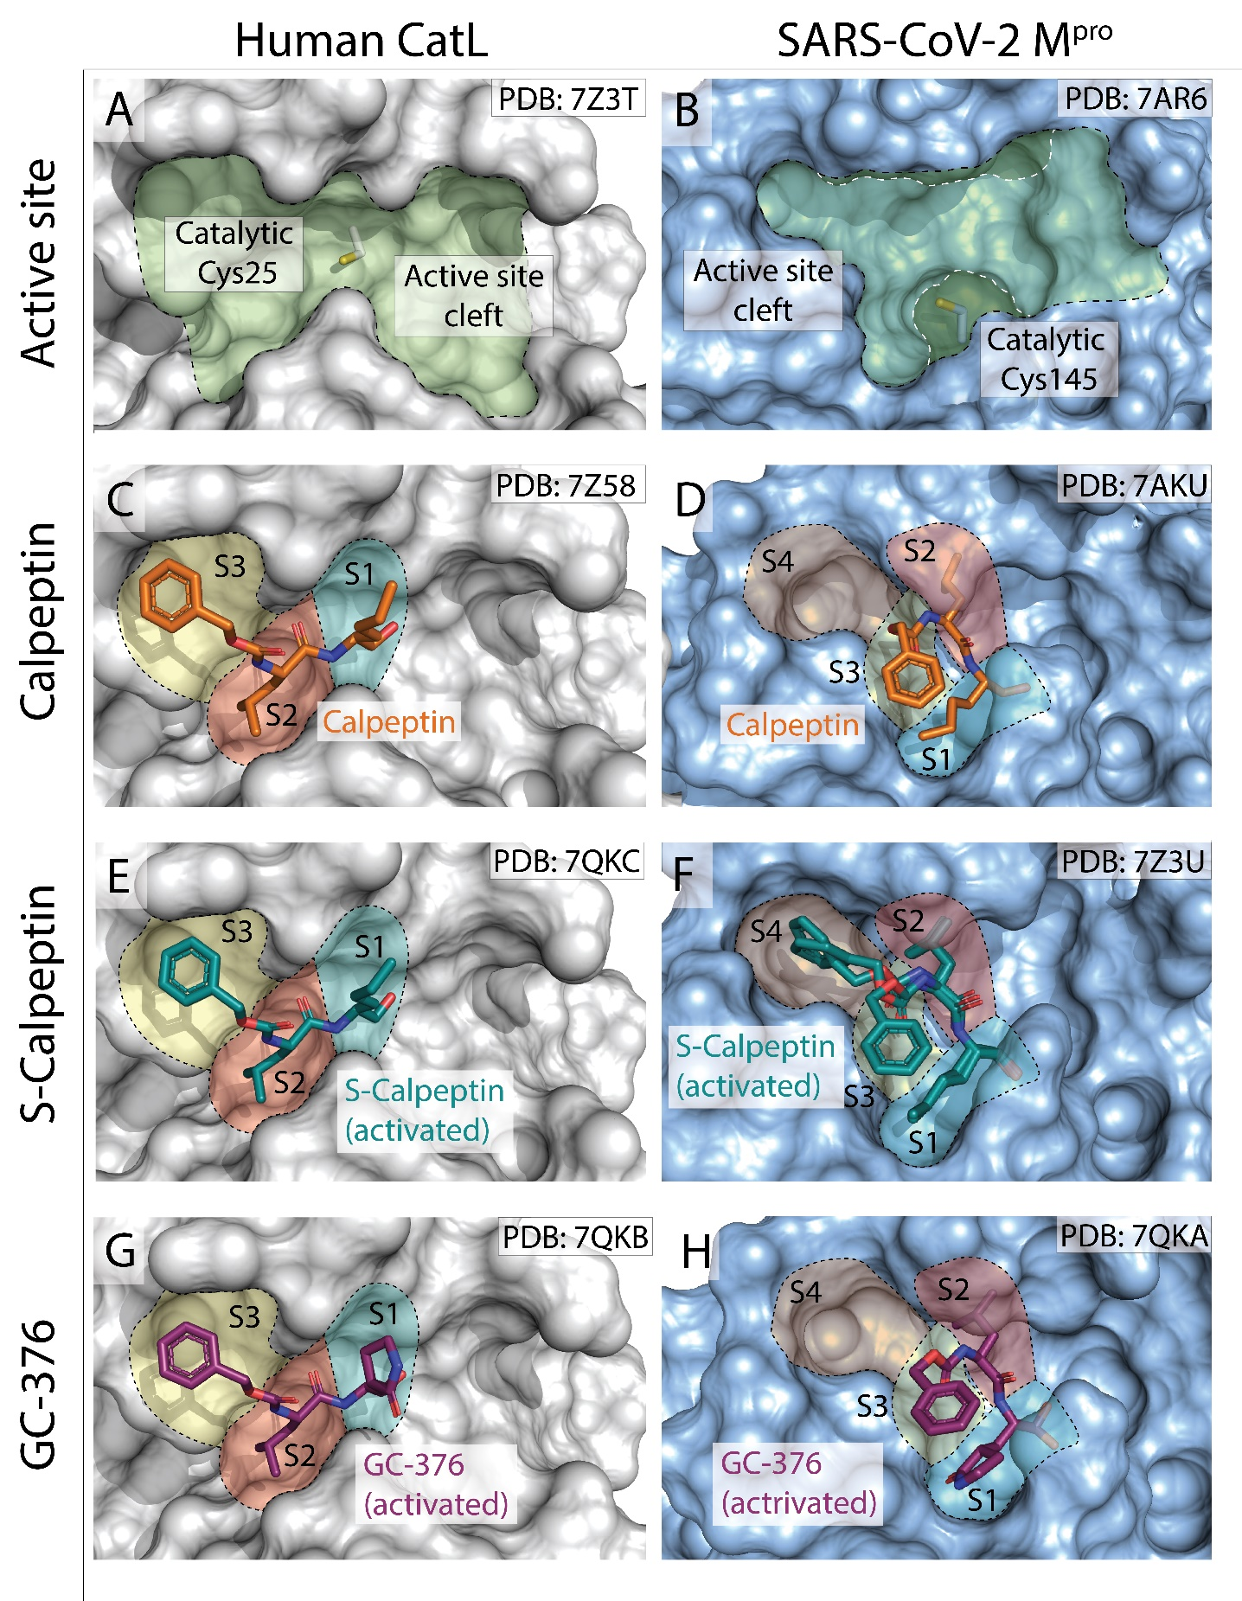

Fig. S2.
Comparison of inhibitor binding to the active sites of CatL and M^{pro}. Closeup view of the active site (green) of CatL (A, grey surface) and M^{pro} (B, blue surface). M^{pro} residues Ser⁴⁶ and Asn¹⁴² are shown as a transparent area (white dashes, dark green area) to reveal the complete extend of the binding site underneath. The central catalytic cysteine is shown in stick representation. Calpeptin (orange sticks) bound to CatL (C) and M^{pro} (D). Important substrate binding pockets are colored and labelled S1 to S4. Calpeptin derived from S-Calpeptin (teal sticks) bound to CatL (E) and M^{pro} (F), and GC-376 aldehyde derived from GC-376 (purple sticks) bound to CatL (G) and M^{pro} (H) in similar representation.

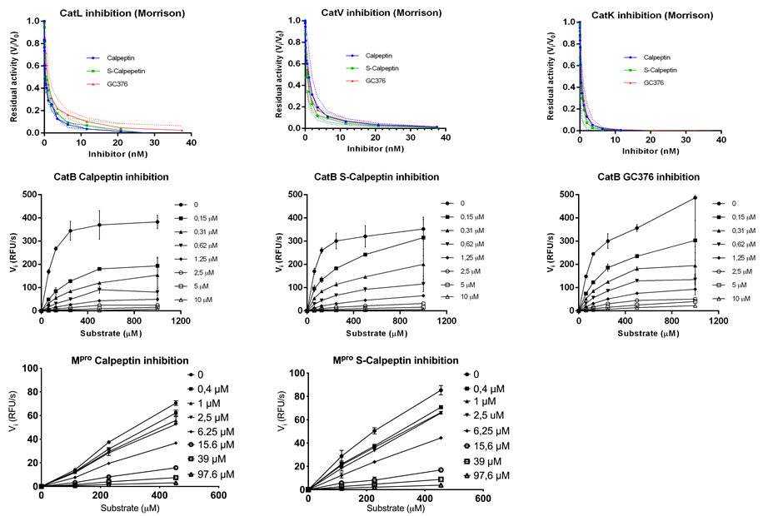

Fig. S3. Inhibition of human cathepsin and SARS-CoV-2 M^{pro} by Calpeptin and Calpeptin-like compounds (Ki determination). A-C) Morrison inhibition plots of residual cathepsin activity against different inhibitor concentrations (standard errors are shown dotted lines). D-H) Mixed-model inhibition plots of either cathepsin or M^{pro} reaction velocities (RFU/seconds) measured at several substrate concentrations for different inhibitor concentrations (standard errors are shown as bars).

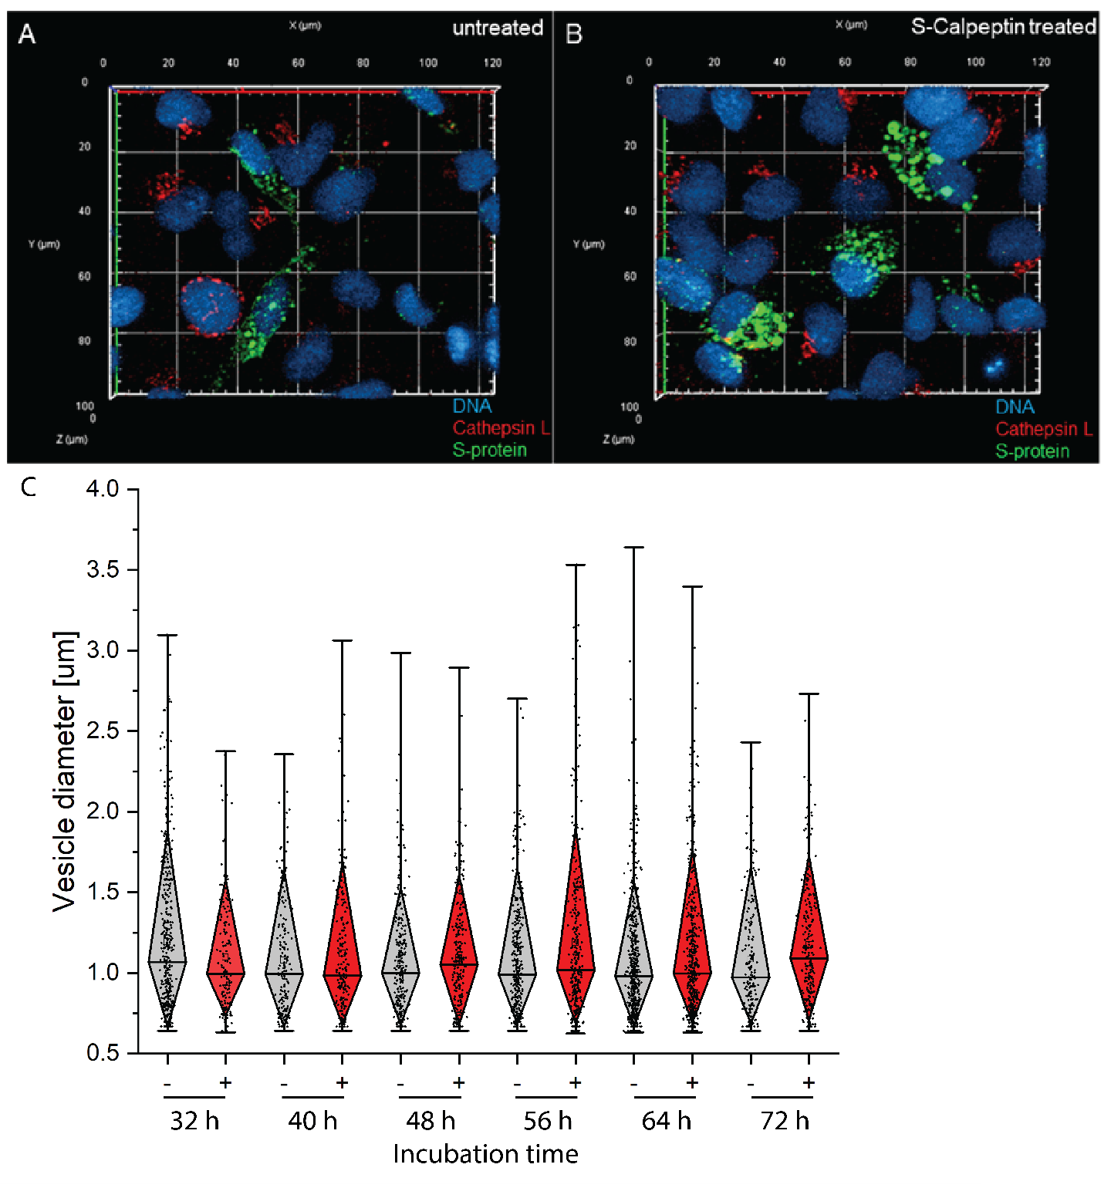
Fig S4: Viral S-protein immunofluorescence microscopy. Representative image from 3D fluorescence microscopy of LC-HK2 cells infected with SARS-CoV-2 at a multiplicity of infection (M.O.I) of 0.05 (A) or treated with S-Calpeptin (B). Co-staining of S-protein (green), CatL (red) and DNA by Hoechst (blue). (C) Vesicle size analysis of various incubation timepoints after SARS-CoV-2 infections in the absence (-) or presence (+) of S-Calpeptin. Images were processed using ZEN (Blue) 2.6 software (ZEISS). Data are shown in diamond box plots (quartiles around median as diamond box, outer quartiles as whiskers).

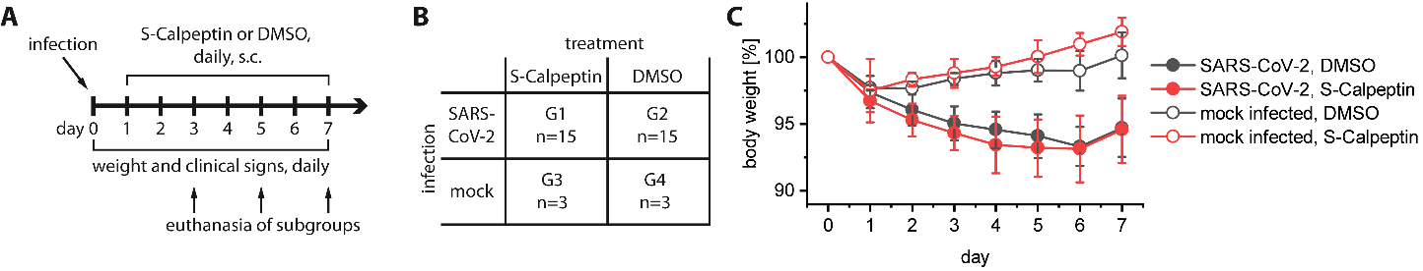

Fig. S5.
Study design and weight of Golden Syrian hamsters infected with SARS-CoV-2 and treated with S-Calpeptin. (A) Study design. The experiment lasted for seven days, animals were infected with SARS-CoV-2 or non-infected (Dulbecco’s Modified Eagle Medium with 2.5% fetal bovine serum) intranasally on day zero and treated daily for seven days with 1 mg/kg of S-Calpeptin or vehicle (DMSO) subcutaneously. Subgroups of SARS-CoV-2 infected animals (n=5, treated or not) were euthanized on days 3, 5 and 7 post-infection (p.i.). Non-infected animals (treated or not) were euthanized on day 7 p.i. (B) Overview over subgroups of all animals. G1: SARS-CoV-2-infected, treated with S-Calpeptin; G2: SARS-CoV-2-infected, injected with DMSO; G3: Non-infected, treated with S-Calpeptin; G4: Non-infected, injected with DMSO. (C) Mean percentual weight change from day of infection of all four experimental groups. Error bars represent standard deviation. Weight loss was significantly different between G1/G2 and G3/G4 (p≤0.05).

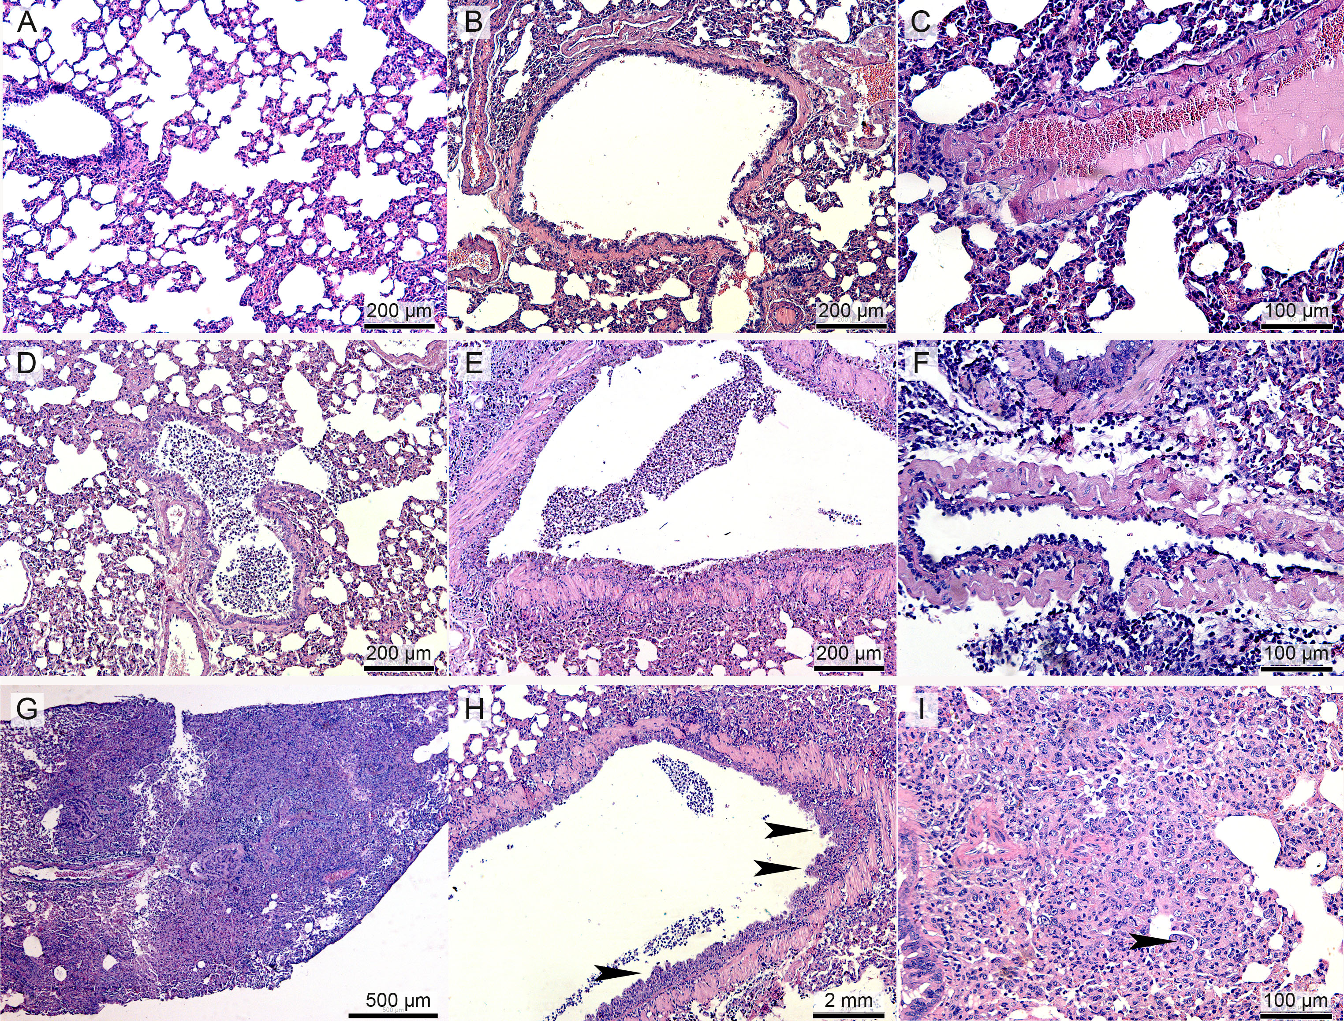

Fig. S6.
Representative histopathology findings in the lungs of Golden Syrian hamsters, hematoxylin and eosin stain. (A) Uninfected control with normal alveolar septa. (B) Bronchus from an uninfected control. (C) Normal endothelial cells in an uninfected control. (D) Suppurative bronchitis in a SARS-CoV-2-infected hamster treated with 1:100 DMSO, day 3 post-infection (p.i.). (E) Necrosis of the bronchial epithelium and suppurative inflammation in a SARS-CoV-2-infected hamster treated with 1:100 DMSO, day 3 p.i. (F) Endothelialitis with hypertrophied endothelial cells and subendothelial inflammatory infiltrate in a medium sized blood vessel of a SARS-CoV-2-infected hamster treated with 1 mg/kg of Calpeptin, day 5 p.i. (G) Severe and diffuse bronchointerstitial pneumonia effacing the pulmonary parenchyma of a SARS-CoV-2-infected hamster treated with 1 mg/kg of Calpeptin, day 5 p.i. (H) The bronchial epithelium is hyperplastic (arrows). (I) Alveolar type II epithelial cells are hyperplastic and line the alveoli with occasional atypical syncytial cells (arrow).

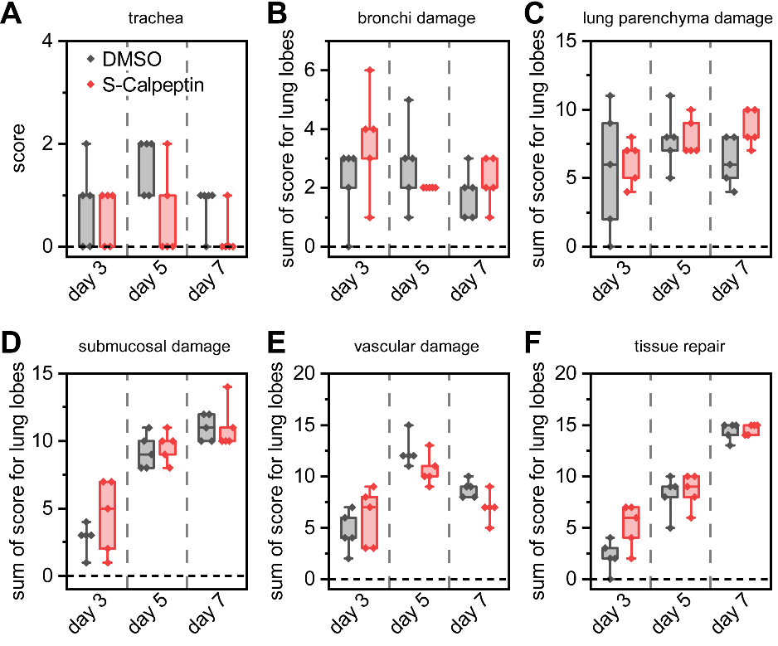

Fig. S7.
Histopathological analysis of tissue from SARS-CoV-2 infected and treated hamsters. Analysis for (A) trachea, (B) bronchi damage, (C) lung parenchyma damage, (D) submucosal damage, (E) vascular damage, and (F) tissue repair. For (B-F) score is sum of analysis of 5 lung lobes per animal. Values are expressed in median, interquartiles and range.

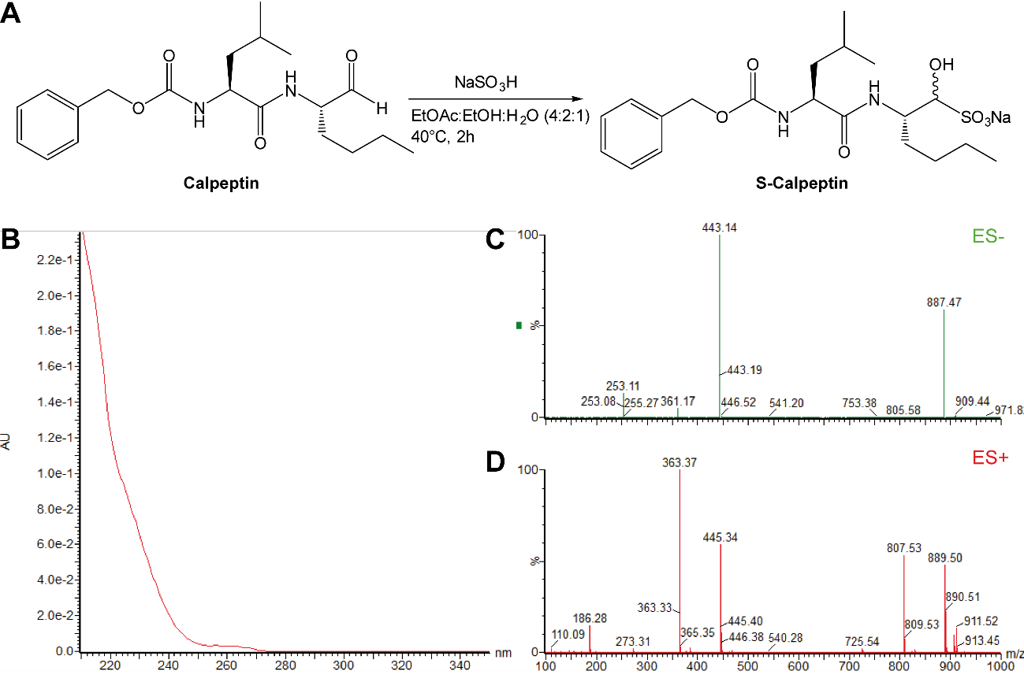

Fig. S8.
Synthesis of S-Calpeptin from Calpeptin. (A) Reaction scheme to create S-Calpeptin, the bisulfite adduct of Calpeptin. (B) UV spectrum of product. (C) ES- and (D) ES+ spectrum of product. Calculated m/z for C₂₀H₃₁N₄O₇S [M-Na]⁻ is 443.1857 Da, found: 443.1887 Da.

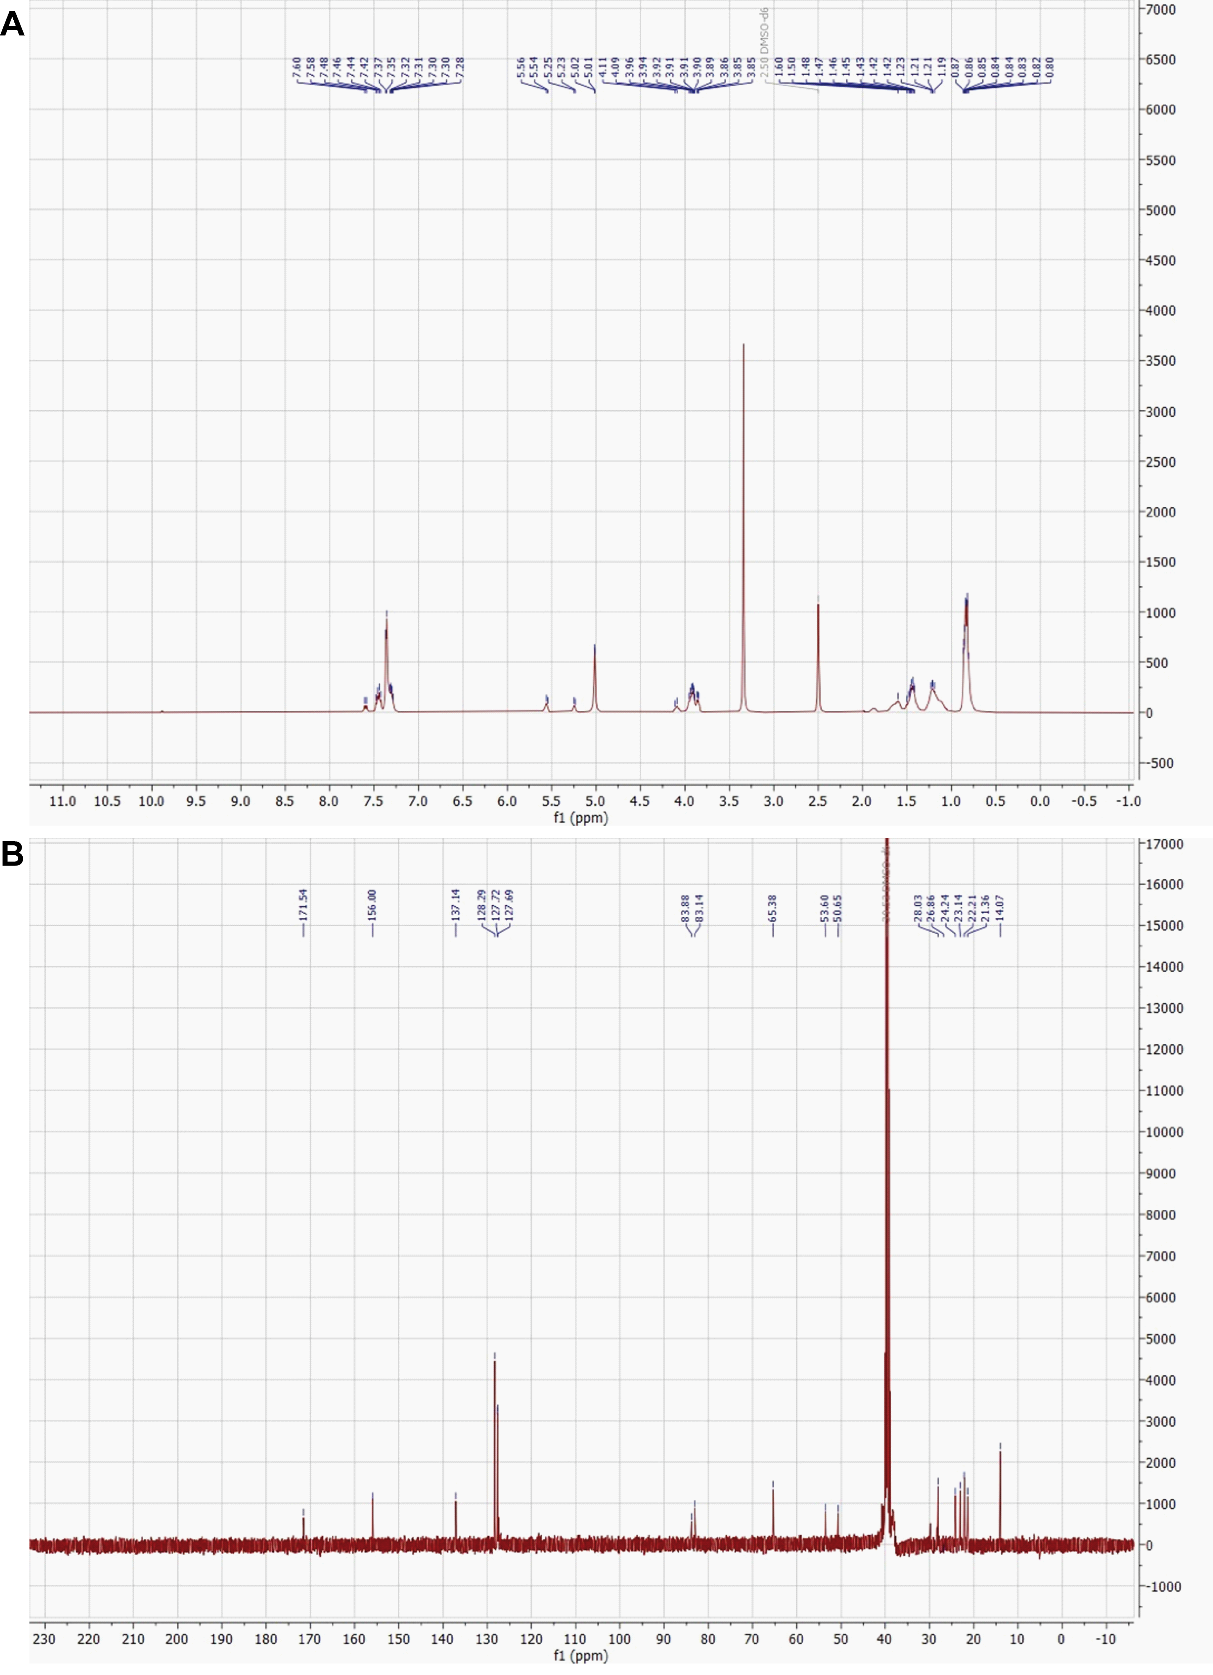

Fig. S9.
NMR analysis of S-Calpeptin. (A) ¹H NMR of bisulfite adduct S-Calpeptin recorded at 400 MHz in DMSO-d₆. (B) ¹³C NMR of bisulfite adduct S-Calpeptin recorded at 100 MHz in DMSO-d₆.

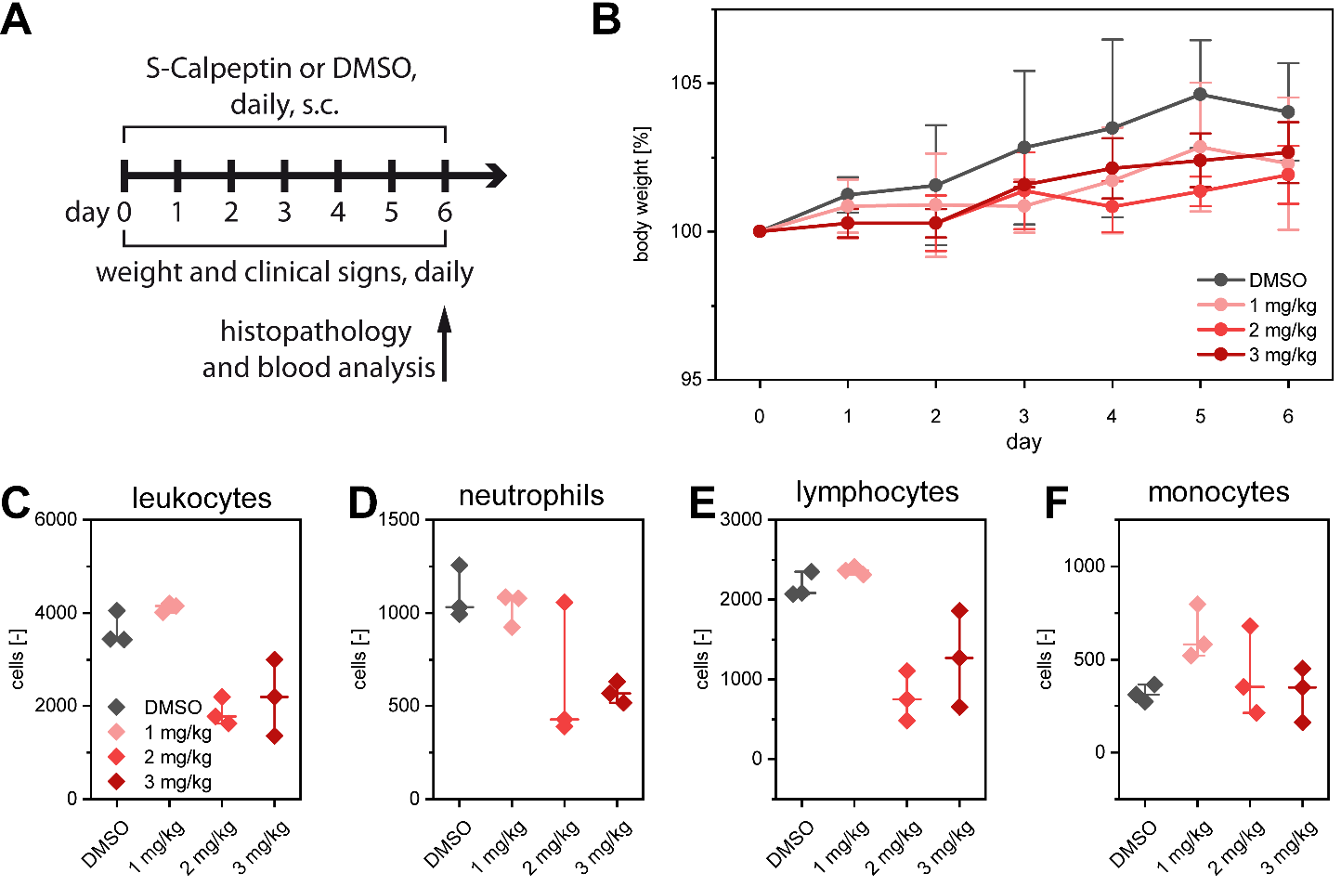

Fig. S10.
S-Calpeptin toxicity experiment. (A) Study design for assessing toxicity of increasing S-Calpeptin doses. Each group included 3 Golden Syrian hamsters. Hamsters received a daily subcutaneous dose of S-Calpeptin (1 mg/kg, 2 mg/kg, or 3 mg/kg of body weight) suspended in 1:100 DMSO or a solution of 1:100 DMSO for seven consecutive days, starting at day zero. (B) Mean percentual weight change from day of infection of all four experimental groups. Blood was analyzed on last day of experiment for cell count of leukocytes (C), neutrophils (D), lymphocytes (E), and monocytes (F). Median and range for all four groups is indicated.

Table S1.
Structure of enzyme/inhibitor-complexes. X-ray data collection and refinement statistics for enzyme/inhibitor-complexes.

Table provided as separate file.

Table S2.
Structure cards. Detailed information about inhibitors derived from X-ray structures.

Table provided as separate file.

Table S3.
Score system for histopathological analysis. Parameters and scores for semiquantitative histopathological evaluation of lungs from hamsters experimentally infected with SARS-CoV-2.

Parameter | Scores
 | Bronchi | Pulmonary parenchyma
Epithelial damage | 0 - normal  1 - degeneration (cuboidal cells)  2 - epithelial detachment  3 - necrosis and sloughing | 0 - normal  1 - degeneration (cuboidal cells) and/or peribronchiolar inflammatory infiltrate  2 - epithelial detachment  3 - necrosis and sloughing and/or bronchiolar inflammatory infiltrate
Submucosal damage | 0 - normal  1 - edema, vascular ectasia, or mild inflammatory infiltrate affecting 10-33% of the examined area  2 - moderate inflammatory infiltrate affecting 34-66% of the examined area  3 - marked inflammatory infiltrate affecting >67% of the examined area
Vascular damage | 0 - normal  1 - perivascular edema and/or endothelial hypertrophy  2 - mild perivascular inflammatory infiltrate and/or endothelialitis  3 - inflammatory infiltrate in the vascular wall and/or below the endothelium (vasculitis)
Tissue repair | 0 - normal  1 - repair with pre-ciliated cells and/or hyperplasia of non-ciliated epithelium  2 - hyperplasia of alveolar type II epithelial cells with or without atypia  3 – hyperplasia of goblet cells, and/or presence of granulation tissue and/or fibrosis

