Supporting Information for
Dark-Bright Exciton Splitting Dominates
Low-Temperature Diffusion in Halide Perovskite Nanocrystal Assemblies
Andreas J. Bornschlegl¹, Michael F. Lichtenegger¹*, Leo Luber¹, Carola Lampe¹, Maryna I. Bodnarchuk², Maksym V. Kovalenko^{2,3} & Alexander S. Urban¹*

Nanospectroscopy Group and Center for Nanoscience (CeNS), Nano-Institute Munich,
Department of Physics, Ludwig-Maximilians-Universität, 80539 Munich, Germany ¹
Laboratory for Thin Films and Photovoltaics, Empa−Swiss Federal Laboratories for Materials Science and Technology, 8600 Dübendorf, Switzerland ²
Department of Chemistry and Applied Biosciences, Institute of Inorganic Chemistry, ETH Zürich, 8093 Zürich, Switzerland ³

- Tables

 | 5 nm | 8 nm | 14 nm
FWHM (nm) | 18.5 | 15.6 | 17.2
FWHM (meV) | 92.6 | 74.5 | 80.4
Peak position (nm) | 497.7 | 509.3 | 514.9
Peak position (eV) | 2.491 | 2.434 | 2.408

Supporting Table 1 Characteristic spectral values extracted from the room temperature PL spectra presented in Fig. 1d.

Sample | Wavelength (nm) | Rep. rate (MHz) | Irradiance (W/cm²) | DC (nm) | LP (nm) | 1
5 nm | 445 | 1.95 | 5 | 450 | 465 | 1
8 nm | 460 | 1.95 | 5 | 495 | 500 | 1
14 nm | 445 | 1.95 | 5 | 450 | 465 | 1

Supporting Table 2 Setup configuration for the different samples. "DC" and "LP" denote the dichroic and long pass mirrors, respectively.

- Figures

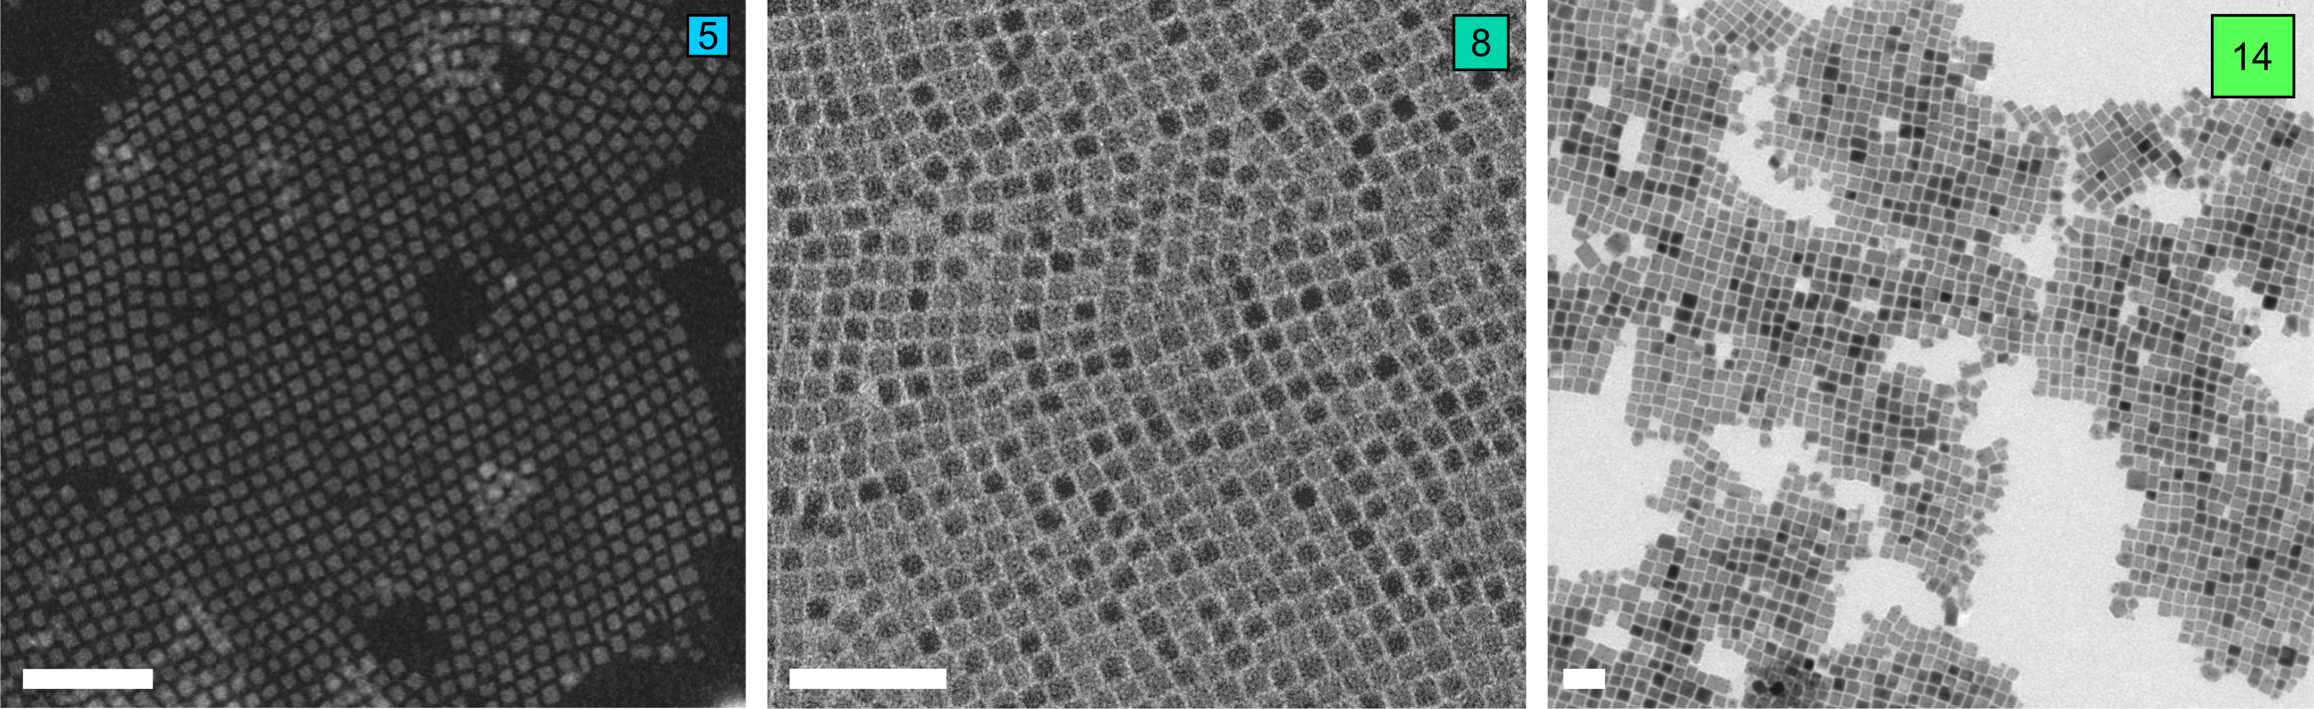

Figure S1 TEM image of dropcasted 5 nm (left), 8 nm (middle), and 14 nm (right) PNC films. The scale bars correspond to 50 nm. The side lengths of the 5 nm PNCs ($a=4.7±0.1$ nm, $b=5.6±0.2$ nm, $c=5.8±0.2$ nm) were determined by fitting experimental SAXS data of a QD dispersion via an analytical model. The side length of the 8 nm PNCs is $8.0±0.5$ nm. The side length of the $14.0±1.5$ nm PNCs was extracted from the TEM images.

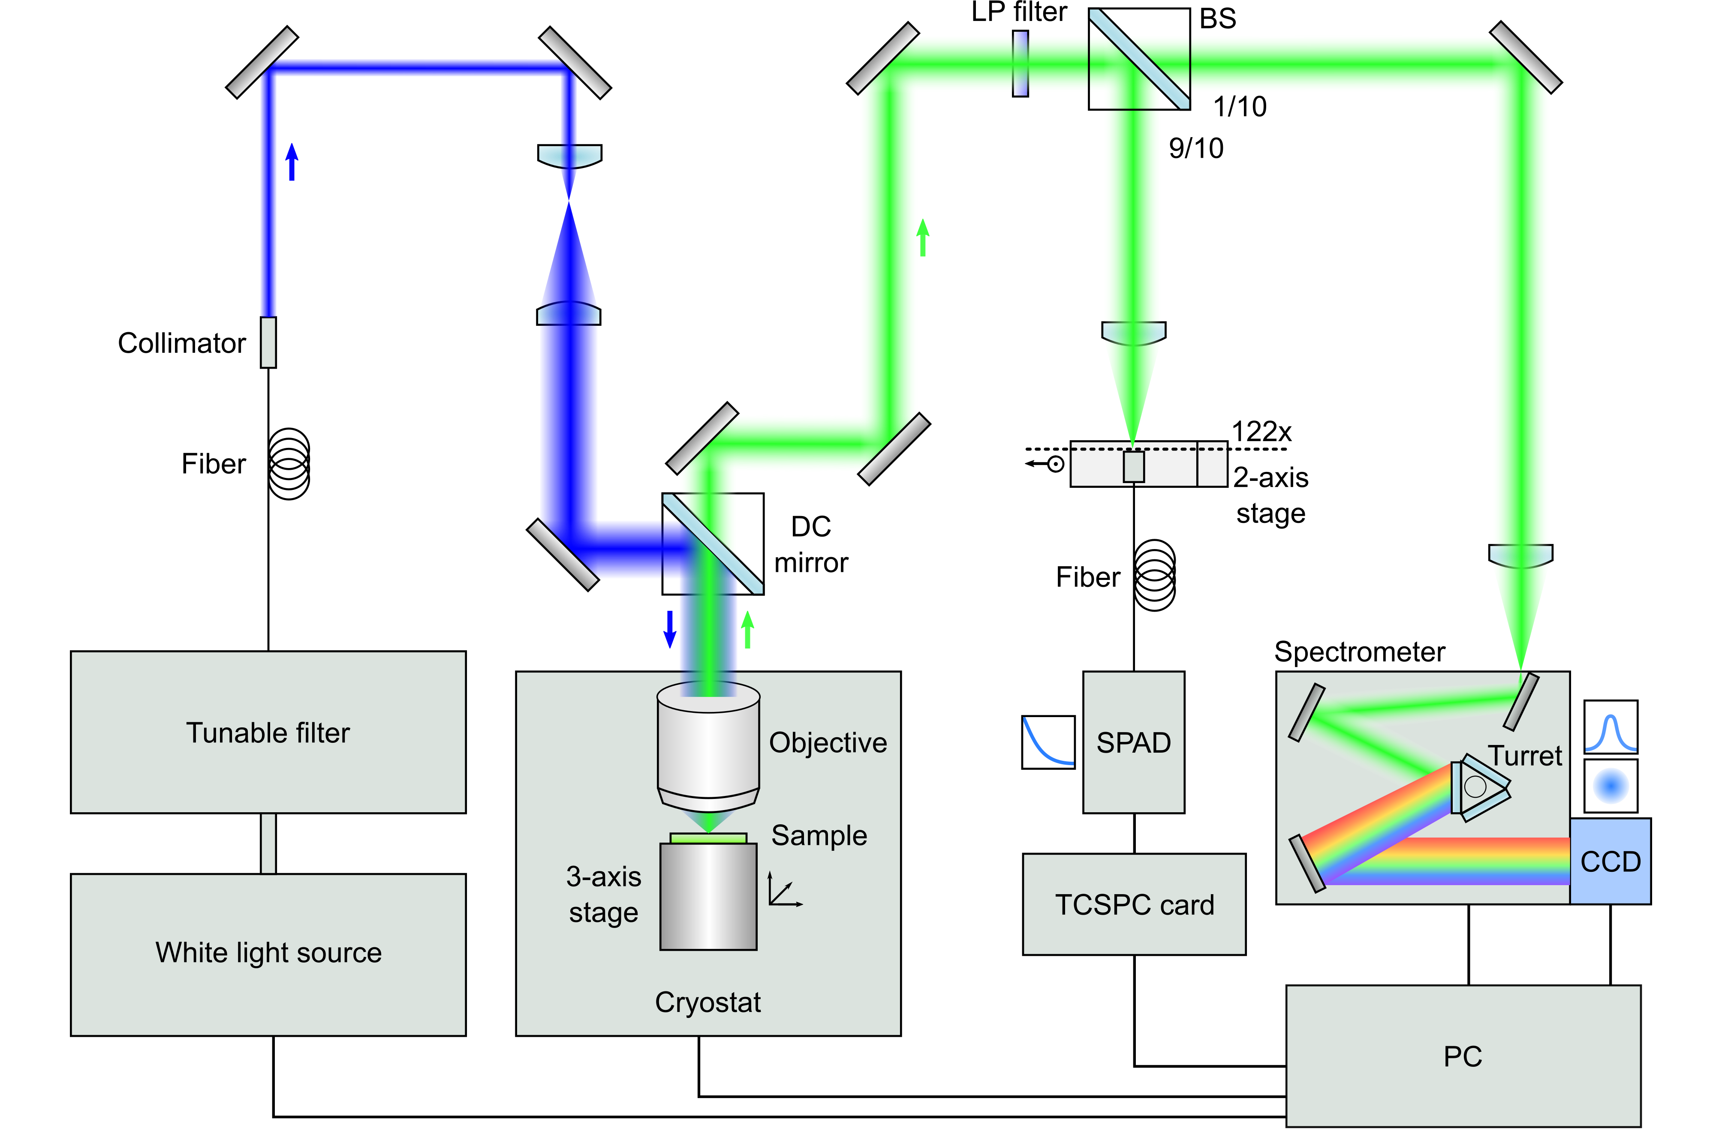

Figure S2 Schematic of confocal low-temperature diffusion setup. Both sample and objective are positioned inside a closed-cycle helium cryostat.
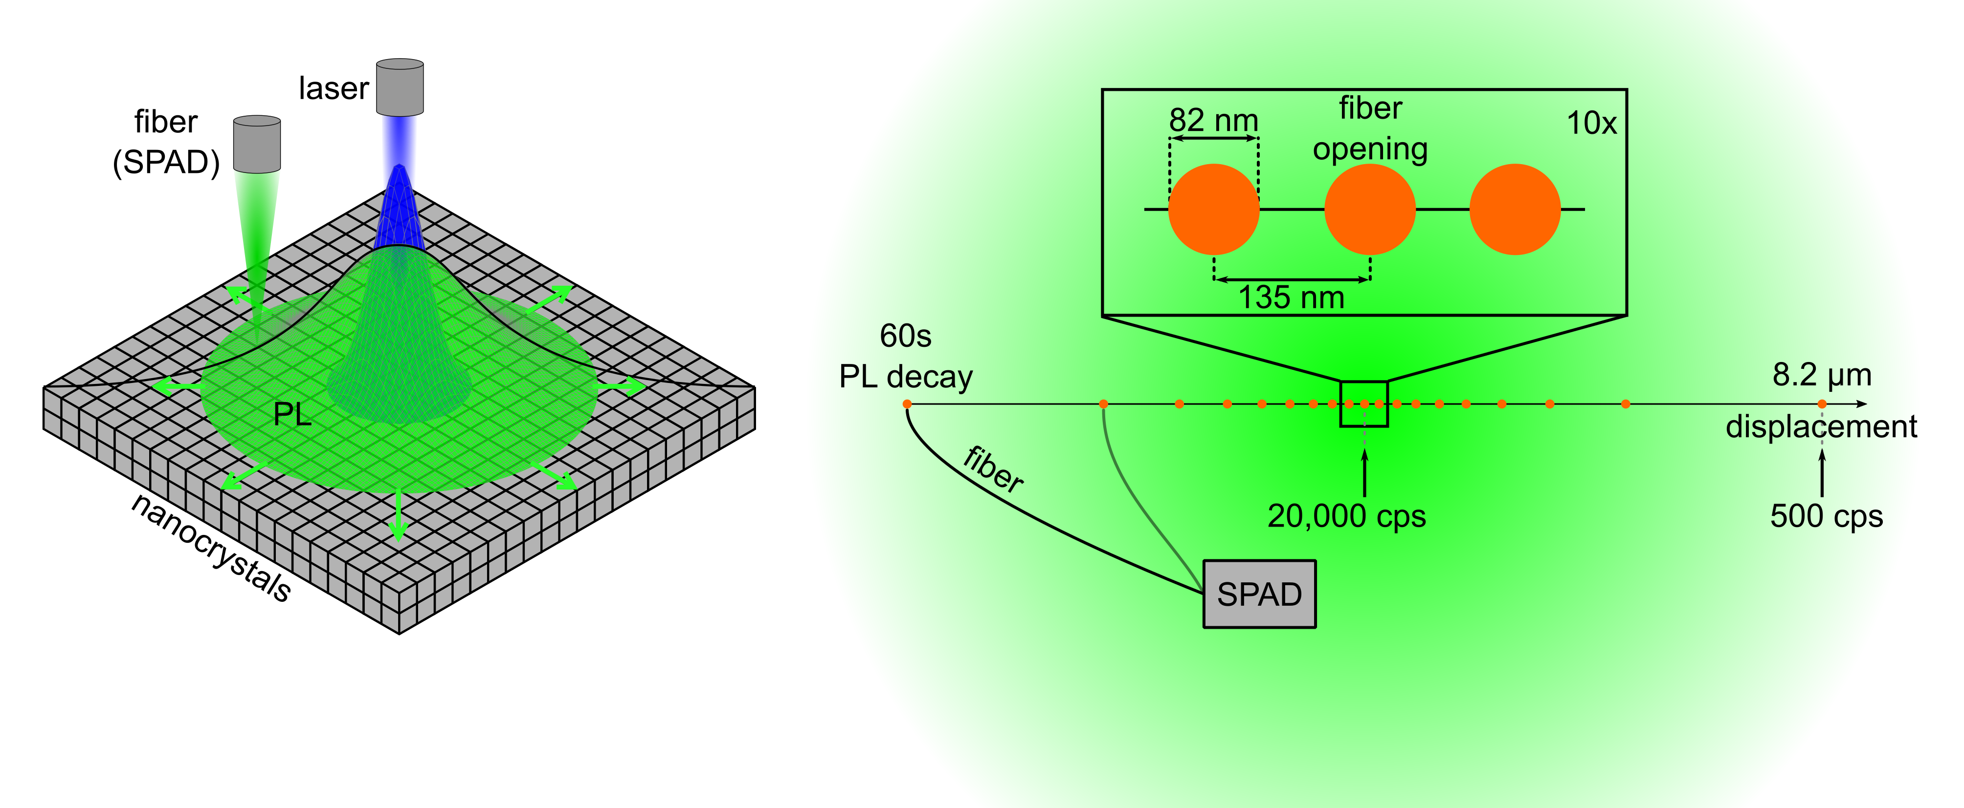
Figure S3 Overview of the exciton diffusion measurement method. Schematic of the measurement method (left). A pulsed laser (blue Gaussian) excites an exciton population in the nanocrystal assembly (grey cubes). The excitons diffuse along the concentration gradient (green arrows) and eventually recombine, generating a PL distribution (green Voigt). A fiber connected to a SPAD is displaced (black line) over the spot and captures the spatial profile of the PL decays. To-scale illustration of the scanning process in the magnified (122x) focal plane (right). The fiber opening (orange circles, 82 nm diameter) is displaced along an 8.2 μm long line centered around the center of the PL emission spot (green glow) from left to right in 20 logarithmically distributed steps (the smallest displacement is 135 nm). A 60 s long PL decay (TCSPC) measurement is conducted at each step. In the central spot, the SPAD registers 20,000 counts per second (cps) and approximately 500 cps at the edge of the spots at a repetition rate of 1.95 MHz.

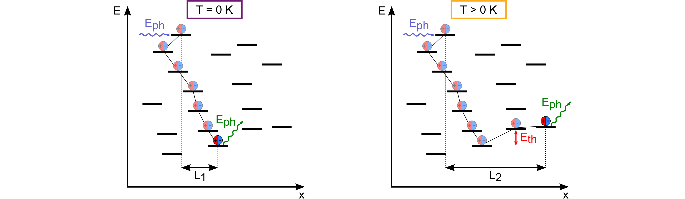

Figure S4 Scheme of a series of FRET processes at 𝑇 = 0 K showing energetic downwards hopping ending in the recombination of the exciton after covering a certain diffusion length $L_{1}$ (left). Same scheme but at a temperature 𝑇 > 0 K (right). The additional thermal energy makes FRET processes to smaller PNCs (energetic upwards hopping) possible, leading to a larger diffusion length $L_{2}$.
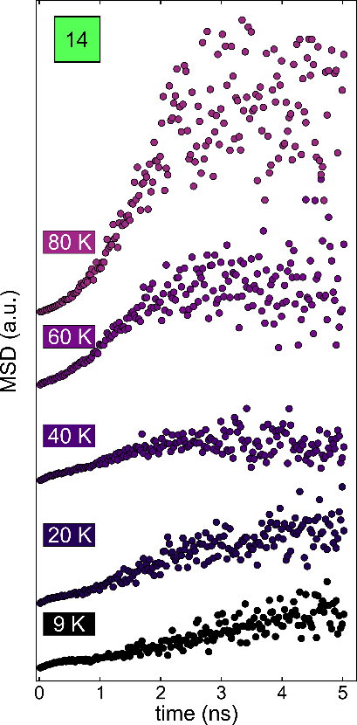

Figure S5 Temporal MSD data for the 14 nm PNC sample in the temperature range $9 K – 80 K$.

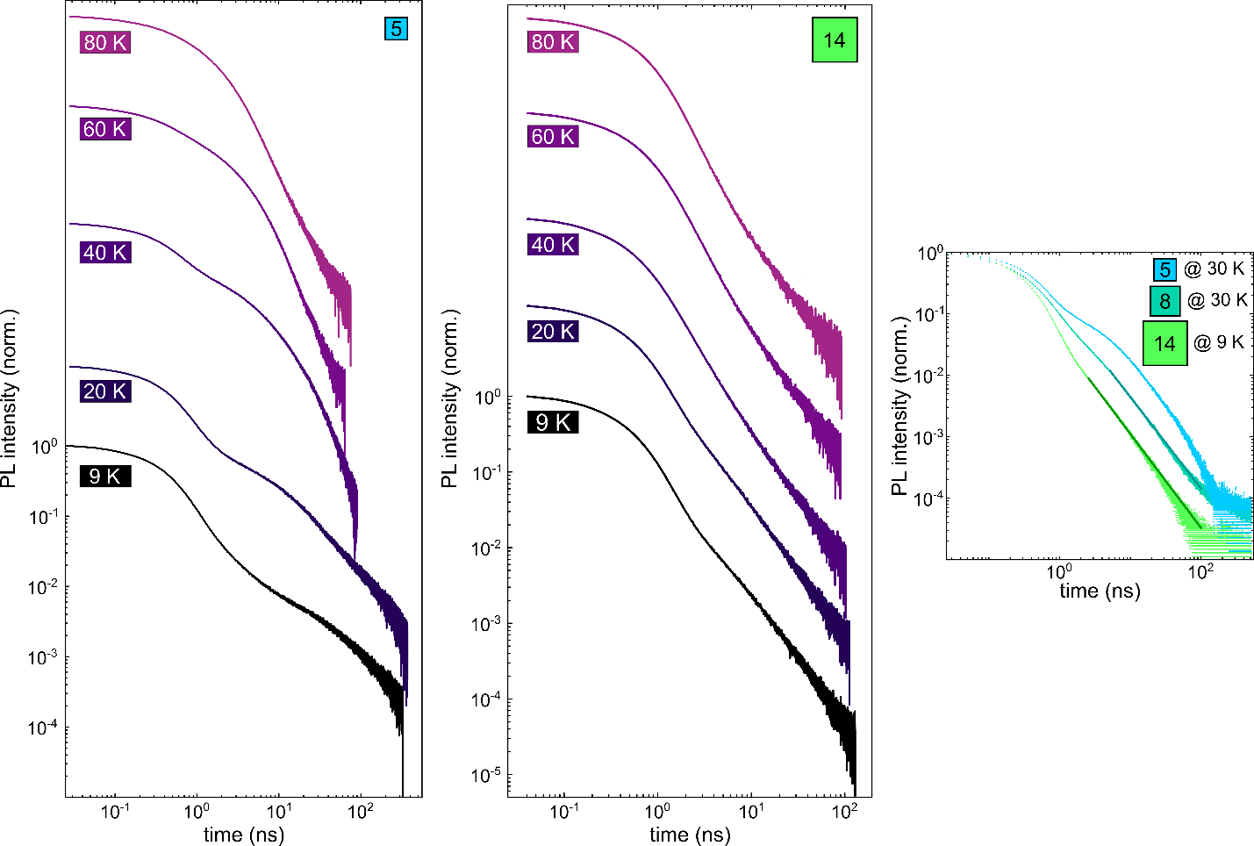

Figure S6 PL decay traces in the temperature range $9 K – 80 K$ for the 5 nm PNC sample (left) and the 14 nm PNC sample (middle). PL decay traces of the 14 nm PNC sample at 9 K and of the 5 nm and 8 nm PNC samples at 30 K (right). The PL decay traces of the 8 nm PNC sample at 30 K and of the 14 nm PNC sample at 9 K are fitted by a power law for long times, while the PL decay trace of the 5 nm PNC sample at 30 K cannot be represented by such a function, being exponential. This indicates that emission from the dark exciton dominates the PL at long times in the smallest NCs and at the lowest temperatures, while delayed emission from trapping and detrapping dominates in the larger NCs and at higher temperatures in all samples.¹



Figure S7 Temperature-dependent bright-state exciton density $n_{bright}$ as a fraction of the total exciton density $N_{tot}$, determined by a Boltzmann distribution for 5 nm, 8 nm, and 14 nm PNC samples.

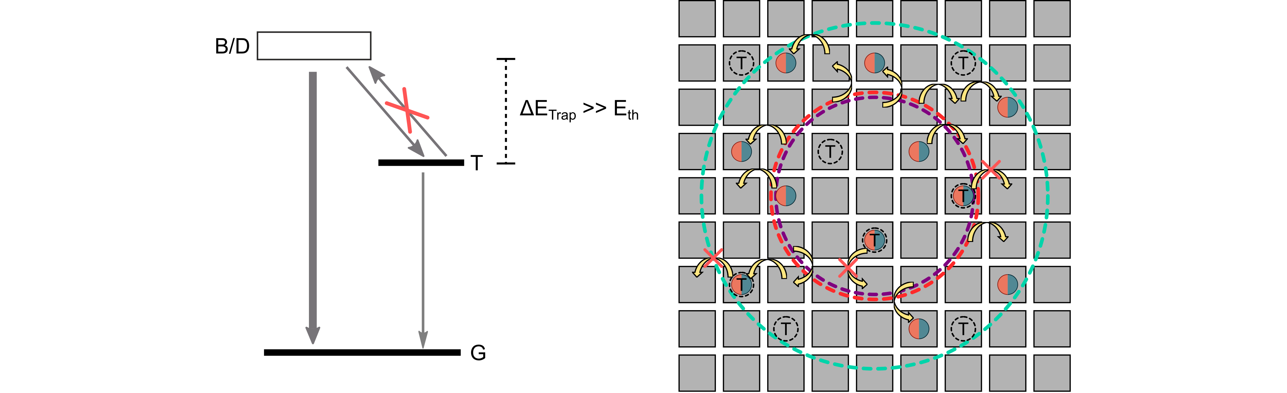

Figure S8 Scheme of the energetic structure used as the basis for the Monte Carlo simulation of trap-influenced exciton diffusion (left). There are two decay channels for the degenerate bright/dark exciton state: radiative decay to the ground state or nonradiative relaxation into a trapped state. Once the exciton is trapped, it stays there and eventually recombines radiatively, albeit at a lower rate than the radiative channel from the bright state. Excitons in traps ("T") cannot diffuse and will recombine eventually (right). Only free excitons can hop to an adjacent NC, depicted by yellow arrows. The dashed circles correspond to the qualitative diameters of laser excitation (purple), steady-state PL emission of free excitons (turquoise), and trapped excitons (red).

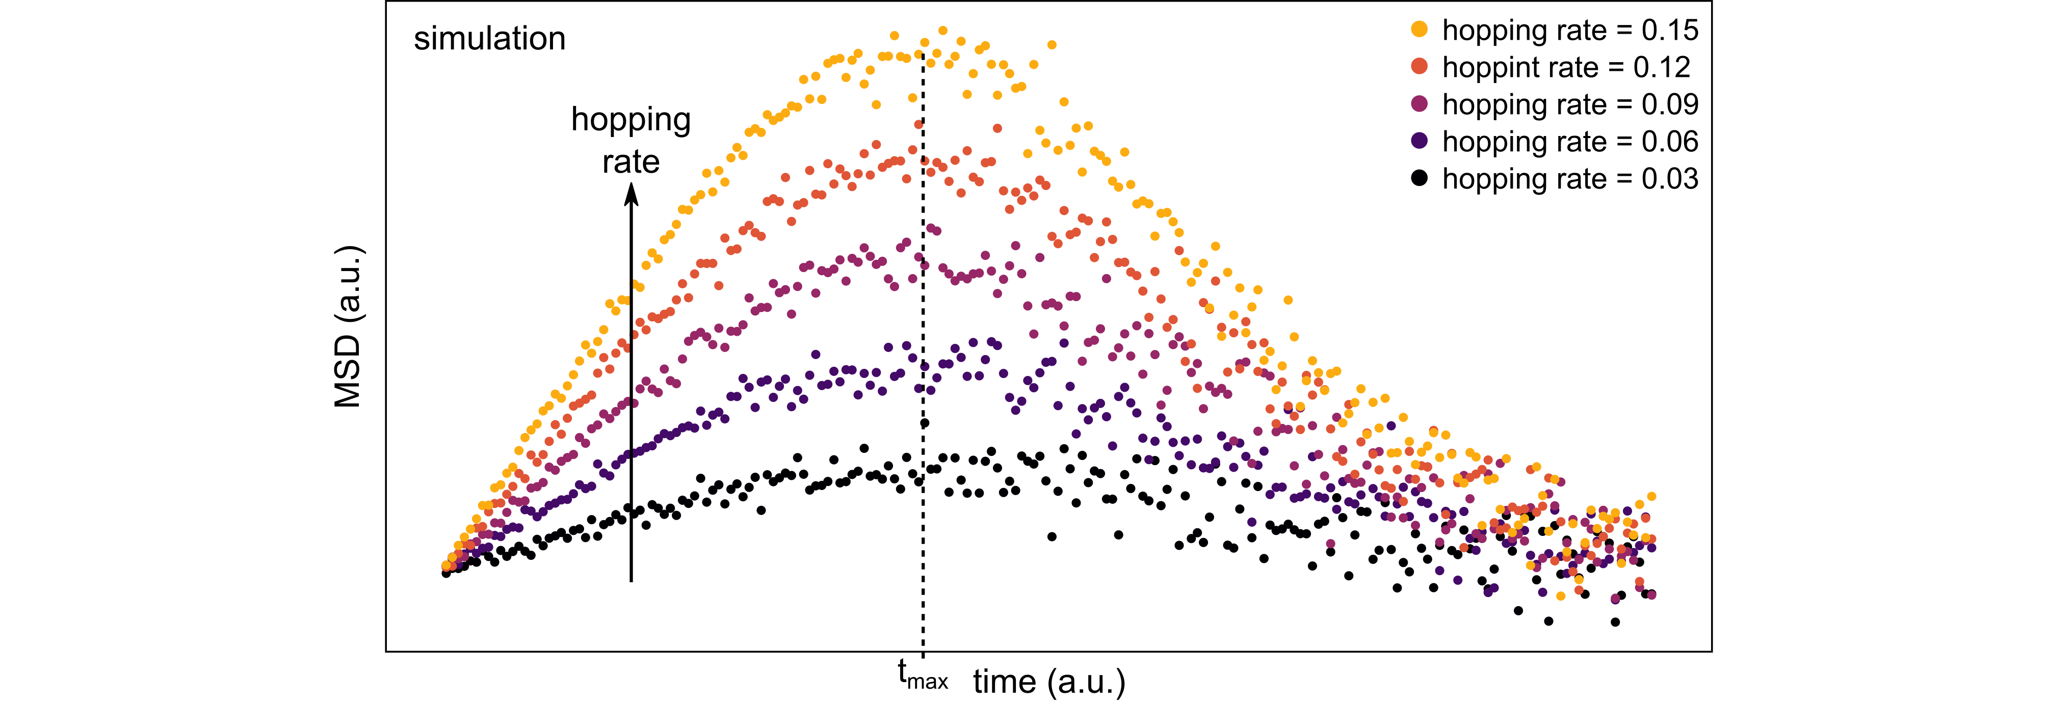

Figure S9 Monte Carlo-simulated MSD data for different FRET hopping rates. The lowest absolute MSD curve corresponds to the smallest hopping probability, and the highest MSD values to the greatest hopping probability simulated for this figure. For all curves, the initial MSD values are restored after a finite time; however, the time at which the MSD curves reach their maximum value is insensitive to hopping rate variations.

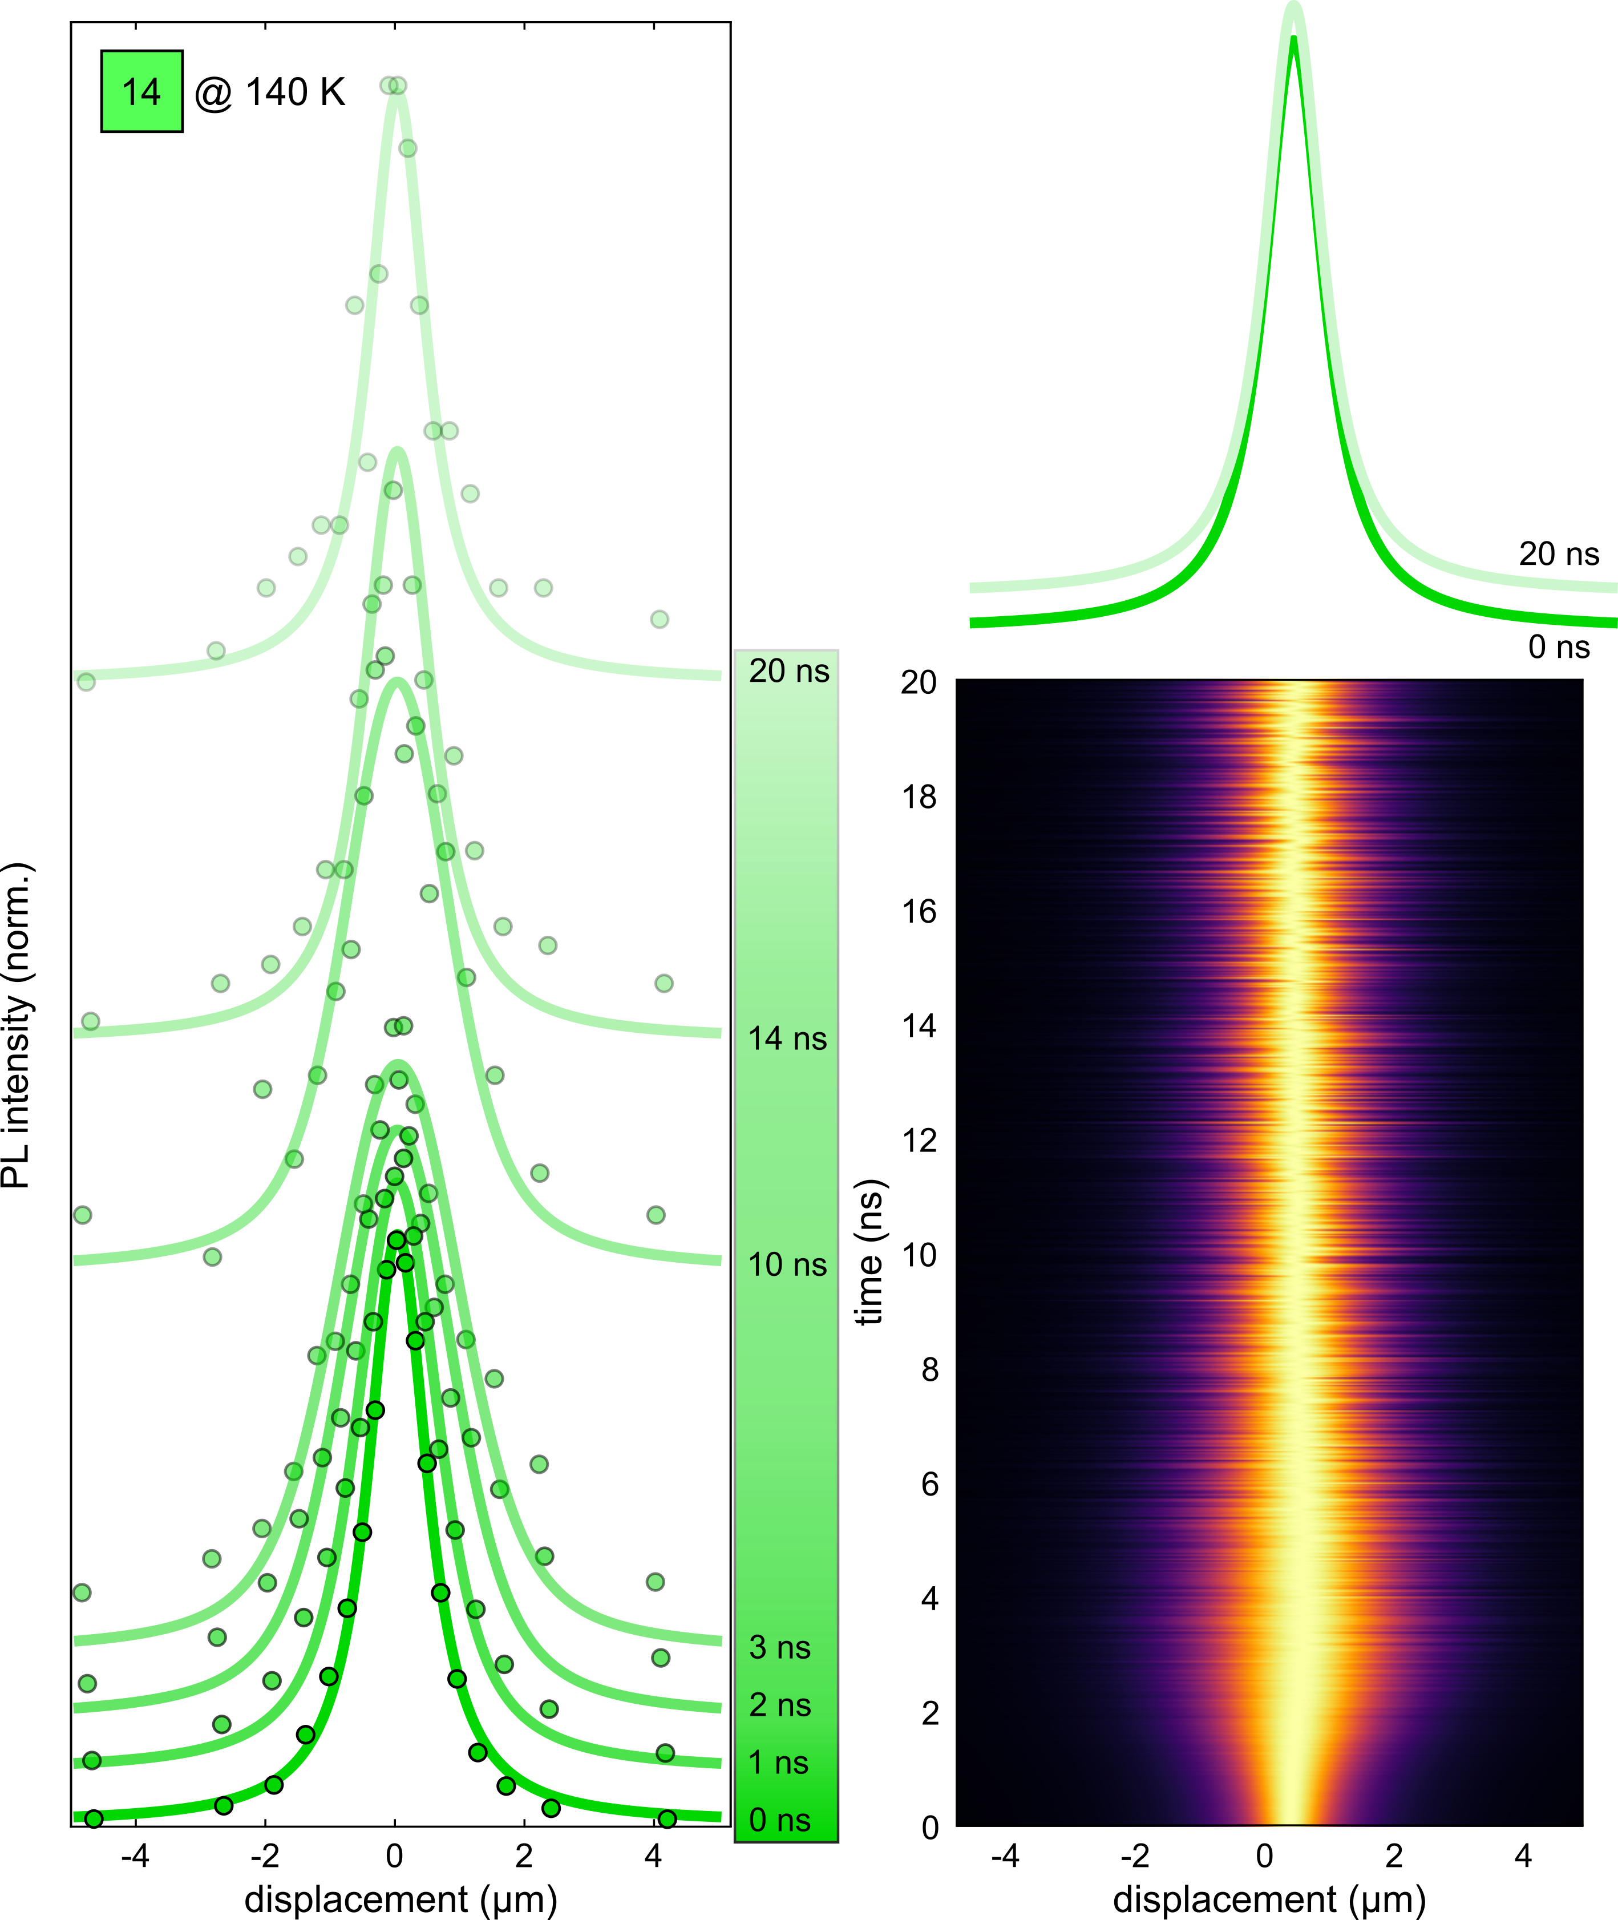
Figure S10 Recorded spatial PL intensity time slices and the corresponding Voigt profile fits of an exciton diffusion measurement at $140 K$ for a $14$nm PNC film (left) between $0 ns$and $20 ns$ after excitation. The Voigt profiles illustrate the restoration of the initial MSD value after a finite time (top right). Spatial PL intensity distribution for all recorded time bins (bottom right). The maximum is reached at around $3 ns$, followed by a spatial PL intensity contraction to the initial distribution.

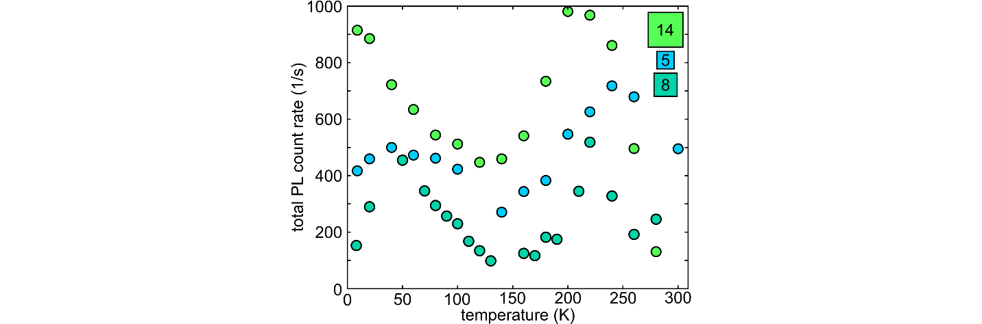
Figure S11 Integrated PL count rate versus temperature extracted from PL spectra of the 5 nm, 8 nm and 14 nm PNC samples. There is a decline in the count rate from a certain temperature onwards for every sample: 200 K for the 14 nm PNC sample, 220 K for the 8 nm SL and 240 K for the 5 nm SL.

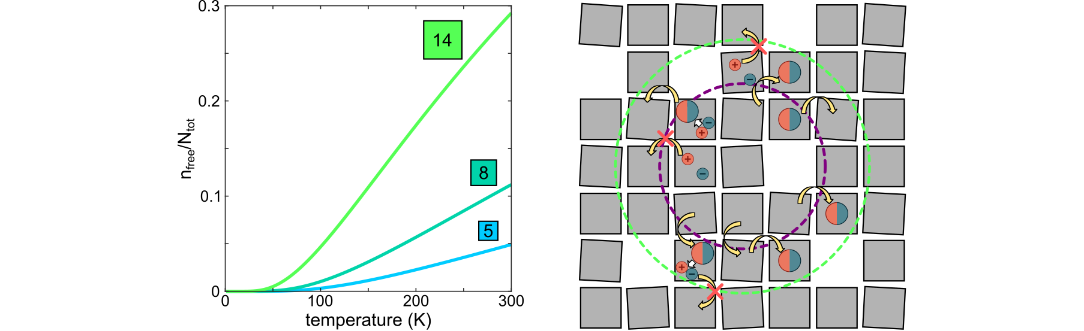

Figure S12 Fraction of the photo-excited electron-hole pairs existing as free charge carriers in the temperature range $0 K – 300 K$ for 14 nm (green), 8 nm (dark green), and 5 nm (blue) PNCs (left). The fraction was calculated with the Saha equation.² Schematic of exciton diffusion highlighting the different transport properties of excitons and free charge carriers (right). Only excitons can transfer their energy to an adjacent NC, depicted by yellow arrows. When an exciton is separated into free charge carriers, the diffusion is halted as free charge carriers can not tunnel through the ligand shell surrounding the PNCs. The dashed circles correspond to the qualitative diameter of laser excitation (purple) and steady-state PL emission of excitons or free charge carriers (green).

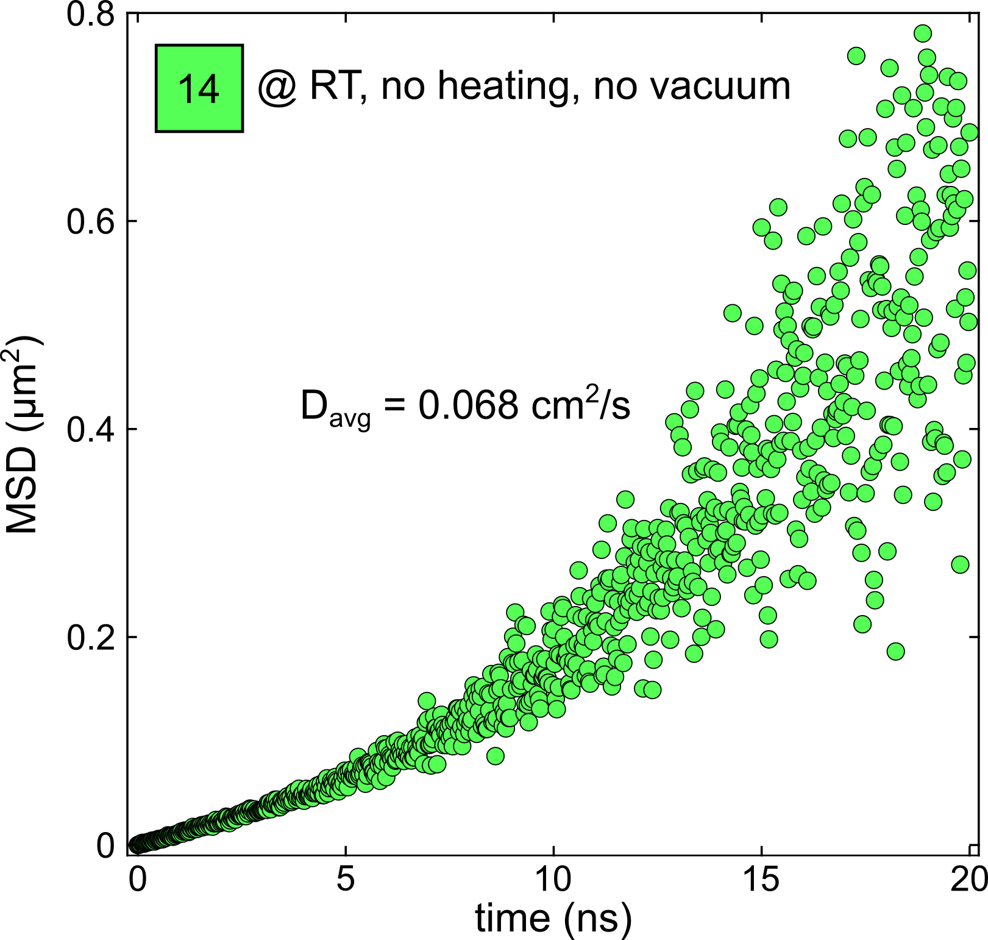
Figure S13 Reference exciton diffusion measurement of a 14 nm PNC film at room temperature where the cryostat was off (no heating/cooling, no vacuum). The average diffusivity is 0.068 cm²/s.

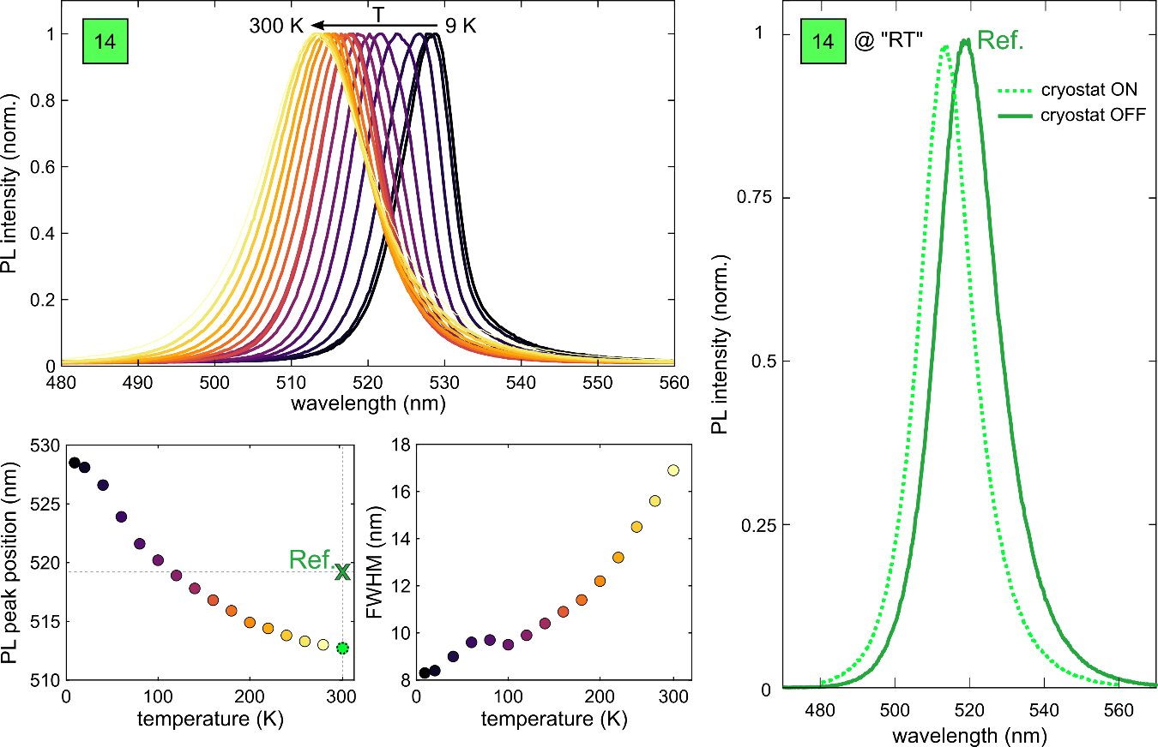
Figure S14 PL spectra of the 14 nm PNC sample in the screened temperature range $9 K – 300 K$ (left). The PL maximum blue shifts with increasing temperature (bottom left), while the FWHM increases (bottom right). The green cross marks the PL peak position of a reference PL spectrum at room temperature, where the cryostat was switched off (no heating/cooling, no vacuum). This PL spectrum is redshifted compared to the PL spectrum, where the sample was heated to 300 K while the cryostat was on (right). This indicates that the sample is warmer than room temperature when the cryostat is set to 300 K, explaining the discrepancy in the absolute values of the MSD curves and resulting diffusion parameters, $D$ and $L$.
References
1. Becker MA, et al. Unraveling the Origin of the Long Fluorescence Decay Component of Cesium Lead Halide Perovskite Nanocrystals. ACS Nano 14, 14939-14946 (2020).

2. Cingolani R, et al. Radiative recombination processes in wide-band-gap II–VI quantum wells: the interplay between excitons and free carriers. J Opt Soc Am B 13, (1996).

