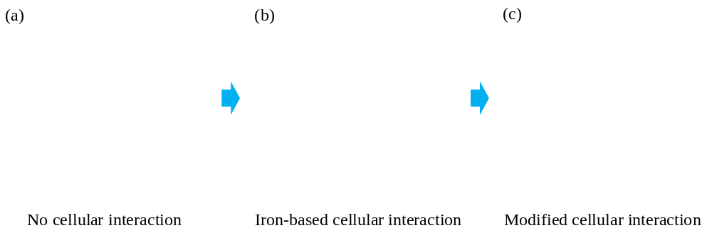
Fig.1 Theoretical foundation for directed regulation of chlorine substitution among PCDD/Fs isomers

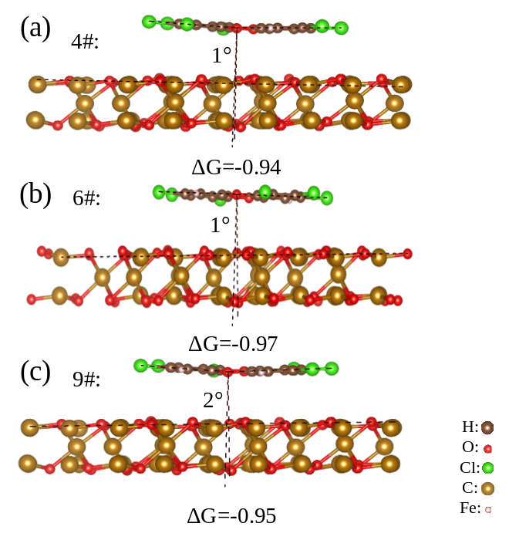
Fig.2 Migration of the action angle and energy barrier during chlorine substitution.

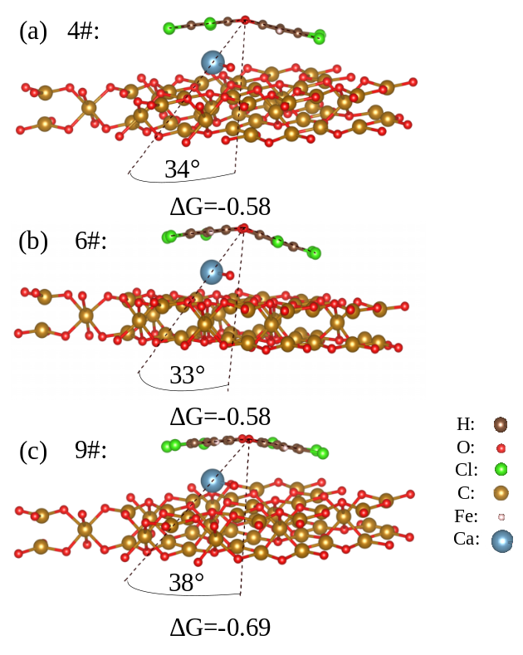
Fig.3 Effects of CaO adsorption on migration of the action angle and energy barrier

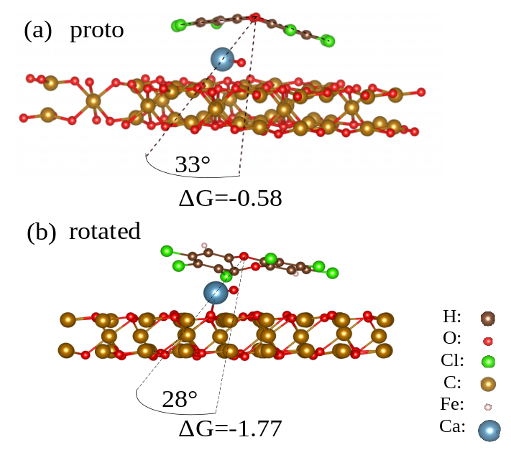
Fig.4 Effects of the components and action sites for CaO load
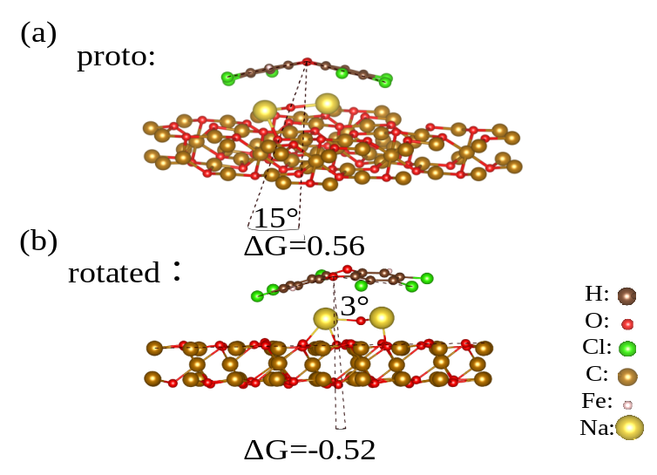
Fig.5 Effects of the components and action sites for Na₂O load
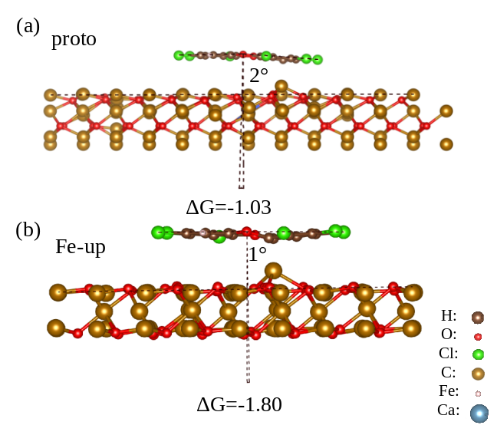
Fig.6 Effects of Fe-based cells structure on migration of the action angle and energy barrier
Fig.7 Directional regulation mechanism of Fe-based OC

