Appendix: Re-Running the Analysis
The results for the Six modelled scenarios for Kenya’s power system can now be compared and analysed. The analysis will focus on three separate investigative points of: power generation, power production and total system costs. Overall, the analysis aims to explore the impact of increased renewable production, Energy Efficiency (EE) measures, and increased demand on the BAU baseline resolutions. As a result the BAU scenario results act as a baseline for all additional scenario results to be compared to.
- Power Generation
This requires a comparison of the ‘AnnualElecProduction’ tab of the results file for all six scenarios. This part of the analysis requires assessing how the overall generation mix changes both: 1) across the modelling periods and 2) across the scenarios as a result of changing constraints (restricting fossil fuel production, increased demand etc).
- Go to the ‘AnnualElecProduction’ tab of the results file.
- Go to the ‘Row Labels’ filter and make sure that only the years 2015 to 2050 are selected.
- Go to the ‘Column Labels’ filter and make sure that only power technologies are selected (all ‘PWR’).
- You can copy and paste the ‘AnnualElecProduction’ graphs generated from each scenario onto a separate file to make the comparison between the different scenarios easier.
Questions to consider:
- How does the generation mix vary from the scenarios with fossil fuel (FF) constraints (Vision 2030, Vision 2030 & EE, LCPDP & Vision 2030, CET) compared to those without (BAU, LCPDP)?
- How does the generation mix change in the scenarios with the higher demand (LCPDP, LCPDP & Vision 2030, CET) compared to those with lower increase in demand (BAU, Vision 2030, Vision 2030 & EE)?
- What are the top 3 sources of power generation in the BAU scenario results and how does this compare across the scenarios?
- Which technologies appear across all the modelled scenarios? And which only appear in select scenarios?
- What impact have each of the scenario constraints had on the overall power generation?
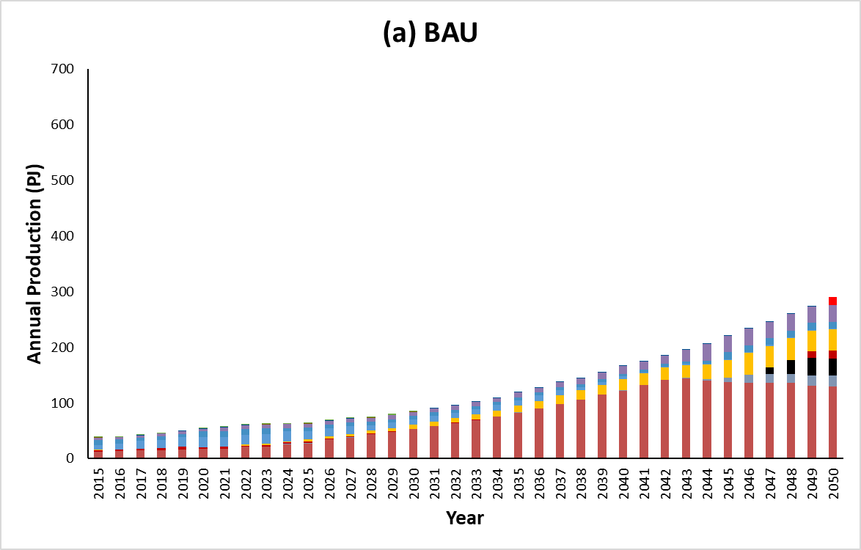 | 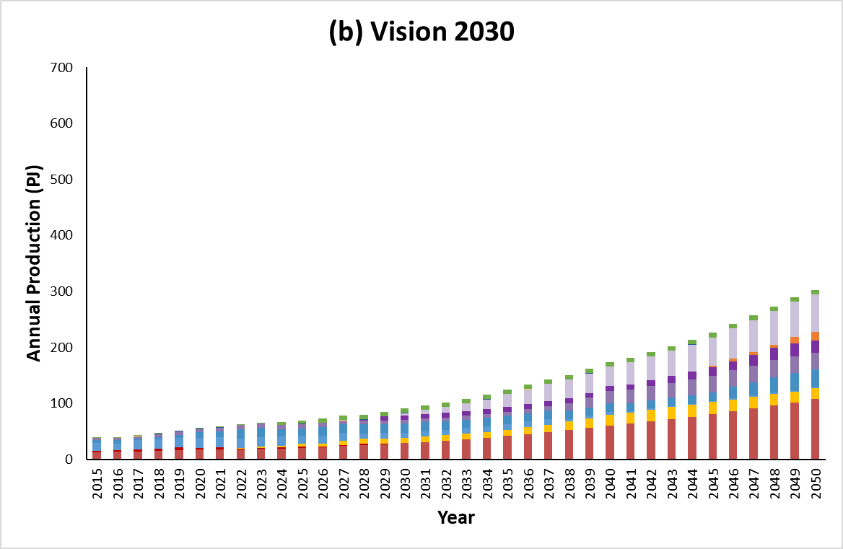
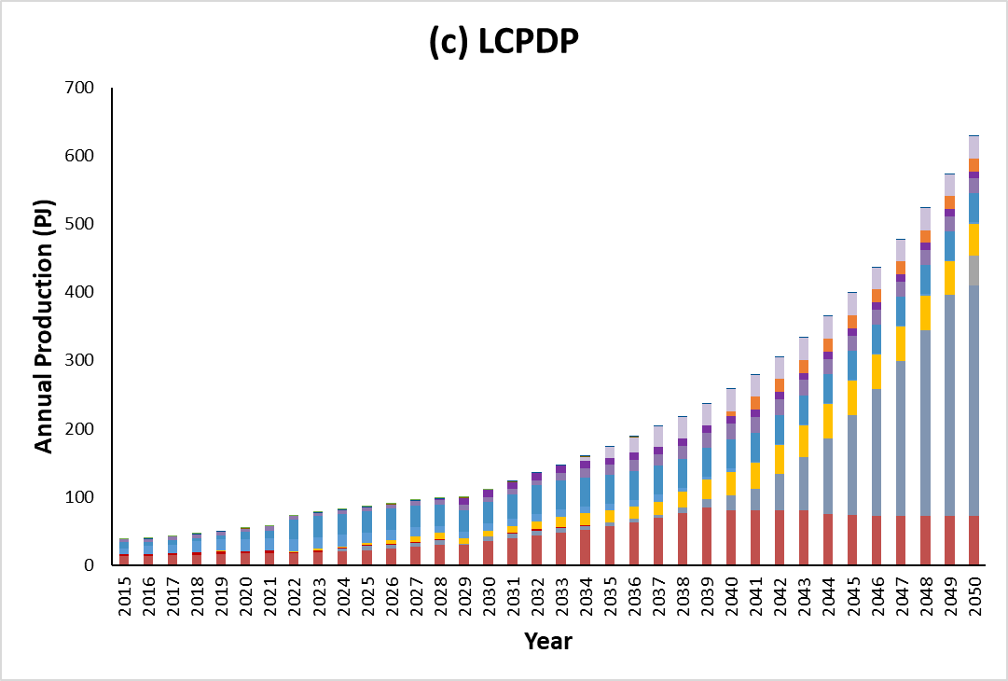 | 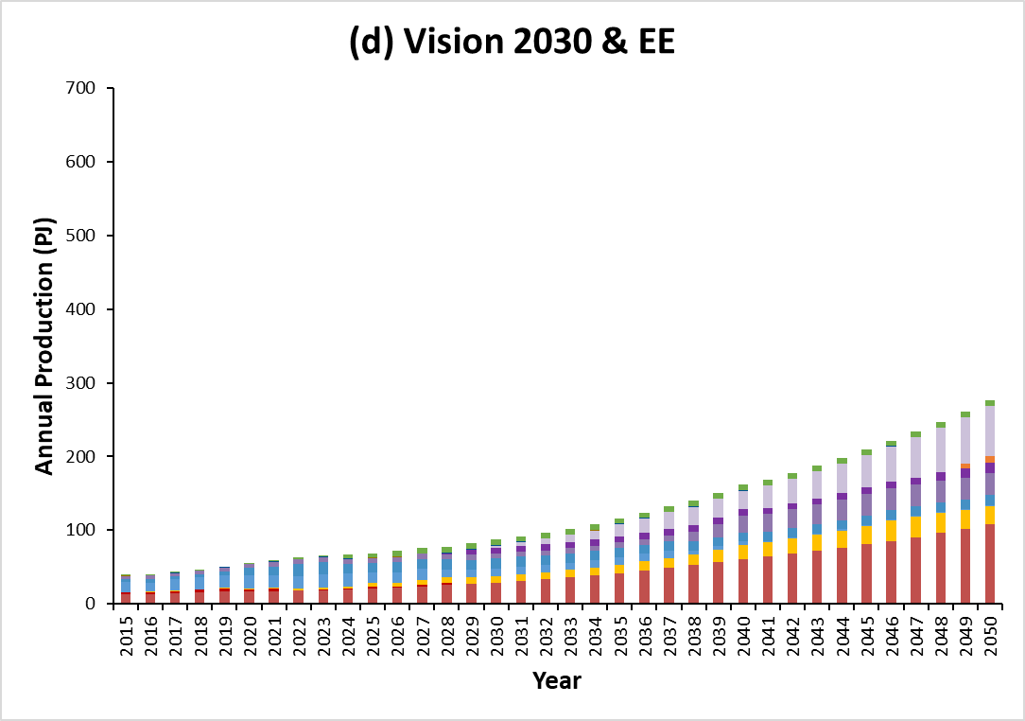
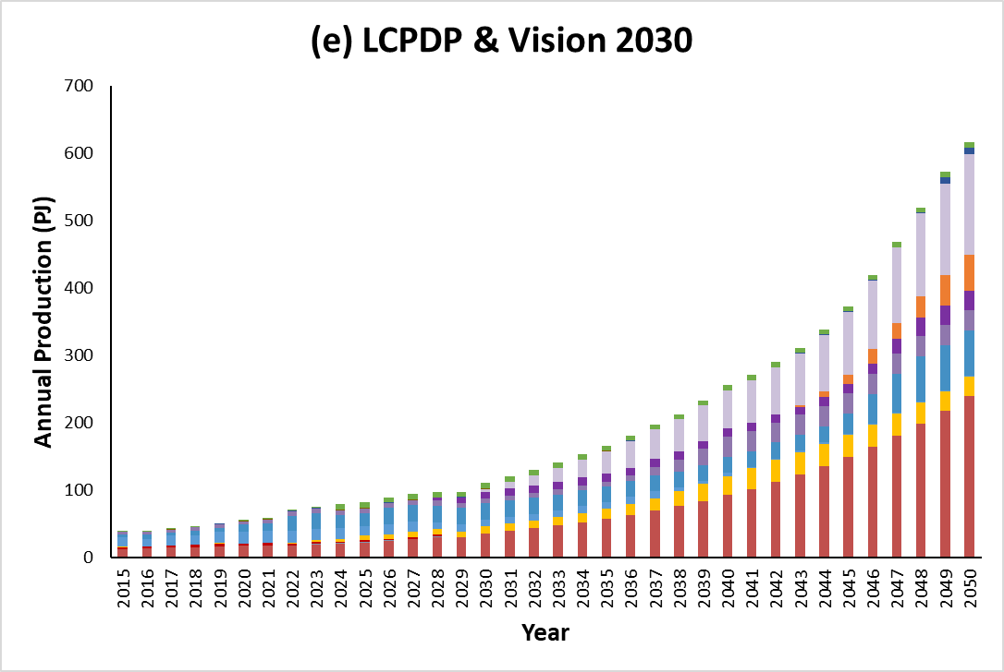 | 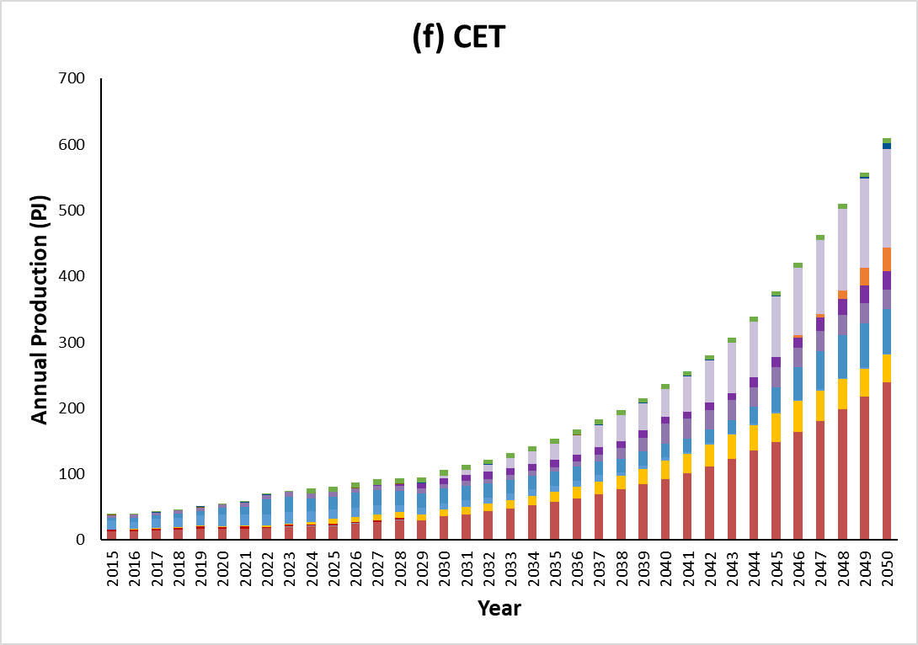
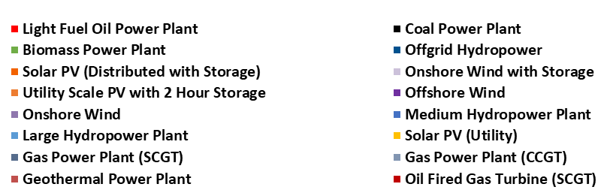
Figure 1: Annual Power Generation Production for Kenya for all six modelled scenarios by source from 2015 to 2050, with 2030 (red arrow) and 2050 (blue arrow) highlighted (see Figures 3–6). (a) Business as usual (BAU); (b) Vision 2030; (c) Least cost power development plan (LCPDP); (d) Vision 2030 & energy efficiency (EE); (e) Least cost power development plan (LCPDP) & Vision 2030; (f) Clean energy transition (CET).

In addition to considering the power generation results across the whole modelling period, the generation mix at specific periods across the modelling period can be considered. Within this study 2030 and 2050 were chosen as key mid- and long-term years to compare the power production and see how the generation mix changes over time.
- Go to the ‘AnnualElecProduction’ tab of the results file.
- Go to the ‘Row Labels’ filter and make sure that only the years 2015 to 2050 are selected.
- Go to the ‘Column Labels’ filter and make sure that only power technologies are selected (all ‘PWR’).
- Copy and paste the figures for both the 2030 and 2050 years for each modelled scenario into a separate excel file.
- You can then make your own figures for specific key years across the modelling period per scenario to help visualise the overall generation mixes.
Questions to consider:
- How does the generation mix compare from 2021 to 2030 and 2050?
- How does the percentage share of each technology compare across the scenarios at the chosen years?
- Which technology produces the biggest percentage share of total production across each scenario and how does this compare across the modelling period?
- How does the power generation mix compare from scenarios without FF constraints (BAU, LCPDP) compared to those with constraints (Vision 2030, Vision 2030 & EE, LCPDP & Vision 2030, CET)?
- What impact have each of the scenario constraints had on the generation mixes?
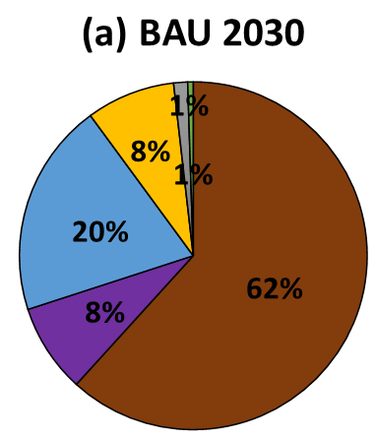 | 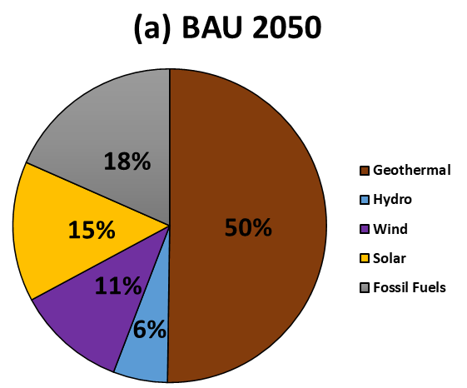
Figure 2: BAU power generation mixes for (a) 2030 and (b) 2050. An example of the type of figures you can create to visualise the results for key years across the modelling period.
- Power Production
This will also require a comparison of the ‘AnnualElecProduction’ tab of the results file for all six scenarios. This part of the analysis requires assessing how the total power production changes across the scenarios.
- Go to the ‘AnnualElecProduction’ tab of the results file.
- Go to the ‘Row Labels’ filter and make sure that only the years 2015 to 2050 are selected.
- Go to the ‘Column Labels’ filter and make sure that only power technologies are selected (all ‘PWR’).
- You can copy and paste the ‘AnnualElecProduction’ graphs generated from each scenario onto a separate file to make the comparison between the different scenarios easier.
- On the results file you can obtain the grand total of energy produced per year from column O for all scenarios. Additionally, cell O41 contains the total power generation for all technologies across the whole modelling period. These values can then be used to create your own figures to help visualise the results.
Questions to consider:
- How the power production needed to meet demand changes across the scenarios with higher demand (LCPDP, LCPDP & Vision 2030, CET), compared to those without (BAU, Vision 2030, Vision 2030 & EE)?
- How does investment into energy efficiency (EE) technologies affect the total power production needed to meet demands compared to the same scenario within EE investment (i.e., Vision 2030 compared to Vision 2030 & EE, LCPDP & Vision 2030 compared to CET)?
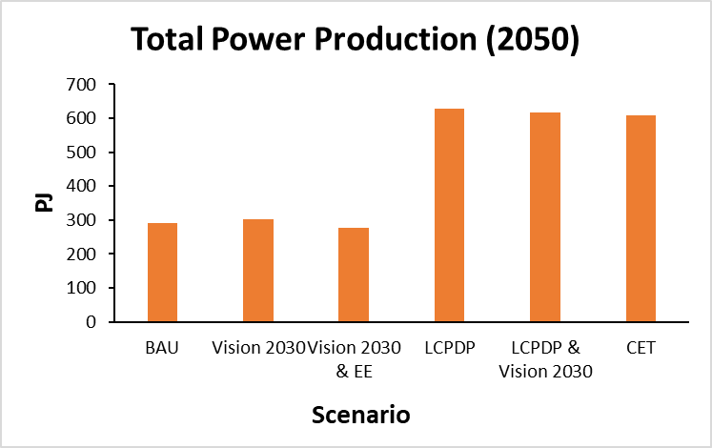
Figure 3: Total combined power production comparison for Kenya in 2050 across all modelled scenarios. Example of a figure you can use to visualise how total power production changes across scenarios.
- Total System Costs
This requires a comparison of the ‘CapitalInvestment’, ‘AnnualVariableOperatingCosts’ and the ‘AnnualFixedOperatingCosts’ tabs of the results file for all six scenarios. This part of the analysis requires assessing how the overall total system costs change across the scenarios as a result of increasing demand, restricting FF production and investing into EE.
- Go to the ‘CapitalInvestment’ tab of the results file.
- Go to the ‘Row Labels’ filter and make sure that only the years 2015 to 2050 are selected.
- Copy and paste the grand total figure for all technologies across all years from the cell K33 into a separate document.
- Repeat this for all six scenarios.
- Then go to the ‘AnnualVariableOperatingCosts’ and ‘AnnualFixedOperatingCosts’ and find the grand total figure.
- Copy and paste the figures into a separate document and repeat this for all six scenarios.
- Find the total system costs for scenario by combining the three total costs of capital investment, variable cost and fixed costs.
- These values can then be used to create your own figures to help visualise the results.
Questions to consider:
- How does the overall system costs compare for each of the scenarios compared to the BAU?
- How does the overall system costs for the increased demand scenarios (LCPDP, LCPDP & Vision 2030, CET) compare to those without (BAU, Vision 2030, Vision 2030 & EE)?
- How does the overall system costs for the scenarios without EE investments (Vision 2030, LCPDP & Vision 2030) compare to their counter scenario with EE investment (Vision 2030 & EE, CET)?
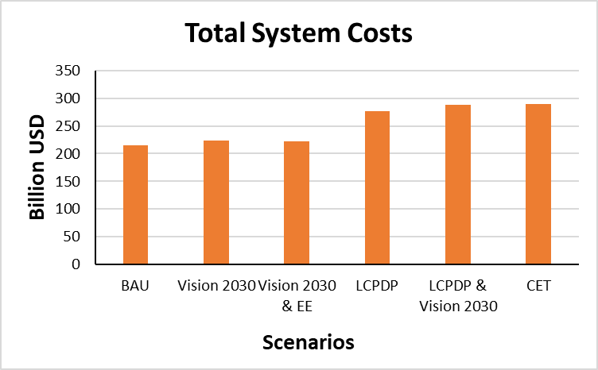
Figure 4: Overall cumulative total system costs for Kenya for all scenarios from 2015 to 2050. Example of a figure you can use to visualise how total system cost changes across scenarios.

