Bone marrow-derived extracellular vesicles carry the TGF-β signal transducer Smad2 to preserve hematopoietic stem cells in mouse

Flavie Gautheron,¹ Aleksandra Georgievski,^{1,2} Carmen Garrido,^{1,2} and Ronan Quéré^{1,2,*}

¹UMR1231, Inserm/Université Bourgogne Franche-Comté, Dijon, France.
²LipSTIC Labex, Dijon, France.

Supplementary Figures S1 to S3

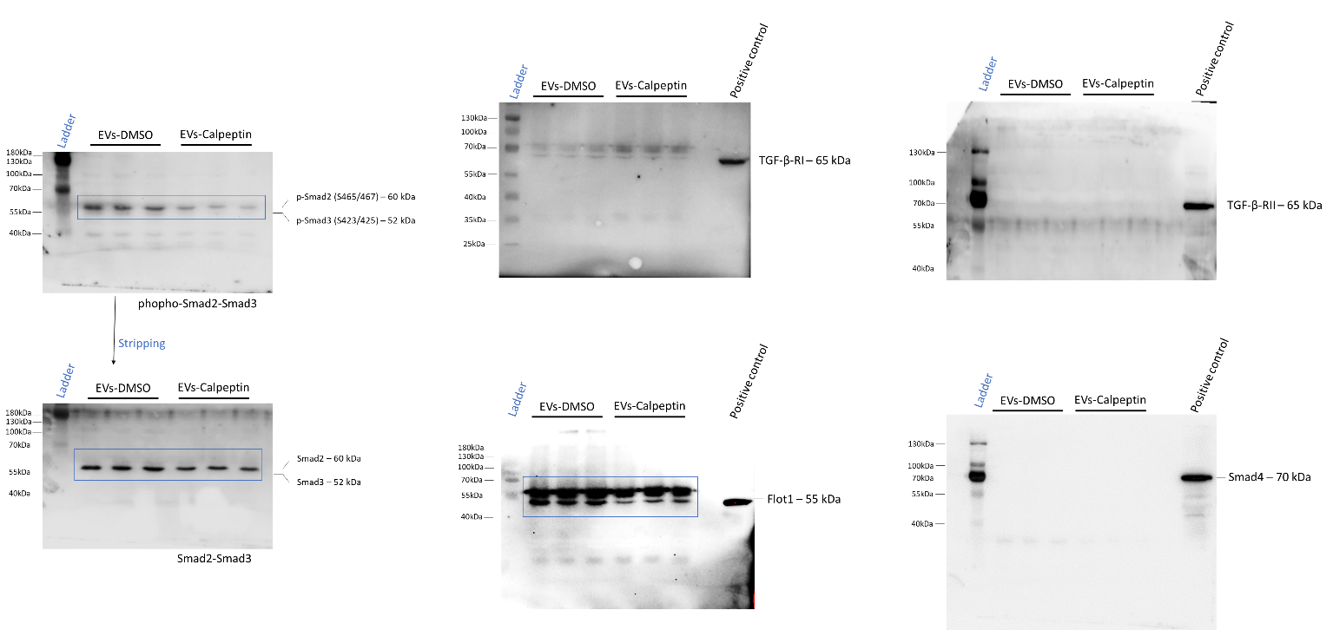

Figure S1: Full length uncropped western blots. Uncropped western blot corresponding to Fig. 1D. Western blot showing also absence in expression of the TGF-β receptor RI and RII, as well as Smad4 in EVs isolated ex vivo from BM. Positive control corresponds to MS5 cell lysate. Blues lines corresponding to cropped western blots shown in Fig. 1D.

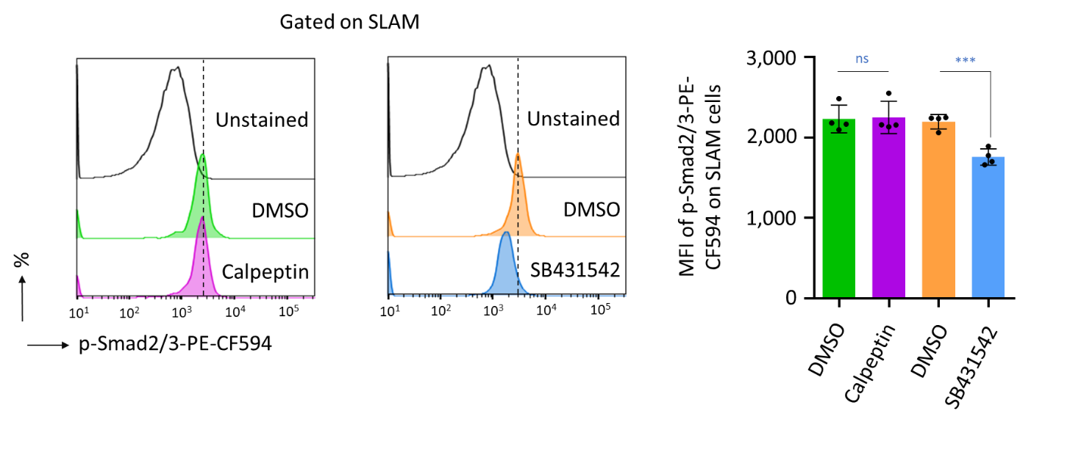
Figure S2: Calpeptin is not an inhibitor of the TGF-β pathway. Lin⁻ cells (2.5×10⁵ cells) isolated from mice were treated ex vivo with 0.5µM of Calpeptin or the TGF-β-RI inhibitor SB431542. Following 18 hours, mean fluorescence intensity (MFI) measured by flow cytometry, showing that the TGF-β inhibitor has reduced the expression level of p-Smad2/3 on SLAM cells, while Calpeptin had no efficiency. Data are shown as means ± SD; n = 4 biological replicates. P value measured by two-tailed unpaired Student’s t test; ***P < 0.001; ns, non-significant
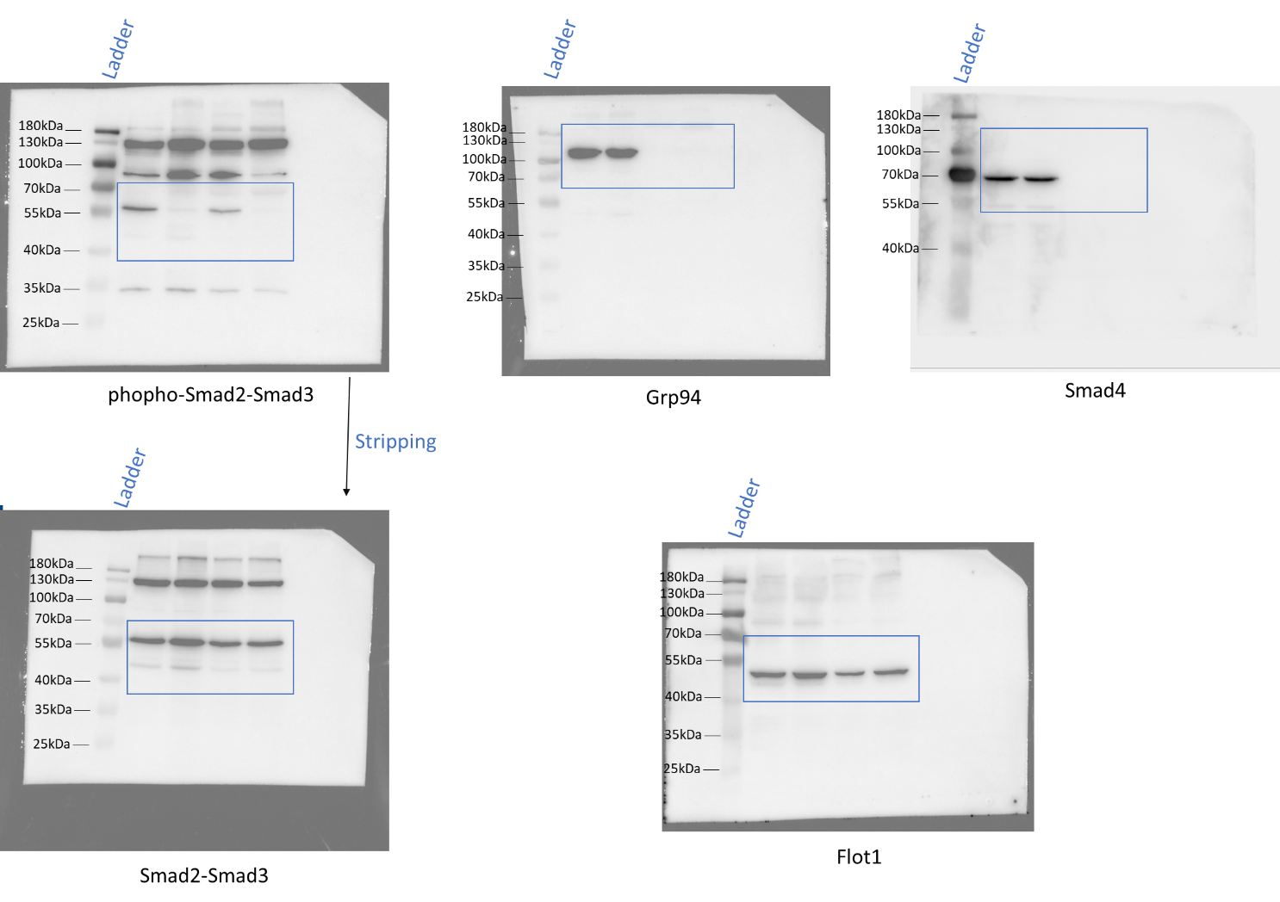

Figure S3: Full length uncropped western blots. Uncropped western blot corresponding to Fig. 3C.

