Supplementary Table 1: Comparison of clinical characteristics of adult COVID-19 patients with and without death outcomes during omicron predominance (1 Feb 2022- 31 Jul 2022) in Chiang Mai, Thailand
Variable | Without death outcome | death outcome | p-value
Number (%) | 260,913 (99.9) | 190 (0.07) | -
Age, years |  |  | <0.01
Median (IQR) | 39 (27-55) | 72 (61-83) | <0.01
Age group, n (%) |  |  | <0.01
18-29 | 78819 (30.2) | 9 (4.7) | <0.01
30-39 | 56059 (21.5) | 9 (4.7) | <0.01
40-49 | 42681 (16.4) | 8 (4.2) | <0.01
50-59 | 36062 (13.8) | 19 (10.0) | <0.01
60-69 | 31393 (12.0) | 38 (20.0) | <0.01
≥70 | 15899 (6.1) | 107 (56.4) | <0.01
Gender, n (%) |  |  | <0.01
Male | 115125 (44.1) | 116 (61.1) | <0.01
Female | 145788 (55.9) | 74 (38.9) | <0.01
Vaccination Status, n (%) |  |  | <0.01
Unvaccinated | 25319 (9.7) | 103 (54.2) | <0.01
Partially vaccinated | 3698 (1.4) | 4 (2.1) | <0.01
Primary vaccine series | 118721 (45.5) | 61 (32.1) | <0.01
Vaccinated three doses | 97448 (37.4) | 20 (10.5) | <0.01
Vaccinated four doses or more | 15727 (6.0) | 2 (1.0) | <0.01
Type of primary vaccine series, n (%) | n=118,721 | n=61 | 0.11
Sinovac/Sinopharm-ChAdOx1 nCoV-19 | 47027 (39.6) | 14 (22.9) | 0.11
Sinovac-Sinovac or Sinopharm-Sinopharm | 16527 (13.9) | 10 (16.4) | 0.11
ChAdOx1 nCoV-19-ChAdOx1 nCoV-19 | 3602 (3.0) | 1 (1.6) | 0.11
Pfizer-BioNTech-Pfizer-BioNTech | 13864 (11.7) | 11 (18.0) | 0.11
ChAdOx1 nCoV-19-Pfizer-BioNTech/Moderna | 32126 (27.0) | 20 (32.8) | 0.11
Sinovac/Sinopharm-Pfizer-BioNTech/Moderna | 594 (0.5) | 0 (0) | 0.11
Moderna-Moderna | 4981 (4.2) | 5 (8.2) | 0.11
Type of third vaccine dose, n (%) | n=97448 | n=20 | 0.84
Pfizer-BioNTech | 48478 (49.7) | 8 (40.0) | 0.84
ChAdOx1 nCoV-19 | 27620 (28.3) | 7 (35.0) | 0.84
Moderna | 21266 (21.8) | 5 (25.0) | 0.84
Other | 84 (0.1) | 0 (0) | 0.84
Type of fourth vaccine dose*, n (%) | n=15332 | n=2 | -
Pfizer-BioNTech | 6838 (44.6) | 1 (50.0) | -
ChAdOx1 nCoV-19 | 803 (5.2) | 0 (0) | -
Moderna | 7679 (50.1) | 1 (50.0) | -
Other | 12 (0.1) | 0 (0) | -
Type of fifth vaccine dose, n (%) | n=394 | n=0 | -
Pfizer-BioNTech | 60 (15.2) | 0 (0) | -
Moderna | 334 (84.8) | 0 (0) | -
Median (IQR) time since last vaccination, days | 105 (69-147) | 120 (70-163) | 0.07
Time since last vaccination (All schedules), n (%) | n=234864 | n=84 | 0.05
≤14 D | 7442 (3.2) | 5 (5.9) | 0.05
>14 to 60 D | 39630 (16.9) | 7 (8.3) | 0.05
>60 to 120 D | 95427 (40.6) | 30 (35.7) | 0.05
>120 to 180 D | 61787 (26.3) | 26 (30.9) | 0.05
>180 D | 30578 (13.0) | 16 (19.1) | 0.05

Supplementary Table 2a: Association between vaccination regimens, time since last vaccine dose and severe COVID-19 outcomes among adult COVID-19 cases
 | Severe COVID-19 |  |  |  |  |  |  |  | Death
 | Crude HR | 95% CI-lower | 95% CI-upper | p-value | Adj. HR | 95% CI-lower | 95% CI-upper | p-value | Crude HR | 95% CI-lower | 95% CI-upper | p-value | Adj. HR | 95% CI-lower | 95% CI-upper | p-value
Age, years | 1.09 | 1.08 | 1.09 | <0.01 | 1.07 | 1.06 | 1.08 | <0.01 | 1.09 | 1.08 | 1.10 | <0.01 | 1.08 | 1.07 | 1.09 | <0.01
Gender
Female | Reference
Male | 1.64 | 1.32 | 2.04 | <0.01 | 1.73 | 1.39 | 2.15 | <0.01 | 1.98 | 1.48 | 2.65 | <0.01 | 2.10 | 1.57 | 2.82 | <0.01
Vaccination status¹
Unvaccinated | Reference
Partially vaccinated | 0.39 | 0.21 | 0.75 | 0.01 | 0.57 | 0.30 | 1.08 | 0.08 | 0.27 | 0.10 | 0.74 | 0.01 | 0.37 | 0.13 | 0.99 | 0.05
Primary vaccine series | 0.13 | 0.10 | 0.17 | <0.01 | 0.27 | 0.21 | 0.35 | <0.01 | 0.13 | 0.09 | 0.18 | <0.01 | 0.25 | 0.18 | 0.35 | <0.01
Vaccinated three doses | 0.06 | 0.04 | 0.08 | <0.01 | 0.12 | 0.08 | 0.17 | <0.01 | 0.05 | 0.03 | 0.08 | <0.01 | 0.11 | 0.07 | 0.21 | <0.01
Vaccinated four doses or more | 0.04 | 0.01 | 0.10 | <0.01 | 0.12 | 0.04 | 0.34 | <0.01 | 0.03 | 0.01 | 0.13 | <0.01 | 0.10 | 0.06 | 0.16 | <0.01
Vaccination status by time since last dose¹
Unvaccinated | Reference |  |  |  |  |  |  |  | Reference
Partially vaccinated | 0.39 | 0.21 | 0.75 | 0.01 | 0.55 | 0.29 | 1.04 | 0.07 | 0.27 | 0.10 | 0.74 | 0.01 | 0.37 | 0.13 | 0.99 | 0.05
Primary vaccine series ≤14 D | 1.01 | 0.32 | 3.16 | 0.98 | 1.64 | 0.52 | 5.17 | 0.39 | 1.16 | 0.28 | 4.72 | 0.83 | 1.72 | 0.42 | 7.01 | 0.44
Primary vaccine series >14 to 60 D | 0.08 | 0.03 | 0.20 | <0.01 | 0.16 | 0.06 | 0.39 | <0.01 | 0.08 | 0.02 | 0.27 | <0.01 | 0.15 | 0.05 | 0.49 | <0.01
Primary vaccine series >60 to 120 D | 0.08 | 0.05 | 0.12 | <0.01 | 0.17 | 0.11 | 0.25 | <0.01 | 0.10 | 0.06 | 0.16 | <0.01 | 0.18 | 0.11 | 0.31 | <0.01
Primary vaccine series >120 to 180 D | 0.13 | 0.09 | 0.18 | <0.01 | 0.27 | 0.19 | 0.39 | <0.01 | 0.14 | 0.09 | 0.22 | <0.01 | 0.28 | 0.17 | 0.45 | <0.01
Primary vaccine series >180 D | 0.24 | 0.17 | 0.35 | <0.01 | 0.42 | 0.29 | 0.60 | <0.01 | 0.16 | 0.09 | 0.27 | <0.01 | 0.29 | 0.17 | 0.52 | <0.01
Three dose or more ≤14 D | 0.07 | 0.02 | 0.21 | <0.01 | 0.14 | 0.04 | 0.43 | <0.01 | 0.11 | 0.03 | 0.35 | <0.01 | 0.22 | 0.07 | 0.71 | 0.01
Three dose or more >14 to 60 D | 0.03 | 0.01 | 0.07 | <0.01 | 0.07 | 0.03 | 0.15 | <0.01 | 0.03 | 0.01 | 0.08 | <0.01 | 0.06 | 0.02 | 0.17 | <0.01
Three dose or more >60 to 120 D | 0.04 | 0.02 | 0.08 | <0.01 | 0.09 | 0.05 | 0.14 | <0.01 | 0.04 | 0.01 | 0.08 | <0.01 | 0.07 | 0.03 | 0.15 | <0.01
Three dose or more >120 to 180 D | 0.10 | 0.05 | 0.18 | <0.01 | 0.23 | 0.12 | 0.41 | <0.01 | 0.07 | 0.03 | 0.17 | <0.01 | 0.20 | 0.08 | 0.47 | <0.01
Three dose or more >180 D | 0.14 | 0.06 | 0.29 | <0.01 | 0.32 | 0.14 | 0.69 | <0.01 | 0.06 | 0.01 | 0.25 | <0.01 | 0.19 | 0.04 | 0.80 | 0.02
1 Adjusted for age, gender, and calendar week of test

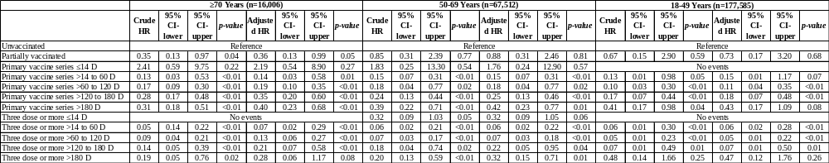
Supplementary Table 2b: Association between time since last vaccine dose and severe COVID-19 outcomes during omicron predominance among adult COVID-19 cases stratified by age group
Adjusted for age, gender, and calendar week of test

Supplementary Table 3: Association between time since last vaccine dose and severe COVID-19 outcomes during omicron predominance among adult COVID-19 cases by type of booster vaccine
 | n | Crude HR | 95% CI-lower | 95% CI-upper | p-value | Adjusted HR | 95% CI-lower | 95% CI-upper | p-value
ChAdOx1 nCoV-19 ≤14 D | 1327 | 0.22 | 0.05 | 0.89 | 0.03 | 0.36 | 0.09 | 1.45 | 0.15
ChAdOx1 nCoV-19 >14 to 60 D | 7311 | 0.08 | 0.03 | 0.21 | <0.01 | 0.14 | 0.05 | 0.39 | <0.01
ChAdOx1 nCoV-19 >60 to 120 D | 11363 | No events
ChAdOx1 nCoV-19 >120 to 180 D | 5693 | 0.07 | 0.02 | 0.24 | <0.01 | 0.15 | 0.05 | 0.28 | <0.01
ChAdOx1 nCoV-19 >180 D | 2736 | 0.21 | 0.08 | 0.58 | <0.01 | 0.40 | 0.18 | 1.38 | 0.18
One or more booster ChAdOx1 nCoV-19 | 28430 | 0.10 | 0.05 | 0.32 | <0.01 | 0.19 | 0.07 | 0.32 | <0.01
Pfizer-BioNTech ≤14 D | 2948 | 0.05 | 0.01 | 0.35 | 0.03 | 0.10 | 0.01 | 0.60 | 0.01
Pfizer-BioNTech >14 to 60 D | 16350 | 0.03 | 0.01 | 0.08 | <0.01 | 0.06 | 0.03 | 0.17 | <0.01
Pfizer-BioNTech >60 to 120 D | 24120 | 0.06 | 0.03 | 0.12 | <0.01 | 0.11 | 0.06 | 0.24 | <0.01
Pfizer-BioNTech >120 to 180 D | 8503 | 0.12 | 0.06 | 0.26 | <0.01 | 0.27 | 0.12 | 0.59 | <0.01
Pfizer-BioNTech >180 D | 3465 | 0.13 | 0.04 | 0.39 | <0.01 | 0.33 | 0.10 | 1.04 | 0.06
One or more booster Pfizer-BioNTech | 55386 | 0.08 | 0.03 | 0.28 | <0.01 | 0.11 | 0.05 | 0.28 | <0.01
Moderna ≤14 D | 2408 | No events
Moderna >14 to 60 D | 9479 | No events
Moderna >60 to 120 D | 11651 | 0.05 | 0.02 | 0.13 | <0.01 | 0.14 | 0.05 | 0.38 | <0.01
Moderna >120 to 180 D | 4473 | 0.09 | 0.03 | 0.31 | <0.01 | 0.36 | 0.11 | 1.15 | 0.08
Moderna >180 D | 1274 | No events
One or more booster Moderna | 29285 | 0.07 | 0.03 | 0.23 | <0.01 | 0.18 | 0.08 | 0.74 | <0.01
Adjusted for age, gender, calendar time and preceding vaccine series type. Reference group: Unvaccinated
Supplementary Figure 1: Flow chart of subject selection for adult COVID-19 cases who are residents of Chiang Mai, Thailand between 1 Feb – 31 Jul 2022

Supplementary Figure 2a: Kaplan-Meier estimates for severe COVID-19 outcomes among adult cases during omicron predominance by age group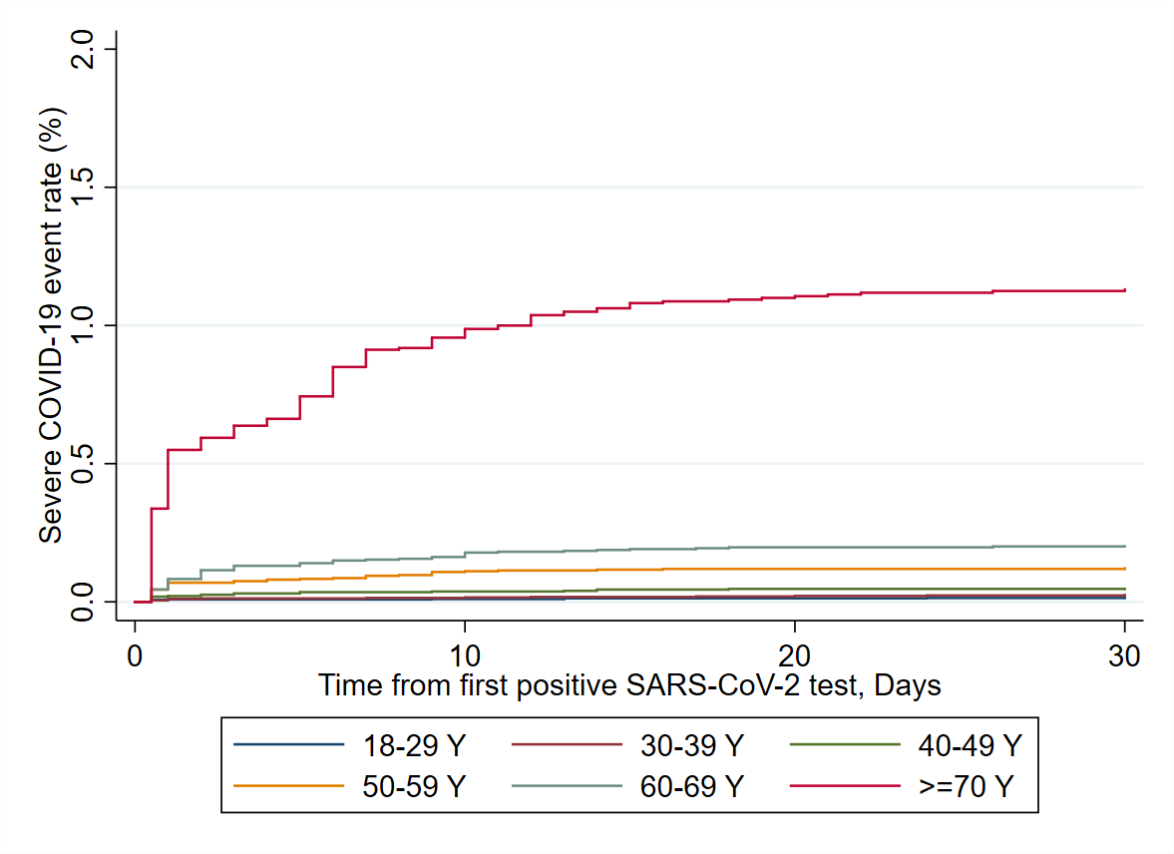
Supplementary Figure 2b: Kaplan-Meier estimates for severe COVID-19 outcomes among adult cases during omicron predominance by vaccine series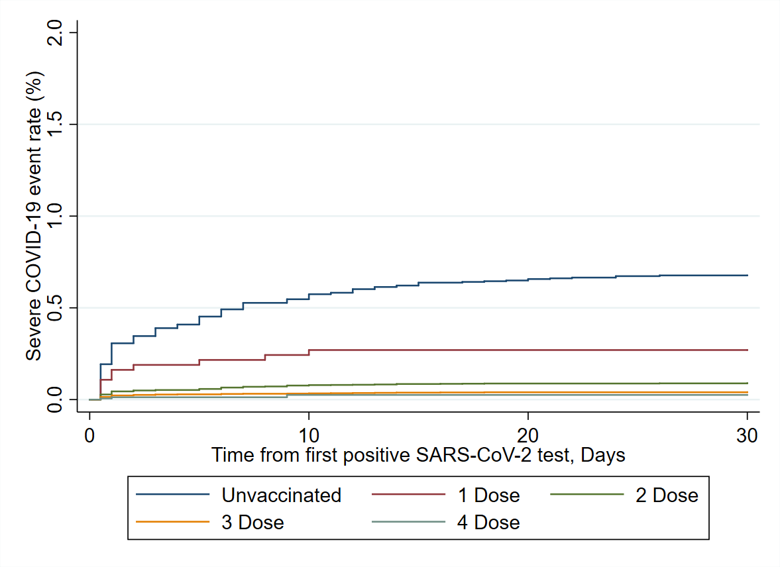

Supplementary Figure 2c: Kaplan-Meier estimates for severe COVID-19 outcomes among adult cases during omicron predominance by time from last vaccine
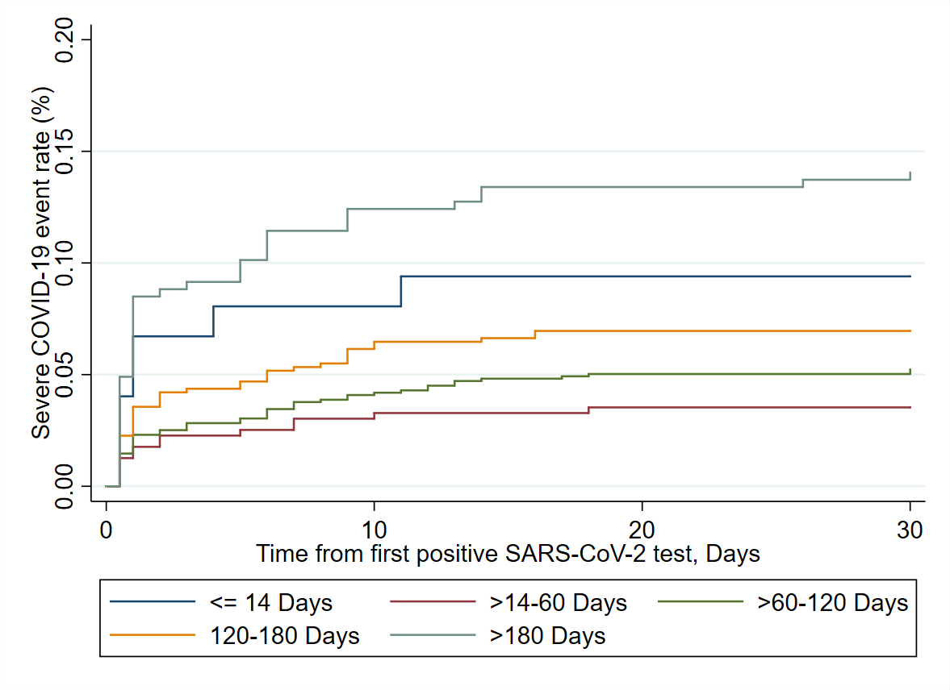

Supplementary Figure 3: Risk reduction of severe COVID-19 among adult cases during omicron predominance, by vaccination regimens and time since last vaccine dose (Sensitivity analysis excluding two or more boosters)
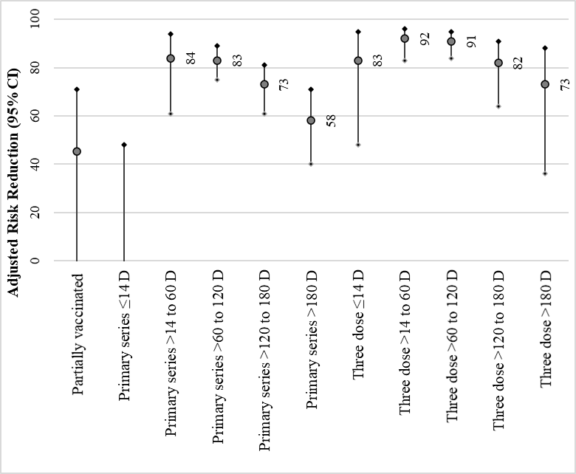

Supplementary Figure 4: Risk reduction of severe COVID-19 among adult cases during omicron predominance by booster vaccine type and time since last dose
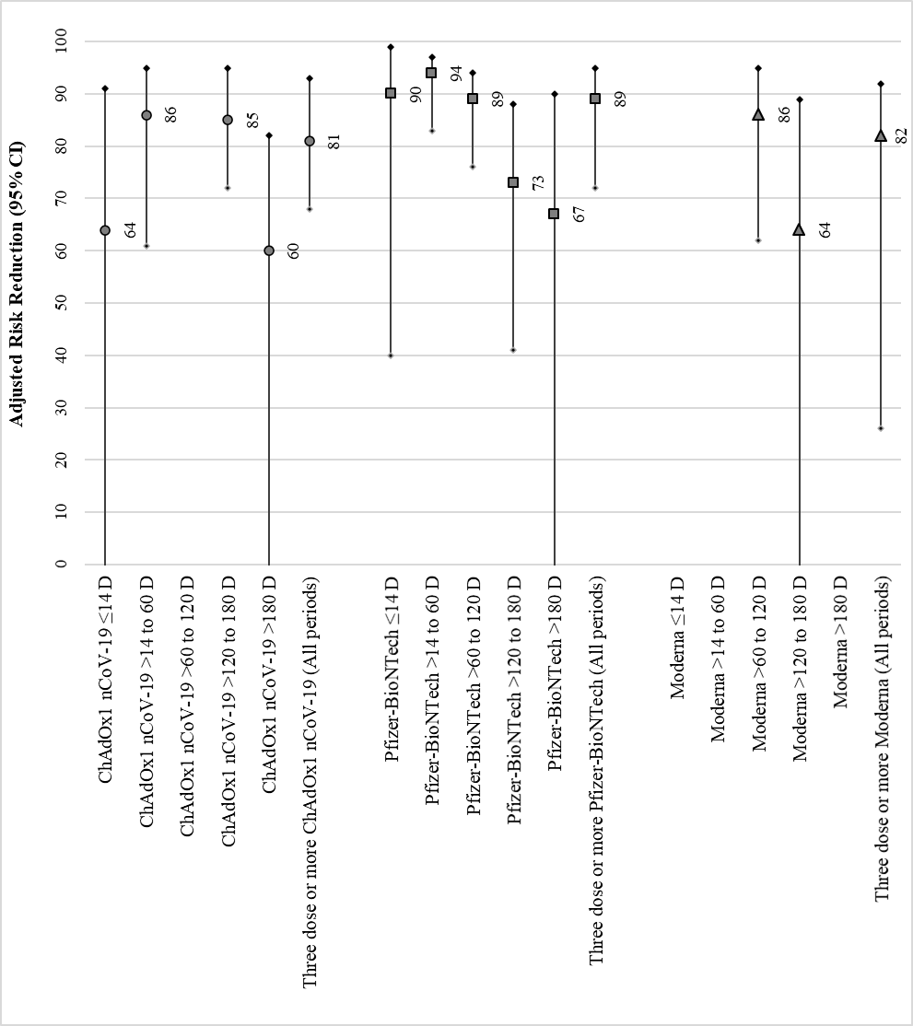
No events
No events
No events
No events
Adjusted for age, gender, calendar time and preceding vaccine series type. Reference group: Unvaccinat

