Supplementary Materials
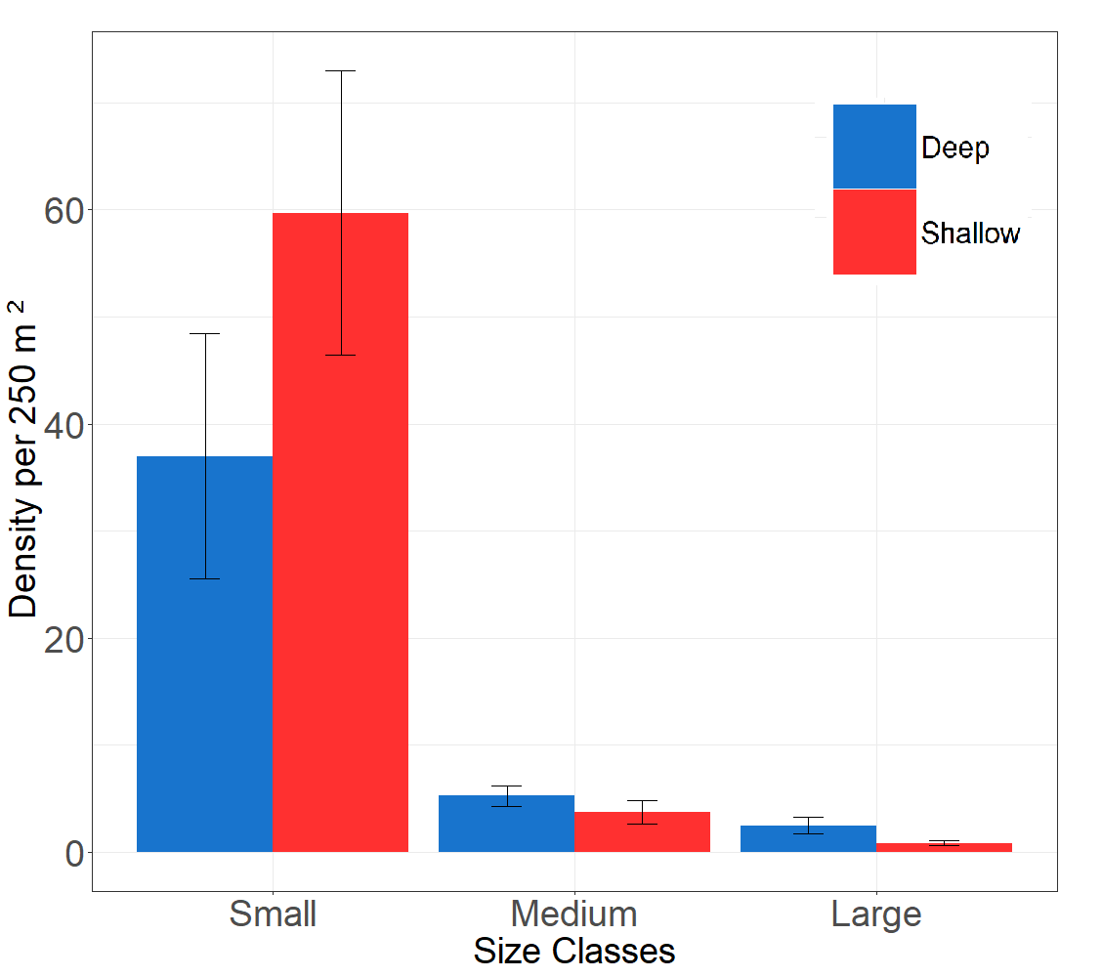
Fig S1. Parrotfish abundances per size class across depth classes. Error bars are standard errors.

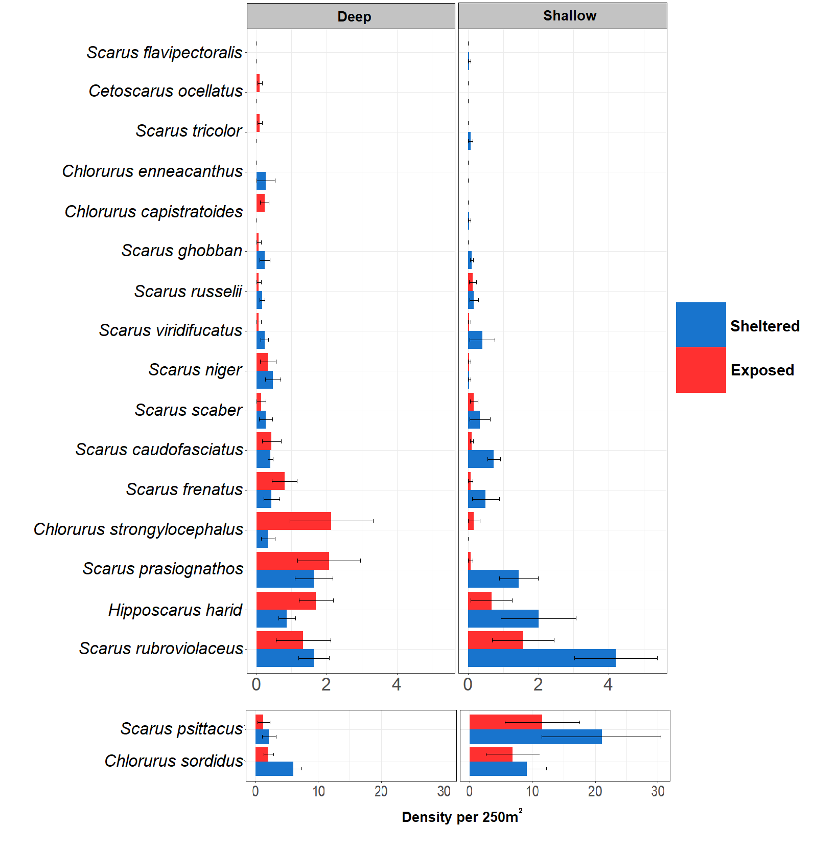
Fig S2: Parrotfish density per species across exposure classes. Error bars are standard errors
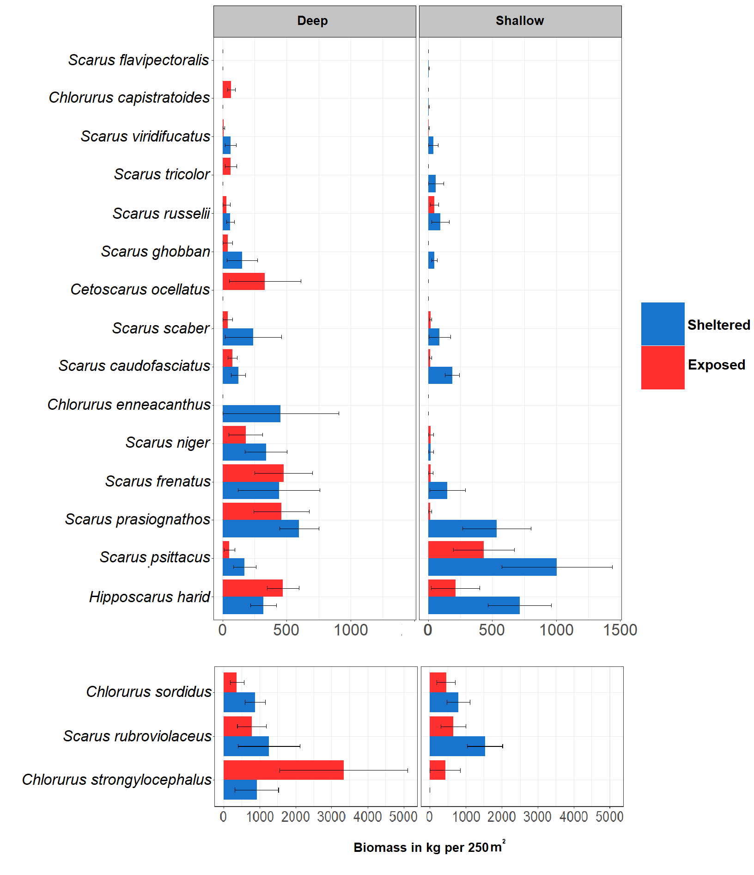Fig S3: Parrotfish biomass per species across exposure classes in kg per transect. Error bars are standard errors.
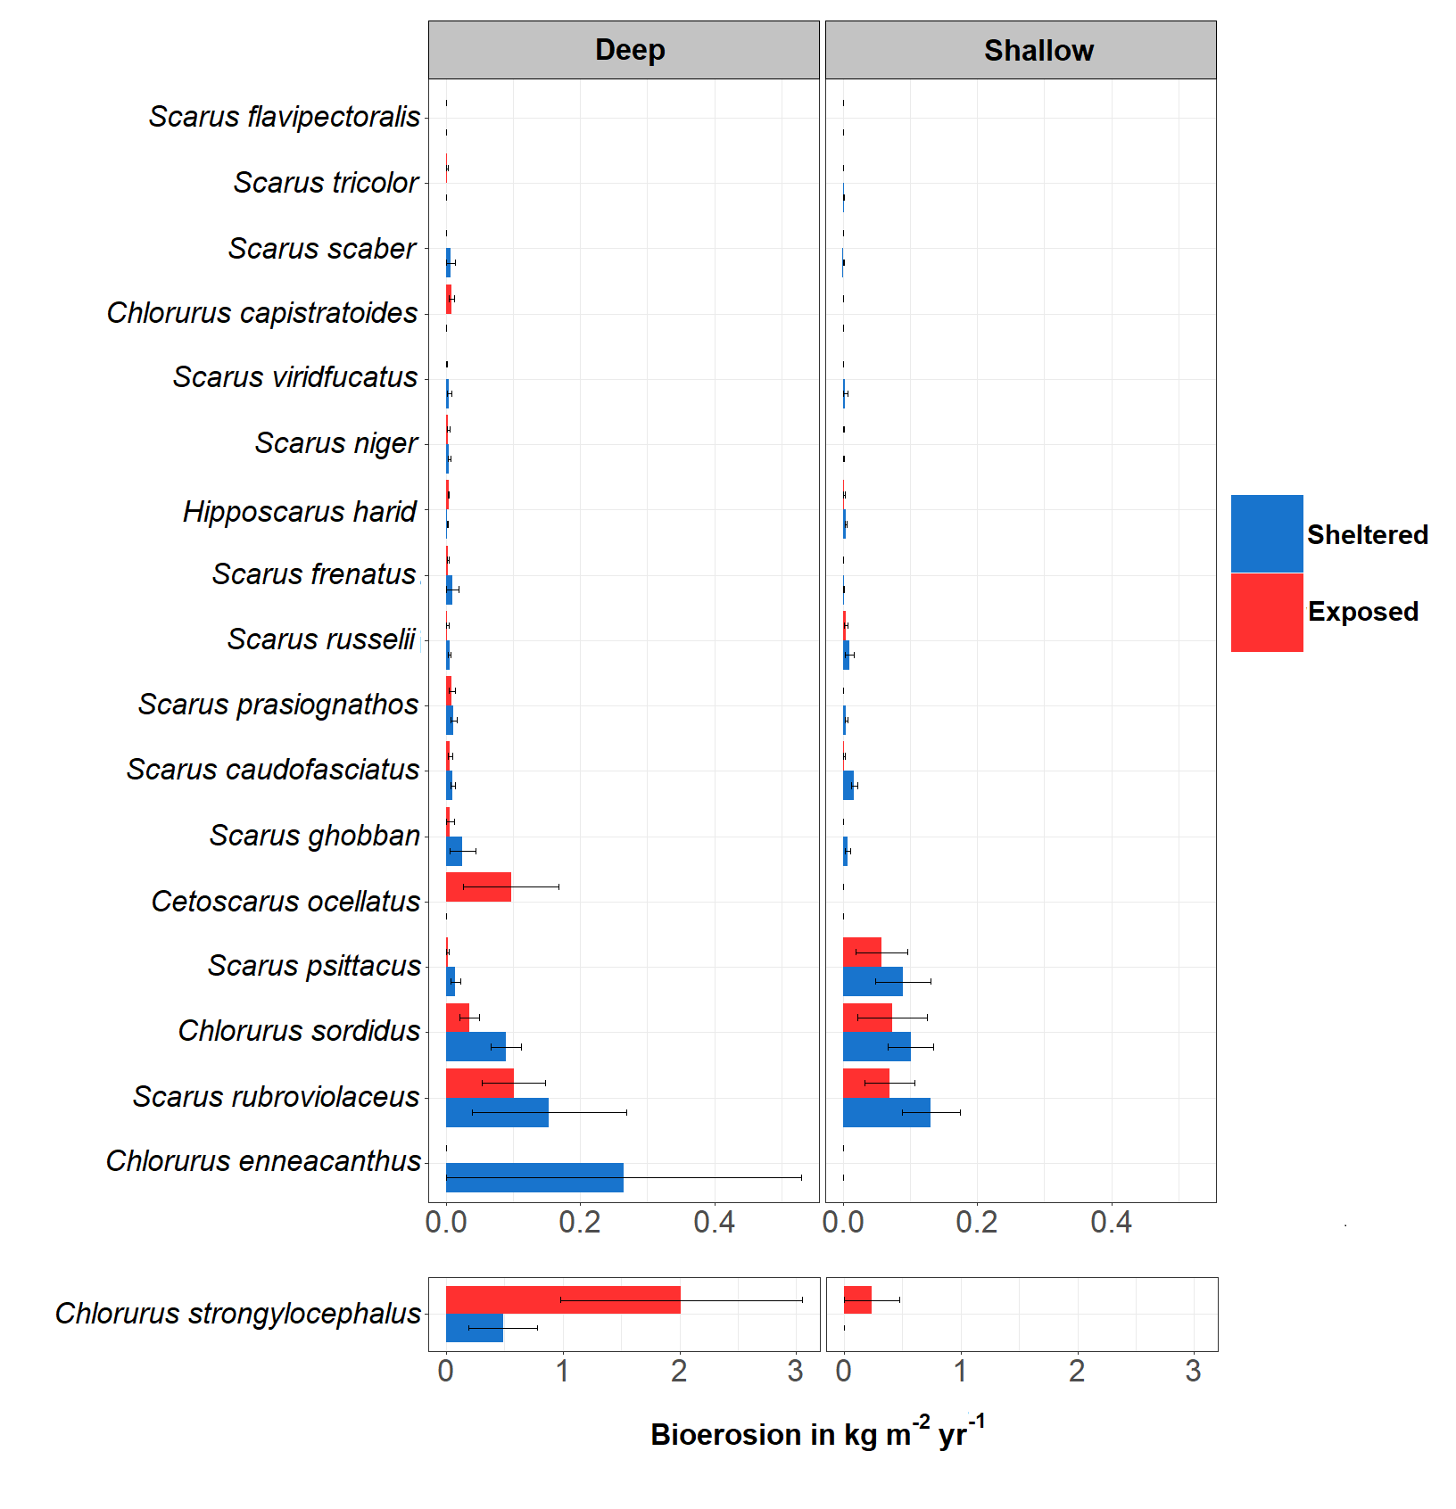
Fig S4: Parrotfish bioerosion per species across exposure classes. Error bars are standard errors.

