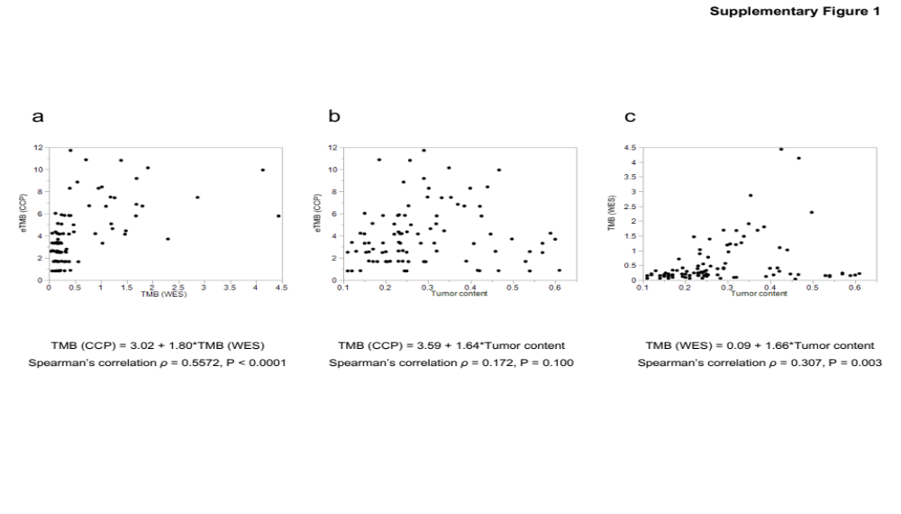
Supplementary Fig.1. The comparison of the TMB between WES and CCP
- Scatter plots of the TMB from WES vs. the TMB from CCP
- A correlation analysis of tumor cellularity with the TMB from WES
- A correlation analysis of tumor cellularity with the TMB from CCP
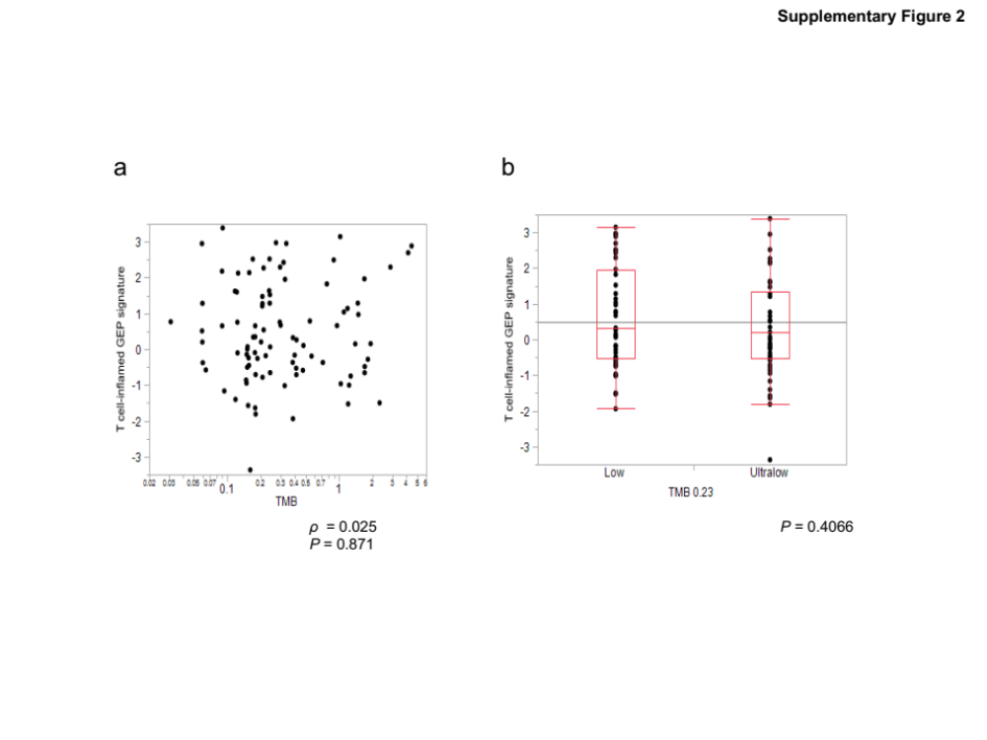
Supplementary Fig.2. Response prediction of ICI in TMB-ultralow tumors
- Scatter plots of the TMB from WES vs. the TMB from CCP
- A comparison of T cell-inflamed GEP signature between TMB-ultra-low PC and TMB-low PC

