Trial protocol
Patients were admitted to the operating room, monitors were connected to monitors for oxygen saturation (SpO₂), electrocardiogram (ECG), heart rate (HR), noninvasive blood pressure (NIBP), partial pressure of end-expiratory carbon dioxide (P_{ET}CO₂), and Bispectral index (BIS), and all patients underwent radial artery puncture for pressure measurement under local anesthesia, and mean arterial pressure (MAP) and HR before induction were recorded.
Anesthesia induction: intravenous access was opened, midazolam (0.03 mg/kg), etomidate (0.3 mg/kg) and sufentanil (0.5ug/kg) were injected, and after the patients lost consciousness and before the administration of cis-atracurium, neuromuscular monitoring was performed: the non-infusion test forearm and fingers were fixed and sterilized, displacement sensors were installed in the thumb and index finger, Ohmeda GEE-NMT-00 (E-NMT integrated neuromuscular transmission module, GE HealthCare FI-00510 Helsinki, Finland) piezoelectric method to monitor TOF changes in the thumb adductor muscle. See figure.1
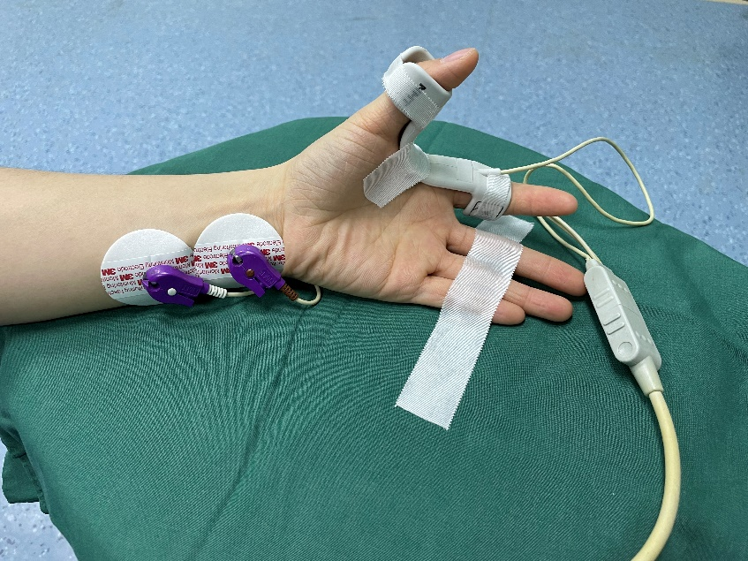
Figure.1
The signal was calibrated through supramaximal stimulation using the inbuilt function of the NMT module, the baseline of TOF stimuli were stabilized at least 2 minutes before cis-atracurium administration, then, frequency 2 Hz, wave width 0.2 ms, current intensity 60 mA, 20s interval between each series of stimuli. See figure.2
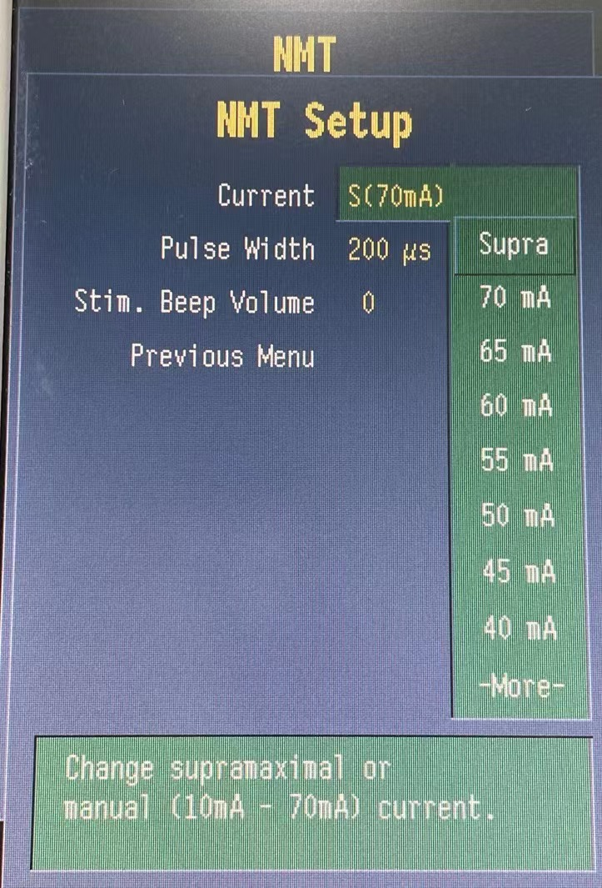
Figure.2
Every patient received 0.15mg/kg cis-atracurium (3×ED95). When TOFc was 0, tracheal intubation and parallel mechanical ventilation were performed, respiratory parameters were set to tidal volume 6-8 ml/kg, inhaled Oxygen concentration was 60%, oxygen flow rate was 2 L/min, and respiratory rate was adjusted to maintain P_{ET}CO₂ at 35~45 mmHg.
Anesthesia maintenance: Intraoperative propofol 4~10 mg/(kg-h) and remifentanil 0.1~0.3μg/(kg-min) were used to maintain BIS value at 40~60. Vasoactive drugs were used according to blood pressure and heart rate changes to maintain HR and MAP fluctuated by no more than 20% of the basal value. All patients used ropivacaine injection (10 ml: 75 mg) diluted to 20 ml and performed ultrasound-guided bilateral transversus abdominis plane nerve blocks; medical warmers and heating blankets were used to maintain the nasopharyngeal temperature of patients at 36.0~37.2℃. When the TOFc was 1, the microinjection pump was turned on and cis-atracurium 1.5μg/(kg-min) was continuously pumped to maintain the TOFc at 1~2.
Discontinuation and extubation: 30 minutes before the end of surgery, stop the pumping of inotropic drugs, when TOFc≥3, inject neostigmine 40μg/kg and atropine 20μg/kg, give calcium gluconate injection 5mg/kg in C₅ group、10mg/kg in C₁₀ group、20mg/kg in C₂₀ group，all diluted to 20ml and pumped at a rate of 5ml/min. The control group was given an equal volume of 0.9% sodium chloride injection at an equal rate. At the end of surgery, remifentanil was discontinued, propofol was discontinued after TOFr≥0.70, and the tracheal tube was removed after reaching the extubation standard. When TOFr≥0.90 send to PACU. When Aldrete score≥9 send back to ward.

