Supplementary Text
“Free drug provision for tuberculosis increases patient follow-ups and successful treatment outcomes in the Indian private sector: A quasi experimental study using propensity score matching”
Ridhima Sodhi¹, Michael J. Penkunas,² Arnab Pal³
- Independent Consultant, Clinton Health Access Initiative, Inc., India
- Independent Consultant, Clinton Health Access Initiative, Inc., Boston, MA, USA
- Associate Director, Diagnostics, Surveillance and TB, Clinton Health Access Initiative, Inc., India

Appendix 1 – Baseline Summary Statistics
Table S1 summarizes the number of patients diagnosed between Jan 2019 and December 2021 who were enrolled with Project JEET under the William J. Clinton Foundation in the seven states (22 cities) running the PPSA program.

Table S1
Patients diagnosed of Tuberculosis between Jan 2019 and December 2021 across 7 states and 22 PPSA cities managed by WJCF
state | district | #patients | #treatment coordinators | minimum diagnosing date | max diagnosing date | % patients on free drugs
Bihar | Darbhanga | 15,276 | 22 | 1/1/2019 | 12/30/2021 | 17%
Bihar | Madhubani | 2,775 | 5 | 4/13/2020 | 12/30/2021 | 33%
Bihar | Muzaffarpur | 5,709 | 6 | 9/1/2019 | 12/31/2021 | 26%
Bihar | Purba Champaran | 8,292 | 6 | 9/1/2019 | 12/30/2021 | 36%
Bihar | Purnia | 6,329 | 5 | 9/1/2019 | 12/30/2021 | 40%
Bihar | Saran | 5,098 | 5 | 9/2/2019 | 12/31/2021 | 44%
Delhi | Delhi | 41,728 | 76 | 1/1/2019 | 12/31/2021 | 18%
Gujarat | Ahmedabad | 25,186 | 46 | 1/1/2019 | 12/31/2021 | 49%
Gujarat | Surat | 22,090 | 25 | 1/1/2019 | 12/31/2021 | 49%
Haryana | Faridabad | 3,035 | 1 | 7/1/2020 | 12/27/2021 | 23%
Haryana | Gurgaon | 8,559 | 10 | 1/1/2019 | 12/31/2021 | 34%
Haryana | Rohtak | 2,819 | 5 | 1/1/2020 | 12/31/2021 | 22%
Madhya Pradesh | Bhopal | 9,741 | 13 | 1/1/2019 | 3/27/2021 | 45%
Madhya Pradesh | Indore | 8,492 | 15 | 1/1/2019 | 3/31/2021 | 45%
Rajasthan | Ajmer | 3,896 | 4 | 6/1/2020 | 12/30/2021 | 12%
Rajasthan | Bikaner | 4,360 | 5 | 10/1/2019 | 12/30/2021 | 20%
Rajasthan | Jaipur | 28,120 | 23 | 1/1/2019 | 12/31/2021 | 6%
Rajasthan | Jodhpur | 4,072 | 12 | 5/10/2020 | 12/31/2021 | 16%
Rajasthan | Kota | 4,387 | 9 | 5/15/2020 | 12/31/2021 | 13%
Rajasthan | Sikar | 5,564 | 4 | 10/1/2019 | 12/31/2021 | 22%
Rajasthan | Udaipur | 4,290 | 7 | 5/15/2020 | 12/25/2021 | 17%
Tamil Nadu | Chennai | 3,811 | 31 | 1/1/2019 | 3/29/2021 | 12%
Grand Total |  | 223,629 | 335

Table S2 details the decisions taken at each stage to arrive at the final analytical dataset consisting of 42,562 patients, who were diagnosed across seven districts in India. This dataset was then used for matching using propensity scores.

Table S2
Data selection process, detailed step wise
#Patients | % Retained at each stage | Data Selection Criterion at each stage
223,629 | 100.0% | Programmatic data for 22 districts, 7 states, and 7212 health facilities
91,127 | 40.7% | Patients diagnosed between 1 January 2019 and 31 March 2020
78,329 | 86.0% | Outcome declared before 31 December 2021
57,046 | 72.8% | Districts which have patients (>=1%) on free drugs across all of the six quarters (7 districts qualified)
50,149 | 87.9% | Patients ≥ 16 years old
48,867 | 97.4% | Outcome declared at least 30 days post the date of diagnosis
48,748 | 99.8% | Patients not transferred to a different district or a public facility during the treatment
48,006 | 98.5% | Doctor has not denied counselling for the patient
47,554 | 99.1% | Patient has not denied counselling
47,539 | 100.0% | Patient is not declared a non-TB patient post diagnosis
47,534 | 100.0% | Patient is not suffering from a drug resistant form of Tuberculosis
47,469 | 99.9% | Outcome was declared post the assignment of a treatment coordinator
42,881 | 90.3% | Follow-up data available for patients by a designated treatment coordinator
42,562 | 99.3% | Post outlier treatment for follow ups. This retained patients who had received ≤ 43 follow ups

Appendix 2 - Outlier Treatment for Follow Ups
Pearson’s method was followed to find skewness. The `moments` package in R was used to compute skewness, and ggplot2 was used to visualize distributions.
$$Moment Coefficient of Skewness= β_{1}=\frac{m_{3}^{2}}{m_{2}^{3}}$$
where,
- $m_{2}=\frac{1}{n}\sum_{i=1}^{n}{{\left(x_{i}-\overline{x}\right)}^{2}}$, second sample central moment
- $m_{3}=\frac{1}{n}\sum_{i=1}^{n}{{\left(x_{i}-\overline{x}\right)}^{3}}$, third sample central moment
Here, $x_{i}$ represents an individual value of the variable in question and $\overline{x}$ defines the mean of that value.
Figures SF1 visually show the skewness for the overall data, and particularly for Ahmedabad and Surat in the state of Gujarat. A tabular distribution of number of follow-ups for each district can be seen in Table S3. Since the distribution is found to not follow a normal distribution (Figure SF2), we employed the interquartile range (IQR) criterion to identify the outliers. Since this method is based on the median, it is a better choice for identifying outliers in a skewed distribution such as this [1, 2]. Iglewicz and Hoaglin [3] detail a range of methods for outlier identification and testing in their textbook. Our choice of method is based on its relative simplicity and the efficacy of application for our particular data and context.
According to this criterion, all observations above q_{0.75} + 1.5*IQR or below q_{0.25} – 1.5*IQR are considered as potential outliers. Here, q_{0.25} and q_{0.75} refer to first and third quartile respectively, and IQR is the difference between the third and first quartile. As per this criterion, observations outside the following interval were considered as potential outliers:
$$I=[{\text{q}}_{\text{0.25 }}-1.5*IQR; {\text{q}}_{\text{0.75 }}+1.5*IQR]$$
A total of 319 (0.7% of 43,092) observations were found to be outliers using these methods, all of which pertained to patients in Ahmedabad & Surat.
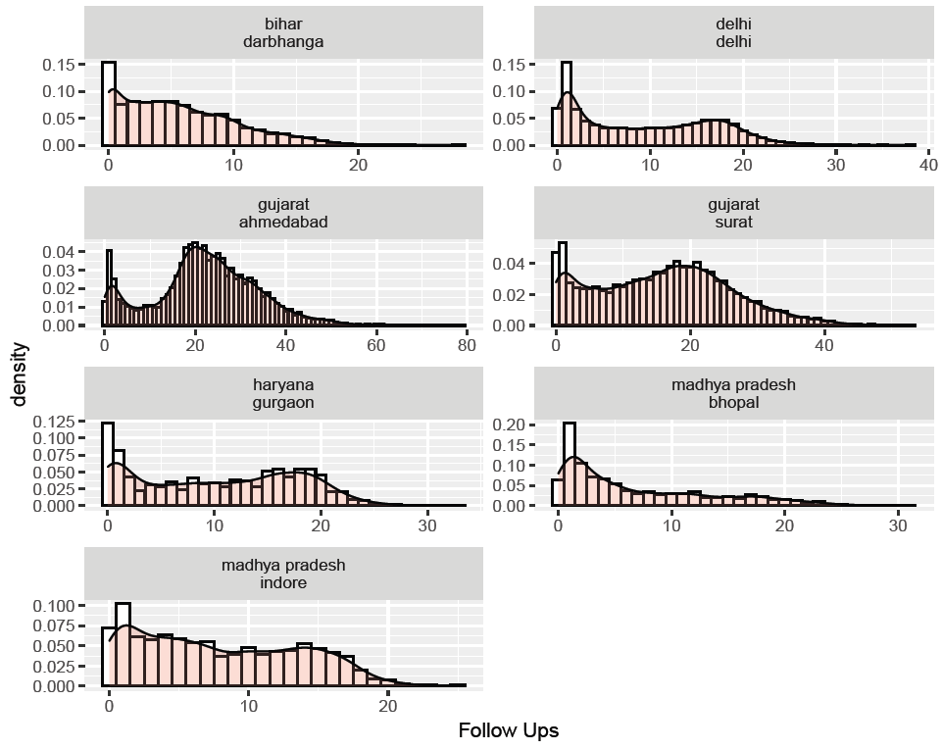
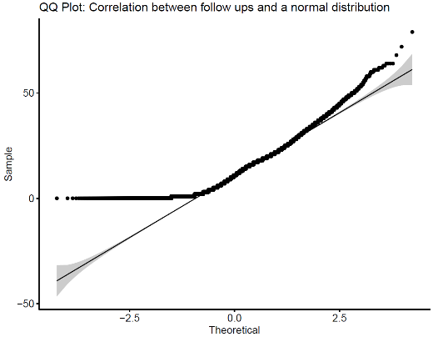
Figure SF1: Density plot overlaid on histogram for successful follow ups; by district; N= 42,881
Figure SF2: QQ Plot for follow ups; N= 42,881

Table S3
Share of patients receiving different number of follow ups, across different cities
District | None | Between 1 to 12 | Between 13-24 | Between 25-36 | Between 37-43 | Between 44-48 | ≥49 | District totals
Ahmedabad | 1% | 17% | 40% | 31% | 7% | 1.97% | 1.74% | 7,887
Bhopal | 6% | 72% | 20% | 1% | 0% | 0.00% | 0.00% | 3,931
Darbhanga | 15% | 75% | 9% | 0% | 0% | 0.00% | 0.00% | 4,547
Delhi | 7% | 56% | 36% | 1% | 0% | 0.00% | 0.00% | 14,112
Gurgaon | 12% | 44% | 42% | 1% | 0% | 0.00% | 0.00% | 2,262
Indore | 7% | 66% | 26% | 0% | 0% | 0.00% | 0.00% | 2,595
Surat | 5% | 33% | 42% | 17% | 2% | 0.30% | 0.06% | 7,547
Note: The column titles indicate the number of follow-ups, while the value in rows indicates the share of patients who received the said number of follow-ups. District totals are given in the last column

Appendix 3 –Estimating propensity scores
We utilized propensity score modelling [4–6] to create a matched dataset comprised of treated patients (free drugs) and untreated patients (no free drugs), by means of a logistic regression model, including all available potential confounders. The exact model results from the same are given in Table S4, and Table S5 displays the mean propensity scores between patients who actually received free drugs or not. The accuracy of the model is 71.1% with a specificity rate of 23.6%. Figure SF3 shows the distribution of propensity scores visually, segregated by whether or not the patient received free drugs
Table S4
Estimating propensity score using logistic regression; N = 42,562
Dependent Variable: free drugs
Male | 0.924*** (0.877, 0.971)
Age: 20-45 | 0.800*** (0.726, 0.874)
Age: 46-65 | 0.641*** (0.557, 0.725)
Age: > =65 | 0.539*** (0.420, 0.658)
Xpert testing | 2.280*** (2.226, 2.335)
Extrapulmonary | 1.159*** (1.109, 1.210)
Bhopal | 0.660*** (0.580, 0.741)
Darbhanga | 0.112** (0.006, 0.218)
Delhi | 0.137*** (0.068, 0.206)
Gurgaon | 0.327*** (0.219, 0.436)
Indore | 0.903*** (0.810, 0.996)
Surat | 0.678*** (0.611, 0.744)
Diag Qtr 2019 Q2 | 1.295*** (1.215, 1.374)
Diag Qtr 2019 Q3 | 1.662*** (1.583, 1.741)
Diag Qtr 2019 Q4 | 1.968*** (1.888, 2.048)
Diag Qtr 2020 Q1 | 2.332*** (2.254, 2.410)
Constant | 0.716*** (0.616, 0.817)
Observations | 42,562
Log Likelihood | -22,199.100
Akaike Inf. Crit. | 44,432.100
Note: a) 95% C.I. based on robust standard errors; b) *p<0.1; **p<0.05; ***p<0.01

Table S5
Propensity Score estimated by whether or not a patient received free drugs
status | N | Mean score | Median score
No free drugs provided | 29,549 | 0.25 | 0.18
Free drugs provided | 13,013 | 0.43 | 0.44
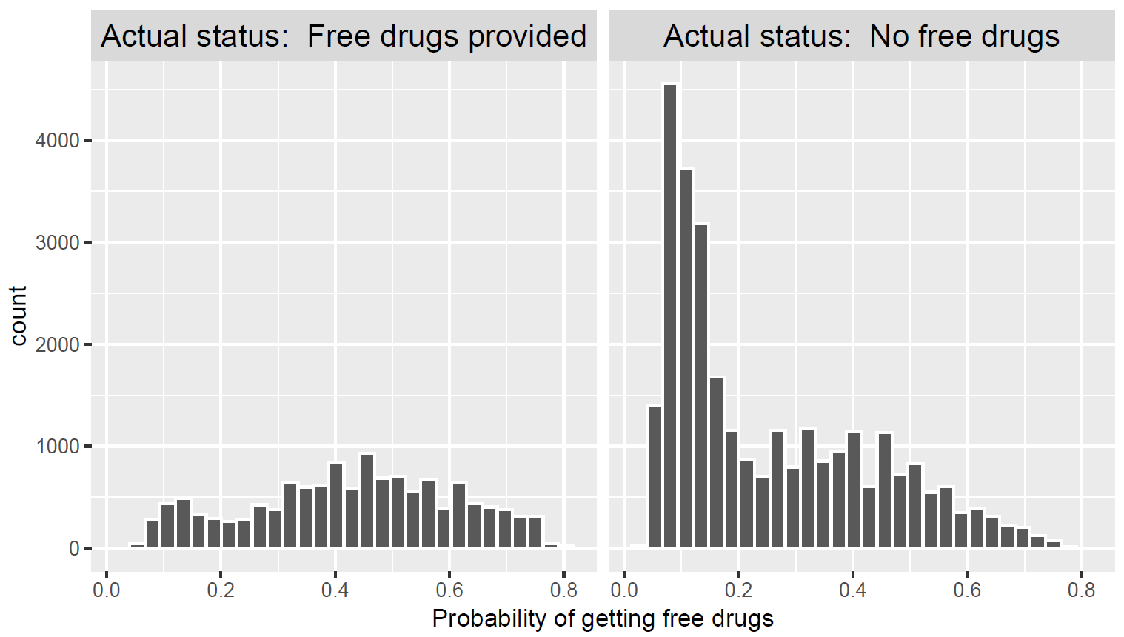
Figure SF3: Histograms of the estimated propensity scores by treatment status; N = 42,562

Appendix 4 –Results from the Matching Procedure
Table S6 depicts the summary of balance achieved for matched dataset, post the propensity choice modeling. This is tabulated in comparison with the results obtained for the observational dataset.

Table S6
Summary of balance achieved for matched dataset relative to the observational dataset
 | Unmatched Dataset (N = 42,562) |  |  |  |  | Matched Dataset; N = 23,242)
 | Means Treated | Means Control | diff | Std. Mean Diff. | Var. Ratio | Means Treated | Means Control | diff | Std. Mean Diff. | Var. Ratio
distance | 0.42 | 0.26 | 0.17 | 0.96 | 1.01 | 0.39 | 0.39 | 0.00 | 0.00 | 1.00
Age: 16-19 | 0.12 | 0.10 | 0.02 | 0.06 |  | 0.12 | 0.12 | 0.00 | 0.00
Age: 20-45 | 0.62 | 0.59 | 0.04 | 0.08 |  | 0.62 | 0.62 | 0.00 | 0.00
Age: 46-65 | 0.20 | 0.24 | -0.04 | -0.09 |  | 0.21 | 0.21 | 0.00 | 0.00
Age: >=65 | 0.05 | 0.07 | -0.02 | -0.10 |  | 0.05 | 0.05 | 0.00 | 0.00
Male | 0.56 | 0.58 | -0.02 | -0.04 |  | 0.56 | 0.56 | 0.00 | 0.00
Xpert Testing | 0.33 | 0.15 | 0.18 | 0.38 |  | 0.26 | 0.26 | 0.00 | 0.00
Extra Pulmonary | 0.32 | 0.31 | 0.02 | 0.04 |  | 0.33 | 0.33 | 0.00 | 0.00
Ahmedabad | 0.30 | 0.13 | 0.17 | 0.38 |  | 0.26 | 0.25 | 0.00 | 0.00
Bhopal | 0.13 | 0.08 | 0.05 | 0.15 |  | 0.13 | 0.12 | 0.01 | 0.03
Darbhanga | 0.04 | 0.14 | -0.10 | -0.51 |  | 0.04 | 0.04 | 0.00 | 0.00
Delhi | 0.14 | 0.42 | -0.28 | -0.80 |  | 0.16 | 0.16 | 0.00 | 0.00
Gurgaon | 0.04 | 0.06 | -0.02 | -0.07 |  | 0.04 | 0.04 | 0.00 | 0.00
Indore | 0.10 | 0.04 | 0.06 | 0.20 |  | 0.09 | 0.09 | 0.00 | -0.01
Surat | 0.25 | 0.14 | 0.11 | 0.25 |  | 0.28 | 0.29 | -0.01 | -0.02

Appendix 5 –Full Model Results; OLS Model; Matched Dataset

Table S7
Results from the full OLS model on matched dataset; N = 23,242
Dependent Variable = Successful follow ups
Constant | 5.037***
Free drugs | 2.522***
Xpert testing | 0.735
Age: 20-45 | -0.401
Age: 46-65 | -0.529
Age: > =65 | -1.435
Male | -0.298
Extrapulmonary | 1.076
Diag Qtr 2019 Q2 | 3.060
Diag Qtr 2019 Q3 | 6.024
Diag Qtr 2019 Q4 | 8.191
Diag Qtr 2020 Q1 | 9.274
Observations | 23,242
R | 0.512
Adjusted R | 0.509
Residual Std. Error | 7.178 (df = 23087)
F Statistic | 157.568 (df = 154; 23087)
Note: a) 95% C.I. based on robust standard errors; b) Model was fitted on the matched dataset; c) *p<0.1; **p<0.05; ***p<0.01; d) TC fixed effects are excluded from the output; a total of 144 TC groups were fitted

Appendix 6 –Full Model Results; Logistic Model; Matched Dataset

Table S8
Logistic Regression; Impact of free drugs on Treatment Outcomes; N = 23,242
Dependent Variable: Binary Treatment Outcome (Successful=1, Unsuccessful = 0)
 | Coefficient | Odds Ratio
(Intercept) | 16.89***
Free drugs | 0.37*** | 1.45
Xpert testing | -0.04 | 0.96
Age: 20-45 | -0.25** | 0.78
Age: 46-65 | -1.00*** | 0.37
Age: > =65 | -1.67*** | 0.19
Male | -0.13* | 0.88
Extrapulmonary | 0.27*** | 1.31
Diag Qtr 2019 Q2 | 0.101 | 1.11
Diag Qtr 2019 Q3 | -0.073 | 0.93
Diag Qtr 2019 Q4 | -0.089 | 0.91
Diag Qtr 2020 Q1 | -0.123 | 0.88
Observations | 23,242
Log Likelihood | -4,690.780
Akaike Inf. Crit. | 9,691.570
Note: a) 95% C.I. based on robust standard errors; b) Model was fitted on the matched dataset; c) *p<0.1; **p<0.05; ***p<0.01; d) TC fixed effects are excluded from the output; a total of 144 TC groups were fitted

Appendix 7 –Sensitivity Analysis; Results from Simple OLS & Logistic Models; Matched and Unmatched (observational) datasets

Table S9
Sensitivity analysis for OLS regression modelling the impact of free drugs on number of follow-ups
 | Coefficient | 95% C.I. |  | Number of observations
Base Model (Observational) | 2.531*** | 2.363 | 2.698 | 42,562
Base Model (Matched) | 2.522*** | 2.325 | 2.719 | 23,242
Base Model (Matched on TC) | 2.558*** | 2.351 | 2.764 | 19,436
Only Ahmedabad | 3.452*** | 2.975 | 3.93 | 5,924
Only Surat | 3.092*** | 2.676 | 3.509 | 6,652
Only Delhi | 2.320*** | 1.908 | 2.731 | 3,614
Only Gurgaon | 4.898*** | 4.018 | 5.778 | 1,028
Only Indore | 1.839*** | 1.494 | 2.185 | 2,019
Only Bhopal | 0.754*** | 0.405 | 1.102 | 2,995
Only Darbhanga | 0.670** | 0.156 | 1.184 | 1,010
Removing lost to follow ups (Observational) | 2.422*** | 2.254 | 2.59 | 40,965
Removing lost to follow ups (Matched) | 2.428*** | 2.23 | 2.626 | 22,622
Removing lost to follow ups (Matched on TC) | 2.454*** | 2.246 | 2.661 | 18,935
Note: a) All models control for all potential confounders, and include fixed effects for diagnosing quarter and treatment coordinator; b) 95% C.I. based on robust standard errors; c) LTFU refers to patient who were lost to follow-up, d) All district wise models are fitted on the matched dataset; e) Matched on TC refers to a matched dataset which was created by matching on treatment coordinator, and not on district. This alternative matching specification ensures an equal share of patients receiving free drugs and not receiving free drugs and results in 19,436 observations or 9718 matching pairs; f) *p<0.1; **p<0.05; ***p<0.01

Table S10
Sensitivity analysis for logistic regression, modelling the impact of free drugs on treatment outcomes
 | Free drugs |  |  | N observations
 | Coeff | 95% C.I.
Base Model (Observational) | 1.496*** | 1.353 | 1.654 | 42562
Base Model (Matched) | 1.452*** | 1.288 | 1.637 | 23242
Base Model (Matched on TC) | 1.42*** | 1.249 | 1.613 | 19436
Only Ahmedabad | 1.244** | 0.950 | 1.631 | 5924
Only Surat | 1.126 | 0.878 | 1.444 | 6652
Only Delhi | 2.148*** | 1.563 | 2.951 | 3614
Only Gurgaon | 1.869** | 1.060 | 3.297 | 1028
Only Indore | 1.173 | 0.700 | 1.967 | 2019
Only Bhopal | 1.407*** | 1.107 | 1.787 | 2995
Only Darbhanga | 1.815*** | 1.030 | 3.197 | 1010
Removing lost to follow ups (Observational) | 1.282*** | 1.121 | 1.467 | 40965
Removing lost to follow ups (Matched) | 1.245** | 1.062 | 1.460 | 22622
Removing lost to follow ups (Matched on TC) | 1.171* | 0.991 | 1.384 | 18935
Note: a) All models control for all potential confounders, and include fixed effects for diagnosing quarter and treatment coordinator; b) 95% C.I. based on robust standard errors; c) LTFU refers to patient who were lost to follow-up, d) All district wise models are fitted on the matched dataset; e) Matched on TC refers to a matched dataset which was created by matching on treatment coordinator, and not on district. This alternative matching specification ensures an equal share of patients receiving free drugs and not receiving free drugs and results in 19,436 observations or 9718 matching pairs; f) *p<0.1; **p<0.05; ***p<0.01

Appendix 8– Definition of treatment outcomes
The definition of treatment outcomes considered in the study are provided below [7].

Table S11
Definitions of treatment outcomes for drug susceptible TB patients

Treatment outcome | Definition | Study outcome | Considered for the study
Cured | Microbiologically confirmed TB patients at the beginning of treatment who was smear or culture negative at the end of the complete treatment | Successful | Yes
Treatment complete | Completed treatment without evidence of failure or clinical deterioration but with no record that the smear or culture results of biological specimen in the last month of treatment was negative | Successful | Yes
Lost to follow up | Treatment was interrupted for one consecutive month or more | Unsuccessful | Yes
Died | Died during the course of anti-TB treatment | Unsuccessful | Yes
Treatment failure | Biological specimen is positive by smear or culture at end of treatment | Unsuccessful | Yes
Not evaluated | Patients for whom no treatment outcome is assigned; also includes former transfer outs | Other outcomes (not considered) | No
Treatment regimen changed | A TB patient who is on first line regimen and has been diagnosed as having DR TB and switched to drug resistant TB regimen prior to being declared as failed | Other outcomes (not considered) | No
Wrongly diagnosed | A patient who is wrongly diagnosed of TB | Other outcomes (not considered) | No
Transferred | A patient who has transferred to another facility or state, prior to the outcome being declared | Other outcomes (not considered) | No

References
1. Seo, Songwon. A Review and Comparison of Methods for Detecting Outliers in Univariate Data Setz. Master’s thesis. Univerity of Pittsburgh; 2006.
2. Walfish S. A review of statistical outlier methods. Pharmaceutical technology. 2006;30:82.
3. Iglewicz B, Hoaglin DC. How to detect and handle outliers. Milwaukee, Wis: ASQC Quality Press; 1993.
4. Rosenbaum PR, Rubin DB. The central role of the propensity score in observational studies for causal effects. Biometrika. 1983;70:41–55.
5. Winkelmayer WC, Kurth T. Propensity scores: help or hype? Nephrology Dialysis Transplantation. 2004;19:1671–3.
6. Heinrich C, Maffioli A, Vázquez G. A Primer for Applying Propensity-Score Matching. SPD Working Paper. Inter-American Development Bank, Office of Strategic Planning and Development Effectiveness (SPD); 2010.
7. Central TB Division. Technical and Operational Guidelines for TB Control in India [Ebook]. In: Technical and Operational Guidelines for TB Control in India. New Delhi, India: Ministry of Health & Family Welfare; 2016. p. Chapter 4.

