Appendix A

Table S1. The Preferred Reporting Items for Systematic Reviews and Meta-Analyses (PRISMA) 2009 Checklist.[1]
Section/topic | # | Checklist item | Reported on page #
TITLE
Title | 1 | Identify the report as a systematic review, meta-analysis, or both. | 1
ABSTRACT
Structured summary | 2 | Provide a structured summary including, as applicable: background; objectives; data sources; study eligibility criteria, participants, and interventions; study appraisal and synthesis methods; results; limitations; conclusions and implications of key findings; systematic review registration number. | 1
INTRODUCTION
Rationale | 3 | Describe the rationale for the review in the context of what is already known. | 2
Objectives | 4 | Provide an explicit statement of questions being addressed with reference to participants, interventions, comparisons, outcomes, and study design (PICOS). | 2
METHODS
Protocol and registration | 5 | Indicate if a review protocol exists, if and where it can be accessed (e.g., Web address), and, if available, provide registration information including registration number. | 2
Eligibility criteria | 6 | Specify study characteristics (e.g., PICOS, length of follow-up) and report characteristics (e.g., years considered, language, publication status) used as criteria for eligibility, giving rationale. | 3
Information sources | 7 | Describe all information sources (e.g., databases with dates of coverage, contact with study authors to identify additional studies) in the search and date last searched. | 2-3
Search | 8 | Present full electronic search strategy for at least one database, including any limits used, such that it could be repeated. | 2-3
Study selection | 9 | State the process for selecting studies (i.e., screening, eligibility, included in systematic review, and, if applicable, included in the meta-analysis). | 3
Data collection process | 10 | Describe method of data extraction from reports (e.g., piloted forms, independently, in duplicate) and any processes for obtaining and confirming data from investigators. | 3
Data items | 11 | List and define all variables for which data were sought (e.g., PICOS, funding sources) and any assumptions and simplifications made. | 3
Risk of bias in individual studies | 12 | Describe methods used for assessing risk of bias of individual studies (including specification of whether this was done at the study or outcome level), and how this information is to be used in any data synthesis. | 3
Summary measures | 13 | State the principal summary measures (e.g., risk ratio, difference in means). | 3
Synthesis of results | 14 | Describe the methods of handling data and combining results of studies, if done, including measures of consistency (e.g., I²) for each meta-analysis. | 3
Risk of bias across studies | 15 | Specify any assessment of risk of bias that may affect the cumulative evidence (e.g., publication bias, selective reporting within studies). | 8
Additional analyses | 16 | Describe methods of additional analyses (e.g., sensitivity or subgroup analyses, meta-regression), if done, indicating which were pre-specified. | 3
RESULTS
Study selection | 17 | Give numbers of studies screened, assessed for eligibility, and included in the review, with reasons for exclusions at each stage, ideally with a flow diagram. | 3
Study characteristics | 18 | For each study, present characteristics for which data were extracted (e.g., study size, PICOS, follow-up period) and provide the citations. | Appendix S2 & S3 & S4 & S5
Risk of bias within studies | 19 | Present data on risk of bias of each study and, if available, any outcome level assessment (see item 12). | Appendix S6 & S7
Results of individual studies | 20 | For all outcomes considered (benefits or harms), present, for each study: (a) simple summary data for each intervention group (b) effect estimates and confidence intervals, ideally with a forest plot. | 4
Synthesis of results | 21 | Present results of each meta-analysis done, including confidence intervals and measures of consistency. | 4
Risk of bias across studies | 22 | Present results of any assessment of risk of bias across studies (see Item 15). | 8
Additional analysis | 23 | Give results of additional analyses, if done (e.g., sensitivity or subgroup analyses, meta-regression [see Item 16]). | 3-5
DISCUSSION
Summary of evidence | 24 | Summarize the main findings including the strength of evidence for each main outcome; consider their relevance to key groups (e.g., healthcare providers, users, and policy makers). | 5-7
Limitations | 25 | Discuss limitations at study and outcome level (e.g., risk of bias), and at review-level (e.g., incomplete retrieval of identified research, reporting bias). | 7
Conclusions | 26 | Provide a general interpretation of the results in the context of other evidence, and implications for future research. | 8
FUNDING
Funding | 27 | Describe sources of funding for the systematic review and other support (e.g., supply of data); role of funders for the systematic review. | 8

Appendix B

Table S2. Search strategies to identify studies reporting the prevalence and risk factor for antibiotic utilization in children in China.
- English database
- Pubmed
Search | Query | Items found
#7 | Search: ((((anti-bacterial agents [MeSH Terms]) AND (antibiot*[Title/Abstract] OR antimicrobial*[Title/Abstract] OR anti-biotic[Title/Abstract] OR anti-microbial[Title/Abstract] OR anti-bacterial[Title/Abstract] OR agents, anti-bacterial[Title/Abstract] OR antibacterial agents[Title/Abstract])) AND (((epidemiology [MeSH Terms]) OR (prevalence rate [Title/Abstract] OR epidemic [Title/Abstract] OR epidemiological investigation[Title/Abstract] OR distribution[Title/Abstract] OR rate*[Title/Abstract] OR ratio[Title/Abstract] OR proport*[Title/Abstract] OR percent*[Title/Abstract])) OR ((risk factor[MeSH Terms]) OR (cause OR drive OR driving OR predict* OR determinant* OR mechanism OR risk factor)))) AND ((infant OR child OR adolescent[MeSH Terms]) OR (preschool[Title/Abstract] OR child*[Title/Abstract] OR adolesen*[Title/Abstract] OR teen*[Title/Abstract] OR youth*[Title/Abstract] OR neonat*[Title/Abstract] OR pre-school[Title/Abstract] OR new-born [Title/Abstract]))) AND (China[Title/Abstract] OR Chinese[Title/Abstract]) | 479
#6 | Search: China [Title/Abstract] OR Chinese [Title/Abstract] | 348,637
#5 | Search: (infant OR child OR adolescent [MeSH Terms]) OR (preschool [Title/Abstract] OR child*[Title/Abstract] OR adolesen*[Title/Abstract] OR teen*[Title/Abstract] OR youth*[Title/Abstract] OR neonat*[Title/Abstract] OR pre-school [Title/Abstract] OR new-born [Title/Abstract]) | 4,316,709
#4 | Search: ((epidemiology [MeSH Terms]) OR (prevalence rate [Title/Abstract] OR epidemic [Title/Abstract] OR epidemiological investigation [Title/Abstract] OR distribution [Title/Abstract] OR rate*[Title/Abstract] OR ratio [Title/Abstract] OR proport*[Title/Abstract] OR percent*[Title/Abstract])) OR ((risk factor [MeSH Terms]) OR (cause OR drive OR driving OR predict* OR determinant* OR mechanism OR risk factor)) | 15,657,921
#3 | Search: (risk factor [MeSH Terms]) OR (cause OR drive OR driving OR predict* OR determinant* OR mechanism OR risk factor) | 13,136,935
#2 | Search: (epidemiology [MeSH Terms]) OR (prevalence rate [Title/Abstract] OR epidemic [Title/Abstract] OR epidemiological investigation [Title/Abstract] OR distribution [Title/Abstract] OR rate*[Title/Abstract] OR ratio [Title/Abstract] OR proport*[Title/Abstract] OR percent*[Title/Abstract]) | 5,238,710
#1 | Search: (anti-bacterial agents [MeSH Terms]) AND (antibiot*[Title/Abstract] OR antimicrobial*[Title/Abstract] OR anti-biotic [Title/Abstract] OR anti-microbial [Title/Abstract] OR anti-bacterial [Title/Abstract] OR agents, anti-bacterial [Title/Abstract] OR antibacterial agents [Title/Abstract]) | 197,830
- Web of Science
Search | Query | Items found
#7 | #6 AND #5 AND #4 AND #1 | 2,450
#6 | TS= (China OR Chinese) | 1,761,831
#5 | TS= (infant OR preschool OR child* OR adolesen* OR teen* OR youth* OR neonat* OR pre-school OR new-born) | 4,650,903
#4 | #3 OR #2 | 29,814,295
#3 | TS= (risk factor OR cause OR drive OR driving OR predict* OR determinant* OR mechanism) | 17,088,808
#2 | TS= (epidemiology OR prevalence rate OR epidemic OR epidemiological investigation OR distribution OR rate* OR ratio OR proport* OR percent*) | 18,213,422
#1 | TS= (antibiot* OR antibacterial OR antimicrobial* OR anti-biotic OR anti-microbial OR anti-bacterial) | 1,288,160
- Embase
Search | Query | Items found
#7 | #1 AND #4 AND #5 AND #6 | 547
#6 | china:ab,ti OR chinese:ab,ti | 431,292
#5 | infant:ab,ti OR preschool:ab,ti OR child*:ab,ti OR adolesen*:ab,ti OR teen*:ab,ti OR youth*:ab,ti OR neonat*:ab,ti OR 'pre school':ab,ti OR 'new born':ab,ti | 2,307,826
#4 | #2 OR #3 | 10,592,493
#3 | 'risk factor':ab,ti OR cause:ab,ti OR drive:ab,ti OR driving:ab,ti OR predict*:ab,ti OR determinant*:ab,ti OR mechanism:ab,ti | 5,198,010
#2 | epidemiology:ab,ti OR 'prevalence rate':ab,ti OR epidemic:ab,ti OR 'epidemiological investigation':ab,ti OR distribution:ab,ti OR rate*:ab,ti OR ratio:ab,ti OR proport*:ab,ti OR percent*:ab,ti | 6,979,968
#1 | antibiot*:ab,ti OR antibacterial:ab,ti OR antimicrobial*:ab,ti OR 'anti biotic':ab,ti OR 'anti microbial':ab,ti OR 'anti bacterial':ab,ti | 672,477
- Chinese database
Database |  | Query | Items
 | Chongqing VIP | M=(抗生素 OR 抗菌素 OR 抗菌药 OR 抗微生物) AND M=(影响因素 OR 危险因素 OR 决定因素 OR 高危因素 OR 原因 OR 率 OR 流行病 OR 分布) AND M=(婴儿 OR 新生儿 OR 幼儿 OR 小儿 OR 患儿 OR 儿童 OR 青少年 OR 未成年) | 385
 | CNKI | (KY % '抗生素'+'抗菌素'+'抗菌药'+'抗微生物') AND (SU % '影响因素'+ '危险因素'+'决定因素'+'高危因素'+'原因'+'率'+'流行率'+'分布') AND (SU % '婴儿'+ '新生儿'+ '幼儿'+ '小儿'+ '患儿'+ '儿童'+ '青少年'+ '未成年') | 2,450
 | Wan Fang | 题名或关键词:(抗生素 OR 抗菌素 OR 抗菌药 OR 抗微生物)*主题:(影响因素 OR 危险因素 OR 决定因素 OR 高危因素 OR 原因 OR 率 OR 流行病 OR 分布)*主题:(婴儿 OR 新生儿 OR 幼儿 OR 小儿 OR 患儿 OR 儿童 OR 青少年 OR 未成年) | 3,662
CNKI: China National Knowledge Infrastructure

Appendix C

Table S3. Detailed characteristics of the included articles (outpatient, n=35).
Study  (Publication Year) | Study Period | Province | Geographical Region | Setting | Hospital Levels | Sample Size (N) | Age | Number of Children with Antibiotics(n) | Number of Children with Single Antibiotic | Number of Children with Combined Antibiotic
Liang X, et al. (2010)[2] | 2009-2010 | Guangdong | eastern | urban | 3 | 5585 | 0-14 | 5362 | 4466 | 896
Hu X (2010)[3] | 2010 | Chongqing | western | urban | 2 | 859 | 0-12 | 611 | 298 | 313
Chen C, et al. (2010)[4] | 2010 | Guangdong | eastern | urban | 3 | 1000 | 0-14 | 833 | 649 | 184
Zhang J (2011)[5] | 2010 | Tianjin | eastern | urban | 3 | 6996 | 0-14 | 3541 | 3460 | 81
Wang J, et al. (2011)[6] | 2010 | Guangdong | eastern | urban | 3 | 1000 | 0-14 | 799 | 439 | 360
Li X (2011)[7] | 2009-2010 | Hunan | central | urban | 2 | 756 | 0-14 | 522 | 489 | 33
Liang J, et al. (2012)[8] | 2010 | Guangdong | eastern | urban | 1 | 500 | 0-15 | 354 | 146 | 208
Huang X, et al. (2012)[9] | 2012 | Jiangsu | eastern | urban | 3 | 194 | 0-14 | 62 | NA | NA
Li H (2012)[10] | 2010 | Shandong | eastern | urban | 3 | 2111 | 0-14 | 1326 | NA | NA
Chen L (2012)[11] | 2012 | Jiangsu | eastern | urban | 3 | 6687 | 0-14 | 3423 | NA | NA
Zhou H, et al. (2012)[12] | 2011 | Fujian | eastern | urban | 3 | 3360 | 0-14 | 1441 | 1279 | 162
Li L, et al. (2013)[13] | 2011-2012 | Shanxi(陕西) | western | urban | 3 | 1272 | 0-14 | 1015 | 965 | 50
Xiao B (2013)[14] | 2011 | Sichuan | western | urban | 3 | 3256 | 0-14 | 1553 | 1366 | 187
Chen H, et al. (2013)[15] | 2012 | Guangdong | eastern | urban | 2 | 4172 | 3m-5 | 315 | NA | NA
Liu H (2013)[15] | 2012-2014 | Hebei | eastern | urban | 2 | 2178 | 0-8 | 814 | 198 | 616
Miao C, et al. (2014)[17] | 2012 | Guangdong | eastern | urban | 3 | 1000 | 0-14 | 457 | NA | NA
Zeng Y (2014)[18] | 2012 | Hunan | central | urban | 3 | 1230 | 0-14 | 788 | NA | NA
Gui M, et al. (2014)[19] | 2010 | Henan | central | urban | 2 | 1000 | 0-5 | 1000 | 873 | 127
Gui M, et al. (2014)[19] | 2010 | Henan | central | urban | 2 | 1000 | 0-5 | 960 | 907 | 53
Gui M, et al. (2014)[19] | 2010 | Henan | central | urban | 2 | 1000 | 0-5 | 879 | 879 | 0
Yuan Y, et al. (2015)[20] | 2011-2010 | Beijing | eastern | urban | 3 | 37211 | 0-18 | 21864 | NA | NA
Xu P, et al. (2015)[21] | 2014 | Shandong | eastern | urban | 1 | 600 | 0-14 | 586 | 337 | 249
Xu X, et al. (2015)[22] | 2014-2015 | Guangdong | eastern | urban | 1 | 300 | 2m-12 | 120 | 106 | 14
Gao Y, et al. (2016)[23] | 2015 | Xinjiang | western | rural | 1 | 566 | 2-12 | 513 | 513 | 0
Xie Y (2016)[24] | 2015 | Anhui | central | urban | 3 | 258 | 1-13 | 214 | NA | NA
Lin Y, et al. (2016)[25] | 2014-2015 | Yunnan | western | urban | 3 | 600 | 0-14 | 430 | 430 | 0
Wang J (2016)[26] | 2011-2014 | Hebei | eastern | urban | 3 | 1300 | 0-11 | 1020 | NA | NA
Wang S (2017)[27] | 2016 | Jiangsu | eastern | urban | 3 | 28069 | 0-14 | 15692 | NA | NA
Pan Y (2017)[28] | 2016 | Shanghai | eastern | urban | 3 | 1000 | 0-14 | 532 | 532 | 0
Nie C, et al. (2017)[29] | 2017 | Yunnan | western | urban | 2 | 1087 | 0-14 | 511 | 494 | 17
Zhang Z, et al. (2017)[30] | 2014 | Guangxi | eastern | rural | 2 | 8166 | 2-14 | 2736 | 1438 | 1298
Zhang Z, et al. (2017)[30] | 2014 | Guangxi | eastern | rural | 1 | 877 | 2-14 | 593 | 506 | 87
Wei X, et al. (2017)[31] | 2015-2016 | Guangxi | eastern | rural | 1 | 2349 | 2-14 | 1936 | 1661 | 275
Wei X, et al. (2017)[31] | 2015-2016 | Guangxi | eastern | rural | 1 | 2548 | 2-14 | 1922 | 1667 | 255
Wei X, et al. (2017)[32] | 2014 | Guangxi | eastern | rural | 1 | 4452 | 2-14 | 399 | 30 | 369
Wei X, et al. (2017)[32] | 2011 | Guangxi | eastern | rural | 1 | 1809 | 2-14 | 1590 | 873 | 717
Wei X, et al. (2017)[32] | 2014 | Guangxi | eastern | rural | 1 | 2333 | 2-14 | 2018 | 1259 | 759
Wang Z, et al. (2018)[33] | 2016 | Jiangsu | eastern | rural | 1 | 466 | 0-16 | 304 | NA | NA
Wang C (2019)[34] | 2015-2016 | Shanxi(陕西) | western | urban | 2 | 900 | 0-14 | 738 | 617 | 121
Wei X, et al. (2019)[35] | 2015 | Guangxi | eastern | rural | 1 | 1400 | 2-14 | 1063 | NA | NA
Wei X, et al. (2019)[35] | 2015 | Guangxi | eastern | rural | 1 | 1400 | 2-14 | 1171 | NA | NA
Peng L, et al. (2019)[36] | 2017-2018 | Shandong | eastern | urban | 3 | 1541 | 0-14 | 1199 | 713 | 486
NA: not available

Table S4. Detailed characteristics of the included articles (inpatient, n=44).
Study  (Publication Year) | Study Period | Province |  | Geographical Region |  | Setting |  | Hospital Levels |  | Sample Size (N) |  | Age | Number of Children with Antibiotics(n) |  | Number of Children with Single Antibiotic |  |  | Number of Children with Antibiotic Combination
Wei X, et al. (2017) [32] | 2011 | Guangxi | eastern |  | rural |  | 2 |  | 74 |  | 2-14 |  |  | 47 |  | NA | NA
Wei X, et al. (2017) [32] | 2014 | Guangxi | eastern |  | rural |  | 2 |  | 51 |  | 2-14 |  |  | 38 |  | NA | NA
Wei X, et al. (2017) [32]  He D (2011)[37]  Cui Y (2011)[38]  Qiu Z, et al. (2011)[39]  Xie H, et al. (2011)[40] | 2011  2009-2010  2010-2011  2009-2011  2008-2010 | Guangxi  Guizhou  Sichuan  Guangdong  Sichuan | eastern  western  western  eastern  western |  | rural  urban  urban  urban  urban |  | 2  2  3  3  3 |  | 59  877  1560  200  900 |  | 2-14  1m-14  3m-15  1m-13  0-14 |  |  | 49  877  1017  195  900 |  | NA  613  538  65  765 | NA  264  479  130  135
Chen J, et al. (2011)[41] | 2010 | Guangdong | eastern |  | urban |  | 3 |  | 341 |  | 1m-14 |  |  | 328 |  | NA | NA
Lin Y, et al. (2011) [42] | 2008-2010 | Hainan | eastern |  | urban |  | 3 |  | 132 |  | 9m-14 |  |  | 52 |  | 48 | 4
Liang Z, et al. (2011)[43] | 2009-2010 | Guangdong | eastern |  | urban |  | 3 |  | 180 |  | 1d-12 |  |  | 122 |  | 40 | 82
Zhou L (2012)[44] | 2011 | Guangxi | eastern |  | urban |  | 2 |  | 426 |  | 0-14 |  |  | 293 |  | 293 | 0
Bian H, et al. (2012)[45] | 2010-2011 | Jiangsu | eastern |  | urban |  | 3 |  | 360 |  | 0-14 |  |  | 320 |  | 179 | 141
Fang J (2012)[46] | 2010 | Sichuan | western |  | urban |  | 2 |  | 196 |  | 0-14 |  |  | 193 |  | 141 | 52
Wu J (2012)[47] | 2010-2011 | Guangdong | eastern |  | urban |  | 2 |  | 213 |  | 0-14 |  |  | 213 |  | 138 | 75
Wu W (2012)[48] | 2011 | Sichuan | western |  | urban |  | 3 |  | 2466 |  | 1m-13 |  |  | 2424 |  | 898 | 1526
He M (2012)[49] | 2009-2011 | Hunan | central |  | urban |  | 2 |  | 360 |  | 2-12 |  |  | 326 |  | 98 | 228
Guan L (2012)[50] | 2010 | Anhui | central |  | urban |  | 3 |  | 628 |  | 1m-14 |  |  | 467 |  | 428 | 39
Jiang L, et al. (2012)[51] | 2011 | Xinjiang | western |  | urban |  | 3 |  | 1148 |  | 0-16 |  |  | 1087 |  | 709 | 378
Zhu J, et al. (2012)[52] | 2007-2010 | Yunnan | western |  | urban |  | 3 |  | 7400 |  | 1-28d |  |  | 2675 |  | NA | NA
Wang Q, et al. (2012)[53] | 2011 | Shandong | eastern |  | urban |  | 3 |  | 1289 |  | 0-17 |  |  | 1264 |  | 945 | 319
Che Y, et al. (2013)[54] | 2010-2011 | Shanxi(陕西) | western |  | urban |  | 2 |  | 447 |  | 1-30 days |  |  | 395 |  | 32 | 363
Lu J, et al. (2013)[55] | 2011-2013 | Guangxi | eastern |  | urban |  | 3 |  | 2258 |  | 0-14 |  |  | 1867 |  | 410 | 1457
Xu J (2013)[56] | 2012 | Zhejiang | eastern |  | urban |  | 3 |  | 1188 |  | 2m-13 |  |  | 1099 |  | 1040 | 59
Huang X, et al. (2013)[57] | 2011 | Sichuan | western |  | urban |  | 3 |  | 215 |  | 0-14 |  |  | 199 |  | 136 | 63
Zhan J, et al. (2013)[58] | 2012-2013 | Guangdong | eastern |  | urban |  | 2 |  | 360 |  | 3-5 |  |  | 325 |  | 69 | 256
Li C, et al. (2013)[59] | 2010 | Nationwide | nationwide |  | urban |  | 3 |  | 3607 |  | 1-28d |  |  | 2724 |  | NA | NA
Li C, et al. (2013)[59] | 2010 | Nationwide | nationwide |  | urban |  | 3 |  | 9874 |  | 1-18 |  |  | 8113 |  | NA | NA
Yao Q, et al. (2014)[60] | 2010-2012 | Anhui | central |  | urban |  | 3 |  | 800 |  | 0-14 |  |  | 700 |  | 349 | 351
Wu M, et al. (2014)[61] | 2012 | Guangdong | eastern |  | urban |  | 2 |  | 240 |  | 0-14 |  |  | 227 |  | 85 | 142
Zhu G, et al. (2014)[62] | 2012 | Jiangsu | eastern |  | urban |  | 3 |  | 1269 |  | 34d-4 |  |  | 1132 |  | 708 | 424
Liu Y (2014)[63] | 2014 | Guizhou | western |  | urban |  | 2 |  | 240 |  | 0-14 |  |  | 205 |  | NA | NA
Huang W (2014)[64] | 2013 | Guangxi | eastern |  | urban |  | 3 |  | 395 |  | 0-13 |  |  | 347 |  | 285 | 62
Huang G, et al. (2014)[65] | 2011 | Guangxi | eastern |  | urban |  | 3 |  | 1139 |  | 1-28d |  |  | 876 |  | 774 | 102
Cheng X, et al. (2014)[66] | 2013 | Guangdong | eastern |  | urban |  | 3 |  | 297 |  | 1m-14 |  |  | 258 |  | 146 | 112
Cheng H, et al. (2014)[67] | 2013 | Hubei | central |  | urban |  | 3 |  | 1352 |  | 0-14 |  |  | 1306 |  | 814 | 492
Chen Y, et al. (2015)[68] | 2014 | Jiangsu | eastern |  | urban |  | 3 |  | 2286 |  | 1-28d |  |  | 2216 |  | NA | NA
Li L, et al. (2017)[69] | 2013-2014 | Hebei | eastern |  | urban |  | 2 |  | 68 |  | 0-2 |  |  | 65 |  | NA | NA
Su X, et al. (2017)[70] | 2008-2011 | Neimenggu | central |  | urban |  | 3 |  | 800 |  | 0-14 |  |  | 795 |  | 699 | 96
Su X, et al. (2017)[70] | 2012-2015 | Neimenggu | central |  | urban |  | 3 |  | 800 |  | 0-14 |  |  | 615 |  | 563 | 52
Zhu J, et al. (2017)[71] | 2015 | Guangdong | eastern |  | urban |  | 3 |  | 3349 |  | 1-28d |  |  | 2271 |  | NA | NA
Li R, et al. (2018)[72] | 2016 | Shanxi(山西) | central |  | urban |  | 3 |  | 1000 |  | 3-14 |  |  | 454 |  | NA | NA
Chen Z, et al. (2018)[73] | 2016 | Tianjin | eastern |  | urban |  | 3 |  | 918 |  | 0-10 |  |  | 454 |  | 314 | 140
Zhang J, et al. (2018)[74] | 2016-2017 | Nationwide | nationwide |  | urban |  | 3 |  | 1439 |  | 1-18 |  |  | 975 |  | 722 | 253
Zhang J, et al. (2018)[74] | 2016-2017 | Nationwide | nationwide |  | urban |  | 3 |  | 298 |  | 1-28d |  |  | 173 |  | 123 | 50
Ju J, et al. (2019)[75] | 2016-2018 | Shandong | eastern |  | urban |  | 3 |  | 236 |  | 0-15 |  |  | 139 |  | 58 | 81
Wei W, et al. (2019)[76] | 2014-2016 | Nationwide | nationwide |  | urban |  | 3 |  | 1383 |  | 0-14 |  |  | 1232 |  | 963 | 269
Niu J (2020)[77] | 2018-2019 | Ningxia | western |  | urban |  | 2 |  | 850 |  | 1m-12 |  |  | 790 |  | 650 | 140
Miao R, et al. (2020)[78] | 2018 | Sichuan | western |  | urban |  | 3 |  | 881 |  | 1-14 |  |  | 406 |  | NA | NA
Miao R, et al. (2020)[78] | 2018 | Sichuan | western |  | urban |  | 3 |  | 323 |  | 1-14 |  |  | 285 |  | NA | NA
Miao R, et al. (2020)[78] | 2018 | Sichuan | western |  | urban |  | 2 |  | 382 |  | 1-14 |  |  | 334 |  | NA | NA
Miao R, et al. (2020)[78] | 2018 | Sichuan | western |  | urban |  | 2 |  | 127 |  | 1-14 |  |  | 108 |  | NA | NA
Miao R, et al. (2020)[78] | 2018 | Sichuan | western |  | rural |  | 1 |  | 45 |  | 1-14 |  |  | 43 |  | NA | NA
Zhang M, et al. (2020)[79] | 2015 | Hebei | eastern |  | urban |  | 3 |  | 766 |  | 0-18 |  |  | 701 |  | 477 | 224
Zhang M, et al. (2020)[79] | 2016 | Hebei | eastern |  | urban |  | 3 |  | 696 |  | 0-14 |  |  | 645 |  | 287 | 358
Zhang M, et al. (2020)[79] | 2017 | Hebei | eastern |  | urban |  | 3 |  | 862 |  | 0-14 |  |  | 788 |  | 368 | 420
Zhang M, et al. (2020)[79] | 2018 | Hebei | eastern |  | urban |  | 3 |  | 657 |  | 0-14 |  |  | 611 |  | 260 | 351
NA: not available

Table S5. Detailed characteristics of the included articles (caregiver’s self-medicating of antibiotics for children at home, n=4).
Study (Publication Year) | Study Period | Province | Setting | Sample Size (N) | Number of Children with Antibiotics(n)
Cui F, et al. (2015)[80] | 2011 | Beijing | Hospital | 1412 | 218
Zhao M, et al. (2016)[81] | NA | Shanxi(陕西) | School | 1052 | 767
Yin Y, et al. (2018)[82] | 2016 | Shandong | Hospital and School | 362 | 154
Peng D, et al. (2018)[83] | NA | Zhejiang | School | 556 | 113
NA: not available

Table S6. Detailed characteristics of the included articles (risk factors, n=43).
Study  (Publication Year) | Province | No. of participants | Data Sources | Authors' conclusions and summary of key findings
Liang X, et al. (2010)[2] | Guangdong | 5585 pieces of transfusion prescriptions | outpatient department | The infusion antibiotics usage rate account for 96% of survey prescriptions. Repeated use of antibiotics is one of the risk factors of unreasonable use of drugs. The physiological characteristics of children determine the drug use.
Hu X (2010)[3] | Chongqing | 859 pieces of prescriptions | outpatient department | The utilization of antibiotics in pediatric outpatient department is reasonable. However, there are some problems, including physicians prescribe antibiotics based on practical experience, no clear indication of drug utilization and unreasonable antibiotic combination, etc.
Huang X, et al. (2012)[9] | Jiangsu | 194 pieces of prescriptions | outpatient department | The utilization of antibiotics in pediatric outpatient department is reasonable. Distribution of disease, the physiological characteristics of children are associated with high utilization of antibiotics.
Zhou H, et al. (2012)[12] | Fujian | 3360 prescriptions | outpatient department | Physicians prescribed antibiotics based on practical experience, and the traditional misunderstanding that family members regard antibiotics as "panacea" has contributed to the high utilization rate of pediatric antibiotics. The special physiological characteristics of children make it difficult to use pediatric drugs rationally in clinical practice.
Li L, et al. (2013)[13] | Shanxi(陕西) | 1272 copies of upper respiratory tract infection prescriptions | outpatient department | Antibiotics continue to be widely prescribed to treat upper respiratory tract infection. The cognition of rational drug us in clinicians is low, and they prescribe antibiotics based on practical experience.
Gui M, et al. (2014)[19] | Henan | 3000 cases of prescription with upper respiratory tract infection | outpatient department | For the upper respiratory tract infection caused mostly by virus, no pharyngeal swab bacterial culture and drug sensitivity test were performed, and there was no indication of using antibiotics, physicians prescribed antibiotics based on practical experience. Parents lack of knowledge about antibiotics, and clinicians did not attach importance to rational antibiotic use.
Yuan Y, et al. (2015)[20] | Beijing | 37211 prescriptions with upper respiratory infection | outpatient department | Antibiotics prescription rate are high for children with upper respiratory infections, particularly the prescription of broad-spectrum antibiotics and intravenous antibiotics.
Lin Y, et al. (2016)[25] | Yunnan | 600 prescriptions for upper respiratory tract infection | outpatient department | Viral infection and bacterial infection are similar in early clinical manifestations, and some clinicians tend to prophylactic medication for the purpose of "double insurance". Doctors and parents lack of knowledge about the adverse reactions of intravenous infusion.
Wang S (2017)[27] | Jiangsu | 28069 cases of respiratory tract infection | outpatient department | Most parents believe that antibiotics have a therapeutic effect on upper respiratory tract infection; at present, the doctor-patient relationship is highly strained, and outpatient doctors are afraid of taking risks and applying antibiotics.
Wang C (2019)[34] | Shanxi(陕西) | 900 cases with acute upper respiratory tract infection | outpatient department | Immunofluorescence detection is difficult to operate for some physicians. Some parents are eager to see a doctor and blindly ask doctors use drugs in a rapid and large dose in order to increase the curative effect, which easily leads to the abuse of antibiotics.
He D (2011)[37] | Guizhou | 877 cases with acute under respiratory tract | inpatient department | The utilization of antibiotics in pediatric inpatient department is unreasonable. The etiology of pneumonia in children is uncertain, leading to physicians prescribe antibiotics based on experience.
Qiu Z, et al. (2011)[39] | Guangdong | 200 cases with acute upper respiratory tract infection. | inpatient department | The phenomenon of irrational use of antibiotics for acute upper respiratory tract infection exists. There is lack of pathogen detection for children with acute upper respiratory tract infection; the caregivers’ expectations to antibiotics is associated with whether an antibiotic is prescribed.
Fang J (2012)[46] | Sichuan | 196 cases with acute upper respiratory tract infection | inpatient department | The use of antibiotics in pediatric patients with acute upper respiratory infection is a severe problem. Doctors’ understanding to etiology of acute upper respiratory tract infection in children is obscure; doctors believe that antibiotics are necessary to treat upper respiratory infections; parents lack of knowledge about antibiotics.
Wu W (2012)[48] | Sichuan | 2466 cases of infection | inpatient department | High prevalence of antibiotic utilization among hospitalized children was found in the study. The doctor-patient relationship is extremely tense, and pediatricians have been used antibiotics as a weapon to protect themselves.
Che Y, et al. (2013)[54] | Shanxi(陕西) | 447 medical records of neonates | primary hospital | The utilization of antibiotics of children is unreasonable. Doctors lack of awareness to use antibiotics rationally. Parents lack of knowledge about antibiotics, and ask doctors for antibiotics proactively. Retail pharmacies sale antibiotics without prescription.
Lu J, et al. (2013)[55] | Guangxi | 2258 cases with acute upper respiratory tract infection | inpatient department | There is a high rate of antibiotic use and low pathogens rate of children with acute respiratory tract infection. Pediatricians lack of knowledge about antibiotics.
Xu J (2013)[56] | Zhejiang | 1188 pieces of prescriptions | inpatient department | The prevalence of antibiotics use in inpatient department is high. Clinicians payed little attention to the use of antimicrobials reasonably.
Zhu G, et al. (2014)[62] | Jiangsu | 1269 medical records | inpatient department | There is a high rate of antibiotic use of children in inpatient department. Children have lower immune resistance than adults. Misunderstanding to antibiotics of pediatricians and children's parents exists.
Liu Y (2014)[63] | Guizhou | 240 medical records | inpatient department | The doctor did not adjust the antibiotics usage according to the conditions of the microbiological examination and the results of the examination.
Su X, et al. (2017)[70] | Neimenggu | 800 cases of pediatric bronchial pneumonia | inpatient department | Caregivers regarded antibiotics as panacea and retail pharmacies sale antibiotics without prescription. Community physicians who did not have the conditions or experience to test for pathogens prescribed antibiotics.
Cui F, et al. (2015)[80] | Beijing | 1500 parents of children | three hospitals | Currently antibiotics abuse still exists to some extent. The antibiotic application of the parents of children indicated cognitive deficiencies.
Yin Y, et al. (2018)[82] | Shandong | 362 parents of children | 5 hospitals and 2 kindergartens | There are abuse of antibiotics and overuse of intravenous antibiotic administration among preschool children. In addition, the parents of the children have limited knowledge about antibiotic use and its adverse effect and they do not consider indications of antibiotics administrated to their children．
Peng D, et al. (2018)[83] | Zhejiang | 2806 parents of children | a kindergarten and a primary school | Poor knowledge and massive antibiotic misuse for children among parents are of a great concern. Parents with city residence, higher education level and medical background were more likely to store antibiotics at home; parents with city residence and those store antibiotics at home were more likely to self-medicate their children with antibiotics.
Zhao M, et al. (2016)[81] | Shanxi(陕西) | 1052 children' caregivers | a kindergarten and a primary school | There are still many problems in rational use of antibiotics in children. The age, occupation and monthly income of the interviewees may be the factors influencing parents' self-medication with antibiotics in the children．
Yao Z, et al. (2013)[84] | Guangzhou | 1295 children' caregivers | kindergarten | The prevalence of self-medication with antibiotics for kindergarten children is high. The educational level of parents and antibiotics kept at home were the main determinants of self-medication with antibiotics in the children．
Miao R (2013)[85] | Sichuan | 539 pupils' parents | primary school | There were serious problems in the cognitive behaviors of pupils' parents about antibiotic use. Home-reserving antibiotics was the risk factor for parents using antibiotics independently. Parental age and medical professional of the family were protective factors.
Zhang G, et al. (2014)[86] | Beijing | 2055 children' caregivers | pediatrics medicine clinic | The level of parent’s antibiotic knowledge had been slightly improved in that 10 years. Parents’ compliance to doctor about antibiotic’s application had decreased between that 10 years. There was no significant change on the parents’ knowledge about antibiotic abuse will reduce therapy effects and will lead to bacteria resistance in that decade.
Yu M, et al. (2014)[87] | Jiangxi | 854 children' caregivers | clinics for the vaccination | Low levels of knowledge on the use of antibiotics and a high prevalence of self-medicating children with antibiotics were observed among parents in rural China. Living in rural villages, raising more than one child, increasing age of child, purchasing antibiotics without a prescription, storing antibiotics at home and good adherence to physicians’ advice were independently associated with self-medicating behavior.
Ding L, et al. (2016)[88] | Shandong | 727 children' caregivers | 12 villages in Yanggu | The rural parents’ cognition on rational use of antibiotics needs to be improved by strengthening popularity. Its main influencing factors were educational background and age of caregivers, and the relationship between caregivers and their children．
Cen Q, et al. (2016)[89] | Hubei | 80 novice mothers | community service center | Novice mothers are generally short of knowledge about the use of antibiotics, especially of knowledge about use of drugs for treating viral infections. There are errors in administration of the antibiotics and the cognitive level of novice mothers to the dangers of abusing antibiotics is limited.
Li R, et al. (2016)[90] | Nationwide | 53665 guardians of children | community health centers | There has been a high rate of antibiotic misuse without a prescription in children with diarrhea in China. Urban area, female children, higher education of guardians, being raised by parents, guardians having basic health knowledge were protective factors and children's age, 4-6 years was risk factor of antibiotic misuse among children.
Zhang Z, et al. (2016)[91] | Qinghai | 35 village doctors, 13 primary caregivers, 17 directors of township hospitals, county-level health bureaus, county-level Centers for Disease Control and Prevention, or county-level Chinese Food and Drug Administration offices. | NA | Most of the village doctors had inadequate knowledge and misconceptions about antibiotic use, which was an important factor in the unnecessary prescribing. Village doctors and directors reported that the doctors’ fear of complications, the primary caregivers’ pressure for antibiotic treatment, and the financial considerations of patient retention were the main factors influencing the decision to prescribe antibiotics.
Wang J, et al. (2017)[92] | Hunan | 310 parents of young children | community health service centers | The knowledge about rational use of antibiotics needs to be promoted among the parents of young children. The parents’ behavior of buying antibiotics from drug stores for the medication of their children are influenced by the age of their children, education level of themselves, and whether their children having been prescribed with antibiotics by doctors.
Zhang Y, et al. (2017)[93] | Shanxi(陕西) | 250 parents of young children | rural residents | The awareness rate of antibiotics in the guardians of children aged 0-6 years in the rural area is low, and guardians with low educational level as well as grandparents as the caregivers are the key groups.
Cheng Y, et al. (2017)[94] | Beijing | 4220 students | nine middle schools | The cognition of drug safety in middle school students is good, but problems still exist in medication adherence, the management of expired drugs and the antibiotics cognition.
Chang J, et al. (2018)[95] | Shanghai  Hunan  Shanxi(陕西) | 4200 caregivers of children | preschool | There was a high proportion of primary caregivers self-medicate antibiotics for children in urban China, despite their insufficient knowledge about antibiotic use.
Fan W, et al. (2019)[96] | Tianjin | 400 parents of children | 3 hospitals and 3 communities | There was a relatively high degree of antibiotic cognition among parents of preschool children in Tianjin, but there were misunderstandings in the cognition and use principles of antibiotics. Antibiotic use in children was 77.5%.
Ge Y, et al. (2019)[97] | Nationwide | 55 newborn units | 25 provinces | Antibiotic use rates were significantly different by newborn ward bed capacity. Newborn units with more than 100 beds had the highest rate of antibiotic use.
Cheng J, et al. (2019)[98] | Anhui | 960 households with children | respondents’ homes | Children with upper respiratory tract infection had a high consultation rate and a high prescription rate of antibiotics. For the children, some caregivers adopted, without rationale, ‘self -medication’ with antibiotics. Children with fever were more likely to be taken to a doctor and children with particular symptoms were more likely to receive a prescription for antibiotics.
Wang J, et al. (2019)[99] | Shanghai | 1368 young parents | three community healthcare centers | Antibiotics use is widespread over all three study sites. Lack of knowledge and poor perception of antibiotics usage are found among young parents.
Ye D, et al. (2020)[100] | Shanxi(陕西) | 472 pediatricians | online | The pediatricians' age, education level, and monthly income and whether had ever received training had significant associations with their knowledge level. Uncertain diagnosis, parent requirements and insufficient time were barriers to appropriate antibiotic prescription.
Wei X, et al. (2020)[101] | Guangxi | hospital directors, doctors, and caregivers of children | Rong County and Liujiang County | Intervention-arm doctors described that training sessions improved their knowledge, skills and confidence in appropriate prescribing. Caregiver participants reported that intervention educational materials were helpful but they identified information from doctors was more useful. Providers and caregivers also described contextual health system factors, including hospital competition, short consultation times, and antibiotic availability without prescription, which shaped care preferences.
Zhang J, et al. (2020)[102] | Asia-Pacific countries | 731 physicians | online | Chinese physicians were significantly more concerned about safety profile and antibiotic resistance when deciding for antibiotic prescription in acute respiratory symptoms with fever.

Appendix D

Table S7. Quality scores for assessing the risk of bias of in the included articles for observation study.
Score  Study (Year) | Q1 | Q2 | Q3 | Q4 | Q5 | Q6 | Q7 | Q8 | Q9 | Q10 | Q11 | Total Score
Liang X, et al. (2010)[2] | 1 | 0 | 1 | 1 | 1 | 0 | 0 | 0 | 0 | 1 | 1 | 6
Hu X (2010)[3] | 1 | 0 | 1 | 1 | 1 | 0 | 0 | 0 | 0 | 1 | 1 | 6
Chen C, et al. (2010) [4] | 1 | 1 | 1 | 1 | 1 | 0 | 0 | 0 | 0 | 1 | 1 | 7
Zhang J (2011)[5] | 1 | 0 | 1 | 1 | 1 | 0 | 0 | 0 | 0 | 1 | 1 | 6
Wang J, et al. (2011)[6] | 1 | 0 | 1 | 1 | 1 | 0 | 0 | 0 | 0 | 1 | 1 | 6
Li X (2011)[7] | 1 | 1 | 1 | 1 | 1 | 0 | 1 | 0 | 0 | 1 | 1 | 8
Liang J, et al. (2012)[8] | 1 | 0 | 1 | 1 | 1 | 0 | 0 | 0 | 0 | 1 | 1 | 6
Huang X, et al. (2012)[9] | 1 | 0 | 1 | 1 | 1 | 0 | 0 | 0 | 0 | 1 | 1 | 6
Li H (2012)[10] | 1 | 0 | 1 | 1 | 1 | 0 | 0 | 0 | 0 | 1 | 1 | 6
Chen L (2012)[11] | 1 | 1 | 1 | 1 | 1 | 0 | 0 | 0 | 0 | 1 | 1 | 7
Zhou H, et al. (2012)[12] | 1 | 1 | 1 | 1 | 1 | 0 | 1 | 1 | 0 | 1 | 1 | 9
Li L, et al. (2013)[13] | 1 | 1 | 1 | 1 | 1 | 0 | 1 | 1 | 0 | 1 | 1 | 9
Xiao B (2013)[14] | 1 | 1 | 1 | 1 | 1 | 0 | 0 | 0 | 0 | 1 | 1 | 7
Chen H, et al. (2013)[15] | 1 | 1 | 1 | 1 | 1 | 0 | 0 | 1 | 0 | 1 | 1 | 8
Liu H (2013)[16] | 1 | 1 | 1 | 1 | 1 | 0 | 1 | 1 | 0 | 1 | 1 | 9
Miao C, et al. (2014)[17] | 1 | 0 | 1 | 1 | 1 | 0 | 0 | 0 | 0 | 1 | 1 | 6
Zeng Y (2014)[18] | 1 | 0 | 1 | 1 | 1 | 0 | 0 | 0 | 0 | 1 | 1 | 6
Gui M, et al. (2014)[19] | 1 | 1 | 1 | 1 | 1 | 0 | 0 | 0 | 0 | 1 | 1 | 7
Yuan Y, et al. (2015)[20] | 1 | 1 | 1 | 1 | 1 | 0 | 1 | 1 | 0 | 1 | 1 | 9
Xu P, et al. (2015)[21] | 1 | 0 | 1 | 1 | 1 | 0 | 0 | 0 | 0 | 1 | 1 | 6
Xu X, et al. (2015)[22] | 1 | 1 | 1 | 1 | 1 | 0 | 1 | 1 | 0 | 1 | 1 | 9
Gao Y, et al. (2016)[23] | 1 | 0 | 1 | 1 | 1 | 0 | 0 | 0 | 0 | 1 | 1 | 6
Lin Y, et al. (2016)[25] | 1 | 0 | 1 | 1 | 1 | 0 | 0 | 0 | 0 | 1 | 1 | 6
Wang J (2016)[26] | 1 | 0 | 1 | 1 | 1 | 0 | 0 | 0 | 0 | 1 | 1 | 6
Wang S (2017)[27] | 1 | 1 | 1 | 1 | 1 | 0 | 1 | 0 | 0 | 1 | 1 | 8
Pan Y (2017)[28] | 1 | 1 | 1 | 1 | 1 | 0 | 0 | 0 | 0 | 1 | 1 | 7
Nie C, et al. (2017)[29] | 1 | 1 | 1 | 1 | 1 | 0 | 0 | 0 | 0 | 1 | 1 | 7
Zhang Z, et al. (2017)[30] | 1 | 1 | 1 | 1 | 1 | 0 | 1 | 1 | 0 | 1 | 1 | 9
Wei X, et al. (2017)[32] | 1 | 1 | 1 | 1 | 1 | 0 | 1 | 1 | 0 | 1 | 1 | 9
Wang Z, et al. (2018)[33] | 1 | 1 | 1 | 1 | 1 | 0 | 0 | 0 | 0 | 1 | 1 | 7
Wang C (2019)[34] | 1 | 0 | 1 | 1 | 1 | 0 | 0 | 0 | 0 | 1 | 1 | 6
Peng L, et al. (2019)[36] | 1 | 1 | 1 | 1 | 1 | 0 | 1 | 1 | 0 | 1 | 1 | 9
He D (2011)[37] | 1 | 0 | 1 | 1 | 1 | 0 | 0 | 0 | 0 | 1 | 1 | 6
Cui Y (2011)[38] | 1 | 0 | 1 | 1 | 1 | 0 | 0 | 0 | 0 | 1 | 1 | 6
Qiu Z, et al. (2011)[39] | 1 | 0 | 1 | 1 | 1 | 0 | 0 | 0 | 0 | 1 | 1 | 6
Xie H, et al. (2011)[40] | 1 | 1 | 1 | 1 | 1 | 0 | 1 | 0 | 0 | 1 | 1 | 8
Chen J, et al. (2011)[41] | 1 | 1 | 1 | 1 | 1 | 0 | 0 | 0 | 0 | 1 | 1 | 7
Lin Y, et al. (2011)[42] | 1 | 0 | 1 | 1 | 1 | 0 | 0 | 0 | 0 | 1 | 1 | 6
Liang Z, et al. (2011)[43] | 1 | 1 | 1 | 1 | 1 | 0 | 0 | 0 | 0 | 1 | 1 | 7
Zhou L (2012)[44] | 1 | 1 | 1 | 1 | 1 | 0 | 0 | 0 | 0 | 1 | 1 | 7
Bian H, et al. (2012)[45] | 1 | 1 | 1 | 1 | 1 | 0 | 0 | 0 | 0 | 1 | 1 | 7
Fang J (2012)[46] | 1 | 1 | 1 | 1 | 1 | 0 | 0 | 0 | 0 | 1 | 1 | 7
Wu J (2012)[47] | 1 | 1 | 1 | 1 | 1 | 0 | 0 | 0 | 0 | 1 | 1 | 7
Wu W (2012)[48] | 1 | 0 | 1 | 1 | 1 | 0 | 0 | 0 | 0 | 1 | 1 | 6
He M (2012)[49] | 1 | 1 | 1 | 1 | 1 | 0 | 0 | 0 | 0 | 1 | 1 | 7
Guan L (2012)[50] | 1 | 0 | 1 | 1 | 1 | 0 | 0 | 0 | 0 | 1 | 1 | 6
Jiang L, et al. (2012)[51] | 1 | 1 | 1 | 1 | 1 | 0 | 1 | 1 | 0 | 1 | 1 | 9
Zhu J, et al. (2012)[52] | 1 | 1 | 1 | 1 | 1 | 0 | 1 | 0 | 0 | 1 | 1 | 8
Wang Q, et al. (2012)[53] | 1 | 1 | 1 | 1 | 1 | 0 | 0 | 0 | 0 | 1 | 1 | 7
Che Y, et al. (2013)[54] | 1 | 1 | 1 | 1 | 1 | 0 | 0 | 0 | 0 | 1 | 1 | 7
Lu J, et al. (2013)[55] | 1 | 1 | 1 | 1 | 1 | 0 | 0 | 0 | 0 | 1 | 1 | 7
Xu J (2013)[56] | 1 | 1 | 1 | 1 | 1 | 0 | 0 | 0 | 0 | 1 | 1 | 7
Huang X, et al. (2013)[57] | 1 | 1 | 1 | 1 | 1 | 0 | 0 | 0 | 0 | 1 | 1 | 7
Zhan J, et al. (2013)[58] | 1 | 0 | 1 | 1 | 1 | 0 | 0 | 0 | 0 | 1 | 1 | 6
Li C, et al. (2013)[59] | 1 | 1 | 1 | 1 | 1 | 0 | 1 | 1 | 0 | 1 | 1 | 9
Yao Q, et al. (2014)[60] | 1 | 0 | 1 | 1 | 1 | 0 | 0 | 0 | 0 | 1 | 1 | 6
Wu M, et al. (2014)[61] | 1 | 1 | 1 | 1 | 1 | 0 | 0 | 0 | 0 | 1 | 1 | 7
Zhu G, et al. (2014)[62] | 1 | 0 | 1 | 1 | 1 | 0 | 0 | 0 | 0 | 1 | 1 | 6
Liu Y (2014)[63] | 1 | 0 | 1 | 1 | 1 | 0 | 0 | 0 | 0 | 1 | 1 | 6
Huang W (2014)[64] | 1 | 1 | 1 | 1 | 1 | 0 | 0 | 0 | 0 | 1 | 1 | 7
Huang G, et al. (2014)[65] | 1 | 1 | 1 | 1 | 1 | 0 | 0 | 0 | 0 | 1 | 1 | 7
Cheng X, et al. (2014)[66] | 1 | 0 | 1 | 1 | 1 | 0 | 0 | 0 | 0 | 1 | 1 | 6
Cheng H, et al. (2014)[67] | 1 | 1 | 1 | 1 | 1 | 0 | 0 | 0 | 0 | 1 | 1 | 7
Chen Y, et al. (2015)[68] | 1 | 0 | 1 | 1 | 1 | 0 | 0 | 0 | 0 | 1 | 1 | 6
Su X, et al. (2017)[70] | 1 | 1 | 1 | 1 | 1 | 0 | 1 | 0 | 0 | 1 | 1 | 8
Li R, et al. (2018)[72] | 1 | 0 | 1 | 1 | 1 | 0 | 0 | 0 | 0 | 1 | 1 | 6
Chen Z, et al. (2018)[73] | 1 | 1 | 1 | 1 | 1 | 0 | 0 | 0 | 0 | 1 | 1 | 7
Zhang J, et al. (2018)[74] | 1 | 1 | 1 | 1 | 1 | 0 | 1 | 0 | 0 | 1 | 1 | 8
Wei W, et al. (2019)[76] | 1 | 1 | 1 | 1 | 1 | 0 | 1 | 1 | 0 | 1 | 1 | 9
Niu J (2020)[77] | 1 | 0 | 1 | 1 | 1 | 0 | 0 | 0 | 0 | 1 | 1 | 6
Miao R, et al. (2020)[78] | 1 | 1 | 1 | 1 | 1 | 0 | 0 | 1 | 0 | 1 | 1 | 8
Zhang M, et al. (2020)[79] | 1 | 1 | 1 | 1 | 1 | 1 | 0 | 0 | 0 | 1 | 1 | 8
Cui F, et al. (2015)[80] | 1 | 1 | 1 | 1 | 1 | 1 | 0 | 1 | 0 | 1 | 1 | 9
Yin Y, et al. (2018)[82] | 1 | 1 | 1 | 1 | 1 | 0 | 0 | 1 | 0 | 1 | 1 | 8
Peng D, et al. (2018)[83] | 1 | 1 | 1 | 1 | 1 | 0 | 0 | 1 | 0 | 1 | 1 | 8
Zhao M, et al. (2016)[81] | 1 | 0 | 1 | 1 | 1 | 0 | 0 | 0 | 0 | 1 | 1 | 6
Yao Z, et al. (2013)[84] | 1 | 1 | 1 | 1 | 1 | 1 | 0 | 1 | 0 | 1 | 1 | 9
Miao R (2013)[85] | 1 | 0 | 0 | 1 | 1 | 1 | 0 | 1 | 0 | 1 | 1 | 7
Zhang G, et al. (2014)[86] | 1 | 1 | 1 | 1 | 1 | 1 | 0 | 1 | 0 | 1 | 1 | 9
Yu M, et al. (2014)[87] | 1 | 1 | 1 | 1 | 1 | 1 | 0 | 1 | 0 | 1 | 1 | 9
Ding L, et al. (2016)[88] | 1 | 1 | 1 | 1 | 1 | 1 | 0 | 1 | 0 | 1 | 1 | 9
Cen Q, et al. (2016)[89] | 1 | 0 | 1 | 1 | 1 | 1 | 0 | 0 | 0 | 1 | 1 | 7
Li R, et al. (2016)[90] | 1 | 1 | 1 | 1 | 1 | 0 | 0 | 1 | 0 | 1 | 1 | 8
Zhang Z, et al. (2016)[91] | 1 | 1 | 1 | 1 | 1 | 0 | 0 | 1 | 0 | 1 | 1 | 8
Wang J, et al. (2017)[92] | 1 | 1 | 1 | 1 | 1 | 0 | 0 | 1 | 0 | 1 | 1 | 8
Zhang Y, et al. (2017)[93] | 1 | 0 | 1 | 1 | 1 | 0 | 0 | 0 | 0 | 1 | 1 | 6
Cheng Y, et al. (2017)[94] | 1 | 0 | 1 | 1 | 1 | 0 | 0 | 1 | 0 | 1 | 1 | 7
Chang J, et al. (2018)[95] | 1 | 1 | 1 | 1 | 1 | 1 | 0 | 1 | 0 | 1 | 1 | 9
Fan W, et al. (2019)[96] | 1 | 1 | 1 | 1 | 1 | 0 | 0 | 0 | 0 | 1 | 1 | 7
Ge Y, et al. (2019)[97] | 1 | 0 | 1 | 1 | 1 | 1 | 0 | 1 | 0 | 1 | 1 | 8
Cheng J, et al. (2019)[98] | 1 | 1 | 1 | 1 | 1 | 0 | 0 | 1 | 0 | 1 | 1 | 8
Wang J, et al. (2019)[99] | 1 | 1 | 1 | 1 | 1 | 1 | 0 | 1 | 0 | 1 | 1 | 9
Ye D, et al. (2020)[100] | 1 | 1 | 1 | 1 | 1 | 0 | 0 | 1 | 0 | 1 | 1 | 8
Wei X, et al. (2020)[101] | 1 | 1 | 1 | 1 | 1 | 0 | 0 | 1 | 0 | 1 | 1 | 8
Zhang J, et al. (2019)[102] | 1 | 1 | 1 | 1 | 1 | 0 | 0 | 1 | 0 | 1 | 1 | 8
“No” or “Unclear” was scored “0”, and “Yes” was scored “1”. ≤3 scores: low quality; 4-7 scores: moderate quality; ≥8 scores: high quality. Q1: Define the source of information (survey, record review); Q2: List inclusion and exclusion criteria for exposed and unexposed subjects (cases and controls) or refer to previous publications; Q3: Indicate time period used for identifying patients; Q4: Indicate whether or not subjects were consecutive if not population-based; Q5: Indicate if evaluators of subjective components of study were masked to other aspects of status of the participants; Q6: Describe any assessments undertaken for quality assurance purpose; Q7: Explain any patient exclusions from analysis; Q8: Describe how confounding was assessed and/or controlled; Q9: If applicable, explain how missing data were handled in the analysis; Q10: Summarize patient response rates and completeness of data collection; Q11: Clarify what follow-up, if any, was expected and the percentage of patients for which incomplete data or follow-up was obtained.

Table S8. Quality scores for assessing the risk of bias of in the included articles for randomized controlled study.
Score  Study (Year) | Q1 | Q2 | Q3 | Q4 | Total score
Xie Y (2016)[24] | 2 | 1 | 1 | 1 | 5
Wei X, et al. (2017)[31] | 2 | 2 | 1 | 2 | 7
Wei X, et al. (2019)[35] | 2 | 2 | 1 | 2 | 7
Li L, et al. (2017)[69] | 2 | 1 | 0 | 1 | 4
Zhu J, et al. (2017)[71] | 2 | 0 | 1 | 1 | 4
Ju JL, et al. (2019)[75] | 2 | 1 | 0 | 1 | 4
“No” was scored “0”, “unclear” was scored “1”, “Yes” was scored “2”. ≤3 scores: low quality; 4-5 scores: moderate quality; 6-7 scores: high quality. Q1: The generation of random sequences:1) adequate: random numbers or similar methods generated by computers or random number table (two points); 2) unclear: random test without random distribution method (one point); and 3) inadequate: alternate distribution method, such as odd and even numbers (zero point); Q2: Randomization: 1) adequate: center or pharmacy control allocation scheme, or containers with consistent sequence numbers, onsite computer control, sealed opaque envelopes, or other methods so that clinicians and participants cannot predict the allocation sequence (two points); 2) unclear: only using a random number table or other random allocation scheme (one point); 3) inadequate: alternate distribution, case number, and any other measures cannot prevent predictability packets; and 4) unused (zero point); Q3: Blindness: 1) adequate: using completely consistent placebo tablets or similar methods (two points); 2) unclear: just having the statement of blindness, but without description (one point); and 3) inadequate: not by double-blindness or way of blindness is not appropriate, such as the comparison of tablets and injections (zero point); and Q4: Follow-up: describing the number and reasons for withdrawal (one point), without the number or reasons for withdrawing (zero point).

Appendix E

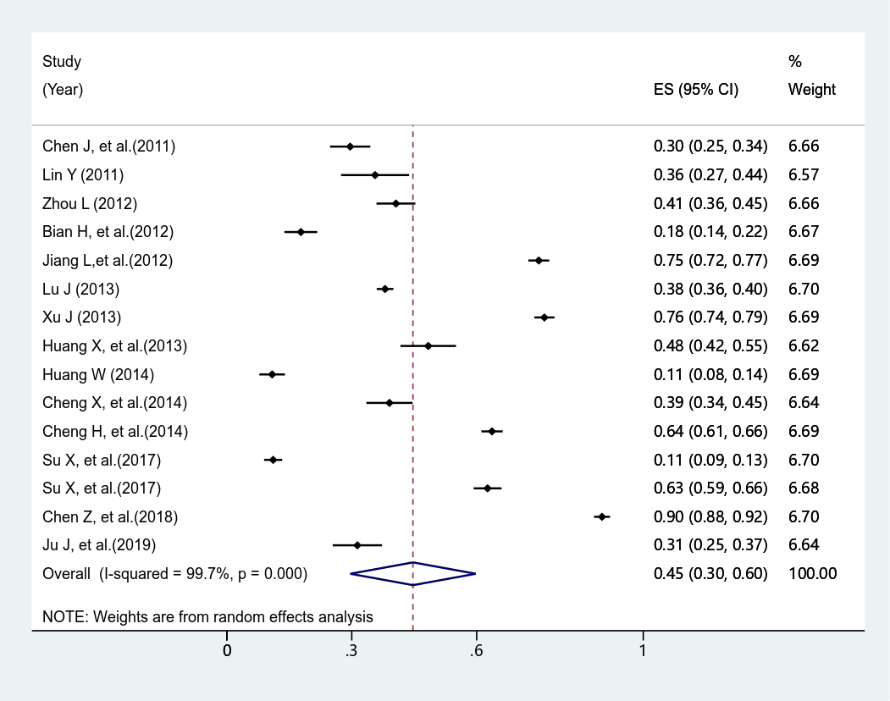
Fig. S1. Forest plot of the studies for pathogen detection of inpatient department.

Table S9. Forest plot of the studies for risk of antibiotic utilization of children and their caregivers lack of skills and knowledge
Question | Study (Year) | Number of  Right Responders | Number of Responders | Random-effects meta -analysis
antibiotics and anti-inflammatory drugs are the same drugs | Yu M, et al. (2014)[87] | 180 | 481 | 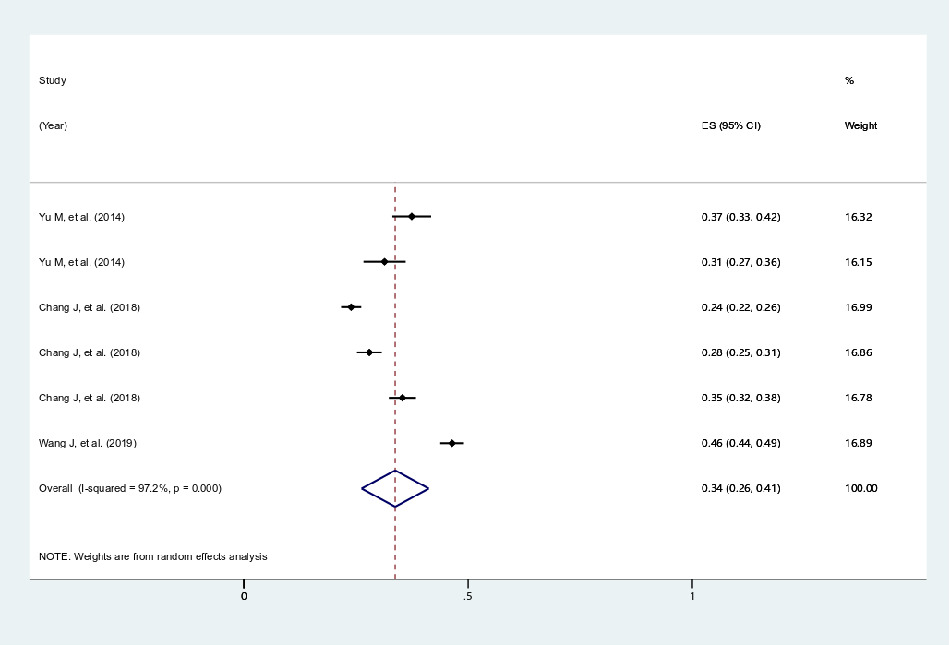
antibiotics and anti-inflammatory drugs are the same drugs | Yu M, et al. (2014)[87] | 117 | 373
antibiotics and anti-inflammatory drugs are the same drugs | Chang J, et al. (2018)[95] | 332 | 1388
antibiotics and anti-inflammatory drugs are the same drugs | Chang J, et al. (2018)[95] | 282 | 1008
antibiotics and anti-inflammatory drugs are the same drugs | Chang J, et al. (2018)[95] | 340 | 962
antibiotics and anti-inflammatory drugs are the same drugs | Wang J, et al. (2019)[99] | 635 | 1368
antibiotics can cure infections caused by virus | Zhang G, et al. (2014)[86] | 350 | 818 | 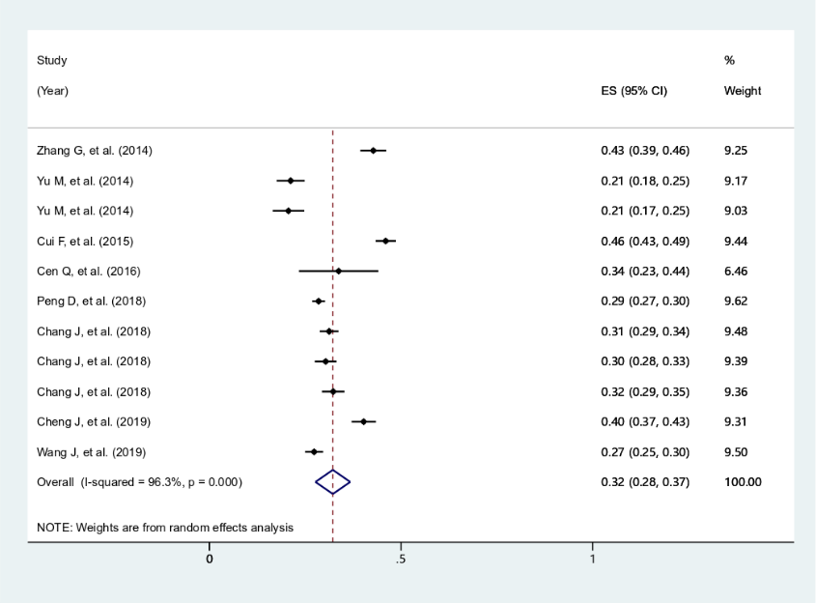
antibiotics can cure infections caused by virus | Cui F, et al. (2015)[80] | 629 | 1367
antibiotics can cure infections caused by virus | Yu M, et al. (2014)[87] | 102 | 481
antibiotics can cure infections caused by virus | Yu M, et al. (2014)[87] | 77 | 373
antibiotics can cure infections caused by virus | Cen Q, et al. (2016)[89] | 27 | 80
antibiotics can cure infections caused by virus | Peng D, et al. (2018)[83] | 800 | 2806
antibiotics can cure infections caused by virus | Chang J, et al. (2018)[95] | 434 | 1388
antibiotics can cure infections caused by virus | Chang J, et al. (2018)[95] | 306 | 1008
antibiotics can cure infections caused by virus | Chang J, et al. (2018)[95] | 311 | 962
antibiotics can cure infections caused by virus | Cheng J, et al. (2019) [98] | 371 | 921
antibiotics can cure infections caused by virus | Wang J, et al. (2019)[99] | 374 | 1368
antibiotics can be used to treat common cold | Zhang G, et al. (2014)[86] | 263 | 872 | 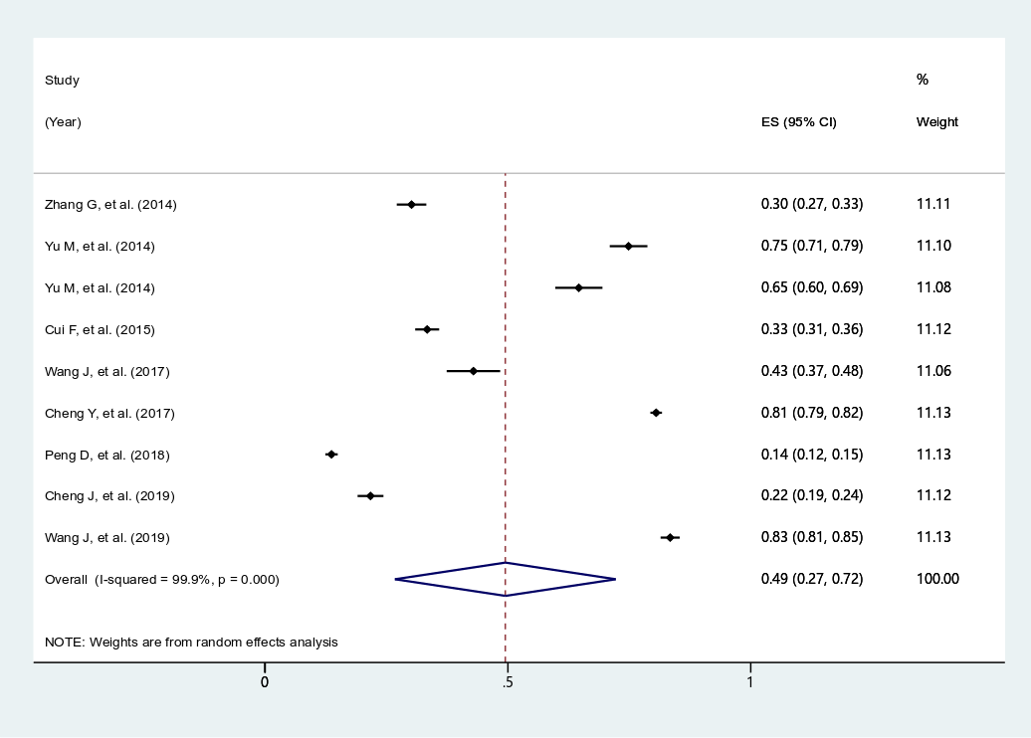
antibiotics can be used to treat common cold | Cui F, et al. (2015)[80] | 468 | 1402
antibiotics can be used to treat common cold | Yu M, et al. (2014)[87] | 360 | 481
antibiotics can be used to treat common cold | Yu M, et al. (2014)[87] | 241 | 373
antibiotics can be used to treat common cold | Wang J, et al. (2017)[92] | 133 | 310
antibiotics can be used to treat common cold | Cheng Y, et al. (2017)[94] | 3391 | 4211
antibiotics can be used to treat common cold | Peng D, et al. (2018)[83] | 384 | 2806
antibiotics can be used to treat common cold | Cheng J, et al. (2019)[98] | 200 | 921
antibiotics can be used to treat common cold | Wang J, et al. (2019)[92] | 1141 | 1368
antibiotics can be used to treat pharyngitis or nonsuppurative tonsillitis | Zhang G, et al. (2014)[86] | 193 | 888 | 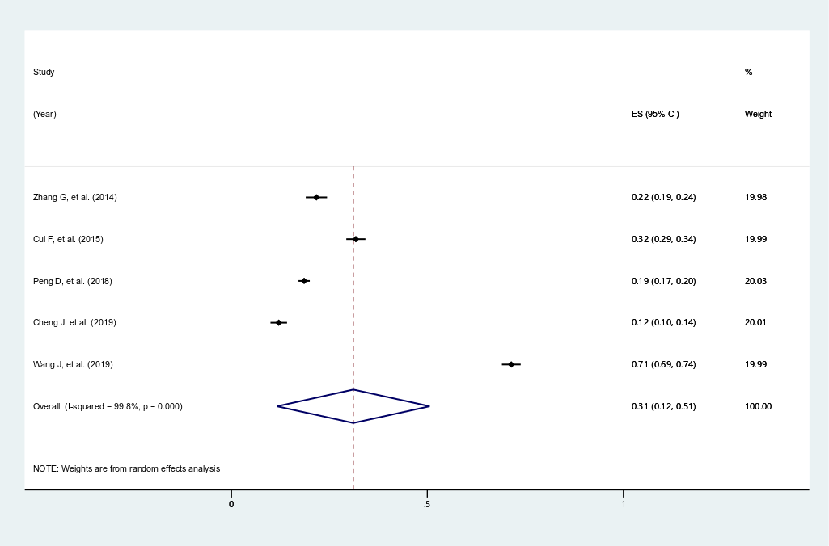
 | Cui F, et al. (2015)[80] | 446 | 1403
 | Peng D, et al. (2018)[83] | 522 | 2806
 | Cheng J, et al. (2019)[98] | 112 | 923
 | Wang J, et al. (2019)[98] | 977 | 1368
antibiotics should only be obtained with a doctor’s prescription | Miao R, et al. (2020)[85] | 251 | 509 | 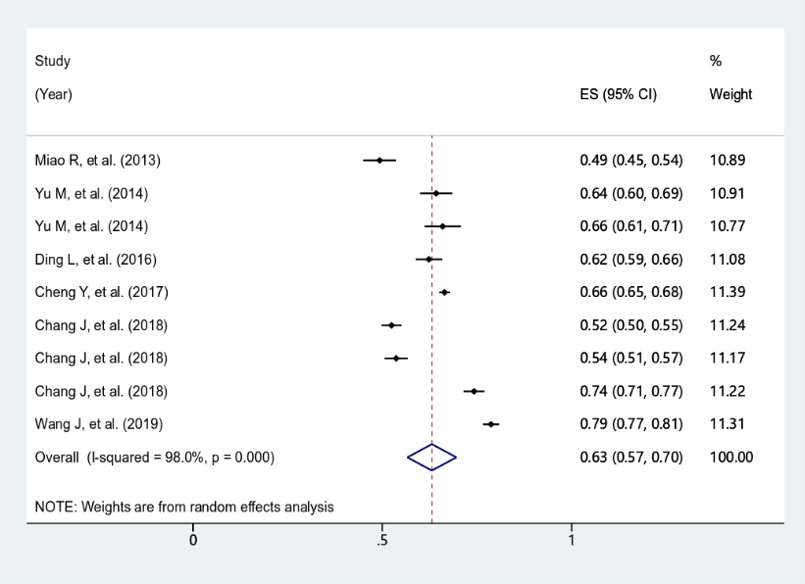
 | Ding L, et al. (2016)[88] | 453 | 727
 | Yu M, et al. (2014)[87] | 309 | 481
 | Yu M, et al. (2014)[87] | 246 | 373
 | Cheng Y, et al. (2017)[94] | 2791 | 4201
 | Chang J, et al. (2018)[95] | 728 | 1388
 | Chang J, et al. (2018)[95] | 541 | 1008
 | Chang J, et al. (2018)[95] | 714 | 962
 | Wang J, et al. (2019)[99] | 1077 | 1368
inappropriate use of antibiotics can reduce the effectiveness of antibiotics | Zhang G, et al. (2014)[86] | 453 | 859 | 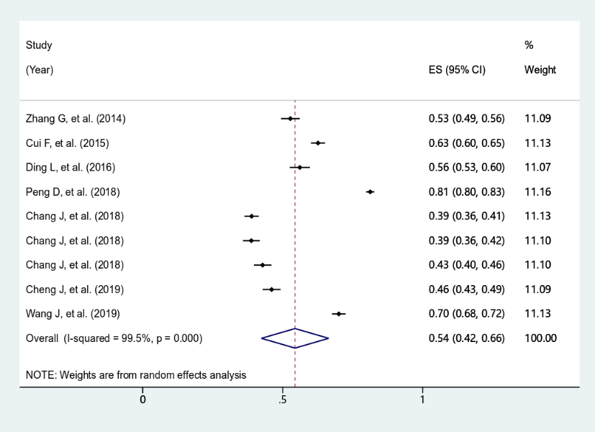
 | Cui F, et al. (2015)[80] | 885 | 1414
 | Ding L, et al. (2016)[88] | 408 | 727
 | Peng D, et al. (2018)[83] | 2280 | 2806
 | Chang J, et al. (2018)[95] | 540 | 1388
 | Chang J, et al. (2018)[95] | 391 | 1008
 | Chang J, et al. (2018)[95] | 412 | 962
 | Cheng J, et al. (2019)[98] | 424 | 921
 | Wang J, et al. (2019)[99] | 958 | 1368

References
1. Moher D, Liberati A, Tetzlaff J et al: Preferred reporting items for systematic reviews and meta-analyses: the PRISMA statement. Plos Medicine 2009, 6(7):e1000097.
2. Liang X, Zhuo Y: Analysis of appliance of antibiotics about outpatient transfusion prescriptions in our hospital. Guangzhou Medical Journal 2010, 41(4):65-66.
3. Hu X: Analysis of the utilization of antibiotics in pediatric department of our hospital. China Pharmacy 2010, 21(44):4186-4188.
4. Chen C, Xin L, Tan F: Analysis on the use of antibacterials in pediatric outpatient department of our hospital. China Practical Medicine 2010, 5(29):9-10.
5. Zhang J: Analysis on antibiotic treatment among pediatric outpatients in our hospital in 2010. Chinese Journal of Medicinal Guide 2011, 13(12):2166, 2172.
6. Wang J, Li G, Xiang F: Analysis of antibiotic application in outptient pediatric presccriptions. Modern Hospitals 2011, 11(5):57-58.
7. Li X: The application situation analysis of antibiotic usage in outpatient department with acute upper respiratory infections in our hospital. China Modern Medicine 2011, 18(9):150-151.
8. Liang J, Liang Y: Clinical observation of 500 cases with antibiotics in outpatient department of pediatrics. Contemporary Medicine 2012(30):144-145.
9. Huang X, Xie J, Xu Y et al: The investigation research of the prescription of antibiotic drugs in outpatient of the pediatric department of one hospital. Chinese Journal of Clinical Rational Drug Use 2012, 5(36):1-2.
10. Li H: Analysis and evaluation of drug application in pediatric outpatients of our hospital. China Medical Herald 2012, 9(08):114-115.
11. Chen L: Our hospital antimicrobial prescription pediatric clinic is not reasonable use analysis. Journal of North Pharmacy 2012, 9(11):66-67.
12. Zhou H, Lin Z, Lv D et al: Investigation of the use of antibacterial drugs in pediatric outpatient department of our hospital. Chinese Journal of Pharmacovigilance 2012, 9(09):566-568.
13. Li L, Feng L: Analysis of drugs application for upper respiratory tract infection in pediatric outpatient. China Medical Herald 2013, 10(02):114-116.
14. Xiao B: Analysis of the use of antibiotics in 1553 outpatient pediatric patients. Medical Journal of National Defending Forces in Southwest China 2013, 23(07):779-780.
15. Chen H, Zhu F, Lu H: Application analysis of antibacterial drugs in pediatric outpatient department of Lianzhou People's Hospital. China Medicine and Pharmacy 2013, 3(11):64-65.
16. Liu H: The analysis of the pediatric outpatient anti-infective drug using. Hebei Medicine 2013, 19(03):436-439.
17. Miao C, Lei H, Rong Y et al: Medication analysis on pediatrics outpatient prescription at our hospital. China Health Industry 2014(4):5, 7.
18. Zeng Y: Analysis on the pediatric prescriptions in the outpatient. The Medical Forum 2014(1):121-123.
19. Gui M, Wang J: To analyze the service condition of antibacterial agents of upper respiratory tract infection prescription in pediatric outpatient department. Chinese Community Doctors 2014(15):5, 7.
20. Yuan Y, Cao L, Yu X et al: Prescriptions of antibiotics for children with upper respiratory infections in outpatient department. Chinese Journal of General Practitioners 2015, 14(8):616-620.
21. Xu P, Lin R: Investigation on current situation of using antibiotics for acute upper respiratory infection in Children. Journal of Pediatric Pharmacy 2015, 21(7):47-49.
22. Xu X, Liu T: Analysis of usage of anti-infection drugs in department of pediatrics in our hospital. China Medicine and Pharmacy 2015, 5(24):72-74.
23. Gao Y: Analysis of antibiotics in pediatric patients with acute upper respiratory tract infection. Chinese Community Doctors 2016, 32(19):13-14.
24. Xie Y: MTP rationality of prescription and the effect of interventions in the treatment of acute upper respiratory tract infection in outpatient pediatrics. Anhui Medical and Pharmaceutical Journal 2016, 20(9):1784-1786, 1787.
25. Lin Y, Nie C, Yang L et al: Analysis and evaluation of prescriptions for pediatric upper respiratory tract infection. China Licensed Pharmacist 2016, 13(2):15-18.
26. Wang J: Evaluation of the use of antimicrobial drugs in pediatric outpatients with acute respiratory infection. Journal of Tropical Medicine 2016, 16(06):796-798.
27. Wang S: Analysis of antibacterials usage in respiratory tract infection of outpatient department of pediatrics in our hospital. Chinese Journal of Drug Evaluation 2017, 34(4):290-293.
28. Pan Y: Analysis on application of oral medicine for upper respiratory tract infections in our hospital. Chinese and Foreign Medical Research 2017, 15(13):142-143.
29. Nie C, Zhang J, Zhao Q et al: Investigation and analysis of antibiotics application in pediatric clinic of our hospital. Modern Hospital 2017, 17(08):1223-1225.
30. Zhang Z, Hu Y, Zou G et al: Antibiotic prescribing for upper respiratory infections among children in rural China: a cross-sectional study of outpatient prescriptions. Global Health Action 2017, 10(1):1287334.
31. Wei X, Zhang Z, Walley JD et al: Effect of a training and educational intervention for physicians and caregivers on antibiotic prescribing for upper respiratory tract infections in children at primary care facilities in rural China: a cluster-randomised controlled trial. Lancet Global Health 2017, 5(12):e1258-e1267.
32. Wei X, Yin J, Walley JD et al: Impact of China's essential medicines scheme and zero-mark-up policy on antibiotic prescriptions in county hospitals: a mixed methods study. Tropical medicine & international health: TM & IH 2017, 22(9):1166-1174.
33. Wang Z, Li L, Huang F et al: Analysis of rational drug use of the pediatric prescriptions from 45 grassroots hospitals in an area. Pharmaceutical Administration 2018, 27(17):86-89.
34. Wang C: Analysis of the use of antibiotics in outpatients with acute upper respiratory tract infections in pediatrics department. Clinical Research and Practice 2019, 4(03):118-119.
35. Wei X, Zhang Z, Hicks JP et al: Long-term outcomes of an educational intervention to reduce antibiotic prescribing for childhood upper respiratory tract infections in rural China: Follow-up of a cluster-randomised controlled trial. Plos Medicine 2019, 16(2):e1002733.
36. Peng L, Wang Z, Zhang Y: Analysis of rational use of antibiotic drugs in hospital pediatrics based on children's drug utilization index and drug safety. Boletin De Malariologia Y Salud Ambiental 2019, 59(1):89-95.
37. He D: 877 example young child acute under respiratory tract infects in hospital trouble clinical analysis. Chinese Manipulation and Rehabilitation Medicine 2011(8):97.
38. Cui Y: Analysis of antibiotics in hospitalized children. Chinese Journal of Clinical Rational Drug Use 2011, 04(23):43-44.
39. Qiu Z, Xie L, Xie H: Application analysis on antibiotics in pediatric patient with acute upper respiratory tract infection. Chinese Journal of Clinical Rational Drug Use 2011, 04(25):4-5.
40. Xie H, Zhou J, Liu F: Paediatric antibiotic use and monitoring of common bacterial resistance. Chinese Journal of Ethnomedicine and Ethnopharmacy 2011, 20(9):8, 10.
41. Chen J, Wen Z: Research study on antibiotic application for bronchopneumonia of the children in-patient in pediatrics in 2010. International Medicine and Health Guidance News 2011, 17(24):3075-3078.
42. Lin Y: Analysis of antibiotics application in pediatric upper respiratory tract infection. Chinese Journal of Nosocomiology 2011, 21(12):2576-2577.
43. Liang Z, Li L, Li K: Analysis of the use of antibiotic in pediatric inpatients. Medical Recapitulate 2011, 17(12):1890-1891.
44. Zhou L: The analysis of nosocomial infection and antibiotics usage in hospitalized neonates. China Practical Medicine 2012, 07(15):32-34.
45. Bian H, Zhang T: Investigation of drug use in pediatrics in our hospital. Chinese Journal of Pharmacoepidemiology 2012, 21(3):138-139, 145.
46. Fang J: Antibiotics application in 196 pediatric patients with acute upper respiratory infection. Journal of Modern Clinical Medicine 2012, 38(2):123-124.
47. Wu J: The Analysis of utilization of antibiotics in children with respiratory tract infection. Guide of China Medicine 2012, 10(11):31-32, 35.
48. Wu W: An empirical analysis of antibiotic drug usage in pediatrics. World Health Digest Medical Periodieal 2012(39):72-73.
49. He M: Investigation of antibiotic use in hospitalized children with respiratory tract infection in our hospital from 2009 to 2011. Gems of Health 2012(4):389.
50. Guan L: Investigation of antibiotic use in pediatric inpatient with acute upper respiratory tract infections. World Health Digest Medical Periodieal 2012, 9(49):231-232.
51. Jiang L, Yang P: Investigation and analysis of nosocomial infection and antibiotic application in 1148 hospitalized children. Journal of Frontiers of Medicine 2012(20):94-95.
52. Zhu J, Shen N, Wang Y et al: Application of antibiotics in neonatal wards. Chinese Journal of Nosocomiology 2012, 22(17):3836-3837, 3840.
53. Wang Q, Sun C, Xu Y: Analysis on the usage of antibacterials in pediatric inpatients. Chinese Journal of Drug Application and Monitoring 2012, 9(06):348-350.
54. Che Y, Dong J: Use of antibiotics for neonates in a basic hospital and influencing factors analysis. Chinese Journal of Woman and Child Health Research 2013, 24(3):296-298.
55. Lu J, Huang J: Clinical analysis of antibiotics application for children with acute respiratory infection in Qinzhou. Journal of Clinical Pulmonary Medicine 2013, 18(12):2210-2212.
56. Xu J: Analysis of the usage of antibacterials in pediatric inpatients. Chinese Journal of Pharmacoepidemiology 2013, 22(4):196-198.
57. Huang X, Zhang W, Xu Q: Investigation of 215 medical records in internal medicine of pediatrics and analysis of antimicrobial drug Use. Journal of Pediatric Pharmacy 2013, 19(3):38-42.
58. Zhan J, Chen Q: Investigation and analysis of the application condition of antibacterial agents on hospitalization children in our hospital. Nei Mongol Journal of Traditional Chinese Medicine 2013, 32(18):96-97.
59. Li C, Ren N, Wen X et al: Changes in antimicrobial use prevalence in China: results from five points prevalence studies. Plos One 2013, 8(12):e82785.
60. Yao Q, Luo Z: Clinical application of antibiotic in department of pediatrics. Chinese Journal of Clinical Rational Drug Use 2014(15):1-2.
61. Wu M, Chen Y, Wu X: Investigation of pediatric medical records and analysis of antimicrobial drug application in a certain hospital. Journal of Navy Medicine 2014(4):260-262.
62. Zhu G, Wu X: Antibiotics usage analysis in pediatric inpatients. Journal of Modern Medicine & Health 2014, 30(21):3239-3240.
63. Liu Y: Survey and analysis of the use of antibacterials in pediatric inpatients of our hospital. China Licensed Pharmacist 2014, 11(11):13-15.
64. Huang W: Analysis of the use of antibiotic in our hospital in 2013 were from January to December in pediatrics. China Health Industry 2014, 11(21):35-36.
65. Huang G, Miao D, Lai X et al: Investigation of use of antibiotics by hospitalized neonates. Chinese Journal of Nosocomiology 2014, 24(01):97-98.
66. Cheng X, Yan X, Lin S: The Investigation and analysis of antimicrobial drugs used by 258 pediatric inpatients. Journal of Hubei University for Nationalities Medical Edition 2014, 31(02):40-41.
67. Cheng H, Wu D: Survey of antimicrobial agents use in pediatric inpatients. Chinese Journal of Pharmaco Epidemiology 2014, 23(12):737-740.
68. Chen Y, Ye J: Pharmaceutical intervention on the use of antibiotics in the neonatology of X-hospital. China Health Industry 2015(16):12-14.
69. Li L, Xu H, Zhou J et al: Application effect of clinical pathway management in infantile capillary bronchitis and the impact on antibiotics utilization ratio. Chinese Journal of Clinical Rational Drug Use 2017, 10(12):35-36, 41.
70. Su X, Zhu H, Yuan H: Analysis of antibiotic use for bronchial pneumonia in pediatrics. Journal of Kunming Medical University 2017, 38(7):126-129.
71. Zhu J, Luo M, Li L et al: Promotion of PDCA cycle on rational usage of antibiotics in neonatal department. Journal of Guangdong Pharmaceutical University 2017, 33(5):649-653.
72. Li R, Zhang J, Li G: Analysis of clinical antibiotic use and adverse reactions in pediatrics. Chinese Nursing Research 2018, 32(23):3815-3817.
73. Chen Z, Xiao Y: Analysis on usage of antibacterial drugs in inpatient children of Tianjin Children's Hosptial in 2016. Drugs & Clinic 2018, 33(03):672-675.
74. Zhang JS, Liu G, Zhang WS et al: Antibiotic usage in Chinese children: a point prevalence survey. World Journal of Pediatrics: WJP 2018, 14(4):335-343.
75. Ju J: Study on the effect of pharmacist intervention on rational use of pediatric antibiotics. China & Foreign Medical Treatment 2019, 38(7):127-129.
76. Wei W, Wang XF, Liu JP et al: Status of antibiotic use in hospitalized children with community-acquired pneumonia in multiple regions of China. Chinese Journal of Contemporary Pediatrics 2019, 21(1):11-17.
77. Niu J: Analysis on the treatment and intervention of pediatric upper respiratory tract infection in hospital. Chinese Community Doctors 2020, 36(16):18.
78. Miao R, Wan C, Wang Z et al: Inappropriate antibiotic prescriptions among pediatric inpatients in different type hospitals. Medicine (Baltimore) 2020, 99(2):e18714.
79. Zhang M, Ma XY, Feng ZQ et al: Survey of antibiotic use among hospitalised children in a hospital in Northeast China over a 4-year period. Journal for specialists in pediatric nursing: JSPN 2020, 25(2):e12282.
80. Cui F, Yuan Y, Cui H et al: A survey on the knowledge of antibiotics of children parents in three children-hospitals of Beijing. Chinese Journal of Medicine 2015(8):67-70.
81. Zhao M, Nan W, Jiao X et al: Survey on the parent situation of antibacteriol drugs use for children. Northwest Pharmaceutical Journal 2016, 31(02):200-202.
82. Yin Y, Cui N: Antibiotics use among preschool children and parental cognition in Ji'nan city. Chinese Journal of Public Health 2018, 34(1):118-120.
83. Peng D, Zhou X: Parents' antibiotic use for children in Ningbo: knowledge, behaviors and influencing factors. Journal of Zhejiang University 2018, 47(2):156-162.
84. Yao Z, Zhou J, Li Y et al: Prevalence of self-medication with antibiotics in kindergarten children of Guangzhou city. Chinese Journal of Public Health 2013, 29(10):1485-1487.
85. Miao R: Investigation on the impact of parents' cognitive level of antibiotics on self-directed use of antibiotics in pupils. Practical Preventive Medicine 2013, 20(1):42-45.
86. Zhang G, Cao L, Yuan Y: 10 years' changes on parent's antibiotic knowledge in Beijing. Chinese Journal of Medicine 2014(10):41-44.
87. Yu M, Zhao G, Stålsby LC et al: Knowledge, attitudes, and practices of parents in rural China on the use of antibiotics in children: a cross-sectional study. Bmc Infectious Diseases 2014, 14:112.
88. Ding L, Sun W, Li Y et al: Studying on the status of rural parents' cognition on antibiotics and its influencing factors. Chinese Health Service Management 2016, 33(2):111-114.
89. Cen Q, Dai D: The relationship between novice mother and neonates in use of antibiotic cold medications and the effects of health education. Drug Evaluation 2016, 13(21):47-50.
90. Li R, Xiao F, Zheng X et al: Antibiotic misuse among children with diarrhea in China: results from a national survey. Peerj 2016, 4:e2668.
91. Zhang Z, Zhan X, Zhou H et al: Antibiotic prescribing of village doctors for children under 15 years with upper respiratory tract infections in rural China: A qualitative study. Medicine (Baltimore) 2016, 95(23):e3803.
92. Wang J, Huang C, Li Z et al: Knowledge and behavior of antibiotic use for upper respiratory tract infection among parents of young children in Changsha city. Chinese Journal of Public Health 2017, 33(3):415-418.
93. Zhang Y, Lin S, Li G et al: Cognition and usage of antibiotics in caregivers of 0-6 years old children in the rural area of Weinan City, 2015. Practical Preventive Medicine 2017, 24(2):196-198.
94. Cheng YC, Pan YP, Zhang Y et al: Investigation of the cognition and behavior on drug safety in Beijing middle school students. Journal of Peking University (Health Sciences) 2017, 49(6):1038-1043.
95. Chang J, Lv B, Zhu S et al: Non-prescription use of antibiotics among children in urban China: a cross-sectional survey of knowledge, attitudes, and practices. Expert Rev Anti Infect Ther 2018, 16(2):163-172.
96. Fan W, Mu J, Song X et al: Investigation on antibiotic cognition and use of parents of preschool children in Tianjin. Chinese Primary Health Care 2019, 33(4):61-62.
97. Ge Y, Chipenda DS, Liao XP: Advanced neonatal medicine in China: Is newborn ward capacity associated with inpatient antibiotic usage? Plos One 2019, 14(8):e219630.
98. Cheng J, Chai J, Sun Y et al: Antibiotics use for upper respiratory tract infections among children in rural Anhui: children's presentations, caregivers' management, and implications for public health policy. Journal of Public Health Policy 2019, 40(2):236-252.
99. Wang J, Sheng Y, Ni J et al: Shanghai parents' perception and attitude towards the use of antibiotics on children: A cross-sectional study. Infection and Drug Resistance 2019, 12:3259-3267.
100. Ye D, Yan K, Zhang H et al: A survey of knowledge, attitudes and practices concerning antibiotic prescription for upper respiratory tract infections among pediatricians in 2018 in Shaanxi Province, China. Expert Review of Anti-Infective Therapy 2020, 18(9):927-936.
101. Wei X, Deng S, Haldane V et al: Understanding factors influencing antibiotic prescribing behaviour in rural China: a qualitative process evaluation of a cluster randomized controlled trial. Journal of Health Services Research & Policy 2020, 25(2):94-103.
102. Zhang J, Cameron D, Quak SH et al: Rates and determinants of antibiotics and probiotics prescription to children in Asia-Pacific countries. Beneficial Microbes 2020, 11(4):329-338.

