Supporting Information

INVASIVE GRASS SPECIES ALTER PLANT-POLLINATOR NETWORK STRUCTURE IN THE BRAZILIAN CAATINGA

Rodrigo F. R. Carmo¹*, Cássio H. Carvalho²*, Reginaldo A. F. Gusmão², Lucas F.C.S. Alencar¹, Jeferson Vizentin-Bugoni³, Thiago Gonçalves-Souza^{1,4}**

Figure S1: in this figure, we constructed violin plots to summarize the average richness of native pollinators in plots with a low (0 to 6.8) and high number of honeybee visits. To make easier comparisons, native pollinator richness was compared between plots that received a number of honeybee visits below or above the average (i.e., 6.8).

Figure S2: Estimated diversity among treatments compared with Hill numbers from different orders. The advantages of Hill number to estimate diversity is fully described in Chao et al. (2014). The order q = 0 represents the estimated diversity without considering species visitation number (i.e., estimate diversity given weight to rare species), q = 2 gives proportional weight to species based on their visitation numbers, and q = 3 is the estimated diversity considering the effective number of dominant species (i.e., those species with more visits). Because the varying number of visits among treatment may affect our ability to estimate and compare diversity, we used a abundance-based estimation using the number of visits in the less visited plot (i.e., 330 visits in the highly invaded plot). Therefore, the estimated diversity values in Figure S2 were obtained by using an individual-based rarefaction (Gotelli & Colwell, 2001).

Figure S3: Results of correlation matrix using our predict variables and covariables (please see text to find the variables).

Literature cited
Chao, A., Chiu, C.-H. & Jost, L. (2014) Unifying Species Diversity, Phylogenetic Diversity, Functional Diversity, and Related Similarity and Differentiation Measures Through Hill Numbers. Annual Review of Ecology, Evolution, and Systematics, 45, 297–324.
Gotelli, N.J. & Colwell, R.K. (2001) Quantifying biodiversity: procedures and pitfalls in the measurement and comparison of species richness. Ecology Letters, 4, 379–391.

Table S1: List of pollinators species and native plant species sampled along field experiment

Table S2. Simplification of Generalized Mixed Models (GLMM) and Log-likehood to obtain the most likely model. We represented each model used to investigate the effects of the predictors on each dependent variable and the values of the Log-likelihood.

Table S3: Detailed information about the average values (and 95% Confidence Intervals) of all dependent variables across the three treatments (i.e., control, low-invaded, and highly-invaded)

Table S4: Between-treatment comparisons from each dependent variable. After running each GLMM model (see main text) we performed multiple comparisons using the function lsmeans in R (Lenth 2016). We did not compare the effects of grass cover treatments on honeybees because it was not retained in the model (see main text).

Literature cited
Lenth, R. V. (2016). Least-squares means: The R Package lsmeans. Journal of Statistical Software, 69, https://doi.org/10.18637/jss.v069.i01.

Table S5: Detailed information about species and the visitation numbers of native and invasive pollinators on each invasion (invasive grass Megathyrsus maximus) treatments (control, low and high)

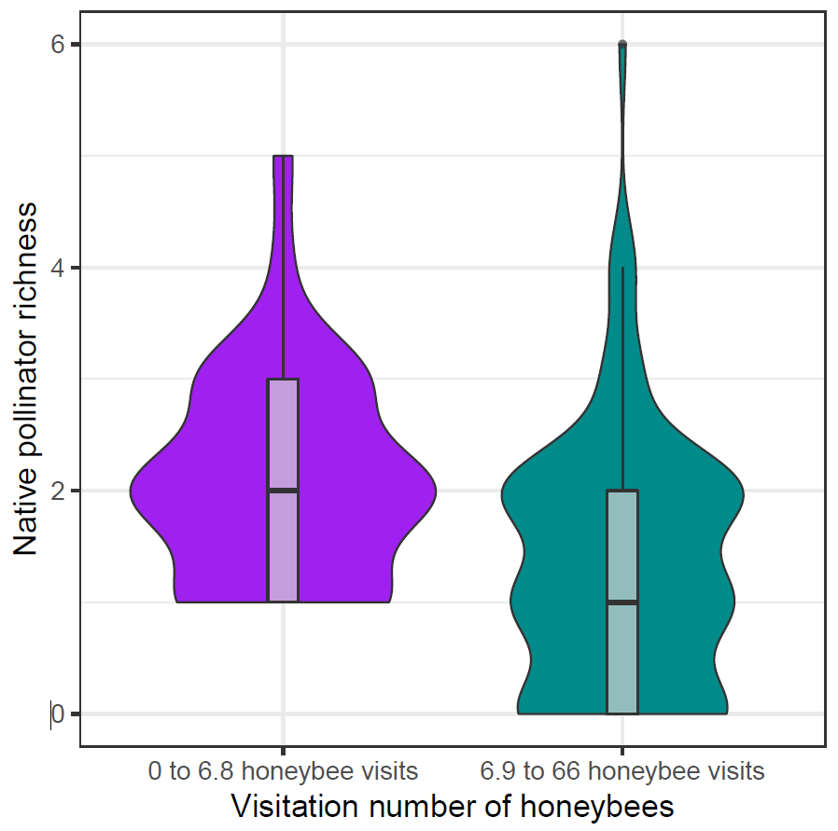
Figure S1. Violin plots summarizing the average richness of native pollinators in plots with a low (0 to 6.8) and high (6.9 to 66) number of honeybee visits.

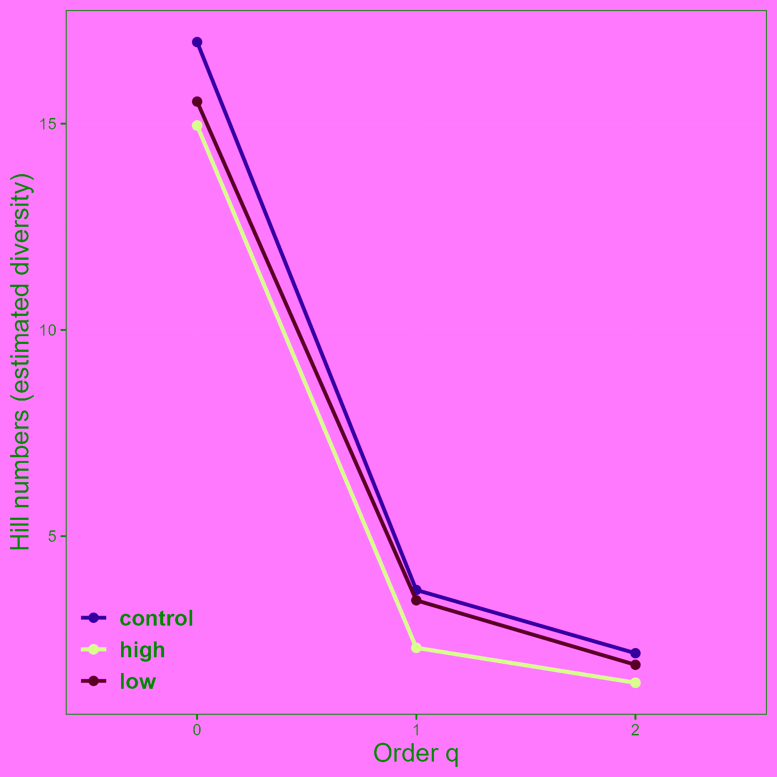

Figure S2. Estimated diversity among treatments compared with order q = 0 that estimates diversity given weight to rare species, q = 1 that gives proportional weight to species based on their visitation numbers, and q = 2 as the estimated diversity considering the effective number of dominant species.

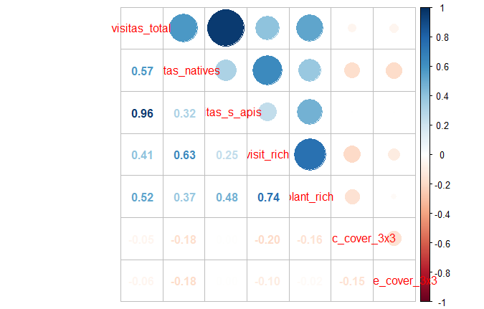
Figure S3: Results of correlation matrix using our predict variables and covariables (see text)

Table S1. List of pollinators species and native plant species sampled along field experiment
Taxon
Pollinators | Native plants
Order Diptera | Family Amaranthaceae
Stratiomyidae 1 | Froelichia humboldtiana
Order Hymenoptera | Family Asteraceae
Apis mellifera | Ageratum conyzoides
Bombus brevivillu | Lepidaploa chalybaea
Chalcididae 1 | Family Cleomaceae
Eucharitidae 1 | Tarenaya diffusa
Megachile sp. | Family Euphorbiaceae
Perditomorpha sp. | Cnidoscolus urens
Psaenythia variabilis | Family Fabaceae
Tetrapedia sp. | Chamaecrista rotundifolia
Trigona spinipes | Stylosanthes viscosa
Vespidae 1 | Family Malvaceae
Vespidae 2 | Herissantia tiubae
Vespidae 3 | Pavonia cancellata
Order Lepidoptera | Pavonia varian
Agraulis vanillae | Sida galheirensis
Ascia monuste | Family Portulacaceae
Euptoieta hegesia | Portulaca elatior
Eurema elathea | Family Rubiaceae
Heliopyrgus domicella | Diodella tere
Hemiargus hanno | Mitracarpus eichleri
Panoquina lucas | Richardia grandiflora
Pyrgus veturius | Family Turneraceae
Strymon rufofusca | Piriqueta duarteana

Table S2. Simplification of Generalized Mixed Models (GLMM) and Log-likehood to obtain the most likely model.
 |  | Model | Log-likelihood
All native visitors | M1 | log(native visitors + 1) ~ treatment * Apis visitors + plant_richenss + native_coverage + PC1_soil, random = ~ 1 | month | -147.77
All native visitors | M2 | log(native visitors + 1) ~ treatment + Apis visitors + plant_richness + native_coverage + PC1_soil, random = ~ 1 | month | -150.19
All native visitors | M3 | log(native visitors + 1) ~ treatment + plant_richness + native_coverage + PC1_soil, random = ~ 1 | month | -150.38
All native visitors | M4 | log(native visitors + 1) ~ treatment + plant_richness + native_coverage, random = ~ 1 | month | -151.16
Richness of native visitors | M1 | log(visitors_richness + 1) ~ treatment*Apis visitors + plant_richness + native_coverage + PC1_soil, random = ~ 1 | month | -23.27
Richness of native visitors | M2 | log(visitors_richness + 1) ~ treatment + Apis visitors + plant_richness + native_coverage + PC1_soil, random = ~ 1 | month | -23.53
Richness of native visitors | M3 | log(visitors_richness + 1) ~ treatment + Apis visitors + plant_richness + native_coverage, random = ~ 1 | month | -23.66
Apis mellifera | M1 | log(Apis visitors + 1) ~ treatment + plant_richness + native_coverage + PC1_soil, random = ~ 1 | month | -200.59
Apis mellifera | M2 | log(Apis visitors + 1) ~ treatment + plant_richness + PC1_soil, random = ~ 1 | month | -200.59
Apis mellifera | M3 | log(Apis visitors + 1) ~ plant_richness + PC1_soil, random = ~ 1 | month | -200.85

Table S3. Average values (and 95% Confidence Intervals) of all dependent variables on each treatment.

Dependents variables | Treatment | Average value | 95% Confidence Interval
Native visitation number | control | 4.02 | 1.68
Native visitation number | low | 2.33 | 1.06
Native visitation number | high | 1.43 | 0.55
Honeybee visitation number | control | 7.62 | 3.41
Honeybee visitation number | low | 6.07 | 3.20
Honeybee visitation number | high | 6.90 | 4.66
Native pollinator richness | control | 2.00 | 0.35
Native pollinator richness | low | 1.30 | 0.26
Native pollinator richness | high | 1.18 | 0.31
Native plant richness | control | 1.56 | 0.30
Native plant richness | low | 1.23 | 0.23
Native plant richness | high | 1.10 | 0.29

Table S4. Between-treatment comparisons from each dependent variable. After running each GLMM model (see main text) we performed multiple comparisons using the function lsmeans in R. We did not compare the effects of grass cover treatments on honeybees because it was not retained in the model (see main text).
Dependent variables / paired comparisons | Estimate | t ratio | P
Native plant richness
control vs. low | 0.212 | 2.26 | 0.064
control vs. high | 0.144 | 1.71 | 0.206
low vs. high | -0.068 | -0.76 | 0.731
Native pollinator richness
control vs. low | 0.169 | 3.01 | 0.009
control vs. high | 0.198 | 3.03 | 0.008
low vs. high | -0.029 | -0.48 | 0.879
Native visitation number
control vs. low | 0.320 | 2.47 | 0.038
control vs. high | 0.442 | 2.96 | 0.010
low vs. high | -0.122 | -0.89 | 0.647

Table S5. Species list and visitation numbers of native and invasive pollinators on each invasion (invasive grass Megathyrsus maximus) treatments (control, low and high).

Treatment | Pollinator species | Pollinator origin | Visitation number
control | Apis mellifera | Invasive | 381
control | Trigona spinipes | Native | 102
control | Hemiargus hanno hanno | Native | 18
control | Stratiomyidae | Native | 10
control | Polistinae sp3 | Native | 9
control | Ascia monuste orseis | Native | 8
control | Heliopyrgus domicella | Native | 8
control | Pyrgus veturius | Native | 8
control | Agraulis vanillae maculosa | Native | 7
control | Panoquina lucas | Native | 6
control | Strymon rufofusca | Native | 6
control | Euptoieta hegesia meridiania | Native | 5
control | Megachile sp | Native | 4
control | Tetrapedia sp | Native | 4
control | Eurema elathea flavescens | Native | 2
control | Bombus brevivillus | Native | 1
control | Chalcididade | Native | 1
control | Perditomorpha sp. | Native | 1
control | Psaenythia variabilis | Native | 1

Table S5. Species list and visitation numbers of native and invasive pollinators on each invasion (invasive grass Megathyrsus maximus) treatments (control, low and high).
Treatment | Pollinator species | Pollinator origin | Visitation number
high | Apis mellifera | Invasive | 276
high | Stratiomyidae | Native | 14
high | Trigona spinipes | Native | 14
high | Agraulis vanillae maculosa | Native | 6
high | Pyrgus veturius | Native | 6
high | Hemiargus hanno hanno | Native | 4
high | Ascia monuste orseis | Native | 2
high | Perditomorpha sp | Native | 2
high | Polistinae sp3 | Native | 2
high | Tetrapedia sp | Native | 2
high | Euptoieta hegesia meridiania | Native | 1
high | Heliopyrgus domicella | Native | 1
high | Panoquina lucas | Native | 1
high | Polistinae sp1 | Native | 1
high | Strymon rufofusca | Native | 1
low | Apis mellifera | Invasive | 370
low | Trigona spinipes | Native | 29
low | Perditomorpha sp | Native | 24
low | Polistinae sp3 | Native | 19

Table S5. Species list and visitation numbers of native and invasive pollinators on each invasion (invasive grass Megathyrsus maximus) treatments (control, low and high).

Treatment | Pollinator species | Pollinator origin | Visitation number
low | Hemiargus hanno hanno | Native | 13
low | Pyrgus veturius | Native | 13
low | Ascia monuste orseis | Native | 8
low | Polistinae sp2 | Native | 7
low | Stratiomyidae | Native | 7
low | Heliopyrgus domicella | Native | 5
low | Strymon rufofusca | Native | 5
low | Agraulis vanillae maculosa | Native | 4
low | Psaenythia variabilis | Native | 4
low | Eucharitidae | Native | 1
low | Euptoieta hegesia meridiania | Native | 1
low | Megachile sp | Native | 1
low | Polistinae sp1 | Native | 1

