Supplementary Appendix
Interplay of Transcription Factor 7-Like-2 Polymorphisms with Type 2 Diabetes Mellitus in a Ghanaian Population
Running Title: Genetic Variants Associated with Diabetes
Christian Obirikorang¹, Evans Asamoah Adu¹, Emmanuel Acheampong², Enoch Odame Anto^{2,3}, Lawrence Quaye⁴, Brodrick Yeboah Amoah⁵, Max Efui Annani-Akollor¹, Aaron Siaw Kwakye⁶, Foster Fokuoh⁶, Michael Appiah¹, Eric Nana Yaw Nyarko¹, Freeman Aidoo¹, Eric Adua², Ebenezer Afrifa-Yamoah⁷, Lois Balmer², Wei Wang^{2,8}
¹ Department of Molecular Medicine, School of Medicine and Dentistry, Kwame Nkrumah University of Science and Technology, Kumasi, Ghana
² School of Medical and Health Sciences, Edith Cowan University, Perth, Australia
³ Department of Medical Diagnostics, Faculty of Allied Health Science, Kwame Nkrumah University of Science and Technology, Kumasi, Ghana
⁴Department of Biomedical Laboratory Sciences, School of Allied Health Sciences, University for Development Studies, Tamale, Ghana
⁵Chemical Pathology Unit, Medical Laboratory Sciences Department, School of Basic and Allied Health Sciences, University of Ghana, Accra, Ghana
⁶ Eastern Regional Hospital, Koforidua, Ghana
⁷School of Science, Edith Cowan University, 270 Joondalup Drive, Western Australia
⁸ Beijing Key Laboratory of Clinical Epidemiology, School of Public Health, Capital Medical University, Beijing, China

*Corresponding authors
Evans Asamoah Adu
Email: evansasamoahadu@gmail.com

Text Summary
The supplementary material contains detailed information on the modified and simplified salting-out technique for DNA extraction (pp.2-3). Quality control and troubleshooting procedures for the genotyping of the SNPs have been shown on page 4-5. Figure S1 and S2 shows the results of DNA purity and concentrations. Figure S3 and S4 demonstrate the genotyping results of the two SNPs. Table S1 shows the recipe of the recipe of the master mix for Quality Control and trouble shooting. Table S2-S5 shows the association between rs12255372 and rs7903146 with cardiometabolic risk factors in both cases and control participants.
All images are in Joint Photographic Experts Group (Jpeg) format.

Modified Salting-Out Non-enzymatic DNA extraction Method
Erythrocyte Lysis Buffer
Add 9 volume of 0.155M NH₄Cl (8.291g NH₄Cl into 1L dH₂O) to 1 volume of 0.17M Tris HCL (pH= 7.65)
Wash Buffer
Mix 5 ml of 1.0M NaCl and 10 ml of 0.5M EDTA (pH=8.0) into 985 mL dH2O
TKM 2 (High salt buffer) Preparation (100 ml)
0.121g of Tris HCL (10mM, pH=7.6), 0.074g of KCl (10mM), 1.203g of MgCl₂ (10mM), 0.074g of EDTA (2mM), 0.467g of NaCl (0.4M) is dissolved in 100ml of dH₂O.
Saturated Sodium chloride (6M NaCl) solution
Dissolve 8.765g of NaCl in 25 ml of dH₂O
Steps
In a nuclease-free tube (Eppendorf Tube) add 3:1 ratio of Erythrocyte Lysis Buffer to whole blood sample (at 37 °C temperature). Incubate the mixture for 5 minutes. Centrifuged the mixture at 8000 rpm for 3 minutes. Discard the supernatant and keep the sediment. To ensure complete removal of haemoglobin stain, add 600 µl of wash buffer to the sediment and centrifuge the mixture at low speed (6000 rpm) for 5 minutes. Discard the supernatant. Resuspend the white cell pellet with 300 µl of TKM-2 buffer and add 40 µl of 10% SDS. Mix thoroughly by 30-secs vertexing and incubate at 37°C for 5 minutes. At the end of the incubation, add 100 µl of 6M NaCl and vortex for 15 seconds to precipitate the proteins and leave DNA out in solution. Centrifuge the content at 8000 rpm for 5 minutes. Transfer the supernatant into a new Eppendorf tube containing 300 µl of absolute isopropanol (99.9%). Invert the tube slowly several times to precipitate DNA. Centrifuge at 8000 rpm for 10 minutes to pellet down the precipitated DNA. Discard the supernatant and add 70% isopropanol, mix slowly to remove any excess salts. Final centrifugation is conducted at 8000 rpm for 5 minutes to pellet down the DNA. Discard the supernatant. Place Eppendorf tube downward on the tissue paper to drain the ethanol completely. Air-dry the DNA and after thorough drying, add 50 µl of nuclease-free water buffer to dissolve the DNA.

Results visualisation of DNA products isolated with MSO method

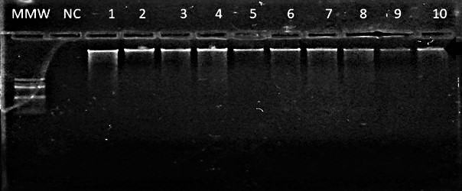
Figure S1: 1% agarose gel electrophoresis of genomic DNA extracted from MSO method

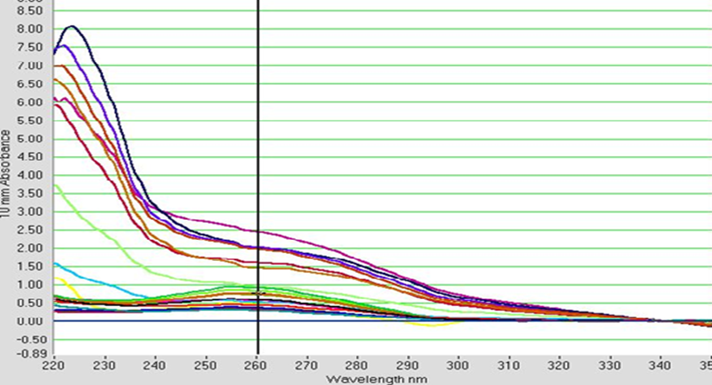
Figure S2: A typical Nanodrop curve of absorbance against the path of light travel (wavelength)

MTPA Quality control and Trouble Shooting
The optimization step of the MTPA solely depends on the primer concentration. Where appropriate, increase the Mg++ concentration of the commercially prepared OneTaq® 2X Master Mix (New England Biolabs) by 0.2 µM during the optimization step.
Amplification of common product
Amplification of common primers was performed in a total volume of 25µL containing ≥50 ng of DNA template, 0.4 µM each of forward and reverse outer primers and 1X of OneTaq® 2X Master Mix (New England Biolabs).
MTPA reaction
Allele-specific Amplification
Forward outer vs reverse inner primers; and Forward inner vs reverse outer primer combinations were used to optimise the allele-specific amplification conditions. The reaction was completed with 0.4 µM each of forward-outer vs reverse-inner primers in 25 uL reaction volume using the 1X of OneTaq® 2X Master Mix (New England Biolabs).

Table S1: Recipe for the master mix for Quality Control
Component | Initial Conc. | Final conc. | Volume (µL)  Per Sample
Amplification of common Primers
FOP | 10 µM | 0.4 µM | 1
ROP | 10 µM | 0.4 µM | 1
MTPA reaction
FIP | 10 µM | 0.2 µM | 0.5
RIP | 10 µM | 0.2 µM | 0.5
FOP | 10 µM | 0.2 µM | 0.5
ROP | 10 µM | 0.2 µM | 0.5
Amplification of mutant Allele
FIP | 10 µM | 0.4 µM | 1
ROP | 10 µM | 0.4 µM | 1
Amplification of ancestral Allele
RIP | 10 µM | 0.2 µM | 1
FOP | 10 µM | 0.4 µM | 1
Onetaq® 2x Master Mix | 2X | 1X | 12.5
Nuclease Free water | - | -
DNA sample | >50 ng/ µL | >50 ng/ µL | 1
FIP- forward inner primer; RIP- reverse inner primer; FOP; forward outer primer; ROP: reverse outer primer

Results of TCF7L2- rs7903146 and rs12255372 genotyping

Figure S3: 2% agarose gel electrophoresis of TCF7L2- rs7903146

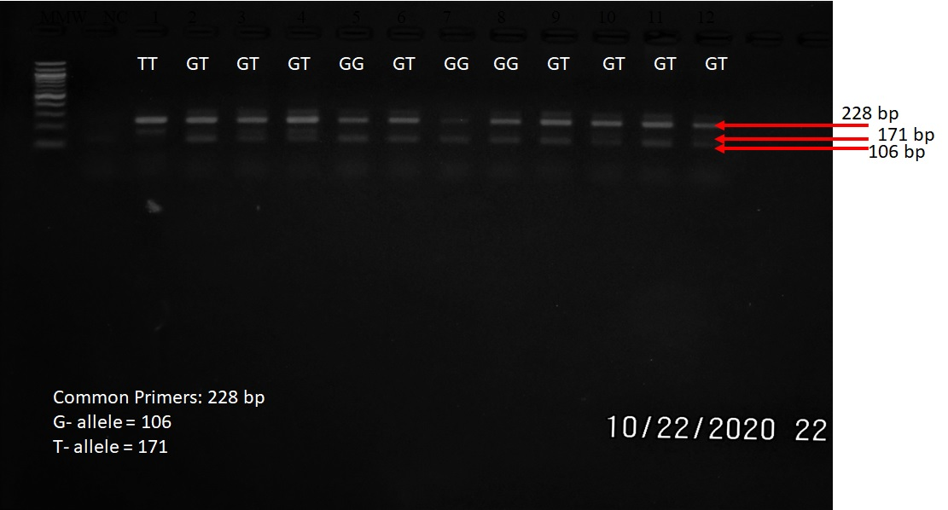
Figure S4: 2% agarose gel electrophoresis of TCF7L2- rs12255372

Table S2: Association of TCF7L2 SNPs with Anthropometric and biochemical markers
Variables | Wild type | Mutant type | P-value
rs7903146
Controls (N=110)
BMI (Kg/m²) | 26.14±5.40 | 26.07±3.45 | 0.924
Systolic BP (mmHg) | 120.96±19.15 | 121..49±17.96 | 0.142
Diastolic BP (mmHg) | 75.57±11.11 | 76.74±11.28 | 0.403
Triglycerides (mmol/l) | 1.31±0.33 | 1.27±0.61 | 0.048
T. Chol (mmol/l) | 4.52±0.98 | 4.76±1.13 | 0.465
HDL-C(mmol/l) | 1.24±0.23 | 1.22±0.30 | 0.163
LDL-C (mmol/l) | 3.19±0.50 | 3.42±0.85 | 0.001
FPG (mmol/l) | 4.63±0.75 | 5.02±0.98 | 0.069
HbA1c (%) | 4.81±0.52 | 4.85±0.66 | 0.981
Cases (N=106)
BMI (Kg/m²) | 28.62±5.71 | 28.04±5.49 | 0.160
Systolic BP (mmHg) | 138.19±21.46 | 131.78±19.05 | 0.015
Diastolic BP (mmHg) | 84.65±12.93 | 83.36±11.39 | 0.450
Triglycerides (mmol/l) | 1.53±0.46 | 1.74±0.68 | 0.284
T. Chol (mmol/l) | 4.95±0.94 | 5.35±1.04 | 0.110
HDL-C(mmol/l) | 1.06±0.22 | 0.98±0.24 | 0.283
LDL-C (mmol/l) | 3.31±0.72 | 3.48±1.01 | 0.046
FPG (mmol/l) | 7.38±4.52 | 9.16±4.64 | 0.414
HbA1c (%) | 6.23±1.49 | 7.24±1.92 | 0.099
rs12255372
Controls (N=110)
BMI (Kg/m²) | 25.72±4.64 | 27.17±3.53 | 0.493
Systolic BP (mmHg) | 121.56±17.90 | 120.41±21.10 | 0.145
Diastolic BP (mmHg) | 76.00±11.29 | 76.83±10.98 | 0.402
Triglycerides (mmol/l) | 1.20±0.36 | 1.54±0.72 | 0.003
T. Chol (mmol/l) | 4.51±1.03 | 5.04±1.07 | 0.048
HDL-C(mmol/l) | 1.24±0.26 | 1.21±0.31 | 0.122
LDL-C (mmol/l) | 3.27±0.61 | 3.45±0.99 | 0.001
FPG (mmol/l) | 4.67±0.71 | 5.34±1.19 | 0.005
HbA1c (%) | 4.72±0.55 | 5.17±0.63 | <0.001
Cases (N=106)
BMI (Kg/m²) | 27.54±6.00 | 29.05±4.75 | 0.044
Systolic BP (mmHg) | 128.57±17.09 | 139.82±21.41 | 0.003
Diastolic BP (mmHg) | 81.61±10.69 | 86.49±12.60 | 0.077
Triglycerides (mmol/l) | 1.63±0.57 | 1.77±0.71 | 0.476
T. Chol (mmol/l) | 5.30±1.09 | 5.18±0.95 | 0.339
HDL-C(mmol/l) | 1.02±0.26 | 0.96±0.19 | 0.459
LDL-C (mmol/l) | 3.48±0.99 | 3.38±0.89 | 0.061
FPG (mmol/l) | 8.47±4.31 | 9.06±5.12 | 0.935
HbA1c (%) | 6.69±1.52 | 7.40±2.21 | 0.078
Mt- mutant type, Wt- wild type. Highlighted P-values are statistically significant.

Table S3: Logistic regression analysis of TCF7L2 SNPs associated with cardiometabolic risk factors
Variables | Wild type  (C-allele) | Mutant type  (T-allele) | aOR  (95%CI) | P-value
rs7903146
Controls (N=110)
High BP | 4 (8.2) | 6 (9.8) | 0.991 (0.25-3.96) | 0.990
High TC | 1 (2.0) | 5 (8.2) | 5.14 (0.57-46.67) | 0.146
High TG | 7 (14.3) | 9 (14.8) | 0.93 (0.31-2.77) | 0.890
Low HDL-C | 24 (49.0) | 28 (45.9) | 1.12 (0.46-2.73) | 0.800
High LDL-C | 11 (22.4) | 25 (41.0) | 2.98 (1.23-7.30) | 0.017
Atherogenic dyslipidaemia | 1 (2.0) | 4 (6.6) | 3.71 (0.39-35.43) | 0.254
Overweight/Obesity | 23 (46.9) | 37 (60.7) | 1.73 (0.78-3.76) | 0.164
MetS | 6 (12.2) | 8 (13.1) | 1.02 (0.32-3.28) | 0.969
Cases (N=106)
High BP | 11 (42.3) | 25 (31.3) | 0.62 (0.25-1.55) | 0.307
High TC | 1 (3.8) | 12 (15.0) | 4.46 (0.55-36.17) | 0.162
High TG | 10 (38.5) | 51 (63.7) | 2.95 (1.16-7.50) | 0.023
Low HDL-C | 18 (69.2) | 63 (78.8) | 1.73 (0.62-4.83) | 0.299
High LDL-C | 13 (50.0) | 51 (63.7) | 1.95 (0.75-5.10) | 0.174
Atherogenic dyslipidaemia | 7 (26.9) | 37 (46.3) | 2.67 (0.95-7.52) | 0.063
Overweight/Obesity | 16 (61.5) | 56 (70.0) | 1.48 (0.58-3.79) | 0.405
MetS | 15 (57.7) | 55 (68.8) | 1.70 (0.66-4.39) | 0.272
rs12255372
Controls (N=110)
High BP | 6 (7.4) | 4 (13.8) | 1.48 (0.35-6.45) | 0.597
High TC | 2 (2.5) | 4 (13.8) | 14.0 (1.43-137.32) | 0.023
High TG | 9 (11.1) | 7 (24.1) | 1.96 (0.64-6.02) | 0.239
Low HDL-C | 39 (48.1) | 13 (44.8) | 1.41 (0.48-4.18) | 0.533
High LDL-C | 23 (28.4) | 13 (44.8) | 3.12 (1.14-8.56) | 0.027
Atherogenic dyslipidaemia | 4 (4.9) | 1 (3.4) | 0.65 (0.08-6.30) | 0.710
Overweight/Obesity | 42 (51.9) | 18 (62.1) | 1.55 (0.62-3.84) | 0.348
MetS | 7 (8.6) | 7 (24.1) | 2.91 (0.88-9.59) | 0.080
Cases (N=106)
High BP | 15 (24.6) | 21 (46.7) | 3.01 (1.27-7.18) | 0.013
High TC | 8 (13.1) | 5 (11.1) | 0.91 (0.27-3.09) | 0.883
High TG | 31 (50.8) | 30 (66.7) | 1.89 (0.83-4.32) | 0.131
Low HDL-C | 45 (73.8) | 36 (80.0) | 1.46 (0.56-3.88) | 0.439
High LDL-C | 36 (41.0) | 28 (62.2) | 1.24 (0.53-2.94) | 0.622
Atherogenic dyslipidaemia | 21 (34.4) | 23 (51.1) | 2.17 (0.91-5.17) | 0.082
Overweight/Obesity | 36 (59.0) | 36 (80.0) | 3.33 (1.30-8.53) | 0.012
MetS | 37 (60.7) | 33 (73.3) | 2.04 (0.84-4.97) | 0.117
Mt- mutant type, Wt- wild type. Highlighted P-values are statistically significant. aOR-adjusted for age and sex

