Docking scores for compound 1 with target 3Q7D
Ligand | Binding Affinity | rmsd/ub | rmsd/lb
3q7d_1a_uff_E=302.93 | -9.932 | 0 | 0
3q7d_1a_uff_E=302.93 | -9.725 | 19.98 | 16.537
3q7d_1a_uff_E=302.93 | -9.662 | 25.275 | 23.746
3q7d_1a_uff_E=302.93 | -9.59 | 24.966 | 23.438
3q7d_1a_uff_E=302.93 | -9.441 | 25.515 | 23.886
3q7d_1a_uff_E=302.93 | -9.377 | 21.568 | 19.85
3q7d_1a_uff_E=302.93 | -9.28 | 35.23 | 32.669
3q7d_1a_uff_E=302.93 | -8.985 | 26.771 | 25.243
3q7d_1a_uff_E=302.93 | -8.924 | 2.109 | 1.59
Docking scores for compound 2 with target 3Q7D
Ligand | Binding Affinity | rmsd/ub | rmsd/lb
3q7d_2a_uff_E=255.35 | -7.745 | 0 | 0
3q7d_2a_uff_E=255.35 | -7.621 | 43.791 | 41.79
3q7d_2a_uff_E=255.35 | -7.413 | 19.314 | 15.667
3q7d_2a_uff_E=255.35 | -7.38 | 9.644 | 7.043
3q7d_2a_uff_E=255.35 | -7.342 | 5.004 | 3.829
3q7d_2a_uff_E=255.35 | -7.339 | 41.892 | 40.263
3q7d_2a_uff_E=255.35 | -7.338 | 48.664 | 46.053
3q7d_2a_uff_E=255.35 | -7.295 | 32.944 | 30.153
3q7d_2a_uff_E=255.35 | -7.212 | 15.74 | 12.678
Docking scores for compound 3 with target 3Q7D
Ligand | Binding Affinity | rmsd/ub | rmsd/lb
3q7d_3a_uff_E=237.51 | -8.504 | 0 | 0
3q7d_3a_uff_E=237.51 | -8.283 | 27.891 | 25.531
3q7d_3a_uff_E=237.51 | -8.255 | 29.116 | 26.353
3q7d_3a_uff_E=237.51 | -8.214 | 18.041 | 14.658
3q7d_3a_uff_E=237.51 | -8.061 | 23.506 | 18.531
3q7d_3a_uff_E=237.51 | -7.942 | 24.921 | 20.063
3q7d_3a_uff_E=237.51 | -7.938 | 26.16 | 24.127
3q7d_3a_uff_E=237.51 | -7.919 | 27.076 | 24.097
3q7d_3a_uff_E=237.51 | -7.691 | 27.132 | 22.247

Docking scores for compound 4 with target 3Q7D
Ligand | Binding Affinity | rmsd/ub | rmsd/lb
3q7d_4a_uff_E=258.52 | -8.283 | 0 | 0
3q7d_4a_uff_E=258.52 | -8.234 | 3.035 | 1.86
3q7d_4a_uff_E=258.52 | -8.205 | 2.67 | 1.691
3q7d_4a_uff_E=258.52 | -7.566 | 40.003 | 37.794
3q7d_4a_uff_E=258.52 | -7.43 | 19.084 | 16.886
3q7d_4a_uff_E=258.52 | -7.309 | 42.89 | 40.393
3q7d_4a_uff_E=258.52 | -7.295 | 30.618 | 28.095
3q7d_4a_uff_E=258.52 | -7.293 | 24.163 | 21.868
3q7d_4a_uff_E=258.52 | -7.161 | 39.569 | 38.132
Docking scores for compound 5 with target 3Q7D
Ligand | Binding Affinity | rmsd/ub | rmsd/lb
3q7d_5a_uff_E=301.11 | -7.917 | 0 | 0
3q7d_5a_uff_E=301.11 | -7.834 | 29.493 | 26.645
3q7d_5a_uff_E=301.11 | -7.788 | 31.115 | 28.687
3q7d_5a_uff_E=301.11 | -7.778 | 7.024 | 2.84
3q7d_5a_uff_E=301.11 | -7.543 | 17.228 | 14.944
3q7d_5a_uff_E=301.11 | -7.443 | 7.107 | 2.853
3q7d_5a_uff_E=301.11 | -7.392 | 31.006 | 28.535
3q7d_5a_uff_E=301.11 | -7.308 | 34.635 | 30.899
3q7d_5a_uff_E=301.11 | -7.287 | 31.768 | 29.346
Docking scores for compound 6 with target 3Q7D
Ligand | Binding Affinity | rmsd/ub | rmsd/lb
3q7d_6a_uff_E=288.31 | -9.624 | 0 | 0
3q7d_6a_uff_E=288.31 | -9.039 | 6.361 | 2.88
3q7d_6a_uff_E=288.31 | -8.915 | 6.432 | 2.924
3q7d_6a_uff_E=288.31 | -8.88 | 5.657 | 3.775
3q7d_6a_uff_E=288.31 | -8.87 | 6.483 | 3.272
3q7d_6a_uff_E=288.31 | -8.862 | 4.863 | 2.521
3q7d_6a_uff_E=288.31 | -8.713 | 31.454 | 28.756
3q7d_6a_uff_E=288.31 | -8.708 | 6.127 | 2.752
3q7d_6a_uff_E=288.31 | -8.693 | 18.099 | 15.625

Docking scores for compound 7 with target 3Q7D
Ligand | Binding Affinity | rmsd/ub | rmsd/lb
3q7d_7a_uff_E=303.01 | -8.293 | 0 | 0
3q7d_7a_uff_E=303.01 | -8.027 | 31.177 | 26.777
3q7d_7a_uff_E=303.01 | -7.973 | 30.997 | 28.458
3q7d_7a_uff_E=303.01 | -7.902 | 2.125 | 1.358
3q7d_7a_uff_E=303.01 | -7.886 | 7.138 | 2.009
3q7d_7a_uff_E=303.01 | -7.844 | 31.393 | 28.807
3q7d_7a_uff_E=303.01 | -7.84 | 18.031 | 15.791
3q7d_7a_uff_E=303.01 | -7.801 | 28.985 | 27.14
3q7d_7a_uff_E=303.01 | -7.781 | 17.848 | 16.029
Docking scores for compound 8 with target 3Q7D
Ligand | Binding Affinity | rmsd/ub | rmsd/lb
3q7d_8a_uff_E=279.79 | -8.88 | 0 | 0
3q7d_8a_uff_E=279.79 | -8.534 | 5.806 | 2.299
3q7d_8a_uff_E=279.79 | -8.443 | 5.891 | 2.32
3q7d_8a_uff_E=279.79 | -8.121 | 6.136 | 2.536
3q7d_8a_uff_E=279.79 | -8.09 | 5.912 | 2.289
3q7d_8a_uff_E=279.79 | -8.048 | 5.937 | 2.169
3q7d_8a_uff_E=279.79 | -8.04 | 5.762 | 3.01
3q7d_8a_uff_E=279.79 | -8.036 | 4.697 | 2.137
3q7d_8a_uff_E=279.79 | -7.998 | 17.327 | 14.969
Docking scores for compound 9 with target 3Q7D
Ligand | Binding Affinity | rmsd/ub | rmsd/lb
3q7d_9a_uff_E=303.52 | -7.889 | 0 | 0
3q7d_9a_uff_E=303.52 | -7.865 | 39.385 | 37.796
3q7d_9a_uff_E=303.52 | -7.827 | 40.765 | 39.196
3q7d_9a_uff_E=303.52 | -7.702 | 27.808 | 24.598
3q7d_9a_uff_E=303.52 | -7.688 | 28.976 | 24.999
3q7d_9a_uff_E=303.52 | -7.536 | 41.276 | 39.732
3q7d_9a_uff_E=303.52 | -7.518 | 42.446 | 40.928
3q7d_9a_uff_E=303.52 | -7.381 | 42.185 | 40.71
3q7d_9a_uff_E=303.52 | -7.378 | 27.033 | 24.794

Docking scores for compound 10 with target 3Q7D
Ligand | Binding Affinity | rmsd/ub | rmsd/lb
3q7d_10a_uff_E=273.37 | -8.641 | 0 | 0
3q7d_10a_uff_E=273.37 | -7.986 | 18.502 | 16.296
3q7d_10a_uff_E=273.37 | -7.933 | 36.639 | 33.609
3q7d_10a_uff_E=273.37 | -7.849 | 35.914 | 31.858
3q7d_10a_uff_E=273.37 | -7.801 | 43.948 | 41.796
3q7d_10a_uff_E=273.37 | -7.74 | 26.739 | 25.028
3q7d_10a_uff_E=273.37 | -7.736 | 5.542 | 2.356
3q7d_10a_uff_E=273.37 | -7.604 | 28.103 | 26.327
3q7d_10a_uff_E=273.37 | -7.602 | 36.499 | 33.297

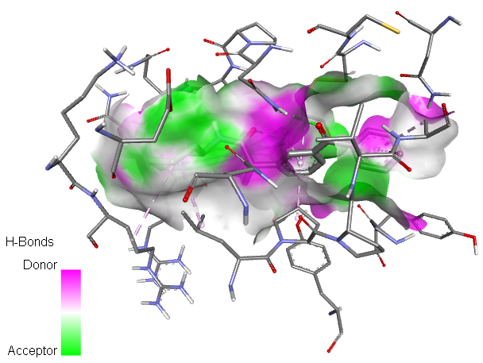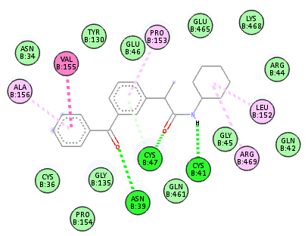
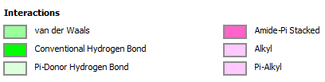
Figure 1. Compound 1 docked in cyclooxygenase-2 COX-2 (3Q7D): (left) The Hbond donor-acceptor residues are visible in the pocket view of 3Q7D binding to compound 1. (right) A docking model of interactions between chemical 1 and an amino acid with H-bonds in 3Q7D is shown in a 2D schematic picture.
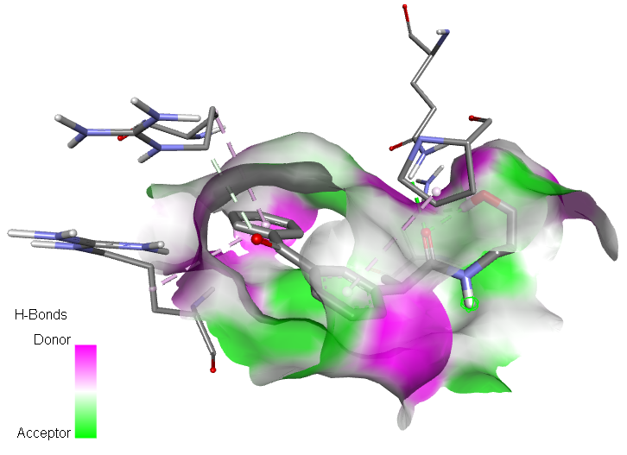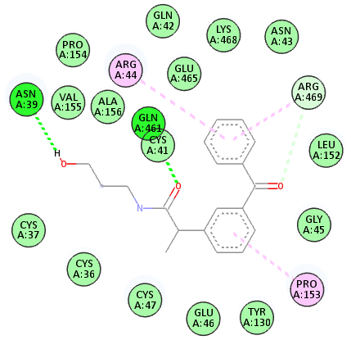
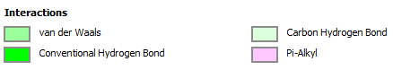
Figure 2. Compound 2 docked in cyclooxygenase-2 COX-2 (3Q7D): (left) The Hbond donor-acceptor residues are visible in the pocket view of 3Q7D binding to compound 1. (right) A docking model of interactions between chemical 1 and an amino acid with H-bonds in 3Q7D is shown in a 2D schematic picture.
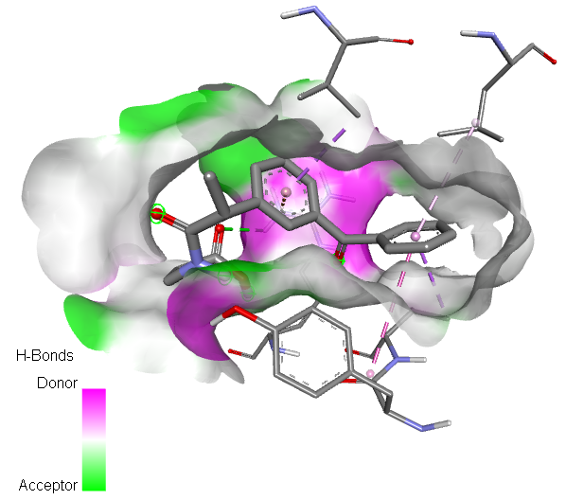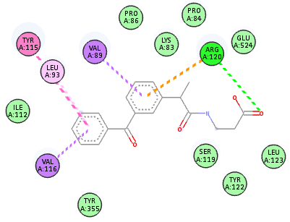
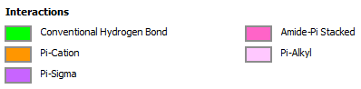
Figure 3. Compound 3 docked in cyclooxygenase-2 COX-2 (3Q7D): (left) The Hbond donor-acceptor residues are visible in the pocket view of 3Q7D binding to compound 1. (right) A docking model of interactions between chemical 1 and an amino acid with H-bonds in 3Q7D is shown in a 2D schematic picture.
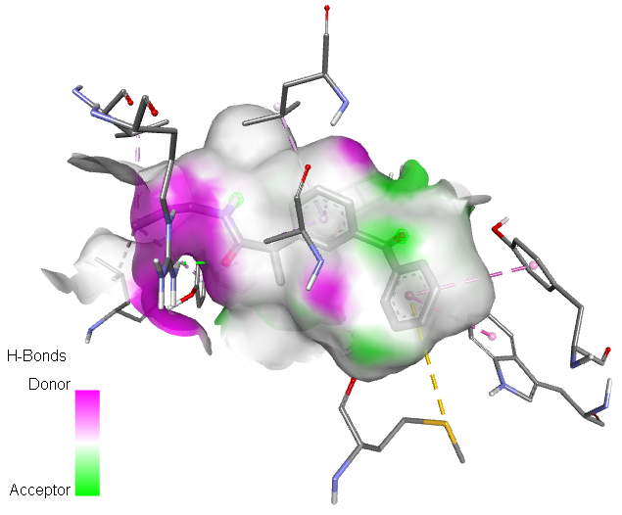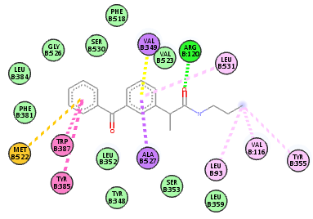
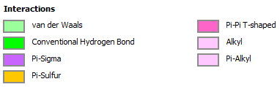
Figure 4. Compound 4 docked in cyclooxygenase-2 COX-2 (3Q7D): (left) The H-bond donor-acceptor residues are visible in the pocket view of 3Q7D binding to compound 1. (right) A docking model of interactions between compound 4 and an amino acid with H-bonds in 3Q7D is shown in a 2D schematic picture.
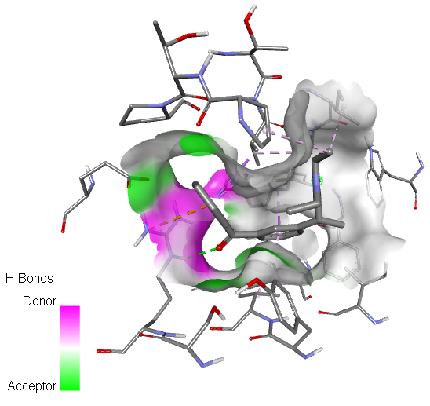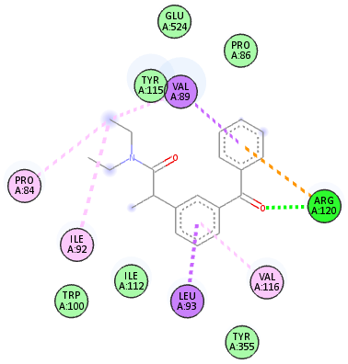
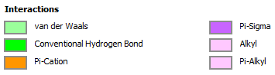
Figure 5. Compound 5 docked in cyclooxygenase-2 COX-2 (3Q7D): (left) The Hbond donor-acceptor residues are visible in the pocket view of 3Q7D binding to compound 1. (right) A docking model of interactions between chemical 1 and an amino acid with H-bonds in 3Q7D is shown in a 2D schematic picture.
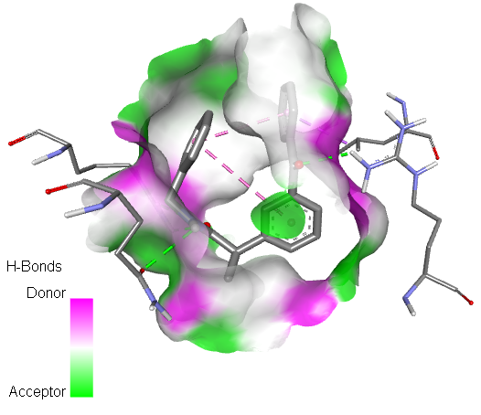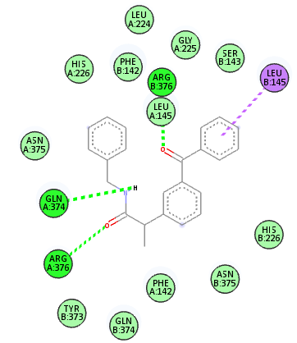
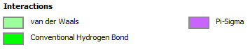
Figure 6. Compound 6 docked in cyclooxygenase-2 COX-2 (3Q7D): (left) The Hbond donor-acceptor residues are visible in the pocket view of 3Q7D binding to compound 6. (right) A docking model of interactions between compound 6 and an amino acid with H-bonds in 3Q7D is shown in a 2D schematic picture.
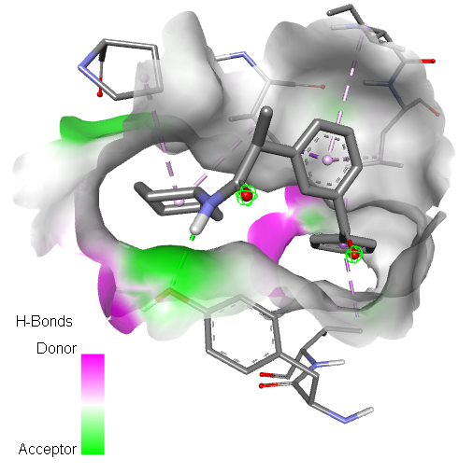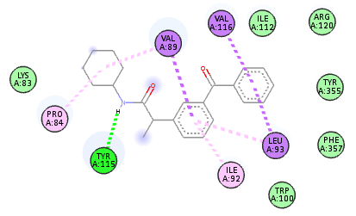
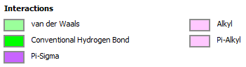
Figure 7. Compound 7 docked in cyclooxygenase-2 COX-2 (3Q7D): (left) The Hbond donor-acceptor residues are visible in the pocket view of 3Q7D binding to compound 7. (right) A docking model of interactions between compound 7 and an amino acid with H-bonds in 3Q7D is shown in a 2D schematic picture.
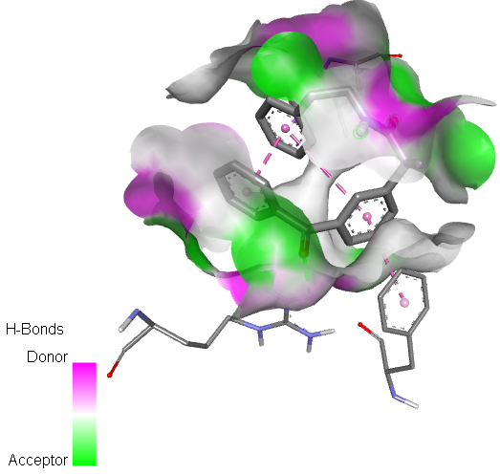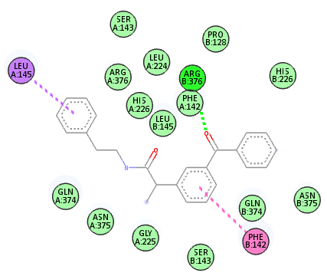
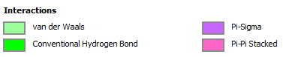
Figure 8. Compound 8 docked in cyclooxygenase-2 COX-2 (3Q7D): (left) The Hbond donor-acceptor residues are visible in the pocket view of 3Q7D binding to compound 8. (right) A docking model of interactions between compound 8 and an amino acid with H-bonds in 3Q7D is shown in a 2D schematic picture.
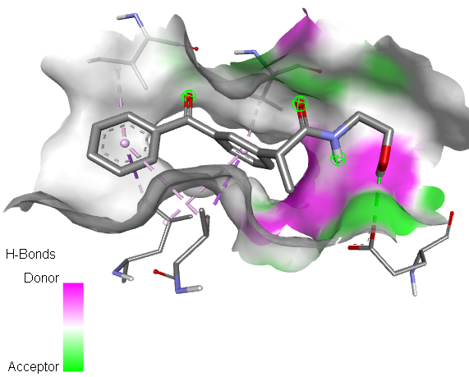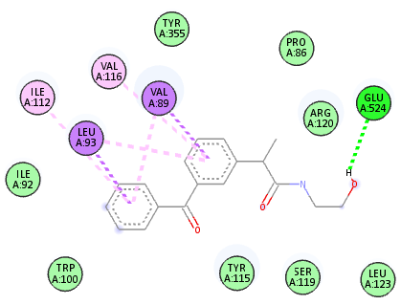
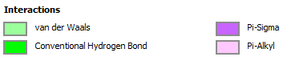
Figure 9. Compound 9 docked in cyclooxygenase-2 COX-2 (3Q7D): (left) The Hbond donor-acceptor residues are visible in the pocket view of 3Q7D binding to compound 9. (right) A docking model of interactions between compound 9 and an amino acid with H-bonds in 3Q7D is shown in a 2D schematic picture.
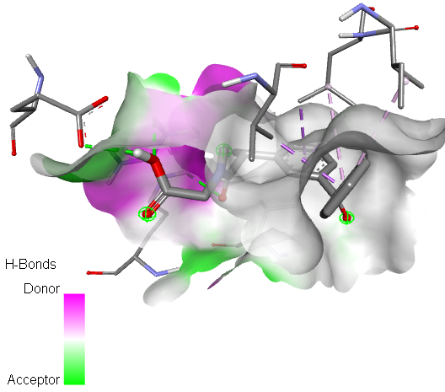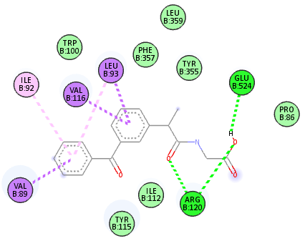
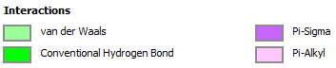
Figure 10. Compound 10 docked in cyclooxygenase-2 COX-2 (3Q7D): (left) The Hbond donor-acceptor residues are visible in the pocket view of 3Q7D binding to compound 10. (right) A docking model of interactions between compound 10 and an amino acid with H-bonds in 3Q7D is shown in a 2D schematic picture.

