Table 1. Information about ligands
Compound | Name | Mol. Wt. | 2D Structure | 3D Optimized Structure
1 | 2-(3-benzoylphenyl)-N-cyclohexylpropanamide | 335.44 | 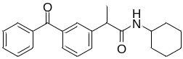 | 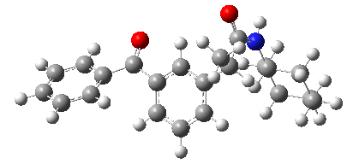
2 | 2-(3-benzoylphenyl)-N-(3-hydroxypropyl)propanamide | 311.37 | 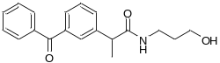 | 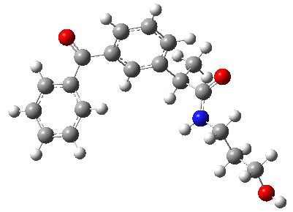
3 | 3-(2-(3-benzoylphenyl)propanamido)propanoic acid | 325.36 | 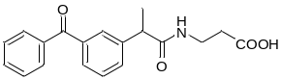 | 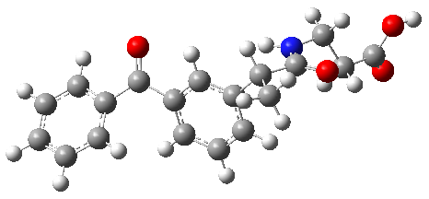
4 | 2-(3-benzoylphenyl)-N-propylpropanamide | 295.38 | 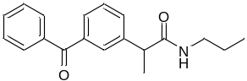 | 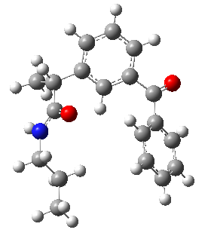
5 | 2-(3-benzoylphenyl)-N,N-diethylpropanamide | 309.40 | 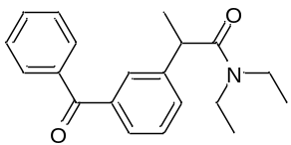 | 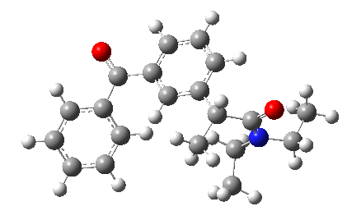
6 | 2-(3-benzoylphenyl)-N-benzylpropanamide | 343.42 | 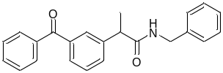 | 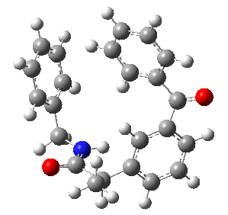
7 | 2-(3-benzoylphenyl)-N-cyclohexylpropanamide | 335.44 | 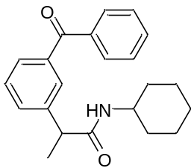 | 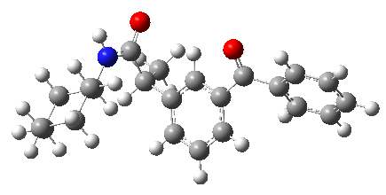
8 | 2-(3-benzoylphenyl)-N-phenethylpropanamide | 357.44 | 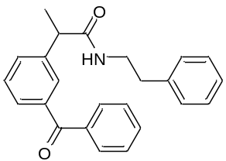 | 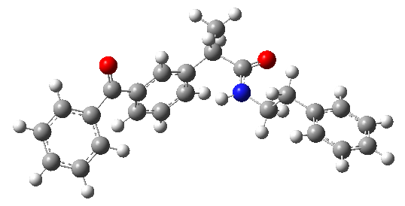
9 | 2-(3-benzoylphenyl)-N-(2-hydroxyethyl)propanamide | 297.35 | 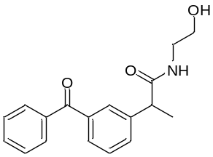 | 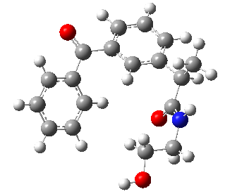
10 | 2-(2-(3-benzoylphenyl)propanamido)acetic acid | 311.33 | 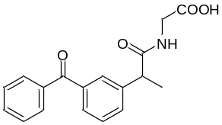 | 