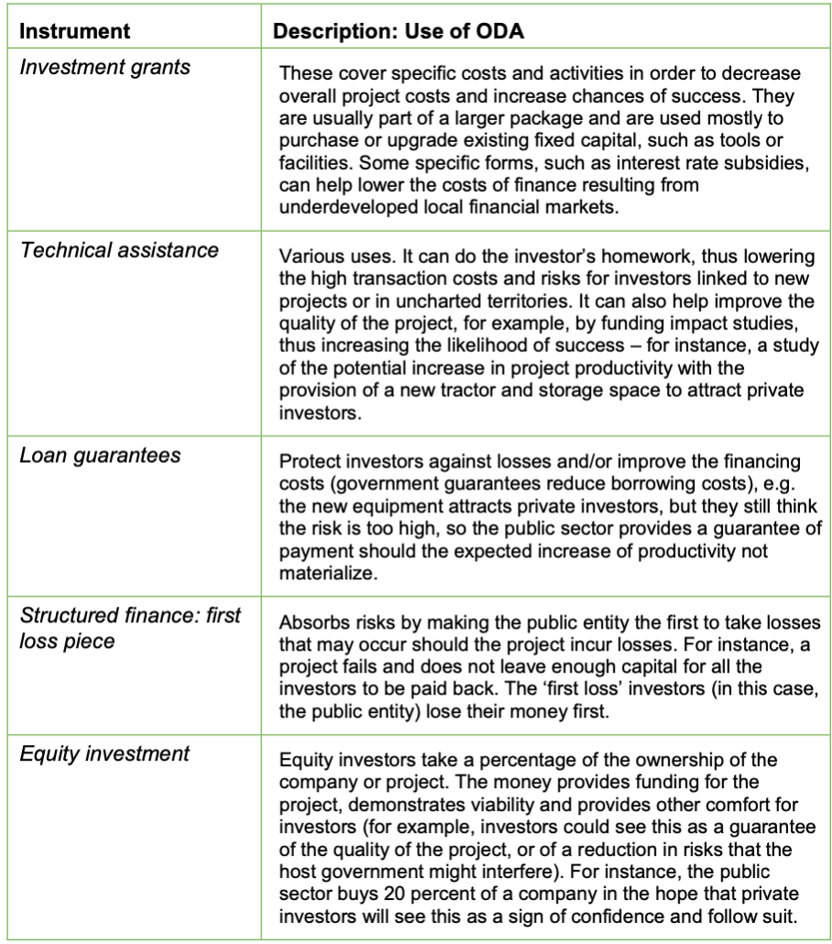

Table 1: Financial instruments and how they are used in blended finance (Source: Pereira 2017).

Power Plant | Installed Capacity 2021 (MW)
Coal | 11,669
Gas | 3,453
Oil | 3,847
Solar PV | 1,317
Hydropower | 3,752
Biomass | 489
Geothermal | 1,928
Onshore Wind | 427
Table 2: Installed power plant capacities (2021) in the Philippines.
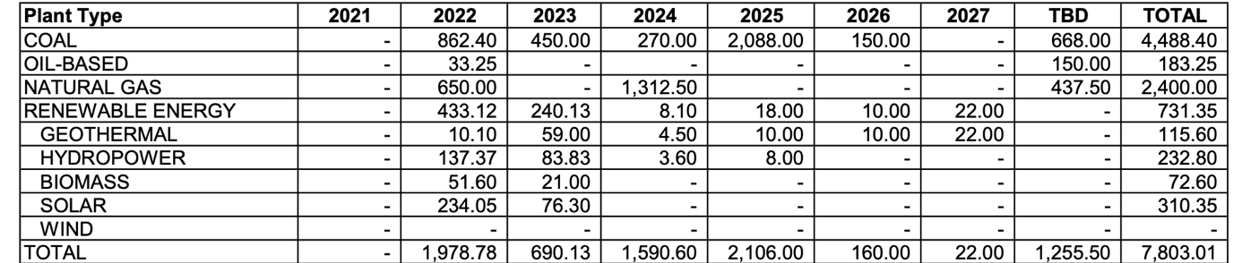

Table 3: Planned power plant installations by capacity (MW) per plant type in the Philippines.

Power Plant | Cost ($) per kW
Onshore Wind | 1325
Offshore Wind | 2858
Solar PV | 857
CSP | 9091
Small Hydro | 2000
Large Hydro | 2135
Geothermal | 3991
Biomass | 2353

Table 4: Capital costs ($) per kW for each renewable energy source in 2021 (IRENA 2022).

