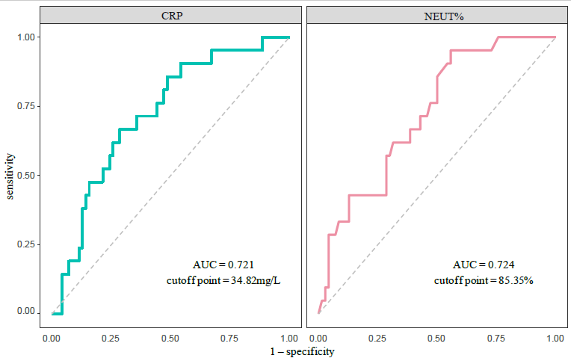

eFigure1. The cut-offs of the CRP level and the NEUT%.

