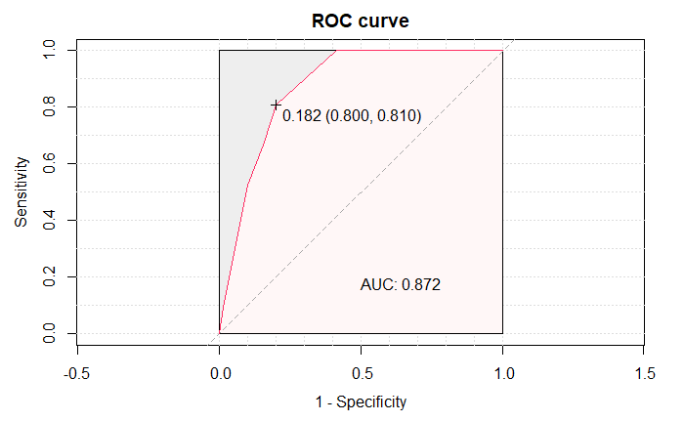
eFigure.2. The nomogram of ROC.

