Supporting Information
Microcrystalline cellulose grafted hyperbranched polyester with roll comb structure for synergistic toughening and strengthening of PHBV/ bio-based polyester elastomer composites
Xiaolong Han^{1,2}, Yi Han^{3,4}, Yujuan Jin^{1,2*}, Zhao Wang^{3,4}, Huafeng Tian^{1,2**}, Jiawei Huang^{1,2}, Maolin Guo^{1,2}, Shuang Men^{2,5}, Haibo Lei⁶, Rakesh Kumar⁷
1 School of Chemistry and Materials Engineering, Beijing Technology and Business University, Beijing, P. R. China, 100048
2 Beijing Key Laboratory of Quality Evaluation Technology for Hygiene and Safety of Plastics, Beijing Technology and Business University, Beijing, P. R. China,100048
3 State Key Laboratory of Organic−Inorganic Composites, Beijing University of Chemical Technology, 15 North Third Ring Road, Beijing 100029, P. R. China
4 Beijing Laboratory of Biomedical Materials, Beijing University of Chemical Technology, 15 North Third Ring Road, Beijing, 100029, P. R. China
5 Institute of Cosmetic Regulatory Science, Beijing Technology and Business University, Beijing, P. R. China,100048
6 College of Basic Science, Tianjin Agricultural University, Tianjin 300392, China.
7 Department of Biotechnology, Central University of South Bihar, Gaya - 824236, India

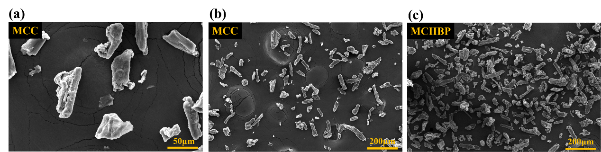 Fig S1. SEM pictures of MCC and MCHBP at different magnifications.
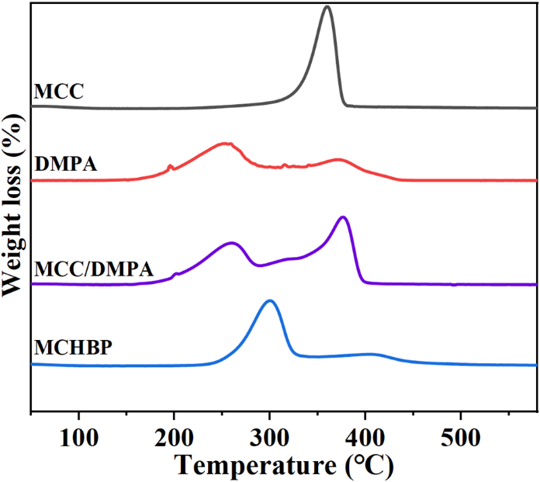
Fig S2. DTG curves of MCC, DMPA, MCC/DMPA composites and MCHBP.
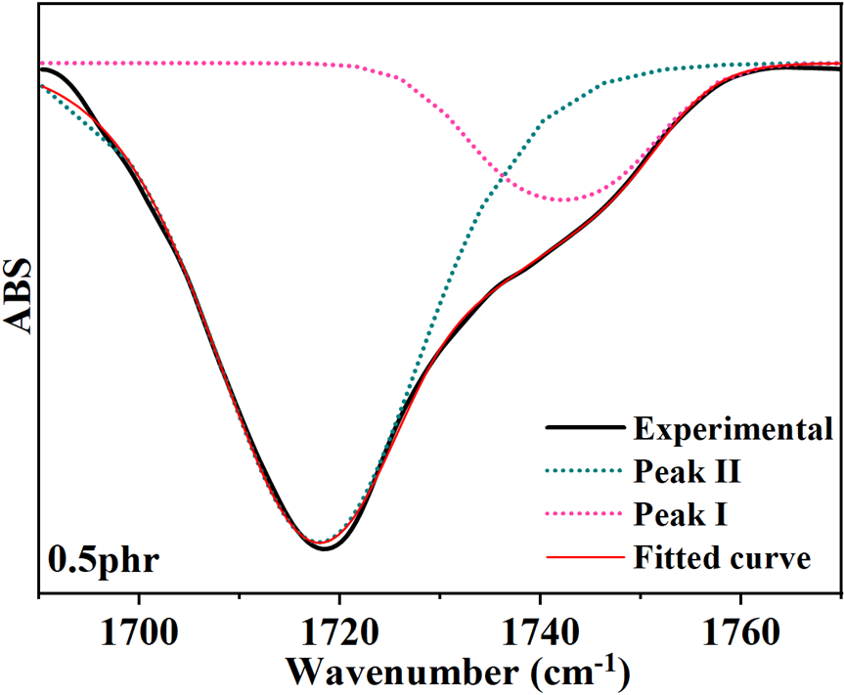
Fig S3. Peak separation fitting of carbonyl groups at 0.5phr.
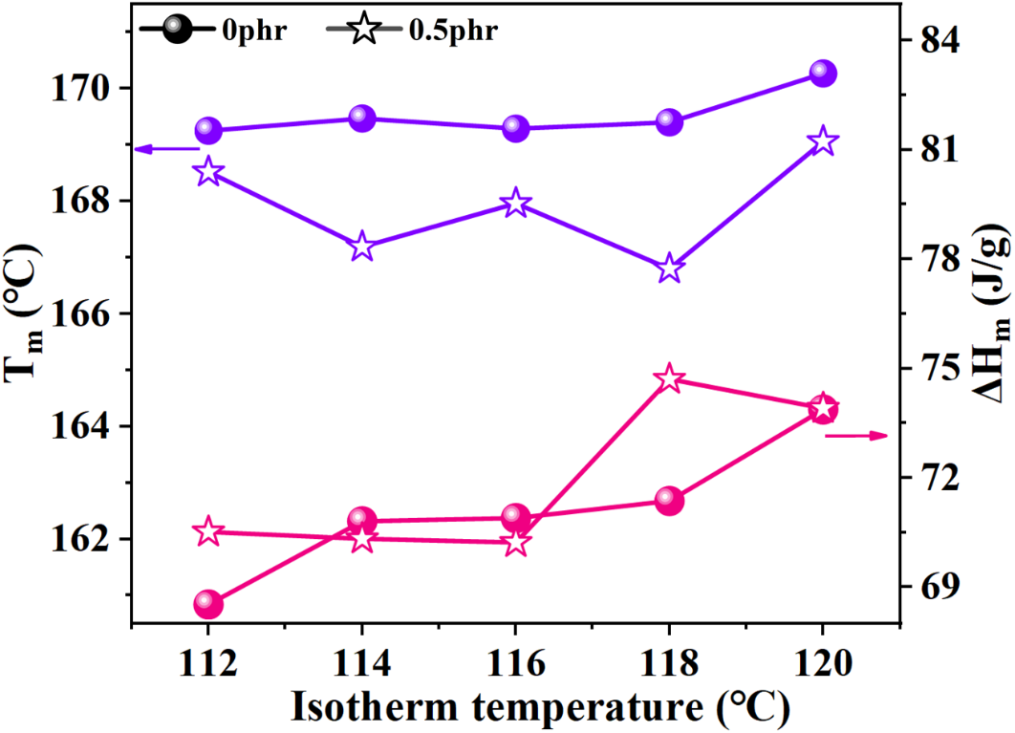
Fig S4. Peak temperatures and melting enthalpy of the melting peaks as a function of isotherm temperature.
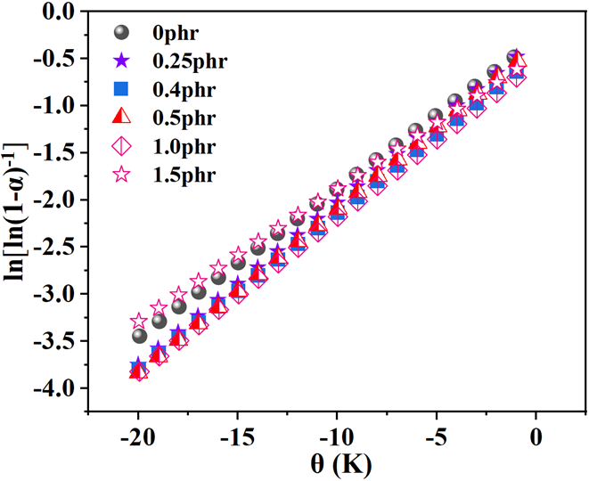
Fig S5. Plots of ln[ln(1-α) -1] vs θ for determination of the decomposition activation energy. Straight lines are the linear fit of the data points.
Table. S1 Contact angle parameters of PHBV/BEPE composites with different content of MCHBP and test results of contact angle after forming film of trichloromethane dispersion of MCC or MCHBP on glass.
 |  | Contact Angle (°)
MCHBP  content  (phr) | 0 | 73.63±1.66
MCHBP  content  (phr) | 0.25 | 71.03±0.32
MCHBP  content  (phr) | 0.4 | 71.50±1.56
MCHBP  content  (phr) | 0.5 | 68.95±2.04
MCHBP  content  (phr) | 1 | 68.26±7.71
MCHBP  content  (phr) | 1.5 | 69.03±3.73
 | Glass | 25.40±2.02
 | MCC | 34.26±2.36
 | MCHBP | 20.95±3.61
Table. S2 Thermal parameters of isothermal crystallization and melting behaviors of PHBV/BEPE blends with various MCHBP content
MCHBP content  (phr) | T_{c}  (℃) | T_{c,onset}  (℃) | ΔH_{c}  (J/g) | T_{m}  (℃) | ΔH_{m}  (J/g) | X_{c}  (%)
PHBV | 117.29 | 121.29 | 89.85 | 169.94 | 100.1 | 68.28
0 | 115.62 | 118.57 | 69.80 | 169.12 | 77.06 | 65.71
0.25 | 115.56 | 118.38 | 69.63 | 167.35 | 77.19 | 65.99
0.4 | 115.44 | 118.72 | 70.16 | 168.78 | 77.96 | 66.02
0.5 | 115.65 | 118.83 | 68.49 | 168.65 | 76.27 | 66.36
1 | 114.21 | 118.02 | 68.63 | 167.89 | 66.54 | 57.31
1.5 | 114.62 | 118.06 | 69.69 | 167.78 | 70.36 | 60.90
Table. S3 Thermal parameters for PHBV/BEPE blends with various MCHBP content
MCHBP  Content（phr） | T₀ (℃) | T_{max} (℃) | T₀-T_{m} (℃) | E_{t} (kJ/mol)
0phr | 274.6 | 300.6 | 105.5 | 118.1
0.25phr | 281.2 | 306.4 | 113.9 | 134.1
0.4phr | 282.6 | 306.5 | 113.9 | 130.0
0.5phr | 283.1 | 306.6 | 114.5 | 135.6
1.0phr | 281.7 | 304.6 | 113.8 | 127.1
1.5phr | 280.4 | 304.2 | 112.6 | 108.3
Table. S4 Mechanical properties parameters for PHBV/BEPE blends with various MCHBP content
 |  | Elongation at break (%) |  | Tensile strength (MPa) | Tensile toughness  (MJ/m³)
MCHBP  content  (phr) | 0 |  | 3.94±0.33 | 11.87±2.21 | 24.66
MCHBP  content  (phr) | 0.25 |  | 5.67±1.49 | 12.97±1.20 | 47.16
MCHBP  content  (phr) | 0.4 |  | 12.22±1.92 | 13.27±0.40 | 114.19
MCHBP  content  (phr) | 0.5 |  | 12.68±2.95 | 15.65±2.61 | 162.69
MCHBP  content  (phr) | 1 |  | 7.15±1.07 | 12.15±0.87 | 78.85
MCHBP  content  (phr) | 1.5 |  | 6.28±0.98 | 11.69±0.88 | 51.15
MCC  content  (phr) | 0.25 |  | 4.84±0.45 | 10.56±0.68 | -
MCC  content  (phr) | 0.5 |  | 4.76±0.60 | 9.37±0.72 | -
MCC  content  (phr) | 1.5 |  | 6.14±1.09 | 8.31±1.20 | -

