Inhibitive effect of new nitrogen and sulfur containing azole derivatives on mild steel corrosion in HCl solution: Electrochemical, SEM and AFM studies

Zohreh Gikani ª, Hamid Khanmohammadi ª ∗, Hossein Hassannejad ^{b}
a) Department of Chemistry, Faculty of Science, Arak University, 38156-8-8349 Arak, Iran
b) Department of Metallurgy and Materials Engineering, Faculty of Engineering, Arak University, 38156-8-8349 Arak, Iran

Page No. Contents

S1 ¹H NMR and IR spectra of TIB
S2 ¹H NMR and IR spectra of BTP
S3 Bode phase angle plots and Nyquist plots in the presence of (a) TIB and (b) BTP
S4 and S5 The average surface roughness values

S1

S2

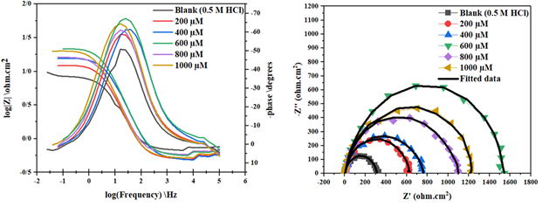
(a)
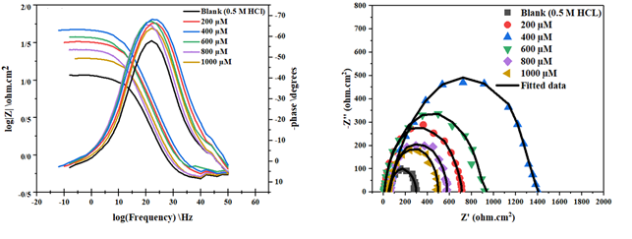
(b)

S3

Surface of the polished mild steel
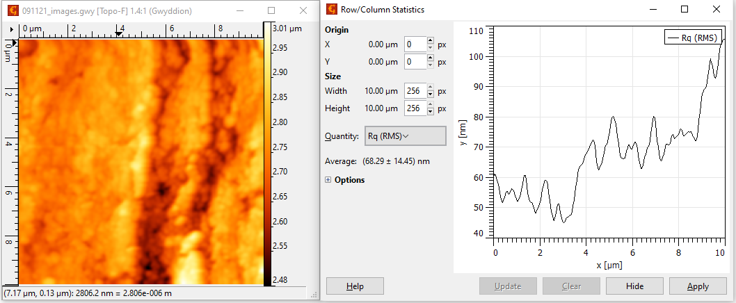

Surface of corroded mild steel in 0.5 M HCl
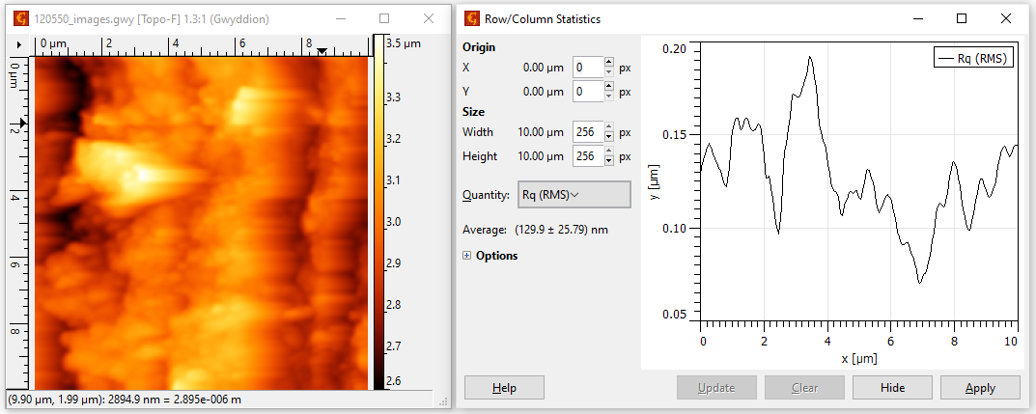

S4

Surface of mild steel in the presence of 600 μM TIB in 0.5 M Hall

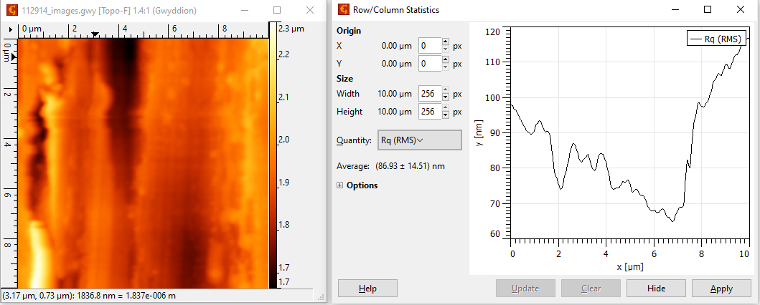

Surface of mild steel in the presence of 400 μM BTP in 0.5 M HCl

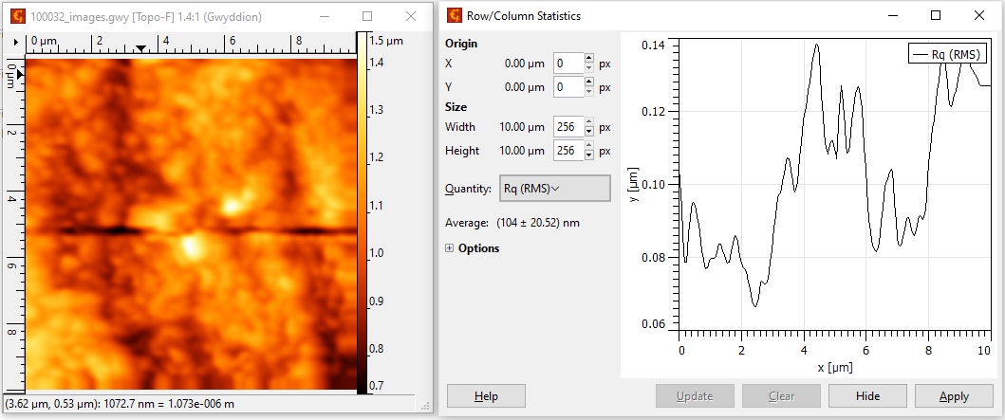

S5

∗ Corresponding author; h-khanmohammadi@araku.ac.ir ; Tel: +98-86-34173431; Fax: +98-86-34173406.

