Supplement Information
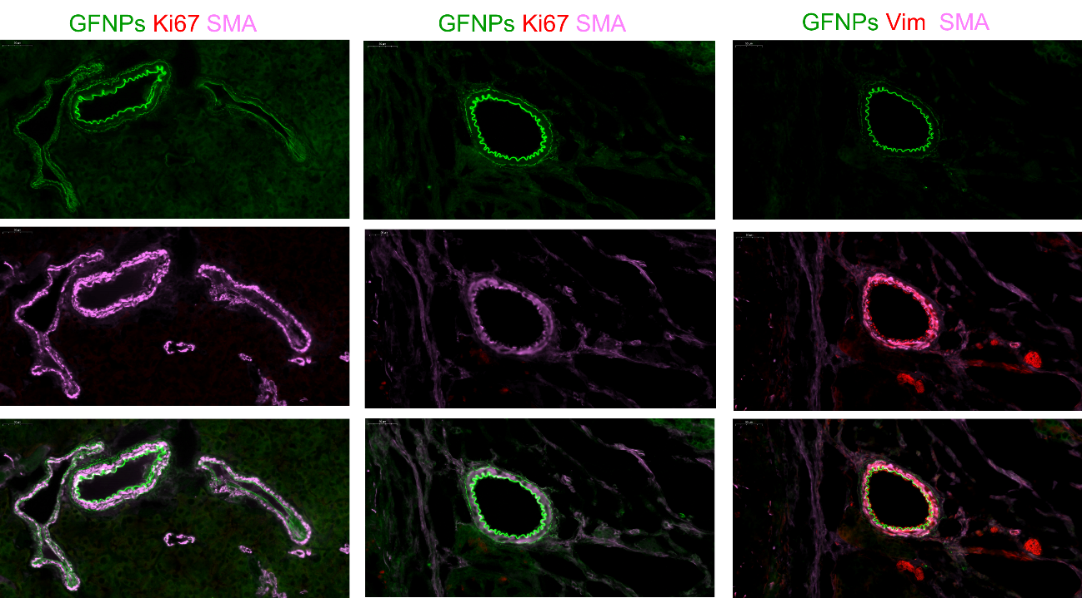
Fig. S1 GFNPs specifically label the inner side of the duct lumen, showing an in-adjacent positional relationship with Vim and an out-adjacent positional relationship with αSMA. scale bar = 50 um.
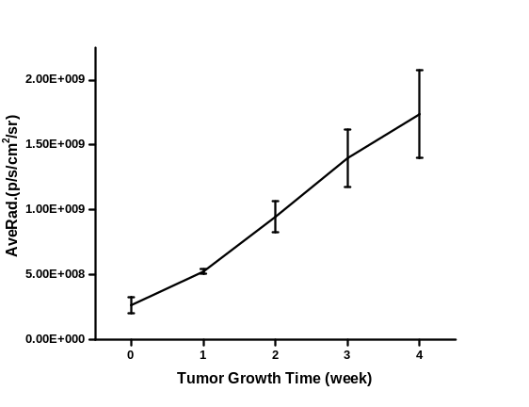
Fig. S2 GFNPs fluorescence signal intensity was proportional to the tumor proliferation cycle.

