Supplemental Table 1. Cox regression analysis of prior CAD, CVD and presence or absence of DM for incidence of CAD.
 | CAD-/CVD- |  | CAD+/CVD- |  | CAD-/CVD+ | CAD+/CVD+
 | Hazard Ratio (95% CI) |  | Hazard Ratio (95% CI) |  | Hazard Ratio (95% CI) | Hazard Ratio (95% CI)
Non-DM | Reference |  | Reference |  | Reference | Reference
DM | 2.05 (1.85-2.26) *** |  | 1.48 (0.93-2.34) |  | 1.42 (0.78-2.59) | 1.74 (0.67-4.52)
Non-DM | Reference |  | 1.68 (1.29-2.18) *** |  | 1.86 (1.32-2.63) *** | 2.71 (1.45-5.06) **
DM | Reference |  | 1.08 (0.78-1.52) |  | 1.26 (0.80-1.97) | 2.64 (1.48-4.70) **
Non-DM | Reference |  | 1.78 (1.37-2.32) *** |  | 2.01 (1.42-2.83) *** | 3.00 (1.61-5.61) **
DM | 2.09 (1.89-2.30) *** |  | 2.00 (1.44-2.79) *** |  | 2.26 (1.45-3.54) *** | 4.70 (2.65-8.35) ***
*P<0.05, **P<0.01, ***P<0.001 vs reference.
Each variable for CVD adjusted by age, BMI, SBP, LDL-C, HDL-C, medication for hypertension, medication for dyslipidemia and current smoking.

Supplemental Figure 1. Kaplan-Meier curve of cumulative incidence of CAD according to prior cardiovascular disease A) without DM and B) with DM.
A) B)
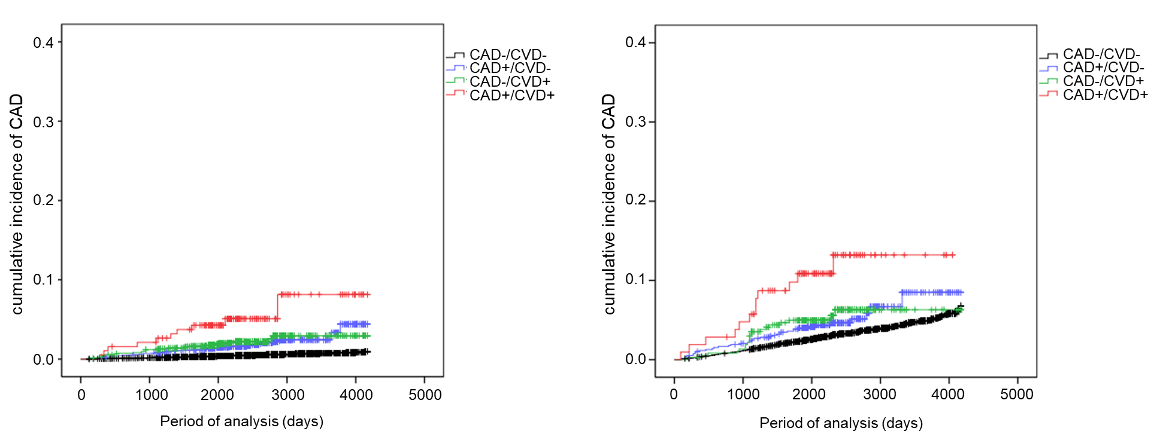
Supplemental Table 2. Cox regression analysis of prior CAD, CVD and presence or absence of DM for incidence of CVD.
 | CAD-/CVD- |  | CAD+/CVD- |  | CAD-/CVD+ | CAD+/CVD+
 | Hazard Ratio (95% CI) |  | Hazard Ratio (95% CI) |  | Hazard Ratio (95% CI) | Hazard Ratio (95% CI)
Non-DM | Reference |  | Reference |  | Reference | Reference
DM | 1.28 (1.16-1.41) *** |  | 1.45 (0.98-2.15) |  | 1.11 (0.83-1.50) | 1.01 (0.53-1.92)
Non-DM | Reference |  | 1.91 (1.55-2.36) *** |  | 8.11 (7.00-9.40) *** | 7.48 (5.16-10.83) ***
DM | Reference |  | 1.57 (1.15-2.13) ** |  | 5.00 (3.85-6.49) *** | 5.65 (3.61-8.85) ***
Non-DM | Reference |  | 1.90 (1.54-2.34) *** |  | 8.13 (7.03-9.41) *** | 7.45 (5.15-10.78) ***
DM | 1.34 (1.21-1.48) *** |  | 2.14 (1.59-2.88) *** |  | 6.64 (5.17-8.53) *** | 7.68 (4.96-11.9) ***
*P<0.05, **P<0.01, ***P<0.001 vs reference.
Each variable for CVD adjusted by age, BMI, SBP, LDL-C, HDL-C, medication for hypertension, medication for dyslipidemia and current smoking.

Supplemental Figure 2. Kaplan-Meier curve of cumulative incidence of CVD according to prior cardiovascular disease A) without DM and B) with DM.
A) B)
