Supplemental Material

Chemically and Electronically Active Metal Ions on InAs Quantum Dots for Infrared Detectors
Seongchan Kim^{‡,1}, Sooyeon Yeon^{‡,1}, Minwoo Lee¹, Junyoung Jin², Seungki Shin¹, Namyoung Gwak¹, Inyoung Jeong¹, Hyunwoo Jang¹, Gyu Weon Hwang² and Nuri Oh*^{,1}
¹Division of Materials Science and Engineering, Hanyang University, 222, Wangsimni-ro, Seongdong-gu, Seoul, 04763, Republic of Korea, and ²Center for Neuromorphic Engineering, Korea Institute of Science and Technology, 5 Hwarang-ro 14-gil, Seongbuk-gu, Seoul, 02792, Republic of Korea

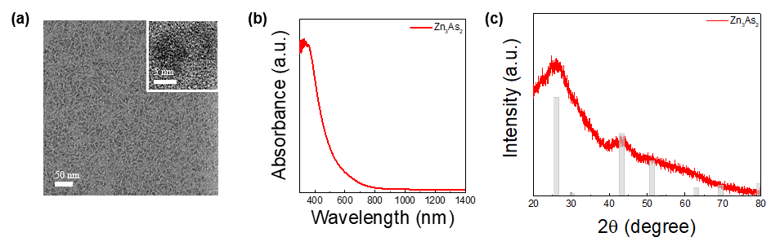
Figure S1. (a) TEM image, (b) absorption, and (c) XRD pattern of zinc arsenide amorphous particles. (JCPDS No. 04-002-0147)
Figure S2. Absorption spectra of InAs QDs synthesized at 330 °C by changing the Zn/In molar ratio from 0 (red) to 2 (green).
Figure S3. XRD patterns of InAs QDs synthesized at 330 °C by changing the Zn/In molar ratio from 0 (red) to 2 (green).

Table S1. Molar ratios of In to As and In to Zn obtained by ICP-OES
In : As : Zn  (mole fraction) | Molar ratio obtained by ICP-OES
In : As : Zn  (mole fraction) | In | As | Zn
2 : 1 : 0 | 1 | 0.9379 | -
2 : 1 : 2 | 1 | 0.9368 | 0.01677
2 : 1 : 4 | 1 | 0.9320 | 0.02152

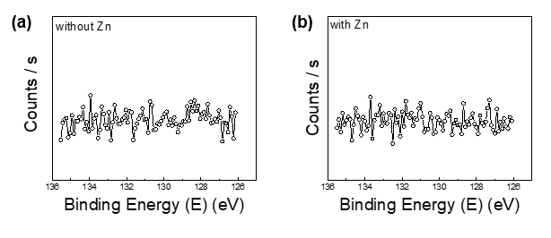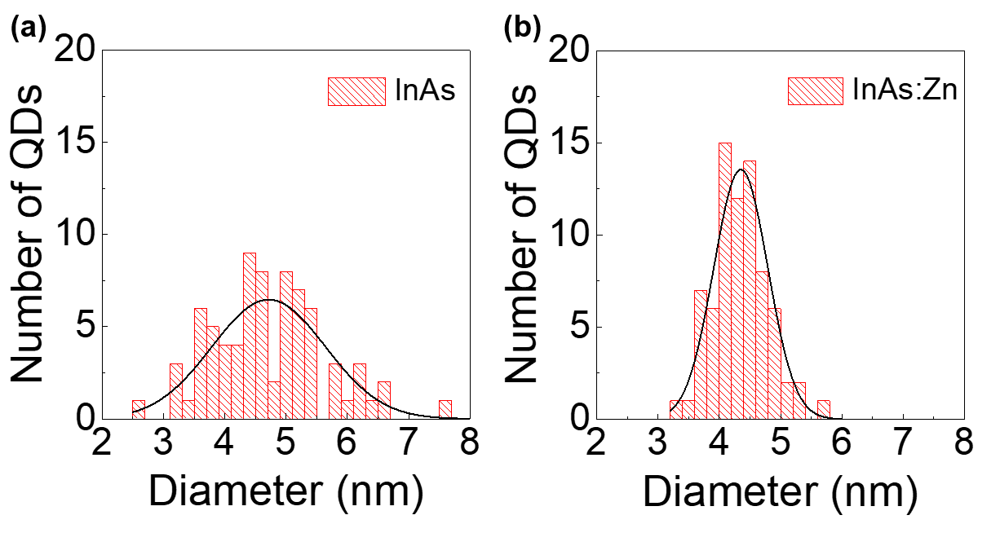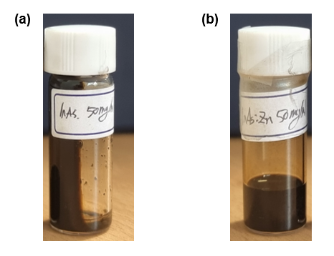
Figure S4. XPS spectra for P 2p level of InAs QDs synthesized (a) without and (b) with Zn precursor.
Figure S5. The size distribution and histograms measured diameters for (a) InAs QDs and (b) InAs:Zn QDs.
Figure S6. Photographs of (a) InAs and (b) InAs:Zn QDs two months after the synthesis.

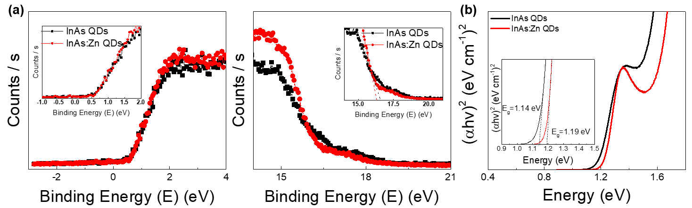
Figure S7. UPS spectra (a) of InAs and InAs:Zn QDs (The inset shows the secondary electron cut-off), and (b) Tauc plots of both QDs.

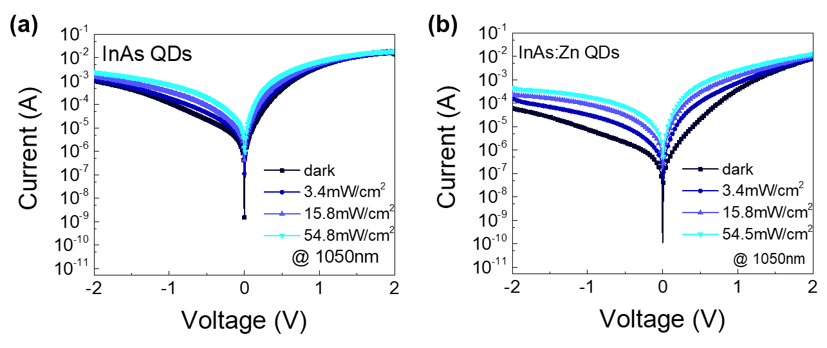
Figure S8. Photocurrent of (a) bare InAs and (b) InAs:Zn QD-photodiodes as a function of bias with different power density of 1050 nm IR illumination.
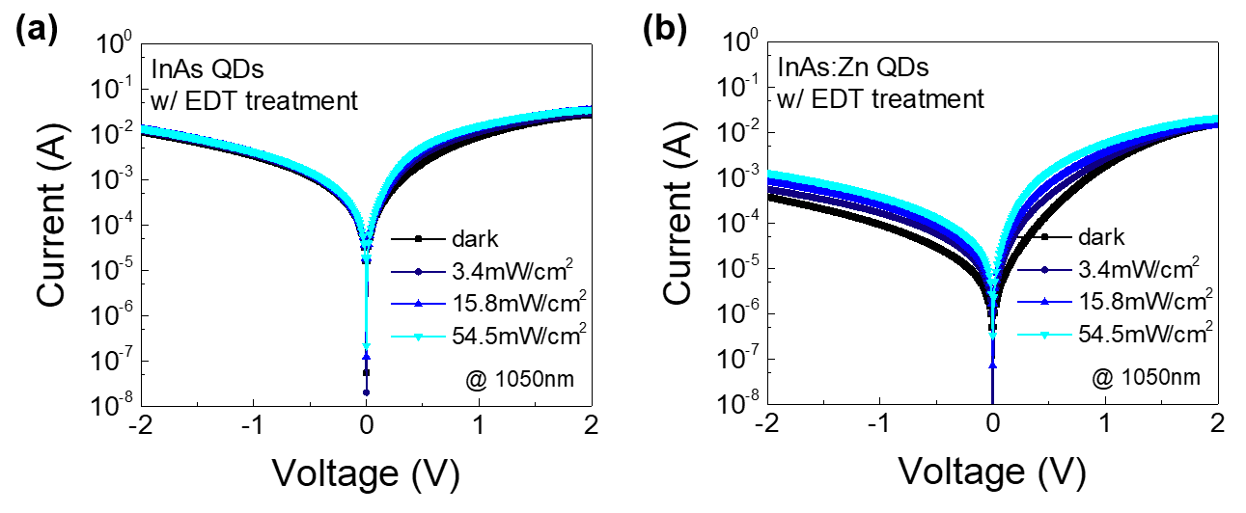
Figure S9. Photocurrent versus bias voltage plots under illumination of 1050nm: (a) bare InAs QD- and (b) InAs:Zn QD-photodiodes with EDT ligand exchange.
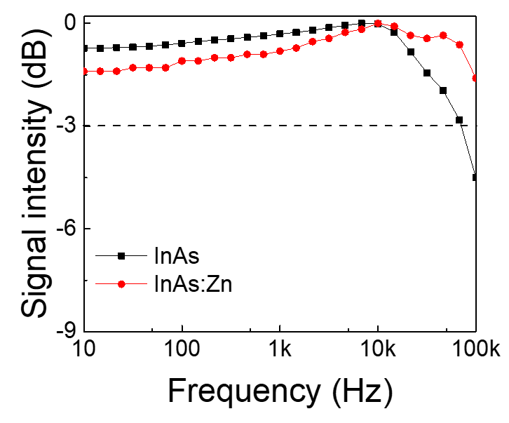
Figure S10. Frequency response of QD-photodiodes at 9.55 mW/cm² for 808 nm illumination.

