Supporting Information Online Resource 1
Title Monitoring for the presence of invasive arboreal rodents: an assessment of monitoring tools across forest strata
Submitted to Biological Invasions
Authors Alexandra H. Nance^{1,2}*, Melinda Wilson², Carly N. Cook¹, Rohan H. Clarke¹
¹ Monash University, School of Biological Sciences, Clayton, VIC, Australia
² Parks Australia, Norfolk Island National Park and Botanic Garden, Norfolk Island
* Corresponding author. Email: allie.nance@dcceew.gov.au
Author ORCIDs
Alexandra Nance - 0000-0002-8171-419X
Carly Cook - 0000-0002-4855-6409
Rohan Clarke – 0000-0002-6179-8402

Description of supporting information Model selection metrics for station-level rodent presence (Table 1) and device performance (Table 2); full equipment costings for cost-effectiveness analysis (Table 3); map of site locations of rodent monitoring areas (Figure 1); strata-specific breakdown of device agreement categories (Figure 2).

Table 1 Model selection metrics for models comparing station-level rodent presence across three different forest strata. All listed models included forest strata (ground, mid-storey and canopy) as a fixed effect. Asterisks (*) indicate models that yielded singular fit warnings. Cross (†) indicates models that failed to converge. Final model indicated in bold text (tie-break between the two models with ΔAIC < 2 was based on residual diagnostics and dispersion tests using R package DHARMa).
model random effects | deviance | residual df | AIC | ΔAIC | weight
(1|Season) + (1|SiteID) | 72.7 | 175 | 82.7 | 0.00 | 0.42
(1|Season) | 76.5 | 176 | 84.5 | 1.73 | 0.18
(1|ForestType) + (1|Season) + (1|SiteID)* | 72.7 | 174 | 84.7 | 2.00 | 0.15
(1|SiteID) | 77.2 | 176 | 85.2 | 2.49 | 0.12
(1|ForestType) + (1|Season)* | 76.5 | 175 | 86.5 | 3.73 | 0.06
(1|ForestType) + (1|SiteID)† | 77.2 | 175 | 87.2 | 4.49 | 0.04
(1|ForestType)* | 80.4 | 176 | 88.4 | 5.64 | 0.02

Table 2 Model selection metrics for models comparing positive rodent detection rates across different monitoring devices. All listed models included method and the interaction between method and forest strata as predictors of positive detections. Asterisks (*) indicate models that yielded singular fit warnings. Cross (†) indicates models that failed to converge. Final model indicated in bold text.
model random effects | deviance | residual df | AIC | ΔAIC | weight
(1|SiteID/StationID) * | 417.1 | 494 | 439.1 | 0.00 | 0.53
(1|ForestType) + (1|SiteID/StationID)† | 417.1 | 493 | 441.1 | 2.00 | 0.20
(1|SiteID/StationID) + (1|Season) * | 417.1 | 493 | 441.1 | 2.00 | 0.20
(1|ForestType) + (1|SiteID/StationID) + (1|Season)† | 417.1 | 492 | 443.1 | 4.00 | 0.07
(1 |ForestType) | 463.0 | 495 | 483.0 | 43.87 | 0.00
(1|Season) * | 464.1 | 495 | 484.1 | 44.99 | 0.00
(1|ForestType) + (1|Season) * | 463.0 | 494 | 485.0 | 45.87 | 0.00

Table 3 Cost-effectiveness analysis of three common tools used to monitor invasive rodents: chew cards, tracking tunnels and camera traps. Equipment costs are specific to the experimental design of this study. Effectiveness values are the percentage of devices for each method that positively detected a rodent when it was present. Costs are given in Australian dollars (AUD).
Method and equipment requirements | Equipment costs | Effectiveness (% positive detections) | Cost-effectiveness ($ per 1% positive detections)
Chew cards | $ 85.40 | 89 | $0.96
180 unfilled cards (single use) | $ 50.40
Peanut butter | $ 15.00
Nails | $ 20.00
Tracking tunnels | $ 1,336.25 | 74 | $18.06
90 tunnels (re-useable) | $ 1,003.00
180 tracking cards (single use) | $ 274.00
Peanut butter | $ 15.00
Cable ties | $ 44.25
Camera traps | $ 52,830.00 | 75 | $704.40
90 Reconyx camera traps (HC600) | $ 49,500.00
Rechargeable batteries (12 per camera) | $ 1,080.00
SD memory cards (1 per camera) | $ 2,250.00

Figure 1 Invasive rodent monitoring sites in Norfolk Island National Park and adjoining Botanic Gardens (BG) according to forest type: Red cherry guava sites (grey points), native hardwood sites (black points), and native palm sites (white points). Approximate boundary between the National Park and Botanic Gardens indicated by continuous black line. Spatial bias towards the eastern sections of the Park is due to a lack of availability of focal forest types; Eucalyptus sp. forests and African Olive (Olea europaea cuspidata) thickets dominate the western sections of the Park.
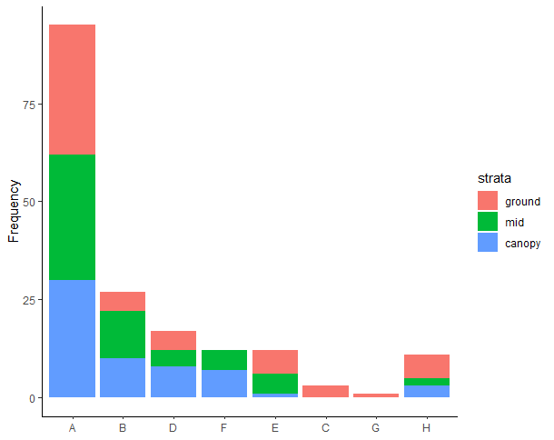
Figure 2 Number of invasive monitoring stations assigned to each device agreement category (stations = 178) according to forest strata (indicated by bar fill colour). Category definitions in order of appearance: A = all devices in a station detected a rodent; B = chew cards and tunnels detected a rodent; D = camera traps and chew cards detected a rodent; F = only chew cards detected a rodent; E = only camera traps detected a rodent; C = camera traps and tracking tunnels detected a rodent; G = only tracking tunnels detected a rodent; H = no devices detected a rodent.

