Dynamics of LacMeta’s role in the complete degradation and detoxification of malachite green
Natália Sarmanho Monteiro Lima^{a,b,c}, Elisângela Soares Gomes-Pepe ^{a,b}, Flavio Vinicius Crizostomo Kock^{d}, Luiz Alberto Colnago^{e}, Eliana Gertrudes de Macedo Lemos^{a,b *}

ª Department of Agricultural, Livestock and Environmental Biotechnology (UNESP), Faculty of Agricultural and Veterinary Sciences (FCAV), 14884-900, Jaboticabal, São Paulo State, Brazil.
^{b} Molecular Biology Laboratory, Institute for Research in Bioenergy (IPBEN), 14884-900, Jaboticabal, São Paulo State, Brazil.
^{c} Agricultural Microbiology Graduate Program at UNESP, Jaboticabal, São Paulo State, Brazil
^{d} Laboratory of Nuclear Magnetic Resonance, Department of Chemistry, Federal University of São Carlos, São Carlos, Brazil.
^{e} Embrapa Instrumentation. Rua 15 de Novembro 1452, São Carlos, SP, 13560-970

* Corresponding author
E-mail address: eliana.lemos@unesp.br

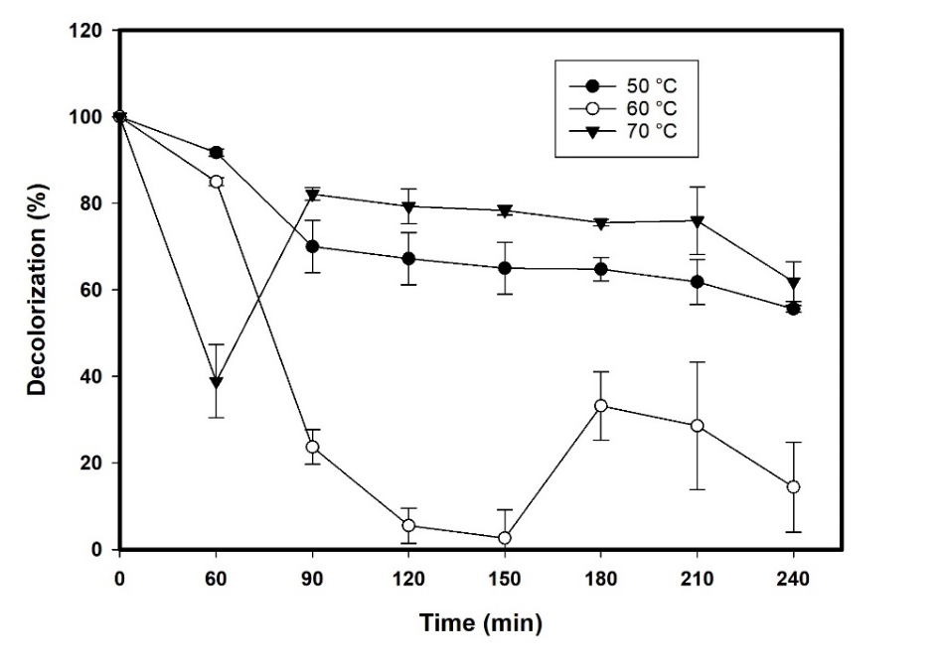
F
Figure S1. Thermostability of LacMeta and its effects on the decolorization of malachite green (50 mg L⁻¹). Tests were performed by measuring the percentage of decolorization every 60 min. The lowercase letters above the bars indicate significant differences between the conditions according to ANOVA and Tukey’s test at a 5% probability.

Table S1. Evaluation of ions in the decolorization process.
Ion | Concentration (mmol L⁻¹) | Decolorization (%^{dc})
Fe³⁺ | 1 | 85.86 ± 0.72 f
 | 3 | 79.26 ± 1.24 l
 | 5 | 3.42 ± 1.32 r
 | 10 | 3.52 ± 1.02 q
Li⁺ | 1 | 16.00 ± 3.13 p
 | 3 | 63.63 ± 2.82 j
 | 5 | 81.28 ± 1.24 o
 | 10 | 88.02 ± 0.54 d
Zn²⁺ | 1 | 87.17 ± 1.04 e
 | 3 | 88.89 ± 0.62 d
 | 5 | 87.17 ± 0.35 c
 | 10 | 90.13 ± 0.92 c
Co²⁺ | 1 | 77.41 ± 1.19 n
 | 5 | 91.31 ± 0.84 a
 | 10 | 91.94 ± 0.27 a
Ca²⁺ | 1 | 90.21 ± 1.82 c
 | 3 | 82.93 ± 1.14 i
 | 5 | 85.82 ± 0.70 f
 | 10 | 91.13 ± 0.70 a
Cu²⁺ | 1 | 83.22 ± 0.51 h
 | 3 | 88.98 ± 0.35 c
 | 5 | 88.95 ± 0.54 d
 | 10 | 86.96± 0.59 d
Mg²⁺ | 1 | 84.44 ± 0.75 g
 | 3 | 90.58 ± 0.61 b
 | 5 | 89.69 ± 0.17 c
 | 10 | 85.90 ± 0.95 f
Mn²⁺ | 1 | 78.46 ± 5.9 i
 | 3 | 86.68 ± 6.60 e
 | 5 | 91.18 ± 2.8 a
 | 10 | 91.63 ± 0.78 a
 | Control* | 91.74 ± 0.85 a
* Performed with enzyme + cofactor

