Journal of Research on Chemical Intermediates
Synthesis and molecular docking study of new thiazolidinones incorporating a benzoate moiety as anti-HepG2 cancer agents, EGFR inhibitors and apoptosis inducers

Salwa Magdy Eldaly¹. Dalia Salama Zakaria¹. Nadia Hanafy Metwally^{1*}

Department of Chemistry, Faculty of Science, Cairo University-Giza-Egypt
*Email: mnadia@sci.cu.edu.eg
Table of contents

1. Experimental

1.1. Chemistry

Spectral and analytical data:
Melting points were determined in (ºC) on an electrothermal (9100) apparatus (Kleinfled, Gehrden, Germany) and are uncorrected. IR spectra were recorded as KBr pellets on a Nicolet 205 spectrophotometer (Nicolet, Madison, WI, USA). The ¹H-NMR (300 MHz) spectra and ¹³C-NMR spectra (75 MHz) were obtained on a Varian EM-300 MHz spectrometer and DMSO-d⁶is used to desolve the tested compounds besides, tetramethylsilane as an internal standard sand the results are obtained as δ value (Varian Inc., Palo Alto, CA, USA). Mass spectra were taken on a Shimadzu GCMS-GB 1000 PX (Shimadzu, Kyoto, Japan; 70 eV). Elemental analyses and spectral analyses were carried out through the Microanalytic center at Cairo University and Microanalytic Unit- FOPC- NMR Unit- Faculty of Pharmacy- Cairo University. The anticancer investigations were carried out at Faculty of Pharmacy-El Mansoura University. The aldehydes 4-formylphenyl benzoate 1a and 4-formyl-2-methoxyphenyl benzoate 1b were prepared according to the reported method. [1,2]

General procedure for the synthesis of thiosemicarbazones 2a, 2b
An equimolar of the aldehydes 1a,b (0.01 mol) and thiosemicarbazide (0.01 mol) was added to a solution of absolute ethanol (10 ml) containing drops of glacial acetic acid (3 drops), then the reaction mixture was refluxed for 4 hrs. The reaction mixture was cooled and filtered off then the so formed product was recrystallized from ethanol-dioxane mixture.
4-[(2-Carbamothioylhydrazineylidene)methyl]phenyl benzoate (2a)
Buff crystals, m.p 238-240 ºC, yield (90%); v_{max} / cm⁻¹= 3455, 3285 (NH₂ & NH), 1734 (CO); δ¹_{H} = 6.51 (b, 2H, NH₂), 7.29 (d, 2H, J = 8.7 Hz, Ar-H), 7.58-7.72 (m, 3H, Ar-H), 7.80 (d, 2H, J = 8.7 Hz, Ar-H), 7.90 (s, 1H, =CH), 8.12 (d, 2H, J = 7.2 Hz, Ar-H), 10.30 (s, 1H, NH); δ¹³_{C} = 122.6, 128.2, 129.4, 129.5, 130.3, 133.2, 134.6, 138.8, 151.5, 157.2, 165.0; Elemental anal. For C₁₅H₁₃N₃O₂S (299.35): Calc. = C, 60.19; H, 4.38; N, 14.04; S, 10.71%; Found = C, 60.38; H, 4.55; N, 14.26; S, 10.92 %.
4-[(2-Carbamothioylhydrazineylidene)methyl]phenyl 2-methoxybenzoate (2b)
Yellow crystals, m.p 240-242 ºC, yield (87%); v_{max} / cm⁻¹ = 3448 (NH₂ & NH), 1735 (CO); δ¹_{H} = 3.85 (s, 3H, OCH₃), 7.37 (d, 1H, J = 8.1 Hz, Ar-H), 7.50 (d, 2H, J = 8.1 Hz, Ar-H), 7.60-7.77 (m, 6H, Ar-H & NH₂), 8.13 (d, 1H, J = 7.8 Hz, Ar-H), 8.78 (s, 1H, =CH); δ¹³_{C} = 55.8, 111.0, 122.09, 123.5, 128.3, 129.02, 129.8, 132.8, 134.1, 141.8, 151.2, 160.9, 163.7; Elemental anal. For C₁₆H₁₅N₃O₃S (329.37): Calc. = C, 58.35; H, 4.59; N, 12.76; S, 9.73%; Found = C, 58.57; H, 4.77; N, 12.92; S, 9.90 %.

General procedure for the synthesis of thiazolidinone derivatives 3a,b
Method A: Aldehydes 2a,b (0.01 mol) was refluxed with choloroacetic acid (0.01 mol) in pure ethanol (10 ml) and fused sodium acetate (0.01 mol) for 4 hours. Thiazolidines 3a,b were collected through filtration, washed by ethanol and then recrystallized from glacial acetic acid.
Method B: Aldehydes 2a,b (0.01 mol) refluxed with ethylbromoacetate (0.01 mol) in pure ethanol (0.01) for 4 hours. Thiazolidines 3a,b were collected through filtration and recrystallized from glacial acetic acid.
4-[((4-Oxothiazolidin-2-ylidene)hydrazineylidene)methyl]phenyl benzoate (3a)
Yellow crystals, m.p 260-262 ºC, yield (Method A; 76%, Method B; 80%); v_{max} / cm⁻¹ = 3416 (NH), 1726 (CO), 1633 (CO); δ¹_{H} = 3.91 (s, 2H, CH₂), 7.40 (d, 2H, J = 8.4 Hz, Ar-H), 7.44-7.80 (m, 3H, Ar-H), 7.85 (d, 2H, J = 8.4, Ar-H), 8.14 (d, 2H, J = 7.6 Hz, Ar-H), 8.46 (s, 1H, =CH), 12.01 (s, 1H, NH); δ¹³_{C} = 33.57, 122.7, 122.97, 128.9, 129.1, 129.2, 129.3, 129.46, 129.48, 130.3, 132.5, 134.6, 134.6, 141.7, 152.1, 152.7, 155.7, 164.8, 164.9, 178.5; m/z = 339 (M⁺, 6.16%), 338 (0.2%), 265 (0.04%), 234 (0.09%), 163 (0.04%), 149 (0.07%), 133 (0.37%), 132 (0.13%), 121 (0.15%), 120 (0.25%), 119 (0.17%), 118 (0.08%), 107 (0.57%), 105 (100%), 102 (0.54%), 93 (0.2%), 91 (0.46%), 87 (0.22%), 80 (0.12%), 77 (37.25%), 76 (3.6%); Elemental anal. For C₁₇H₁₃N₃O₃S (339.37): Calc. = C, 60.17; H, 3.86; N, 12.38; S, 9.45%; Found = C, 60.35; H, 4.03; N, 12.61; S, 9.69 %.
2-Methoxy-4-[((4-oxothiazolidin-2-ylidene) hydrazineylidene) methyl] phenyl benzoate (3b)
Yellow crystals, m.p 263-265 ºC, yield (Method A; 79%, Method B; 78%); v_{max} / cm⁻¹ = 3421 (NH), 1727 (CO), 1633 (CO); δ¹_{H} = 3.81 (s, 3H, OCH₃), 3.88 (s, 2H, CH₂), 7.32 (d, 2H, J = 8.1 Hz, Ar-H), 7.42-7.58 (m, 2H, Ar-H), 7.61 (d, 2H, J = 7.8 Hz, Ar-H), 7.73-7.78 (m, 1H, Ar-H), 8.11 (d, 1H, J = 7.2 Hz, Ar-H), 8.43 (s, 1H, =CH), 12.01 (s, 1H, NH); δ¹³_{C} = 33.5, 56.3, 111.8, 120.8, 121.4, 123.6, 123.9, 128.9, 128.99, 129.5, 130.3, 133.8, 134.6, 141.1, 141.6, 141.9, 151.6, 155.8, 164.3; m/z = 369 (M⁺, 4.55%), 368 (0.13%), 264 (0.22%), 254 (0.03%), 236 (0.04%), 193 (0.04%), 165 (0.13%), 163 (0.28%), 150 (0.13%), 148 (0.19%), 135 (0.73%), 121 (0.29%), 120 (0.65%), 119 (0.23%), 106 (8.06%), 105 (100%), 104 (4.96%), 92 (3.49%), 78 (2.83%), 77 (32.67%), 76 (3.51%); Elemental anal. For C₁₈H₁₅N₃O₄S (369.40): Calc. = C, 58.53; H, 4.09; N, 11.38; S, 8.68 %; Found = C, 58.70; H, 4.28; N, 11.58; S, 8.92 %.
General procedure for the synthesis of 5-arylidenyl thiazolidinones 5a-j
Method A: to a mixture of thiazolidinones 3a,b (0.01 mol) in N,N-dimethylformamide solution (10 ml) with 1ml of piperidine and aromatic or heteryl aldehydes 4a-e (0.01 mol) was added. The reaction was heated under reflux for 4-6 hours then cooled. The obtained products 5a-j were collected through filtration and recrystallized from glacial acetic acid.
Method B: An equimolar amounts of aldehydes 1a,b (0.01 mol), choloroacetic acid (0.01 mol) and aromatic or heteryl aldehydes 4a-e (0.01 mol) were added to a solution of glacial acetic acid (10 ml) and fused sodium acetate (0.01 mol). The reaction mixture was heated under reflux for 9-14 hrs. The obtained products 5a-j were collected through filtration and recrystallized from glacial acetic acid.
4-[((5-(Benzylidene)-4-oxothiazolidin-2-ylidene)hydrazineylidene)methyl]phenyl benzoate (5a)
Yellow crystals, m.p <300 ºC, v_{max} / cm⁻¹ = 3389 (NH), 1728 (CO), 1660 (CO); δ¹_{H} = 7.43-7.74 (m, 8H, Ar-H), 7.97-8.02 (m, 6H, Ar-H), 8.13 (s, 1H, =CH), 8.74 (s, 1H, Ar-H), 12.00 (s, 1H, NH); Elemental anal. for C₂₄H₁₇N₃O₃S (427.48): Calc. = C, 67.43; H, 4.01; N, 9.83; S, 7.50%; Found = C, 67.59; H, 4.23; N, 10.06; S, 7.71%.
4-[((5-(4-Chlorobenzylidene)-4-oxothiazolidin-2-ylidene) hydrazineylidene) methyl] phenyl benzoate (5b)
Brown crystals, m.p <300 ºC, v_{max} / cm⁻¹ = 3423 (NH), 1731 (CO), 1642 (CO); δ¹_{H =} 6.86 (d, 2H, J = 8.0 Hz, ArH), 7.33-7.46 (m, 4H, ArH), 7.65 (d, 2H, J = 8.4 Hz, ArH), 7.71-7.86 (m, 4H, Ar-H), 8.06 (d, 2H, J = 7.6 Hz, Ar-H), 8.42 (s, 1H, =CH), 12.62 (s, 1H, NH); Elemental anal. For C₂₄H₁₆ClN₃O₃S (461.92): Calc. = C, 62.41; H, 3.49; Cl, 7.67; N, 9.10; S, 6.94%; Found = C, 63.01; H, 3.77; N, 9.32; S, 7.17%.
4-[((5-(4-Methoxybenzylidene)-4-oxothiazolidin-2-ylidene)hydrazineylidene)methyl]phenyl benzoate (5c)
Brown crystals, m.p <300ºC, v_{max} / cm⁻¹= 3430 (NH), 1733 (CO), 1656 (CO); δ¹_{H} = 3.83 (s, 3H, OCH₃), 7.12 (d, 2H, J = 7.8 Hz, Ar-H), 7.38 (d, 2H, J = 7.2 Hz, Ar-H), 7.42-7.71 (m, 7H, Ar-H), 7.84 (d, 2H, J = 7.2 Hz, Ar-H), 8.16 (d, 1H, J = 7.8 Hz, Ar-H), 8.41 (s, 1H, =CH), 12.08 (s, 1H, NH); Elemental anal. For C₂₅H₁₉N₃O₄S (457.50): Calc. = C, 65.63; H, 4.19; N, 9.18; S, 7.01%; Found = C, 65.86; H, 4.44; N, 9.37; S, 7.22%.
4-[((5-(2,5-Dimethoxybenzylidene)-4-oxothiazolidin-2-ylidene)hydrazineylidene)methyl] phenyl benzoate (5d)
Yellow crystals, m.p <300 ºC, v_{max} / cm⁻¹ = 3433 (NH), 1738 (CO), 1635 (CO); δ¹_{H} = 3.80 (s, 3H, OCH₃), 3.85 (s, 3H, OCH₃), 6.86-7.09 (m, 3H, Ar-H), 7.44 (d, 2H, J = 8.0 Hz, Ar-H), 7.62-7.65 (t, 1H, J = 7.6 Hz, Ar-H), 7.76-7.80 (m, 3H, Ar-H), 7.92 (d, 2H, J = 8.0 Hz, Ar-H), 8.15 (d, 2H, J = 7.2 Hz, Ar-H), 8.57 (s, 1H, =CH), 12.65 (s, 1H, NH); δ¹³_{C} = 55.8, 56.2, 110.4, 111.7, 112.8, 113.9, 116.2, 118.6, 122.9, 129.3, 129.4, 130.3, 131.7, 132.5, 134.6, 149.5, 152.7, 152.74, 153.4, 153.4, 155.7, 155.9, 164.8, 174.7, 174.9; Elemental anal. For C₂₆H₂₁N₃O₅S (487.53): Calc. = C, 64.05; H, 4.34; N, 8.62; 6.58 %; Found = C, 64.24; H, 4.46; N, 8.86; S, 6.81 %.
4-[((4-Oxo-5-(thiophen-2-ylmethylene)thiazolidin-2-ylidene)hydrazineylidene)methyl] phenyl benzoate (5e)
Yellow crystals, m.p 270-275 ºC, v_{max} / cm⁻¹ = 3440 (NH), 1748 (CO), 1658 (CO); δ¹_{H} = 7.43 (t, 1H, J = 3.6 Hz, thienyl-H), 7.60-7.74 (m, 8H, Ar-H), 7.97 (d, 2H, J = 6.5 Hz, Ar-H), 8.12 (d, 2H, J = 6.5 Hz, Ar-H), 8.76 (s, 1H, =CH), 10.26 (s, 1H, NH); Elemental anal. For C₂₂H₁₅N₃O₃S₂ (433.50): Calc. = C, 60.96; H, 3.49; N, 9.69; S, 14.79%; Found = C, 61.12; H, 3.67; N, 9.84; S, 15.02%.
4-[((5-Benzylidene-4-oxothiazolidin-2-ylidene)hydrazineylidene)methyl]-2-methoxyphenyl benzoate (5f)
Orange crystals, m.p <300 ºC, v_{max} / cm⁻¹ = 3455 (NH), 1737 (CO); δ¹_{H =} 3.82 (s, 3H, OCH₃), 7.43-7.67 (m, 7H, Ar-H), 7.69 (d, 2H, J = 8.4 Hz, ArH), 7.74 (d, 2H, J = 8.1 Hz, ArH), 7.77-7.83 (m, 3H, Ar-H), 8.31 (s, 1H, =CH), 12.51 (s, 1H, NH); Elemental anal. For C₂₅H₁₉N₃O₄S (457.50): Calc. = C, 65.63; H, 4.19; N, 9.18; O, 13.99; S, 7.01 %; Found: C, 65.86; H, 4.37; N, 9.37; S, 7.25 %.
4-[((5-(4-Chlorobenzylidene)-4-oxothiazolidin-2-ylidene)hydrazineylidene)methyl]-2-methoxyphenyl benzoate (5g)
Brown crystals, m.p <300 ºC, v_{max} / cm⁻¹ = 3383 (NH), 1768 (CO), 1665 (CO); δ¹_{H =} 3.85 (s, 3H, OCH₃), 6.88 (d, 1H, J = 8.0 Hz, Ar-H), 7.30 (d, 1H, J = 8.0 Hz, Ar-H), 7.37-7.77 (m, 8H, Ar-H), 8.14 (d, 2H, J = 7.6 Hz, Ar-H), 8.39 (s, 1H, =CH), 8.55 (s, 1H, =CH), 12.59 (s, 1H, NH); Elemental anal. For C₂₅H₁₈ClN₃O₄S (491.95): Calc. = C, 61.04; H, 3.69; Cl, 7.21; N, 8.54; S, 6.52 %; Found = C, 61.34; H, 4.03; Cl, 7.49; N, 8.72; S, 6.74 %.
2-Methoxy-4-[((5-(4-methoxybenzylidene)-4-oxothiazolidin-2-ylidene)hydrazineylidene) methyl]phenyl benzoate (5h)
Yellowish orange crystals, m.p <300 ºC, v_{max} / cm⁻¹ = 3427 (NH), 1748 (CO), 1662 (CO); δ¹_{H} = 3.82 (s, 3H, OCH₃), 3.91 (s, 3H, OCH₃), 7.34 (d, 2H, J = 8.0 Hz, Ar-H), 7.43-7.60 (m, 6H, Ar-H), 7.62 (d, 1H, J = 7.8 Hz, Ar-H), 7.77 (d, 2H, J = 7.4 Hz, Ar-H), 8.12 (d, 2H, J = 7.2 Hz, Ar-H), 8.44 (s, 1H, =CH), 12.01 (s, 1H, NH); Elemental anal. For C₂₆H₂₁N₃O₅S (487.53): Calc. = C, 64.05; H, 4.34; N, 8.62; S, 6.58 %; Found = C, 64.27; H, 4.53; N, 8.79; S, 6.76 %.
4-[((5-(2,5-Dimethoxybenzylidene)-4-oxothiazolidin-2-ylidene)hydrazineylidene)methyl]-2-methoxyphenyl benzoate (5i)
Orange crystals, m.p <300 ºC, v_{max} / cm⁻¹ = 3434 (NH), 1712 (CO), 1645 (CO); δ¹_{H} = 3.78 (s, 3H, OCH₃), 3.81 (s, 3H, OCH₃), 3.83 (s, 3H, OCH₃), 6.76-6.80 (m, 3H, Ar-H), 6.83 (d, 1H, J = 7.8 Hz, Ar-H), 6.95-7.01 (m, 2H, Ar-H), 7.06 (d, 1H, J = 8.1 Hz, Ar-H), 7.25-7.27 (m, 2H, Ar-H), 7.85 (d, 2H, J = 7.5 Hz, Ar-H), 8.04 (s, 1H, =CH), 8.14 (s, 1H, =CH), 12.10 (s, 1H, NH); Elemental anal. For C₂₇H₂₃N₃O₆S (517.56): Calc. = C, 62.66; H, 4.48; N, 8.12; S, 6.19 %; Found = C, 62.85; H, 4.65; N, 8.30; S, 6.42 %.
2-Methoxy-4-[((4-oxo-5-(thiophen-2-ylmethylene)thiazolidin-2-ylidene)hydrazineylidene) methyl]phenyl benzoate (5j)
Yellow crystals, m.p <300 ºC, v_{max} / cm⁻¹ = 3386 (NH), 1732 (CO), 1695 (CO); δ¹_{H =} 3.84 (s, 3H, OCH₃), 7.22-7.31 (m, 1H, thienyl-H), 7.60-7.74 (m, 8H, Ar-H), 7.64 (d, 2H, J = 8.1 Hz, Ar-H), 8.12 (d, 1H, J = 4.8 Hz, thienyl-H), 8.57 (s, 1H, =CH), 12.26 (s, 1H, NH); Elemental anal. For C₂₃H₁₇N₃O₄S₂ (463.53): Calc. = C, 59.60; H, 3.70; N, 9.07; S, 13.83 %; Found = C, 59.81; H, 3.88; N, 9.26; S, 14.06 %.
General procedure for the synthesis of (7a-h)
Method A: Thiazolidinones 3a,b (0.01 mol) heated with pyrazole aldehydes 6a-d (0.01 mol) in N,N-dimethylformamide solution (10 ml) containing 1ml of piperidine for 6 hours afforded the arylidenes 7a-h. The obtained products 7a-h were collected through filtration and recrystallized from glacial acetic acid.
Method B: To mixture of aldehydes 1a,b (0.01 mol) in a solution of glacial acetic acid (10 ml) and fused sodium acetate (0.01 mol), choloroacetic acid (0.01 mol) and pyrazole aldehydes 6a-d (0.01 mol) were added. The reaction mixture was heated under reflux for 12-18 hrs. The obtained products 7a-h were collected through filtration and recrystallized from glacial acetic acid.
4-[((5-((1,3-Diphenyl-1H-pyrazol-4-yl)methylene)-4-oxothiazolidin-2-ylidene)hydrazine-ylidene)methyl]phenyl benzoate (7a)
Yellow crystals, m.p 275-277 ºC, v_{max} / cm⁻¹ = 3418 (NH), 1671 (CO); δ¹_{H} = 7.38 (d, 2H, J = 7.2 Hz, ArH), 7.43 (d, 2H, J = 7.6 Hz, ArH), 7.51 (d, 2H, J = 7.2 Hz, ArH), 7.55-7.62 (m, 5H, ArH), 7.67 (d, 2H, J = 7.2 Hz, ArH), 7.69-7.78 (m, 2H, ArH), 8.10 (d, 2H, J = 7.6 Hz, ArH), 8.22 (d, 2H, J = 7.2 Hz, ArH), 8.42 (s, 1H, =CH), 8.51 (s, 1H, py-H), 8.82 (s, 1H, =CH), 12.51 (s, 1H, NH); Elemental anal. For C₃₃H₂₃N₅O₃S (569.64): Calc. = C, 69.58; H, 4.07; N, 12.29; S, 5.63%; Found: C, 69.76; H, 4.29; N, 12.50; S, 5.82%.
4-[((5-((3-(4-Chlorophenyl)-1-phenyl-1H-pyrazol-4-yl)methylene)-4-oxothiazolidin-2-ylidene)hydrazineylidene)methyl]phenyl benzoate (7b)
Yellowish brown crystals, m.p <300 ºC, v_{max} / cm⁻¹ = 3381 (NH), 1698 (CO), 1648 (CO); δ¹_{H} = 7.34 (d, 2H, J = 7.6 Hz, ArH), 7.41-7.55 (m, 6H, ArH), 7.61 (d, 2H, J = 7.2 Hz, ArH), 7.65 (d, 2H, J = 7.6 Hz, ArH), 7.71-8.04 (m, 4H, ArH), 8.18 (d, 2H, J = 8.4 Hz, ArH), 8.43 (s, 1H, =CH), 8.48 (s, 1H, py-H), 8.77 (s, 1H, =CH), 12.48 (s, 1H, NH); Elemental anal. For C₃₃H₂₂ClN₅O₃S (604.08): Calc. = C, 65.61; H, 3.67; Cl, 5.87; N, 11.59; S, 5.31%; Found: C, 65.80; H, 3.85; Cl, 6.04; N, 11.81; S, 5.54%.
4-[((5-((3-(4-Methoxyphenyl)-1-phenyl-1H-pyrazol-4-yl)methylene)-4-oxothiazolidin-2-ylidene)hydrazineylidene) methyl]phenyl benzoate (7c)
Yellowish orange crystals, m.p <300 ºC, v_{max} / cm⁻¹ = 3411 (NH), 1728 (CO), 1652 (CO); δ¹_{H} = 3.82 (s, 3H, OCH₃), 7.41 (d, 2H, J = 7.8 Hz, ArH), 7.46 (d, 2H, J = 8.1 Hz, ArH), 7.52 (d, 2H, J = 8.4 Hz, ArH), 7.58-7.63 (m, 3H, ArH), 7.66 (d, 2H, J = 7.8 Hz, ArH), 7.70-7.81 (m, 3H, ArH), 8.12 (d, 2H, J = 8.1 Hz, ArH), 8.21 (d, 2H, J = 8.4 Hz, ArH), 8.33 (s, 1H, =CH), 8.42 (s, 1H, py-H), 8.81 (s, 1H, =CH), 12.58 (s, 1H, NH); Elemental anal. For C₃₄H₂₅N₅O₄S (599.67): Calc. = C, 68.10; H, 4.20; N, 11.68; S, 5.35 %; Found: C, 68.29; H, 4.38; N, 11.85; S, 5.55 %.
4-[((4-Oxo-5-((1-phenyl-3-(p-tolyl)-1H-pyrazol-4-yl)methylene)thiazolidin-2-ylidene) hydrazineylidene)methyl]phenyl benzoate (7d)
Yellowish brown crystals, m.p <300 ºC, v_{max} / cm⁻¹ = 3428 (NH), 1690 (CO), 1654 (CO); δ¹_{H} = 2.33 (s, 3H, CH₃), 7.22 (d, 2H, J = 7.8 Hz, ArH), 7.38 (d, 2H, J = 8.4 Hz, ArH), 7.41-7.53 (m, 3H, ArH), 7.58 (d, 2H, J = 7.8 Hz, ArH), 7.62-7.88 (m, 7H, ArH), 8.16 (d, 2H, J = 8.1 Hz, ArH), 8.43 (s, 1H, =CH), 8.53 (s, 1H, py-H), 8.78 (s, 1H, =CH), 12.48 (s, 1H, NH); Elemental anal. For C₃₄H₂₅N₅O₃S (583.67): Calc.= C, 69.97; H, 4.32; N, 12.00; S, 5.49 %; Found: C, 70.19; H, 4.51; N, 12.18; S, 5.72 %.
4-[((5-((1,3-Diphenyl-1H-pyrazol-4-yl)methylene)-4-oxothiazolidin-2-ylidene)hydrazine-ylidene)methyl]-2-methoxyphenyl benzoate (7e)
Yellowish orange crystals, m.p <300 ºC, v_{max} / cm⁻¹ = 3417 (NH), 1674 (CO); δ¹_{H =} 3.86 (s, 3H, OCH₃), 7.32 (d, 1H, J = 7.2 Hz, Ar-H), 7.34-7.60 (m, 9H, Ar-H), 7.64 (d, 2H, J = 7.8 Hz, Ar-H), 7.72-7.86 (m, 4H, Ar-H), 8.14 (d, 2H, J = 7.6 Hz, Ar-H), 8.42 (s, 1H, =CH), 8.56 (s, 1H, py-H), 8.79 (s, 1H, =CH), 12.00 (s, 1H, NH); Elemental anal. For C₃₄H₂₅N₅O₄S (599.66): Calc. = C, 68.10; H, 4.20; N, 11.68; S, 5.35 %; Found: C, 68.32; H, 4.41; N, 11.86; S, 5.54 %.
4-[((5-((3-(4-Chlorophenyl)-1-phenyl-1H-pyrazol-4-yl)methylene)-4-oxothiazolidin-2-ylidene)hydrazineylidene)methyl]-2-methoxyphenyl benzoate (7f)
Yellowish brown crystals, m.p <300 ºC, v_{max} / cm⁻¹ = 3431 (NH), 1684 (CO), 1638 (CO); δ¹_{H} = 3.84 (s, 3H, OCH₃), 7.33 (d, 1H, J = 8.4 Hz, Ar-H), 7.46-7.53 (m, 4H, Ar-H), 7.57 (d, 1H, J = 8.1 Hz, Ar-H), 7.41-7.63 (m, 3H, Ar-H), 7.66 (d, 2H, J = 7.8 Hz, Ar-H), 7.73-7.92 (m, 4H, Ar-H), 8.16 (d, 2H, J = 7.8 Hz, Ar-H), 8.35 (s, 1H, =CH), 8.49 (s, 1H, py-H), 8.71 (s, 1H, =CH), 12.49 (s, 1H, NH); Elemental anal. For C₃₄H₂₄ClN₅O₄S (634.11): Calc. = C, 64.40; H, 3.82; Cl, 5.59; N, 11.04; S, 5.06%; Found: C, 64.57; H, 4.01; Cl, 5.75; N, 11.25; S, 5.29%.
2-Methoxy-4-[((5-((3-(4-methoxyphenyl)-1-phenyl-1H-pyrazol-4-yl)methylene)-4-oxothiazolidin-2-ylidene)hydrazineylidene) methyl]phenyl benzoate (7g)
Yellowish brown crystals, m.p <300 ºC, v_{max} / cm⁻¹ = 3422 (NH), 1728 (CO), 1648 (CO); δ¹_{H} = 3.85 (s, 3H, OCH₃), 3.91 (s, 3H, OCH₃), 7.34-7.54 (m, 5H, Ar-H), 7.56 (d, 1H, J = 7.6 Hz, Ar-H), 7.60 (d, 2H, J = 7.6 Hz, Ar-H), 7.66 (d, 2H, J = 7.2 Hz, Ar-H), 7.69-7.80 (m, 3H, Ar-H), 8.03 (d, 2H, J = 7.6 Hz, Ar-H), 8.14 (d, 2H, J = 7.2 Hz, Ar-H), 8.44 (s, 1H, =CH), 8.56 (s, 1H, py-H), 8.84 (s, 1H, =CH), 12.55 (s, 1H, NH); Elemental anal. For C₃₅H₂₇N₅O₅S (629.69): Calc. = C, 66.76; H, 4.32; N, 11.12; S, 5.09 %; Found: C, 66.94; H, 4.51; N, 11.29; S, 5.30%.
2-Methoxy-4-[((4-oxo-5-((1-phenyl-3-(p-tolyl)-1H-pyrazol-4-yl)methylene)thiazolidin-2-ylidene)hydrazineylidene) methyl]phenyl benzoate (7h)
Yellowish brown crystals, m.p <300 ºC, v_{max} / cm⁻¹ = 3484 (NH), 1687 (CO); δ¹_{H} = 2.31 (s, 3H, CH₃), 3.87 (s, 3H, OCH₃), 7.31-7.58 (m, 4H, Ar-H), 7.62 (d, 2H, J = 8.1 Hz, Ar-H), 7.63-7.78 (m, 7H, Ar-H), 7.81 (d, 2H, J = 8.4 Hz, Ar-H), 8.09 (d, 2H, J = 8.4 Hz, Ar-H), 8.38 (s, 1H, =CH), 8.45 (s, 1H, py-H), 8.69 (s, 1H, =CH), 12.56 (s, 1H, NH); Elemental anal. For C₃₅H₂₇N₅O₄S (613.69): Calc. = C, 68.50; H, 4.43; N, 11.41; S, 5.22%; Found: C, 68.71; H, 4.65; N, 11.59; S, 5.39%.
General procedure for the synthesis of (9a-h)
Method A: Thiazolidinones 3a,b (0.01 mol) heated with azo salicyladehydes 8a-e (0.01 mol) in N,N-dimethylformamide solution (10 ml) and 1 ml of piperidine for 4-6 hours to afford the arylidenes 9a-j. The obtained products 9a-j were collected through filtration and recrystallized from glacial acetic acid.
Method B: An one pot reaction mixture of aldehydes 1a,b (0.01 mol), choloroacetic acid (0.01 mol) and azo salicyladehydes 8a-e (0.01 mol) were added to a solution of glacial acetic acid (10 ml) and fused sodium acetate (0.01 mol). The reaction mixture was heated under reflux for 12-18 hrs. The obtained products 9a-h were collected through filtration and recrystallized from glacial acetic acid.
4-[((5-(2-Hydroxy-5-(phenyldiazenyl)benzylidene)-4-oxothiazolidin-2-ylidene)hydrazine-ylidene)methyl]phenyl benzoate (9a)
Yellow crystals, m.p 275-277 ºC, v_{max} / cm⁻¹ = 3412 (OH), 3242 (NH), 1736 (CO), 1684 (CO); δ¹_{H} = 6.88 (d, 1H, J = 7.2 Hz, ArH), 7.07-7.78 (m, 8H, ArH), 7.87 (d, 2H, J = 8.0 Hz, ArH), 7.94 (d, 2H, J = 7.6 Hz, ArH), 8.09-8.18 (m, 5H, ArH), 8.61 (s, 1H, =CH), 10.28 (s, 1H, NH), 12.08 (s, 1H, OH); Elemental anal. For C₃₀H₂₁N₅O₄S (547.59): Calc. = C, 65.80; H, 3.87; N, 12.79; S, 5.85%; Found: C, 65.96; H, 4.04; N, 12.89; S, 6.07%.
4-[((5-(5-((4-Chlorophenyl)diazenyl)-2-hydroxybenzylidene)-4-oxothiazolidin-2-ylidene)hydrazineylidene)methyl]phenyl benzoate (9b)
Yellowish brown crystals, m.p <300 ºC, v_{max} / cm⁻¹ = 3422 (OH & NH), 1740 (CO), 1665 (CO); δ¹_{H} = 6.48 (d, 1H, J = 6.8 Hz, ArH), 7.18-7.62 (m, 6H, ArH), 7.68 (d, 2H, J = 7.2 Hz, ArH), 7.71-7.84 (m, 4H, ArH), 7.89 (d, 2H, J = 8.4 Hz, ArH), 8.16 (d, 2H, J = 8.0 Hz, ArH), 8.72 (s, 1H, =CH), 10.28 (s, 1H, NH), 12.10 (s, 1H, OH); Elemental anal. For C₃₀H₂₀ClN₅O₄S (582.03): Calc. = C, 61.91; H, 3.46; N, 12.03; S, 5.51%; Found: C, 62.08; H, 3.62; N, 12.22; S, 5.69%.
4-[((5-(2-Hydroxy-5-((4-methoxyphenyl)diazenyl)benzylidene)-4-oxothiazolidin-2-ylidene)hydrazineylidene)methyl]phenyl benzoate (9c)
Yellowish brown crystals, m.p <300 ºC, v_{max} / cm⁻¹ = 3412 (OH), 3242 (NH), 1736 (CO), 1637 (CO); δ¹_{H} = 3.85 (s, 3H, OCH₃), 6.81 (d, 1H, J = 8.1 Hz, ArH), 7.13 (d, 2H, J = 8.4 Hz, ArH), 7.30-7.44 (m, 3H, ArH), 7.47 (d, 2H, J = 8.1 Hz, ArH), 7.52-7.88 (m, 4H, Ar-H), 7.92 (d, 2H, J = 8.1 Hz, ArH), 8.13 (d, 2H, J = 8.4 Hz, ArH), 8.26 (s, 1H, =CH), 8.56 (s, 1H, =CH), 9.97 (s, 1H, NH), 11.91 (s, 1H, OH); Elemental anal. For C₃₁H₂₃N₅O₅S (577.62): Calc. = C, 64.46; H, 4.01; N, 12.12; S, 5.55%; Found: C, 64.62; H, 4.19; N, 12.26; S, 5.78%.
4-[((5-(2-Hydroxy-5-(p-tolyldiazenyl)benzylidene)-4-oxothiazolidin-2-ylidene)hydrazine-ylidene)methyl]phenyl benzoate (9d)
Yellowish brown crystals, m.p <300 ºC, v_{max} / cm⁻¹ = 3433 (OH), 3261 (NH), 1738 (CO), 1672 (CO); δ¹_{H} = 2.38 (s, 3H, CH₃), 6.87 (d, 1H, J = 7.2 Hz, ArH), 6.92-7.41 (m, 6H, ArH), 7.60 (d, 2H, J = 7.6 Hz, ArH), 7.72 (d, 2H, J = 7.2 Hz, ArH), 7.84 (d, 2H, J = 8.0 Hz, ArH), 7.89-8.11 (m, 4H, ArH), 8.74 (s, 1H, =CH), 10.35 (s, 1H, NH), 11.89 (s, 1H, OH); Elemental anal. For C₃₁H₂₃N₅O₄S (561.62): Calc. = C, 66.30; H, 4.13; N, 12.47; S, 5.71%; Found: C, 66.51; H, 4.32; N, 12.65; S, 5.93%.
4-[((5-(2-Hydroxy-5-((4-nitrophenyl)diazenyl)benzylidene)-4-oxothiazolidin-2-ylidene)hydrazineylidene)methyl]phenyl benzoate (9e)
Yellow crystals, m.p <300 ºC, v_{max} / cm⁻¹ = 3411 (OH), 3218 (NH), 1742 (CO), 1658 (CO); δ¹_{H} = 6.92 (d, 1H, J = 7.6 Hz, ArH), 7.08-7.58 (m, 3H, ArH), 7.64 (d, 1H, J = 7.6 Hz, ArH), 7.68-7.86 (m, 6H, ArH), 7.92 (d, 2H, J = 7.2 Hz, ArH), 8.14 (d, 2H, J = 8.0 Hz, ArH), 8.22 (d, 2H, J = 7.6 Hz, ArH), 8.68 (s, 1H, =CH), 10.29 (s, 1H, NH), 12.08 (s, 1H, OH); Elemental anal. For C₃₀H₂₀N₆O₆S (592.59): Calc. = C, 60.81; H, 3.40; N, 14.18; S, 5.41%; Found: C, 61.02; H, 3.58; N, 14.38; S, 5.62%.
4-[((5-(2-Hydroxy-5-(phenyldiazenyl)benzylidene)-4-oxothiazolidin-2-ylidene)hydrazineylidene)methyl]-2-methoxyphenyl benzoate (9f)
Reddish yellow crystals, m.p <300 ºC, v_{max} / cm⁻¹ = 3428 (OH & NH), 1735 (CO), 1662 (CO); δ¹_{H} = 3.78 (s, 3H, OCH₃), 6.78 (d, 1H, J = 7.2 Hz, ArH), 6.89 (d, 1H, J = 7.6 Hz, ArH), 7.11-7.68 (m, 7H, ArH), 7.74 (d, 2H, J = 7.2 Hz, ArH), 7.83 (d, 2H, J = 7.2 Hz, ArH), 7.91 (d, 2H, J = 7.6 Hz, ArH), 8.22 (d, 2H, J = 8.0 Hz, ArH), 8.74 (s, 1H, =CH), 10.28 (s, 1H, NH), 12.07 (s, 1H, OH); Elemental anal. For C₃₁H₂₃N₅O₅S (577.62): Calc. = C, 64.46; H, 4.01; N, 12.12; S, 5.55%; Found: C, 64.63; H, 4.18; N, 12.34; S, 5.78%.
4-[((5-(5-((4-Chlorophenyl)diazenyl)-2-hydroxybenzylidene)-4-oxothiazolidin-2-ylidene)hydrazineylidene)methyl]-2-methoxyphenyl benzoate (9g)
Yellowish brown crystals, m.p <300 ºC, v_{max} / cm⁻¹ = 3327 (OH & NH), 1742 (CO), 1659 (CO); δ¹_{H} = 3.82 (s, 3H, OCH₃), 6.88 (d, 1H, J = 7.8 Hz, ArH), 6.92 (d, 1H, J = 7.5 Hz, ArH), 7.18-7.81 (m, 10H, ArH), 7.87 (d, 2H, J = 7.8 Hz, ArH), 8.18 (d, 2H, J = 8.1 Hz, ArH), 8.68 (s, 1H, =CH), 10.36 (s, 1H, NH), 11.88 (s, 1H, OH); Elemental anal. For C₃₁H₂₂ClN₅O₅S (612.06): Calc. = C, 60.83; H, 3.62; N, 11.44; S, 5.24%; Found: C, 60.96; H, 3.79; N, 11.63; S, 5.41%.
4-[((5-(2-Hydroxy-5-((4-methoxyphenyl)diazenyl)benzylidene)-4-oxothiazolidin-2-ylidene)hydrazineylidene)methyl]-2-methoxyphenyl benzoate (9h)
Reddish yellow crystals, m.p <300 ºC, v_{max} / cm⁻¹ = 3418 (OH), 3277 (NH), 1741 (CO), 1657 (CO); δ¹_{H} = 3.85 (s, 3H, OCH₃), 3.90 (s, 3H, OCH₃), 6.81 (d, 1H, J = 8.1 Hz, ArH), 7.13 (d, 1H, J = 8.4 Hz, ArH), 7.35-7.44 (m, 4H, ArH), 7.50 (d, 2H, J = 7.5 Hz, Ar-H), 7.56 (d, 1H, J = 8.1 Hz, Ar-H), 7.60-7.88 (m, 3H, Ar-H), 7.92 (d, 2H, J = 8.1 Hz, Ar-H), 8.16 (d, 2H, J = 7.2 Hz, Ar-H), 8.26 (s, 1H, =CH), 9.97 (s, 1H, NH), 12.11 (s, 1H, OH); Elemental anal. For C₃₂H₂₅N₅O₆S (607.64): Calc. = C, 63.25; H, 4.15; N, 11.53; S, 5.28%; Found: C, 63.48; H, 4.38; N, 11.71; S, 5.47%.
4-[((5-(2-Hydroxy-5-(p-tolyldiazenyl)benzylidene)-4-oxothiazolidin-2-ylidene)hydrazine-ylidene)methyl]-2-methoxyphenyl benzoate (9i)
Yellowish brown crystals, m.p 270-272 ºC, v_{max} / cm⁻¹ = 3423 (OH), 3247 (NH), 1732 (CO), 1635 (CO); δ¹_{H} = 2.33 (s, 3H, CH₃), 3.79 (s, 3H, OCH₃), 6.93 (d, 1H, J = 7.6 Hz, ArH), 7.12 (d, 1H, J = 8.0 Hz, ArH), 7.21-7.78 (m, 10H, ArH), 7.82 (d, 2H, J = 7.2 Hz, ArH), 8.21 (d, 2H, J = 8.4 Hz, ArH), 8.74 (s, 1H, =CH), 10.37 (s, 1H, NH), 12.11 (s, 1H, OH); Elemental anal. For C₃₂H₂₅N₅O₅S (591.64): Calc. = C, 64.96; H, 4.26; N, 11.84; S, 5.42%; Found: C, 65.15; H, 4.42; N, 12.01; S, 5.63%.
4-[((5-(2-Hydroxy-5-((4-nitrophenyl)diazenyl)benzylidene)-4-oxothiazolidin-2-ylidene)hydrazineylidene)methyl]-2-methoxy phenyl benzoate (9j)
Reddish yellow crystals, m.p <300 ºC, v_{max} / cm⁻¹ = 3421 (OH), 3238 (NH), 1735 (CO), 1664 (CO) ; δ¹_{H} = 3.79 (s, 3H, OCH₃), 6.91 (d, 1H, J = 7.2 Hz, ArH), 7.08 (d, 1H, J = 7.2 Hz, ArH), 7.20 (d, 1H, J = 7.6 Hz, ArH), 7.24-7.81 (m, 9H, ArH), 7.86 (d, 2H, J = 7.6 Hz, ArH), 8.22 (d, 2H, J = 8.0 Hz, ArH), 8.69 (s, 1H, =CH), 10.35 (s, 1H, NH), 12.21 (s, 1H, OH); Elemental anal. For C₃₁H₂₂N₆O₇S (622.61): Calc. = C, 59.80; H, 3.56; N, 13.50; S, 5.15%; Found: C, 59.97; H, 3.74; N, 13.69; S, 5.37%.

1.2. Biological activity

1.2.1. In Vitro Anticancer screening.

MTT assay:
Some selected compounds were examined for their cytotoxic activity against human breast cancer cells (MCF-7), human liver carcinoma cell line (HepG2) and cervical cancer cell line (HeLa). The cell lines were obtained from ATCC via Holding company for biological products and vaccines (VACSERA), Cairo, Egypt. Sorafenib was used as a standard anticancer drug for comparison. The reagents used are RPMI-1640 medium, tetrazolium bromide MTT and DMSO (sigma co., St. Louis, USA), Fetal Bovine serum (GIBCO, UK). The cell lines were grown in RPMI-1640 media including 10% foetal bovine serum. 100 units of antibiotics were added. RPMI-1640 medium with 10% foetal bovine serum was used to grow the cell lines. At 37ºC in a 5% CO₂ incubator, antibiotics of 100 units/ml penicillin and 100 g/ml streptomycin were introduced. The cell lines were seeded at a density of 1.0 x 10⁴ cells/well in 96-wells plate at 37°C for 48 hours under 5% CO₂. Following incubation, the cells were exposed to various concentrations of chemicals and incubated for another 24 hours. After 24 hours of medication treatment, 20 litres of 5 mg/ml MTT solution were added and incubated for 4 hours. To dissolve the purple formazan produced, 100 l dimethyl sulfoxide (DMSO) is applied to each well. A plate reader is used to measure and record the colorimetric assay at 570 nm absorbance (EXL 800,USA). (A570 of treated samples/A570 of untreated sample) x100 was used to compute relative cell viability in percentage. [3]

1.2.2. EGFR kinase inhibitory assay.

Compounds 5c and 5h that are the most cytotoxic compounds that showed promising IC₅₀ in the cell lines under study in MTT assay, were further examined for their inhibitory activities against EGFR. The master mixture (6 μL 5X Kinase Buffer + 1 μL ATP (500 μM) + 1 μL 50 X PTK substrate + 17 μL water) was prepared then, 25 μL to every well was added. 5 μL of Inhibitor solution of each well labeled as “Test Inhibitor” was added. However, for the “Positive Control" and “Blank”, 5 μL of the same solution without inhibitor (Inhibitor buffer) was added. 3 mL of 1X Kinase Buffer by mixing 600 μL of 5X Kinase Buffer with 2400 μL water was prepared. So, 3 mL of 1X Kinase Buffer became sufficient for 100 reactions. To the wells designated as "Blank", 20 μl of 1X Kinase Buffer was added. EGFR enzyme on ice was thawed. Upon first thaw, briefly the tube containing enzyme was spun to recover full content of the tube. The amount of EGFR required for the assay and dilute enzyme to 1 ng/μL with 1X Kinase Buffer was calculated. Moreover, the remaining undiluted enzyme in aliquots was stored at -80°C. The reaction was initiated by adding 20 μL of diluted EGFR enzyme to the wells designated “Positive Control” and "Test Inhibitor Control", after that it was incubated at 30°C for 40 minutes. After the 40 minutes reaction, 50 μL of Kinase-Glo Max reagent was added to each well and the plate was covered with aluminum foil and incubated at room temperature for 15 min. Luminescence was measured using the microplate reader

1.2.3. In vitro DNA-flow cytometric (cell cycle) analysis.
In vitro cell cycle analysis: HepG2 cells are pre-cultured in 25 cm² cell culture fask. RPMI-1640 medium was used tested compounds 5c and 5h were used in the cell treatment, at their IC₅₀ by dissolving them in the required medium separately. After treatment overnight, the cells were harvested and fixed gently by using 70% (v/v) ethanol in PBS and incubated overnight at 4 °C, followed by resuspension in PBS containing 40 µg/ml propidium iodide (PI), 0.1 mg/ml RNase and 0.1% (v/v) Triton X-100 in a dark room. After 30 min at 37 °C, the cell cycle analysis was determined using a flow cytometer and the percentage of cells at G1, S and G2/M were calculated also (Becton–Dickinson, San Josa, CA-USA) equipped with an argon-ion laser at a wavelength of 488 nm.

1.2.4. Annexin V-FITC apoptosis assay.
Annexin V-FITC apoptosis detection kit (BD biosciences) was used to quantify the percentage of cells undergoing apoptosis and to determine the mode of cell death whether by apoptosis or necrosis in the presence or absence of the active compounds 5c and 5h. HepG2 cells were harvested and incubated with compound 5c and 5h separately for 48 h. The experiment was carried to the BioVision Annexin V-FITC Apoptosis Detection Kit As follow:

A. Incubation of cells with Annexin V-FITC
- Induce apoptosis by desired method.
- Collect 1-5 x 105 cells by centrifugation.
- Resuspend cells in 500 µl of 1X Binding Buffer.
- Add 5 µl of Annexin V-FITC and 5 µl of propidium iodide (PI 50mg/ml, optional.)
- Incubate at room temperature for 5 min in the dark.

B. Quantification by Flow Cytometry
Analyze Annexin V-FITC binding by flow cytometry (Ex = 488 nm; Em = 530 nm) using FITC signal detector (usually FL1) and PI staining by the phycoerythrin emission signal detector (usually FL2). For adherent cells, gently trypsinize and wash cells once with serum-containing media before incubation with Annexin V-FITC

1.3. Computational studies

1.3.1. Molecular docking
The 2D structure of the newly synthesized derivatives 5c and 5h was drawn through chem. Draw. The protonated 3D was employed using standard bond lengths and angles, using Molecular Operating Environment (MOE) software version 2015.The co-crystallized structure of EGFR kinase with its ligand erlotinib was downloaded (PDB code: 1M17) from protein data bank (www.rcsb.org/structure/1m17 ). The docking steps are as follows:
  - The ligand molecule is omitted from the enzyme's active site.
  - Use MOE to insert hydrogen atoms into the protein and lower it till the RMS gradient is 0.01 kcal mol1 and the RMS distance is 0.1 while all heavy atoms remain fixed.
  - To calculate partial loads, the MMFF94x force field is employed.
  - To make ligands, utilize the MOE Constructor interface.
  - Minimize the frame's energy using the MMFF94x force field, and calculate partial loads using the same force field.
The berthing calculation is done with the triangle placement method, and the location is determined with the scoring method (London dG)

1.3.2. In silico toxicity potential.
Physicochemical characteristics and toxicity risks of 3a, 3b, 5a, 5b, 5c, 5d, 5f, 5h, 5i, 7a, 7e and 9a were detected through Osiris methodology. Each compound`s structure was drawn on chemdraw and copied as a smile then pasted into the program. The lipophilicity (milogP) and topological polar surface area (TPSA) were calculated using the online software Molinspiration, while the aqueous solubility, drug-likeness, drug score were calculated using the OSIRIS property explorer software. Furthermore, according to Veber et al., good bioavailability is more favorable for targets having TPSA of ≤ 140 Aº2 and ≤ 10 rotatable bonds. Decreased molecular flexibility, as determined by the rotatable bond number, and low polar surface area or total hydrogen bond count are vital predictors of good oral bioavailability, independent of molecular weight. [4]
References:
- Current Patent Assignee: ROKA FURADADA - WO2011/45389, 2011, A1.
- N. H. Metwally, M. A. Badway, D. S. Okpy, Synth. Commun. 48 (19), 2496 (2018).
- T. Mosmann. J. Immunol. Methods. 65, 55-63 (1983).
- The OSIRIS property explorer software. Available from: http://www.organic-chem istry.org/prog/peo/.

2. Spectral data of some of the compounds:
¹H NMR Spectra

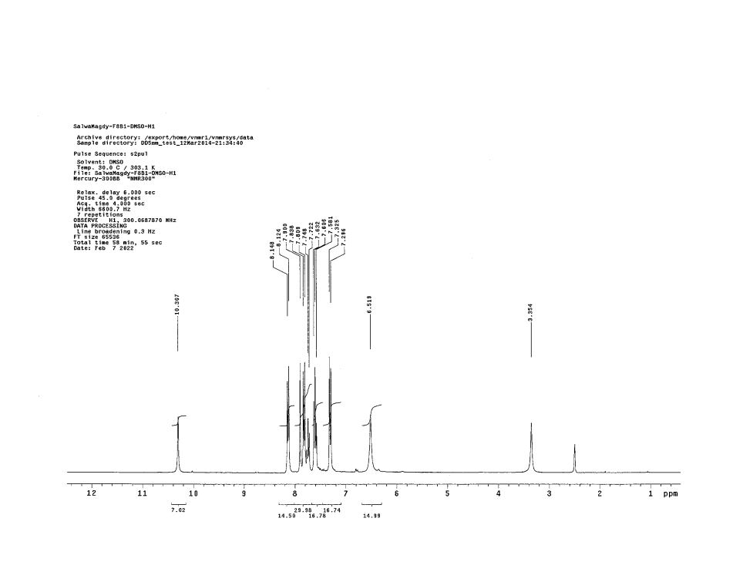

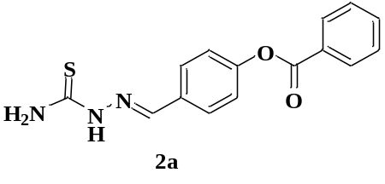

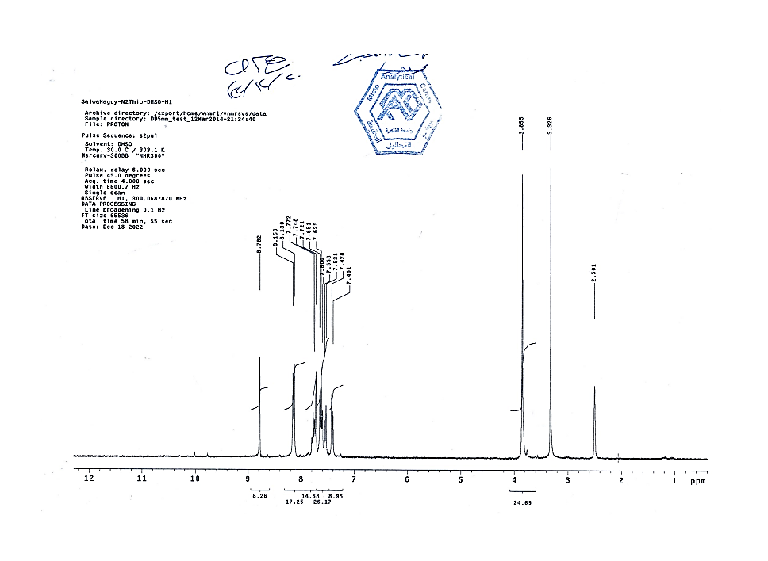

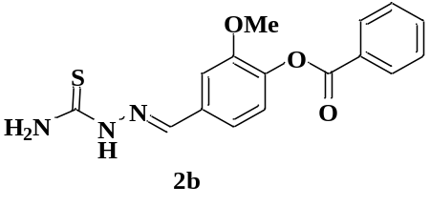

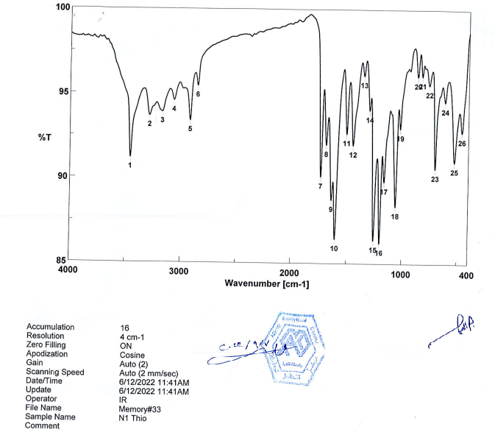

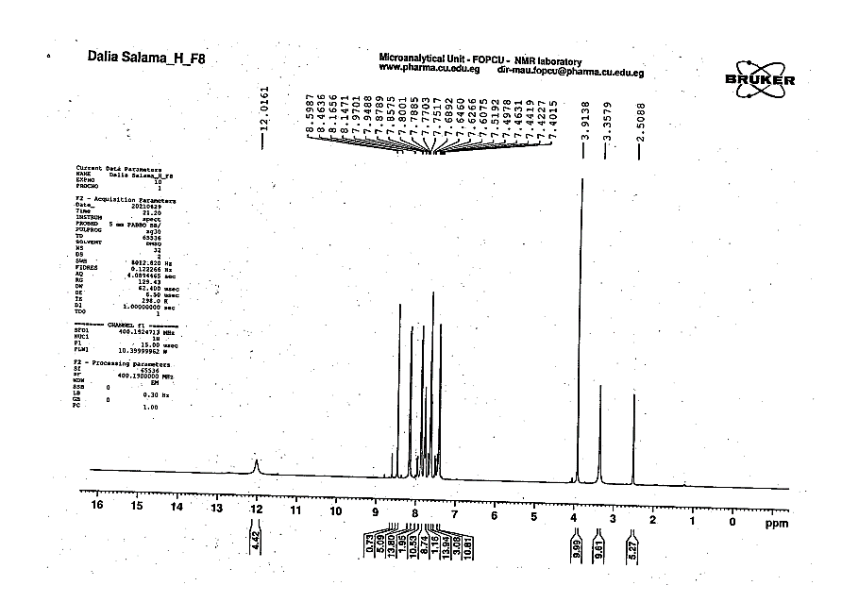

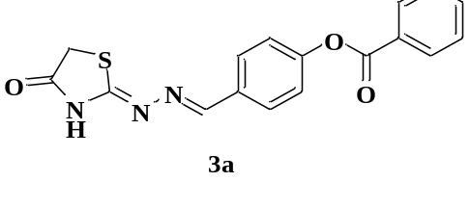

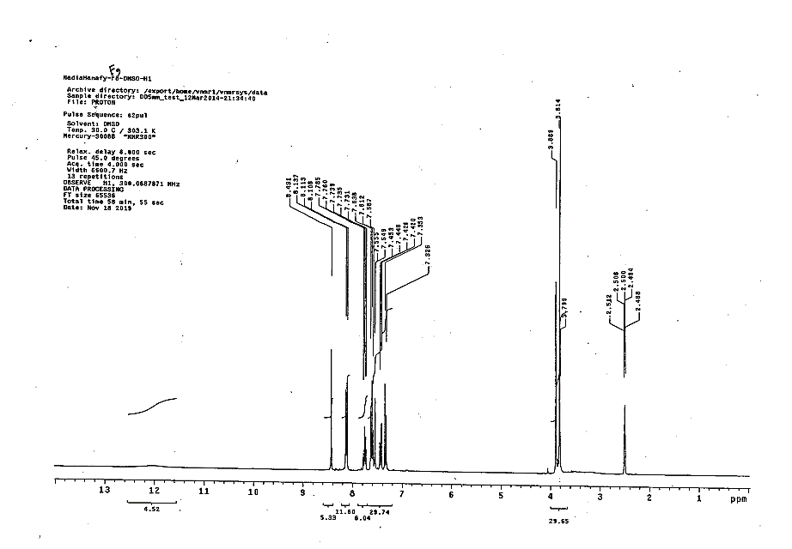
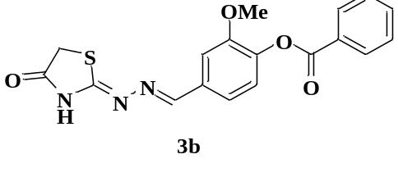

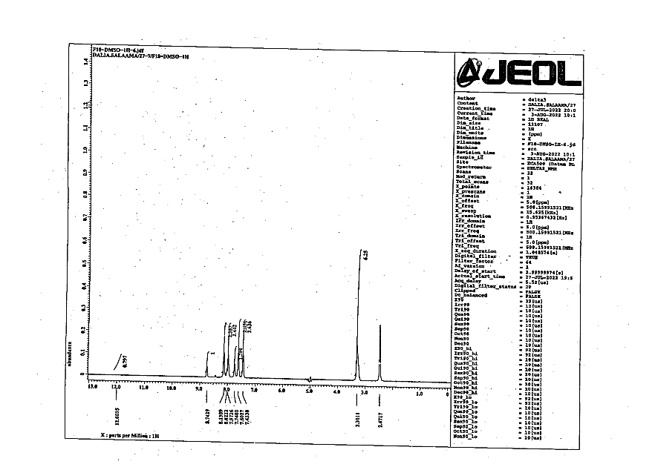

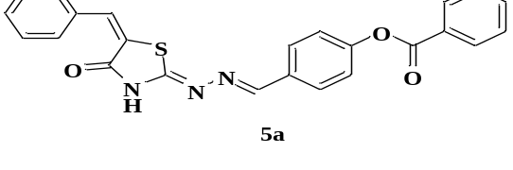

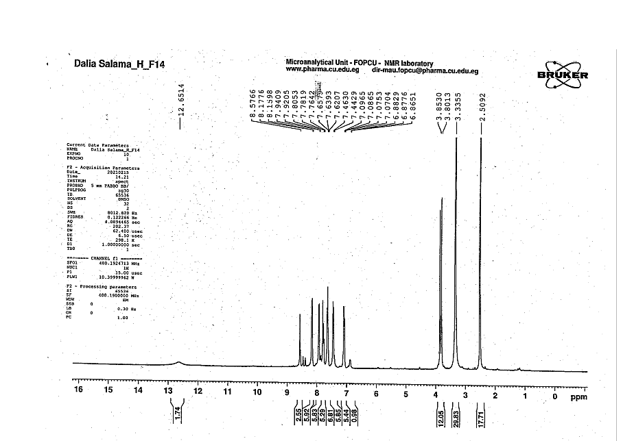
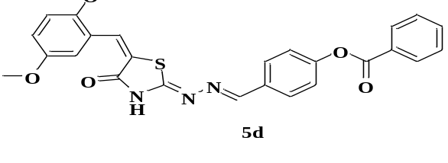

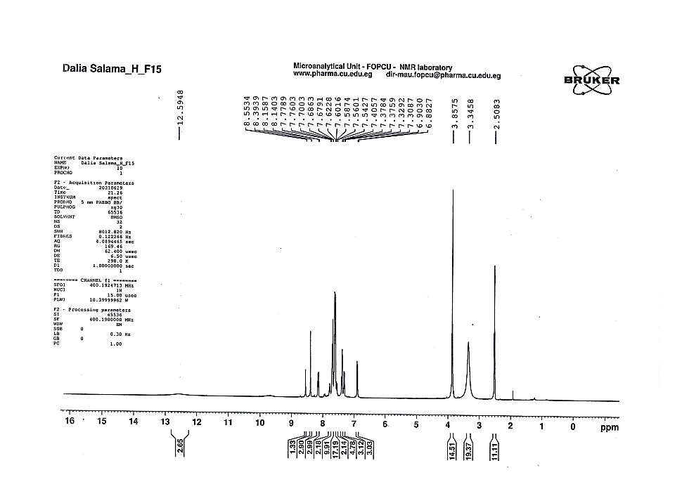
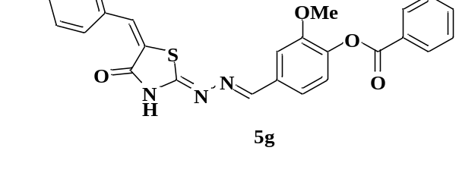

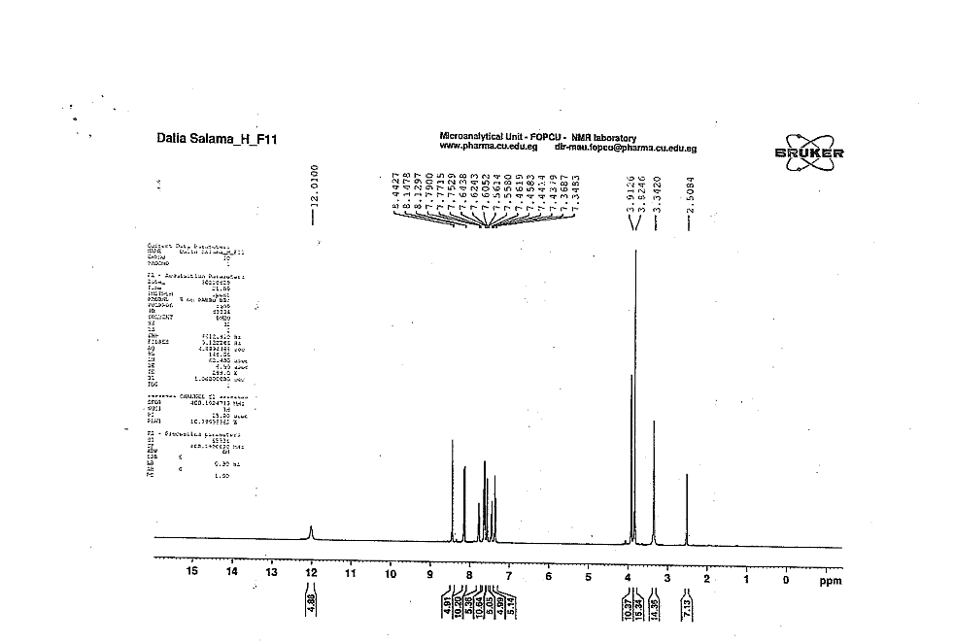
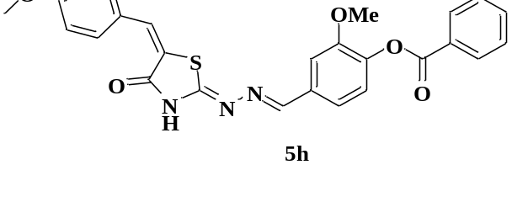

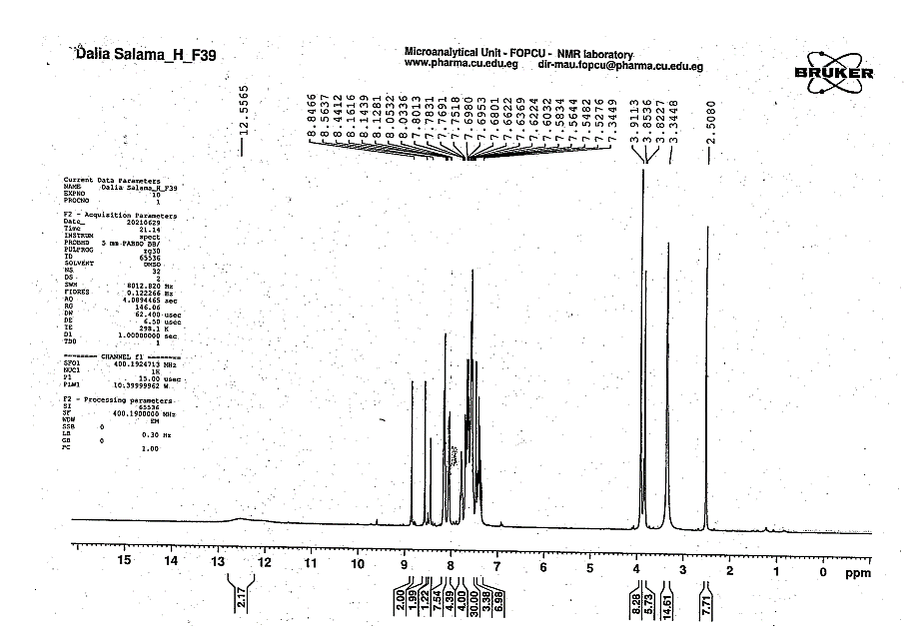
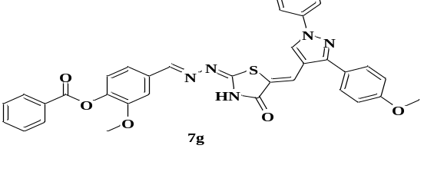

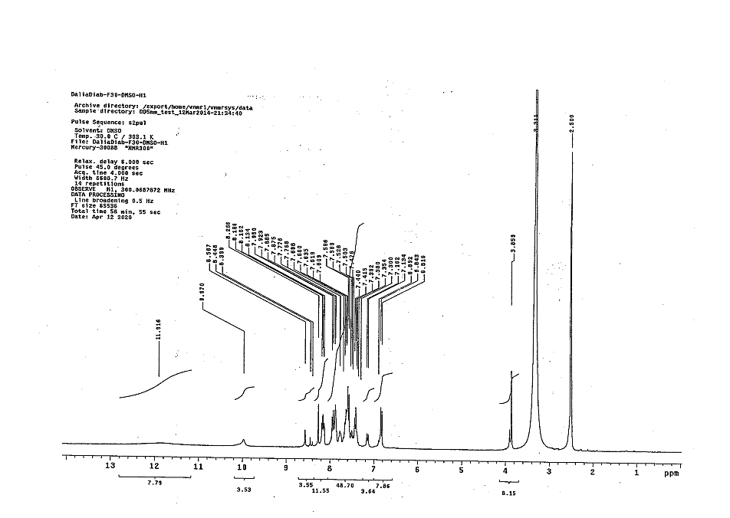
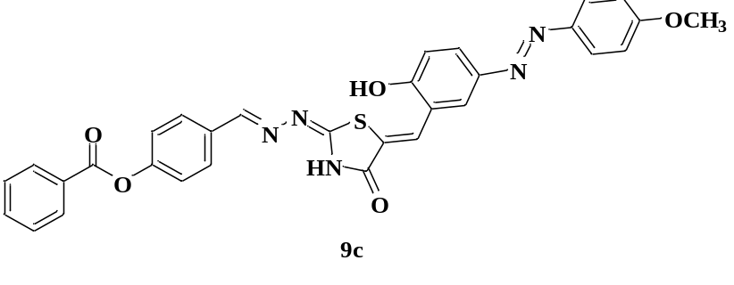

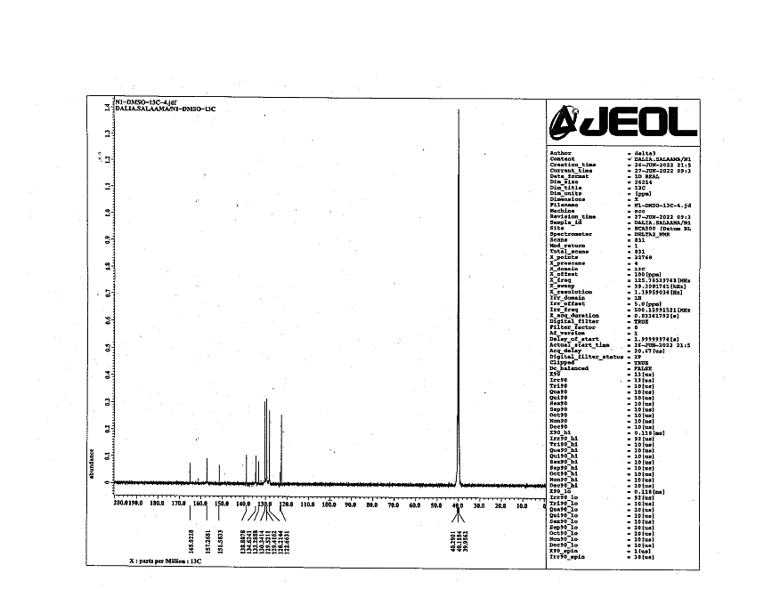
¹³C NMR Spectra

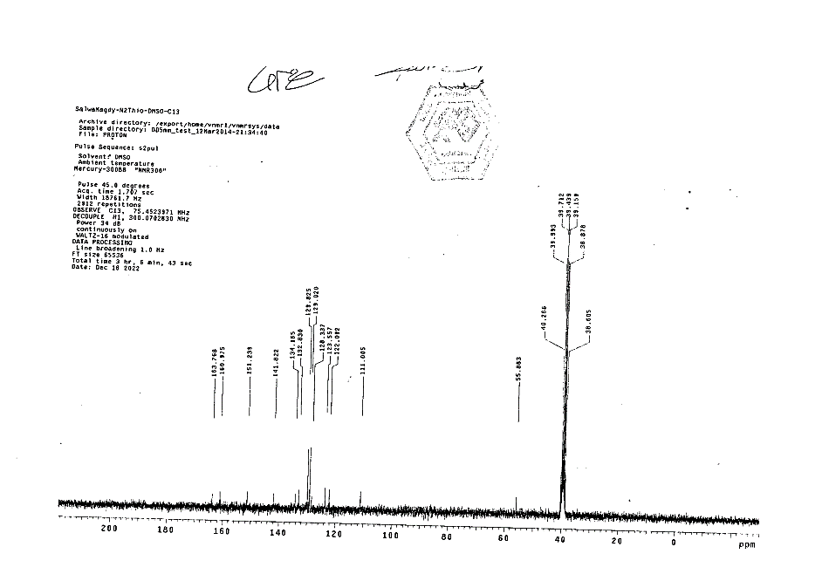

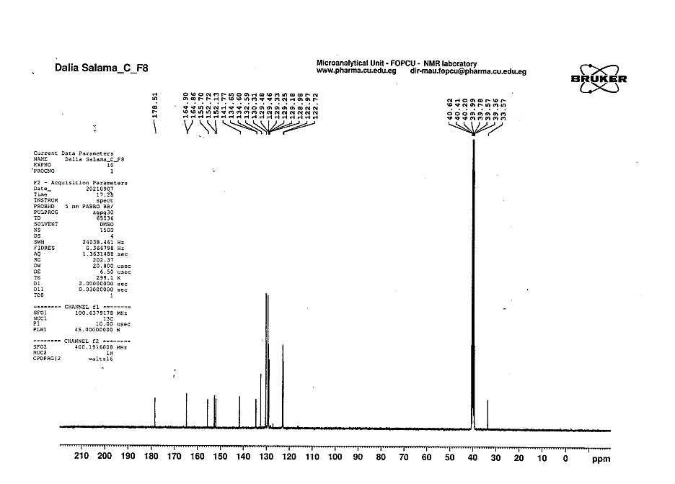
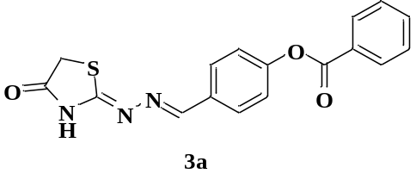

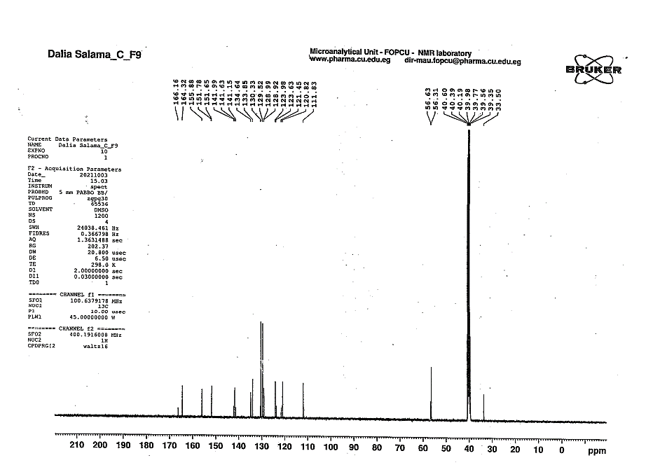
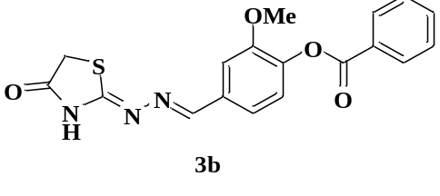

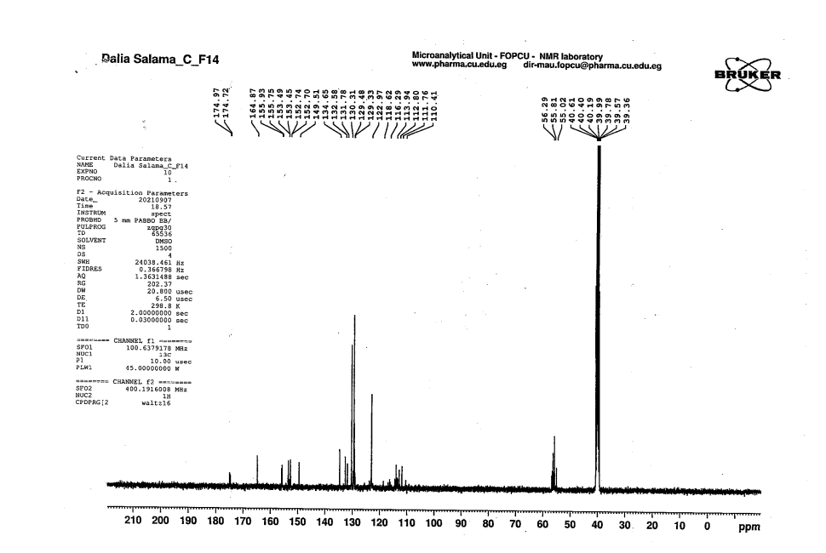
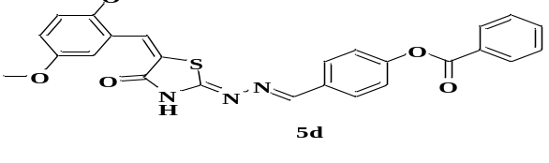

IR Spectra
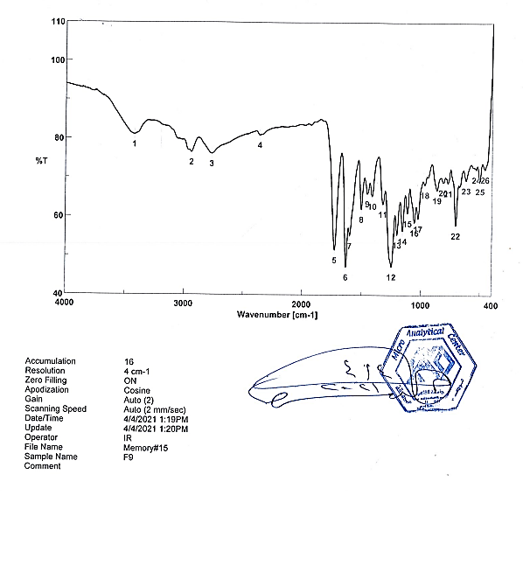

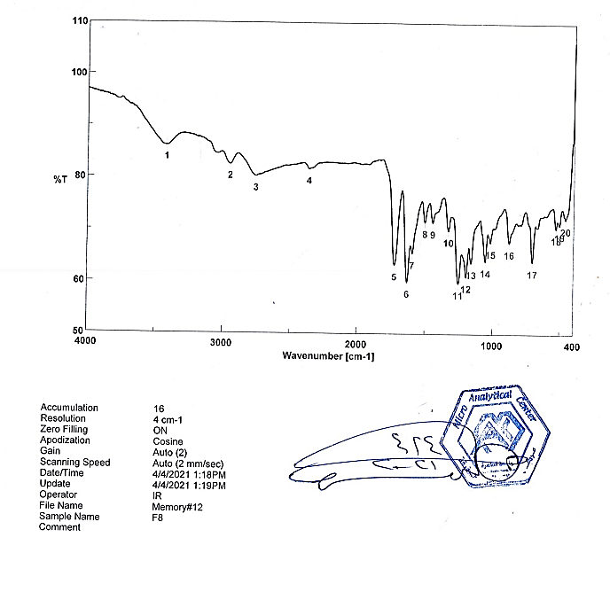

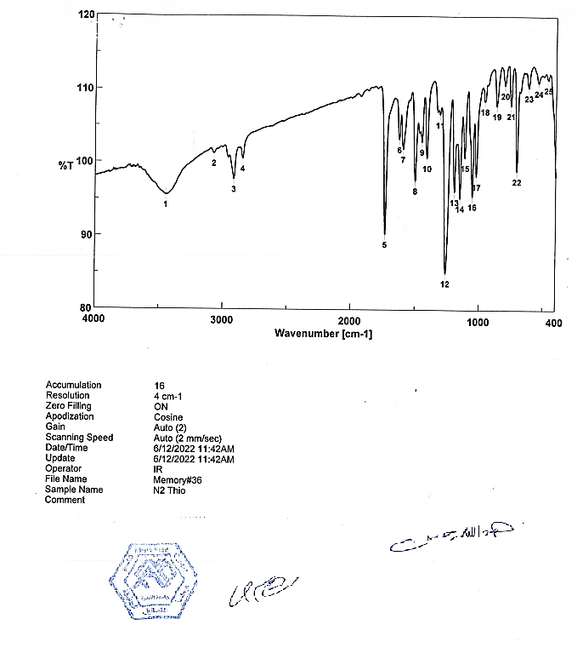

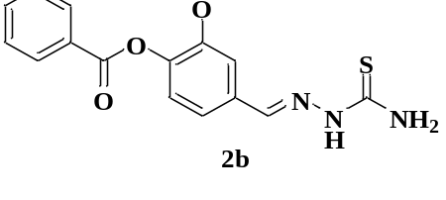

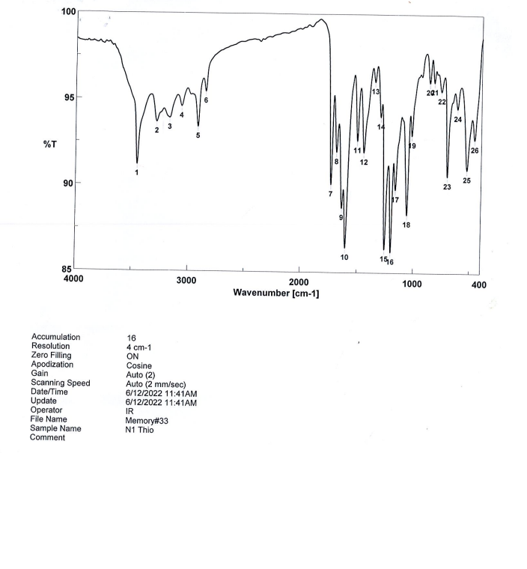

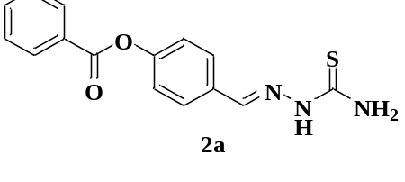

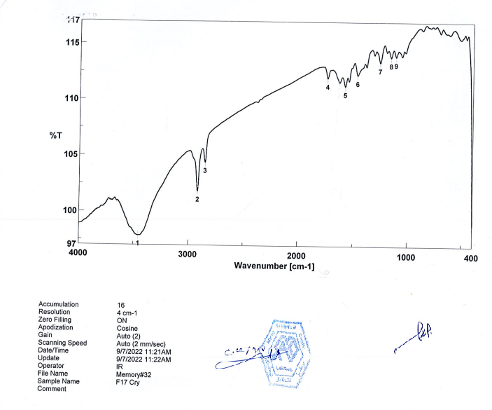

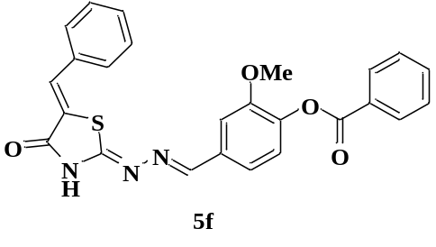

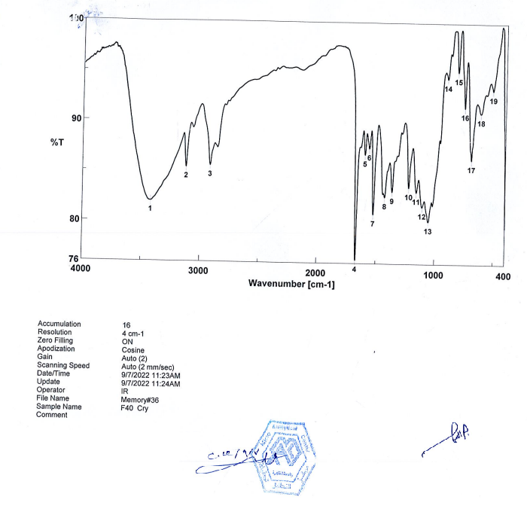

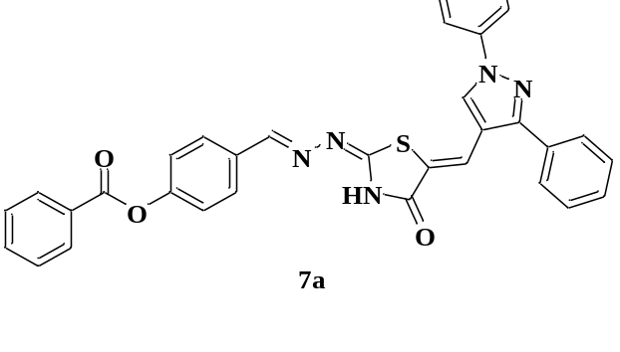

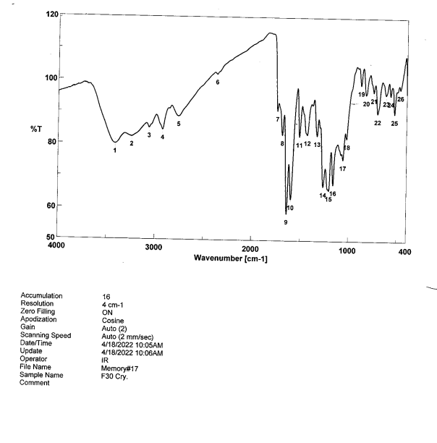

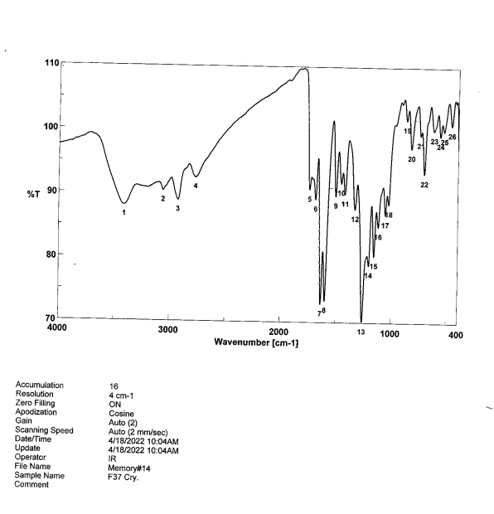
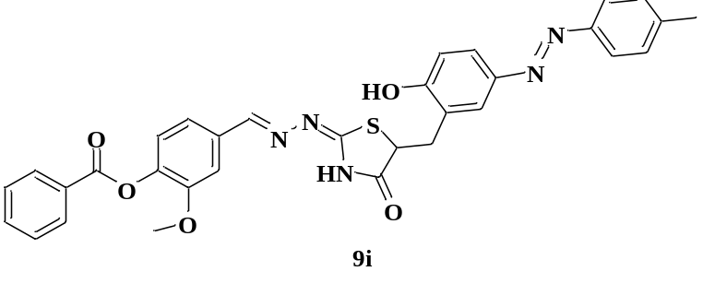

Mass Spectra
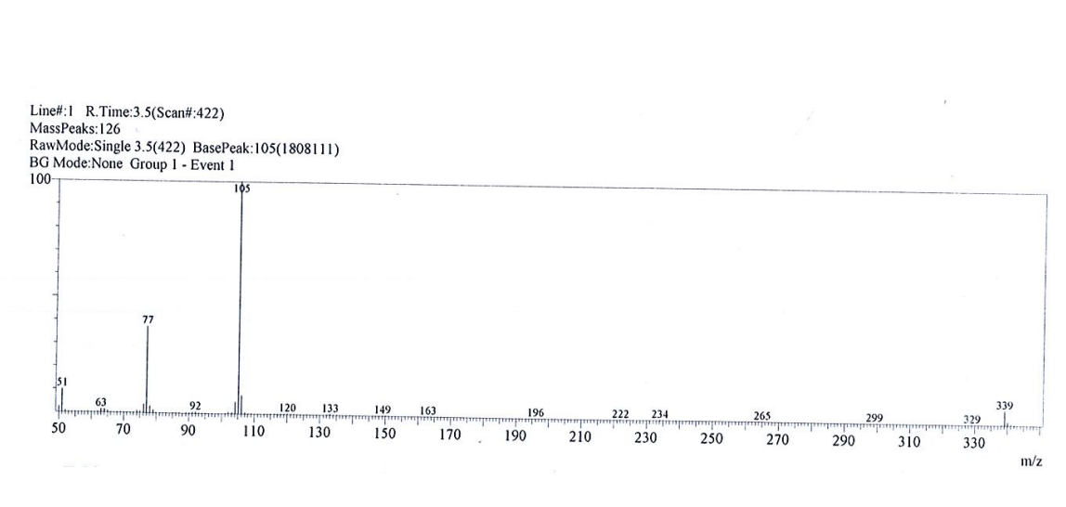

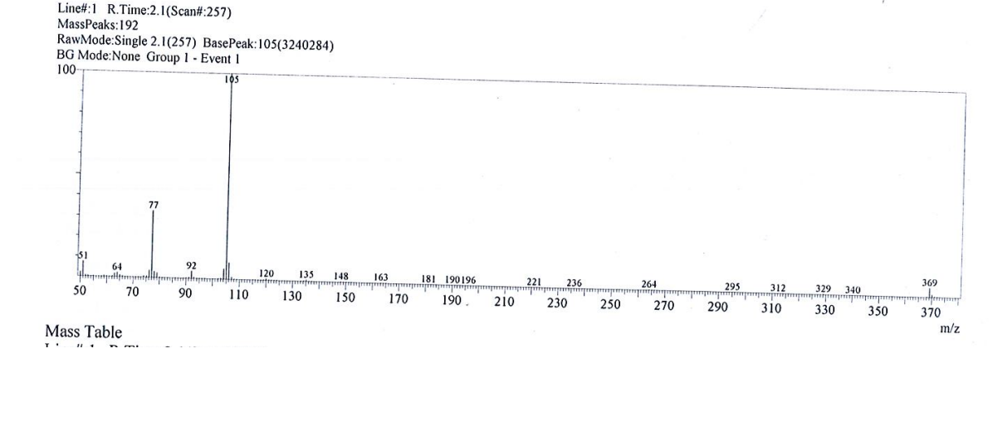
3. Raw data for biological assays.
3.1. Raw data for In Vitro Anticancer screening
Comp. | Conc. | O.D |  |  | Mean O.D | % Viability | IC₅₀
Hela | Control | 0.310 | 0.308 | 0.312 | 0.310 | 100
2 | 100 | 0.113 | 0.112 | 0.113 | 0.113 | 36.4 | 50.67±2.8
2 | 50 | 0.147 | 0.147 | 0.146 | 0.146 | 47.1 | 50.67±2.8
2 | 25 | 0.204 | 0.203 | 0.202 | 0.203 | 65.5 | 50.67±2.8
2 | 12.5 | 0.261 | 0.260 | 0.260 | 0.260 | 83.9 | 50.67±2.8
2 | 6.25 | 0.285 | 0.287 | 0.286 | 0.285 | 91.9 | 50.67±2.8
2 | 3.125 | 0.297 | 0.296 | 0.298 | 0.297 | 95.8 | 50.67±2.8
2 | 1.56 | 0.311 | 0.310 | 0.310 | 0.310 | 100 | 50.67±2.8
1 | 100 | 0.081 | 0.080 | 0.081 | 0.080 | 25.8 | 11.66±0.9
1 | 50 | 0.099 | 0.097 | 0.099 | 0.098 | 31.6 | 11.66±0.9
1 | 25 | 0.115 | 0.116 | 0.113 | 0.114 | 36.8 | 11.66±0.9
1 | 12.5 | 0.146 | 0.149 | 0.148 | 0.147 | 47.4 | 11.66±0.9
1 | 6.25 | 0.171 | 0.170 | 0.171 | 0.170 | 54.8 | 11.66±0.9
1 | 3.125 | 0.215 | 0.213 | 0.216 | 0.214 | 69.0 | 11.66±0.9
1 | 1.56 | 0.253 | 0.250 | 0.251 | 0.251 | 81.0 | 11.66±0.9
9 | 100 | 0.118 | 0.120 | 0.119 | 0.118 | 38.1 | 59.98±3.3
9 | 50 | 0.159 | 0.161 | 0.161 | 0.160 | 51.6 | 59.98±3.3
9 | 25 | 0.226 | 0.227 | 0.226 | 0.226 | 72.9 | 59.98±3.3
9 | 12.5 | 0.290 | 0.290 | 0.291 | 0.290 | 93.5 | 59.98±3.3
9 | 6.25 | 0.297 | 0.296 | 0.295 | 0.296 | 95.5 | 59.98±3.3
9 | 3.125 | 0.305 | 0.307 | 0.306 | 0.305 | 98.4 | 59.98±3.3
9 | 1.56 | 0.312 | 0.310 | 0.311 | 0.311 | 100 | 59.98±3.3
11 | 100 | 0.092 | 0.089 | 0.091 | 0.091 | 29.3 | 23.79±1.9
11 | 50 | 0.111 | 0.110 | 0.110 | 0.110 | 35.5 | 23.79±1.9
11 | 25 | 0.157 | 0.161 | 0.158 | 0.158 | 51.0 | 23.79±1.9
11 | 12.5 | 0.180 | 0.180 | 0.181 | 0.180 | 58.1 | 23.79±1.9
11 | 6.25 | 0.201 | 0.202 | 0.202 | 0.201 | 64.8 | 23.79±1.9
11 | 3.125 | 0.272 | 0.273 | 0.273 | 0.272 | 87.7 | 23.79±1.9
11 | 1.56 | 0.294 | 0.295 | 0.294 | 0.294 | 94.8 | 23.79±1.9
10 | 100 | 0.123 | 0.123 | 0.121 | 0.122 | 39.3 | 64.05±3.4
10 | 50 | 0.171 | 0.171 | 0.170 | 0.170 | 54.8 | 64.05±3.4
10 | 25 | 0.231 | 0.230 | 0.231 | 0.230 | 74.2 | 64.05±3.4
10 | 12.5 | 0.269 | 0.271 | 0.270 | 0.269 | 86.8 | 64.05±3.4
10 | 6.25 | 0.287 | 0.290 | 0.289 | 0.288 | 92.9 | 64.05±3.4
10 | 3.125 | 0.299 | 0.300 | 0.300 | 0.299 | 96.4 | 64.05±3.4
10 | 1.56 | 0.309 | 0.310 | 0.311 | 0.309 | 99.7 | 64.05±3.4
7 | 100 | 0.101 | 0.100 | 0.100 | 0.100 | 32.2 | 30.89±2.1
7 | 50 | 0.128 | 0.127 | 0.129 | 0.128 | 41.3 | 30.89±2.1
7 | 25 | 0.169 | 0.168 | 0.169 | 0.168 | 54.2 | 30.89±2.1
7 | 12.5 | 0.197 | 0.196 | 0.195 | 0.196 | 63.2 | 30.89±2.1
7 | 6.25 | 0.213 | 0.210 | 0.211 | 0.211 | 68.1 | 30.89±2.1
7 | 3.125 | 0.289 | 0.287 | 0.288 | 0.288 | 92.9 | 30.89±2.1
7 | 1.56 | 0.299 | 0.299 | 0.299 | 0.299 | 96.4 | 30.89±2.1

Comp. | Conc. | O.D |  |  | Mean O.D | % Viability | IC50
HePG2 | Control | 0.369 | 0.365 | 0.363 | 0.366 | 100
2 | 100 | 0.125 | 0.126 | 0.125 | 0.125 | 34.1 | 21.26±1.5
2 | 50 | 0.148 | 0.148 | 0.145 | 0.147 | 40.2 | 21.26±1.5
2 | 25 | 0.173 | 0.173 | 0.174 | 0.173 | 47.3 | 21.26±1.5
2 | 12.5 | 0.192 | 0.190 | 0.193 | 0.191 | 52.2 | 21.26±1.5
2 | 6.25 | 0.226 | 0.225 | 0.224 | 0.225 | 61.5 | 21.26±1.5
2 | 3.125 | 0.275 | 0.273 | 0.275 | 0.274 | 74.9 | 21.26±1.5
2 | 1.56 | 0.311 | 0.310 | 0.311 | 0.310 | 84.7 | 21.26±1.5
1 | 100 | 0.117 | 0.116 | 0.118 | 0.117 | 32.0 | 14.50±1.1
1 | 50 | 0.135 | 0.137 | 0.137 | 0.136 | 37.1 | 14.50±1.1
1 | 25 | 0.168 | 0.165 | 0.166 | 0.166 | 45.3 | 14.50±1.1
1 | 12.5 | 0.182 | 0.180 | 0.181 | 0.181 | 49.4 | 14.50±1.1
1 | 6.25 | 0.206 | 0.205 | 0.206 | 0.205 | 56.0 | 14.50±1.1
1 | 3.125 | 0.230 | 0.230 | 0.230 | 0.230 | 62.8 | 14.50±1.1
1 | 1.56 | 0.289 | 0.290 | 0.291 | 0.289 | 79.0 | 14.50±1.1
9 | 100 | 0.186 | 0.187 | 0.186 | 0.186 | 50.8 | 78.65±3.6
9 | 50 | 0.199 | 0.199 | 0.200 | 0.199 | 54.4 | 78.65±3.6
9 | 25 | 0.241 | 0.240 | 0.243 | 0.241 | 65.8 | 78.65±3.6
9 | 12.5 | 0.267 | 0.268 | 0.265 | 0.266 | 72.7 | 78.65±3.6
9 | 6.25 | 0.305 | 0.301 | 0.304 | 0.303 | 82.8 | 78.65±3.6
9 | 3.125 | 0.329 | 0.330 | 0.327 | 0.328 | 89.6 | 78.65±3.6
9 | 1.56 | 0.368 | 0.369 | 0.370 | 0.368 | 100 | 78.65±3.6
11 | 100 | 0.176 | 0.175 | 0.178 | 0.176 | 48.1 | 63.86±3.2
11 | 50 | 0.191 | 0.190 | 0.192 | 0.191 | 52.2 | 63.86±3.2
11 | 25 | 0.223 | 0.224 | 0.225 | 0.223 | 60.9 | 63.86±3.2
11 | 12.5 | 0.258 | 0.259 | 0.257 | 0.258 | 70.5 | 63.86±3.2
11 | 6.25 | 0.295 | 0.298 | 0.296 | 0.296 | 80.9 | 63.86±3.2
11 | 3.125 | 0.326 | 0.327 | 0.325 | 0.326 | 89.1 | 63.86±3.2
11 | 1.56 | 0.372 | 0.371 | 0.372 | 0.371 | 100 | 63.86±3.2
10 | 100 | 0.201 | 0.200 | 0.200 | 0.200 | 54.6 | 108.60±4.8
10 | 50 | 0.223 | 0.224 | 0.225 | 0.223 | 60.9 | 108.60±4.8
10 | 25 | 0.264 | 0.263 | 0.261 | 0.263 | 71.8 | 108.60±4.8
10 | 12.5 | 0.289 | 0.291 | 0.289 | 0.289 | 79.0 | 108.60±4.8
10 | 6.25 | 0.322 | 0.320 | 0.321 | 0.321 | 87.7 | 108.60±4.8
10 | 3.125 | 0.345 | 0.346 | 0.344 | 0.345 | 94.3 | 108.60±4.8
10 | 1.56 | 0.368 | 0.368 | 0.365 | 0.367 | 100 | 108.60±4.8
7 | 100 | 0.164 | 0.163 | 0.161 | 0.163 | 44.5 | 52.27±2.9
7 | 50 | 0.187 | 0.188 | 0.189 | 0.187 | 51.1 | 52.27±2.9
7 | 25 | 0.215 | 0.211 | 0.213 | 0.213 | 58.2 | 52.27±2.9
7 | 12.5 | 0.239 | 0.236 | 0.238 | 0.238 | 65.0 | 52.27±2.9
7 | 6.25 | 0.287 | 0.289 | 0.287 | 0.287 | 78.4 | 52.27±2.9
7 | 3.125 | 0.325 | 0.324 | 0.322 | 0.324 | 88.5 | 52.27±2.9
7 | 1.56 | 0.368 | 0.369 | 0.370 | 0.368 | 100 | 52.27±2.9

Comp. | Conc. | O.D |  |  | Mean O.D | % Viability | IC50
MCF7 | Control | 0.296 | 0.297 | 0.301 | 0.297 | 100
2 | 100 | 0.051 | 0.050 | 0.049 | 0.050 | 16.8 | 17.71±1.4
2 | 50 | 0.089 | 0.088 | 0.087 | 0.088 | 29.6 | 17.71±1.4
2 | 25 | 0.128 | 0.129 | 0.130 | 0.128 | 43.1 | 17.71±1.4
2 | 12.5 | 0.177 | 0.175 | 0.174 | 0.175 | 58.9 | 17.71±1.4
2 | 6.25 | 0.195 | 0.196 | 0.198 | 0.196 | 66.0 | 17.71±1.4
2 | 3.125 | 0.253 | 0.254 | 0.252 | 0.253 | 85.2 | 17.71±1.4
2 | 1.56 | 0.272 | 0.270 | 0.272 | 0.271 | 91.2 | 17.71±1.4
1 | 100 | 0.029 | 0.029 | 0.028 | 0.028 | 9.4 | 17.26±1.5
1 | 50 | 0.098 | 0.097 | 0.095 | 0.097 | 32.6 | 17.26±1.5
1 | 25 | 0.117 | 0.118 | 0.119 | 0.117 | 39.4 | 17.26±1.5
1 | 12.5 | 0.189 | 0.190 | 0.188 | 0.189 | 63.6 | 17.26±1.5
1 | 6.25 | 0.210 | 0.210 | 0.211 | 0.210 | 70.7 | 17.26±1.5
1 | 3.125 | 0.235 | 0.234 | 0.233 | 0.234 | 78.8 | 17.26±1.5
1 | 1.56 | 0.259 | 0.260 | 0.260 | 0.259 | 87.2 | 17.26±1.5
9 | 100 | 0.116 | 0.117 | 0.116 | 0.116 | 39.0 | 45.15±2.7
9 | 50 | 0.143 | 0.143 | 0.143 | 0.143 | 48.1 | 45.15±2.7
9 | 25 | 0.175 | 0.175 | 0.171 | 0.174 | 58.6 | 45.15±2.7
9 | 12.5 | 0.198 | 0.200 | 0.198 | 0.198 | 66.7 | 45.15±2.7
9 | 6.25 | 0.247 | 0.247 | 0.248 | 0.247 | 83.2 | 45.15±2.7
9 | 3.125 | 0.272 | 0.271 | 0.270 | 0.271 | 91.2 | 45.15±2.7
9 | 1.56 | 0.291 | 0.291 | 0.290 | 0.290 | 97.6 | 45.15±2.7
11 | 100 | 0.105 | 0.106 | 0.109 | 0.106 | 35.7 | 41.38±2.5
11 | 50 | 0.140 | 0.141 | 0.143 | 0.141 | 47.5 | 41.38±2.5
11 | 25 | 0.171 | 0.170 | 0.172 | 0.171 | 57.6 | 41.38±2.5
11 | 12.5 | 0.195 | 0.196 | 0.197 | 0.195 | 65.6 | 41.38±2.5
11 | 6.25 | 0.251 | 0.250 | 0.251 | 0.250 | 84.2 | 41.38±2.5
11 | 3.125 | 0.280 | 0.281 | 0.281 | 0.280 | 94.3 | 41.38±2.5
11 | 1.56 | 0.289 | 0.283 | 0.293 | 0.288 | 97.0 | 41.38±2.5
10 | 100 | 0.136 | 0.135 | 0.134 | 0.135 | 45.4 | 63.96±3.3
10 | 50 | 0.157 | 0.160 | 0.159 | 0.158 | 53.2 | 63.96±3.3
10 | 25 | 0.191 | 0.191 | 0.189 | 0.190 | 64.0 | 63.96±3.3
10 | 12.5 | 0.223 | 0.224 | 0.224 | 0.223 | 75.1 | 63.96±3.3
10 | 6.25 | 0.265 | 0.264 | 0.261 | 0.263 | 88.5 | 63.96±3.3
10 | 3.125 | 0.281 | 0.280 | 0.280 | 0.280 | 94.3 | 63.96±3.3
10 | 1.56 | 0.295 | 0.296 | 0.293 | 0.294 | 99.0 | 63.96±3.3
7 | 100 | 0.096 | 0.097 | 0.082 | 0.092 | 31.0 | 36.24±2.4
7 | 50 | 0.138 | 0.139 | 0.140 | 0.138 | 46.5 | 36.24±2.4
7 | 25 | 0.165 | 0.164 | 0.163 | 0.164 | 55.2 | 36.24±2.4
7 | 12.5 | 0.199 | 0.199 | 0.200 | 0.199 | 67.0 | 36.24±2.4
7 | 6.25 | 0.234 | 0.235 | 0.232 | 0.233 | 78.4 | 36.24±2.4
7 | 3.125 | 0.279 | 0.279 | 0.280 | 0.279 | 93.9 | 36.24±2.4
7 | 1.56 | 0.290 | 0.291 | 0.291 | 0.290 | 97.6 | 36.24±2.4

Comp. | Conc. | O.D |  |  | Mean O.D | % Viability | IC50
WI38 | Control | 0.237 | 0.238 | 0.240 | 0.238 | 100
2 | 100 | 0.121 | 0.120 | 0.119 | 0.120 | 50.4 | 83.87±4.1
2 | 50 | 0.140 | 0.141 | 0.140 | 0.140 | 58.8 | 83.87±4.1
2 | 25 | 0.157 | 0.156 | 0.158 | 0.157 | 66.0 | 83.87±4.1
2 | 12.5 | 0.192 | 0.190 | 0.191 | 0.191 | 80.2 | 83.87±4.1
2 | 6.25 | 0.210 | 0.210 | 0.210 | 0.210 | 88.2 | 83.87±4.1
2 | 3.125 | 0.230 | 0.232 | 0.231 | 0.231 | 97.0 | 83.87±4.1
2 | 1.56 | 0.237 | 0.238 | 0.236 | 0.237 | 99.6 | 83.87±4.1
1 | 100 | 0.110 | 0.111 | 0.109 | 0.110 | 46.2 | 80.07±3.9
1 | 50 | 0.145 | 0.147 | 0.147 | 0.146 | 61.3 | 80.07±3.9
1 | 25 | 0.161 | 0.160 | 0.160 | 0.160 | 67.2 | 80.07±3.9
1 | 12.5 | 0.193 | 0.192 | 0.191 | 0.192 | 80.7 | 80.07±3.9
1 | 6.25 | 0.207 | 0.206 | 0.205 | 0.206 | 86.5 | 80.07±3.9
1 | 3.125 | 0.223 | 0.224 | 0.225 | 0.224 | 94.1 | 80.07±3.9
1 | 1.56 | 0.238 | 0.237 | 0.240 | 0.238 | 100 | 80.07±3.9
3 | 100 | 0.089 | 0.087 | 0.091 | 0.089 | 37.4 | 38.20±2.4
3 | 50 | 0.115 | 0.114 | 0.116 | 0.115 | 48.3 | 38.20±2.4
3 | 25 | 0.127 | 0.125 | 0.127 | 0.126 | 52.9 | 38.20±2.4
3 | 12.5 | 0.146 | 0.147 | 0.145 | 0.146 | 61.3 | 38.20±2.4
3 | 6.25 | 0.183 | 0.183 | 0.181 | 0.182 | 76.5 | 38.20±2.4
3 | 3.125 | 0.225 | 0.224 | 0.223 | 0.224 | 94.1 | 38.20±2.4
3 | 1.56 | 0.235 | 0.232 | 0.234 | 0.233 | 97.9 | 38.20±2.4
6 | 100 | 0.110 | 0.108 | 0.107 | 0.108 | 45.4 | 79.30±3.7
6 | 50 | 0.145 | 0.147 | 0.148 | 0.146 | 61.3 | 79.30±3.7
6 | 25 | 0.163 | 0.165 | 0.164 | 0.164 | 68.9 | 79.30±3.7
6 | 12.5 | 0.194 | 0.192 | 0.192 | 0.192 | 80.7 | 79.30±3.7
6 | 6.25 | 0.210 | 0.212 | 0.211 | 0.211 | 88.6 | 79.30±3.7
6 | 3.125 | 0.224 | 0.223 | 0.226 | 0.224 | 94.1 | 79.30±3.7
6 | 1.56 | 0.237 | 0.235 | 0.236 | 0.236 | 99.1 | 79.30±3.7
5 | 100 | 0.102 | 0.100 | 0.101 | 0.101 | 42.4 | 57.54±3.2
5 | 50 | 0.137 | 0.136 | 0.134 | 0.135 | 56.7 | 57.54±3.2
5 | 25 | 0.142 | 0.141 | 0.140 | 0.141 | 59.2 | 57.54±3.2
5 | 12.5 | 0.164 | 0.162 | 0.163 | 0.163 | 68.5 | 57.54±3.2
5 | 6.25 | 0.193 | 0.195 | 0.195 | 0.194 | 81.5 | 57.54±3.2
5 | 3.125 | 0.230 | 0.233 | 0.230 | 0.231 | 97.0 | 57.54±3.2
5 | 1.56 | 0.237 | 0.238 | 0.236 | 0.237 | 99.6 | 57.54±3.2

3.2. Raw data for EGFR kinase inhibitory assay.
ser | Compound |  | EGFR | SD  ±
ser | code | MW  g/mol | IC50  uM | SD  ±
1 | F11 | 489 | 0.098 | 0.004
2 | F12 | 459 | 0.2 | 0.009
*** | Erlotenib | 393.436 | 0.037 | 0.002

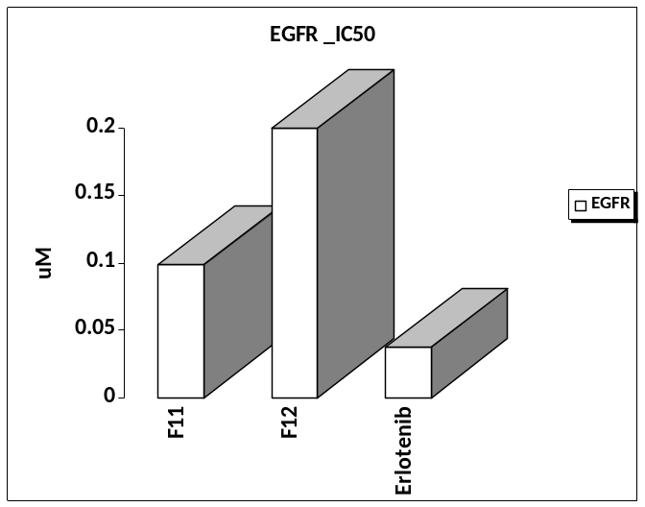
EGFR
code | IC50 | conc | log | %inh | T2 | T1 | ∆T | RFU2 | RFU1 | ∆RFU | slope | K.Activity
F11 |  | 100 | 2 | 94.03 | 30 | 0 | 30 | 5.97 | 0 | 5.97 | 3.3333 | 7.16407
 |  | 10 | 1 | 88.39 | 30 | 0 | 30 | 11.61 | 0 | 11.61 | 3.3333 | 13.9321
 |  | 1 | 0 | 66.41 | 30 | 0 | 30 | 33.59 | 0 | 33.59 | 3.3333 | 40.3084
 |  | 0.1 | -1 | 52.77 | 30 | 0 | 30 | 47.23 | 0 | 47.23 | 3.3333 | 56.6766
 |  | 0.01 | -2 | 30.39 | 30 | 0 | 30 | 69.61 | 0 | 69.61 | 3.3333 | 83.5328
EC |  |  |  | 0 | 30 | 0 | 30 | 100 | 0 | 100 | 3.3333 | 120
code | IC50 | conc | log | %inh | T2 | T1 | ∆T | RFU2 | RFU1 | ∆RFU | slope | K.Activity
F12 |  | 100 | 2 | 93.58 | 30 | 0 | 30 | 6.42 | 0 | 6.42 | 3.3333 | 7.70408
 |  | 10 | 1 | 83.24 | 30 | 0 | 30 | 16.76 | 0 | 16.76 | 3.3333 | 20.1122
 |  | 1 | 0 | 60.62 | 30 | 0 | 30 | 39.38 | 0 | 39.38 | 3.3333 | 47.2565
 |  | 0.1 | -1 | 46.78 | 30 | 0 | 30 | 53.22 | 0 | 53.22 | 3.3333 | 63.8646
 |  | 0.01 | -2 | 25.91 | 30 | 0 | 30 | 74.09 | 0 | 74.09 | 3.3333 | 88.9089
EC |  |  |  | 0 | 30 | 0 | 30 | 100 | 0 | 100 | 3.3333 | 120
code | IC50 | conc | log | %inh | T2 | T1 | ∆T | RFU2 | RFU1 | ∆RFU | slope | K.Activity
Erlotenib |  | 100 | 2 | 95.65 | 30 | 0 | 30 | 4.35 | 0 | 4.35 | 3.3333 | 5.22005
 |  | 10 | 1 | 92.48 | 30 | 0 | 30 | 7.52 | 0 | 7.52 | 3.3333 | 9.02409
 |  | 1 | 0 | 78.93 | 30 | 0 | 30 | 21.07 | 0 | 21.07 | 3.3333 | 25.2843
 |  | 0.1 | -1 | 57.82 | 30 | 0 | 30 | 42.18 | 0 | 42.18 | 3.3333 | 50.6165
 |  | 0.01 | -2 | 35.63 | 30 | 0 | 30 | 64.37 | 0 | 64.37 | 3.3333 | 77.2448
EC |  |  |  | 0 | 30 | 0 | 30 | 100 | 0 | 100 | 3.3333 | 120

3.3. Raw data for In vitro DNA-flow cytometric (cell cycle) analysis.
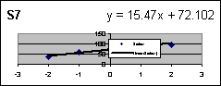
ser | Sample |  | DNA content
ser | code | IC50  uM | %G0-G1 | %S | %G2/M | Comment
1 | F11/HepG2 | --- | 47.22 | 42.04 | 10.74 | cell growth arrest@G1/S
2 | F12/HepG2 | --- | 52.48 | 31.66 | 15.86 | cell growth arrest@G1
3 | cont.HepG2 | --- | 44.81 | 35.49 | 19.7 | ---

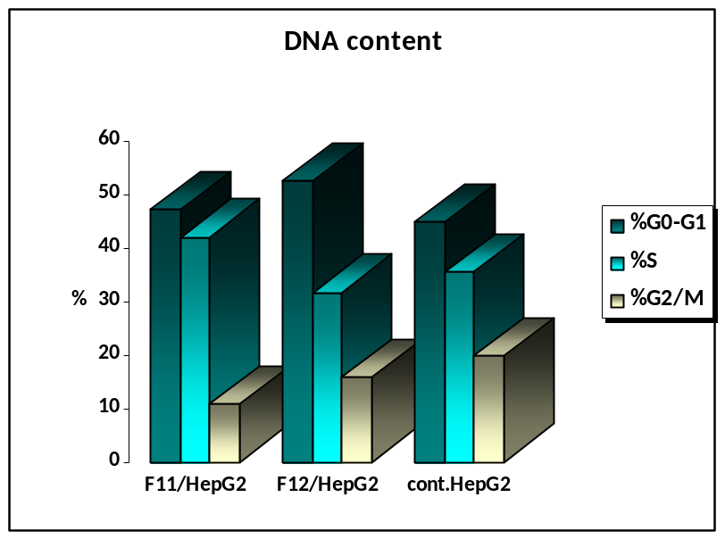

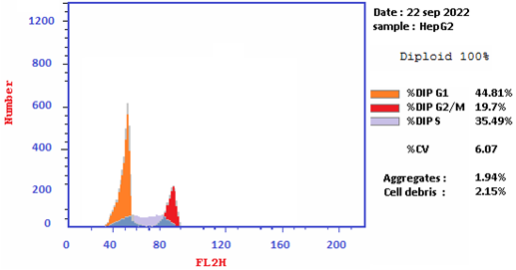

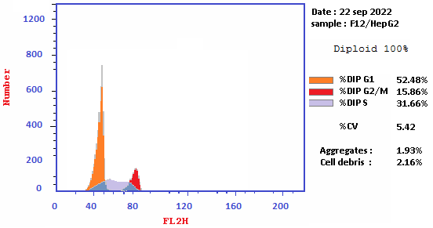

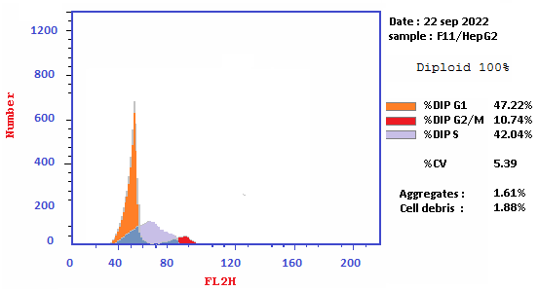

3.4. Raw data for Annexin V-FITC apoptosis assay.
s | code | conc | Apoptosis |  |  | Necrosis
s | code | conc | Total | Early | Late | Necrosis
1 | F11/HepG2 |  | 51.39 | 28.51 | 16.36 | 6.52
2 | F12/HepG2 |  | 42.16 | 11.93 | 21.95 | 8.28
3 | cont.HepG2 |  | 2.33 | 0.61 | 0.19 | 1.53

