Supplement 1. Educational postcards addressing misconceptions distributed during the season of 2019/20
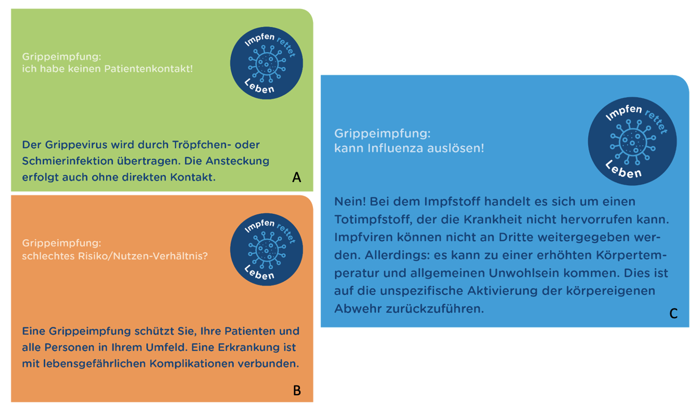
A. Postcard stating “Flu vaccination: I do not have any patient contact! The influenza virus is transmitted via droplets and smear. Transmission is possible without direct contact.”
B. Postcard stating “Flu vaccination: Unsatisfactory risk-/benefit ratio? Influenza vaccination provides protection for yourself, your patients, and others around you.”
C. Postcard stating “Flu vaccination: Can cause influenza! No! The implemented vaccine is not a live vaccine and therefore cannot cause nor transmit influenza. However: Elevated body temperature and malaise is possible following vaccination. This is due to the unspecific activation of the immune system.”
Supplement 2. Links to educational videos distributed during the intensified influenza vaccination campaign 2020/21
https://www.youtube.com/watch?v=Y1Ozg8v16QM&t=13s
https://www.youtube.com/watch?v=vBzXNM_8TFs&t=3s

Supplement 3. Survey on campaign 2020/21 (translated from German)
“Introductory text to survey:
Welcome to the survey on the “influenza vaccination campaign 2020/21”
Your participation will support the evaluation of this year's influenza vaccination campaign and help optimize future vaccination campaigns.
Survey:
- Have you been vaccinated against influenza („the flu“) in the season of 2020/21?
  - Yes
  - No

- Which professional group do you belong to?
  - Physicians
  - Nursing staff
  - Research staff
  - Administration staff
  - Functional service
  - Students/Trainees/Interns
  - Subsidiary company employees
  - Other
If yes to 1:
- Where did you receive the influenza vaccination?
  - On-site through the mobile vaccination team of UHC
  - At the central vaccination site
  - At the occupational health department
  - I received the flu vaccine externally (e.g., primary health physician) or in a different not here mentioned way
If yes to 1:
- Did you get vaccinated against influenza for the first time this year or was your last vaccination more than 10 years ago?
  - Yes
  - No
If yes to 1:
- Was the COVID-19 pandemic a decisive factor in your decision to get vaccinated against influenza this year?
  - Yes
  - No
If yes to 1:
- Has the intensified 2020/21 flu vaccination campaign increased your willingness to get the flu shot?
  - Yes
  - No

Your comments on the 2020/21 influenza vaccination campaign:
(Text field)

Thanks for the participation:
Thank you very much for participating in our survey

