Supplementary Figures:-

Figure 1: Stratigraphic diagram of pH level, moisture content, P, S and Fe content with sample depth. The zone of vivianite formation is highlighted in blue – between the dotted lines
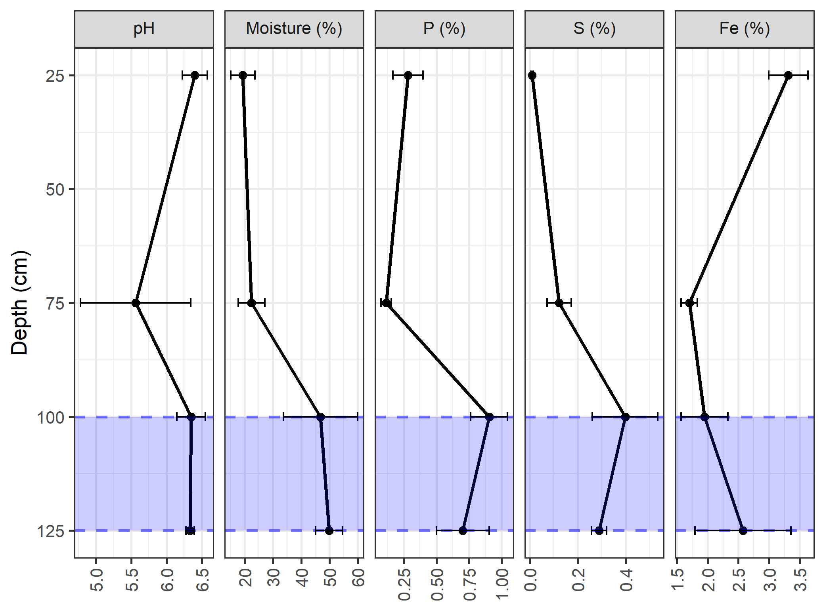

Supplementary Figure 2: Archaeological section from the trench at Vindolanda where the samples were collected.
A-C: replicate samples.
d1-4: samples at depth (d) 1-4. Depths 1 and 2 representing the oldest archaeological contexts, associated with good preservation (p). Depth 3 is an interface (i) layer.
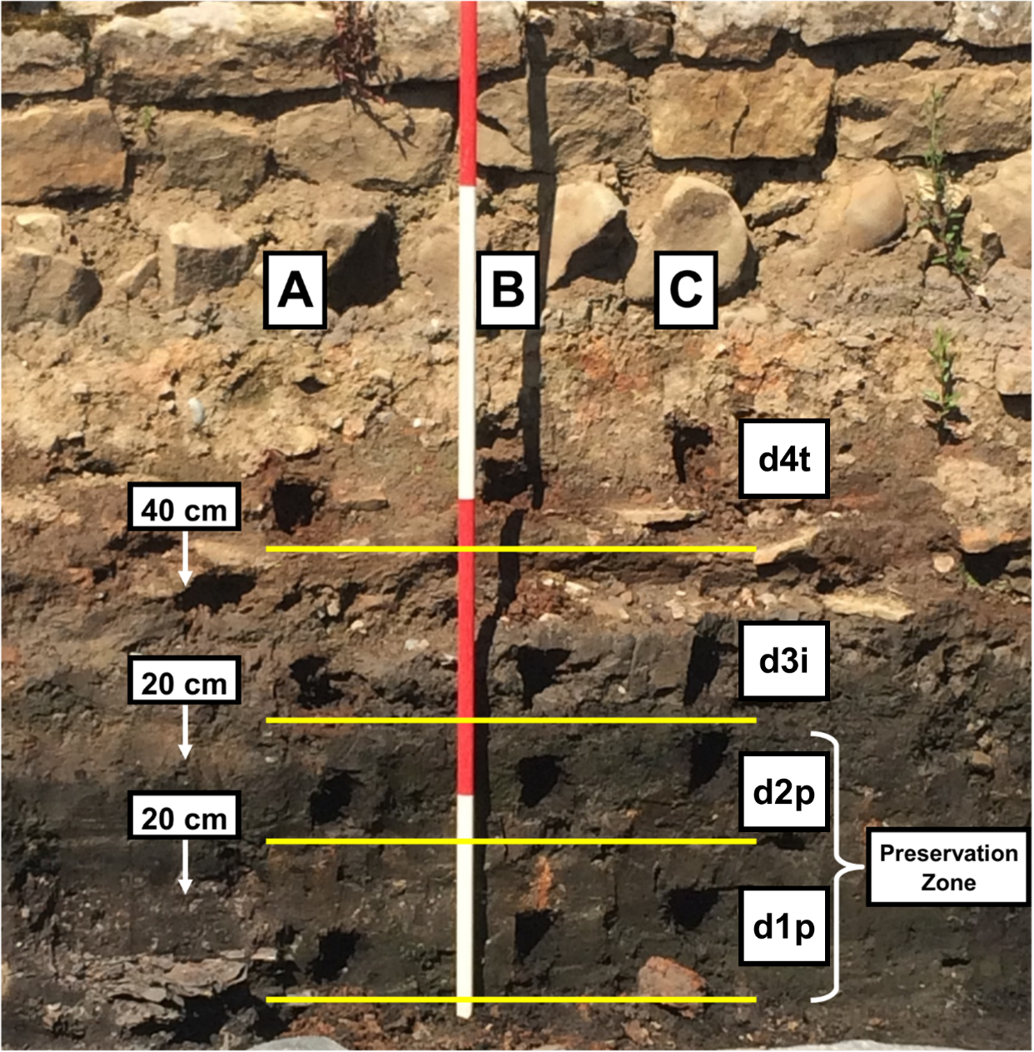

Supplementary Figure 2: Control section at Vindolanda not associated with human activity.
A-C: replicate samples.
C1-2: samples at natural control (c), taken at two depths: 1 and 2.

