Supplemental Materials for
A piston-cylinder-configured nano-motor prototype
Long-Bing He ^{1, 2, 3 *}, Lei Shangguan ^{1, 2}, Yu-Tian Gao ^{1, 2}, Sen Yang ^{1, 2}, Ya-Ting Ran ^{1, 3}, Zi-Yu Lu ^{1, 3}, Jiong-Hao Zhu ^{1, 3}, Bin-Jie Wang ⁴, Li-Tao Sun ^{1, 2 *}
¹ SEU-FEI Nano-Pico Center, Key Laboratory of MEMS of Ministry of Education, Southeast University, Nanjing 210096, P. R. China.
² Centre for Advanced Materials and Manufacturing, Joint Research Institute of Southeast University and Monash University, Suzhou 215123, P. R. China.
³ SEU-AMTE Collaborative Center for Atomic Layer Deposition and Etching, Southeast University, Wuxi 214000, P. R. China.
⁴ Thermo Fisher Shanghai Nanoport, Thermo Fisher Electronic Technology Research and Development (Shanghai) Co., Ltd., Shanghai 201203, P. R. China.

*Corresponding Emails: helongbing@seu.edu.cn, slt@seu.edu.cn

Electromigration of Te atoms.
The electromigration of the Te atoms is induced by the flowing current through the carbon cylinder. The Te nanoparticles that are initially located inside the carbon cylinder can be electromigrated along the electron wind direction, as shown in Figure S1 and Video S2.
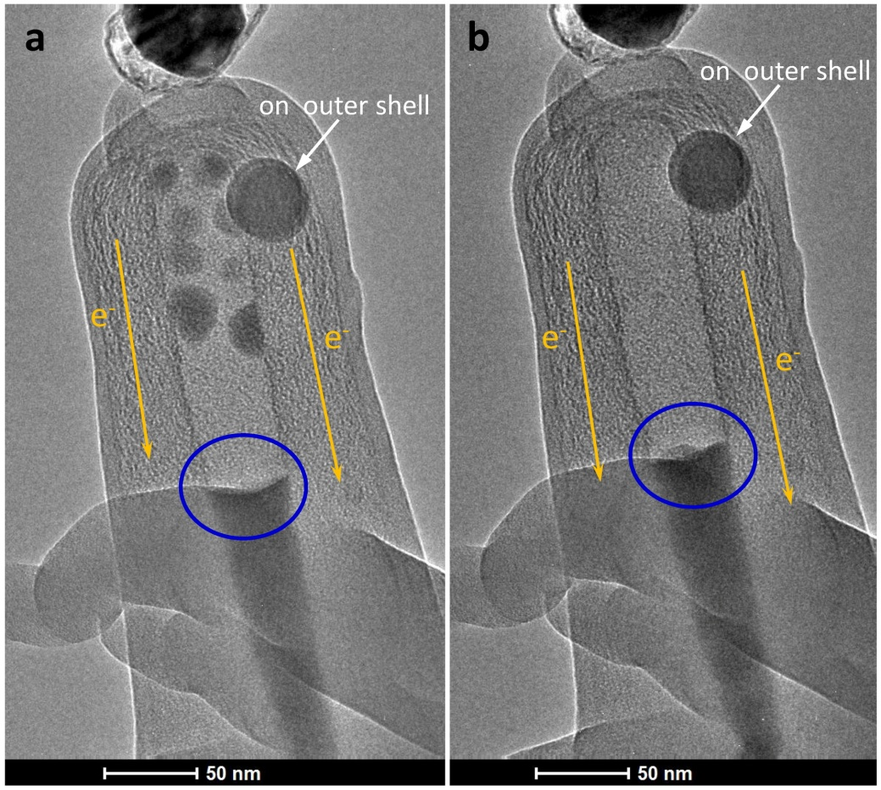
Figure S1. Electromigration of Te nanoparticles inside the C-cylinder. (a) Te nanoparticles initially locate inside the C-cylinder. The big nanoparticle is on the outer shell. (b) After loading a certain current, the Te nanoparticles are electromigrated to the Te nanorod (indicated by the blue circles).

To demonstrate that the big nanoparticle in Figure S1 is on the outer shell, a STEM image is acquired after the holder is tilted 15 degrees. As shown in Figure S2, the Te nanoparticles are still located in the center region of the C-cylinder. In contrast, the big nanoparticle appears at the edge of the C-cylinder. This indicates that the big nanoparticle should be on the outer surface of the C-cylinder.
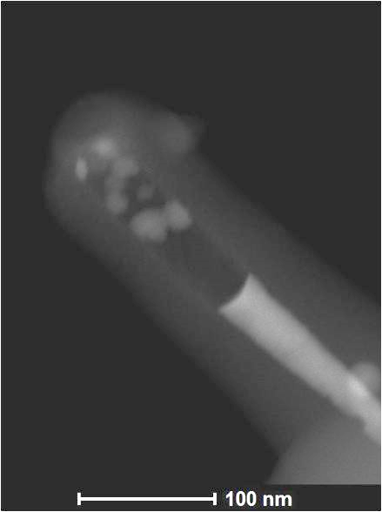
Figure S2. STEM image of the nanoparticles after the holder is tilted 15 degrees.

Electromigration force-induced compression
The electromigration force is demonstrated by exerting a current on the C-cylinder with Te nanorod capsulated inside, as shown in Figure S3. The electrons flow from the Ag end to the Te end. A void is formed inside the C-cylinder at the interfacial region between the Ag electrode and Te nanorod. The volume of the void increases with the increase of the exerted current. The compression ratio is roughly estimated to be around 6.7% under a current of around 200 μA. When the current decreases, the compressed Te starts to release and the void disappears. Noticeably, the C-cylinder should be strong enough to sustain this pressure, otherwise, nano-explosion would happen, as shown in Figure S4.
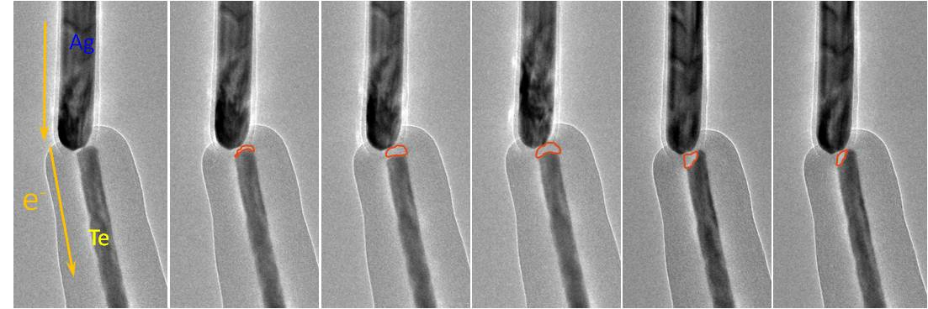
Figure S3. Formation of a void inside the C-cylinder induced by the electron wind. The void increases with the increase of the exerted current and disappears when the current is largely reduced. The dynamic process is provided in Video S1.

High pressure-induced nano-explosion
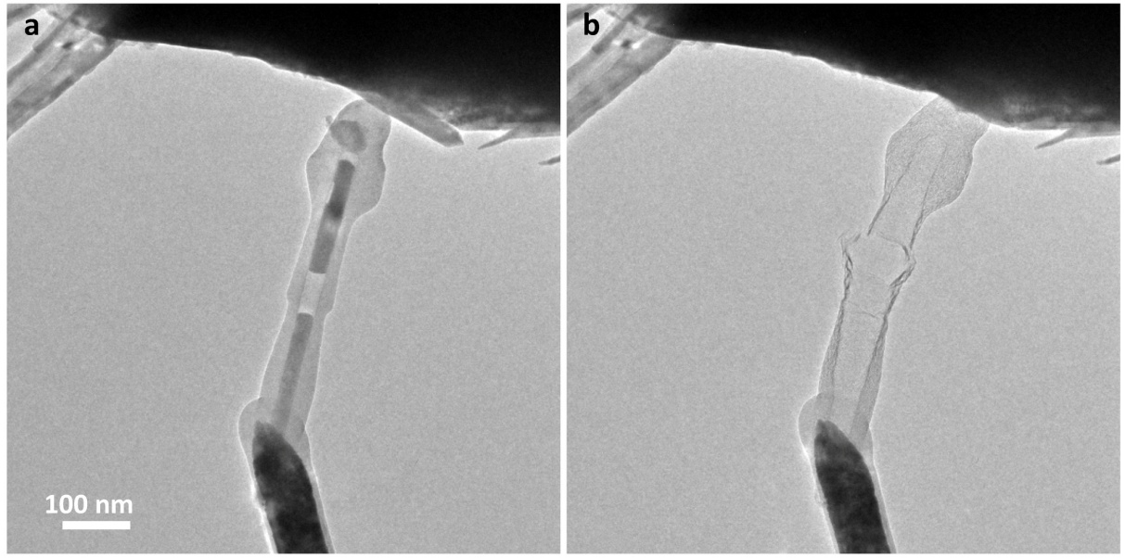
Figure S4. Nanoexplosion induced by a large current. (a) Initial configuration of the Te-C core-shell structure. (b) Broken structure after nano-explosion.

