Supporting Information
Coastal wetlands mitigate storm flooding and associated costs in estuaries

Tom P. Fairchild¹, William G. Bennett¹, Greg Smith², Brett Day³, Martin W Skov⁴, Iris Moller⁵, Nicola Beaumont⁶, Harshinie Karunarathna¹, John N. Griffin¹

¹ Faculty of Science and Engineering, Swansea University, Swansea SA2 8PP, UK
²CSIRO Land and Water, Hobart, Tasmania, 7001, Australia
³LEEP, University of Exeter, Exeter EX4 4ST, UK
⁴School of Ocean Sciences, Bangor University, LL59 5EG, UK
⁵Trinity College Dublin, D02 PN40, Ireland
⁶Plymouth Marine Laboratory, PL1 3DH, UK

Table of Contents:
Contents
1: Systematic Literature Review: 3
Supplementary Table S1: 4
2: Supplementary results 5
Supplementary Table S2: 5
Supplementary Table S3: 6
Supplementary Table S4: 6
Supplementary Table S5: 7
Supplementary Table S6: 7
Supplementary Table S7: 8
Supplementary Figure S1: 8
Supplementary Table S8:. 10
Supplementary Table S9 9
Supplementary Table S10 9
Supplementary Figure S2: 11
Supplementary Table S11: 11
Supplementary Figure S3: 12
Supplementary Table S12: 13
Supplementary Table S13 14
Supplementary Table S14 15
Supplementary Figure S4: 16
3: Additional Methodological Details 17
3.1: Hydrodynamic models 17
Supplementary Figure S5: 18
3.2: Inputs 18
3.2.1 Bathymetries 18
3.2.2: Boundary Conditions 19
3.2.3: Vegetation 21
Supplementary Table S15 21
3.2.4: Model Validation 22
Supplementary Figure S6: 23
Supplementary Table S16 24
3.3: Economic analysis 24
3.4: Assumptions and Limitations of modelling methodologies: 27
References: 30

1: Systematic Literature Review:
To better understand the state of knowledge around the role of saltmarshes in reducing potential flooding, we conducted a systematic review of the literature. Searches were conducted using the Boolean search terms [("Surge" OR "Wave") AND ("Wetland" OR "marsh" OR "Saltmarsh") AND ("attenuation" OR "reduction" OR "mitigation") AND “coastal”] between 1970-2020 on Google Scholar, ISI Web of Science, and Science Direct to identify potential research articles for inclusion and reference lists were checked to identify additional relevant articles. Returned articles were then filtered to only include articles which explicitly examined the role of saltmarsh vegetation on resulting wave or surge attenuation, other aquatic vegetative ecosystems (e.g. mangrove or seagrass systems), or small-scale fluid-dynamics modelling studies of vegetation stems were rejected. Of the 284 unique articles returned by searches, 26 met the criteria for inclusion. For each article, the type of study (hydrodynamic/ numerical modelling, observational studies or experimental manipulation) was identified, along with the scale (local area or regional) of the study. We then identified whether studies had considered the role of marsh vegetation for; localised, direct over-marsh attenuation of waves or surge, potential far-field upstream attenuation, or resulting flood extents and impacts, as well as the type of coastline considered and whether the study explicitly examined the specific role of vegetation by having unvegetated reference states. The results from the systematic review are presented in table S1, as well as visually represented in figure 1b in the main article.
Supplementary Table S1: Systematic review of the role of saltmarshes in reducing flood impacts from waves or surge, highlighting the gap in our understanding of the combined roles of wave and surge reduction across scales. Study types are grouped into categories, with the first part representing the study type (“HDM-“ studies are from hydrodynamic model simulations, “OBS-“ are observational studies and “EXP- “ are experimental manipulations ex-situ), and the second part representing the scale at which the study has been undertaken (“-M” is at multiple scales (both local and estuary scales), “-L” is local-scale only, and “-R” are studies at regional scales only). Similarly, studies were grouped by coastline type: where “ES-S/M” represents small to medium sized estuaries, “ES-L” are large estuaries, “EMB” are embayments, “BB” are back-barrier marsh systems, “OP” are open coastline marsh systems, “LAG” are marsh systems in lagoons, and “SYN-OP” are synthetically created idealised marsh sections which are representative of open coastline conditions. * included the role of surge in modifying wave attenuation, but did not measure surge attenuation per se.
Study Type | Spatial Coverage | Direct Attenuation | Up-stream attenuation | Wave | Surge | Flooding | Unvegetated Comparison | Coastline Type | Country | Ref
HDM-M | Transects + Whole estuary, 8 Estuaries | YES | YES | YES | YES | YES | YES | ES-S/M | UK | THIS STUDY
HDM-L | Transects, Single Estuary | YES | NO | NO | YES | NO | YES | ES-L, EMB | USA | Wamsley et al., 2010¹
HDM-L | Transects, Single Loci | YES | NO | YES | NO | NO | NO | SYN-OP | N/A Synthetic | Meijer, 2005²
HDM-L | Single Estuary Section | YES | ALONG CREEK | NO | YES | NO | NO | ES-L | Netherlands | Stark et al., 2016³
HDM-L | Transects, Single Loci | YES | NO | YES | NO | NO | YES | BB | Netherlands | van Loon-Steensma et al., 2016⁴
HDM-L | Single Coastline | YES | NO | NO | YES | NO | YES | EMB | USA | Loder et al., 2009⁵
HDM-L | Transects, Single Loci | YES | NO | NO | YES | NO | YES | OP | N/A Synthetic | Temmerman et al., 2012⁶
HDM-L | Transects, Single Estuary | YES | NO | NO | YES | NO | YES | EMB | USA | Hu et al., 2015⁷
HDM-L, OBS-L | Transects, Single Estuary | YES | NO | YES | NO | NO | YES | ES-L | Netherlands | Vuik et al., 2016⁸
HDM-R | Contiguous Coastline | YES | NO | NO* | NO* | YES | NO | ES-L | USA | Haddad et al., 2015⁹
HDM-R | Single Estuary | NO | YES | NO | YES | NO | YES | ES-L | Netherlands | Smolders et al., 2015¹⁰
HDM-R | Contiguous Coastline | YES | NO | NO | YES | YES | YES | ES-L, EMB | USA | Barbier et al., 2013¹¹
HDM-R | Contiguous Coastline | YES | YES | NO | YES | YES | YES | ES-L, EMB, OP | USA | Narayan et al., 2017 ¹²
OBS-L | Transects, Single Estuary | YES | ALONG CREEK | NO | YES | NO | NO | ES-L | Netherlands | Stark et al., 2015¹³
OBS-L | Transects, Single Estuary | YES | NO | YES | NO | NO | YES | ES-L, OP | China | Yang et al., 2012¹⁴
OBS-L | Transects, Single Estuary | YES | NO | YES | NO | NO | NO | ES-L, OP | China | Ysebaert et al., 2011¹⁵
OBS-L | Transects, Single Estuary | YES | NO | YES | YES | NO | NO | ES-L | USA | Paquier et al., 2017¹⁶
OBS-L | Transects, Single Estuary | YES | NO | YES | NO | NO | NO | EMB | USA | Foster-Martinez et al., 2018¹⁷
OBS-L | Transects, Single Estuary | YES | NO | YES | NO | NO | NO | LAG | USA | Jadhav and Chen, 2012¹⁸
OBS-L | Transects, Single Loci | YES | NO | YES | NO* | NO | NO | EMB | China | Zhang et al., 2020¹⁹
OBS-L | Transects, Two Loci | YES | NO | YES | NO | NO | NO | OP, BB | UK | Möller et al., 1999²⁰
OBS-L | Transects, Single Estuary | YES | NO | YES | NO | NO | NO | ES-L | USA | Knutson et al., 1982²¹
OBS-L | Transects, Single Loci | YES | NO | YES | NO | NO | NO | OP | UK | Möller et al., 2006²²
OBS-L | Transects, Two Loci | YES | NO | YES | NO | NO | YES | OP | UK | Möller & Spencer, 2002²³
OBS-L | Transects, Single Loci | YES | NO | YES | NO | NO | NO | OP | UK | Cooper, 2005²⁴
OBS-R | Transects, 10 Locations | YES | NO | YES | NO | NO | YES | OP, EMB | USA | Morgan et al., 2009²⁵
EXP-L | Transects, Single Loci | YES | NO | YES | NO* | NO | YES | SYN-OP | N/A Synthetic | Möller et al., 2014²⁶

2: Supplementary results
Supplementary Table S2: The positive role of marsh vegetation in reducing flood extents. Modelled terrestrial flooded extent (km²) for each storm event, vegetation scenario and estuary, with the proportion of flood extent area relative to the maximum observed within the estuary in parentheses. The reduction in flood extents are also presented as a percent reduction by vegetation, relative to the unvegetated scenario (Relative Reduction).
Estuary | Event | Vegetated | Grazed | Unvegetated | Relative Reduction
Dee | 1 | 2.165km² (0.56) | 2.356km² (0.61) | 2.407km² (0.62) | 10.0%
 | 10 | 3.145km² (0.82) | 3.268km² (0.85) | 3.659km² (0.95) | 14.0%
 | 100 | 3.444km² (0.89) | 3.497km² (0.91) | 3.854km² (1.00) | 10.6%
Glaslyn | 1 | 4.509km² (0.33) | 4.678km² (0.35) | 8.451km² (0.63) | 46.6%
 | 10 | 7.337km² (0.54) | 8.184km² (0.61) | 11.368km² (0.84) | 35.5%
 | 100 | 9.260km² (0.69) | 10.981km² (0.82) | 13.468km² (1.00) | 31.2%
Gwendaerth | 1 | 0.263km² (0.10) | 0.455km² (0.16) | 1.970km² (0.72) | 86.6%
 | 10 | 0.508km² (0.18) | 0.954km² (0.35) | 2.450km² (0.91) | 79.3%
 | 100 | 1.143km² (0.42) | 1.913km² (0.69) | 2.750km² (1.00) | 58.4%
Loughor | 1 | 3.971km² (0.55) | 3.765km² (0.52) | 4.733km² (0.65) | 16.1%
 | 10 | 4.610km² (0.64) | 4.973km² (0.69) | 6.157km² (0.85) | 25.1%
 | 100 | 5.813km² (0.80) | 5.906km² (0.82) | 7.246km² (1.00) | 19.8%
Mawddach | 1 | 1.027km² (0.38) | 0.994km² (0.36) | 1.028km² (0.38) | <0.01%
 | 10 | 1.883km² (0.69) | 1.871km² (0.68) | 2.243km² (0.82) | 16.1%
 | 100 | 2.273km² (0.83) | 2.250km² (0.82) | 2.733km² (1.00) | 16.8%
Neath | 1 | 0.479km² (0.24) | 0.538km² (0.27) | 0.869km² (0.43) | 56.6%
 | 10 | 1.067km² (0.53) | 1.141km² (0.57) | 1.459km² (0.72) | 26.9%
 | 100 | 1.665km² (0.83) | 1.733km² (0.86) | 2.014km² (1.00) | 17.3%
Taf | 1 | 1.177km² (0.15) | 1.124km² (0.15) | 1.356km² (0.18) | 13.2%
 | 10 | 2.199km² (0.28) | 2.523km² (0.33) | 3.707km² (0.47) | 40.7%
 | 100 | 3.221km² (0.42) | 3.609km² (0.47) | 7.729km² (1.00) | 58.3%
Towy | 1 | 0.164km² (0.15) | 0.221km² (0.20) | 0.899km² (0.80) | 81.7%
 | 10 | 0.567km² (0.50) | 0.594km² (0.52) | 1.007km² (0.90) | 43.7%
 | 100 | 0.710km² (0.63) | 0.820km² (0.73) | 1.125km² (1.00) | 36.9%

Supplementary Table S3: Marsh proportion and presence reduced flood extents, particularly during large storms. Mixed-effects beta-regression model summary of the effects of vegetation state, proportional saltmarsh area, tidal prism and estuary sinuosity on flood extent for different magnitude storms.
 | Storm Magnitude |  | Predictor |  | Estimate |  | S.E. |  | Z-value |  | P
1 in 1 |  | Intercept |  | -0.445 |  | 0.121 |  | -3.680
 |  | Vegetation |  | -0.112 |  | 0.153 |  | -0.730 |  | 0.463
 |  | Saltmarsh Proportion |  | -0.432 |  | 0.166 |  | -2.610 |  | 0.009**
 |  | Tidal Prism |  | 0.356 |  | 0.138 |  | 2.580 |  | 0.009**
 |  | Sinuosity |  | 0.041 |  | 0.133 |  | 0.310 |  | 0.755
 | 1 in 10 |  | Intercept |  | 0.618 |  | 0.106 |  | 5.840
 |  |  | Vegetation |  | -0.163 |  | 0.123 |  | -1.320 |  | 0.185
 |  |  | Saltmarsh Proportion |  | -0.552 |  | 0.127 |  | -4.340 |  | <0.001***
 |  |  | Tidal Prism |  | 0.337 |  | 0.134 |  | 2.520 |  | 0.012*
 |  |  | Sinuosity |  | -0.130 |  | 0.115 |  | -1.130 |  | 0.259
 | 1 in 100 |  | Intercept |  | 1.746 |  | 0.158 |  | 11.090
 |  |  | Vegetation |  | -0.413 |  | 0.154 |  | -2.680 |  | 0.008**
 |  |  | Saltmarsh Proportion |  | -0.739 |  | 0.156 |  | -4.750 |  | <0.001***
 |  |  | Tidal Prism |  | 0.086 |  | 0.175 |  | 0.490 |  | 0.625
 |  |  | Sinuosity |  | -0.172 |  | 0.147 |  | -1.170 |  | 0.242

Supplementary Table S4: Marsh proportion and presence reduced estuary-scale flood depths, particularly during large storms. Statistical model summary of the effects of vegetation state, proportional saltmarsh area, tidal prism, and estuary sinuosity on flood depths for different magnitude storms.
 | Event |  | Predictor |  | Estimate |  | S.E. |  | Z-value |  | P
1 |  | Intercept |  | -0.96 |  | 0.105 |  | -9.140
 |  | Vegetation |  | -0.224 |  | 0.131 |  | -1.710 |  | 0.088
 |  | Saltmarsh Proportion |  | -0.274 |  | 0.137 |  | -2.000 |  | 0.046*
 |  | Tidal Prism |  | 0.457 |  | 0.109 |  | 4.190 |  | <0.001***
 |  | Sinuosity |  | 0.152 |  | 0.107 |  | 1.420 |  | 0.155
 | 10 |  | Intercept |  | 0.003 |  | 0.100 |  | 0.030
 |  |  | Vegetation |  | -0.177 |  | 0.124 |  | -1.430 |  | 0.153
 |  |  | Saltmarsh Proportion |  | -0.470 |  | 0.132 |  | -3.570 |  | <0.001***
 |  |  | Tidal Prism |  | 0.130 |  | 0.113 |  | 1.150 |  | 0.252
 |  |  | Sinuosity |  | 0.075 |  | 0.111 |  | 0.670 |  | 0.501
 | 100 |  | Intercept |  | 1.220 |  | 0.174 |  | 7.010
 |  |  | Vegetation |  | -0.426 |  | 0.190 |  | -2.240 |  | 0.025*
 |  |  | Saltmarsh Proportion |  | -0.795 |  | 0.203 |  | -3.930 |  | <0.001***
 |  |  | Tidal Prism |  | -0.066 |  | 0.184 |  | -0.360 |  | 0.721
 |  |  | Sinuosity |  | 0.019 |  | 0.173 |  | 0.110 |  | 0.915

Supplementary Table S5: Absolute economic Cost in USD ($) for each return level flood event in each of the studied estuaries. The proportion of flood costs relative to the maximum observed within the estuary are presented in parentheses. The reduction in flood costs are also presented as a percent reduction by vegetation, relative to the unvegetated scenario (Relative Reduction).
Estuary | Event | Vegetated | Grazed | Unvegetated | Relative Reduction
Dee | 1 | 741,389 (0.04) | 748,521 (0.04) | 846,660 (0.04) | 18.9%
 | 10 | 972,446 (0.05) | 1,023,941 (0.05) | 1,172,298 (0.06) | 17.0%
 | 100 | 20,525,272 (1.00) | 18,773,367 (0.91) | 19,151,840 (0.93) | -7.2%
Glaslyn | 1 | 11,405,888 (0.47) | 11,239,830 (0.46) | 14,080,255 (0.58) | 19.0%
 | 10 | 14,906,068 (0.61) | 15,479,399 (0.64) | 17,205,588 (0.71) | 13.4%
 | 100 | 19,085,844 (0.78) | 20,322,408 (0.83) | 24,321,775 (1.00) | 21.5%
Gwendaerth | 1 | 226,137 (0.04) | 310,223 (0.06) | 2,729,451 (0.54) | 91.7%
 | 10 | 658,286 (0.13) | 737,589 (0.15) | 4,851,947 (0.96) | 86.4%
 | 100 | 721,313 (0.14) | 2,890,137 (0.57) | 5,031,895 (1.00) | 85.7%
Loughor | 1 | 27,216,780 (0.29) | 25,679,302 (0.27) | 32,381,332 (0.35) | 15.9%
 | 10 | 32,968,084 (0.35) | 34,593,229 (0.37) | 49,772,910 (0.53) | 33.8%
 | 100 | 55,846,542 (0.60) | 58,721,312 (0.63) | 93,508,450 (1.00) | 40.3%
Mawddach | 1 | 3,512,196 (0.37) | 3,360,404 (0.35) | 3,865,585 (0.41) | 9.1%
 | 10 | 4,601,089 (0.49) | 4,519,453 (0.48) | 5,385,253 (0.57) | 14.6%
 | 100 | 8,538,553 (0.90) | 7,344,694 (0.78) | 9,471,251 (1.00) | 9.9%
Neath | 1 | 774,695 (0.03) | 204,558 (0.01) | 782,866 (0.03) | 1.0%
 | 10 | 1,641,912 (0.07) | 1,637,603 (0.07) | 1,753,762 (0.07) | 6.4%
 | 100 | 6,319,308 (0.27) | 5,684,524 (0.24) | 23,714,089 (1.00) | 73.4%
Taf | 1 | 239,133 (0.12) | 358,873 (0.19) | 316,238 (0.16) | 24.4%
 | 10 | 399,012 (0.21) | 446,776 (0.23) | 795,147 (0.41) | 49.8%
 | 100 | 780,380 (0.40) | 917,698 (0.47) | 1,935,827 (1.00) | 59.7%
Towy | 1 | 157,974 (0.06) | 966,420 (0.36) | 656,482 (0.25) | 75.9%
 | 10 | 747,287 (0.28) | 850,026 (0.32) | 2,237,577 (0.84) | 66.6%
 | 100 | 865,569 (0.32) | 2,090,271 (0.78) | 2,668,690 (1.00) | 67.6%

Supplementary Table S6: Annualised flood damage costs in USD ($) for fully vegetated, grazed and unvegetated marshes, demonstrating the positive role of marsh vegetation in reducing flooding costs. Parentheses in the vegetated and grazed scenarios represent percentage cost savings compared with the unvegetated reference state.
 | Vegetated | Grazed | Unvegetated | Difference
Dee | 1,943,877 (3.5%) | 1,876,221 (6.9%) | 2,014,634 | 70,757
Glaslyn | 13,560,874 (16.2%) | 13,837,957 (14.5%) | 16,190,578 | 2,629,704
Gwendaerth | 467,285 (88.0%) | 663,664 (83.0%) | 3,906,721 | 3,439,436
Loughor | 31,638,312 (28.7%) | 31,909,007 (28.1%) | 44,352,154 | 12,713,842
Mawddach | 4,327,648 (12.2%) | 4,153,269 (15.7%) | 4,926,132 | 598,484
Neath | 1,508,921 (40.2%) | 1,215,312 (51.9%) | 2,524,677 | 1,015,756
Taf | 348,041 (45.8%) | 433,121 (32.6%) | 642,376 | 294,335
Towy | 488,602 (68.5%) | 1,075,371 (30.6%) | 1,549,795 | 1,061,193
 | 54,283,560 | 55,163,924 | 76,107,068

 | Flood Saving (ha/yr) | Carbon Value (ha/yr)^{A} | Grazing Value (ha/yr)^{B}
Dee | $ 34 | $64-220 | $41
Glaslyn | $ 7,557 | $64-220 | $41
Gwendaerth | $ 5,676 | $64-220 | $41
Loughor | $ 5,813 | $64-220 | $41
Mawddach | $ 2,733 | $64-220 | $41
Neath | $11,162 | $64-220 | $41
Taf | $ 873 | $64-220 | $41
Towy | $ 4,331 | $64-220 | $41
Average | $ 4,772 | (SE±$1285)
^{A}From Beaumont et al., 2013²⁷; ^{B}From King and Lester, 1995²⁸. In 2020 values, accounting for inflation.
Supplementary Table S7: Annualised flood damage cost savings per hectare, per year (ha/yr) in USD ($) (2020 values) and comparison with carbon storage and grazing land service values for UK saltmarshes, adjusted for inflation (Bank of England) at 2.7% PA between 1995-2020 (grazing value), and 2.9% PA between 2009-2020 (carbon value).

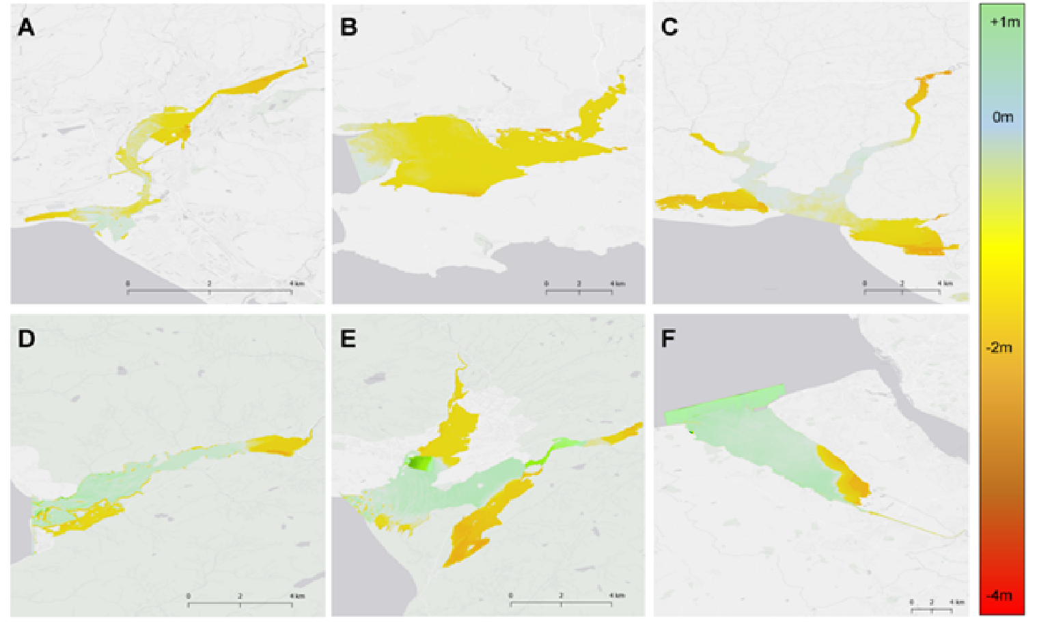
Supplementary Figure S1: Differences in water level between unvegetated and vegetated scenarios for a 1 in 100 Storm, illustrating the estuary-scale reductions in flooding of upstream areas by vegetation. Green colours (positive values) indicate enhancement of water level due to vegetation, and warmer yellows to reds (negative values) indicate water level reduction caused by vegetation. Results presented for the Neath (A), Loughor (B), Three Rivers Complex (Taf, Towy, Gwendraeth)(C), Mawddach (D), Glaslyn (E) and Dee (F) estuaries. The Red box on the Dee Estuary (F) indicates an industrial area that saw additional flooding when vegetation was present for a 100 year storm event. In units of meters (m).

Supplementary Table S8: Vegetation drives reductions in channel flood current velocity particularly with increasing distance upstream and during large storms. Statistical model summary of the effects of vegetation state, proportional distance upstream and their interaction on flood current velocity within 1km long estuary “zones”.
Event | Predictor | Estimate | S.E. | Z-value | P
1 | Intercept | 0.710 | 0.258 | 2.750
 | Grazed Vegetation | -1.268 | 0.151 | -8.410 | <0.001***
 | Full Vegetation | -1.559 | 0.151 | -10.310 | <0.001***
 | Proportional Distance | -0.688 | 0.114 | -6.030 | <0.001***
 | Prop. Distance:Grazed | -0.246 | 0.154 | -1.600 | 0.109
 | Prop. Distance: Vegetated | -0.364 | 0.153 | -2.380 | 0.018*
10 | Intercept | 1.686 | 0.244 | 6.920
 | Grazed Vegetation | -1.453 | 0.179 | -8.120 | <0.001***
 | Full Vegetation | -1.648 | 0.179 | -9.200 | <0.001***
 | Proportional Distance | -0.064 | 0.119 | -0.540 | 0.589
 | Prop. Distance:Grazed | -0.354 | 0.159 | -2.230 | 0.026*
 | Prop. Distance: Vegetated | -0.437 | 0.159 | -2.740 | 0.006**
100 | Intercept | 3.744 | 0.248 | 15.090
 | Grazed Vegetation | 0.043 | 0.117 | 0.360 | 0.716
 | Full Vegetation | -3.190 | 0.192 | -16.600 | <0.001***
 | Proportional Distance | -3.255 | 0.192 | -16.960 | <0.001***
 | Prop. Distance:Grazed | -0.537 | 0.160 | -3.350 | 0.001***
 | Prop. Distance: Vegetated | -0.508 | 0.159 | -3.190 | 0.001***

Supplementary Table S9: Vegetation drives progressive reductions in channel water depths with increasing distance upstream. Statistical model summary of the effects of vegetation state, proportional distance upstream and their interaction on flood depth within 1km long estuary “zones”.
Event | Predictor | Estimate | S.E. | Z-value | P
1 | Intercept | 0.86 | 0.20 | 4.36
 | Grazed Vegetation | -0.27 | 0.07 | -3.82 | <0.001***
 | Full Vegetation | -0.34 | 0.07 | -4.83 | <0.001***
 | Proportional Distance | -8.11 | 1.01 | -8.01 | <0.001***
 | Prop. Distance:Grazed | -4.30 | 1.42 | -3.03 | 0.002**
 | Prop. Distance: Vegetated | -8.28 | 1.41 | -5.87 | <0.001***
10 | Intercept | 1.30 | 0.26 | 4.99
 | Grazed Vegetation | -0.24 | 0.08 | -2.84 | 0.005**
 | Full Vegetation | -0.30 | 0.08 | -3.59 | <0.001***
 | Proportional Distance | -9.76 | 1.24 | -7.55 | <0.001***
 | Prop. Distance:Grazed | -4.42 | 1.71 | -2.58 | 0.010*
 | Prop. Distance: Vegetated | -5.05 | 1.71 | -2.96 | 0.003**
100 | Intercept | 3.49 | 0.21 | 16.62
 | Grazed Vegetation | -1.36 | 0.14 | -10.09 | <0.001***
 | Full Vegetation | -1.25 | 0.13 | -9.38 | <0.001***
 | Proportional Distance | 3.36 | 1.79 | 1.88 | 0.060
 | Prop. Distance:Grazed | -19.57 | 2.51 | -7.80 | <0.001***
 | Prop. Distance: Vegetated | -19.66 | 2.53 | -7.79 | <0.001***

Supplementary Table S10: Vegetation drives progressive reductions in flood extent with increasing distance upstream. Statistical model summary of the effects of vegetation state, proportional distance upstream and their interaction on flood extent within 1km long estuary “zones”.
Event | Predictor | Estimate | S.E. | Z-value | P
1 | Intercept | -0.14 | 0.17 | -0.84
 | Grazed Vegetation | -0.47 | 0.13 | -3.63 | <0.001***
 | Full Vegetation | -0.61 | 0.13 | -4.71 | <0.001***
 | Proportional Distance | 2.74 | 1.81 | 1.52 | 0.129
 | Prop. Distance:Grazed | -6.20 | 2.59 | -2.39 | 0.017*
 | Prop. Distance: Vegetated | -5.93 | 2.58 | -2.30 | 0.022*
10 | Intercept | 1.03 | 0.15 | 6.81
 | Grazed Vegetation | -0.68 | 0.14 | -4.69 | <0.001***
 | Full Vegetation | -0.75 | 0.14 | -5.22 | <0.001***
 | Proportional Distance | -1.71 | 2.05 | -0.83 | 0.400
 | Prop. Distance:Grazed | -4.52 | 2.91 | -1.56 | 0.120
 | Prop. Distance: Vegetated | -5.96 | 2.90 | -2.05 | 0.040*
100 | Intercept | 1.67 | 0.14 | 11.61
 | Grazed Vegetation | -0.96 | 0.14 | -6.68 | <0.001***
 | Full Vegetation | -0.85 | 0.14 | -5.90 | <0.001***
 | Proportional Distance | 1.78 | 1.95 | 0.91 | 0.361
 | Prop. Distance:Grazed | -6.33 | 2.87 | -2.21 | 0.027*
 | Prop. Distance: Vegetated | -5.99 | 2.88 | -2.08 | 0.038*

Supplementary Figure S2: Estuary-scale decreases in flood current velocity in upstream areas are driven by marsh vegetation. Differences in water flood current between unvegetated and vegetated scenarios for a 1 in 100 Storm, Green colours (positive values) indicate enhancement of current velocity due to vegetation, and warmer yellows to reds (negative values) indicate flood current velocity reduction caused by vegetation. Results presented for the Neath (A), Loughor (B), Three Rivers Complex (Taf, Towy, Gwendraeth)(C), Mawddach (D), Glaslyn (E) and Dee (F) estuaries. In units of meters per second (ms)
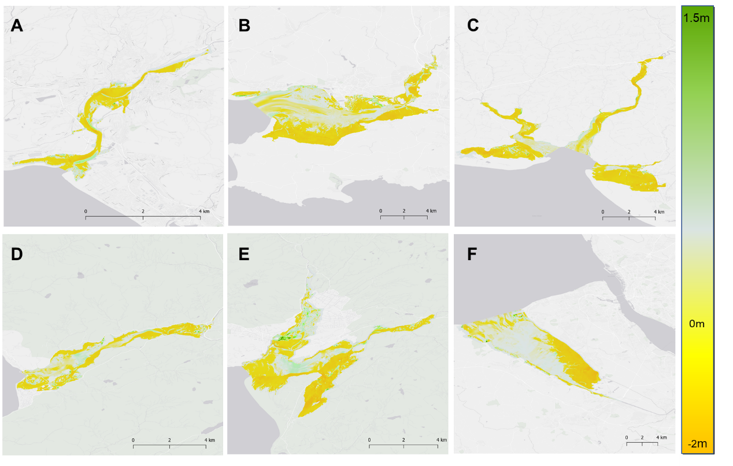
Supplementary Table S11: Marsh vegetation is less effective at reducing up-stream surge in larger estuaries. Statistical model summary of the effects of Estuary Size (km²), marsh proportion and storm intensity on proportional reductions of surge at upstream tidal limits.
Predictor | Estimate | S.E. | T-value | P
Intercept | -0.069 | 0.454 | -0.151
Estuary Size | -0.548 | 0.111 | -4.940 | <0.001***
Marsh Proportion | 0.013 | 0.007 | 1.859 | 0.080
Storm | 0.001 | 0.005 | 0.170 | 0.867
Estuary Size:Storm | -0.001 | 0.002 | -0.679 | 0.506

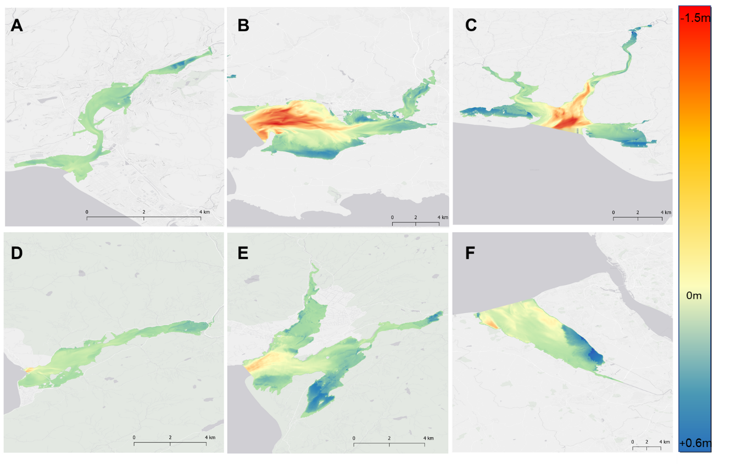
Supplementary Figure S3: Wave heights are amplified by vegetation close to estuary mouths, but decay quickly due to vegetation drag in upstream areas. Differences in wave height between unvegetated and vegetated scenarios for a 1 in 100 Storm, Warm colours (negative values) indicate enhancement of wave height due to vegetation, and cooler blues (positive values) indicate wave height reduction caused by vegetation. Results presented for the Neath (A), Loughor (B), Three Rivers Complex (Taf, Towy, Gwendraeth)(C), Mawddach (D), Glaslyn (E) and Dee (F) estuaries. In units of meters (m).

Supplementary Table S12: Marsh vegetation attenuates upstream wave propagation, and strengthens with the proportional distance upstream. Statistical model summary of the effects of vegetation state, proportional distance upstream and their interaction on wave height within 1km long estuary “zones”.
Event | Predictor | Estimate | S.E. | Z-value | P
1 | Intercept | 0.03 | 0.19 | 0.15
 | Grazed Vegetation | -0.21 | 0.11 | -1.96 | 0.04*
 | Full Vegetation | -0.45 | 0.11 | -4.09 | <0.001***
 | Proportional Distance | -13.91 | 1.57 | -8.85 | <0.001***
 | Prop. Distance:Grazed | -3.83 | 2.21 | -1.73 | 0.08
 | Prop. Distance: Vegetated | -7.61 | 2.23 | -3.41 | <0.001***
10 | Intercept | -0.210 | 0.308 | -0.680
10 | Grazed Vegetation | -0.308 | 0.213 | -1.440 | 0.149
10 | Full Vegetation | -0.334 | 0.210 | -1.590 | 0.113
10 | Proportional Distance | -0.520 | 0.111 | -4.690 | <0.001***
10 | Prop. Distance:Grazed | -0.071 | 0.155 | -0.450 | 0.650
10 | Prop. Distance: Vegetated | -0.395 | 0.159 | -2.480 | 0.013*
100 | Intercept | 2.21 | 0.20 | 11.25
 | Grazed Vegetation | -1.22 | 0.14 | -8.81 | <0.001***
 | Full Vegetation | -0.891 | 0.14 | -6.49 | <0.001***
 | Proportional Distance | 7.88 | 1.95 | 4.05 | <0.001***
 | Prop. Distance:Grazed | -22.09 | 2.80 | -7.90 | <0.001***
 | Prop. Distance: Vegetated | -33.29 | 2.80 | -11.89 | <0.001***

Supplementary Table S13: Marsh vegetation locally attenuates waves traveling over marsh platforms, and wider marshes were the most effective and consistent. Statistical model summary of the effects of vegetation state, marsh width, marsh slope, overlying water depth, initial wave height at marsh-estuary boundary and distance upstream on wave transformation over marshes
Event | Predictor | Estimate | S.E. | Z-value | P
1 | Intercept | -2.470 | 0.597 | -4.140
 | Marsh Width | 0.562 | 0.090 | 6.240 | <0.001***
 | Grazed | -0.001 | 0.495 | 0.000 | 0.999
 | Vegetated | 0.734 | 0.507 | 1.450 | 0.147
 | Marsh Width:Grazed | 0.029 | 0.089 | 0.330 | 0.745
 | Marsh Width:Vegetated | -0.038 | 0.091 | -0.420 | 0.678
 | Slope | 23.900 | 4.270 | 5.590 | <0.001***
 | Depth Over Marsh | -0.371 | 0.114 | -3.260 | 0.001***
 | Distance from Mouth | 0.000 | 0.000 | 0.190 | 0.846
 | Initial Wave Height | -0.204 | 0.349 | -0.580 | 0.559
10 | Intercept | -0.813 | 0.562 | -1.450
10 | Marsh Width | 0.149 | 0.079 | 1.900 | 0.058
10 | Grazed | -1.310 | 0.426 | -3.080 | 0.002**
10 | Vegetated | -1.350 | 0.432 | -3.110 | 0.002**
10 | Marsh Width:Grazed | 0.269 | 0.076 | 3.550 | <0.001***
10 | Marsh Width:Vegetated | 0.309 | 0.077 | 4.010 | <0.001***
 | Slope | 17.200 | 3.710 | 4.650 | <0.001***
 | Depth Over Marsh | -0.550 | 0.084 | -6.570 | <0.001***
 | Distance from Mouth | 0.000 | 0.000 | 1.780 | 0.075
 | Initial Wave Height | 0.751 | 0.308 | 2.440 | 0.015*
100 | Intercept | -2.450 | 0.598 | -4.100
 | Marsh Width | 0.413 | 0.087 | 4.750 | <0.001***
 | Grazed | -0.674 | 0.437 | -1.540 | 0.123
 | Vegetated | -0.518 | 0.436 | -1.190 | 0.234
 | Marsh Width:Grazed | 0.159 | 0.079 | 2.020 | 0.044*
 | Marsh Width:Vegetated | 0.167 | 0.078 | 2.130 | 0.033*
 | Slope | 26.700 | 6.210 | 4.300 | <0.001***
 | Depth Over Marsh | -0.385 | 0.106 | -3.630 | <0.001***
 | Distance from Mouth | 0.000 | 0.000 | -0.890 | 0.372
 | Initial Wave Height | 0.913 | 0.294 | 3.110 | 0.002**

Supplementary Table S14: Marsh vegetation locally attenuates flood water traveling over marsh platforms, and wider marshes were the most effective and consistent. Statistical model summary of the effects of vegetation state, marsh width, marsh slope, overlying water depth, initial wave height at marsh-estuary boundary and distance upstream on flood water depths at terrestrial boundaries.
Event | Predictor | Estimate | S.E. | Z-value | P
1 | Intercept | -1.100 | 0.547 | -2.010
 | Marsh Width | 0.423 | 0.084 | 5.030 | <0.001***
 | Grazed | -0.372 | 0.464 | -0.800 | 0.423
 | Vegetated | -0.763 | 0.463 | -1.650 | 0.099
 | Marsh Width:Grazed | 0.096 | 0.084 | 1.140 | 0.253
 | Marsh Width:Vegetated | 0.184 | 0.083 | 2.200 | 0.027*
 | Slope | 31.700 | 4.260 | 7.440 | <0.001***
 | Depth Over Marsh | -0.609 | 0.100 | -6.090 | <0.001***
 | Distance from Mouth | 0.000 | 0.000 | 0.640 | 0.524
 | Initial Wave Height | -0.243 | 0.306 | -0.800 | 0.426
10 | Intercept | -0.340 | 0.550 | -0.620
10 | Marsh Width | 0.195 | 0.076 | 2.570 | 0.010*
10 | Grazed | -1.060 | 0.396 | -2.680 | 0.007**
10 | Vegetated | -1.000 | 0.398 | -2.520 | 0.012*
10 | Marsh Width:Grazed | 0.231 | 0.071 | 3.280 | 0.001***
10 | Marsh Width:Vegetated | 0.242 | 0.071 | 3.430 | 0.001***
 | Slope | 24.500 | 4.140 | 5.920 | <0.001***
 | Depth Over Marsh | -0.519 | 0.078 | -6.660 | <0.001***
 | Distance from Mouth | 0.000 | 0.000 | -0.560 | 0.576
 | Initial Wave Height | 0.196 | 0.289 | 0.680 | 0.497
100 | Intercept | -1.790 | 0.481 | -3.720
 | Marsh Width | 0.403 | 0.068 | 5.940 | <0.001***
 | Grazed | -0.880 | 0.368 | -2.390 | 0.017*
 | Vegetated | -1.300 | 0.368 | -3.530 | <0.001***
 | Marsh Width:Grazed | 0.185 | 0.066 | 2.800 | 0.005**
 | Marsh Width:Vegetated | 0.267 | 0.066 | 4.050 | <0.001***
 | Slope | 59.800 | 5.170 | 11.560 | <0.001***
 | Depth Over Marsh | -0.532 | 0.082 | -6.500 | <0.001***
 | Distance from Mouth | 0.000 | 0.000 | -0.360 | 0.716
 | Initial Wave Height | 0.214 | 0.219 | 0.980 | 0.329

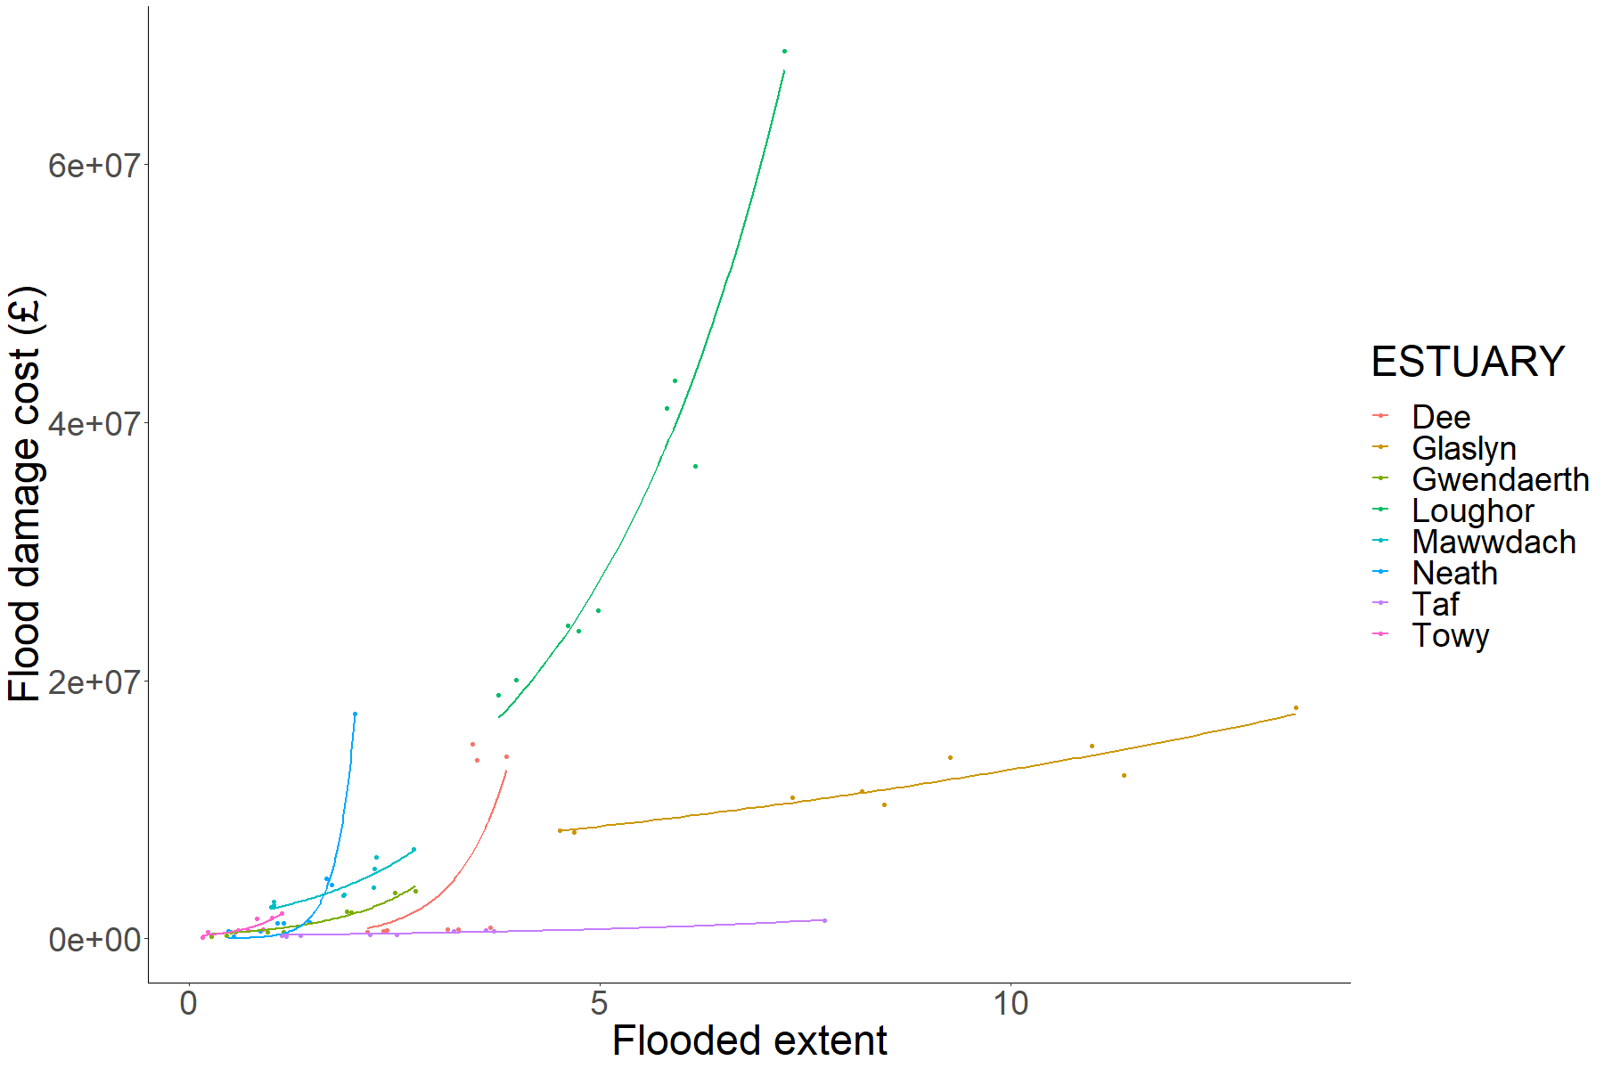
Supplementary Figure S4: General non-linear relationships between flood area and flood damage cost for estuaries in the this study. Most estuaries display exponential increases in cost with increasing flood extent, except for the Taf and Glaslyn estuaries in which low lying land is almost exclusively low-value agricultural or common land.

3: Additional Methodological Details

3.1: Hydrodynamic models
In order to investigate the role of saltmarsh vegetation on estuarine hydrodynamics and coastal flooding risk during storm events we created online coupled Delft3D FLOW and WAVE (SWAN Cycle III 41.31) models²⁹ using 2-dimensional (depth averaged) form of unsteady shallow water equations²⁹ across eight case study estuaries (Supplementary Figure S5). Models were constructed using structured grids, gradually refining from 150x50m grids at offshore locations (to ca. 25m below chart datum), to uniform, high resolution 10 x 10m grids throughout the estuary boundaries. To adequately represent the hydrodynamics, we used 0.01 minute calculation timesteps, and 15 minute output intervals to capture tide and storm surge peaks as they progressed up-stream. Following modelling, we combined data from multiple output intervals, between the water level peak at the estuary mouth, to the water level peak at the Limit of Tidal Intrusion (LTI), to create maximum extent, depth, current and wave maps using the mosaic function in QGIS 3.10.2³⁰.

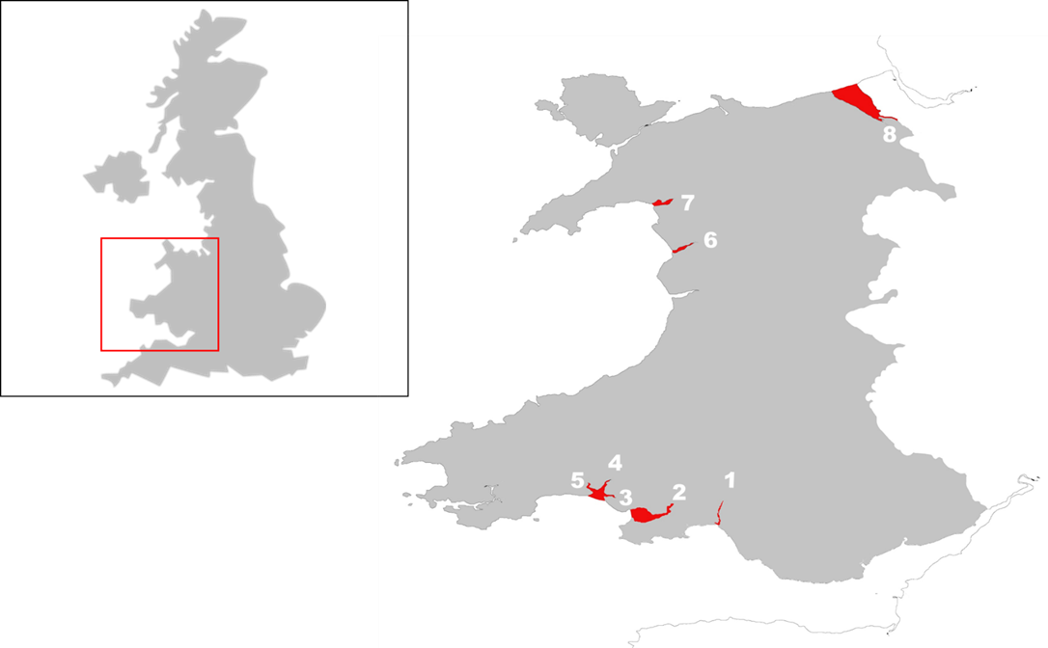
Supplementary Figure S5: Map of the 8 selected estuaries within Wales, UK used in this study: 1) Neath, 2) Loughor, 3) Gwendraeth, 4) Towy, 5) Taf, 6) Mawddach, 7) Glaslyn & 8) Dee

3.2: Inputs
To Accurately characterise the hydrodynamics of the estuaries, the computational models were calibrated and populated with validated observed and modelled data for bathymetries, tides, surge profiles, waves river flows and wind.

3.2.1 Bathymetries
To accurately represent the hydrodynamics in the estuaries and coastal regions, topobathymetries for each estuary and offshore model extent were created using raster EMODNET bathymetries (https://www.emodnet.eu/bathymetry) for open water areas, and high resolution (1m) LiDAR DTM data (available from http://lle.gov.wales) for inshore, estuarine and terrestrial areas. An additional sonographic survey (heave/surge compensated Lowrance Structure Scan 3D transducer) was also undertaken using a ridged inflatable vessel in the Taf Estuary, where LiDAR data quality and coverage was poor in estuary channel areas. Outputs were converted, scaled and mosaiced using base routines using QGIS 3.10.2³⁰ to create topobathymetries matching the grid resolution of the hydrodynamic models.

3.2.2: Boundary Conditions

3.2.2.1: Tidal conditions
Harmonic tidal predictions were determined for each boundary grid cell using the TPXO 8.0³¹ tidal prediction model using the DelftDashboard Tool Suite (TU Delft). Tidal models were then created using the harmonics derived from TPXO 8.0 using Delft3D-FLOW, producing a 1-year tidal model for each estuary. From these models, the largest tide was selected, and the resulting time-varying boundary water levels were used to specify the boundary conditions, along with surge profiles (below in 3.2.2.2), for the coupled FLOW-WAVE storm models.

3.2.2.2: Storm conditions:
Statistically significant water level variations during storms were determined following the method given in McMillan et al.³² For each estuary, we used storm surge level data supplied by the National Tide and Sea Level Facility of the UK (NTSLF) using the skew surge joint probability method (SSJPM), and tidal predictions (see 3.2.2.1) to calculate total water levels for the storm scenarios, following the methodology of Bennett et al.³³. In this study, we assumed that storm peaks coincides with high tide, and that the maximum surge occurs at the peak of the storm, representing worst-case storm event scenarios.
Additionally to tidal and storm surges, we simulated the effects of waves and wave set-up. We used the Centre for Environment Fisheries and Aquaculture Science (CEFAS) Wavenet database to parameterise offshore waves, using hindcast output points closest to each estuary modelled. From this data, storms occurring between 1980-2018 were isolated following the method described in Bennett et al.³³, and based on the storm definitions provided by Dissanayake et al.³⁴. Storms were defined by a threshold storm wave height of 2.5 m, based on the U.K. Channel Coastal Observatory (CCO) guidance for defining storm thresholds³⁵. The Generalised Pareto Distribution (GPD), utilising the R package ismev³⁶, was then used to determine significant storm wave heights corresponding to 1 in 1-, 1 in 10-, and 1 in 100-year return periods. The wave models for each estuary were then populated with the derived average significant storm wave height (W_{avg}), maximum storm wave period (T_{max}) and the average predominant wave direction for all individual storm events (Wd_{avg}) for each storm scenario at the offshore model boundary.
We also considered wind effects on wave propagation and internal generation of waves in the estuaries. We identified and used hourly outputs of wind speed and direction, between January 1977 and January 2018, from weather stations close to each estuary from the U.K. Meteorological Office weather stations network as part of the MIDAS dataset (https://catalogue.ceda.ac.uk/). Similarly to the analysis of storm wave data, storm wind data was filtered to include events where wind speed was >20m/s, and the GPD was fitted to the wind data to give average wind speed for each storm return-level (Wi_{avg}). The predominant wind direction was also then determined from the average observed wind data during storm conditions (Wi_{d}).
The storm wave and wind conditions were then used to generate time-varying storm profiles using three-point spline curves, which closely represented observed storm profiles. In this, storms began when incident wave height and wind speed exceeded the pre-selected threshold wave height and wind speed, and ceased when wave height and wind speed became smaller than the threshold. In our scenarios, storm peaks occurred halfway between the beginning and the end of storm, creating a symmetric storm profile, and giving an average storm duration of 75 hours across the estuaries. The time-varying storm conditions were then passed to the DELFT-3D WAVE and FLOW modules to commence storm hydrodynamic modelling.

3.2.2.3: River inputs:
Inspection of weather records for Wales (Met Office) indicated that the largest storms with high wind speeds often experienced substantial rainfall, but were not generally coupled to the highest rainfall totals (personal observation). As a result, we selected river flow records for each river at the Q₅ exceedance level, where discharged water volume is only exceeded on 5% of days within an average year, rather than Q_{max} maximum recorded water discharge. Data for river discharges is available through the National River Flow Archive Wales (Centre for Ecology and Hydrology [CEH], available at nrfa.ceh.ac.uk). River flows were specified at each major river channel up-stream boundary as a continuous flow in the Delft3D models.

3.2.3: Vegetation
Salt marsh vegetation parameters and extents were provided to the FLOW and WAVE modules to understand the role that vegetation plays in preventing coastal flooding in estuaries. Marsh shapefiles provided by Natural Resources Wales (available at: http://lle.gov.wales/catalogue/item/SaltmarshExtents) were used to populate the extents of marsh area within each estuary, and we undertook field campaigns to map plant distributions and quantify key plant properties within each estuary, which were then used to calculate community weighted means (CWM) for key plant traits used as vegetation inputs in this study (Supplementary Table S14). March vegetative communities tended to be dominated by mixtures of Atriplex portulacoides, Spartina anglica, and mixed communities of Festuca rubra, Tripolium pannonicum, Suaeda maritima and Puccinellia maritima.
Supplementary Table S15: Vegetation Parameters derived from field surveys, used to populate vegetation models.
Mean Plant Density (Stems per m²) (n_{v)} | Mean Vegetation Height (m) (h_{v}) | Mean Stem Thickness (base) (mm) | Mean Stem Thickness (tip) (mm) | Plant drag coefficient (C_{d})
2275 | 0.33 | 3.3 | 1.8 | 1

In this study we modelled Saltmarsh vegetation using simplified rigid cylinders that are parameterized by plant height h_{v}, plant density n_{v}, and stem diameter which reduces towards the end of stems which were derived from CWM from the survey data.
We modelled the drag force induced by rigid cylindrical saltmarsh vegetation on currents as a sink term in the momentum equations (Equation 1)
$$\vec{F}=\frac{1}{2}ρC_{D}b_{v}n_{v}\left|\vec{u}\right|\vec{u}.$$
where F is the drag force produced by vegetation per unit volume in N/m3, ρ is the density of the fluid in kg/m³, u is the local flow velocity in m/s., and C_{D} is a dimensionless drag coefficient. Owing to the inability to measure drag (C_{d}) in the field, a priori, we assumed C_{d} = 1 based on previous experimental studies with stiff cylinders in unidirectional flow and under similar wave conditions^{37,38}, and has been applied successfully to previous studies on saltmarsh vegetation.
In addition to modification of flow, we also looked at the role of vegetation on wave energy using the same rigid cylinder approach. Saltmarsh vegetation dampens waves owing to the work done by the drag force (Equation (2)) on plants stems, implemented in Delft3D WAVE via Equation 2.
$$\frac{∂Ec_{g}}{∂x} =<\int_{-h}^{-h+h_{v}}{\vec{F}\vec{u}dz}>,$$
Where $E=\frac{1}{8}ρgH^{2}$ is the wave energy density in N/m, c_{g} is the group velocity in m/s, h is the water depth in meters and h_{v} is the vegetation height in meters. The horizontal axis x is in the direction of wave propagation, z is the vertical axis in the water column and brackets (< )) denote phase-averaging.

3.2.4: Model Validation
To ensure that hydrodynamic models adequately captured the hydrodynamics in estuaries, we tested observed data against calibrated models using at a number of locations throughout the estuaries. We used a combination of observed data from river and tidal gauging stations (Natural Resources Wales [NRW] and British Oceanographic Data Centre [BODC]) of known elevation, and deployed atmospherically-corrected water depth loggers (HOBO UL21, in pairs) with elevation determined using a GNSS RTK receiver (Leica Viva GS08), to determine water levels for each location. Modelled water levels were compared against the observed data, and model performance metrics (R², RMSE) calculated.
Overall, models performed well for each tested location (Supplementary Figure S6, Supplementary Table S15), particularly around the crucial high-water peaks, and sufficiently predicted water levels.
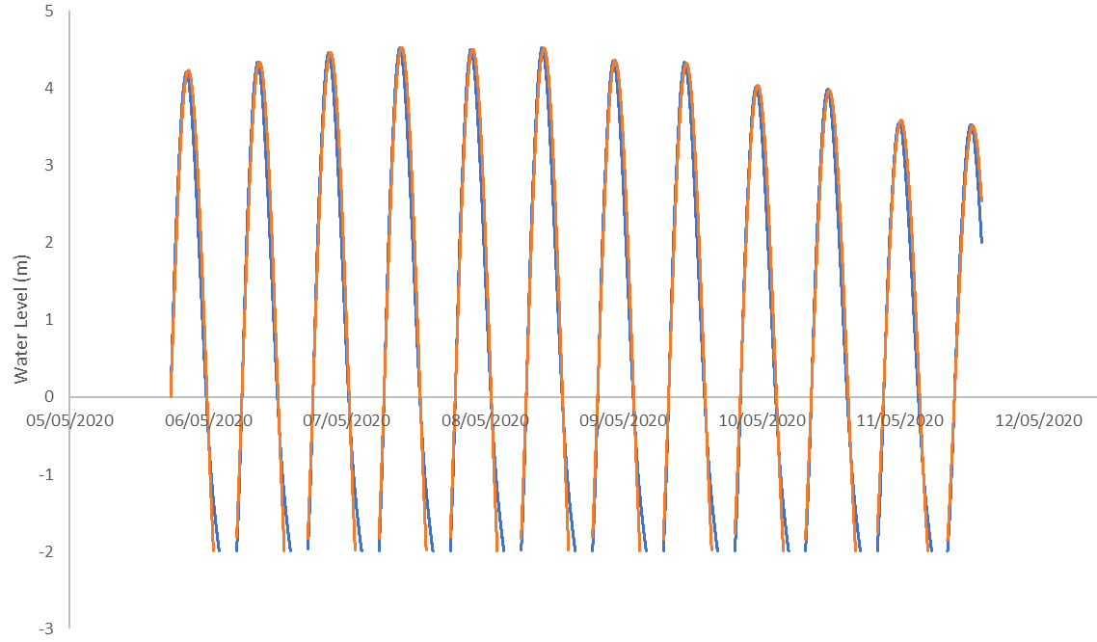
Supplementary Figure S6: Model validation of water levels at Burry Port, Loughor estuary show good agreement with measured water levels (R²=0.97, RMSE=0.27m). Modelled peak high water values vary by <0.05m compared with the observed water levels. Orange lines represent measured values, and blue represent modelled values. Missing values during low tide are due to drying out of the location.

Supplementary Table S16: Modelled water levels show good agreement with observed values at monitoring points in the estuaries, and are suitably well fitting to allow assessment of the role of marsh vegetation in mitigating storm flood impacts. For each location the distance upstream is provided along with the observation measure, model agreement parameters (R², RMSE), and the difference in water level between observed and predicted at peak high tide (positive values indicate modelled > observed, and negative modelled<observed).
Estuary (location) | Distance Upstream | Measure | R² | RMSE (m) | Peak High Water Level Difference (m)
Neath Castle | 6km | Depth Logger (atm corr) | 0.984 | 0.101 | 0.04
Loughor (Burry Port) | 4km | Depth Logger (atm corr) | 0.974 | 0.272 | -0.03
Loughor (Llanelli docks) | 7km | Tidal Gauge (NRW) | 0.954 | 0.295 | 0.06
Three Rivers: Taf (Laugharne South) | 3km | Depth Logger (atm corr) | 0.789 | 0.163 | 0.05
Three Rivers: Taf (Laugharne North) | 6km | Depth Logger (atm corr) | 0.998 | 0.069 | -0.05
Mawddach (Barmouth RW Bridge) | 1km | Tidal Gauge  (BODC) | 0.978 | 0.234 | 0.07
Dee (Hilbre Island) | 2km | Depth Logger (atm corr) | 0.996 | 0.101 | 0.05
Dee (Connah’s Quay) | 22km | Depth Logger (atm corr) | 0.987 | 0.210 | -0.12

3.3: Economic analysis
To quantify the economic value that saltmarshes deliver through mitigating floods, we apply methods used by the UK government to appraise investments in flood-protection infrastructure^{39,40}. We compared the flood damages experienced in each estuary when marshes have no vegetation to those with full or grazed vegetation. Our calculations aggregated flood damage estimates for residential, commercial, industrial and agricultural properties, as well as to public buildings and water and electricity utility installations using flood cost estimates from the 2018 update of the Multi-Coloured Manual (MCM)⁴⁰. For each estuary under each scenario, we overlaid the gridded outputs from the hydrodynamic modelling with OS Mastermap topography layer. OS MasterMap topography layer is the most detailed topographic map produced by Great Britain's national mapping agency, the Ordnance Survey (OS) (Ordnance Survey 2020). From OS Mastermap we were able to identify each property that intersected a flooded grid cell and attribute each with a flood depth. Where a property spanned more than one grid cell, that property was associated with the maximum flood depth. We restricted attention to buildings with a footprint over 25m², of which some 2,331 were in flood-effected areas across the study estuaries. No comprehensive secondary dataset was available to establish the characteristics of those properties. Accordingly, each building was inspected manually using both satellite and Google Streetview imagery⁴¹. That inspection allowed us to establish the type (i.e. terraced, semi-detached, detached, bungalows and flats) and age of each residential property (i.e. pre-1919, 1919-44, 1945-64, 1965-74, 1975-85 and post-1985). In addition, small area data (Output Area) from the 2011 UK Census⁴² was used to establish the socioeconomic grade characterising a property’s neighbourhood. Ultimately, a flooded residential building was characterised by type, age, socioeconomic band and flood depth. Using that building-specific characterisation, estimates of saltwater inundation damages to building fabric, household inventory and domestic clean-up were taken from MCM cost tables⁴⁰. Where a property spanned the boundary of flood extent, only a proportion of the damage cost was used in our calculations, where that proportion was equal to the percentage of the property in the flooded area.
Non-residential buildings were first attributed a detailed characterisation which was later amalgamated into nine-category classification; public buildings (including schools, doctor’s surgeries. hospitals and community centres), industrial buildings (including factories, workshops, agricultural barns and water treatment works), retail properties (including shops, supermarkets, petrol stations, vehicle repair garages, pubs, cafés and restaurants), offices, warehouses, leisure facilities (including hotels, theatres and cinemas), electricity substations, sports centres and sports stadia. Category-specific damage costs per metre squared for saltwater inundation to the flood depth experienced at each non-residential building were taken from MCM cost tables assuming a short duration of inundation but without prior warning of the flood event. The per metre-squared costs were multiplied up by the area of the building footprint experiencing flooding to arrive at the damage cost estimate.
For each estuary the length of motorway, A-road, B-road and minor road inundated in a flood event were identified from the OS Integrated Transport Network data layer. Taking an average over the five years from 2014 to 2018, daily traffic flows by vehicle type (specifically; cars, public service vehicles, light goods vehicles, and heavy goods vehicles) for each category of road in each estuary’s local authority region (specifically; Flintshire, Gwynedd, Carmarthenshire and Neath/Port Talbot) were sourced from Department for Transport road traffic statistics (DfT, 2020). Those daily flows were converted to average hourly flows. To calculate disruption costs from flooding we applied the ‘diversion-value method’. Specifically, we assumed that each journey that would otherwise have used the flooded road, would instead be diverted via a longer route. For the sake of simplicity we assumed that diversion to extend the journey by a distance equal to the length of road made impassable by the flood water. Further assuming a standard 12-hour period of flooding for each storm event we calculated the number of journeys by each vehicle type subject to such an extended journey and multiplying up by the length of diversion arrived at estimates of the additional flood-induced journey distances by each vehicle type on each road category. We arrived at our final estimates of travel-disruption costs by multiplying up those estimates by vehicle- and road-specific costs per kilometre of additional travel provided in the MCM cost tables.
Parks and paths used for outdoor recreation impacted by flooding were identified from the Outdoor Recreation Valuation (ORVal) greenspace map⁴³. Estimates for the annual recreation value generated by those sites was accessed from the ORVal tool⁴⁴. Losses from disruption of recreation activity were calculated by assuming that the flood event restricted access to those recreation sites for one week. Where a recreation site straddled the flood extent boundary, recreation costs were adjusted by a quantity equal to the percentage of the site experiencing flooding.
Agriculture land parcels inundated with saltwater in each flood event were identified from Landcover Map 2015⁴⁵ and categorised as either grazing pasture or as arable. Damage costs were taken from the MCM cost tables using the simplified aggregate costs from a single annual flood by land use. For pasture costs were estimated at £180 per hectare and those for arable at £501 per hectare⁴⁰
Damage costs for a particular event assuming a particular state of marsh vegetation in an estuary are calculated by adding together the property, utility, road, agriculture and recreation cost estimates for that event. To estimate expected annual damages in each estuary, we construct a flood probability-damage curve. Our damage cost estimates provide three points on that curve relating to the 1 in 1 event, (annual probability of 1) 1 in 10 event (annual probability of 0.1) and the 1 in 100 event (annual probability of 0.01). We make the conservative assumption that flood events with magnitude greater than the 1 in 100 event cause the same damage as the 1 in 100 event. Likewise we assume that flood events with magnitude less than the 1 in 1 event generate no damage costs. We complete the probability-damage curve by linearly interpolating damage costs between the estimated 1 in 1 event, 1 in 10 event and 1 in 100 event costs. The expected annual damages can then be calculated by integrating under the probability-damage curve from 0.01 to 1.
Assuming a 50-year appraisal period we adopt UK government recommended discount rates to calculate the present value of those damage costs³⁹. Our estimates of the economic value of maintaining saltmarsh in its natural state is taken to be the reduction in the present value of damage costs that arises from natural vegetation as compared to when that vegetation is grazed or lost.

3.4: Assumptions and Limitations of modelling methodologies:
Hydrodynamic modelling using Delft3D has been validated and performs well for a variety of scenarios^{33,46–48}, but as with any modelling exercise it makes assumptions and approximations of physical processes which may not always capture every nuance of the environment. For instance, our modelling approach used 2-dimensional high resolution (ca. 10 x 10m) depth averaged models which capture large scale processes well, but may miss effects from small features. Features of 10x10m or smaller are not well captured by the model as they are at or below the resolution of the model (Nyquist limit), but may alter local hydrodynamics. These features may also include some small scale, low-crested and single layer coastal defence walls along isolated sections of estuary (see supplementary Figure S7) which were too small to be represented in the models, or on the LiDAR and satellite imagery which were used to identify features, and may have lead to isolated pockets of flooding that would not have occurred in the presence of structures.
Estuary and offshore topobathymetries were constructed using a combination of EMODNET and LiDAR raster images. However, in some estuaries (notably the Taf), LiDAR data has been created from composites from different time points, leading to stepped edges where either bed morphology has changed, or fly-overs have been conducted at different points in the tide, leading to localised inconsistencies in the bathymetries. We corrected these by manually adjusting points where this occurred using the QuickIN utility in Delft-3D to approximate bathymetric profiles, but these smoothed approximations my exclude conspicuous features on the bed. It is also important to note that the LiDAR data was often more than five years old, and may not reflect current bathymetries, especially in dynamic estuaries. Instead, they provide an approximated “snap-shot” which we can use to evaluate the role of vegetation, rather than current flood risk, and outputs should not be used to infer flood potential in any of the case-study estuaries.

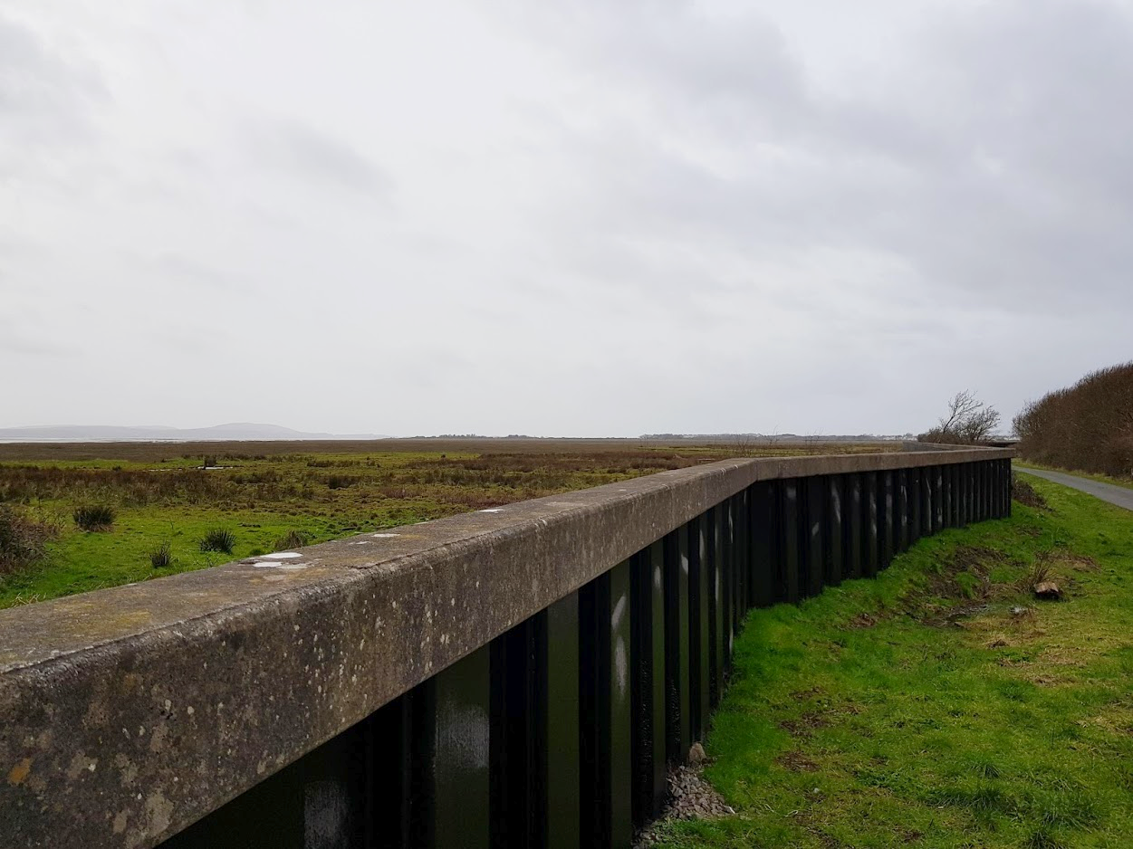Supplementary Figure S7: Low-crested (approx.. 1m), narrow coastal defence walls such as this one between Loughor and Llanelli may be absent within the model domains due to their small size. © Tom Fairchild, 2020

Vegetation also introduces additional element of uncertainty. Currently, the vegetation implementation in coupled Delft3D-WAVE (SWAN Cycle III 41.31) models only allows a single vegetation type to be specified, with regards to height, diameter and drag, whereas marshes are complex mosaics of different species which are likely to vary in their hydrodynamic properties. To overcome this, we used community weighted means of species traits from vegetation surveys to capture estuary level marsh properties. While this should give a good representation of the vegetation under most circumstances, the contributions of some marshes may be over- or under-estimated due to deviation of overall marsh characteristics from the mean values. For example, some marshes may be dominated by tall, ridged species such as Spartina spp. and Phragmites spp., whereas others may be dominated by low and flexible Festuca spp.
Vegetation in our model also uses ridged cylinders to represent the plants. While rigid-cylinder models of vegetation currently are the best method for the approximation of vegetation effects, they may not fully capture hydrodynamic effects for more flexible species, and could overestimate hydrodynamic drag as flexible vegetation can deform due to water currents³⁸. Instead we used conservative drag coefficients for the vegetation (Cd=1) to reduce the risk of overestimation of marsh effects on hydrodynamics and flood potential, which could underestimate the contribution of marsh vegetation communities in our models, and our predictions should as such be seen as conservative.

References:
1. Wamsley, T. V., Cialone, M. A., Smith, J. M., Atkinson, J. H. & Rosati, J. D. The potential of wetlands in reducing storm surge. Ocean Eng. 37, 59–68 (2010).
2. Meijer, M. C. Wave attenuation over salt marsh vegetation. A numerical implementation of vegetation in SWAN. (2005).
3. Stark, J., Plancke, Y., Ides, S., Meire, P. & Temmerman, S. Coastal flood protection by a combined nature-based and engineering approach: Modeling the effects of marsh geometry and surrounding dikes. Estuar. Coast. Shelf Sci. 175, 34–45 (2016).
4. van Loon-Steensma, J. M., Hu, Z. & Slim, P. A. Modelled Impact of Vegetation Heterogeneity and Salt-Marsh Zonation on Wave Damping. J. Coast. Res. 32, 241–252 (2016).
5. Loder, N. M., Irish, J. L., Cialone, M. A. & Wamsley, T. V. Sensitivity of hurricane surge to morphological parameters of coastal wetlands. Estuar. Coast. Shelf Sci. 84, 625–636 (2009).
6. Temmerman, S., De Vries, M. B. & Bouma, T. J. Coastal marsh die-off and reduced attenuation of coastal floods: A model analysis. Glob. Planet. Change 92–93, 267–274 (2012).
7. Hu, K., Chen, Q. & Wang, H. A numerical study of vegetation impact on reducing storm surge by wetlands in a semi-enclosed estuary. Coast. Eng. 95, 66–76 (2015).
8. Vuik, V., Jonkman, S. N., Borsje, B. W. & Suzuki, T. Nature-based flood protection: The efficiency of vegetated foreshores for reducing wave loads on coastal dikes. Coast. Eng. 116, 42–56 (2016).
9. Haddad, J., Lawler, S. & Ferreira, C. M. Assessing the relevance of wetlands for storm surge protection: a coupled hydrodynamic and geospatial framework. Nat. Hazards 80, 839–861 (2016).
10. Smolders, S., Plancke, Y., Ides, S., Meire, P. & Temmerman, S. Role of intertidal wetlands for tidal and storm tide attenuation along a confined estuary: a model study. Nat. Hazards Earth Syst. Sci. Discuss. 3, (2015).
11. Barbier, E. B., Georgiou, I. Y., Enchelmeyer, B. & Reed, D. J. The Value of Wetlands in Protecting Southeast Louisiana from Hurricane Storm Surges. PLOS ONE 8, e58715 (2013).
12. Narayan, S. et al. The Value of Coastal Wetlands for Flood Damage Reduction in the Northeastern USA. Sci. Rep. 7, 9463 (2017).
13. Stark, J., Oyen, T. V., Meire, P. & Temmerman, S. Observations of tidal and storm surge attenuation in a large tidal marsh. Limnol. Oceanogr. 60, 1371–1381 (2015).
14. Yang, S. L., Shi, B. W., Bouma, T. J., Ysebaert, T. & Luo, X. X. Wave Attenuation at a Salt Marsh Margin: A Case Study of an Exposed Coast on the Yangtze Estuary. Estuaries Coasts 35, 169–182 (2012).
15. Ysebaert, T. et al. Wave attenuation by two contrasting ecosystem engineering salt marsh macrophytes in the intertidal pioneer zone. Wetlands 31, 1043–1054 (2011).
16. Paquier, A.-E., Haddad, J., Lawler, S. & Ferreira, C. M. Quantification of the Attenuation of Storm Surge Components by a Coastal Wetland of the US Mid Atlantic. Estuaries Coasts 40, 930–946 (2017).
17. Foster-Martinez, M. R., Lacy, J. R., Ferner, M. C. & Variano, E. A. Wave attenuation across a tidal marsh in San Francisco Bay. Coast. Eng. 136, 26–40 (2018).
18. Jadhav, R. & Chen, Q. Field investigation of wave dissipation over salt marsh vegetation during tropical cyclone. Coast. Eng. Proc. 1, 41 (2012).
19. Zhang, X., Lin, P., Gong, Z., Li, B. & Chen, X. Wave Attenuation by Spartina alterniflora under Macro-Tidal and Storm Surge Conditions. Wetlands (2020) doi:10.1007/s13157-020-01346-w.
20. Möller, I., Spencer, T., French, J. R., Leggett, D. J. & Dixon, M. Wave Transformation Over Salt Marshes: A Field and Numerical Modelling Study from North Norfolk, England. Estuar. Coast. Shelf Sci. 49, 411–426 (1999).
21. Knutson, P. L., Brochu, R. A., Seelig, W. N. & Inskeep, M. Wave damping inSpartina alterniflora marshes. Wetlands 2, 87–104 (1982).
22. Möller, I. Quantifying saltmarsh vegetation and its effect on wave height dissipation: Results from a UK East coast saltmarsh. Estuar. Coast. Shelf Sci. 69, 337–351 (2006).
23. Möller, I. & Spencer, T. Wave dissipation over macro-tidal saltmarshes: Effects of marsh edge typology and vegetation change. J. Coast. Res. 506–521 (2002) doi:10.2112/1551-5036-36.sp1.506.
24. Cooper, N. J. Wave Dissipation Across Intertidal Surfaces in the Wash Tidal Inlet, Eastern England. J. Coast. Res. 21, 28–40 (2005).
25. Morgan, P. A., Burdick, D. M. & Short, F. T. The Functions and Values of Fringing Salt Marshes in Northern New England, USA. Estuaries Coasts 32, 483–495 (2009).
26. Möller, I. et al. Wave attenuation over coastal salt marshes under storm surge conditions. Nat. Geosci. 7, 727–731 (2014).
27. Beaumont, N. J., Jones, L., Garbutt, A., Hansom, J. D. & Toberman, M. The value of carbon sequestration and storage in coastal habitats. Estuar. Coast. Shelf Sci. 137, 32–40 (2014).
28. King, S. E. & Lester, J. N. The value of salt marsh as a sea defence. Mar. Pollut. Bull. 30, 180–189 (1995).
29. Roelvink, J. A. & Van Banning, G. Design and development of DELFT3D and application to coastal morphodynamics. Oceanogr. Lit. Rev. 11, 925 (1995).
30. Team, Q. D. QGIS geographic information system. Open Source Geospatial Found. Proj. (2016).
31. Dushaw, B. D. et al. A TOPEX/POSEIDON global tidal model (TPXO. 2) and barotropic tidal currents determined from long-range acoustic transmissions. Prog. Oceanogr. 40, 337–367 (1997).
32. McMillan, A. et al. Coastal Flood Boundary Conditionsfor UK Mainland and Islands. (2011).
33. Bennett, W. G., van Veelen, T. J., Fairchild, T. P., Griffin, J. N. & Karunarathna, H. Computational Modelling of the Impacts of Saltmarsh Management Interventions on Hydrodynamics of a Small Macro-Tidal Estuary. J. Mar. Sci. Eng. 8, 373 (2020).
34. Dissanayake, P., Brown, J., Wisse, P. & Karunarathna, H. Comparison of storm cluster vs isolated event impacts on beach/dune morphodynamics. Estuar. Coast. Shelf Sci. 164, 301–312 (2015).
35. Dhoop, T. Coastal Wave Network Annual Report 2017. (2018).
36. Coles, S., Bawa, J., Trenner, L. & Dorazio, P. An introduction to statistical modeling of extreme values. vol. 208 (Springer, 2001).
37. Tanino, Y. & Nepf, H. M. Laboratory Investigation of Mean Drag in a Random Array of Rigid, Emergent Cylinders. J. Hydraul. Eng. 134, 34–41 (2008).
38. van Veelen, T. J., Fairchild, T. P., Reeve, D. E. & Karunarathna, H. Experimental study on vegetation flexibility as control parameter for wave damping and velocity structure. Coast. Eng. 157, 103648 (2020).
39. Treasury, H. M. The green book: Central government guidance on appraisal and evaluation. Lond. HM Treas. (2018).
40. Penning-Rowsell, E. et al. Flood and Coastal Erosion Risk Management A Manual for Economic Appraisal. (2013).
41. Anguelov, D. et al. Google street view: Capturing the world at street level. Computer 43, 32–38 (2010).
42. Gale, C. G., Singleton, A. D., Bates, A. G. & Longley, P. A. Creating the 2011 area classification for output areas (2011 OAC). J. Spat. Inf. Sci. 2016, 1–27 (2016).
43. Day, B. & Smith, G. Outdoor Recreation Valuation (ORVal) Data Set Construction. Rep. Dep. Food Rural Aff. (2016).
44. Day, B. & Smith, G. S. The outdoor recreation valuation (ORVal) tool: technical report, January 2018. Rep. Dep. Food Rural Aff. Lond. (2017).
45. Morton, D. et al. Final Report for LCM2015 -the new UK land cover map. 112 (2015).
46. Elias, E. P. L., Walstra, D. J. R., Roelvink, J. A., Stive, M. J. F. & Klein, M. D. Hydrodynamic Validation of Delft3D with Field Measurements at Egmond. 2714–2727 (2012) doi:10.1061/40549(276)212.
47. Hsu, Y. L., Dykes, J. D., Allard, R. A. & Kaihatu, J. M. Evaluation of Delft3D performance in nearshore flows. (2006).
48. Symonds, A. M. et al. Comparison between Mike 21 FM, Delft3D and Delft3D FM flow models of western port bay, Australia. Coast. Eng. 2 (2016).

