Second to fourth digit (2D:4D) ratio and their relationships among first-time mother-and-child population in Ghana

Moses Banyeh¹*, Nafiu Amidu¹, Lawrence Quaye¹

¹ Department of Biomedical Laboratory Science, School of Allied Health Sciences, University for Development Studies, Tamale, Ghana

*Corresponding author

Email: mosesbanyeh@gmail.com
Tel: +233507554477
ORCiD: 0000-0003-3594-6077

Supplementary Table 1. General maternal characteristics by equal or above versus below mean digit ratio for each hand of mother
Characteristics | Right 2D:4D Digit Ratio |  |  |  | Left 2D:4D Digit Ratio
Characteristics | < mean  n (35) | ≥ mean  n (49) | OR (95%CI)/P-value |  | < mean  n (36) | ≥ mean  n (48) | OR (95%CI)/P-value
Demographic
Age (yrs.) | 23.4±3.90 | 23.6±3.37 | 0.858 |  | 24.0±3.77 | 23.1±3.42 | 0.255
Ethnicity
Mole-Dagomba | 34(42.5) | 46(57.5) | 1 |  | 35(43.8) | 45(56.3) | 1
Other-ethnicity | 1(25.0) | 3(75.0) | 2.217(0.221-22.254) |  | 1(25.0) | 3(75.0) | 2.333(0.233-23.410)
Religious affiliation
Islam | 32(43.8) | 41(56.2) | 1 |  | 31(42.5) | 42(57.5) | 1
Christianity | 3(27.3) | 8(72.7) | 2.081(0.511-8.484) |  | 5(45.5) | 6(54.5) | 0.886(0.248-3.168)
Marital status
Married | 33(41.3) | 47(58.8) | 1 |  | 34(42.5) | 46(57.5) | 1
Other partnership | 2(50.0) | 2(50.0) | 0.702(0.094-5.240) |  | 2(50.0) | 2(50.0) | 0.739(0.099-5.513)
Education
None | 6(60.0) | 4(40.0) | 1 |  | 5(50.0) | 5(50.0) | 1
Basic/secondary | 22(40.7) | 32(59.3) | 2.182(0.551-8.644) |  | 21(38.9) | 33(61.1) | 1.571(0.405-6.092)
Post-secondary | 7(35.0) | 13(65.0) | 2.786(0.583-13.305) |  | 10(50.0) | 10(50.0) | 1.000(0.219-4.564)
Employment status
Unemployed | 16(35.6) | 29(64.4) | 1 |  | 15(33.3) | 30(66.7) | 1
Self-employed | 13(44.8) | 16(55.2) | 0.679(0.262-1.761) |  | 16(55.2) | 13(44.8) | 0.406(0.156-1.060)
Salaried work | 6(60.0) | 4(40.0) | 0.368(0.090-1.499) |  | 5(50.0) | 5(50.0) | 0.500(0.125-1.999)
Exercise (≥30min/w)
No | 30(39.5) | 46(60.5) | 1 |  | 30(39.5) | 46(60.5) | 1
Yes | 5(62.5) | 3(62.5) | 0.391(0.087-1.760) |  | 6(75.0) | 2(25.0) | 0.217(0.041-1.149)
Anthropometric
Height (cm) | 163.8±5.35 | 162.5±5.46 | 0.304 |  | 163.6±5.81 | 162.6±5.133 | 0.416
Weight (Kg) | 63.9±11.08 | 62.1±9.26 | 0.410 |  | 64.9±11.24 | 61.3±8.84 | 0.107
BMI (Kg/m2) | 23.7±3.70 | 23.5±3.49 | 0.739 |  | 24.1±3.62 | 23.2±3.49 | 0.222
Results in asterisks (*) were presented as mean ± SD, and the rest as n (%). OR; odds ratios, CI; confidence interval

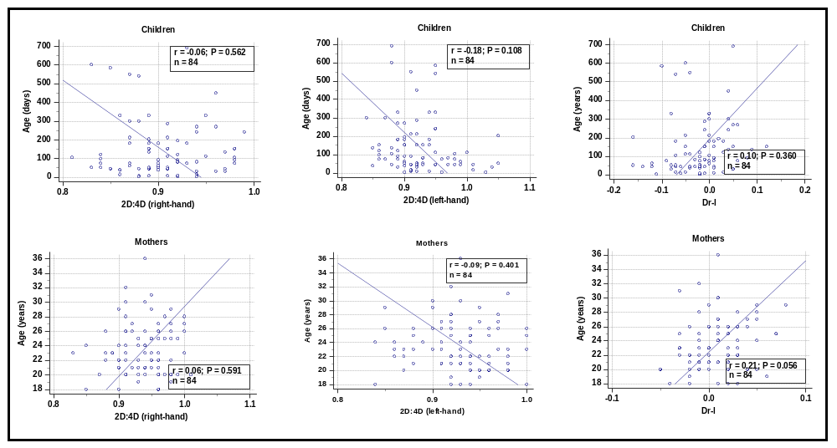
Supplementary Figure 1. Spearman rank correlation plots between 2D:4D digit ratio and age: Top row (right-hand, left-hand, and
Dr-l of children); Bottom row (right-hand, left-hand, and Dr-l of mothers). No significant correlations between age and digit ratios
were observed.

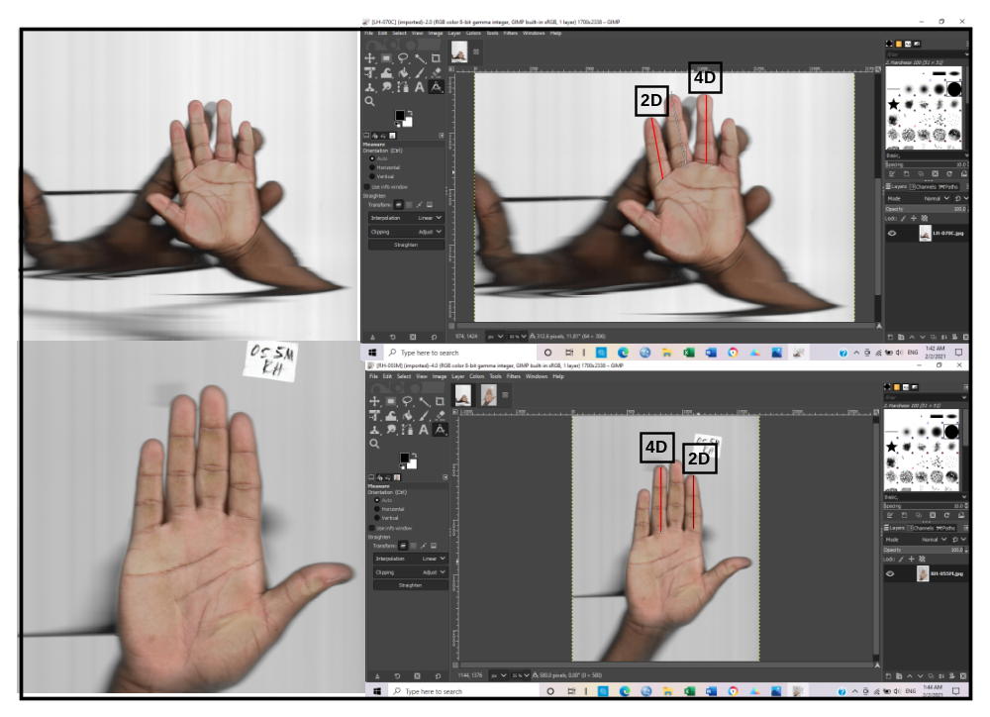

Supplementary Figure 2. The ventral surface of the hand was placed on the flatbed of the scanner as
appropriate before been scanned (left). The scanned images were then exported to the GIMP program
for digit length measurement (right). The pointer was placed on the proximal crease of each finger and
then extended to the tip of the finger.

