Supporting Information

Sunlight active cellulose/g-C₃N₄/TiO₂ nano-photocatalyst for degradation of industrial dye and pharmaceutical drug in real wastewater
Anushka Gargª, Anjali Chauhan^{b}, Charu Agnihotri^{c}, Bhim Pratap Singh^{c}, Vasundhara Mondem^{b}, Soumen Basuª and Shekhar Agnihotri^{c,d}*
ªSchool of Chemistry and Biochemistry, Thapar Institute of Engineering and Technology, Bhadson Road, Patiala 147004, Punjab, India
^{b}Department of Biotechnology, Thapar Institute of Engineering and Technology, BhadsonRoad, Patiala 147004, Punjab, India
^{c}Department of Agriculture and Environmental Sciences, National Institute of Food Technology Entrepreneurship and Management, Kundli, Sonepat 131028, Haryana, India
^{d}Centre for Advanced Translational Research in Food Nano-Biotechnology (CATR-FNB), National Institute of Food Technology Entrepreneurship and Management, Kundli, Sonepat-131028, Haryana, India

*Corresponding author: agnish@niftem.ac.in

S1 Materials Required
Titanium butoxide (>97% purity), cellulose, absolute ethanol (99.9% pure) and NaOH pellets were procured from Sigma-Aldrich, India while urea (ultrapure, >99.9% purity) were purchased from Loba-Chemie Pvt. Ltd, India. Methylene blue dye (>99% purity) was received from SD Fine Chemicals, Mumbai. Atenolol drug (generic salt) was received as a gift from a local manufacturer of active pharmaceutical ingredients. Antibacterial studies were carried out against Escherichia coli MTCC 739 strain, obtained from the microbial type culture collection (MTCC) at CSIR-IMTECH, Chandigarh, India. The real industrial wastewater (as, secondary effluent) was obtained from a textile industry in Ludhiana (Punjab, India). All reagents were of analytical grade and used without any further purification. All working solutions were prepared in deionized water.

S2 Material characterization
The surface morphology of samples was determined through scanning electron microscopy (SEM, JSM-7600F) while the elemental composition was evaluated energy dispersive X-ray (EDX) spectroscopy. Diffuse reﬂectance spectroscopy (DRS) was carried out using an integrating sphere spectrophotometer setup (Shimadzu UV-2600, Japan) at 8˚ incidence in a range 350 –750 nm, integrated over a period of 5s. To characterize the phase and crystallinity of the samples, X-Ray Diffraction (XRD, PANalyticaX'Pert Pro) equipped with graphite monochromatized Cu Kα radiation was operated in a 2θ range from 10^{ᵒ} to 80^{ᵒ}. BET analyzer (Microtrac Belsorp Mini-II, Japan) was employed to determine the surface area of compounds through Barrett–Joyner–Halenda (BJH) method via pore size distribution from N₂ adsorption-desorption isotherms. The dynamic light scattering (DLS) and zeta potential for bionanocomposite was analyzed using Brookhaven 90 Plus particle size analyzer. FTIR (Bruker Inc., Germany) spectroscopy was done to examine the functional moieties present in synthesized bionanocomposite. The photocatalytic performance of synthesized nanocomposite and bionanocomposite was monitored using a UV-Vis spectrophotometer (Shimadzu 2600) for degradation of methylene blue (664 nm) and atenolol (224 nm) at their absorption maxima.

S3 Bang Gap Energy Estimation using DRS data
The band gap energies of the samples were estimated by Kubelka−Munk transformation, αhv = A(hv − Eg), where α represents the absorption coefficient, h is Planck's constant, v is the light frequency, Eg is the band gap energy, and A is a constant. Usually, the determination of Eg involves plotting αhv against hν.
The CB and VB potentials of TiO₂ and g-C₃N₄ can be further estimated according to the following equations:
E_{VB} =X ‒ E^{c} + 0.5Eg
E_{CB} = E_{VB} ‒ Eg
Where E_{VB} represents the VB edge potential, E_{CB} is the CB edge potential, X stands for the electronegativity of the semiconductor (5.81 eV for TiO₂ and 4.64 eV for g-C₃N₄). E^{c} represents the energy of free electrons on the hydrogen scale (about 4.5 eV) while, Eg is the band gap energy of the semiconductor.

S4 Decolouration rate and Kinetic models
The average decolouration rate (g/h) under optimized conditions was also calculated as follows
Average decolouration rate =$\frac{C × \%D × 1000}{100 × t}$
Where, C= initial dye concentration (mg/L), D= rate of dye decoloration (%) after time t (h).
The kinetics of degradation of dyes was studied using the following four kinetics equation.
In general, Langmuir-Hinshelwood kinetic model is used to explain the dependency of photocatalytic reaction rates on the concentration of organic pollutants
$$r=\frac{dC}{dt}= \frac{k_{r}KC}{1+KC}$$
The above reaction can be written simplified to a pseudo first order equation
$$ln\left(\frac{C_{o}}{C}\right)=k_{app}t$$
where r is the oxidation rate of the reactant (mg/L h⁻¹), C the concentration of the reactant at time t (mg/L), C₀ the initial concentration of the reactant (mg/L), t the illumination time, k the reaction rate constant (h⁻¹), and K is the adsorption coefficient of the reactant onto the catalyst particles (L/mg). the rate constant were determined using linear fitted plots of $ln\frac{C_{o}}{C}$ versus t, the time interval of reaction grounded on the dye degradation curves by the approximation of the slope of a line. The R² for first, second and pseudo

First order kinetics: $\ln{(}\frac{C_{O}}{C})=k_{app} ×t$
Psuedo-first order kinetics: $\frac{1}{C_{t }}= \frac{1}{C_{O}}+ K_{app }×t$
Second order kinetic : $\frac{1}{C}-\frac{1}{C_{o}}=K_{app}t$
Psuedo second order $\frac{t}{C}$ = $\frac{t}{Co}$ - $\frac{1}{K_{app}C^{2}}$
Where, C₀ ₌ initial concentration of dye, C= dye concentration at time t, k_{app}= apparent rate constant.

Table S1: BET measurement of Surface area, mean pore diameter & pore volume of composites
Parameters | g-C₃N₄/TiO₂ | cellulose-TiO₂ | gC₃N₄/TiO₂/cellulose
Mean pore diameter (nm) | 9.80 | 8.34 | 10.77
Specific Surface area(m²/g) | 125.76 | 6.49 | 2.997
Total pore volume (cm³/g) | 0.308 | 0.013 | 0.008

Table S2: Kinetic parameters for degradation of MB under sunlight illumination
Models | Equation | Rate constant, k | R² values
First-order | ln [Co-C] = - k_{app}t | 18.52 x 10⁻³ min⁻¹ | 0.894
Pseudo First-order | ln [C-Co] = k_{app}t | 8.78 x 10⁻³ min⁻¹ | 0.996
Second-order | $\frac{1}{C}$ - $\frac{1}{Co}$ = k_{app}t | 2.74 x 10⁻³ mg⁻¹∙L min⁻¹ | 0.588
Pseudo Second-order | $\frac{t}{C}$ = $\frac{t}{Co}$ - $\frac{1}{k_{app}C^{2}}$ | 3.58 x 10⁻¹ mg⁻¹ L min⁻¹ | 0.574

Table S3: A comparative study of degradation efﬁciency and rates of degradation of contaminants

Type of nano-photocatalyst | Contaminants | Degradation efficiency (%) | Light source | Ref.†
g-C₃N₄/TiO₂ | Methylene Blue | 81% | Xenon  lamp (300 W，λ>420 nm) | Duong et al. 2019
g-C₃N₄/TiO₂ | Pharmaceutical contaminants | 95% | oxygen plasma-treated | Liu et al. 2020
Fe/Si/TiO₂ | Metronidazole | 93% | 220 W Xe lamp  (λ = 400 nm) | Du et al. 2018
g-C₃N₄/TiO₂/Cellulose | Methylene Blue | 95% | Sunlight | Present Work
g-C₃N₄/TiO₂/Cellulose | Atenolol | 90.2% | Sunlight | Present Work

†
- Duong, D.P.T., Van, T.D., Dai, P.B., Tran, T.N.N., Nguyen, T.N.U., Minh, T.C., Nguyen, T.K., Kim, Y.S. and Van, V.P., 2019. Excellent visible light-driven photocatalytic performance and band alignment of g-C₃N₄/TiO₂ nanotube heterostructures. Materials Research Express, 6(8), p.085061.
- Liu, R., Sun, L., Qiao, Y., Bie, Y., Wang, P., Zhang, X. and Zhang, Q., 2020. Efficient Photocatalytic degradation of pharmaceutical pollutants using plasma‐treated g‐C₃N₄/TiO₂. Energy Technology, 8(7), p.2000095.
- Du, W., Xu, Q., Jin, D., Wang, X., Shu, Y., Kong, L. and Hu, X., 2018. Visible-light-induced photo-Fenton process for the facile degradation of metronidazole by Fe/Si co-doped TiO₂. RSC advances, 8(70), pp.40022-40034.

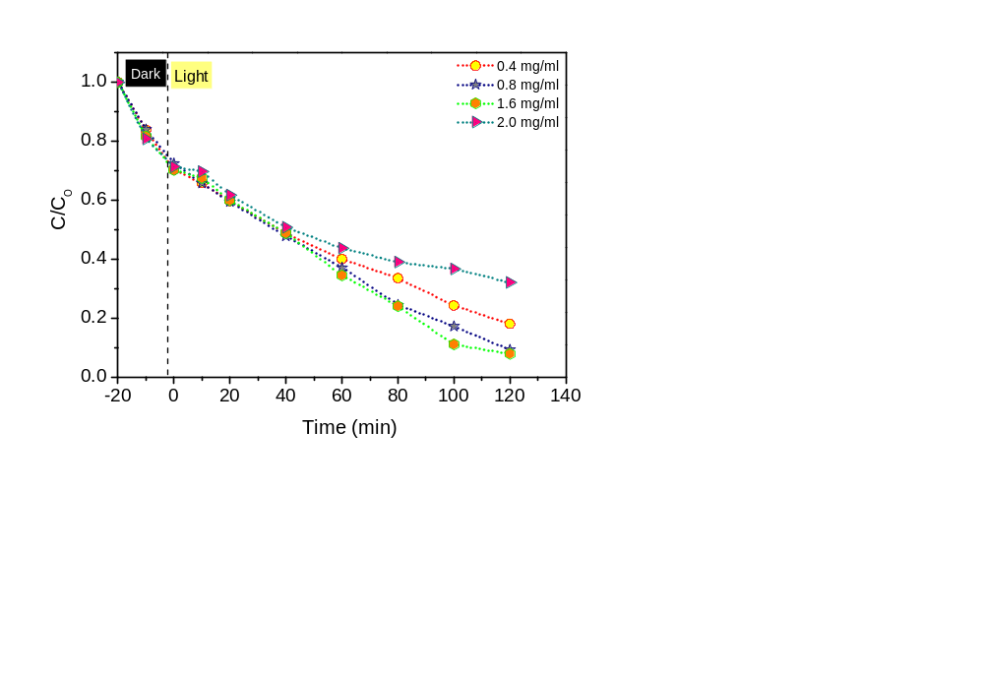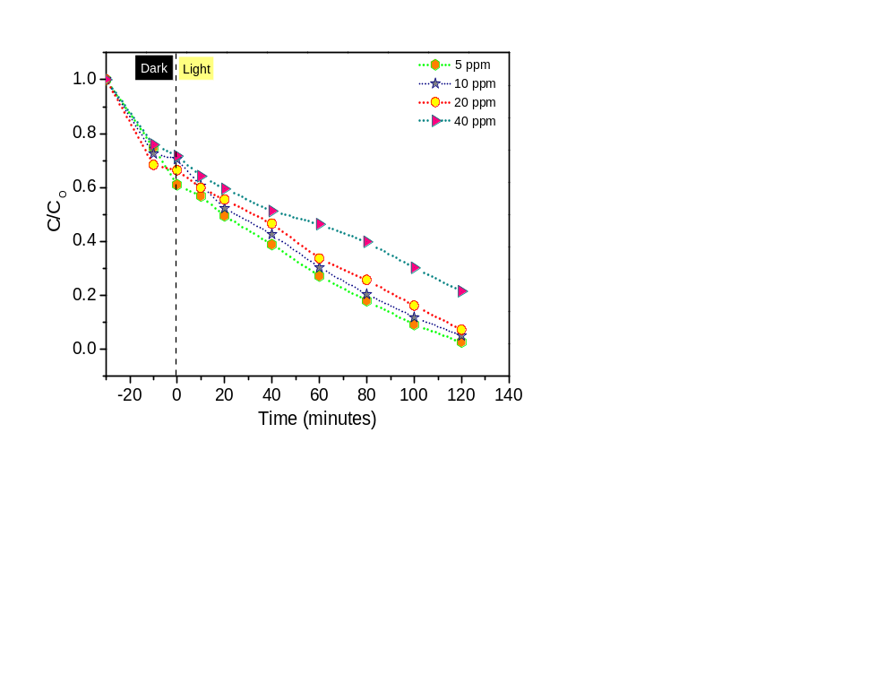
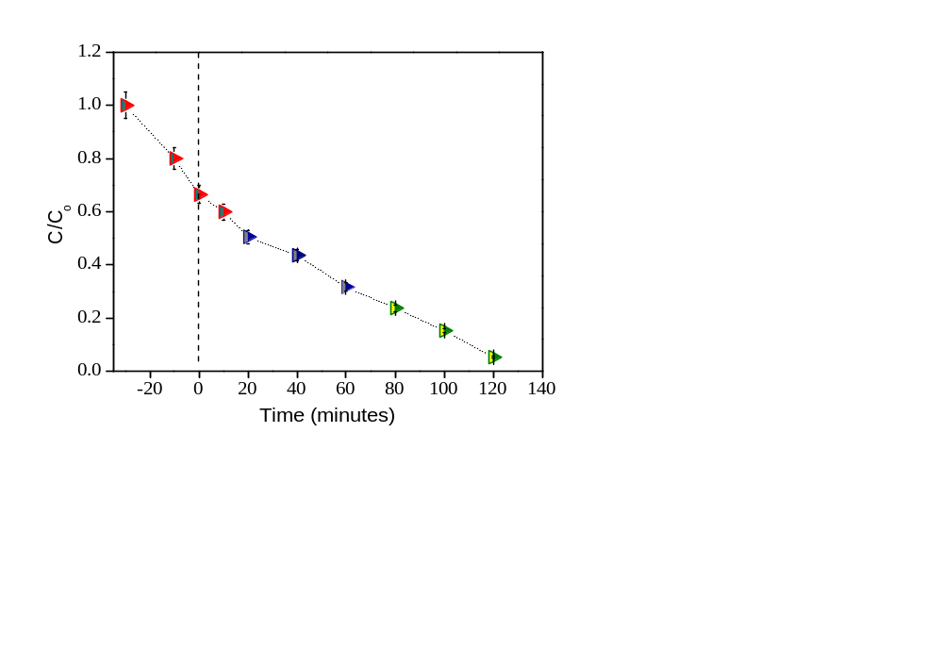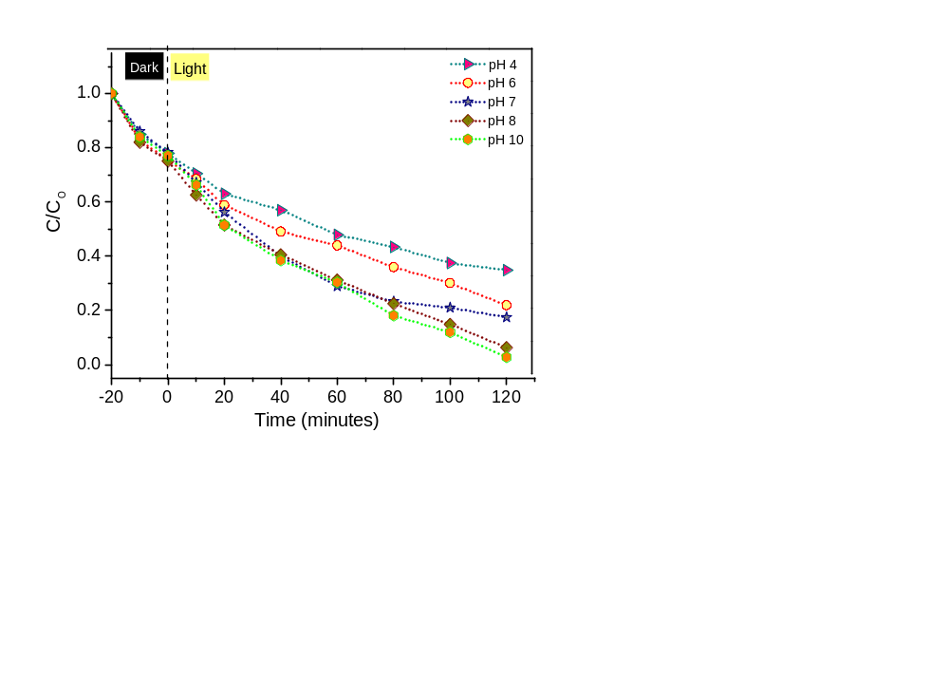
Figure S1: Corresponding degradation kinetics for single parameter studies during optimization (a) Catalyst dose (b) initial dye conc. (c) time and (d) pH
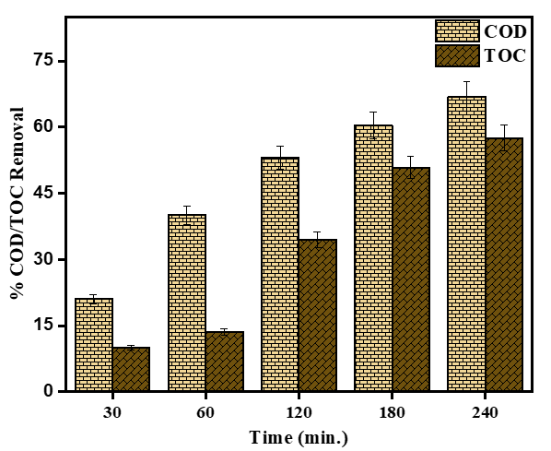
Figure S2: COD and TOC removal in textile wastewater

