SUPPLEMENTARY MATERIALS

Autophosphorylation of αCaMKII regulates alcohol consumption by controlling sedative effects of alcohol and alcohol-induced loss of excitatory synapses

Anna Cały PhD¹, Magdalena Ziółkowska MSc¹, Roberto Pagano PhD¹, Ahmad Salamian PhD¹, Małgorzata A. Śliwińska PhD², Narges Sotoudeh PhD¹, Tytus Bernaś PhD³, Kasia Radwanska PhD^{1*}

¹ Laboratory of Molecular Basis of Behavior, Nencki Institute of Experimental Biology of Polish Academy of Sciences, 3 Pasteur St., Warsaw 02-093, Poland;
² Laboratory of Imaging Tissue Structure and Function, Nencki Institute of Experimental Biology of Polish Academy of Sciences, 3 Pasteur St., Warsaw 02-093, Poland.
³ Department of Anatomy and Neurobiology, Virginia Commonwealth University, Richmond, Virginia 23298, USA.
*Corresponding author: Kasia Radwanska, PhD, Laboratory of Molecular Basis of Behavior, Nencki Institute of Experimental Biology of Polish Academy of Sciences, 3 Pasteur St., Warsaw 02-093, Poland; e-mail: k.radwanska@nencki.edu.pl; tel: +48501736942;

Keywords: alcohol sensitization, alcohol use disorder, IntelliCage, CaMKII autophosphorylation, alcohol sedation, dendritic spines, central amygdala.

MATERIALS AND METHODS
Animals
Heterozygous αCaMKII autophosphorylation-deficient mice (T286A^{+/-}) and their wild-type littermates (WT) were bred as heterozygotes with the C57BL/6J background in the Animal House of the Nencki Institute of Experimental Biology and genotyped as previously described [9]. C57BL/6J mice, used in chemogenetic experiment, were purchased from the Medical University of Bialystok, Poland. Mice were 2-6 months old at the beginning of the experiments. Only female mice were used in the experiments in the IntelliCages, as males are too aggressive for group housing [54–56]. In other experiments mice of both sexes were used (sexes were equally distributed between the experimental groups). Mice were group-housed (3-5 animals) with ad libitum access to food and water in standard mouse home cages and 12/12 hour dark-light cycle, 21-23°C and 50-60% humidity. The studies were carried out in accordance with the European Communities Council Directive of 24 November 1986 (86/609/EEC), Animal Protection Act of Poland and approved by the 1st Local Ethics Committee in Warsaw (approval no. 120/2016). All efforts were made to reduce the number of animals used and to minimize their suffering.

IntelliCage
The IntelliCage system (NewBehavior AG, Zürich, Switzerland) (http://www.newbehavior.com/) consists of a large standard rat cage (20.5 cm high, 40 cm × 58 cm at the top, 55 cm × 37.5 cm at the base). In each corner of a cage, a triangular learning chamber is located with two bottles. Only one mouse can enter a corner through a plastic ring (outer ring: 50 mm diameter; inner ring: 30 mm diameter; 20 mm depth into the outer ring) that ends with two holes (13-mm in diameter) that provide access to two bottle nipples. Each visit to the corner, nosepoke at the doors governing access to the bottles, and lick were recorded by the system and ascribed to a particular animal. During experiments, two corners were active. Groups of 10 to 15 mice were trained per IntelliCage.
Under brief isoflurane anesthesia, mice were subcutaneously injected with unique microtransponders (10.9 mm length, 1.6 mm diameter; Datamars, Slim Microchip T-SL), which allow for mice identification in the IntelliCage. Next, animals were given 7 days to recover prior to introduction to the IntelliCage.

Animal model of alcohol AUD in the IntelliCages
The training in the IntelliCage was composed of the following phases as previously described [2,13,42]: cage adaptation, initiation of alcohol consumption in increasing concentrations, free access to alcohol (FA1), withdrawal, cue relapse, alcohol relapse, second free access to alcohol (FA2) and second withdrawal (W2). Each phase started at the beginning of the dark phase. The timeline of the experiment is shown in the figures.
Adaptation phase (days 1-7). Mice underwent a cage adaptation to habituate to the cage conditions. During this phase all doors were open and mice had unlimited access to all bottles with water in both active corners (day 1-3). When all mice visited and licked from both corners, the doors were closed and mice got access to the bottles after a nosepoke (nosepoke adaptation, day 4-7). Each nosepoke in the corner was rewarded by 5-second access to water (fixed ratio 1, FR1). The adaptation was terminated when all animals learned how to reach the bottles inside the corners.
Initiation of alcohol consumption (days 8-28) and free alcohol access (days 29-47). During this phase two corners were active, each with two bottles available. In one corner, the animals had access to water (“water corner”), and in the other animals had free access to ethanol solution (“alcohol corner”) in increasing concentrations [4, 8 or 12% ethanol changed every 7 days, prepared from 96% ethanol and tap water (volume/volume)]. Corner with alcohol was signaled by a green light (serving as an alcohol-predicting cue) that was turned on each time a mouse entered the corner. All liquids were available at FR1. Next, 8% alcohol was available in the alcohol corner based on maximal alcohol consumption in g/kg/day during initiation of alcohol consumption. Daily alcohol consumption (g/kg/day) was calculated with the following formula: (number of licks of alcohol per day x lick volume (1.94 µl) x % alcohol x 1 g/ml) / animal weight). To calculate the average lick volume, water consumption (in μl) was measured for 3 consecutive days. The average volume of one lick was measured as the total volume consumed / number of licks. According to these calculations, an average lick volume was established as 1.94 ± 0.2 μl.
Alcohol withdrawal (days 48-53) followed by cue and alcohol relapse (days 54 and 55). The withdrawal period lasted 6 days and during this time the alcohol corner was inactive. The green light was turned off, doors to alcohol were closed and nosepokes to this corner were without scheduled consequences. Average daily number of nosepokes performed in the “alcohol corner” during withdrawal was used as an index of alcohol seeking during withdrawal. Withdrawal was followed by a 24-hour cue-induced relapse. A green cue light (reward-predicting cue) in the alcohol corner was presented each time a mouse entered this corner but doors were closed and alcohol was not available. Average number of nosepokes performed in the “alcohol corner” during the first 5 hours of cue relapse was used as an index of alcohol seeking during cue relapse. This test was followed by alcohol relapse when bottles with alcohol were present in the active corner predicted by green light. During the test alcohol was available in the alcohol corner under FR1. Alcohol consumption during the test was used as an index of relapse.

Reward learning in the IntelliCages
Experiments consisted of the following two phases: adaptation (1-8 d) and training (2 d). During adaptation, animals had access to water in both cage corners. Four days before training, mice had 24-h access to 5% sucrose solution (Sigma-Aldrich, in tap water) from the top of the IntelliCage to become familiarized with the taste. Baseline preference to the cage corners was measured during the last day of the adaptation as the percentage of visits or licks. During sucrose training, water was replaced by 5% sucrose in the less visited corner. The change of corner preference during training was compared with the number of visits or licks from the same corner during the last day of adaptation. Training started at the beginning of the dark phase.

Behavioral tests
In all individual behavioral tests mice activity was observed in 48×37×21 cm opaque plastic containers. To record and analyze spontaneous activity of mice we used the PhenoRack system (ViewPoint Life Sciences, Inc.) which automatically measures total distance traveled by animals. There were four animals recorded at the same time in separate cages. Each of the four cages was placed between CCD video cameras allowing for the recording of mice activity. The apparatus was cleaned with a 70% ethanol/water (vol/vol) solution between each trial.
Basal activity. Mice were transferred to the testing room 30 minutes before the experiment. The animals were individually recorded for 30 minutes to characterize their general activity in a new environment. Grooming behavior (licking, scratching, and face-washing) and number of jumps were analyzed from the recorded videos by an experimenter blind to mice genotype.
Novel object recognition test. The test was performed as previously described [33]. For the training session mice were placed for 10 minutes in a new standard mouse cage with two objects. One hour later, the animals were placed back for 10 minutes in the same cage with one old and one novel object. A mouse was considered to be investigating an object when its head was oriented within 45° of the object and within less than 4 cm from it. Rearing with the head oriented upward was also included if at least one forepaw was in contact with the object. Between the sessions, objects were cleaned with 70% ethanol solution (vol/vol) to minimize any olfactory cues.
Marble burying test. The test was performed as previously described [57]. Mice were transferred to the testing room 40 minutes before the experiment. Each mouse was placed in the cage filled with wood chip bedding (5 cm deep) and 12 glass marbles placed in the regular pattern in two rows on the surface. Mice were recorded for 30 minutes after which the experimenter counted the number of buried marbles (to 2/3 their depth) with bedding. Between the tested animals, marbles were cleaned with water and 70% ethanol solution (vol/vol) and dried with towel paper. Recorded videos were analyzed to define the latency to start digging and the total duration of digging. Digging is defined as coordinated movements of fore or hind limbs that displace the object.
Behavioral sensitization to ethanol. Mice were first injected with saline for two consecutive days (H1-2). Mice received an injection of saline (200 µl, i.p.) and were immediately placed in the open arena for 20 minutes to assess their basal locomotor activity. Next, mice received once a day i.p. injections of 2 g/kg ethanol (diluted to 20% (vol/vol) in saline solution (0.9%)) for 7 consecutive days (S1-S7). Control mice received injections of saline. Immediately after injection, a mouse was placed in the arena for 20 minutes and the locomotor behavior was measured. Seven days of the incubation period mice spent undisturbed in their home cages. The efficiency of sensitization was tested during the Test when mice were administered alcohol or saline (the division into groups was maintained from the sensitization period (S1-S7)). Total distance traveled by animals was automatically measured by the PhenoRack system. The dose of alcohol for the induction and expression of sensitization was based on our pilot study demonstrating that the 2.5 g/kg dose induced sedation in C57BL/6J mice. The experimental sessions for behavioral sensitization were conducted during the light phase.

DREADD experiment
Stereotactic intracranial injections. Mice were anesthetized with isoflurane (5% for induction, 1.5-2.0% for preservation), fixed in the stereotactic frame (51503, Stoelting, Wood Dale, IL, USA), and their body temperatures were maintained using a heating pad. Stereotactic injections were performed bilaterally into the central amygdala using coordinates from the Bregma: AP, -1.2 mm; ML, ±2.8 mm; DV, -4.6 mm according to (Paxinos and Franklin, 2004). 0.25 µl of virus solution was microinjected through a beveled 26 gauge metal needle, attached to a 10 µl microsyringe (SGE010RNS, WPI, USA) connected to a microsyringe pump (UMP3, WPI, Sarasota, USA) and its controller (Micro4, WPI, Sarasota, USA), at a rate 0.1 µl/min. The microsyringe was left in place for an additional 10 minutes following injection to prevent leakage of the solution. Mice were injected with adeno-associated viral vectors, serotype 1 and 2 (AAV1/2), coding inhibitory Designer Receptors Exclusively Activated by Designer Drugs (DREADD): hSyn-hM4D(Gi)-mCherry (hM4Di; viral titer 4.4 x 10⁹ gc/ µl; Addgene plasmid #50475) or control αCaMKII-mCherry (mCherry; viral titer 1.35 x 10⁹ gc/ µl (obtained from Karl Deisseroth’s Lab)). The viruses were prepared by the Laboratory of Animal Models at Nencki Institute of Experimental Biology, Polish Academy of Sciences (Warsaw, PL). After the surgery, animals were given 14 days to recover before training in the IntelliCages.
Training in the IntelliCage. During the initial period of the training, after cage and nosepoke adaptation (days 1-7), animals had free access to alcohol at increasing concentrations (4, 8 or 12% ethanol changed every 7 days (days 8-28)) followed by two weeks of free access to 8% alcohol (days 29-42, FA1). Next, the training was composed of the following phases: motivation (days 43-49), free access to alcohol (days 50-56, FA2); withdrawal 1 (days 57-62), cue relapse (day 63); alcohol relapse (day 64); free access to alcohol (days 65-58, FA3); persistence (days 69-72).
CNO administration. During the initiation phase (at days 20 and 31) all animals received two i.p. saline injections to habituate to procedure and experimenter. Clozapine N-Oxide (CNO) was dissolved in 0.9% saline. Mice were i.p. injected with CNO (0.5 mg/kg) or saline as a control. Injections were done at the beginning of the dark phase, every day during motivation test, withdrawal, cue relapse, alcohol relapse, FA3 and persistence test. These doses of CNO did not induce any overt abnormal behaviors except for those reported in the study.
Motivation for alcohol tests. During the test, two corners were active and available to animals. The animals had to perform an increasing number of nosepokes (2, 4, 8, 12, 16, 20, 24, 28, 32, and 36) spaced by less than 1 s during one visit to open the door and be allowed for a 5 s access to the reward bottles. The number of required instrumental responses (nosepokes) increased when an animal performed 10 sets of responses of a given ratio. The tests were terminated when 90% of animals did not change the FR level during the last 24 hours. The FR level reached during the test was used as an index of motivation.
Persistence in reward seeking test. The persistence test lasted 3 days, starting at the beginning of the dark phase and was composed of two phases, changed every 6 hours. During active phase (A) mice had access to alcohol under FR1. The “non-active” periods (NA) were signaled by elimination of the cue light. The doors to the alcohol corner were closed and mice had no access to alcohol. The difference of nosepokes performed to the alcohol corner during NA and A periods (ΔNA-A NPs), were used as an index of persistence.

Electrophysiology
Whole-cell patch-clamp technique was used to analyze AMPA/NMDA EPSCs ratio. Brains from decapitated mice were quickly submerged in the ice-cold cutting solution (135 mM NMDG, 1 mM KCl, 1.2 mM KH₂PO₄, 1.5 mM MgCl₂, 0.5 mM CaCl₂, 20 mM choline bicarbonate, 10 mM D-glucose, bubbled with carbogen – 5% CO2, 95% O2). Coronal 250 µm-thick slices were prepared using Leica VTS1000 vibratome. Slices containing the amygdala were collected into a chamber filled with artificial cerebrospinal fluid (ACSF,119 mM NaCl, 2.5 mM KCl, 1 mM NaH₂PO₄, 26 mM NaHCO₃, 1.3 mM MgCl₂, 2.5 mM CaCl₂, 10 mM D-glucose, bubbled with carbogen) and incubated for at least 60 min at room temperature. Slices were then transferred to the recording chamber, perfused with ACSF solution maintained at 31°C. The stimulating electrode was placed in the axons from the basal amygdala. CeM neurons were identified visually and patched with borosilicate glass capillaries (3–6 MΩ resistance) filled with internal solution (130 mM Cs gluconate, 20 mM HEPES, 3 mM TEA-Cl, 0.4 mM EGTA, 4 mM Na₂ATP, 0.3 mM NaGTP, and 4 mM QX-314Cl, pH = 7.0-7.1, osmolarity: 290-295 mOsm). Series and input resistances were monitored throughout the experiment. Electrical stimulation was elicited by TTL pulse every 5 s. Recorded currents were filtered at 2 kHz (MultiClamp 700B) and digitized at 10 kHz (AxonTM Digidata 1550B). All recordings were performed in the presence of 50 μM picrotoxin (Abcam) in ACSF, to pharmacologically block inhibitory neurotransmission and focus on the excitatory pathway specifically. After reaching the whole-cell configuration, baseline currents were recorded for 2-3 minutes to ensure the stability of recorded amplitudes. AMPA receptor-mediated excitatory postsynaptic currents (EPSCs) were recorded at -60 mV and their amplitudes measured at the peak of each current. NMDAR-mediated EPSCs were recorded at +40 mV and their amplitudes measured at 50 ms after the peak, to ensure the absence of the AMPAR-mediated component. For both AMPARs and NMDARs EPSCs, 50-100 stable sweeps were recorded and averaged.

Serial Block-Face Scanning Electron Microscopy (SBEM)
Mice perfusion and brain slice preparation. Mice were transcardially perfused with cold 0.1 M phosphate buffer pH 7.4 followed by 0.5% EM-grade glutaraldehyde (GA) with 2% paraformaldehyde (PFA) in 0.1 M phosphate buffer pH 7.4 and postfixed overnight in the same solution with 1% GA. Next day, brains were cut into coronal sections of 100 μm on a vibratome (Leica VT1000 S). Sections containing the central nucleus of amygdala were selected for staining, collected, and washed 3 x in cold 0.1 M phosphate buffer pH 7.4.
Sample contrasting for SBEM was performed according to the previously published protocol [58]. First, the slices were postfixed with a solution of 2% osmium tetroxide (#75632 Sigma-Aldrich) and 1.5% potassium ferrocyanide (P3289 Sigma-Aldrich) in 0.1 M of phosphate buffer pH 7.4 for 1 h on ice. Next, the samples were rinsed 5 × 3 min with double distilled water (ddH₂O) and subsequently exposed to 1% aqueous thiocarbohydrazide (TCH) (#88535 Sigma) solution for 20 min, washed 5 × 3 min with ddH₂O, and incubated with aqueous solution of 2% osmium tetroxide for 30 min at room temperature (RT). Afterward, slices were washed 5 × 3 min with ddH₂O and incubated overnight in 1% aqueous solution of uranyl acetate at 4°C. Next day, the slices were rinsed with ddH₂O, incubated with freshly prepared lead aspartate solution (prepared by dissolving lead nitrate in L-aspartic acid as previously described [58]) for 30 min at 60°C, then washed with degassed ddH₂O, and dehydrated using graded dilutions of ice-cold ethanol (20%, 50%, 70%, 90% and 2 × 100%). Brain slices were infiltrated with Durcupan resin (#44610 Sigma-Aldrich) prepared according to the manufacturer's protocol. Part of the resin was then mixed 1:1 (vol/vol) with 100% ethanol and slices were incubated in this 50% resin on a clock-like stirrer for 30 min in RT. The resin was then replaced with 100% Durcupan for 1 hour in RT and then 100% Durcupan infiltration was performed o/n with constant slow mixing. Next day, the samples were infiltrated with freshly prepared resin for another 2 h at RT, then flat embedded between Aclar sheets (Ted Pella #10501-10), and cured in a laboratory oven for at least 72 h at 70°C for the resin to polymerize.
After the resin hardened, the Aclar layers were separated from the resin embedded samples, CeA region was cut out with a razorblade. Caution was taken for the piece to contain minimal resin. Squares of approximately 1 × 1 × 1 mm were attached to aluminum pins (Gatan metal rivets, Oxford instruments) with very little amount of cyanacrylamide glue. After the glue dried, samples were mounted to the ultramicrotome (Leica ultracut R) for trimming and block face polishing. Next, samples were grounded with a silver paint (Ted Pella, 16062-15) and pinned for drying for 4 – 12 hours, before the specimens were mounted into the 3View2 chamber.
SBEM imaging, scan processing and image analysis. Samples were imaged with Zeiss (SigmaVP) scanning electron microscope equipped with 3View2 GATAN chamber using a backscatter electron detector. Images were taken in the middle of the CeC. From each sample, at least 200 sections were collected (thickness 60 nm). Imaging settings: magnification 15000×, high vacuum, electron high tension (EHT) 2.9 kV, aperture 20 μm, pixel dwell time 2 μs, pixel size 6.2 nm. Stacks of images were aligned using the ImageJ software and as .tiff image sequence imported to the Reconstruct software available at http://synapses.clm.utexas.edu/tools/reconstruct/reconstruct.stm (Synapse Web Reconstruct, RRID:SCR_002716) [59]. Spine density was analyzed from 3 bricks per animal with the unbiased brick method [40] per tissue volume of 64 μm³ (4 × 4 × 4 μm) per animal. The inclusion/exclusion criteria required that the object (PSD) touched the inclusion/exclusion plane. To calculate the density of dendritic spines, the total volume of large tissue discontinuities was subtracted from the volume of the brick.
A structure was considered to be a dendritic spine when it was a protrusion from the dendrite, with electron dense material on a part of the membrane (PSD) that opposed and axonal bouton with at least three vesicles within a 50-nm distance from the cellular membrane facing the spine. For 3D reconstructions, PSDs and dendritic spines in one brick (64 μm³) were reconstructed for each sample. PSDs were reconstructed and then their dendritic spines were traced. To separate dendritic spine necks from the dendrites, a cut-off plane was used approximating where the dendritic surface would be without a dendritic spine and terminating the spine on that surface. Reconstruct software was used to extract the volumes of spines and PSDs, and generate 3D models. Custom-made Matlab 2016b script was used to calculate surface areas of PSDs from 3D models of PSDs. The PSD area was measured manually according to the Reconstruct manual. All non-synaptic protrusions were omitted in this analysis. For multisynaptic spines, the PSD areas and volumes have been summed. Data were analyzed by trained annotators blind to experimental conditions.

Statistical analysis
Data acquisition and quantification were performed by an experimenter blind to experimental groups. All statistical analyses were performed using GraphPad Prism 9 Software. The exact sample size (the number of mice, bricks or spines) of each experiment is provided in figures or figure legends. For data with normal distribution and equal variance, Student’s t-test, two-way ANOVA or a mixed-effects model with repeated measures (RM) and post hoc Sidak’s tests for multiple comparison were used. Least significant difference (LSD) post hoc tests were used only for planned comparisons. Dendritic spines volumes and PSD areas did not follow normal distributions and were analyzed with the Mann-Whitney to compare two groups or Kruskal-Wallis test to compare more than two groups. Frequency distributions of spines volume and PSDs area were compared with the Kolmogorov-Smirnov test. Correlations were analyzed using Spearman correlation. All data with normal distribution are presented as the mean ± standard error of the mean (SEM). For samples that did not follow a normal distribution, median and interquartile range (IQR) values are shown. The difference between the experimental groups was considered significant at p < 0.05. Experimental schemes were prepared using BioRender.com.
SUPPLEMENTARY RESULTS
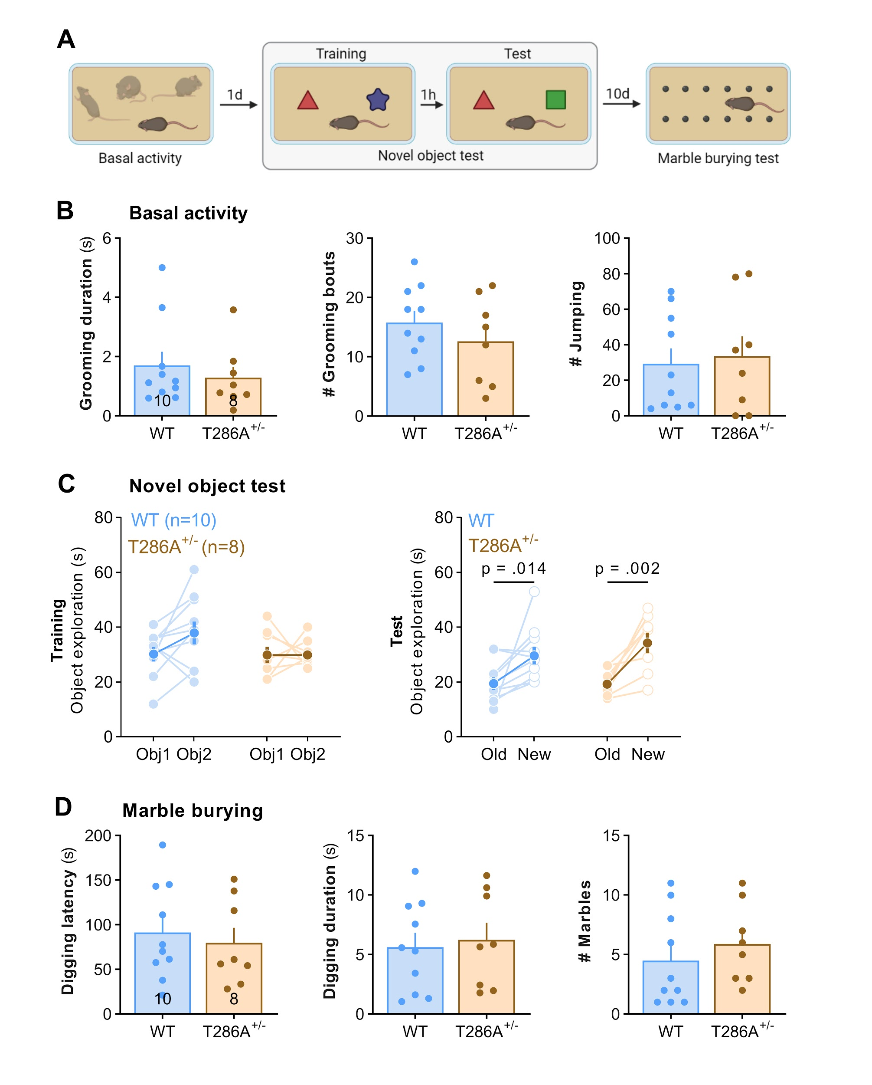
Supplementary Figure 1. T286A^{+/-} mutation does not affect general mouse activity, compulsivity, anxiety and memory.
(A) Experimental timeline. (B) Summary of data showing time spent grooming (t-test, t(16) = 0.677, p = 0.254), number of grooming episodes (t(16) = 0.991, p = 0.336), and number of jumps (t(16) = 0.295, p = 0.771) in novel cage. (C) Novel object recognition training and test (two-way ANOVA, Training: genotype: F(1, 16) = 1.50, p = 0.239; object: F(1, 16) = 1.71, p = 0.209; Test: genotype: F(1, 16) = 0.544, p = 0.471, object: F(1, 16) = 20.9, p < 0.001). Highlighted data points on the graphs present the mean of the groups. (D) Summary of data showing digging latency (t,test, t(16) = 0.482, p = 0.636), digging duration (t(16) = 0.330, p = 0.746) and number of buried marbles (t(16) = 0.790, p = 0.441) during marble burying test.
Mean ± SEM are shown. Fisher’s LSD post hoc tests presented on C. Each dot on the graphs represents one animal.

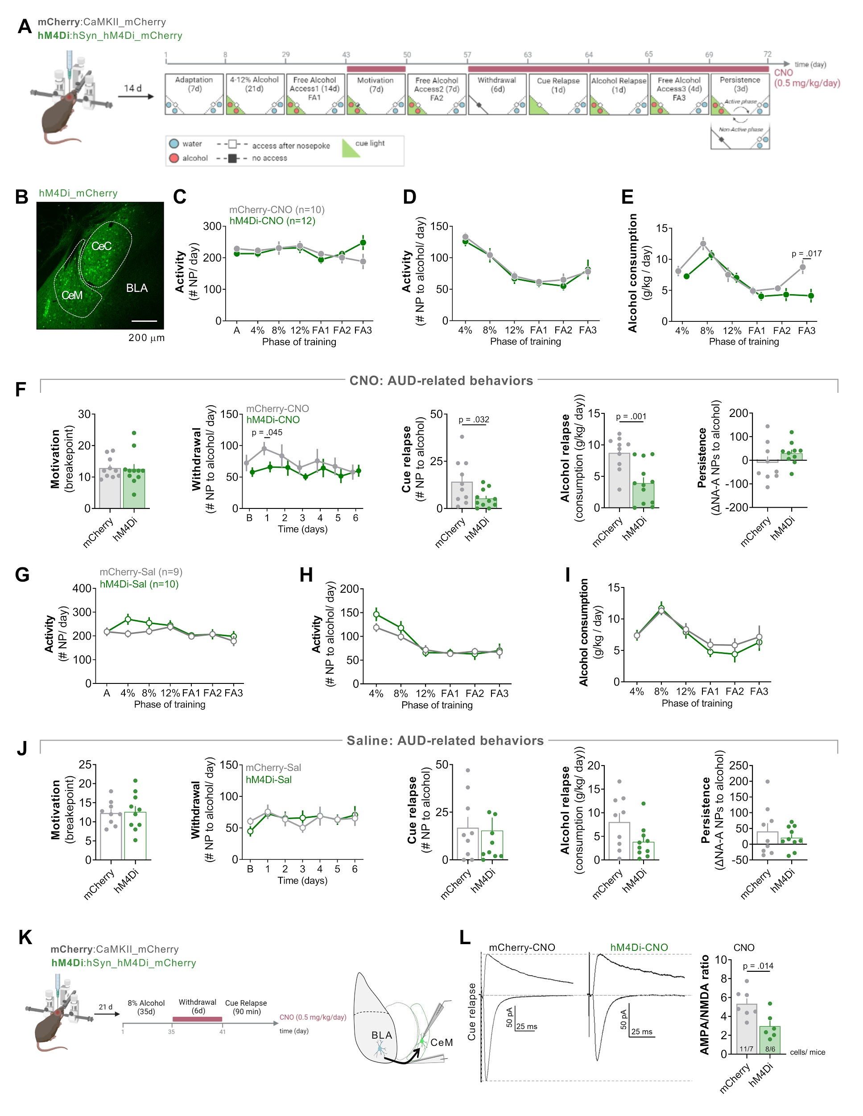Supplementary Figure 2. Chemogenetic inhibition of CeA decreases alcohol consumption and seeking during withdrawal and cue relapse.
(A) Experimental timeline. Mice had bilateral stereotactic injections of viral vectors hM4Di (n=22) or mCherry (n=19) into CeA, and 14 days later they were trained to drink alcohol in the IntelliCages. AUD-related behaviors were assessed, while half of the mice received daily i.p. injections of CNO (0.5 mg/kg) and the other half received equivalent volumes of saline (Sal).
(B) A representative microphotography of mCherry immunostaining in CeA (CeM+CeC) after hM4Di injection.
(C-E) Summary of data showing general activity of hM4Di-CNO and mCherry-CNO mice, including (C) total NPs to both corners (two-way RM ANOVA, genotype: F(1, 20) = 0.0202, p = 0.888) and (D) NPs in the reward corner (RM ANOVA, genotype: F(1, 20) = 0.596, p = 0.449) and (E) alcohol consumption (RM ANOVA, genotype: F(1, 20) = 4.99, p = 0.037) during adaptation and FA periods.
(F) Summary of data showing AUD-related behaviors of hM4Di-CNO and mCherry-CNO mice: motivation (t(19) = 0.171, p = 0.866), withdrawal (two-way RM ANOVA, genotype: F(1, 20) = 1.41, p = 0.248, time: F(4.47, 87.9) = 1.77, p = 0.136, time x genotype: F(6, 118) = 0.498, p = 0.809 ), cue relapse (t-test, t(19) = 2.32, p = 0.32), alcohol relapse (t(20) = 3.75, p = 0.001) and a persistence test (t(17) = 1.33, p = 0.200). Baseline (B) (Withdrawal) represents the last day before withdrawal (day 7 of FA2).
(G-I) Summary of data showing general activity of hM4Di-Sal and mCherry-Sal mice, including (G) total NPs (two-way RM ANOVA, genotype: F(1, 17) = 1.05, p = 0.319) and (H) NPs in the reward corner (RM ANOVA, genotype: F(1, 20) = 0.596, p = 0.449) and (I) alcohol consumption (RM ANOVA, genotype: F(1, 17) = 0.460, p = 0.507) during adaptation and FA periods.
(J) Summary of data showing AUD-related behaviors of hM4Di-Sal and mCherry-Sal mice: motivation (t(17) = 0.151, p = 0.881), withdrawal (two-way RM ANOVA, genotype: F(1, 17) = 0.00225, p = 0.963, time: F(3.95, 67.1) = 1.50, p = 0.213, time x genotype: F(6, 102) = 0.656, p = 0.685), cue relapse (t-test, t(17) = 0.166, p = 0.870), alcohol relapse (t(17) = 2.00, p = 0.062) and a persistence test (t(17) = 0.746, p = 0.466). Baseline (B) (Withdrawal) represents the last day before withdrawal (day 7 of FA2).
(K-L) Chemogenetic inhibition of the BLA→CeM pathway. (K) Experimental timeline. Mice had bilateral stereotactic injections of viral vectors hM4Di (n=7) or mCherry (n=6) into CeA. After recovery, mice were trained for 35 days to drink alcohol in home cages, and they were sacrificed after 6-day withdrawal from alcohol (during which they received daily i.p. injections of CNO (0.5 mg/kg)) followed by 90 minutes of cue relapse. Whole-cell patch-clamp recordings were performed on the CeM cells with the stimulation electrode placed at the axons from BLA. (L) The analysis of AMPA/NMDA EPSCs in the BLA→CeM pathway. (left) Representative EPSCs traces (right) and summary of data showing AMPA/NMDA EPSCs in hM4Di and mCherry mice (t(11) = 2.93, p = 0.014). Mean ± SEM are shown.

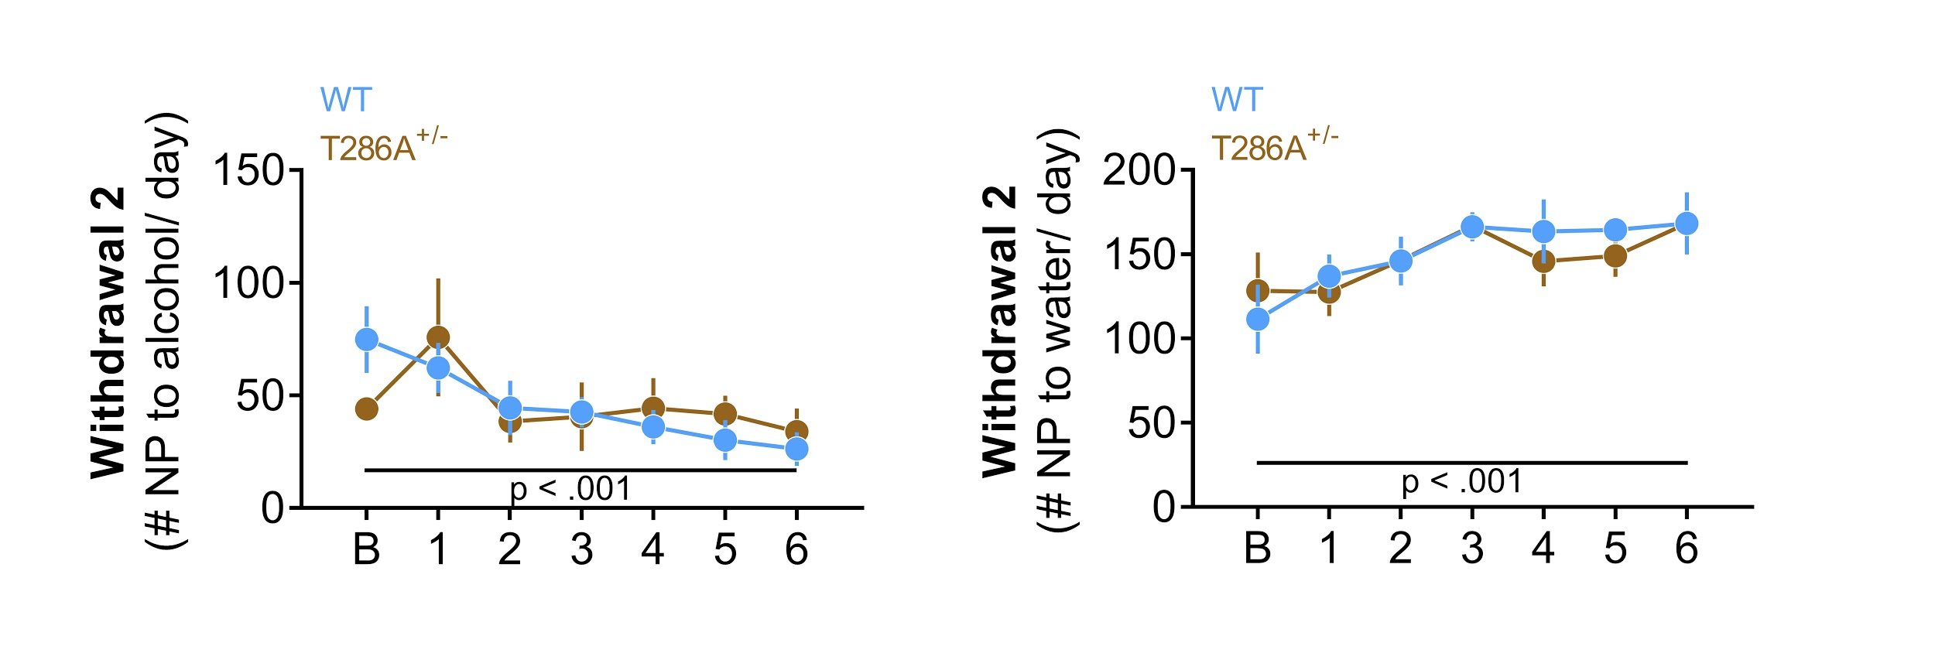
Supplementary Figure 3. T286A^{+/-} mutation does not affect alcohol seeking during withdrawal 2.
Summary of data showing alcohol seeking during withdrawal 2 (two-way RM ANOVA, effect of genotype: F(1, 7) = 0.00118, p = 0.974, effect of time: F(2.66, 18.6) = 3.42, p = 0.043) and activity in the water corner (effect of genotype: F(1, 7) = 0.0783, p = 0.788, effect of time: F(3.15, 22.0) = 3.72, p = 0.025). Mean ± SEM are shown. Baseline (B) on the graphs represents mice activity on the last day before withdrawal (day 9 of FA2).

