Supplementary Table and Figures

Supplementary Table 1 | AET data collection, processing, reconstruction, refinement and statistics
 | Ta film | Pd₁ nanoparticle | Pd₂ nanoparticle
Data Collection and Processing
Voltage (kV) | 300 | 300 | 300
Convergence semi-angle (mrad) | 17.1 | 17.1 | 17.1
Probe size (Å) | 0.7 | 0.7 | 0.7
Detector inner angle (mrad) | 30 | 30 | 30
Detector outer angle (mrad) | 195 | 195 | 195
Depth of focus (nm) | 14 | 14 | 14
Pixel size (Å) | 0.322 | 0.454 | 0.454
Number of projections | 46 | 52 | 54
Tilt range (⁰) | -63.4 | -72.0 | -72.4
Tilt range (⁰) | +55.5 | +66.4 | +69.4
Electron dose (10⁵ e/Å²) | 8.2 | 9.3 | 9.6
Reconstruction
Algorithm | RESIRE | RESIRE | RESIRE
Oversampling ratio | 3 | 4 | 3.5
Number of iterations | 500 | 200 | 200
Refinement
R₁ (%)ª | 15.5 | 8.5 | 6.9
R (%)^{b} | 14.2 | 5.2 | 4.5
B’ factors (Å²) | 22.1 | 45.2 | 58.3
Number of atoms | 8284 | 52308 | 76238
ªThe R₁-factor is defined by Eq. (5) in ref. 36.
^{b}The R-factor is defined by $R=\frac{1}{n}\sum_{θ}{\frac{\sum_{x,y}{\left|Π_{θ}\left(O\right)\left\{x,y\right\}-b_{θ}\left\{x,y\right\}\right|}}{\sum_{x,y}{\left|b_{θ}\left\{x,y\right\}\right|}}}$, where n is the number of projection images.

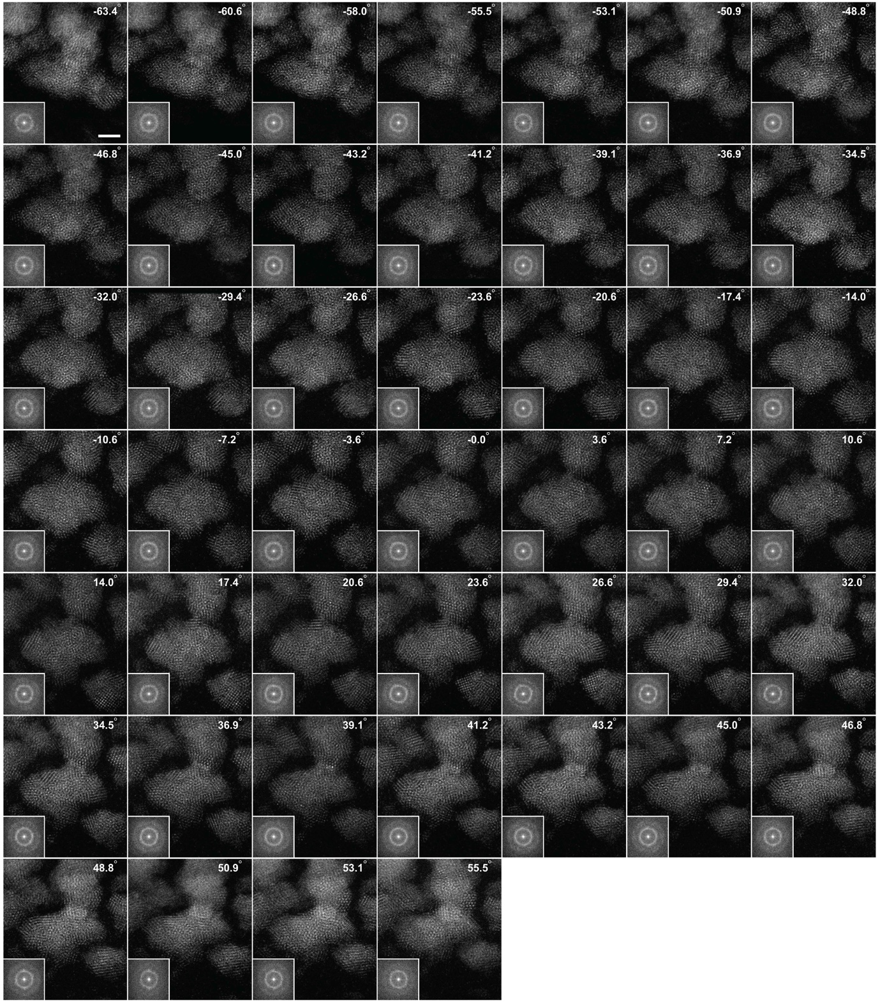

Supplementary Fig. 1 | Tomographic tilt series of an amorphous Ta thin film. 46 ADF-STEM images of the Ta film with a tilt range from −63.4° to +55.5°. The insets show the 2D power spectra of the experimental images (in a logarithmic scale), where the amorphous halo is visible. Scale bar, 2 nm.

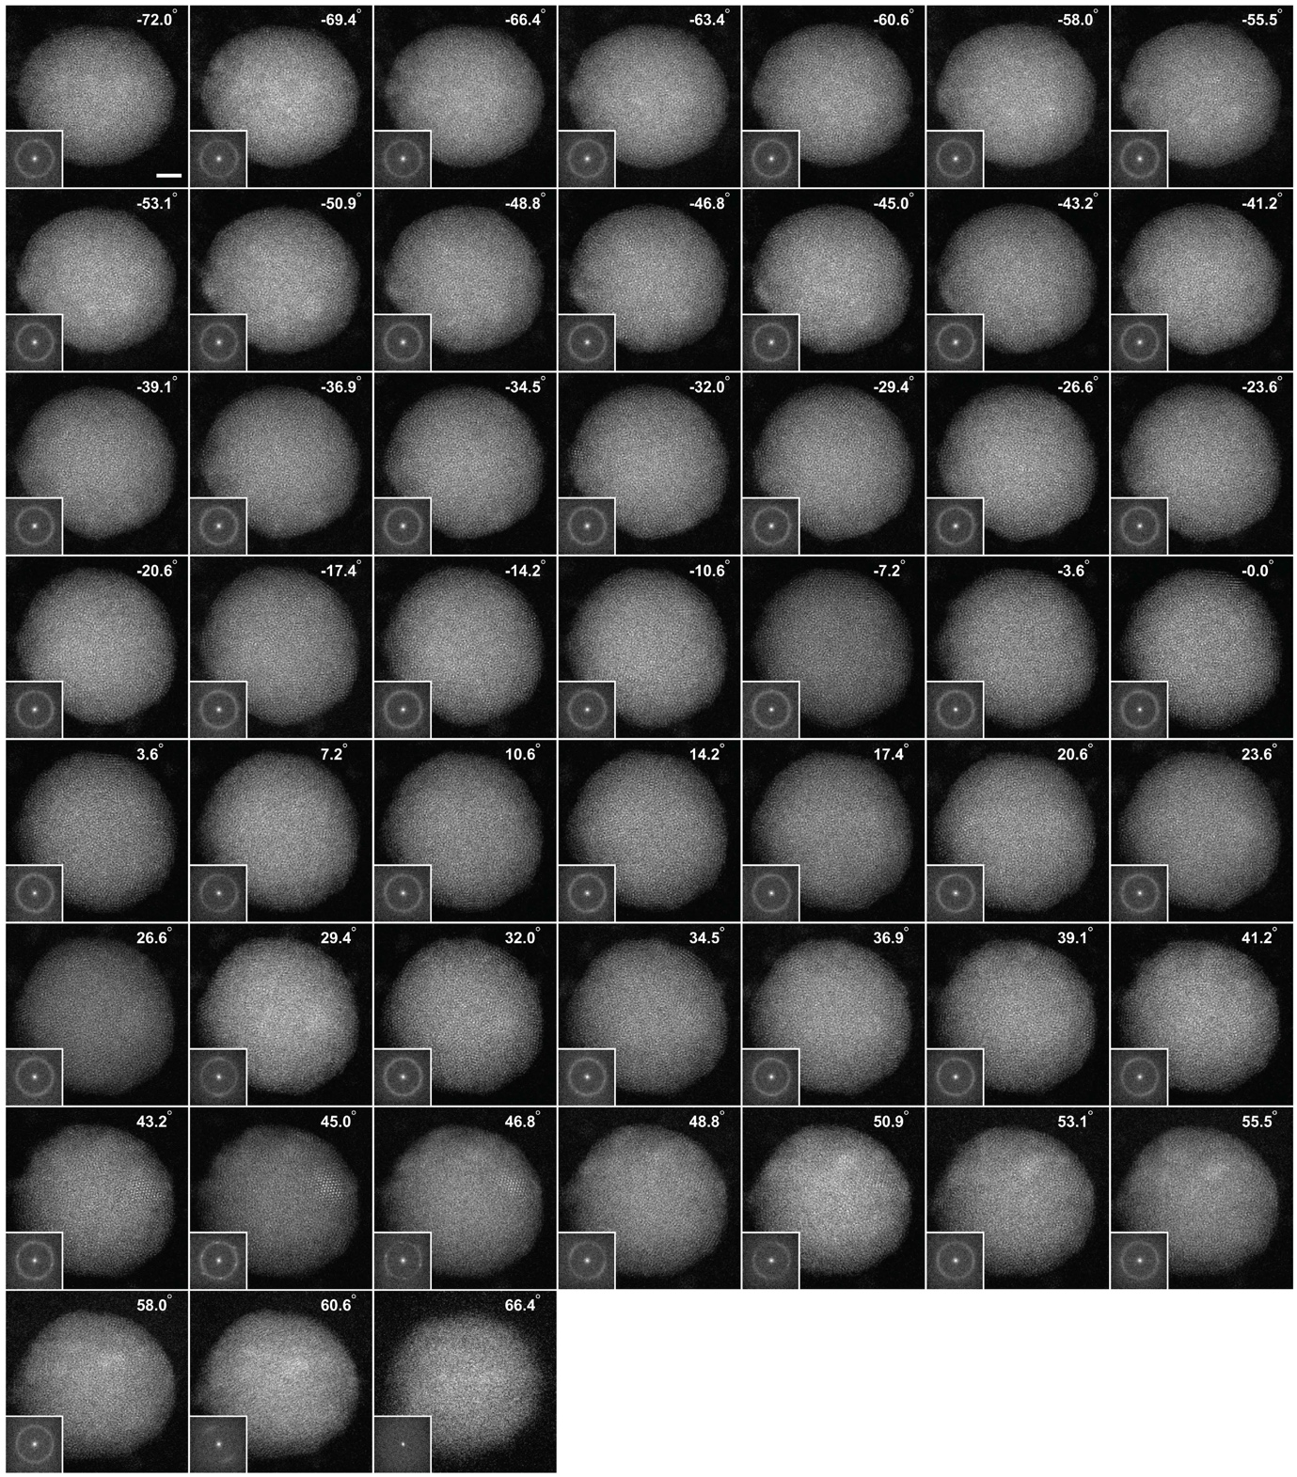
Supplementary Fig. 2 | Tomographic tilt series of an amorphous Pd nanoparticle (Pd₁). 52 ADF-STEM images of the Pd₁ nanoparticle with a tilt range from −72.0° to +66.4°. The insets show the 2D power spectra of the experimental images, where the amorphous halo is visible. Scale bar, 2 nm.
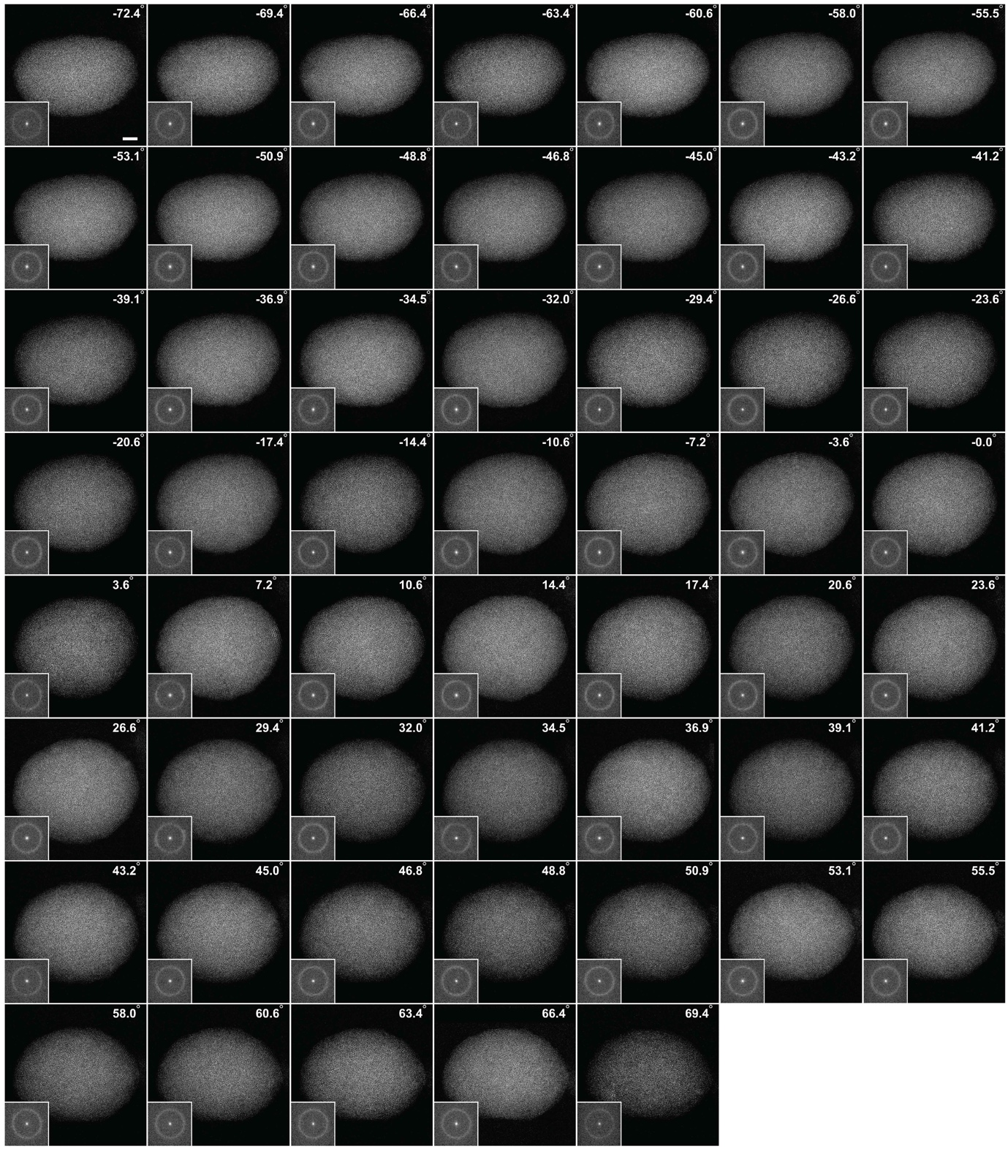

Supplementary Fig. 3 | Tomographic tilt series of an amorphous Pd nanoparticle (Pd₂). 54 ADF-STEM images of the Pd₂ nanoparticle with a tilt range from −72.0° to +69.4°. The insets show the 2D power spectra of the experimental images, where the amorphous halo is visible. Scale bar, 2 nm.

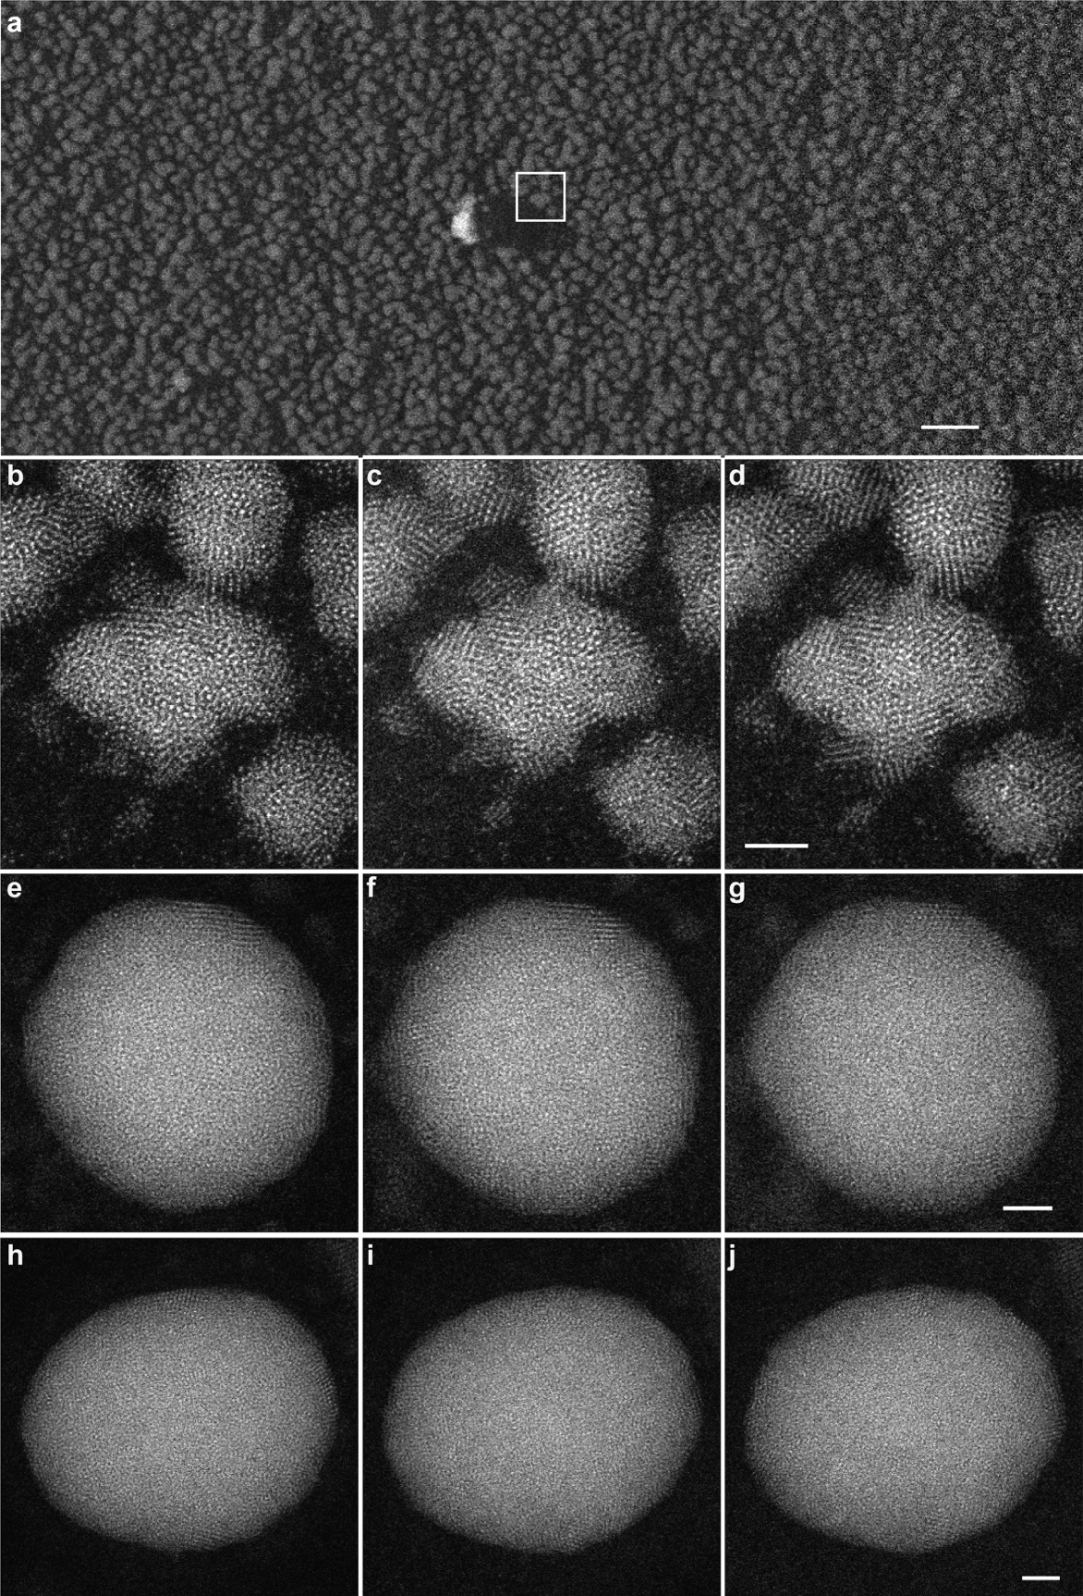
Supplementary Fig. 4 | Overview of the amorphous Ta thin film and consistency check of the sample structure. a, Low magnification overview of the Ta thin film. A tomographic tilt series was acquired from the region marked by the white square. ADF-STEM images taken before, during and after the experiment for the Ta thin film (b-d), Pd₁ (e-g) and Pd₂ (h-j) nanoparticles, indicating a minimal change of the sample structure during the data acquisition. Scale bar, 20 nm in (a) and 2 nm in (d, g, j). All the images were taken at 0° tilt angle.
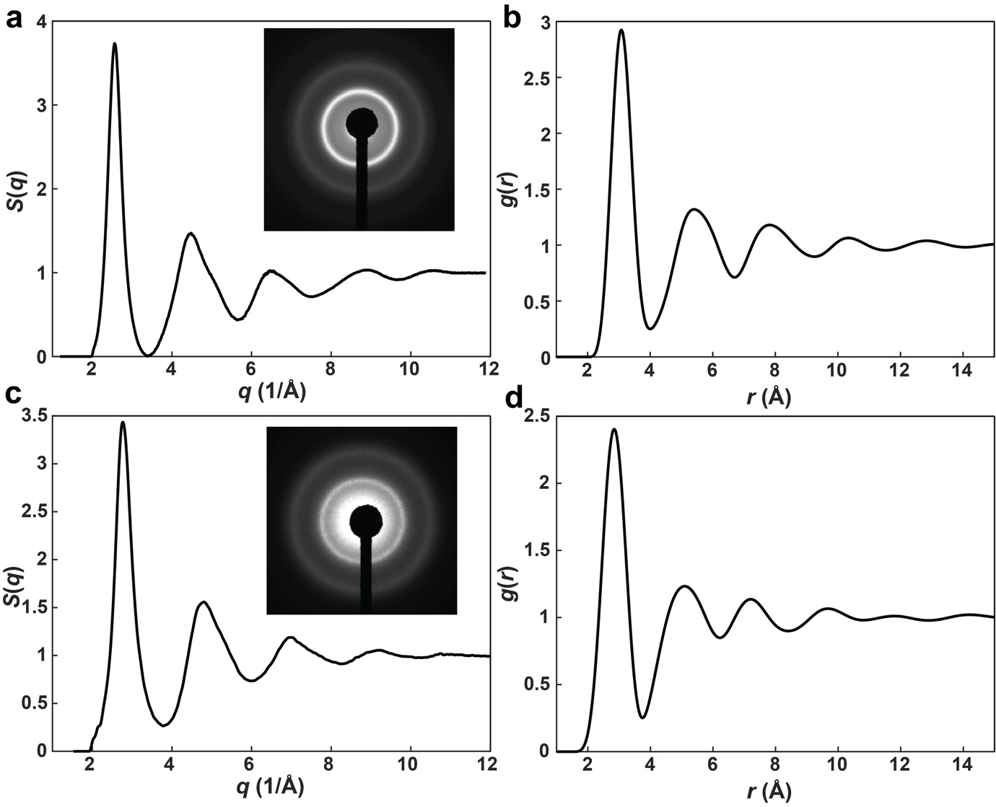
Supplementary Fig. 5 | Electron diffraction experiment and analysis. a, Structure factor S(q) of the amorphous Ta thin film, obtained from the experimental diffraction pattern (inset). b, PDF of the Ta film derived from (a). c, Structure factor S(q) of the amorphous Pd nanoparticles, obtained from the experimental diffraction pattern (inset). d, PDF of the Pd nanoparticles derived from (c).
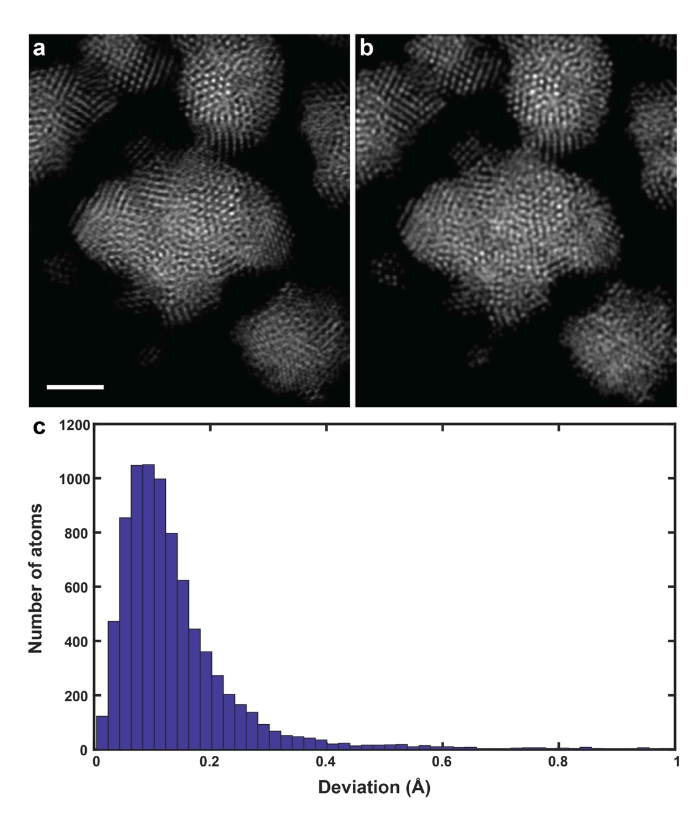
Supplementary Fig. 6 | 3D precision estimation of the experimental 3D atomic model. a, Experimental image of the amorphous Ta film at 0° after denoising. b, Multislice simulation image calculated from the experimental 3D atomic model of the Ta thin film, which is in good agreement with (a). By using 46 multislice simulation images and the same reconstruction, atom tracing and refinement procedure, we obtained a new 3D atomic model. c, Histogram of the root-mean-square deviation between the experimental 3D atomic model and the new 3D atomic model, showing 98.1% of the atoms are identical with a 3D precision of 18 pm. Scale bar, 2 nm.

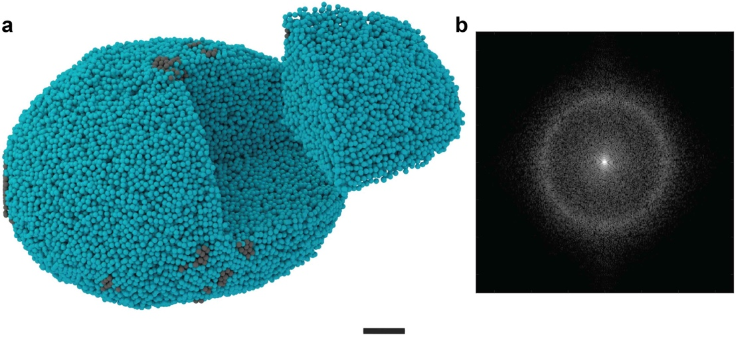
Supplementary Fig. 7 | Experimental 3D atomic structures of the amorphous Pd₂ nanoparticle. a, Experimental 3D atomic model of the Pd₂ nanoparticle with crystal nuclei in grey. Scale bar, 2 nm. b, Average 2D power spectrum of the experimental images of the nanoparticle shows the amorphous halo.
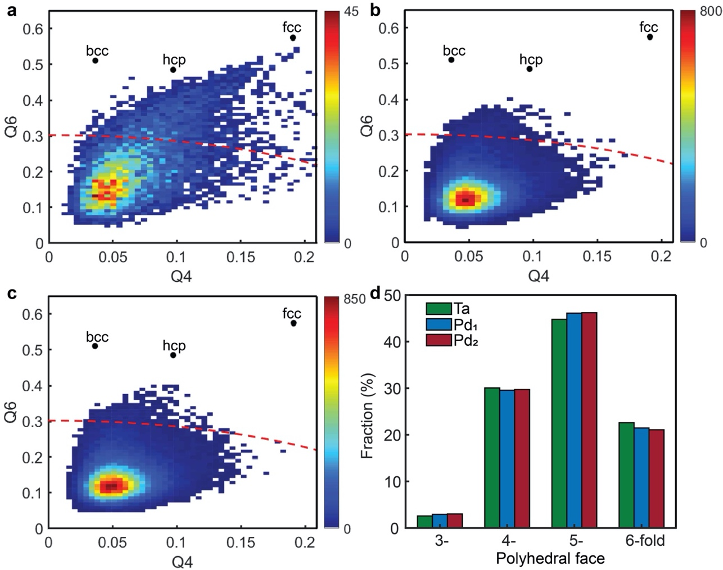
Supplementary Fig. 8 | Local Bond orientational order parameters for the Ta thin film and two Pd nanoparticles. Averaged local bond orientational order parameters for the Ta film (a), Pd₁ (b) and Pd₂ (c) nanoparticles. Red dashed lines correspond to the normalized bond orientational order parameter equal to 0.5. d, The three-, four-, five- and six-edged face distribution for the Voronoi polyhedra in three samples, where the five-edge faces are the most abundant in all three samples.
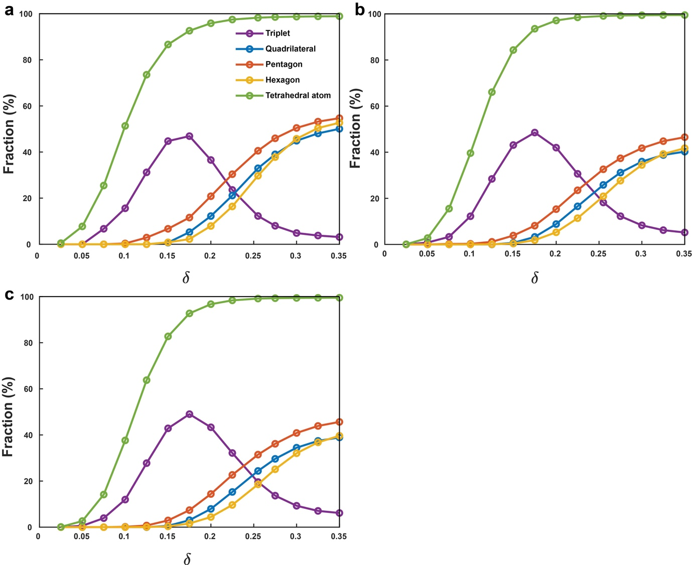
Supplementary Fig. 9 | Population of tetrahedral atoms and polytetrahedral motifs. Fraction of the tetrahedral atoms and four polytetrahedral motifs (triplets, quadrilateral, pentagonal and hexagonal bipyramids) in the amorphous Ta film (a), Pd₁ (b) and Pd₂ (c) nanoparticle, as a function of δ. The green curves show the fractions of the atoms in the three amorphous materials forming tetrahedra. The purple, blue, orange and yellow curves show the fractions of four main motifs, defined as the number of tetrahedra in each motif divided by the total number of tetrahedra in each amorphous material.

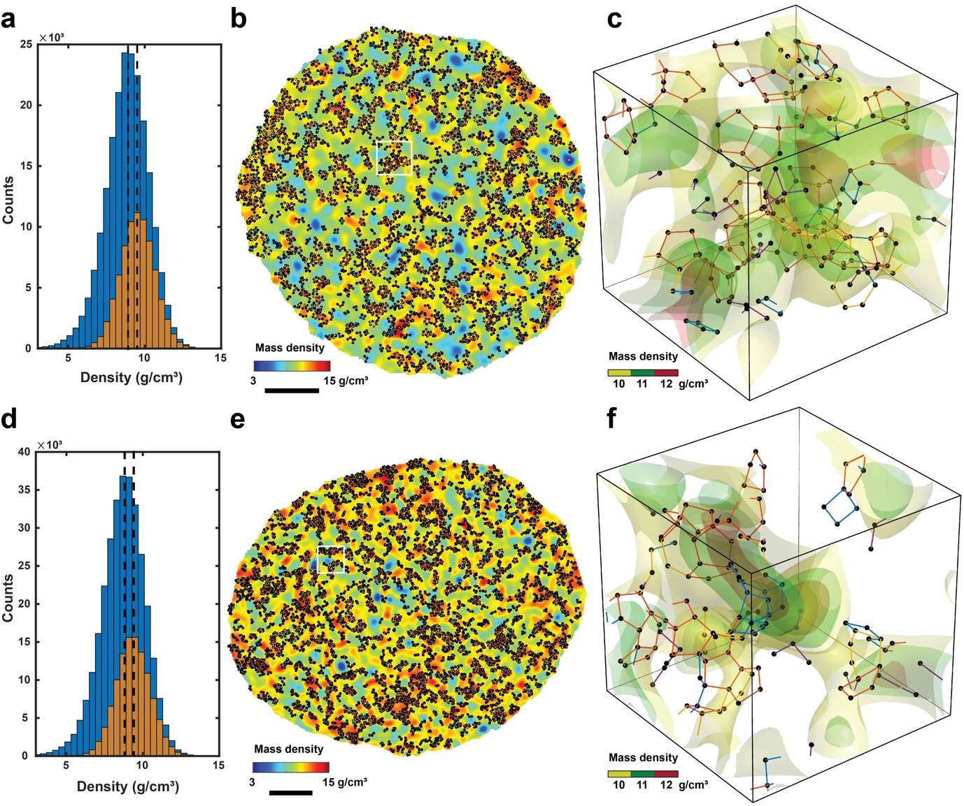
Supplementary Fig. 10 | Correlation of 3D local mass density heterogeneity and polytetrahedral packing. Mass density histograms of the amorphous Pd₁ (a) and Pd₂ nanoparticle (d) with (yellow) and without polytetrahedral packing (blue), where polytetrahedral packing increases the average mass density by 6.7% and 6.3%, respectively. Slices through the Pd₁ (b) and Pd₂ nanoparticles (e) show the local mass density heterogeneity (colour) overlaid with polytetrahedral packing (black). c, f, 3D surface renderings of local mass density heterogeneity magnified from the square regions in (b) and (e), respectively, which are overlaid with three- (purple), four- (blue), five- (orange) and six-fold (yellow) skeletons. Scale bar, 2 nm.

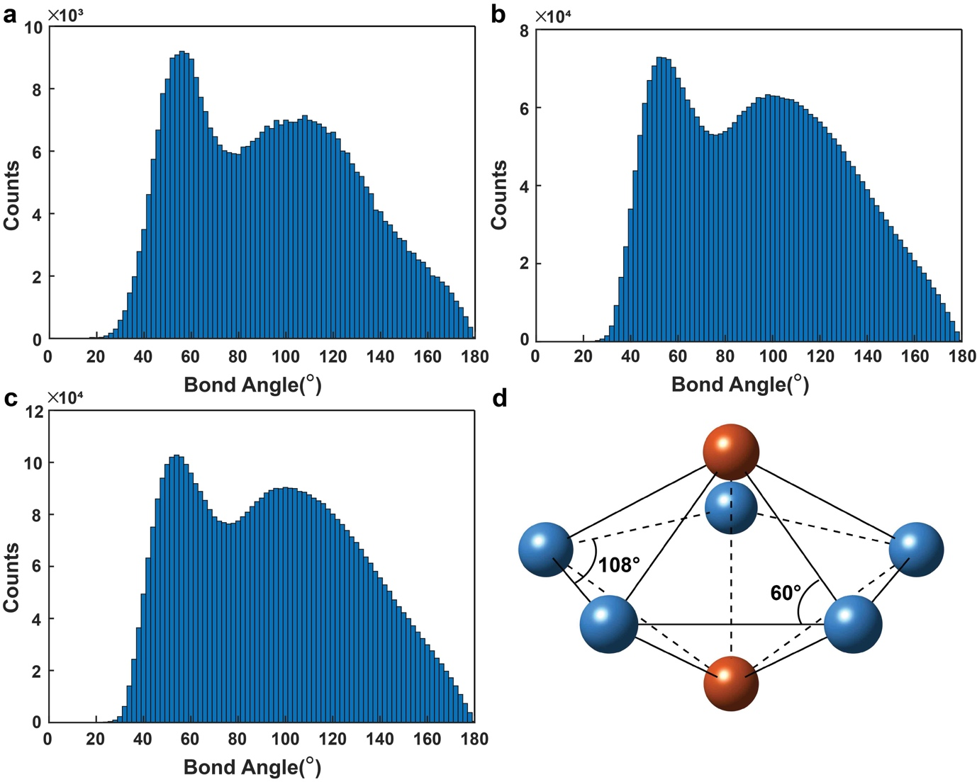
Supplementary Fig. 11 | Bond angle distributions of the amorphous Ta film (a), Pd₁ (b) and Pd₂ (c) nanoparticles, which agree with the previous study of liquid metals by combining experimental measurements with reverse Monte Carlo simulations¹². The two peaks of the bond angle distributions are consistent with the internal angles of a tetrahedron and a pentagon (d).

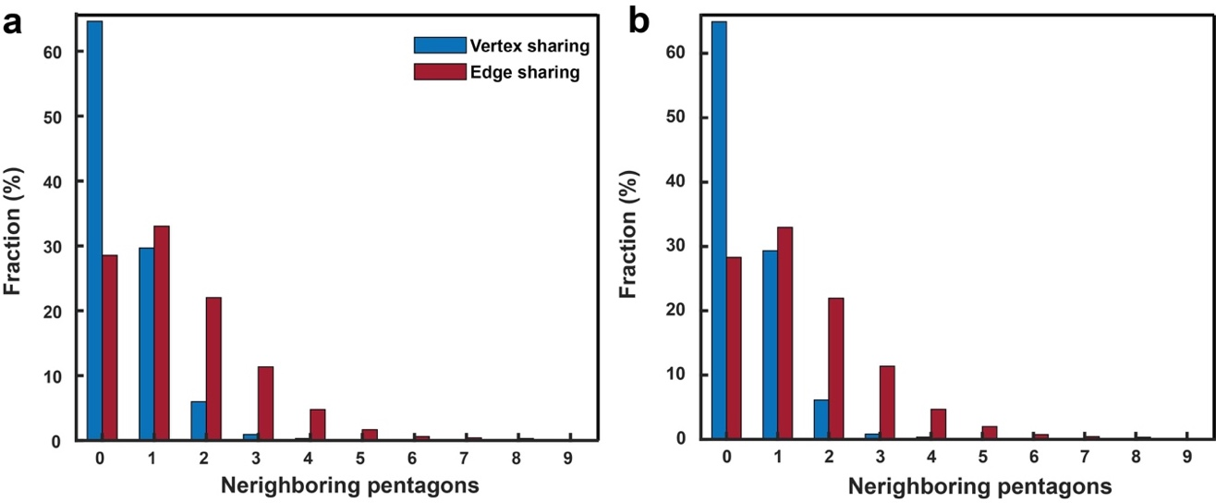
Supplementary Fig. 12 | Vertex- and edge-sharing the five-fold skeletons. Population of pentagonal bipyramids as a function of the number of vertex- (blue) and edge-sharing (red) neighbours in the amorphous Pd₁ (a) and Pd₂ (b) nanoparticle. Edge-sharing of the five-fold skeletons have more neighbours than vertex-sharing of five-fold skeletons.
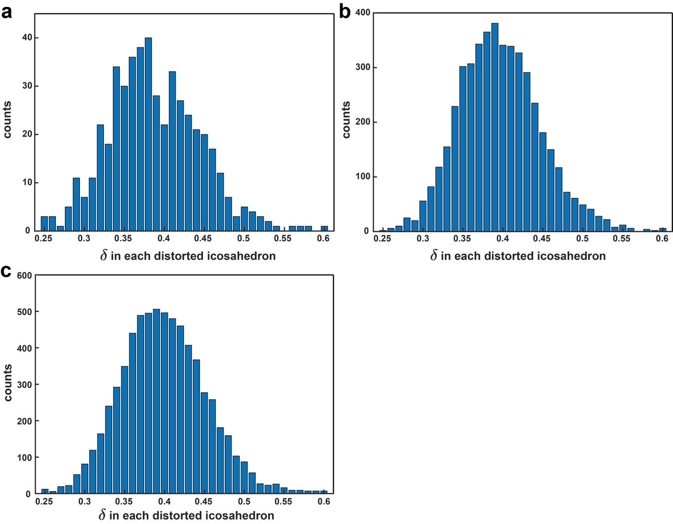
Supplementary Fig. 13 | Distorted icosahedra in Voronoi tessellation. Number of icosahedra (counts) with <0,0,12,0>, <0,1,10,2>, <0,2,8,2> and <0,2,8,1> as a function of $δ$ in the amorphous Ta film (a), Pd₁ (b) and Pd₂ (c) nanoparticles, where the vast majority of the distorted icosahedra in the Voronoi tessellation have a large distortion with $δ>$ 0.255. When choosing $δ$ ≤ 0.255, there are only 17 distorted icosahedra in the three amorphous materials.
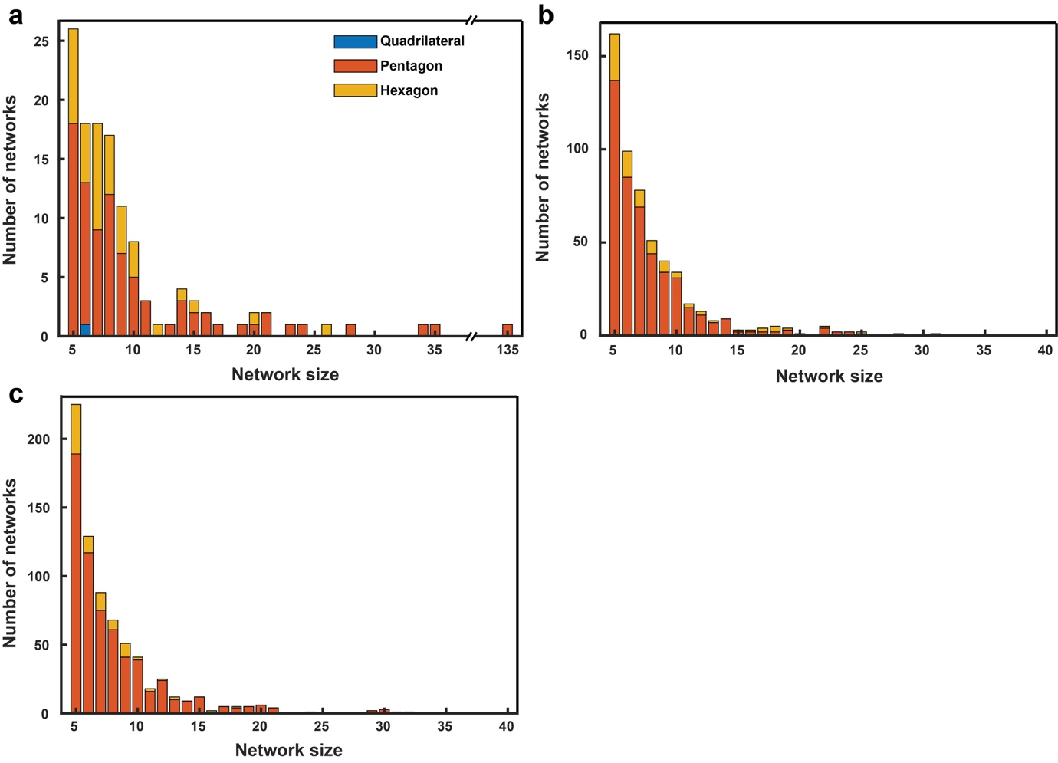
Supplementary Fig. 14 | Analysis of the quadrilateral, pentagonal, and hexagonal bipyramid network size. Population of the quadrilateral (blue), pentagonal (orange), and hexagonal bipyramid (yellow) networks as a function of their size in the amorphous Ta thin film (a), Pd₁ (b) and Pd₂ (c) nanoparticle, where the network size is defined as the number of quadrilateral, pentagonal, and hexagonal bipyramids in the corresponding networks.

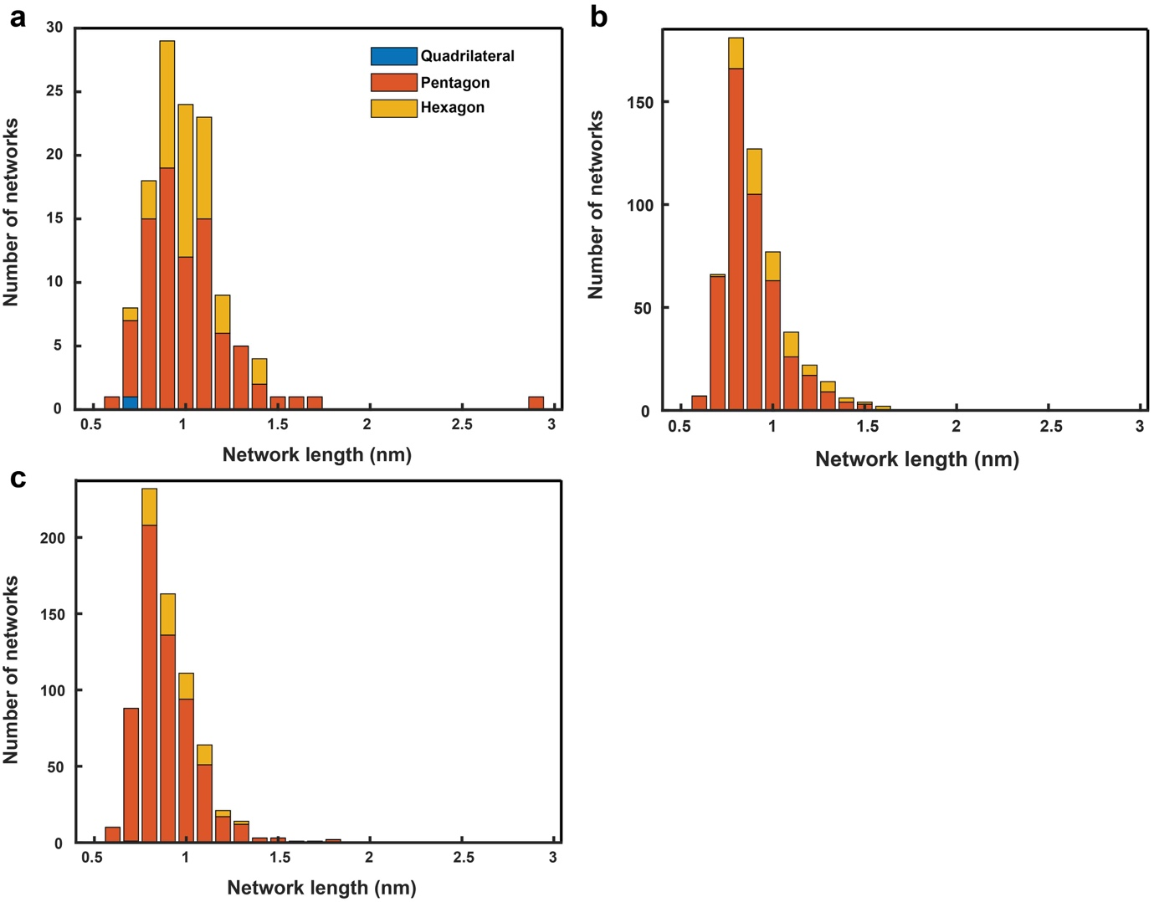
Supplementary Fig. 15 | Analysis of the quadrilateral, pentagonal, and hexagonal bipyramid network length. Population of the quadrilateral (blue), pentagonal (orange), and hexagonal bipyramid (yellow) networks as a function of their length in the amorphous Ta thin film (a), Pd₁ (b) and Pd₂ (c) nanoparticle, where the network length is defined as the distance along the longest direction of each network.

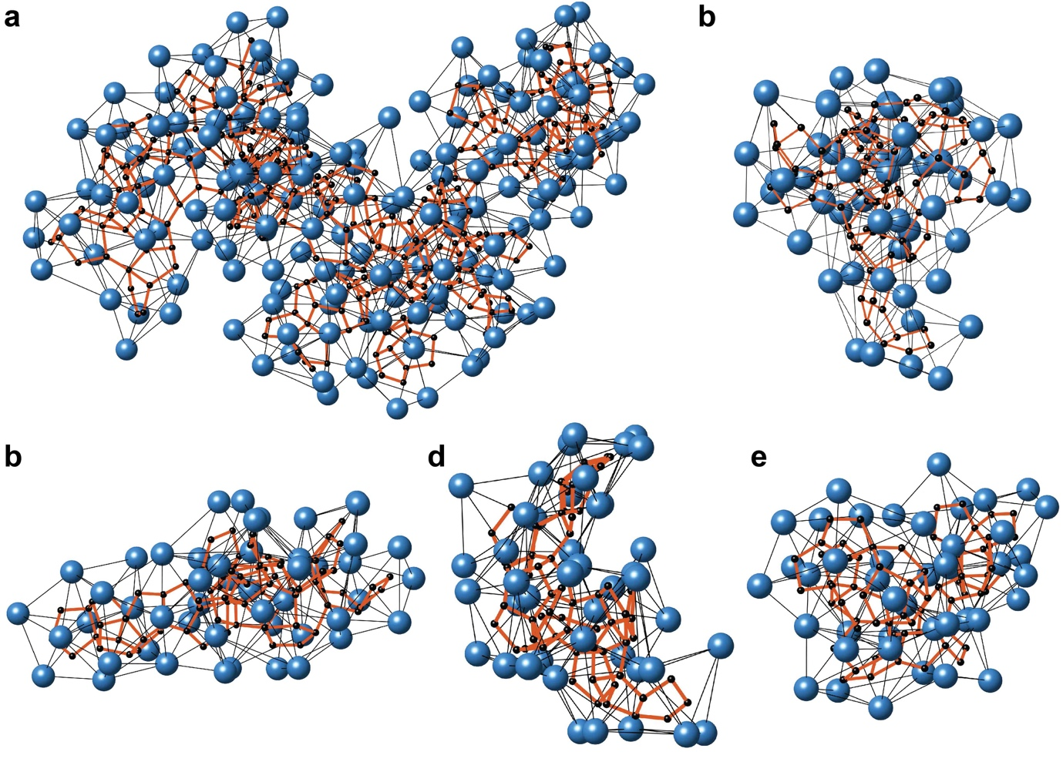
Supplementary Fig. 16 | Five largest PBNs in the amorphous Ta thin film, which contain (a) 135, (b) 35, (c) 34, (d) 28 and (e) 24 pentagonal bipyramids, respectively.

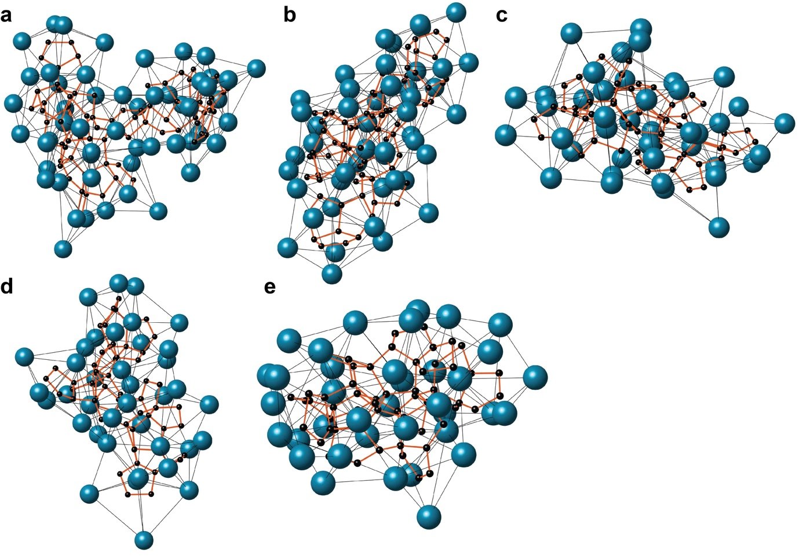
Supplementary Fig. 17 | Five largest PBNs in the amorphous Pd₁ nanoparticle, which contain (a) 31, (b) 28, (c) 25, (d) 24 and (e) 24 pentagonal bipyramids, respectively.

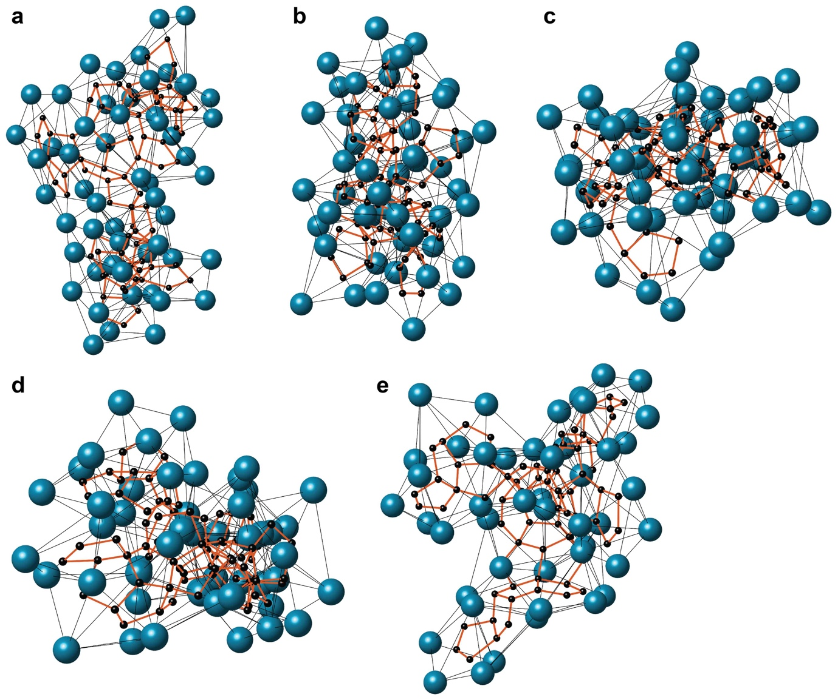
Supplementary Fig. 18 | Five largest PBNs in the amorphous Pd₂ nanoparticle, which contain (a) 32, (b) 31, (c) 30, (d) 30 and (e) 29 pentagonal bipyramids, respectively.

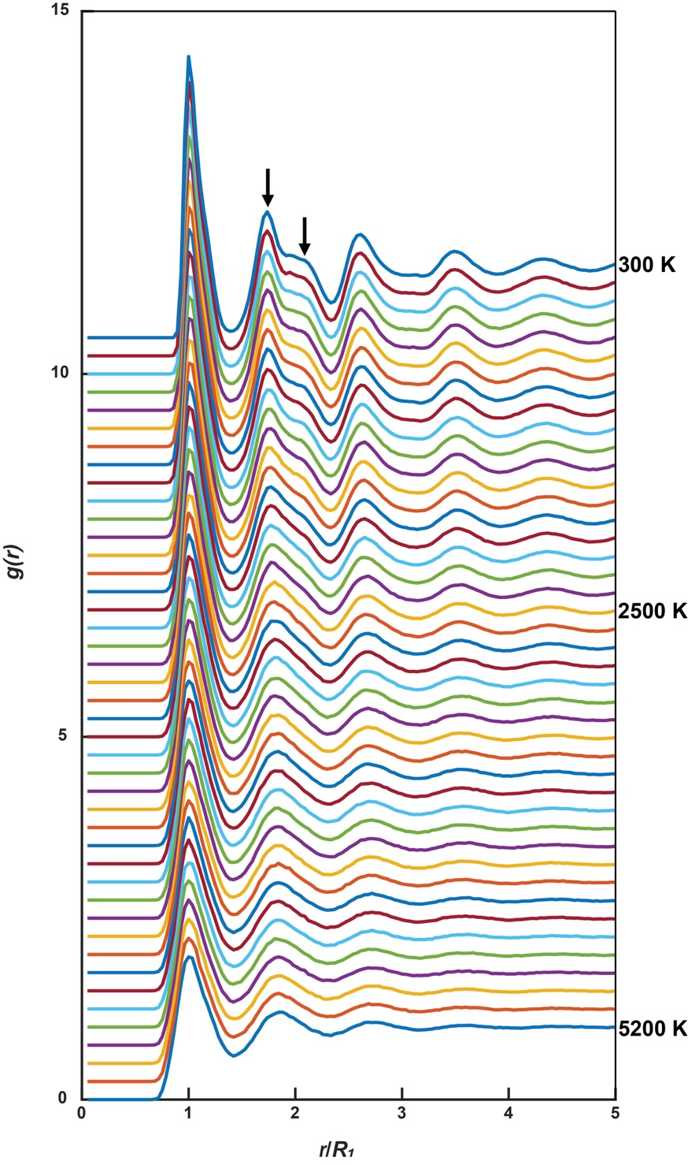
Supplementary Fig. 19 | PDFs of MD simulated Ta structures during the quench from a liquid (5200 K) to a metallic glass state (300 K). At 5200 K, the PDF of the Ta liquid resembles those of the three experimental amorphous materials (Fig. 1c). At 300 K, the splitting of the 2nd and 3rd peaks in the PDF indicates the formation of the Ta metallic glass (arrows). From the free volume vs temperature graph, the glass transition temperature (T_{g}) is determined to be 2496 K.

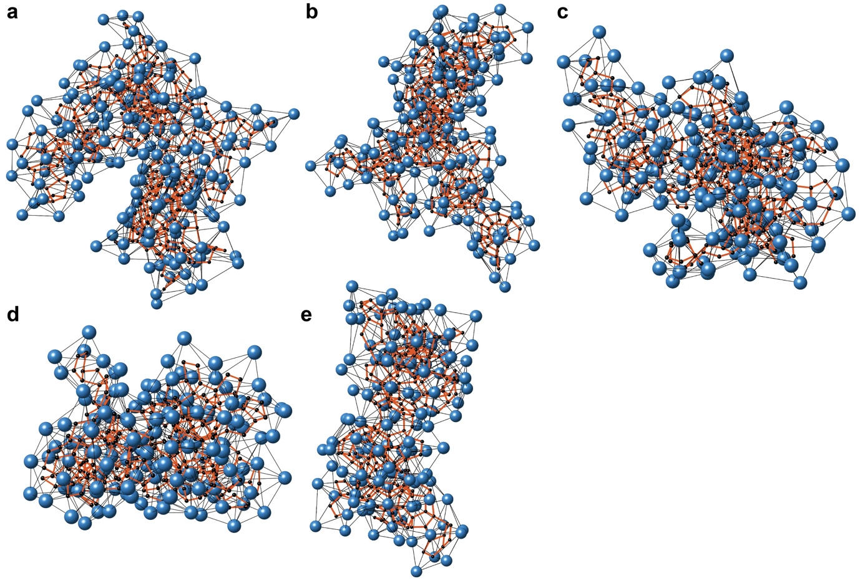
Supplementary Fig. 20 | Five largest PBNs in the MD simulated Ta liquid at 5200 K, which contain (a) 146, (b) 132, (c) 120, (d) 118 and (e) 105 pentagonal bipyramids, respectively.

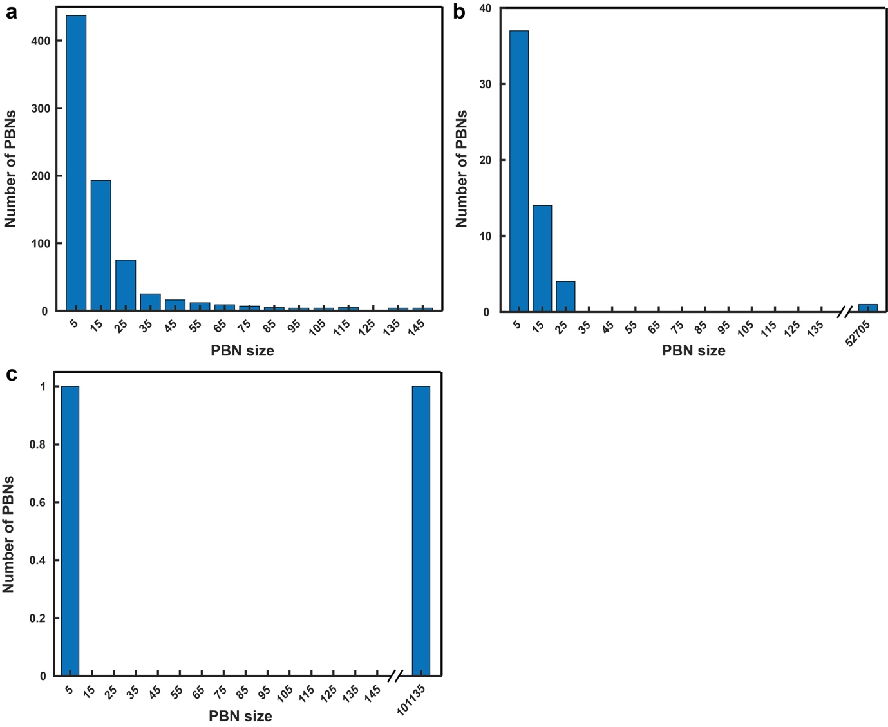
Supplementary Fig. 21 | Histogram of the PBN size for MD simulated Ta structures at different temperatures. Number of PBNs as a function of the network size in MD simulated Ta structures at (a) 5200K, (b) 2500 K and (c) 300 K. During the quench from a liquid to metallic glass state, the PBNs rapidly grow in size. At 300 K, a giant PBN is formed that extends to the entire Ta metallic glass.

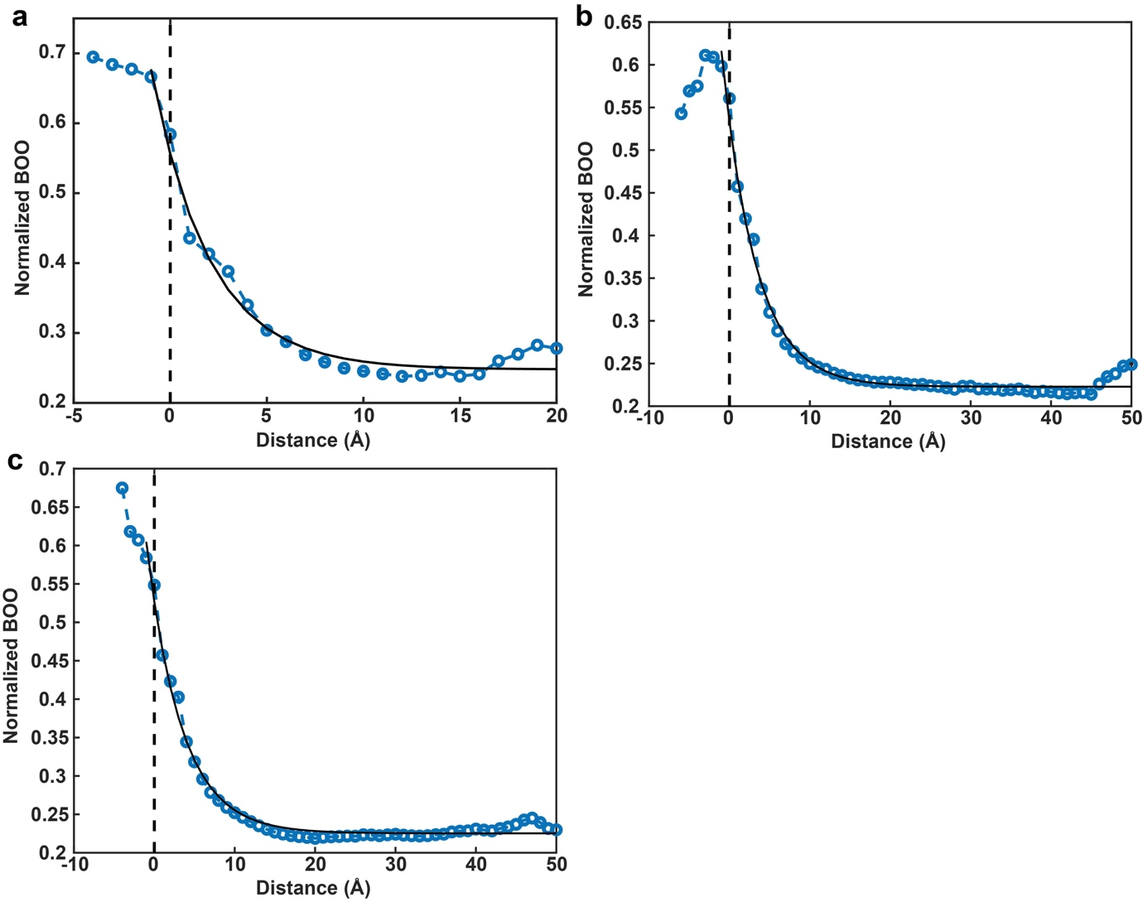
Supplementary Fig. 22 | Quantifying the crystalline-amorphous interface. Distribution of the normalized BOO (blue circles) as a function of the perpendicular distance to the surface of the crystal nuclei (dashed line) for the Ta film (a), Pd₁ (b) and Pd₂ (c) nanoparticle. The experimental data points (blue circles) were fitted with an exponential decay function (solid curves) to determine the characteristic width of the crystalline-amorphous interface to be 3.0, 4.2 and 4.3 Å for the Ta film, Pd₁ and Pd₂ nanoparticle, respectively (Methods).

Supplementary Video legends

Supplementary Video 1. Experimental 3D atomic model of the amorphous Ta thin film. The reconstructed volume of the thin film consists of 6615 disordered atoms (in blue) with several crystal nuclei of 1669 atoms on the surface (in grey).

Supplementary Video 2. Experimental 3D atomic model of the amorphous Pd₁ nanoparticle. The nanoparticle consists of 51170 disordered atoms (in green) with several small crystal nuclei of 1138 atoms on the surface (in grey).

Supplementary Video 3. Experimental 3D atomic model of the amorphous Pd₂ nanoparticle. The nanoparticle consists of 74893 disordered atoms (in green) with several small crystal nuclei of 1345 atoms on the surface (in grey).

