Supplementary information
Supplementary figures 1-7
Supplementary tables 1-2
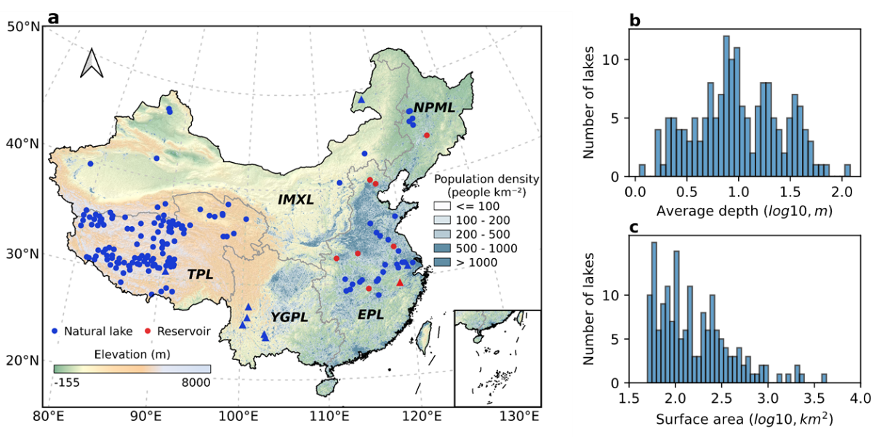
Supplementary Figure 1 Distribution and characteristics of the studied lakes. a, Map of the studied natural lakes and artificial reservoirs. b, Histograms of log10[surface area (km²)]. c, Histograms of log10[average depth (m)]. The information is derived from the HydroLAKES database. The location of lake points is the centroids of lake polygons. China lakes are divided into five lake zones, including the Northeast Plain and Mountain Lake (NPML), Inner Mongolia-Xinjiang Lake (IMXL), Tibetan Plateau Lake (TPL), Eastern Plain Lake (EPL), and Yunnan-Guizhou Plateau Lake (YGPL). The triangles in a represent the nine lakes on which ground observations are available for model verification.
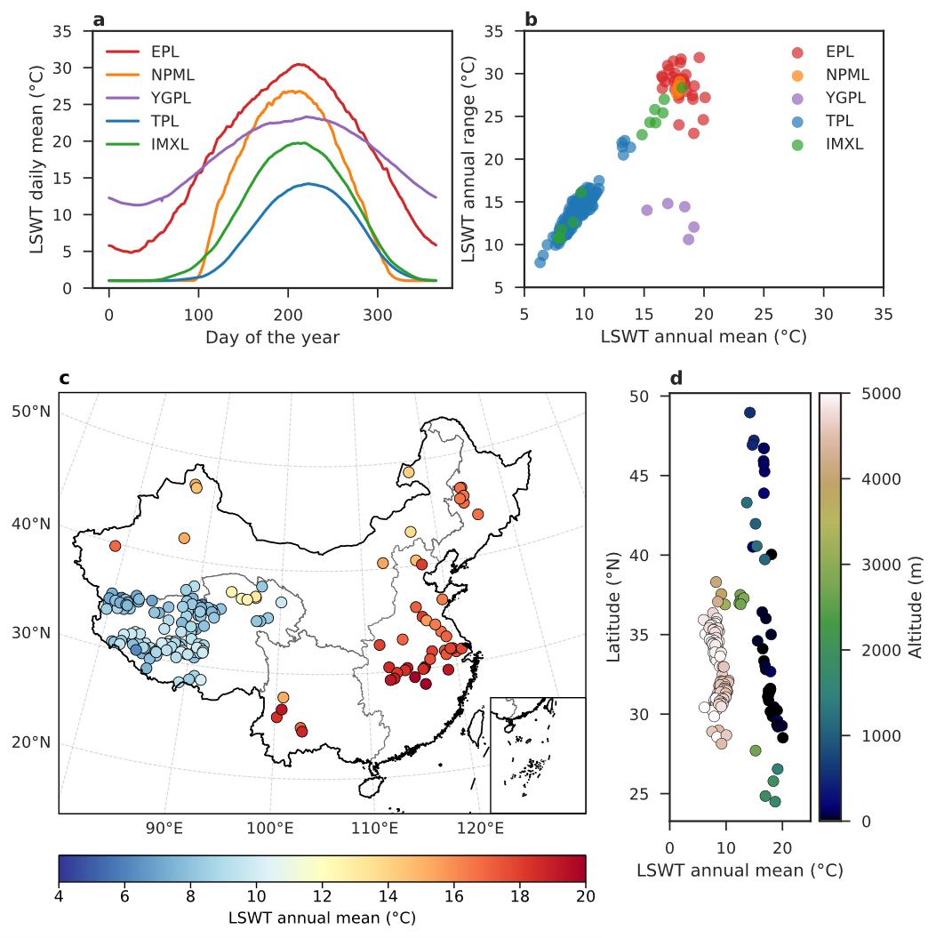
Supplementary Figure 2 Climatological daily mean, annual mean, and annual range of lake surface water temperature. (a) Climatological daily mean lake surface water temperature (LSWT) for each day of the year from 1980 to 2021 in five lake zones. (b) Average of LSWT annual mean vs. annual range from 1980 to 2021 in five lake zones. The annual range is calculated by annual maximum minus annual minimum surface water temperatures. (c) Spatial distribution of the climatological annual mean LSWT for each year from 1980 to 2021 and (d) its variation across latitudes and altitudes.
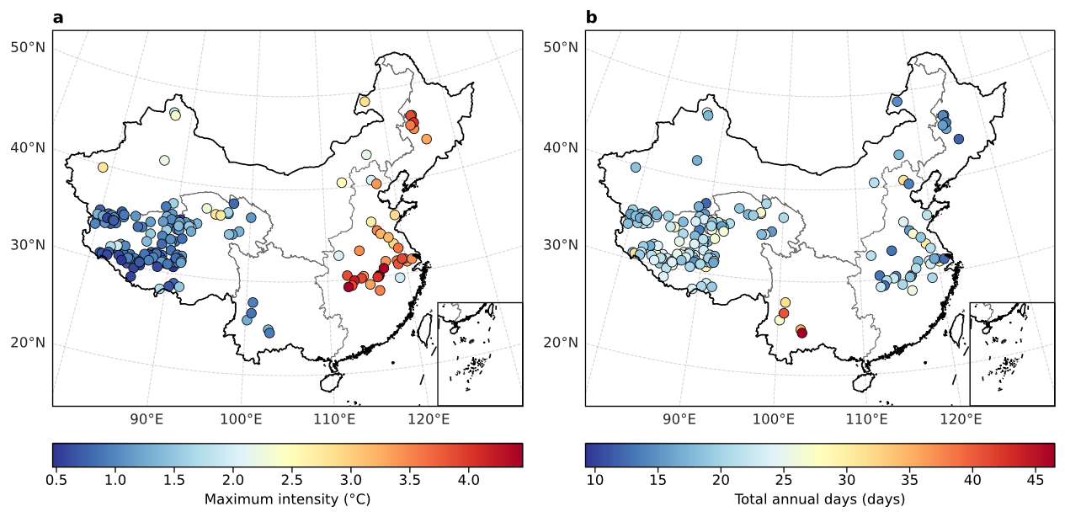
Supplementary Figure 3 Lake heatwave climatology during 1980-2021. The climatological mean during 1980-2021 of lake heatwave maximum intensity (c) and total annual days (d). The climatological period 1980-2009 was selected for the calculation of lake heatwave.
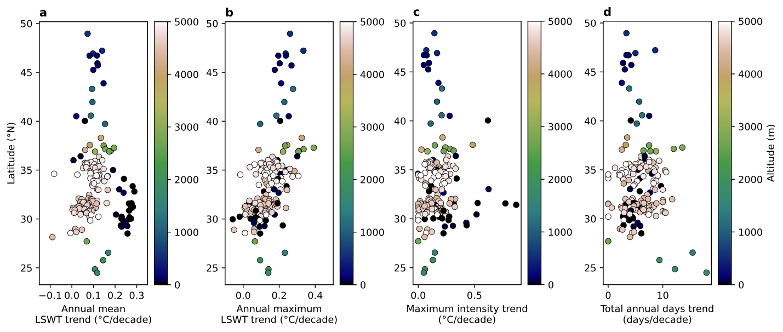
Supplementary Figure 4 Variations along latitude and altitude (1980-2021). a, Annual mean lake surface water temperature (LSWT) trend. b, Annual maximum LSWT trend. c, Lake heatwave (LHW) maximum intensity trend. d, LHW total annual days trend.
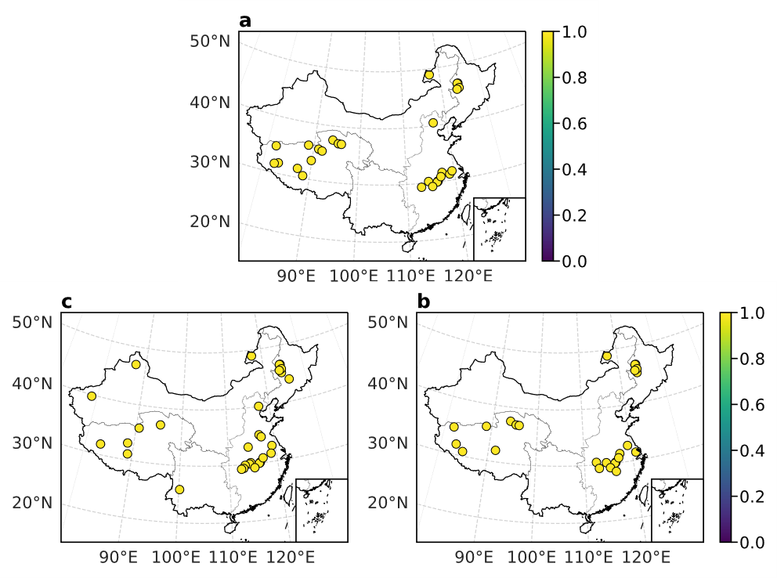
Supplementary Figure 5 Fraction of attributable risk for a long heatwave event. a, Longwave radiation. b, Specific humidity. c, Air temperature.
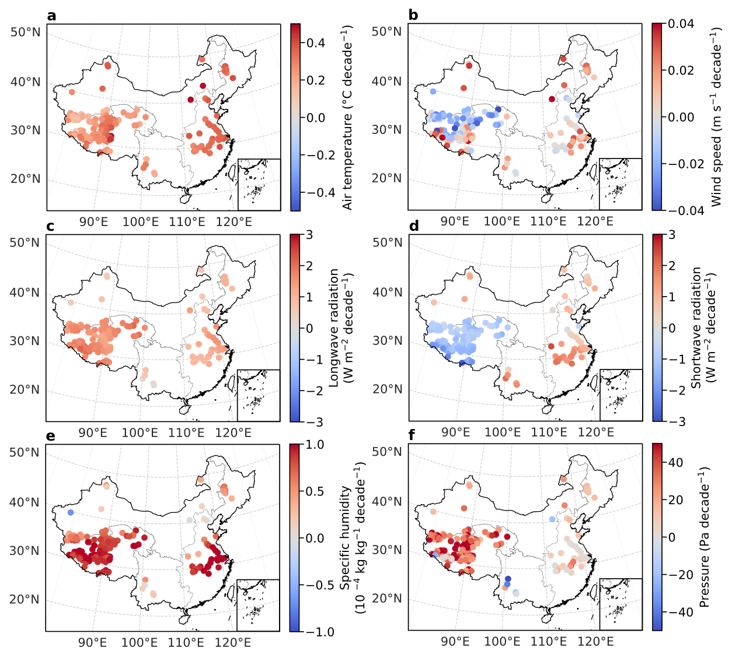
Supplementary Figure 6 Trend of meteorological variables (1980-2021). a, 2 m air temperature. b, 10 m wind speed. c, Surface downward longwave radiation. d, Surface downward shortwave radiation. e, 2 m specific humidity. f, Surface pressure.
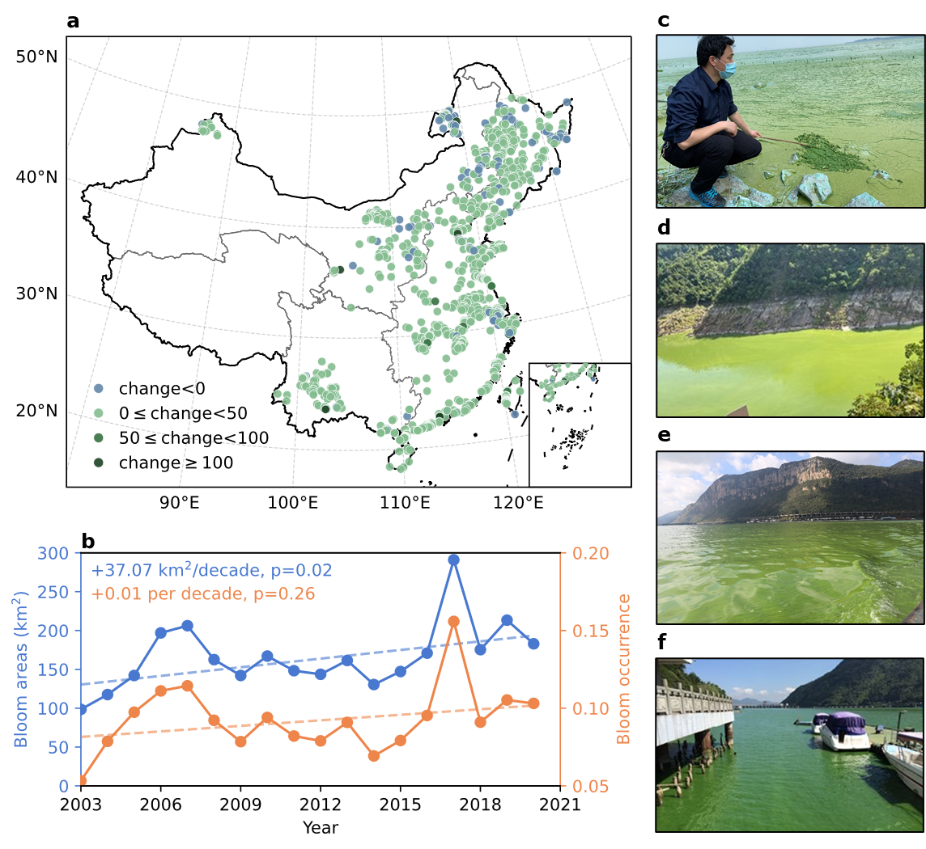
Supplementary Figure 7 Algae blooms in Chinese lakes. a, The changes in the bloom occurrence between the 2010s and 1980-1990s⁵¹. “change” was calculated as (BO_{2010s}-BO_{1980-1990s})/BO_{1980-1990s}, where BO_{x} denotes the bloom occurrence during the period x. b, The bloom areas and occurrence from 2003 to 2020 in Lake Taihu derived from MODIS images⁷¹. c-f, Photographs of algae blooms in May 2020 in Lake Taihu (c), in August 2022 in Three Gorges Reservoir (d), in October 2015 in Lake Dianchi (e), and in August 2016 in Fuchunjiang Reservoir (f).
Supplementary Table 1 Nine lakes with ground observations.
Lake Name | ID | Temporal frequency | Thermal regime
Lake Taihu | 148 | Daily | Warm polymictic
Lake Lugu | 15431 | Daily | Warm monomictic
Lake Namco | 149 | Two-hourly | Dimictic
Lake Hulun | 123 | Monthly | Cold polymictic
Lake Qiandao | 1467 | Hourly | Warm monomictic
Lake Erhai | 1479 | Irregular | Warm polymictic
Lake Dianchi | 1483 | Irregular | Warm polymictic
Lake Fuxian | 1485 | Irregular | Warm monomictic
Lake Chenghai | 15455 | Irregular | Warm monomictic

Supplementary Table 2 Information on the studied lakes and selected best parameters. Lake ID is the ID in the HydroLAKES database. Lake type=1 or 3 represent natural lakes and lake type=2 represent reservoirs. The nine lakes that provided ground lake surface water temperature for model verification are emphasized in italics.
Lake  ID | Lake  type | Lake  zone | Surface area (km²) | Average depth (m) | Elevation (m) | Latitude | Longitude | Light extinction coefficient (m⁻¹) | Ice albedo | Depth factor
123 | 1 | IMXL | 2121.43 | 6.20 | 540 | 48.96 | 117.41 | 0.58 | 0.20 | 0.59
143 | 1 | TPL | 4266.55 | 16.80 | 3194 | 36.89 | 100.05 | 0.24 | 0.25 | 1.02
145 | 2 | EPL | 1374.36 | 9.80 | 10 | 33.35 | 118.77 | 0.38 | 0.18 | 0.49
147 | 1 | TPL | 1749.53 | 28.00 | 4539 | 31.79 | 88.95 | 0.28 | 0.13 | 0.77
148 | 1 | EPL | 2329.14 | 2.20 | 0 | 31.24 | 120.14 | 0.55 | 0.47 | 1.93
149 | 1 | TPL | 1963.82 | 44.40 | 4724 | 30.72 | 90.59 | 0.16 | 0.28 | 0.65
1245 | 1 | IMXL | 854.89 | 8.00 | 478 | 47.22 | 87.21 | 0.17 | 0.15 | 1.13
1250 | 1 | IMXL | 165.81 | 20.90 | 479 | 46.93 | 87.45 | 0.52 | 0.14 | 0.92
1252 | 1 | NPML | 132.18 | 6.90 | 135 | 46.72 | 124.37 | 1.79 | 0.16 | 0.31
1257 | 1 | NPML | 429.94 | 5.20 | 136 | 46.71 | 124.17 | 1.75 | 0.14 | 0.30
1286 | 1 | NPML | 246.95 | 2.70 | 126 | 45.25 | 124.30 | 1.13 | 0.14 | 1.00
1300 | 1 | IMXL | 213.64 | 7.70 | 1223 | 43.30 | 116.65 | 0.54 | 0.20 | 0.80
1304 | 1 | IMXL | 961.84 | 9.10 | 1050 | 41.97 | 87.05 | 2.65 | 0.13 | 1.24
1317 | 2 | EPL | 121.66 | 36.00 | 143 | 40.51 | 116.89 | 1.86 | 0.25 | 0.71
1323 | 2 | EPL | 118.62 | 13.10 | 16 | 40.04 | 117.57 | 1.75 | 0.14 | 0.30
1325 | 1 | IMXL | 102.82 | 8.40 | 1111 | 39.73 | 78.73 | 1.61 | 0.20 | 0.38
1336 | 1 | TPL | 585.60 | 30.00 | 4076 | 38.30 | 97.58 | 0.15 | 0.10 | 0.50
1344 | 1 | IMXL | 616.34 | 10.00 | 3876 | 37.55 | 89.33 | 1.99 | 0.11 | 0.93
1347 | 1 | TPL | 204.51 | 2.40 | 2686 | 37.50 | 93.94 | 0.80 | 0.12 | 1.04
1350 | 1 | TPL | 142.97 | 9.90 | 2805 | 37.14 | 96.95 | 0.25 | 0.12 | 1.00
1352 | 1 | IMXL | 354.71 | 13.60 | 4251 | 37.07 | 88.43 | 0.45 | 0.11 | 0.70
1353 | 1 | TPL | 321.88 | 2.00 | 2680 | 36.96 | 95.23 | 1.62 | 0.11 | 0.79
1357 | 1 | IMXL | 225.85 | 4.10 | 4713 | 36.36 | 89.39 | 0.42 | 0.14 | 3.98
1359 | 1 | EPL | 139.85 | 8.20 | 38 | 36.01 | 116.20 | 0.87 | 0.16 | 0.44
1364 | 1 | TPL | 100.81 | 11.00 | 4881 | 35.93 | 90.64 | 0.10 | 0.20 | 2.00
1366 | 1 | TPL | 220.78 | 16.70 | 4870 | 35.75 | 90.18 | 0.30 | 0.11 | 0.50
1367 | 1 | TPL | 261.40 | 16.60 | 4475 | 35.74 | 92.89 | 0.55 | 0.14 | 1.04
1369 | 1 | TPL | 300.10 | 12.60 | 4886 | 35.58 | 91.09 | 0.31 | 0.12 | 1.44
1370 | 1 | TPL | 255.38 | 14.70 | 4753 | 35.55 | 91.92 | 0.41 | 0.15 | 1.23
1371 | 1 | TPL | 231.17 | 42.70 | 4081 | 35.30 | 98.57 | 1.25 | 0.10 | 0.66
1372 | 1 | TPL | 208.99 | 6.40 | 4787 | 35.30 | 89.27 | 0.17 | 0.15 | 1.13
1373 | 1 | IMXL | 165.96 | 9.60 | 4844 | 35.21 | 79.86 | 0.33 | 0.10 | 1.00
1374 | 1 | TPL | 269.64 | 5.50 | 4772 | 35.22 | 90.31 | 0.30 | 0.10 | 1.00
1375 | 1 | TPL | 198.59 | 16.00 | 4688 | 35.21 | 92.19 | 1.75 | 0.14 | 0.30
1377 | 1 | TPL | 617.76 | 17.40 | 4267 | 34.94 | 97.69 | 0.24 | 0.17 | 0.99
1378 | 1 | TPL | 248.04 | 35.70 | 5080 | 35.03 | 81.08 | 0.32 | 0.12 | 0.71
1379 | 1 | TPL | 121.34 | 8.00 | 4960 | 35.04 | 83.13 | 0.20 | 0.12 | 1.00
1382 | 1 | TPL | 107.02 | 8.50 | 4904 | 34.95 | 81.56 | 0.54 | 0.20 | 0.80
1383 | 1 | EPL | 237.73 | 1.10 | 32 | 35.00 | 116.84 | 1.53 | 0.18 | 4.73
1385 | 1 | TPL | 520.58 | 9.00 | 4290 | 34.91 | 97.25 | 0.40 | 0.10 | 2.00
1386 | 1 | TPL | 372.84 | 19.30 | 4855 | 34.81 | 90.36 | 0.25 | 0.11 | 0.50
1387 | 1 | TPL | 108.03 | 7.20 | 4857 | 34.77 | 90.65 | 0.25 | 0.11 | 1.00
1388 | 1 | EPL | 175.30 | 3.00 | 28 | 34.60 | 117.26 | 0.77 | 0.30 | 1.00
1389 | 1 | TPL | 268.13 | 22.50 | 4818 | 34.57 | 89.00 | 1.75 | 0.14 | 0.30
1391 | 1 | TPL | 127.93 | 8.00 | 4920 | 34.21 | 82.32 | 0.25 | 0.20 | 1.00
1395 | 1 | TPL | 113.96 | 20.00 | 4961 | 34.15 | 79.78 | 0.25 | 0.10 | 0.60
1396 | 1 | EPL | 247.63 | 3.90 | 17 | 34.11 | 118.21 | 0.63 | 0.27 | 4.03
1399 | 1 | TPL | 347.02 | 45.10 | 4812 | 34.01 | 81.64 | 0.20 | 0.10 | 0.30
1401 | 1 | TPL | 105.06 | 19.70 | 4525 | 33.95 | 80.91 | 0.80 | 0.10 | 1.00
1402 | 1 | TPL | 101.50 | 12.80 | 5062 | 33.85 | 88.59 | 0.40 | 0.13 | 1.42
1403 | 1 | TPL | 332.93 | 50.00 | 4239 | 33.60 | 79.70 | 1.65 | 0.11 | 0.62
1404 | 1 | TPL | 472.55 | 25.70 | 4935 | 33.49 | 90.36 | 0.51 | 0.10 | 0.82
1405 | 1 | TPL | 378.99 | 20.00 | 4929 | 33.38 | 89.87 | 0.51 | 0.10 | 0.82
1411 | 1 | TPL | 106.31 | 5.10 | 4872 | 33.01 | 89.81 | 1.13 | 0.14 | 0.25
1416 | 1 | EPL | 703.14 | 7.90 | 2 | 32.81 | 119.28 | 1.86 | 0.49 | 0.41
1417 | 2 | EPL | 286.45 | 72.90 | 134 | 32.68 | 111.56 | 0.73 | 0.14 | 0.49
1419 | 1 | TPL | 149.16 | 8.20 | 4615 | 32.46 | 89.98 | 0.50 | 0.10 | 1.00
1422 | 1 | TPL | 207.16 | 12.70 | 4568 | 32.08 | 90.87 | 0.51 | 0.11 | 1.43
1424 | 1 | TPL | 188.28 | 33.70 | 4585 | 32.03 | 91.47 | 1.14 | 0.10 | 0.72
1425 | 1 | TPL | 251.56 | 8.50 | 4465 | 31.90 | 87.54 | 0.25 | 0.10 | 1.50
1427 | 1 | TPL | 134.17 | 11.90 | 4551 | 31.70 | 91.17 | 0.25 | 0.10 | 0.80
1428 | 1 | TPL | 346.70 | 19.20 | 4554 | 31.71 | 88.03 | 0.27 | 0.18 | 0.95
1429 | 1 | TPL | 267.15 | 37.90 | 4563 | 31.55 | 88.77 | 0.25 | 0.10 | 0.50
1430 | 1 | EPL | 786.91 | 2.60 | 5 | 31.57 | 117.45 | 0.63 | 0.12 | 4.35
1431 | 1 | TPL | 498.06 | 10.00 | 4716 | 31.54 | 82.98 | 2.65 | 0.13 | 1.00
1433 | 1 | TPL | 148.14 | 12.20 | 4529 | 31.51 | 90.97 | 0.20 | 0.13 | 1.00
1434 | 1 | EPL | 161.56 | 2.90 | 0 | 31.58 | 119.82 | 0.68 | 0.15 | 4.28
1436 | 1 | EPL | 206.35 | 3.70 | 4 | 31.47 | 118.88 | 0.73 | 0.30 | 1.00
1437 | 1 | TPL | 146.74 | 2.30 | 4424 | 31.41 | 84.07 | 0.70 | 0.10 | 2.00
1438 | 1 | EPL | 124.24 | 1.70 | 1 | 31.43 | 120.79 | 1.34 | 0.19 | 4.58
1439 | 1 | TPL | 477.00 | 32.10 | 4649 | 31.14 | 88.36 | 0.33 | 0.14 | 0.73
1440 | 1 | TPL | 200.64 | 18.30 | 4560 | 31.25 | 90.59 | 0.48 | 0.10 | 0.97
1441 | 1 | TPL | 144.14 | 38.30 | 4666 | 31.22 | 91.17 | 0.51 | 0.10 | 0.69
1442 | 1 | TPL | 182.53 | 18.80 | 4760 | 31.28 | 83.47 | 0.20 | 0.10 | 1.00
1443 | 1 | TPL | 105.95 | 11.30 | 4623 | 31.24 | 84.96 | 0.30 | 0.10 | 1.00
1444 | 1 | TPL | 101.75 | 14.60 | 4629 | 31.22 | 89.20 | 0.50 | 0.10 | 1.24
1445 | 1 | TPL | 473.71 | 34.10 | 4567 | 31.13 | 84.12 | 0.28 | 0.23 | 0.72
1446 | 1 | EPL | 145.01 | 4.70 | 5 | 31.10 | 118.99 | 0.86 | 0.78 | 0.56
1447 | 1 | TPL | 389.33 | 8.70 | 4685 | 31.02 | 87.16 | 0.40 | 0.10 | 1.00
1448 | 1 | TPL | 102.74 | 5.30 | 4656 | 30.94 | 89.64 | 0.80 | 0.10 | 1.00
1449 | 1 | TPL | 958.10 | 25.00 | 4612 | 30.91 | 85.61 | 0.49 | 0.11 | 0.83
1450 | 1 | TPL | 825.06 | 120.00 | 4535 | 31.06 | 86.58 | 1.80 | 0.12 | 0.31
1451 | 1 | TPL | 141.17 | 15.10 | 5101 | 30.88 | 83.59 | 0.20 | 0.10 | 1.00
1452 | 1 | TPL | 261.27 | 32.50 | 4570 | 30.72 | 81.22 | 0.32 | 0.20 | 0.73
1454 | 1 | TPL | 413.60 | 44.80 | 4585 | 30.68 | 81.49 | 0.19 | 0.13 | 0.65
1456 | 1 | EPL | 128.23 | 2.90 | 27 | 30.45 | 112.46 | 1.04 | 0.14 | 4.28
1457 | 1 | TPL | 205.49 | 36.30 | 4714 | 30.28 | 86.41 | 0.17 | 0.24 | 0.70
1458 | 1 | EPL | 302.36 | 7.40 | 16 | 30.23 | 114.49 | 0.63 | 0.13 | 3.15
1459 | 1 | TPL | 141.90 | 37.90 | 5198 | 30.23 | 84.79 | 0.55 | 0.10 | 0.69
1460 | 1 | EPL | 128.37 | 5.70 | 9 | 30.17 | 116.45 | 1.03 | 0.41 | 0.45
1461 | 1 | EPL | 261.58 | 6.00 | 9 | 30.03 | 116.35 | 1.03 | 0.41 | 0.45
1462 | 1 | EPL | 101.95 | 5.20 | 17 | 30.03 | 114.21 | 0.86 | 0.78 | 0.56
1463 | 1 | EPL | 302.31 | 5.50 | 9 | 29.97 | 116.22 | 1.86 | 0.49 | 0.41
1464 | 1 | EPL | 215.13 | 2.20 | 19 | 29.86 | 113.30 | 1.15 | 0.64 | 0.26
1465 | 1 | TPL | 110.98 | 18.30 | 5145 | 29.85 | 85.73 | 0.26 | 0.10 | 0.97
1467 | 2 | EPL | 424.57 | 50.90 | 100 | 29.60 | 118.96 | 1.00 | 0.70 | 0.70
1470 | 1 | EPL | 143.81 | 3.00 | 19 | 29.33 | 112.97 | 0.80 | 0.17 | 4.25
1472 | 2 | EPL | 201.81 | 39.20 | 55 | 29.28 | 115.21 | 0.34 | 0.17 | 0.69
1473 | 3 | TPL | 566.97 | 28.20 | 4442 | 28.98 | 90.92 | 0.27 | 0.11 | 0.77
1474 | 1 | TPL | 277.69 | 58.30 | 4580 | 28.90 | 85.61 | 0.31 | 0.16 | 0.57
1476 | 1 | EPL | 151.81 | 7.50 | 14 | 28.51 | 116.31 | 0.38 | 0.18 | 0.49
1477 | 1 | TPL | 283.19 | 36.40 | 5013 | 28.56 | 90.40 | 0.37 | 0.11 | 0.70
1479 | 1 | YGPL | 242.26 | 40.00 | 1962 | 25.78 | 100.18 | 0.57 | 0.18 | 0.68
1483 | 1 | YGPL | 298.34 | 19.70 | 1886 | 24.85 | 102.72 | 0.33 | 0.10 | 0.29
1485 | 1 | YGPL | 215.37 | 65.30 | 1721 | 24.49 | 102.89 | 0.14 | 0.23 | 0.52
14153 | 1 | NPML | 73.78 | 1.80 | 125 | 45.92 | 124.45 | 1.99 | 0.11 | 0.93
14177 | 1 | NPML | 98.83 | 2.10 | 125 | 45.71 | 123.87 | 1.13 | 0.14 | 0.25
14316 | 2 | NPML | 58.11 | 25.80 | 182 | 43.88 | 125.83 | 1.13 | 0.14 | 0.25
14520 | 1 | IMXL | 86.94 | 2.70 | 1218 | 40.57 | 112.69 | 0.77 | 0.10 | 1.43
14765 | 1 | TPL | 54.33 | 1.70 | 2814 | 37.29 | 96.90 | 0.30 | 0.10 | 3.00
14800 | 1 | TPL | 82.42 | 1.60 | 2680 | 36.91 | 95.92 | 0.77 | 0.10 | 1.43
14821 | 1 | EPL | 99.99 | 3.90 | 33 | 36.42 | 119.46 | 0.96 | 0.12 | 1.47
14845 | 1 | TPL | 80.39 | 7.80 | 4856 | 36.01 | 88.77 | 1.62 | 0.11 | 0.50
14864 | 1 | TPL | 87.44 | 10.50 | 4858 | 35.81 | 89.43 | 0.30 | 0.10 | 0.70
14872 | 1 | TPL | 53.69 | 8.00 | 4886 | 35.70 | 91.38 | 0.30 | 0.10 | 1.00
14878 | 1 | TPL | 99.99 | 17.40 | 4911 | 35.61 | 90.56 | 0.43 | 0.11 | 0.99
14884 | 1 | TPL | 91.01 | 9.90 | 5049 | 35.57 | 82.76 | 0.30 | 0.10 | 1.00
14894 | 1 | TPL | 59.34 | 6.20 | 4778 | 35.43 | 84.66 | 0.40 | 0.10 | 3.45
14895 | 1 | TPL | 64.77 | 3.20 | 4815 | 35.41 | 88.37 | 0.25 | 0.11 | 2.00
14898 | 1 | TPL | 53.86 | 3.70 | 4783 | 35.33 | 91.87 | 0.78 | 0.10 | 4.08
14901 | 1 | TPL | 86.02 | 7.60 | 4889 | 35.30 | 83.12 | 0.61 | 0.12 | 1.12
14908 | 1 | TPL | 51.96 | 4.30 | 4772 | 35.20 | 90.50 | 0.77 | 0.10 | 1.00
14913 | 1 | TPL | 81.87 | 3.20 | 4793 | 35.12 | 86.73 | 0.54 | 0.10 | 4.20
14940 | 1 | TPL | 53.82 | 3.70 | 4805 | 34.81 | 92.22 | 0.30 | 0.12 | 2.00
14943 | 1 | TPL | 71.81 | 7.50 | 5039 | 34.74 | 81.90 | 0.30 | 0.25 | 0.60
14948 | 1 | IMXL | 50.75 | 4.70 | 5187 | 34.69 | 79.70 | 0.54 | 0.10 | 1.00
14954 | 1 | TPL | 97.70 | 10.60 | 5004 | 34.62 | 80.45 | 0.15 | 0.10 | 1.00
14959 | 1 | TPL | 91.22 | 21.50 | 5194 | 34.53 | 81.05 | 0.20 | 0.10 | 0.60
14966 | 1 | TPL | 61.08 | 9.90 | 5099 | 34.48 | 81.80 | 0.25 | 0.10 | 1.00
14972 | 1 | TPL | 61.93 | 16.10 | 5100 | 34.44 | 81.95 | 0.25 | 0.11 | 0.70
14977 | 1 | TPL | 87.28 | 35.10 | 5166 | 34.40 | 85.78 | 0.15 | 0.20 | 0.30
14984 | 1 | TPL | 57.48 | 9.40 | 4885 | 34.34 | 85.23 | 0.30 | 0.12 | 1.00
15013 | 1 | TPL | 80.93 | 9.80 | 4922 | 33.89 | 91.20 | 0.25 | 0.10 | 1.00
15014 | 1 | TPL | 67.52 | 2.30 | 4836 | 33.87 | 87.02 | 1.00 | 0.10 | 1.50
15026 | 1 | TPL | 63.34 | 5.40 | 4947 | 33.63 | 89.71 | 0.50 | 0.10 | 1.00
15062 | 1 | TPL | 57.10 | 2.50 | 4822 | 32.98 | 88.69 | 0.40 | 0.10 | 3.00
15063 | 1 | TPL | 64.98 | 1.70 | 4557 | 32.97 | 86.72 | 0.40 | 0.10 | 2.00
15064 | 2 | EPL | 77.81 | 21.30 | 52 | 33.03 | 114.26 | 1.91 | 0.72 | 0.27
15135 | 1 | TPL | 93.44 | 5.80 | 4340 | 32.11 | 83.54 | 0.73 | 0.10 | 1.00
15142 | 1 | TPL | 93.66 | 22.90 | 4467 | 32.03 | 84.12 | 0.77 | 0.10 | 0.88
15146 | 1 | TPL | 61.22 | 4.90 | 4515 | 32.00 | 88.23 | 0.30 | 0.10 | 1.50
15160 | 1 | TPL | 60.20 | 7.10 | 4718 | 31.86 | 83.16 | 1.75 | 0.14 | 0.30
15163 | 1 | TPL | 88.15 | 30.70 | 4553 | 31.82 | 88.21 | 0.37 | 0.10 | 0.74
15169 | 1 | TPL | 58.80 | 6.80 | 4683 | 31.72 | 90.74 | 0.30 | 0.20 | 1.00
15175 | 1 | TPL | 53.09 | 8.60 | 4800 | 31.62 | 82.34 | 1.75 | 0.14 | 0.30
15178 | 1 | TPL | 54.89 | 8.80 | 4605 | 31.58 | 87.28 | 0.20 | 0.20 | 1.50
15180 | 1 | TPL | 54.07 | 8.80 | 4464 | 31.57 | 86.75 | 0.40 | 0.10 | 1.00
15184 | 1 | EPL | 83.49 | 2.20 | 0 | 31.61 | 119.55 | 0.86 | 0.21 | 4.45
15191 | 1 | TPL | 70.30 | 4.80 | 4523 | 31.47 | 91.50 | 0.20 | 0.20 | 1.20
15197 | 1 | TPL | 72.23 | 25.80 | 4648 | 31.38 | 87.91 | 0.69 | 0.12 | 0.82
15208 | 1 | TPL | 75.95 | 3.50 | 4524 | 31.30 | 91.46 | 0.73 | 0.10 | 4.13
15232 | 1 | TPL | 81.23 | 10.00 | 4675 | 31.07 | 89.04 | 1.13 | 0.14 | 0.25
15245 | 1 | TPL | 58.45 | 10.80 | 5116 | 30.98 | 82.23 | 0.30 | 0.10 | 1.00
15252 | 1 | TPL | 70.76 | 7.00 | 4692 | 30.98 | 87.41 | 0.50 | 0.10 | 1.50
15257 | 1 | TPL | 56.08 | 4.80 | 4658 | 30.93 | 89.84 | 0.50 | 0.10 | 2.00
15265 | 1 | TPL | 65.39 | 20.10 | 4657 | 30.76 | 84.98 | 0.50 | 0.10 | 0.70
15267 | 1 | TPL | 60.05 | 17.30 | 4640 | 30.81 | 84.79 | 0.41 | 0.11 | 0.99
15270 | 1 | EPL | 71.47 | 2.80 | 6 | 30.85 | 117.11 | 1.15 | 0.64 | 0.26
15276 | 1 | TPL | 58.81 | 6.60 | 4784 | 30.63 | 82.15 | 0.40 | 0.10 | 1.50
15277 | 1 | TPL | 84.68 | 15.50 | 4684 | 30.67 | 86.22 | 0.31 | 0.14 | 1.15
15278 | 1 | TPL | 59.30 | 30.80 | 4684 | 30.61 | 86.31 | 0.31 | 0.11 | 0.74
15292 | 1 | TPL | 81.06 | 10.40 | 5387 | 30.43 | 84.07 | 0.10 | 0.13 | 2.30
15296 | 1 | TPL | 68.93 | 6.70 | 4807 | 30.47 | 88.61 | 0.35 | 0.10 | 1.50
15381 | 1 | EPL | 80.79 | 2.30 | 22 | 29.21 | 112.51 | 0.86 | 0.78 | 0.56
15405 | 1 | TPL | 61.67 | 5.10 | 4616 | 28.68 | 91.68 | 1.20 | 0.14 | 0.30
15424 | 1 | TPL | 62.15 | 4.40 | 4472 | 28.14 | 89.35 | 1.20 | 0.30 | 0.30
15431 | 1 | YGPL | 50.03 | 51.30 | 2692 | 27.71 | 100.79 | 1.60 | 0.20 | 0.61
15455 | 1 | YGPL | 74.75 | 41.70 | 1500 | 26.55 | 100.67 | 0.27 | 0.62 | 0.63

