Ten figures for Extended Data
Extended Data Figure 1-10
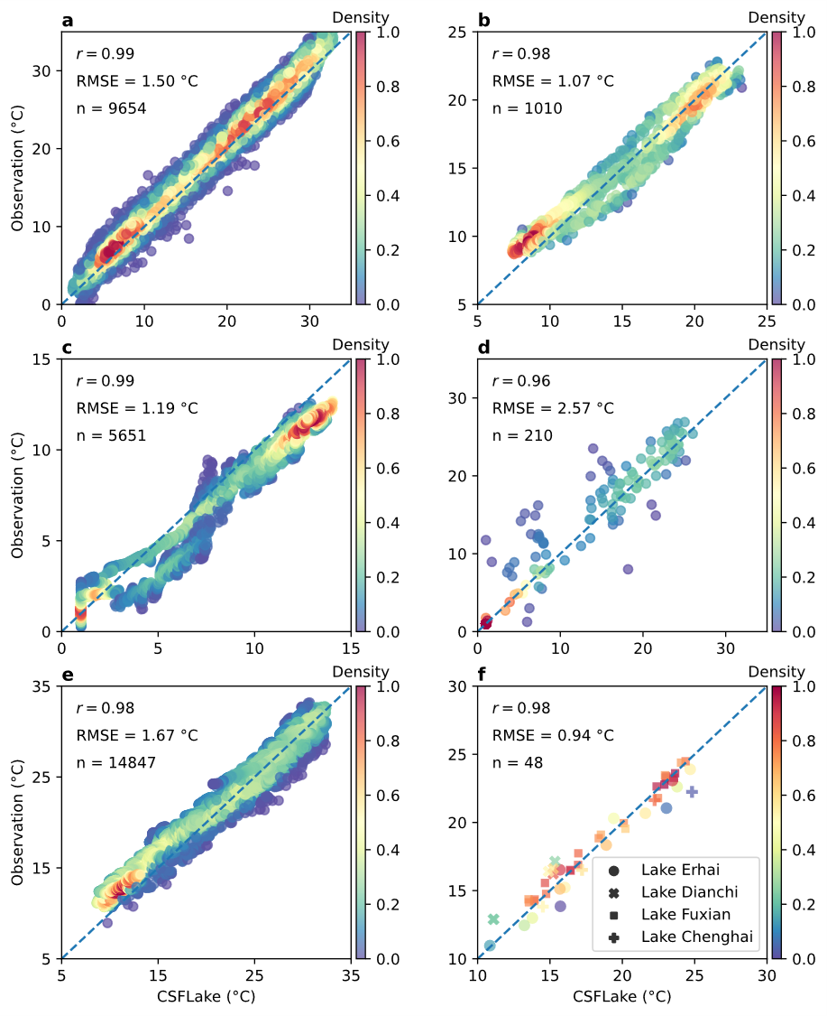
Extended Data Figure 1 Comparison between the simulated lake surface water temperature using CSFLake and observations. a, Lake Taihu. b, Lake Lugu. c, Lake Namco. d, Lake Hulun. e, Lake Qiandao. f, Four lakes on the Yunnan-Guizhou plateau. The Pearson correlation coefficient (italics “r”), root mean square error (RMSE), and the number of points (n) are shown in the text. The density of points was computed as the normalized kernel density estimation.
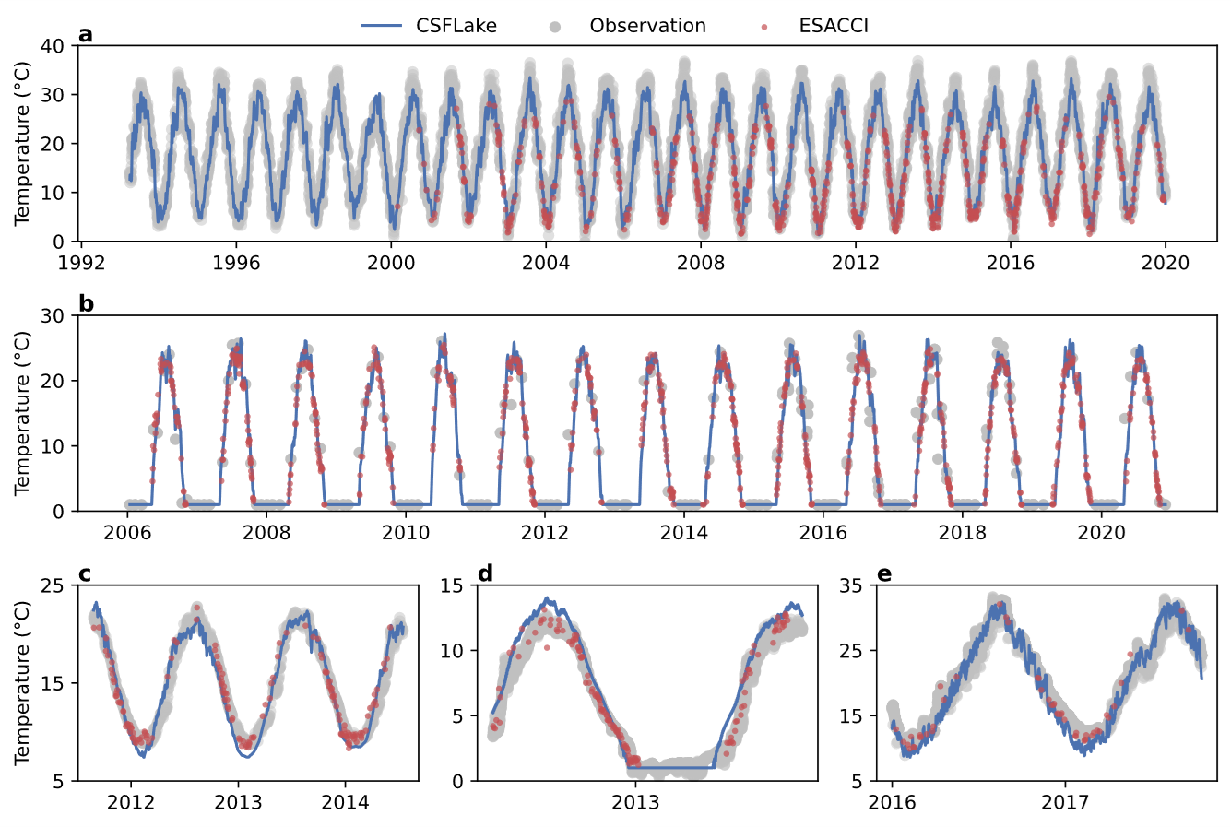
Extended Data Figure 2 Comparison of lake surface water temperature between CSFLake, ESACCI, and ground observations. a, Lake Taihu. b, Lake Hulun. c, Lake Lugu. d, Lake Namco. e, Lake Qiandao.
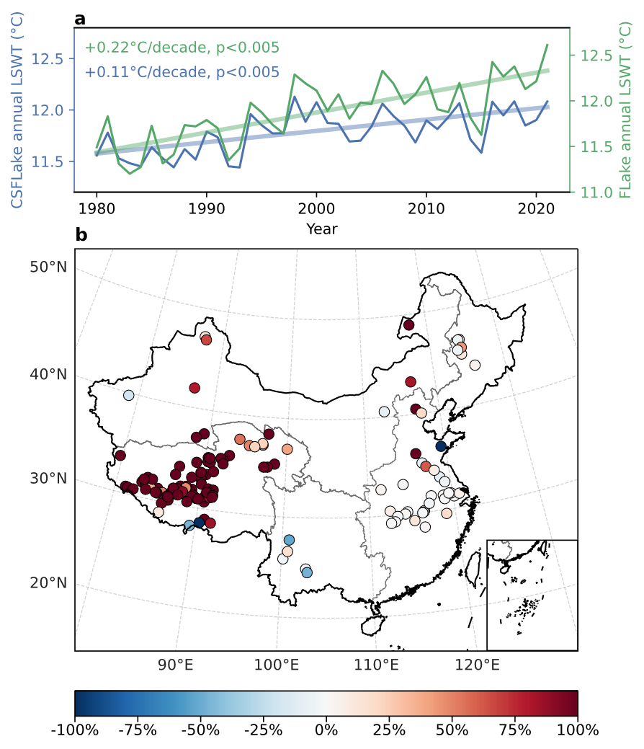
Extended Data Figure 3 Comparison of the LSWT trends simulated by CSFLake and FLake. a, Annual mean LSWT and trend of all studied lakes. b, Percent errors between the LSWT trends simulated by CSFLake and FLake. Percent error=(T-E)/T*100, where T and E denote the LSWT trend simulated by CSFLake and FLake, respectively. Note that some lakes are not shown in the figures because they stayed frozen for at least one year and their trends were therefore not calculated.
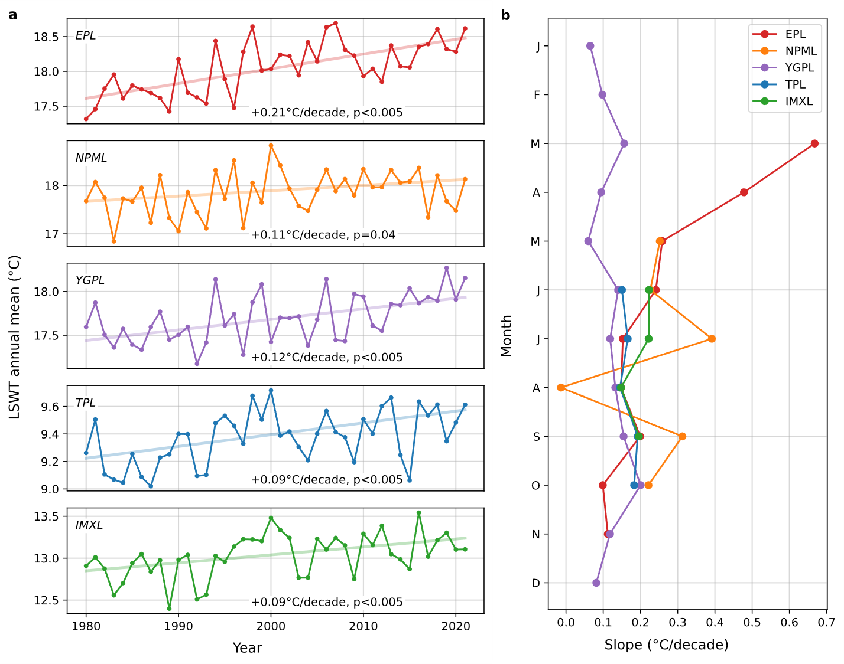
Extended Data Figure 4 Variation of lake surface water temperature at different time scales. a, Interannual variation of lake surface water temperature (LSWT). b, Monthly variation of LSWT. The solid lines in (a-b) denote the annual mean LSWT across the five lake zones.
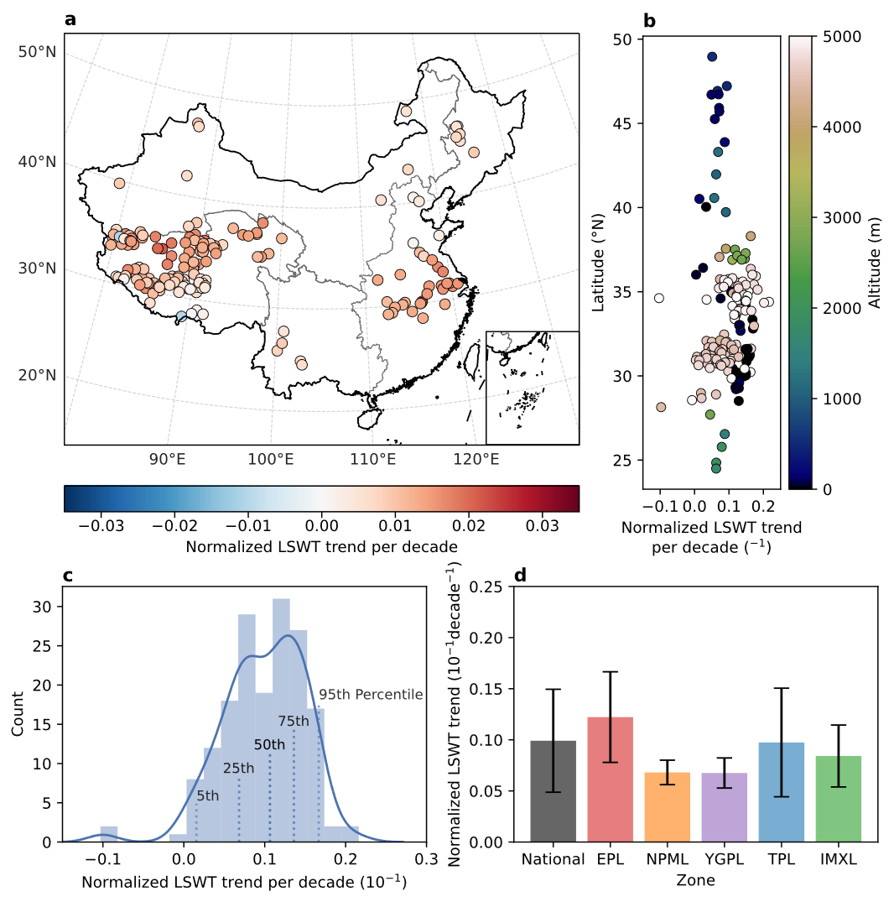
Extended Data Figure 5 Normalized trend of lake surface water temperature (1980-2021). Same as Figure 2 but the trend of lake surface water temperature is normalized by its annual mean climatology from 1980 to 2021.
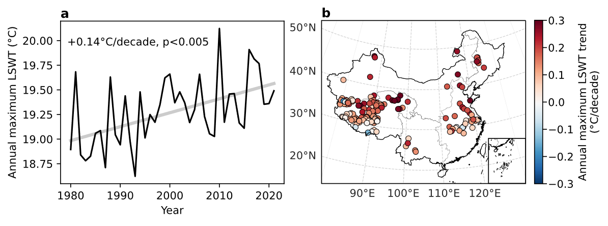
Extended Data Figure 6 Annual maximum lake surface water temperature. The trend of annual maximum lake surface water temperature (LSWT) averaged over all studied lakes (a) and its spatial distribution (b). The annotations in the top left corner show the slope and p value.
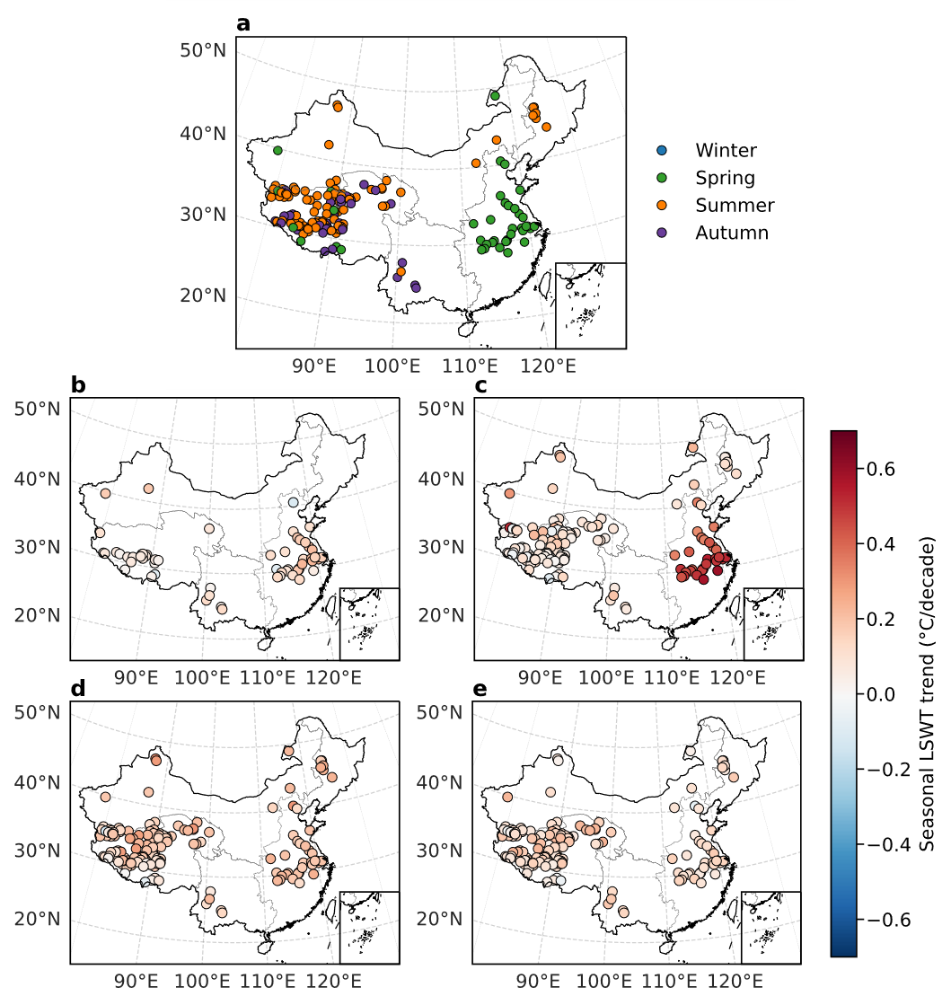
Extended Data Figure 7 Trend of seasonal LSWT. a, The fastest warming season. b-e, The trend of LSWT in winter (b), spring (c), summer (d), and autumn (e).
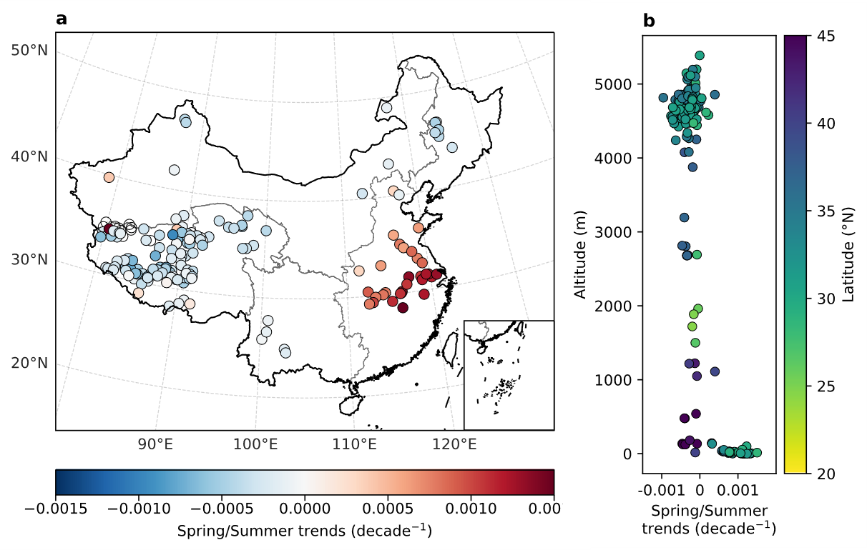
Extended Data Figure 8 Trends of the ratio of spring to summer lake surface water temperature. a, The spatial distribution. b, The variations along altitude and latitude.
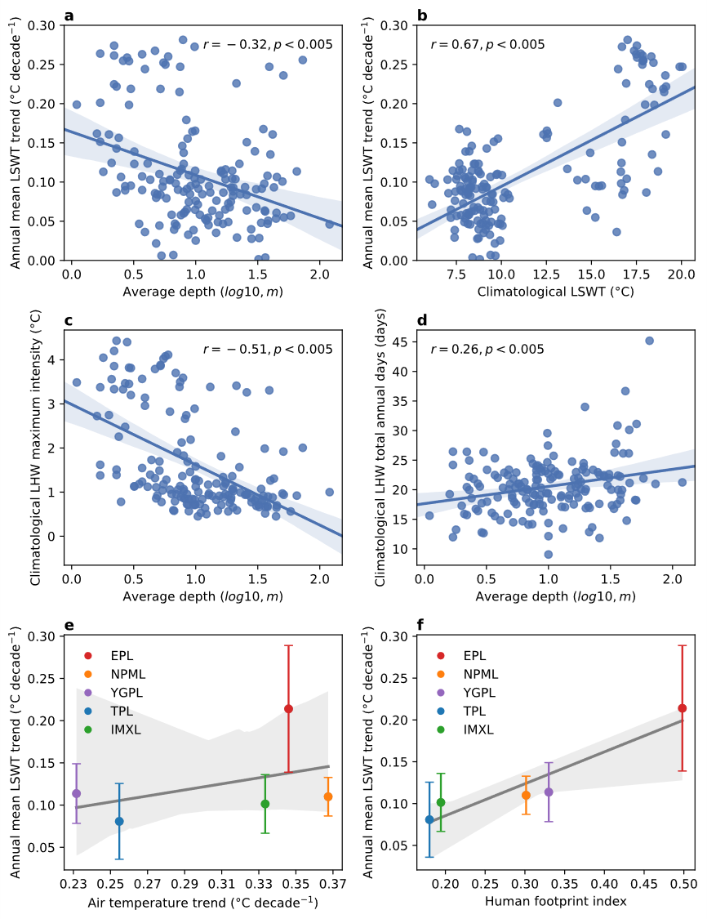
Extended Data Figure 9 Relationships between lake characteristics and lake water temperature. a-b, Lake surface water temperature (LSWT) trend versus average depth (a) and annual mean climatology of LSWT (b; 1980-2021). c-d, Lake average depth versus the annual mean climatology of lake heatwave maximum intensity (c) and total annual days (d). Each point represents a value from one lake. Italics “r” and “p” denote the Pearson correlation coefficient and its significance. e-f, The relationship between LSWT trend and air temperature trend (e) and human footprint index (f). The solid lines and their surrounding shaded areas show the linear regression model fit and 95% confidence interval, respectively.
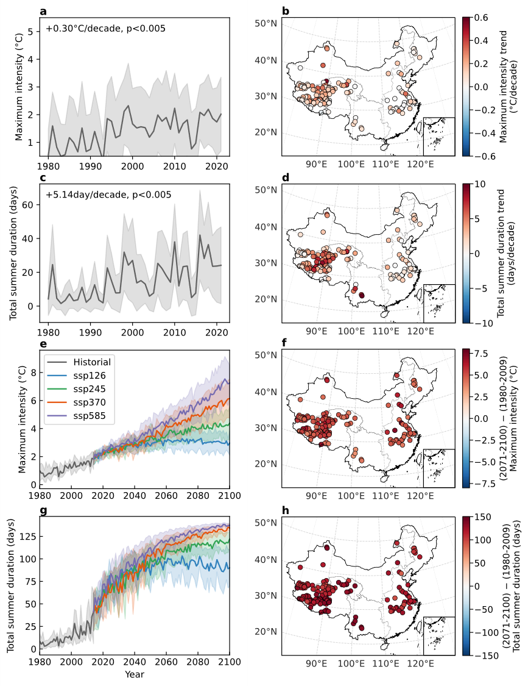
Extended Data Figure 10 Historical and future projection of the warm-season (May-September) lake heatwave (1980-2100). a-b, Annual mean (a) and climatology (b; 1980-2021) of the maximum intensity averaged over all studied lakes. c-d, Annual mean (c) and climatology (d) of the total annual days averaged over all studied lakes. e-f, Future projection (e) and the differences between 2071-2100 and 1980-2009 under the SSP5-8.5 scenario (f) of the maximum intensity. g-h, Future projection (g) and the differences between 2071-2100 and 1980-2009 under the SSP5-8.5 scenario (h) of the total annual days. The solid lines and their surrounding shaded areas represent the ensemble mean and standard deviation of the simulation results driven by five global circulation models, respectively. The upper-right texts in a and c show the trend calculated using the Theil-Sen estimator and its significance.

