GWAS identifies a wheat orthologue of the rice D11 gene as an important contributor to grain size in an international collection of hexaploid wheat

Honoré Tekeu^{1,2,5}, Eddy L.M. Ngonkeu^{4,5}, Sébastien Bélanger^{2,3}, Pierre F. Djocgoué⁵, Amina Abed^{1,2}, Davoud Torkamaneh^{1,2,6}, Brian Boyle², Patrick Tsimi⁵, Wuletaw Tadesse⁷, Martine Jean^{1,2}, François Belzile^{1,2}*
¹Département de Phytologie, Université Laval, Quebec City, QC, Canada
²Institut de Biologie Intégrative et des Systèmes, Université Laval, Quebec City, QC, Canada
³Donald Danforth Plant Science Center, University of Missouri, Missouri, USA.
⁴Institute of Agricultural Research for Development, Yaoundé, Cameroon
⁵Department of Plant Biology, University of Yaoundé I, Yaoundé, Cameroon
⁶Department of Plant Agriculture, University of Guelph, Guelph, ON, Canada
⁷International Center for Agricultural Research in the Dry Areas (ICARDA), Beirut, Lebanon

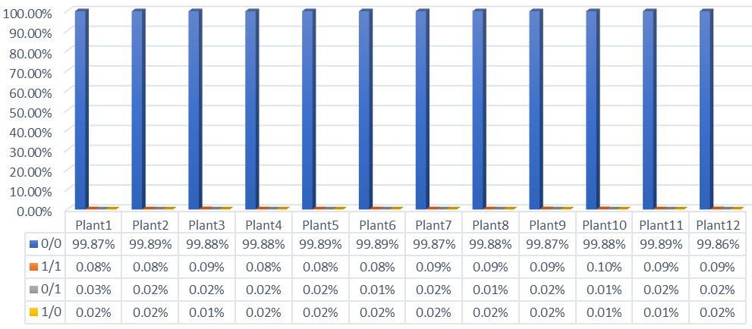
Figure S1: Accuracy of a non-imputed GBS dataset from 12 plants of Chinese Spring using a dataset of 129,940 SNPs. Imputed genotypes were compared to genotypes from the Chinese Spring reference genome. 0/0: Homozygous for the reference allele; 1/1: Homozygous for the alternative allele; 0/1 or 1/0: Heterozygous.

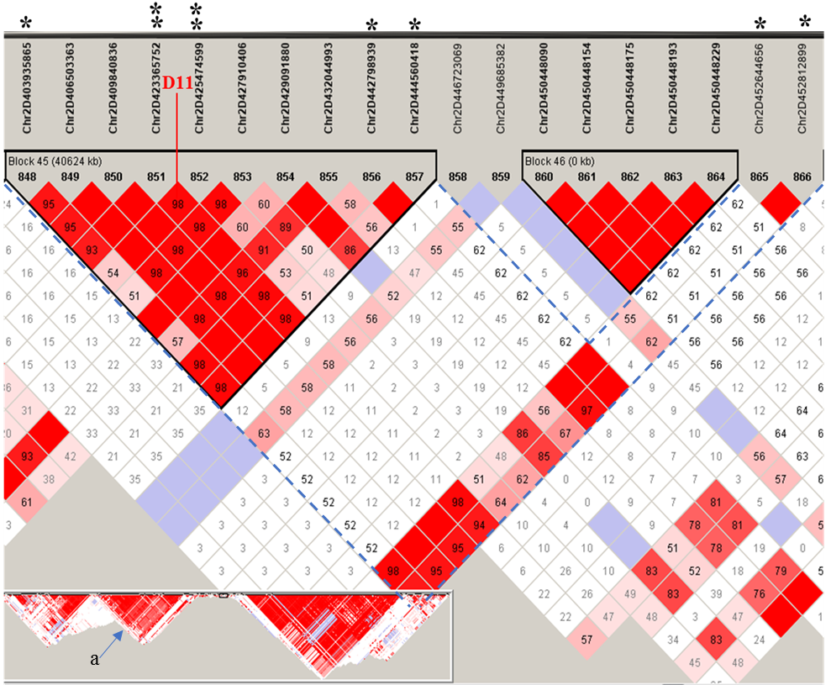
Figure S2: Linkage disequilibrium plots across wheat lines showing SNPs markers associated with grain traits in linkage blocks on chromosome 2D. The box (bottom left: a) in the figure illustrates the LD in an area of ~ 45Mb around SNP peak, with enlargement of the region around the candidate gene D11.
*: significant SNP markers identified by GWAS
**: diagnostic SNP markers identified using HaplotypeMiner tools.

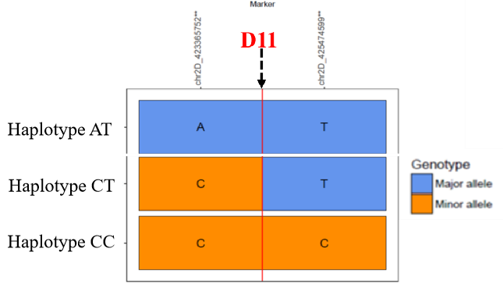
Figure S3: Three haplotypes identified around the D11 gene

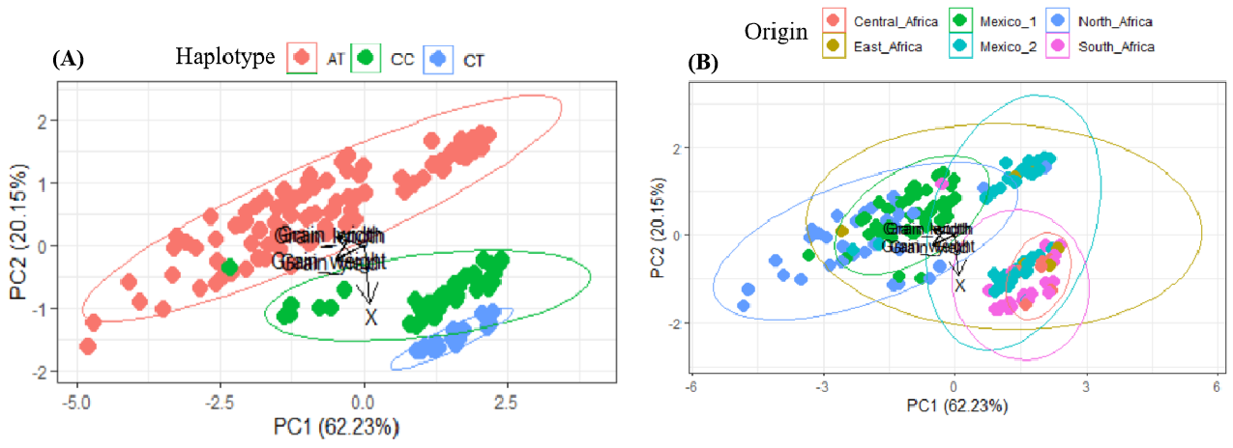
Figure S4: Relations between the 3 haplotypes (A) and the 6 groups found in the population analysis (B). The haplotype AT predominates in the populations of Mexico 1 and North Africa

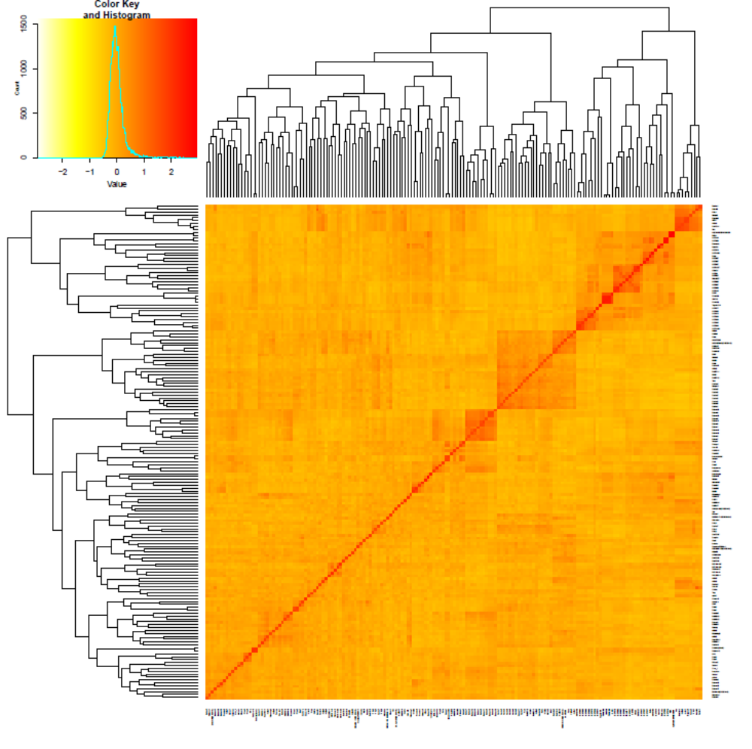
Figure S5: Matrix of genomic relationships among wheat individuals, calculated using the Van Raden method.

