Supplemental Digital Content 1-
3-year outcomes of I-CXL

Parameter | Preoperative | 1 Month | 3 Months | 6 Months | 12 Months | 24 Months | 36 Months
IOP (mmHg) | 11.97 ± 3.43 | 12.76 ± 4.01 | 11.24 ± 3.23 | 10.98 ± 3.19 | 13.01 ± 5.21 | 11.65 ± 3.37 | 12.03 ± 3.51
UDVA(LogMAR) | 0.75 ± 0.35 | 0.72 ± 0.39 | 0.7 ± 0.42 | 0.68 ± 0.4 | 0.71 ± 0.4 | 0.75 ± 0.39 | 0.7 ± 0.4
CDVA(LogMAR) | 0.26 ± 0.17 | 0.21 ± 0.15* | 0.22 ± 0.16 | 0.18 ± 0.17* | 0.18 ± 0.17* | 0.21 ± 0.16 | 0.19 ± 0.13*
SE(D) | -6.35 ± 3.96 | -6.24 ± 4.11 | -6.33 ± 3.4.16 | -6.47 ± 3.92 | -6.62 ± 3.76 | -6.48 ± 3.58 | -6.51 ± 3.46
K_{max}(D) | 59.72 ± 8.71 | 59.74 ± 7.46 | 59.44 ± 8.51 | 59.32 ± 8.18 | 59.09 ± 7.76 | 58.42 ± 7.75* | 58.03 ± 7.96*
MCT (μm) | 441 ± 35 | 436 ± 34 | 438 ± 35 | 442 ± 34 | 441 ± 34 | 445 ± 34 | 450 ± 34*
ISV  IVA | 90.27 ± 39.15  0.8 ± 0.42 | 90.67 ± 37.13  0.74 ± 0.39 | 88.2 ± 37.44  0.74 ± 0.39 | 87.03 ± 37.23*  0.74 ± 0.4* | 86.07 ± 36.13*  0.73 ± 0.39** | 84.7 ± 36.36*  0.72 ± 0.41** | 84.37 ± 36.25*  0.71 ± 0.41**
KI | 1.24 ± 0.14 | 1.22 ± 0.13 | 1.22 ± 0.14 | 1.23 ± 0.14 | 1.22 ± 0.14* | 1.22 ± 0.14* | 1.22 ± 0.14**
CKI | 1.1 ± 0.07 | 1.1 ± 0.07 | 1.1 ± 0.07 | 1.1 ± 0.07 | 1.1 ± 0.07 | 1.1 ± 0.07 | 1.09 ± 0.07
IHD | 0.131 ± 0.073 | 0.113 ± 0.068 | 0.114 ± 0.072 | 0.112 ± 0.071* | 0.11 ± 0.069* | 0.11 ± 0.071* | 0.106 ± 0.07**
ECD (cells/mm2) | 2646 ± 367 | 2589 ± 296 | 2614 ± 301 | 2642 ± 289 | 2623 ± 313 | 2658 ± 279 | 2632 ± 252
IOP = intraocular pressure; UDVA = uncorrected distance visual acuity; CDVA = corrected distance visual acuity; LogMAR = logarithm of the minimum angle of resolution; SE=spherical equivalence; D = diopters; K_{max} = maximum keratometry; MCT = minimum corneal thickness; ISV=index of surface variance; IVA=index of vertical asymmetry; KI=keratoconus index; CKI= central keratoconus index; IHD=index of height decentration; ECD=endothelial cell density.
* indicates P < 0.05 statistically significant difference compared to baseline; ** indicates P < 0.001 statistically significant difference compared to baseline.

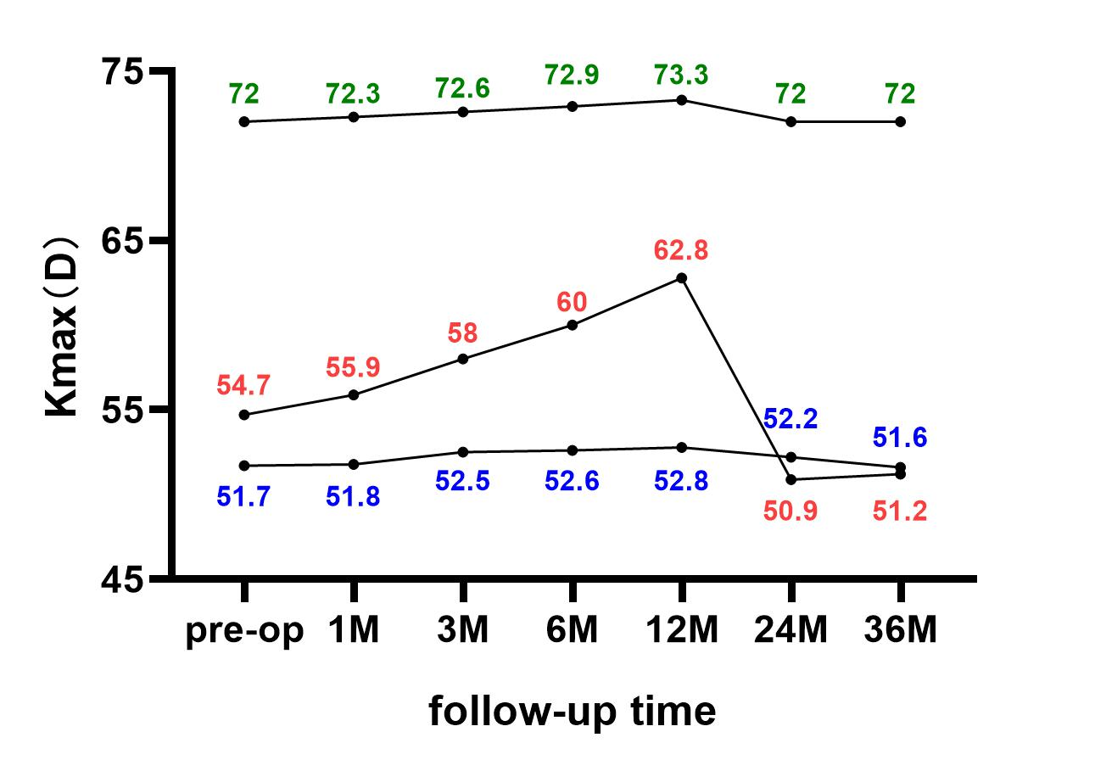
Supplemental Digital Content 2 - Changes of maximum keratometry values of 36months follow-up in three patients whom observed as ‘progression’ at 12 months

