Supplementary Information
Figure A1. Association between UI and BMI by age group by male in HRS study, 2010-2018
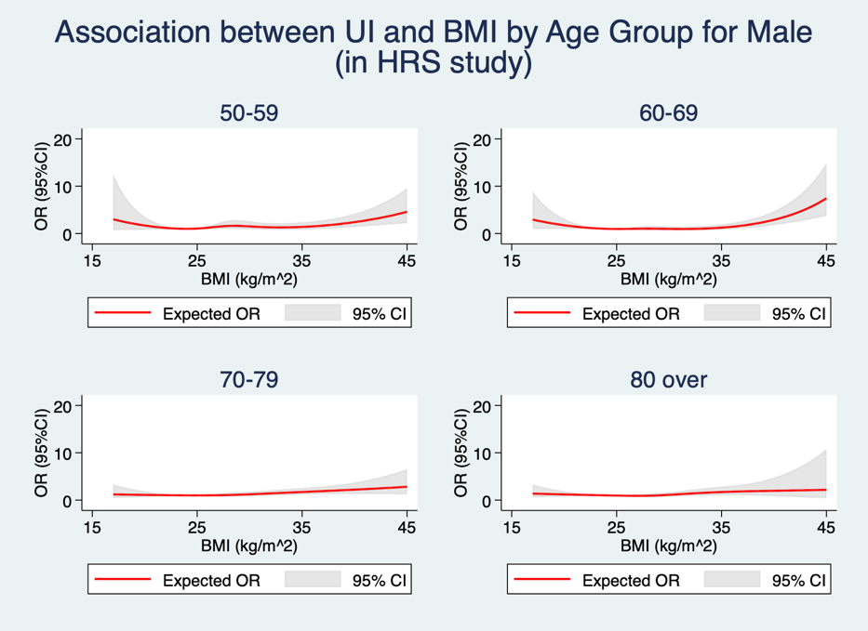
Figure A2. Association between UI and BMI by age group by female in HRS study, 2010-2018
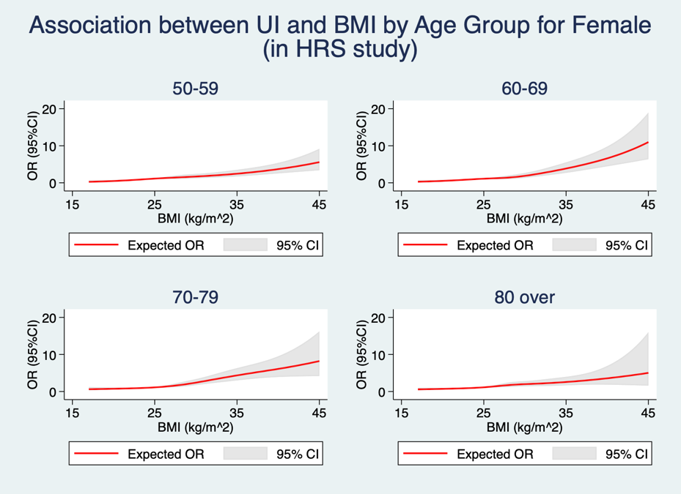

Figure A3. Association between UI and WC by age group by male in HRS study, 2010-2018
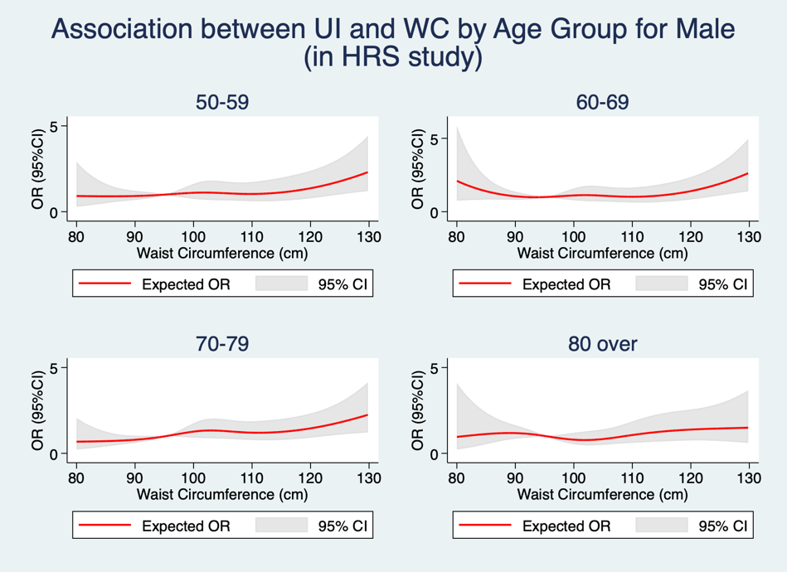
Figure A4. Association between UI and WC by age group by female in HRS study, 2010-2018
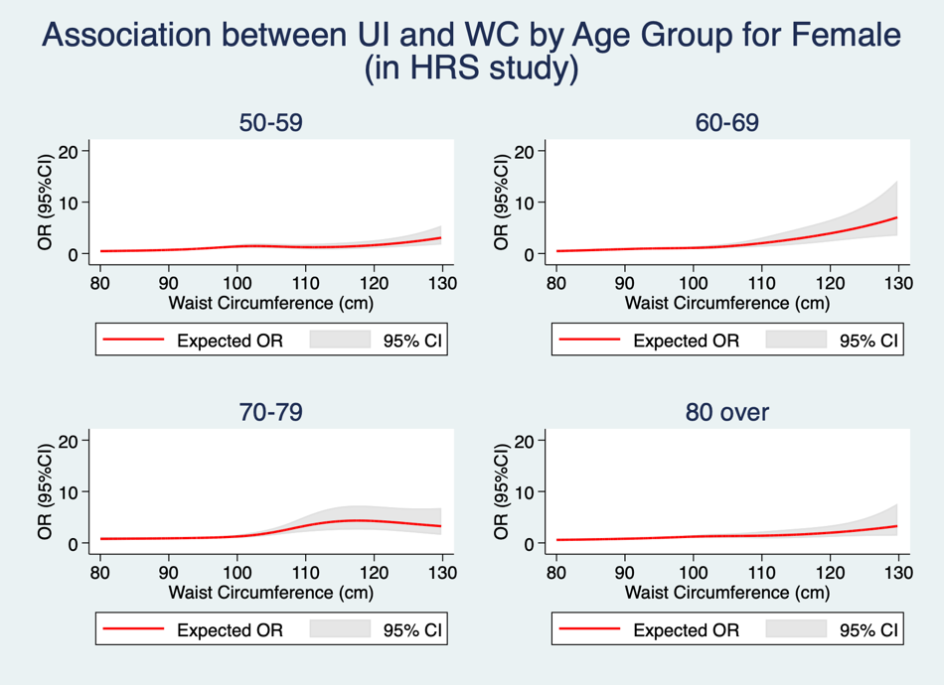

Figure A5. Association between UI and BMI by age group by male in SHARE study, 2004-2010 (except 2018)
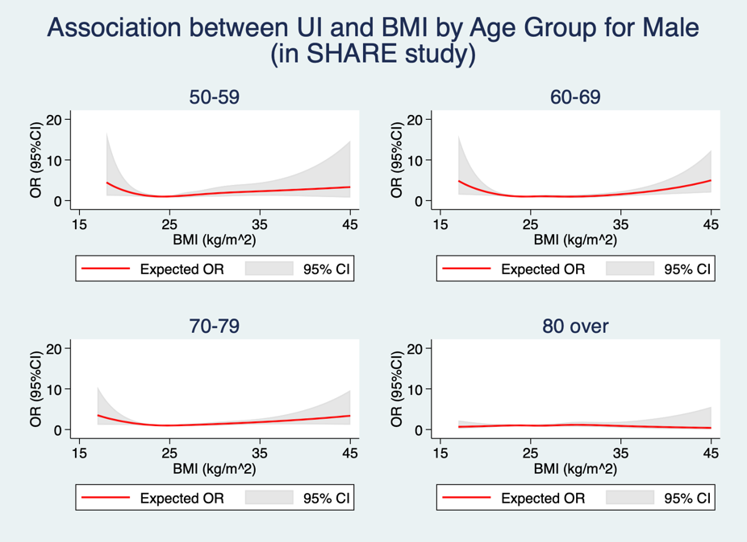
Figure A6. Association between UI and BMI by age group by female in SHARE study, 2004-2010 (except 2018)
