Supplementary Material
Time- and angle-resolved photoemission images at the Γ point
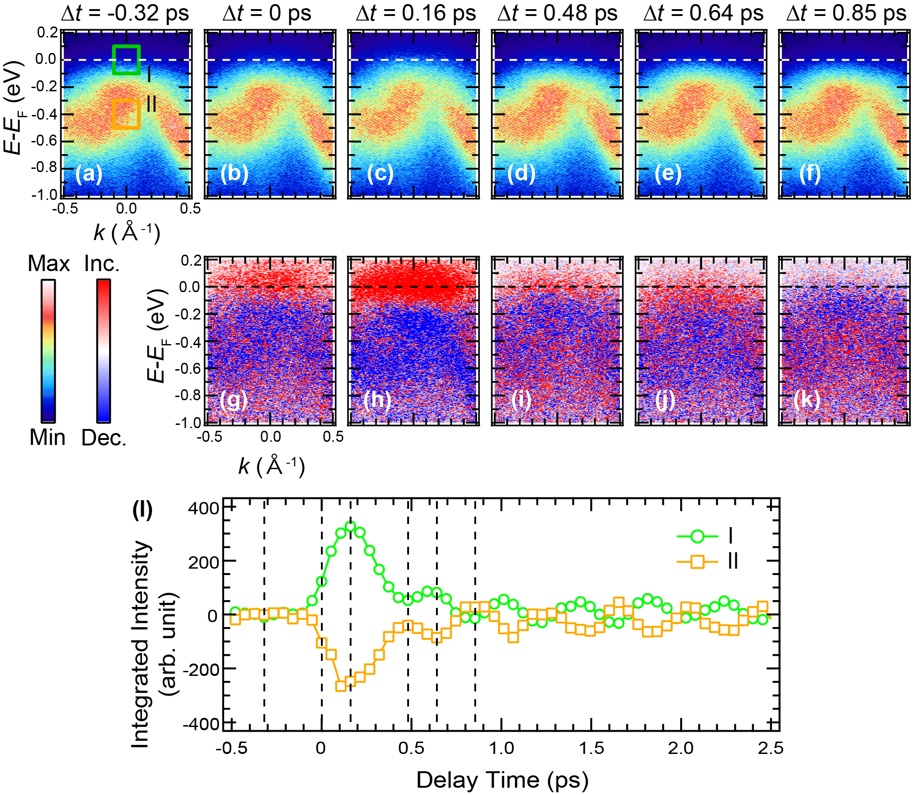
FIG. S1. (a)-(f) Time- and angle-resolved photoemission spectra for Γ at selected pump-probe delays (Δt). (g)-(k) Difference spectra for Γ points at the corresponding delay times given in (b)-(f) obtained by subtracting (a) from each spectrum, respectively. (l) Time-dependent photoemission intensity integrated at the energy-momentum region denoted as I and II in (a). Vertical dashed lines correspond to the selected Δt.

Estimation of the electronic temperature before and after photo-excitations
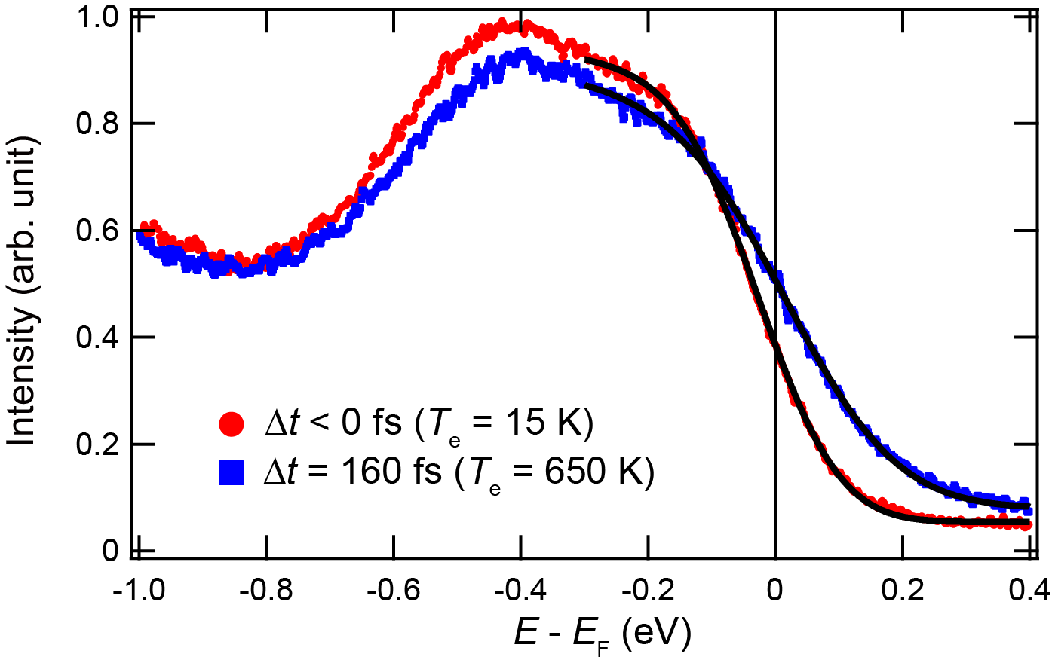
FIG. S2. Momentum-integrated energy distribution curves around the Γ point taken at Δt < 0 fs and Δt =160 fs. Fitted curves to a Fermi-Dirac function are overlaid.

Frequency-domain ARPES images at the different momentum cuts
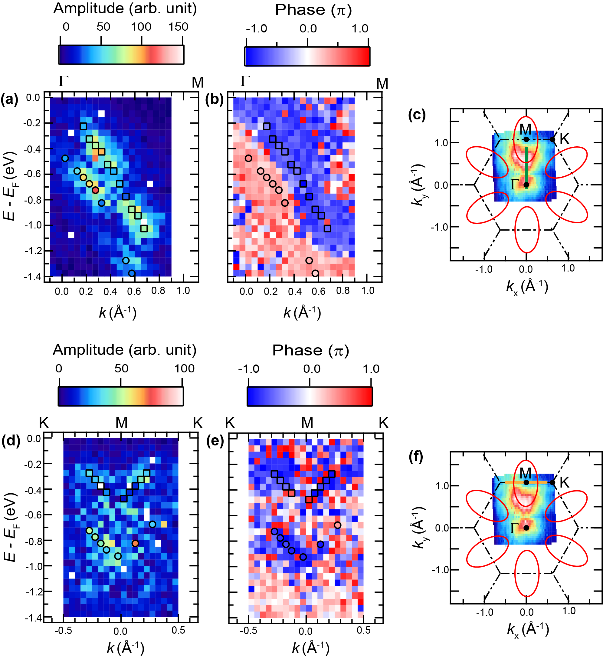
FIG. S3. Frequency-domain ARPES (FDARPES) images at the frequency of 2.5 THz for Γ-M ((a) and (b)) and K-M-K directions ((d) and (e)). (a) and (d) are the amplitude parts, while (b) and (e) show the phase parts. Momentum cuts for the FDARPES images along Γ-M ((a) and (b)) and K-M-K directions ((d) and (e)) are shown in (c) and (f) as green- and orange-solid lines, respectively.

