Table 1

Table 1 Overview of sampling sites
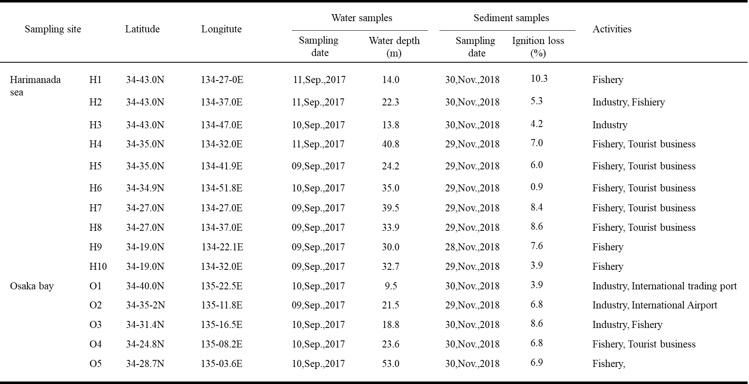

Table 2

Table 2 Abbreviation and mass number of antifouling biocides
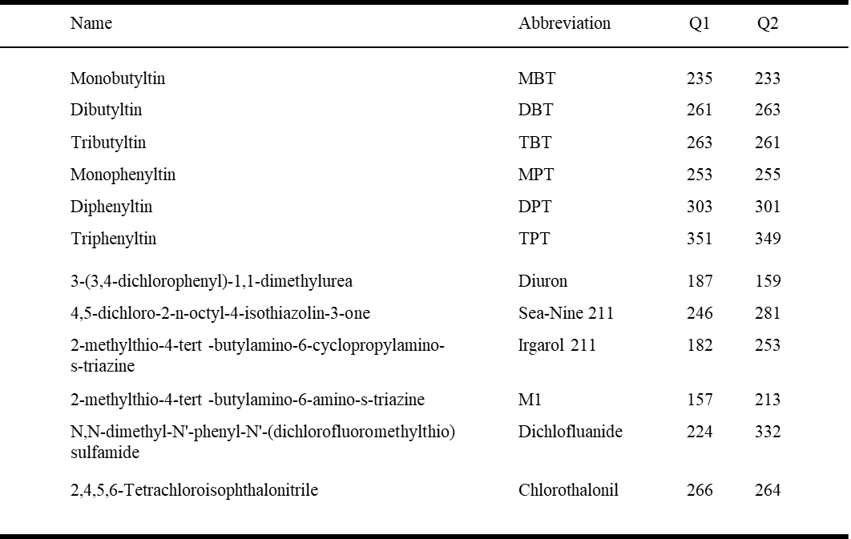

Table 3

Table 3 Concentrations of butyltin compounds in water samples, 2017
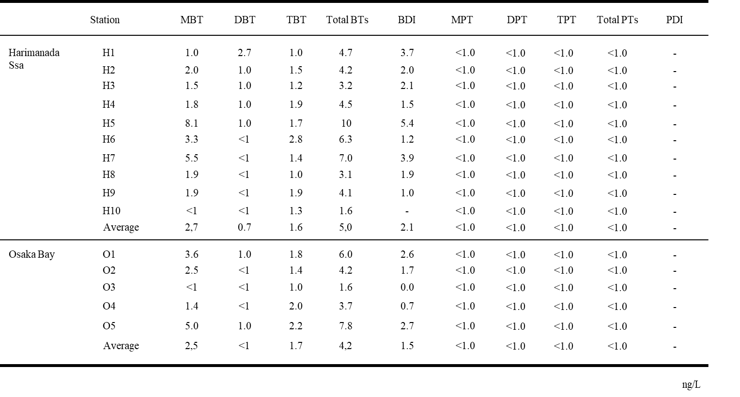

Table 4

Table 4 The concentrations of OTs in water and sediment samples in the worldwide
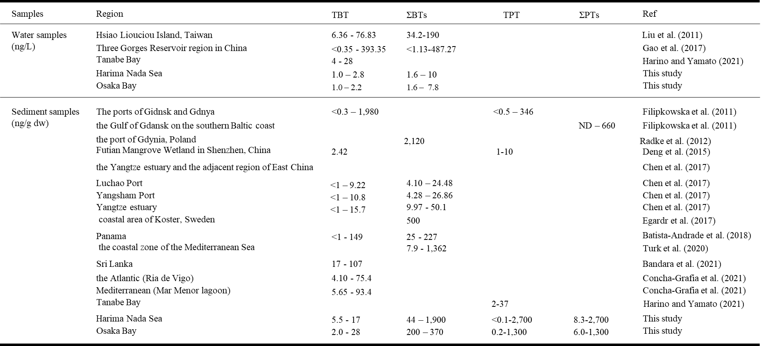

Table 5

Table 5 The concentrations of butyltin and phenyltin compounds in sediment samples, 2018
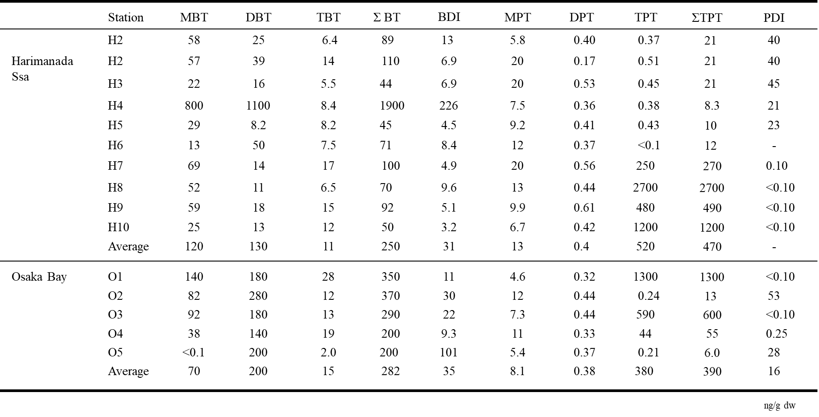

Table 6
Table 6 The concentrations of alternative biocides in water samples, 2017
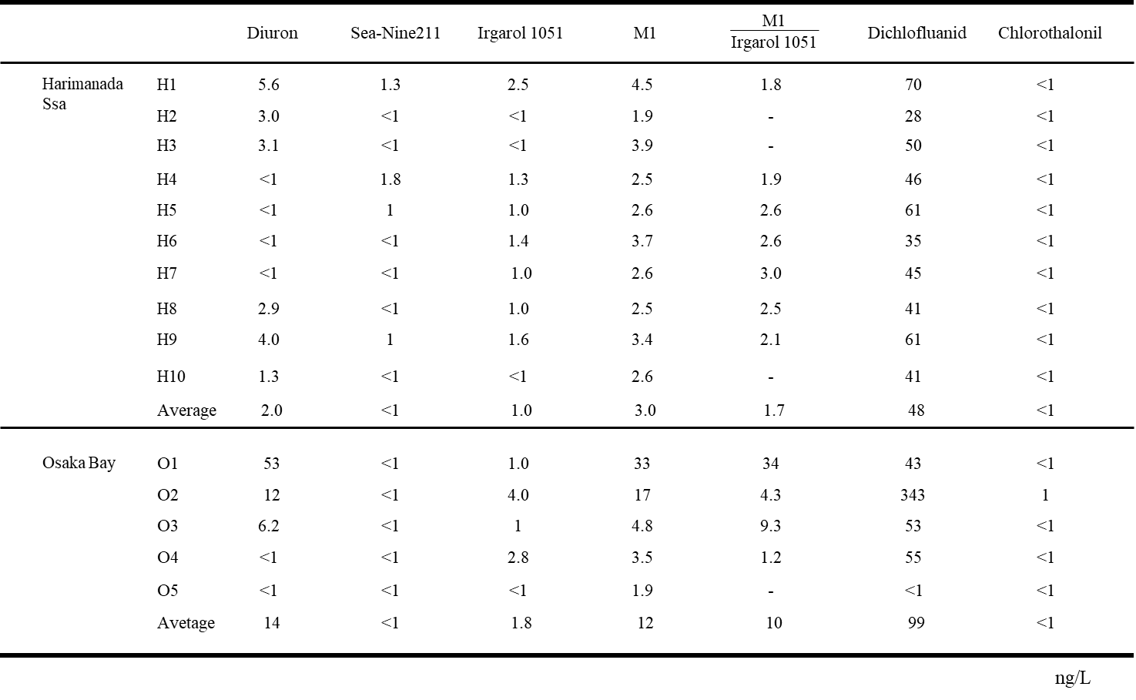

Table 7

Table 7 The concentrations of alternative biocides in water samples in the worldwide
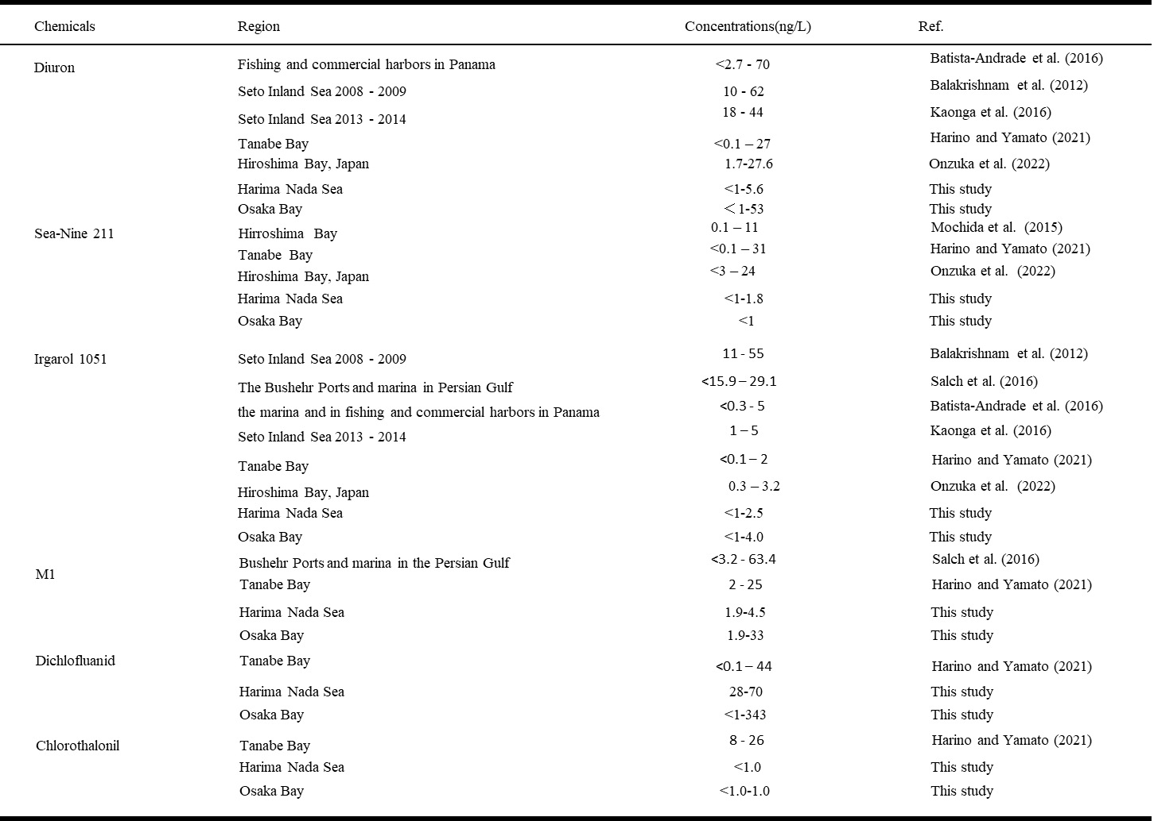

Table 8

Table 8 Concentrations of alternative biocides in sediment samples, 2018
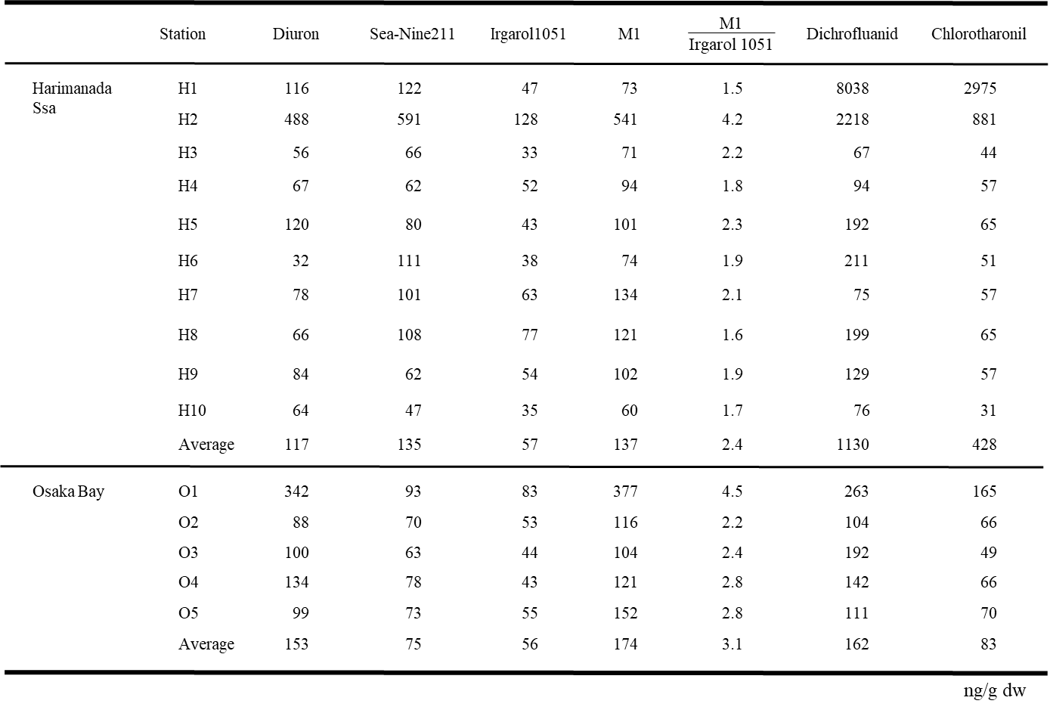

Table 9

Table 9 The concentrations of alternative biocides in sediment samples in the worldwide
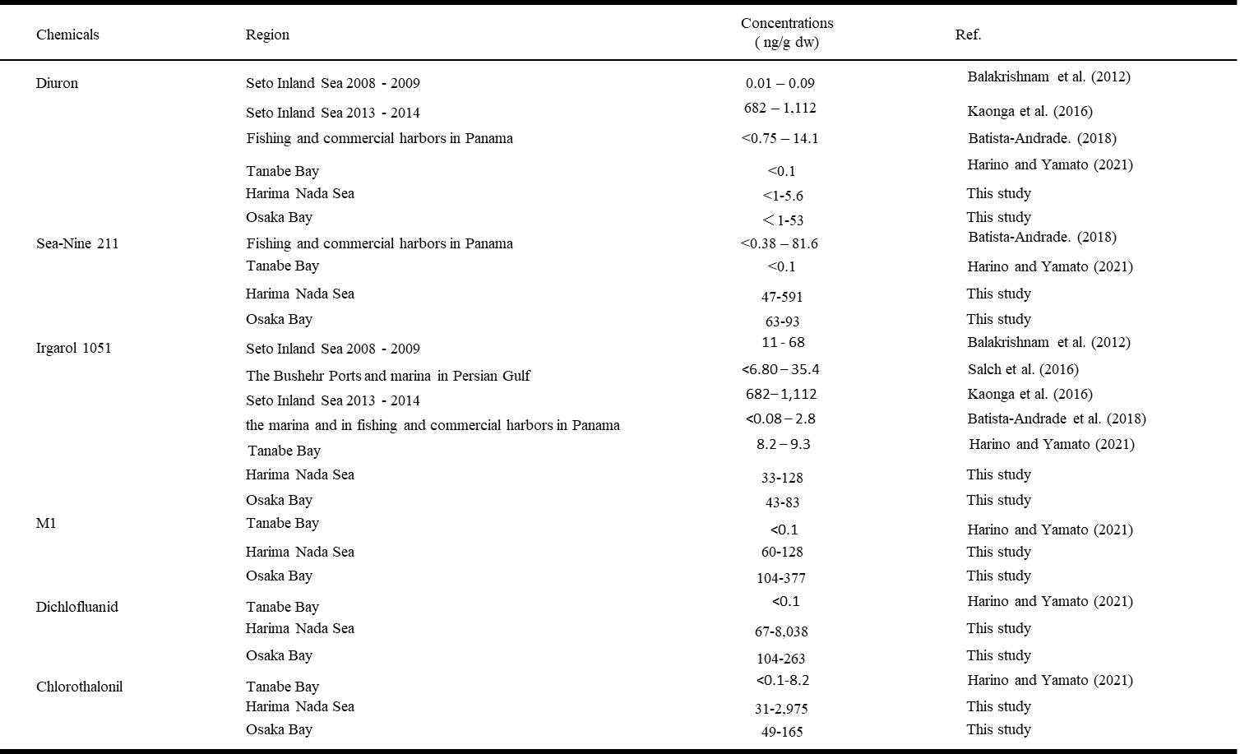

Table 10

Table 10 Correlation coefficient of antifouling biocides in water samples
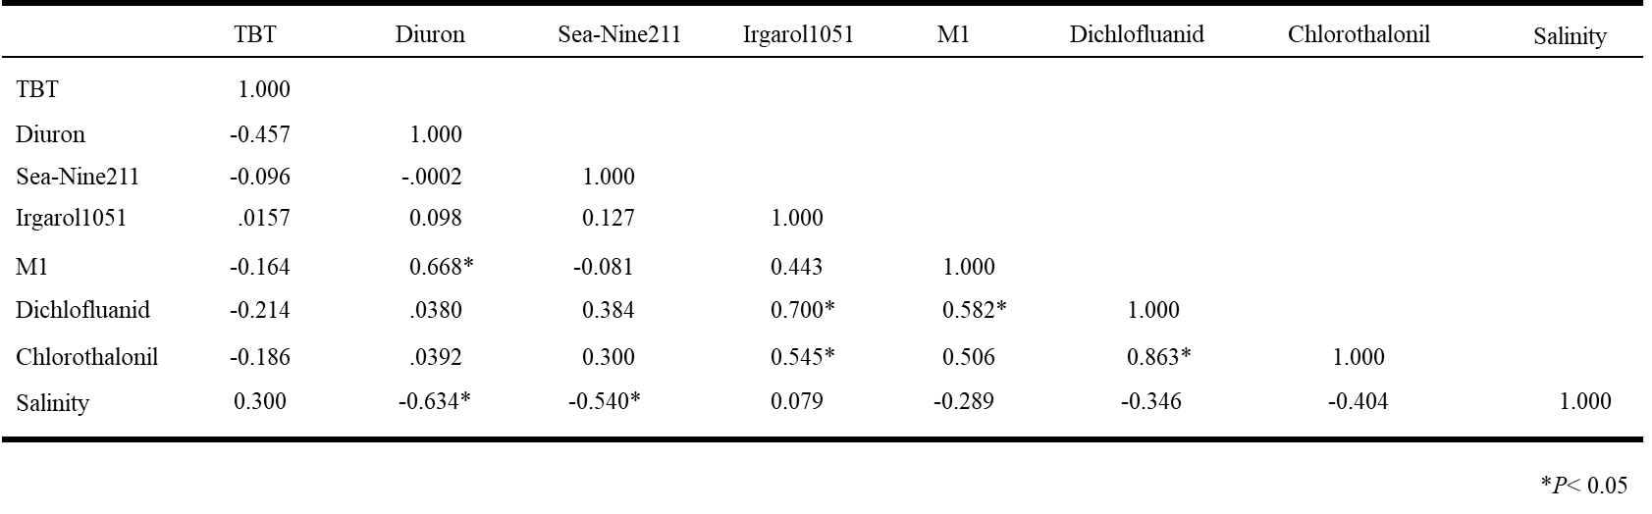

Table 11

Table 11 Correlation coefficient of antifouling biocides in sediment samples
